  Component One:  What are the key skills required when working in the housekeeping team? 750 words (+/- 10%)  Contribution to Overall Module Assessment: 25% | Student No: | 2210859
 | Module Title: | Operating Hotel Facilities
 | Module Code: | BMIH4006
 | Lecturer: | Natalie Brailsford
A housekeeping team is a group of skilled professionals who work hard to make sure hotels remain clean for new guests. They face various challenges depending on the previous guests, and are a vital part of maintaining customer satisfaction and making good first impressions to new guests. Now Let's look at the skills that make up the housekeeping team's expertise.

So How do you improve team effectiveness? Have a rota and rotate the staff around in a way where each member doesn’t have extreme hours and are always refreshed and ready to work. Also, remind the cleaning staff to be thorough and not lazy. Check the room after cleaning to be sure it's clean. If a room is dirty because of laziness, talk to the staff and make sure the cleaning is done properly. (Hassnain, 2019)

Good time management is important for housekeepers. They need to balance urgency and precision to get tasks done efficiently. They make sure guest rooms are prepared perfectly and public areas look great. They're always on time and pay attention to detail.

A housekeeper is skilled at cleaning and knows how to use different methods for different surfaces. They have various cleaning tools and products to transform spaces while protecting delicate materials. (Ambardar, 2017) Their expertise ensures that cleanliness and preservation work together seamlessly.

In housekeeping, being organized is very important. Housekeepers are good at managing inventory and making sure they have enough linens, toiletries, and cleaning materials. They keep everything in its proper place, which helps the operation run smoothly and efficiently.

The housekeeping team needs a lot of physical strength to do their job well. They move around the hotel easily, carrying heavy things and pushing carts full of supplies. They work hard to keep their bodies healthy and strong, even though it can be tiring. (Lee, 2015)

The housekeeping team is great at communicating with guests. They speak well and listen carefully to understand their needs. They work with other hotel departments to provide exceptional service. Every interaction they have is a beautiful part of the hospitality experience.

In housekeeping, it's important to be adaptable. Housekeepers are resilient and flexible, which helps them move around easily. They can change their plans quickly to meet guests' needs. Their improvisational skills are important for maintaining high housekeeping standards.

Word Count

Component Two:
Contribution to Overall Module Assessment: 25%
In this scenario – You have just been promoted to team leader for a floor within the hotel. A guest complains that on their arrival, their room had not been properly cleaned. Create an action plan and answer the following questions.

Problem | Why did it happen? | What are you going to do? | How will you prevent this from happening in the future? | What measures would you introduce to improve team effectiveness?
Angry customer | Miscommunication between reception staff and housekeeping leading to bad customer experience. | Apologise to the customer and fix the problem, while making sure it will never happen again and tell the staff to be more thorough. | Tell the staff it isn’t acceptable and check myself if the room has been cleaned properly after. | Me checking after they clean to see if they did a good job.
Dirty room | Lack of motivation within the cleaning staff | Tell the staff to clean again immediately | Seek to increase motivation by using a different leadership style | I will check the room after they clean it to see if its okay.
Damaged brand reputation | New customers finding their room dirty. | Reimburse the customer with either a free meal or something else to satisfy them, while apologising | Make sure that the rooms wont be dirty for future customers | I will create a mini training that will keep the staff incheck.
Short on staff | Too many people called in sick | Temporarily move people from lesser busy departments to housekeeping. | Hire 1 or 2 more housekeeping staff. | Optimize the schedule to fit in the new staff.
Faulty cleaning equipment | Poorly used by inexperienced staff | Supply the staff with new equipment asap | Have backup equipment at the ready | Let the staff know to be more gentle with the equipment, also make a training to use equipment for new staff.

Component Three:
Contribution to Overall Module Assessment: 50%
Your task is to create and prepare a presentation following the detailed scenario provided below.

As the floor housekeeping manager and given the recent guest complaints you need to put together a basic training presentation for your colleagues within the housekeeping team to get the best out of them, ensure that brand standard is being achieved and that Health and Safety procedures are also being followed.

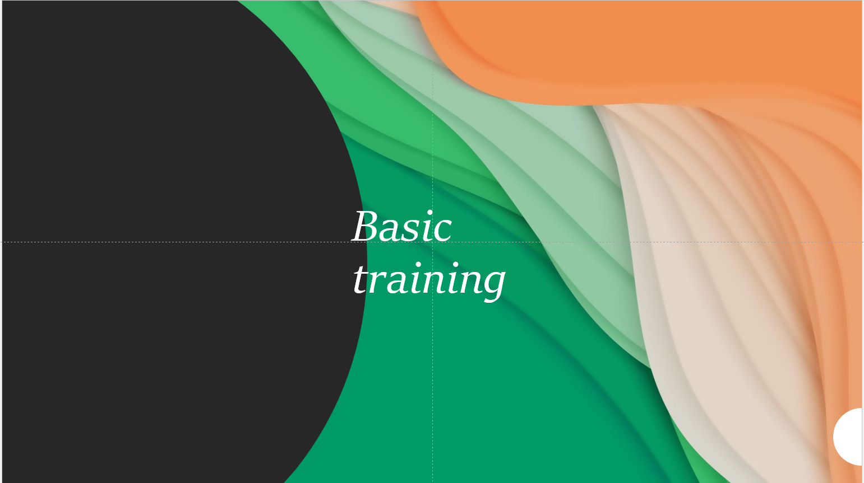

Training Notes:
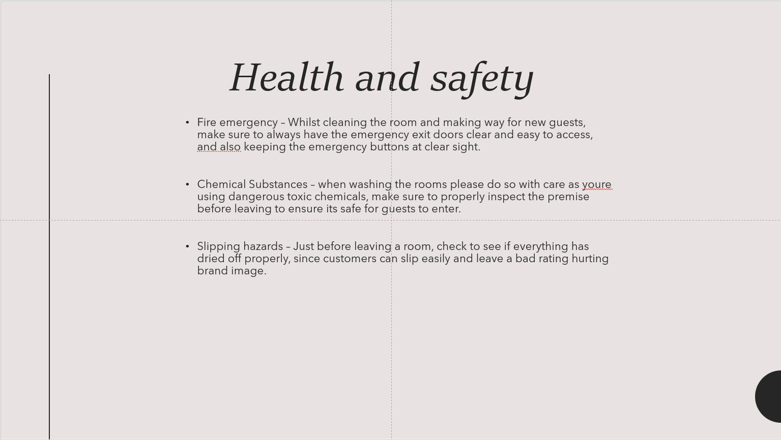

Training Notes:
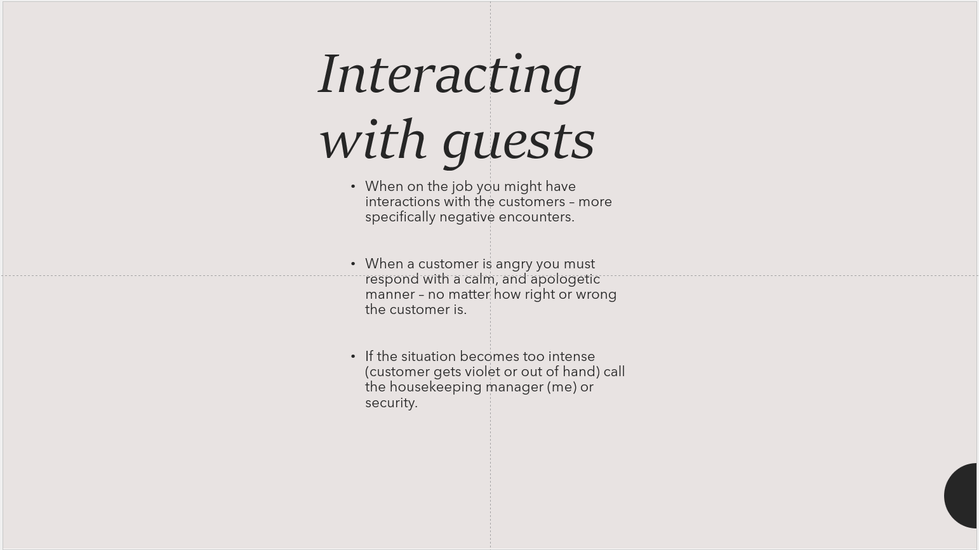

Training Notes:
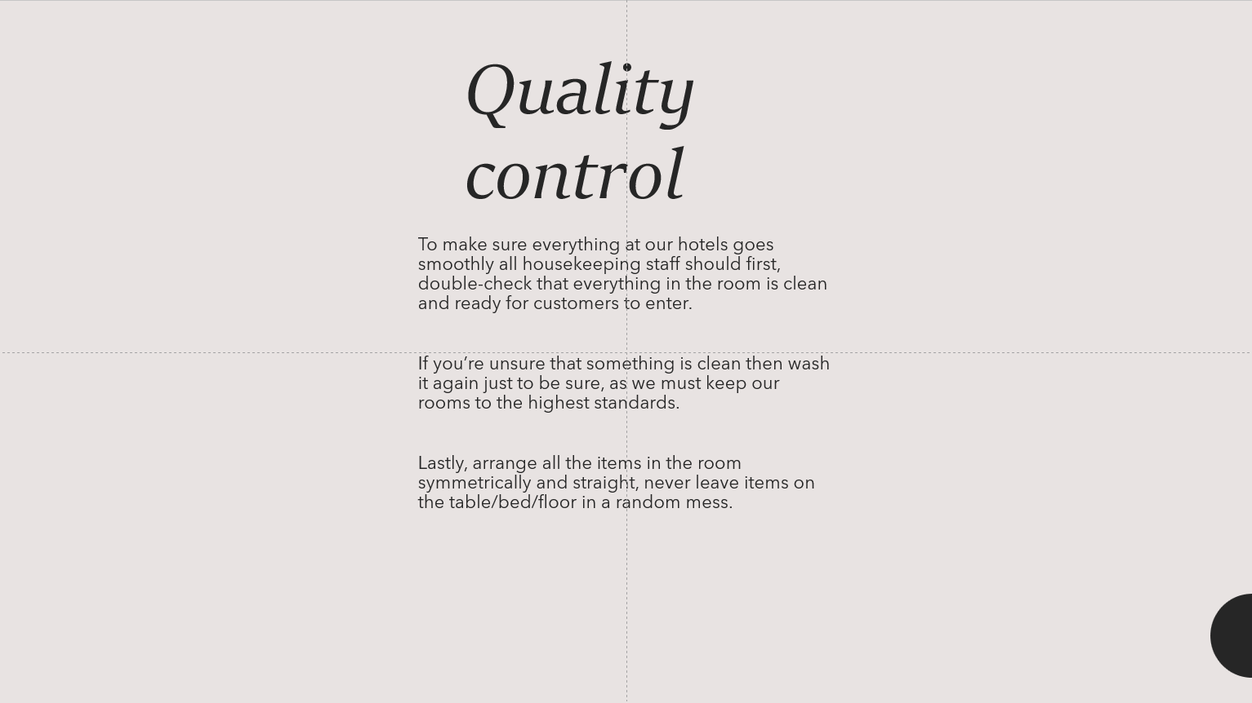

Training Notes:
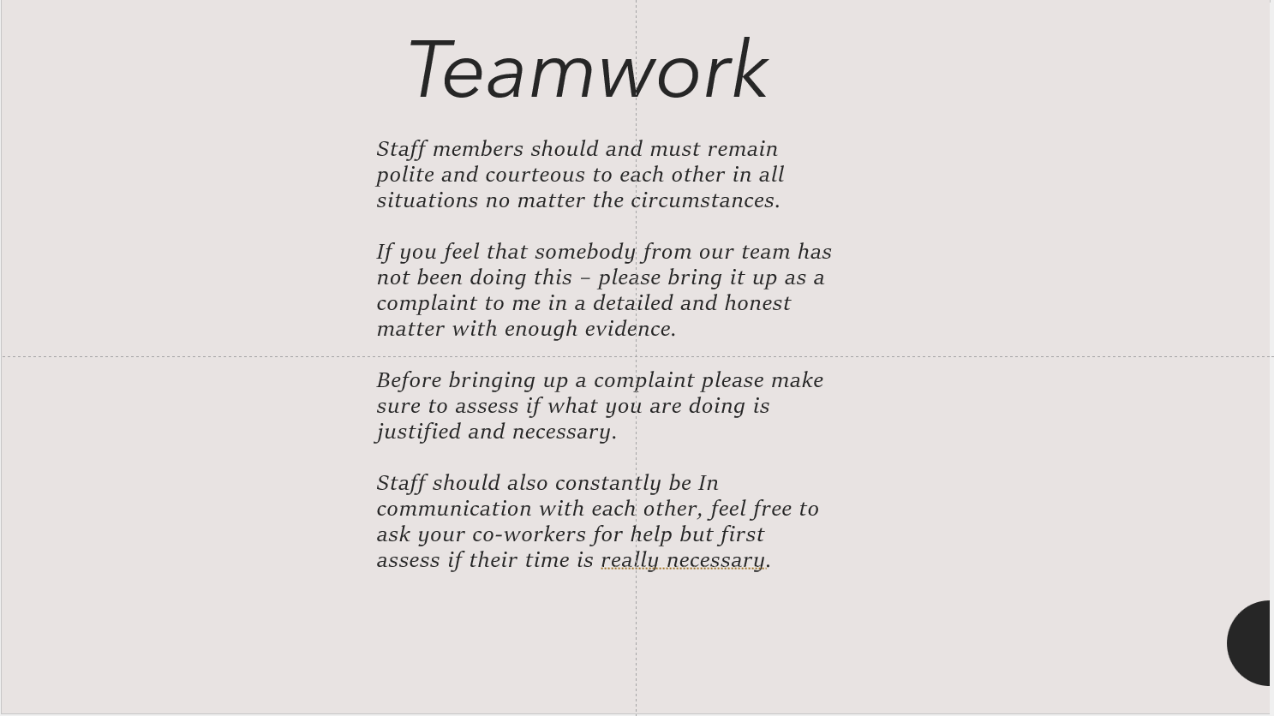

Training Notes:

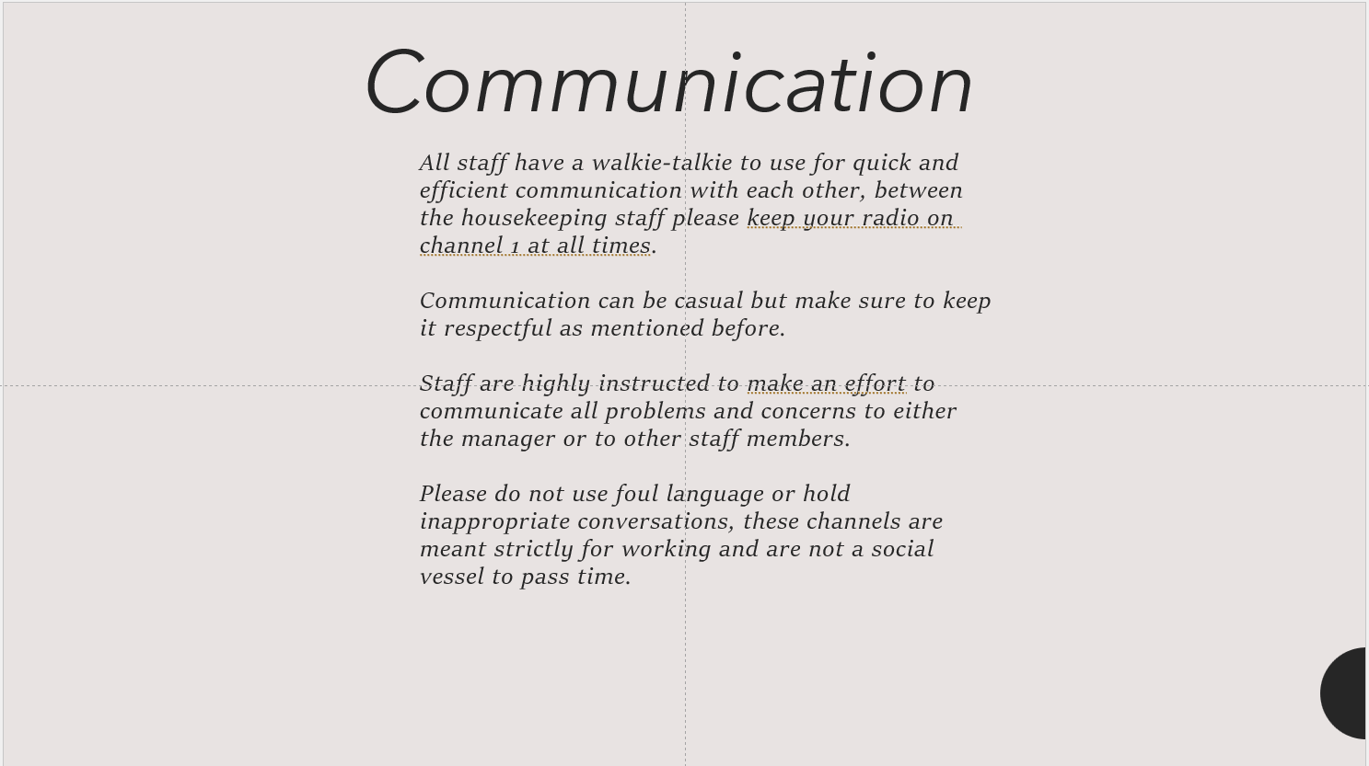

Training Notes:
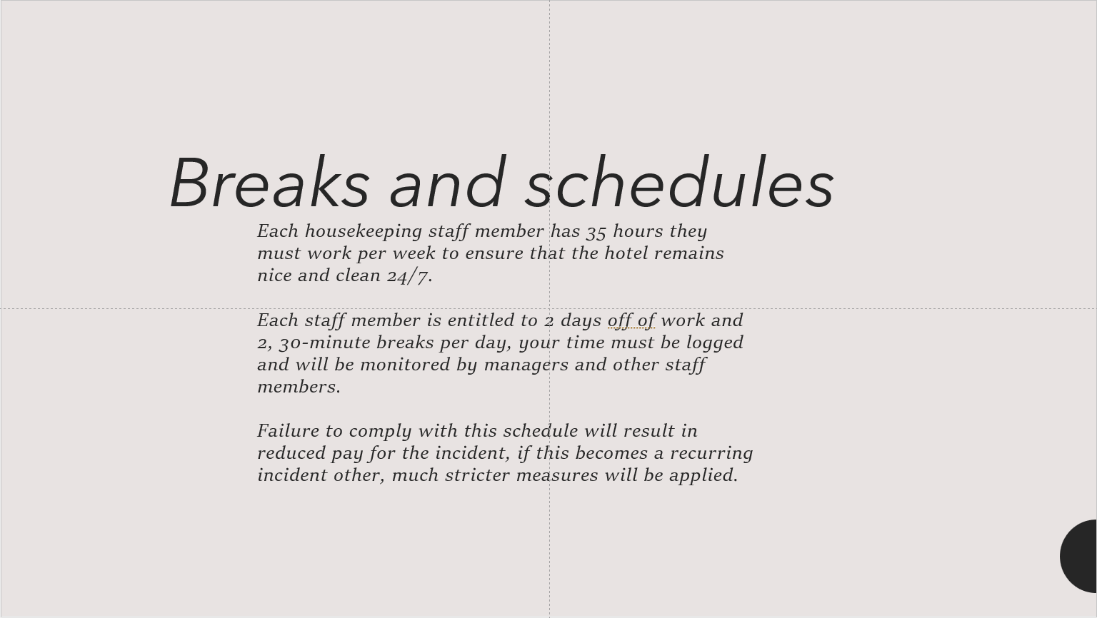

Training Notes:
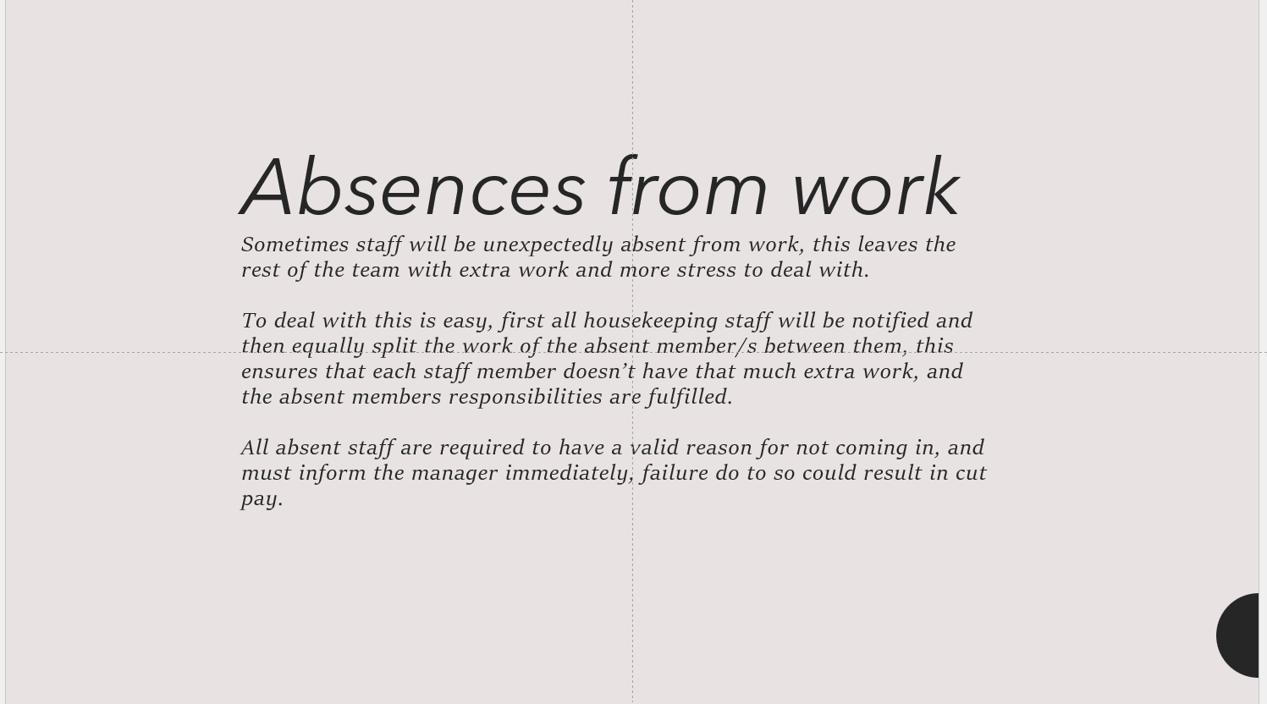

Training Notes:
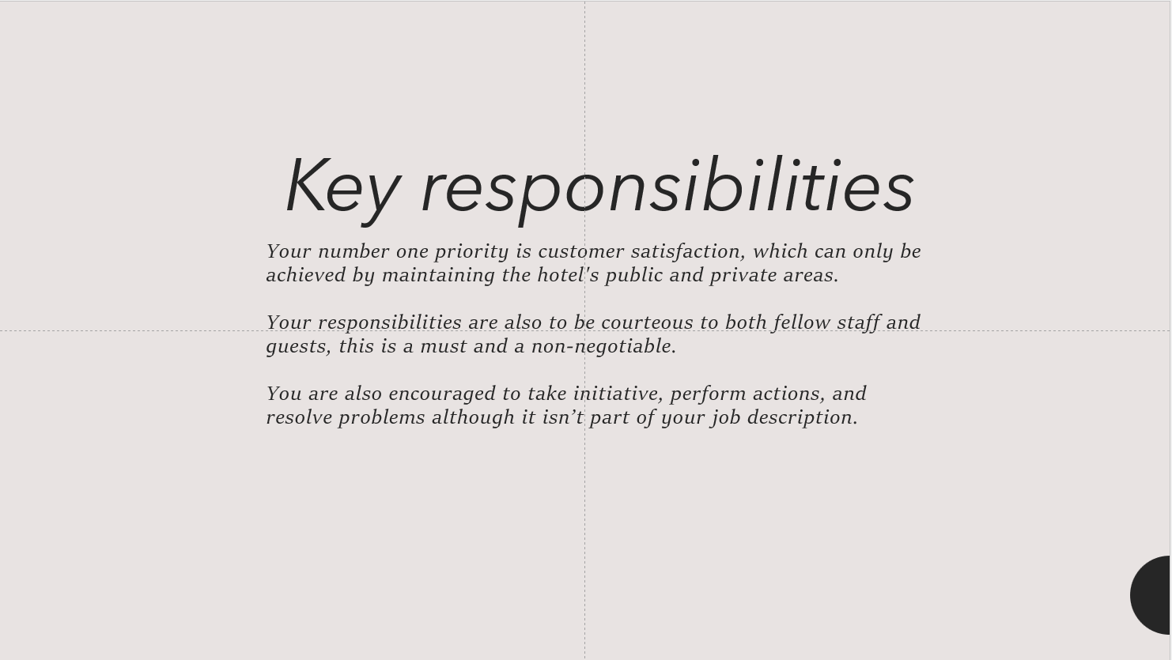

Training Notes:
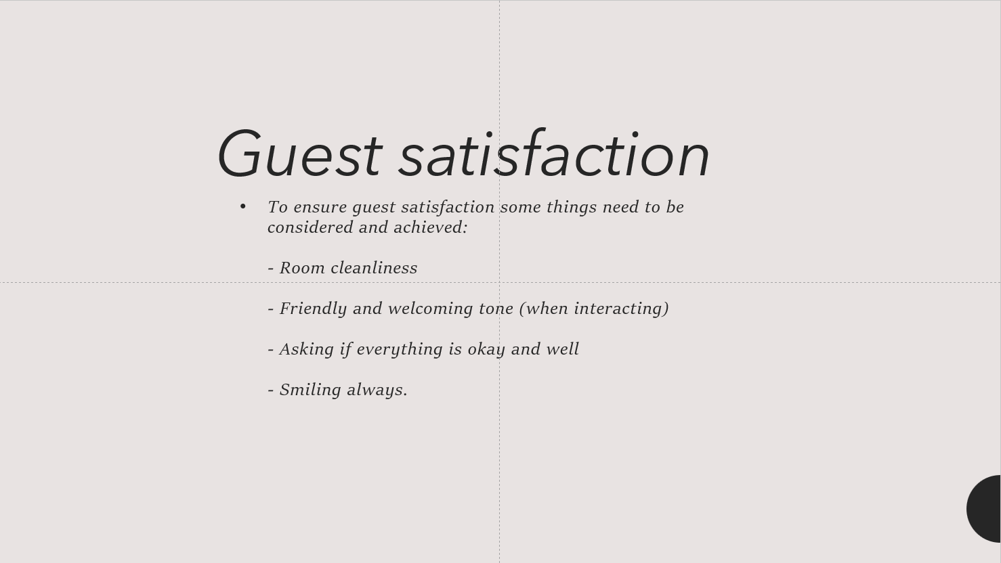

Training Notes:

References:

Aguilar-Escobar, V.G., Garrido-Vega, P., Majado-Márquez, J. and Camuñez-Ruiz, J.A., 2021. Hotel room cleaning: Time study and analysis of influential variables in a Spanish hotel. Journal of Industrial Engineering and Management, 14(3), pp.645-660.
Alcalde-González, V., Mozo, A.G. and Bustos, A.V., 2021. No clean rooms, no hotel business: Subversion tactics in Las Kellys’ struggle for dignity in hotel housekeeping. Annals of Tourism Research, 91, p.103315.
Ambardar, Ankush, and Kunal Raheja. "Occupational Safety and Health of Hotel Housekeeping Employees: A Comparative Study." International Journal of Hospitality & Tourism Systems 10.2 (2017).
Bardi, James-A. "Hotel-Front-Office-Management." (2021).
Bhatnagar, E. and Dheeraj, N., 2019. Impact of housekeeping services and practices on customer satisfaction and repeat business. Prabandhan: Indian Journal of Management, 12(8), pp.46-57.
Ervina, E., Taufiq, R. and Masatip, A., 2021. Guest satisfaction on star hotel preparedness in new normal era of COVID-19. APMBA (Asia Pacific Management and Business Application), 10(1), pp.21-38.
Hassanain, Mohammad A. "Approaches to qualitative fire safety risk assessment in hotel facilities." Structural Survey 27.4 (2009): 287-300.
Hsu, Shih-Yun, et al. "The evaluation mode of hotel housekeeping management." African Journal of Business Management 5.34 (2011): 13249.
Kadry, Seifedine, Aremn Bagdasaryan, and Mohammad Kadhum. "Simulation and analysis of staff scheduling in hospitality management." 2017 7th International Conference on Modeling, Simulation, and Applied Optimization (ICMSAO). IEEE, 2017.
Kim, J., 2011. Exploring how employee empowerment impacts on hotel front desk operations.
Koc, E., 2020. Do women make better in tourism and hospitality? A conceptual review from a customer satisfaction and service quality perspective. Journal of Quality Assurance in Hospitality & Tourism, 21(4), pp.402-429.
Lee, Seonjeong Ally, and Linda Shea. "Investigating the key routes to customers’ delightful moments in the hotel context." Journal of Hospitality Marketing & Management 24.5 (2015): 532-553.
Mmutle, T. and Shonhe, L., 2017. Customers’ perception of service quality and its impact on reputation in the hospitality industry. African Journal of Hospitality, Tourism and Leisure, 6(3), pp.1-25.
Pai, Anusha, et al. "SOFT SKILLS AS A KEY COMPETENCY FOR THE FUTURE LEADERS OF THE HOSPITALITY INDUSTRY." PalArch's Journal of Archaeology of Egypt/Egyptology 17.9 (2020): 4341-4355.
Parmar, S. and Dalal, P., 2017. A study of musculoskeletal disorder among housekeeping staff in hotel industry. Int J Home Sci, 3(3), pp.83-5.
S Sese, J., Cabuang, R.P. and Angelica, J., 2022. Content Analysis of Online Complaints Towards Hotels in Baguio City, Philippines. European Online Journal of Natural and Social Sciences: Proceedings, 11(4 (s)), pp.pp-121.
Tuzon–Guarin, J.M., 2016. Housekeeping Management Practices and Standards of Selected Hotels and Restaurants of Ilocos SUR, Philippines. International Journal of Business Management & Research (IJBMR) ISSN (P), pp.2249-6920.
Verma, Santosh K., et al. "A prospective study of floor surface, shoes, floor cleaning and slipping in US limited-service restaurant workers." Occupational and environmental medicine 68.4 (2011): 279-285.
Yasa, I. Ketut. "The Implementation of Total Quality Management (TQM) in Housekeeping Department of W Bali-Seminyak." International Research Journal of Management, IT and Social Sciences 6.2 (2019): 22-30.
Yilmaz, D.Ö., 2017. An undervalued department or a terra incognita? Hotel housekeeping from the perspectives of executive housekeepers and room attendants. Turizam: međunarodni znanstveno-stručni časopis, 65(4), pp.450-61.

