ecad4008-c
Professional and pedagogical studies: leading the learning; what, how and why am I teaching?
1900552
Ellie Thomas
Targets:
- Check your referencing technique as you should, for example, include page refs with direct quotes. Also, be careful as to how you set out your work using quotations.

- Proof read your work and use educational texts to model a more academic style of writing. Try to avoid contractions in academic essays.

Pedagogy is the expectations of a teacher and the way of teaching; this differs with every individual teacher.
“Pedagogy is defined simply as the method, and practice, of teaching. It encompasses: teaching styles, teaching theory, feedback and assessment”. (tes,2018).
This definition includes the basics of teaching as it includes the way topics are taught, the type of teaching practice and the marking element of feedback, showing how the child can improve. My own pedagogy is based on a constructivist outlook upon education.
Constructivism is ‘an approach to learning that holds that people actively construct or make their own knowledge and that reality is determined by the experiences of the learner’ (Elliott et al., 2000:256).
From this definition it is clear that it is thought children create their own knowledge from a build-up of experience and new information. This is similar to Piaget (Pound, 2014) and his theory of schemas. He suggested by building on old experiences and ideas from these, then new experiences build on previous ideas to improve our overall knowledge. This is supported by Bourne (1994) stating that a constructivist view is perceiving children as actively academic, where they have already formed ideas called schemata before attending school which are then used to make sense of everyday experiences.
This constructivist view is a child centred methodology that was influenced by Piaget (Pound, 2014). He suggested that there are four stages of intellectual development from birth to adulthood which include, the sensorimotor stage where physical actions and senses are used and strengthened. This then progresses to the preoperational stage where manipulation of the environment and the use of words are developed to increase a further understanding. Next concrete operational stage which is a classification, finally formal operations stage, involving orderly thinking and logical thought. To progress through these a child must be at a specific stage before considering different concepts as this is a natural sequence, which Piaget called
“genetic epistemology”.
Through both schemas and intellectual development Piaget created the diagram of equilibrium to demonstrate where both schemas and intellectual development equal as this is the process for the child to move onto a new stage. (See appendices 1). I have a constructivist outlook as I don’t like the idea that the children only learn one way. This is supported by (Pound, 2014) who theorised that there were different aspects that contribute to children learning, through play, language and socio-cultural influences. But the most influential part of Vygotsky’s work is the
“zone of proximal development”.
This is where it is considered either a child led, or adult lead activity. As this allows the child to learn on their own and gain help when needed. Different things influence pedagogical choices as this isn’t a set choice, this can fluctuate depending on resources, the environment and the year group that you are teaching. The objective of pedagogy is to achieve the greatest amount of learning. The process of learning is different for each learner, but ideas such as the dispositions Art Costa demonstrating the habits of the mind (see appendices 2), provide us with a brief underlying base to build upon.
The foundation phase is a curriculum unique to Wales. This is aimed at 3 to 7-year olds and is a child centred democratic curriculum, with its main philosophy including pupil voice and wellbeing. Holistic learning takes place through experimental learning. This curriculum is split into three learning sections which I experienced within my professional teaching experience (PTE), including a main focus task, enhanced provision and continuous provision. The main focus task is undertaken by the class teacher, where the main learning takes place with the teacher, this is mostly a teacher led session. The enhanced provision is where resources are placed in specific areas that relate to a previous lesson taught, for example my enhanced provision was colourings and a maze worksheet based on a book we were working on which improved the childrens understanding but also their fine motor skills. Enhanced provision is the use of other resources such as Lego which help improve the skills of the children that are not necessarily subject knowledge. This includes things such as fine motor skills, were the children improve through repetitive small hand movements such as cutting or threading. Within the enhanced provision there are designated areas where the children learn different skills, some of these include a construction area, sand area, water area, painting area and a role play area, these are the most common within my experience.
The curriculum (Education Wales, 2015) contains seven areas of learning that the children must learn, this includes;
- Personal and Social Development, Well-being and Cultural Diversity.
(Children learn about themselves and relationships with others).

- Language, Literacy and Communication Skills.
(Including talking, singing, listening and communicating).

- Mathematical Development.
(Through practical tasks, real life problems and mathematical skills).

- Welsh Language Development.
(Using oracy, reading and writing).

- Knowledge and Understanding of the World.
(Investigate the indoor and outdoor environment safely and systematically).

- Physical Development.
(Discover spatial awareness, balance, control, coordination and develop motor skills).

- Creative Development.
(Develop imagination and creativity).
Although the curriculum is changing within 2022 the current curriculum is still in place.

“Good teaching and learning means employing a blend of approaches including direct teaching.”
Successful teaching is using different strategies and having an understanding behind the theory of the approach, ensuring that it has been successful and is able to enhance the childrens learning through the expression of direct learning and traditional teaching methods.By using a blend of approaches, this is referring to child- led and adult- led teaching. Adult- led learning is where the adult is in charge and demonstrates what the child is supposed to do, the child then participates and imitates the adult. Child- led teaching is where the child discovers knowledge themselves through experience. Additionally, this is where a child teaches another and engages them in new knowledge without the teacher. An example of this is Dunne and Bennett (Bourne,1990) When there is group work there is
“high levels of task- related talk in the group and the demands on the teacher decrease significantly”.
This blend of approaches depends on the class size, the ability of the groups and the organisation of the pupils in general. Within my PTE I had a class of twenty-seven children who were separated into four groups depending on their ability and behaviour. Within my class the children moved in a carousel sequence, with the main activity being adult- led and the enhanced provision and continuous provision mainly child-led. A blend of approaches that are to be used need to be supported with evidence before use so research must be undertaken as a teacher to ensure that this approach is effective and reliable. Within my placement I used Montessori ideas (Pound,2014), where children need to enjoy their learning through an environment that will meet their needs as they learn through the senses and develop a self- discipline. Montessori (Pound, 2014) also suggests that daily living skills are an important part of the curriculum. Here Montessori proposes that learning in the correct environment is key for learners. Additionally, there are other theorists such as Piaget (Riley, 2007), who believed that there were steps of progression within the mind that lead from concrete to abstract thinking whereas Bruner (Riley, 2007), also held this belief, but suggested that it is an enactive way of thinking which progresses to a symbolic way of thinking. This shows that the theory behind the approaches are different, but they both meet the same end. The outcome for the children is set to be the same, but it just depends on the teacher and which approach they choose depending on the class that they currently have.
“Piaget under-estimated the role of language in learning and over- estimated the role of play;” (Bourne,1994)
Although children learn from playing within the environment shown through many theorists such as Montessori (1936) with her theory of active learning and Froebel (Weston, 2002) suggesting that learning comes from experiencing the environment with physical objects. Additionally, thinkers such as White (teaching expertise, 2007) who suggested outdoor learning through using natural materials and exploration of the outdoors, e.g., den play. This strategy is successful as I saw all of these theorists’ approaches demonstrated within my bridging days and PTE. This was observed through outdoor play including enhanced provision areas such as a construction area, but things such as Lego blocks and painting were also observed which also has an experience of the environment. But as it is stated there is an underestimation of language by Piaget, which is also evident within the foundation phase. I witnessed this on PTE as the enhanced and continuous provision didn’t centre around this aspect, it was centred on the role of play. This is not completely regarded, as within the adult- led focus task there was evidence of (Tizard and Hughes, 1984) which shows a sustained interaction with an adult, as the activity requires the children to listen and watch the teacher for a long period of time. This links to Bruner (Barnes, 2011, pg. 98) who suggests that language helps children deal with abstract concepts to improve the childs cognition. But on the other hand, within the Reggio Emilia approach although the environment is considered the
“third teacher” (Pound, 2014)
It is also referred to as the
“100 languages of children” (Pound, 2014)
This approach to teaching includes everything that the children need to know and is displayed through the childrens personal imagination. As a child- led approach including some direct teaching this is focussing on the children and includes a range of approaches. As Malaguzzi (1995) commented the greatest impression from the children was the
“social maturity of their judgement”
Which links with the 2022 curriculum (Education Wales,2020) of the four main purposes, ethically informed citizens. This is also visible through the Te Whãriki, (Nzcurriculum, 2015) with their specified aims and the children who are considered as a valued contribution to society.
“Good teaching and learning sets tasks and selects resources that build on previous knowledge and experience and engage interest.”
This was modelled when I was on bridging and PTE as the teacher would supply the children with tasks and materials that enhance the skills that the children have used previously in the lessons before. I also created this opportunity for the children when I was on PTE as after completing a lesson on symmetry, I provided the children with a worksheet that included them drawing and colouring the shapes on a shield to match the other side. I also provided plastic shapes and mirrors so the children could see the shapes and how when they reflect, they look the same, also I provided paints so the children could create symmetry themselves. By using different resources, you are appealing to all different types of children as they all prefer different activities and are all at different abilities. By providing the materials for continuous provision in different sections of the enhanced provision this provides them with a larger selection. The strategy that enforced a reinforcement of the knowledge the children have learnt is the spiral curriculum. Bruner (1960:13) suggested this due to the children needing to secure the information that they have learnt so that children should,
“…revisit… basic ideas repeatedly.”
This entails that through all childrens education the basics of the subjects this will be an underlying reinforced part of their education, as when the children learn more, they build on the knowledge that they already have, revisiting and improving showing a spiral education of improvement. I used this within my PTE, as through a maths lesson I taught the children about the value of coins and which are smaller than others. Within a separate lesson the following week I asked the children to use the money to purchase items within a shop role play. This demonstrates the spiral curriculum, as the children were not just using the coins, but they were also working out the price of two items combined. This is using the theory of Montessori (Pound, 2014) and her approach of repetition. This is reflected within the spiral curriculum and the learning cycle (appendices 3). The learning cycle shows how from the spiral curriculum new information is passing through the neurons within the brain and is attaching to the memories of previous information that connects to this. (Science Museum,2019) This shows how we gain more knowledge as we develop. To engage interest from the children we identify and use their interests to engage them within their school work. For example, the children within my PTE class enjoyed playing Crossy Road, so the teacher had the children to complete their activity that was teacher led, then within their free time within their groups they had the chance to play Crossy Road on the I pad’s if they completed their work. Further to engage interest, the children within my placement school had a pupil voice board. This is where the pupils contribute to what and how they are taught. This is addressing health and wellbeing as well as interaction. This also provides the children with a positive experience of school, but this does have negative effects too. Not all suggestions can be undertaken so not all children are being heard and expressed throughout the classroom, this could lead to some negative experiences towards a school environment. But through this experience the child is learning new emotions within a safe environment, therefore the child is still learning. This relates to childrens rights (General Assembly, 1990) as it states,
“Everyone that works with children should always do what is best for each child”.
This indicates the priority of the teacher and the responsibility to ensure that each child is happy and healthy.
To improve these strategies the use of Dweck (Barnes,2011) with growth mindset presents the children with a positive mindset towards their education and life. With a method of thinking I can’t do it yet! Instead of, I can’t do it! This shows a motivated and persevering individual who is within a happy and safe mindset. (appendices 4).

“Good teaching and learning ranges within and across Areas of Learning and experience.”
Most lessons are cross- curricular and range through the areas of learning and experience, this is a priority within the Foundation phase. I demonstrated this through my PTE placement as I planned all lessons to integrate with the cross curricular element. The use of learning a subject area through another is highly purposeful, as the children are learning these skills at a heightened pace, which results in excess space within the timetable to recap. Within the new curriculum for Wales (2020), the areas of learning are changing as there will be six instead of seven, these will include: expressive arts, health and wellbeing, humanities, mathematics and numeracy, science and technology and languages, literacy and communication. Within the curriculum for Wales (2022), the four purposes include: ambitious capable learners, ethically informed citizens, enterprise and creative learners and healthy, confident individuals. These are the aims of what the children should achieve by the end of the curriculum. Within my PTE, the school that I was in were already using elements of the curriculum such as the four purposes as well as using cross curricular activities including English and mathematics. A challenge to this is that not all schools are using this new curriculum at the moment, and do not have to until 2022, so are some children having an advantage through this? This only benefits the teachers as they get to experience this flexible approach to teaching and adjust to it before others. This new curriculum provides teachers with the ability to teach flexibly in their methods, but still incorporate the main key elements of the curriculum. There is evidence of this way of teaching working, as within Finland this way of teaching has been adapted and preformed to suit the educational needs of every child in all communities.
“ensure freedom to make individual choices based on the local needs of different schools, with the core curriculum serving as a common national basis” (Halinen, I. & Järvinen, 2008)
Teaching through areas of learning is also evident within the Te Whãriki (Nzcurriculum, 2015). This also prepares learners not just for their future journey in education, but gives them a sense of identity and ownership as they immerse themselves in culture and tradition. This is part of the new curriculum within Wales to prepare the learners for the world. Within the experience element this is evident within Reggio Emelia as the children are told that there are 100 languages of the child.
“The child has a hundred languages a hundred hands a hundred thoughts a hundred ways of thinking of playing, of speaking”. (Riley, 2007)
As well as this Malaguzzi suggested that children have potential, they are competent, strong and powerful as he stated each and every child is a
“rich child”. (Dahlberg et al, 1999;7)
Within my PTE I adopted all of these approaches to extend the children and challenge each child. Teaching through areas of learning and experience proves more active for the children as they are more hands on and imaginative through this curriculum. For example, using art within a maths lesson or allowing the children to learn what they want to learn, this is ensuring that the children are becoming inquisitive and imaginative. By sharing this practice and creating a curriculum combining many methods of learning is a brand-new way of teaching, this is set to provide the learners with the best education and experience of it. A downfall to this is that without all schools using this curriculum children are having different experiences and teachers are not having the range of experience that is there to take. Additionally, a risk of using these areas of learning is that the children may lose sight of a subject area. But this is needed within education as we do not think of subjects when completing tasks within daily life, we use the skills attached to these. Bruce (Pound, 2014) describes education through holistic development and stated that co-ordinated learning is vital for the children their needs to be some contact with others as this is vital for the childrens development. This therefore supports this new way of teaching as through this there will be an increase in class discussions as this is a more holistic approach to learning with more group investigations to help broaden the childrens imagination and help them achieve the four purposes.
To conclude, Locke suggested that the child was born as a blank slate-
“tabula rasa” (Riley, 2007)
This states that the child is born with no existing knowledge, this shows that all knowledge is learnt through experience. Without this initial experience no additional knowledge can be formed. This is how through a blend of approaches, different tasks and resources and direction through different areas of the curriculum, children can be educated and gain the knowledge that they need to become ambitious, healthy, creative ethically informed citizens. All of this contributes to a transformative approach.
“Transformative education demands active and engaged students, asking critical questions, and searching for additional information at other sources as well as those given in a curriculum”. (Learning theory, 2017)
Founded my Mezirow (Learning theory, 2017) transformative theory includes a teacher challenging the learner to use critical thinking and questioning towards the world and their beliefs. This contributes to using different approaches and using previous knowledge to create ethically informed citizens. this questioning has also been supported Edwards and Mercer (Bourne, 1994) as they suggest that this is essential. Therefore, resulting from this the ideal ingredients for success in my personal pedagogy are enthusiasm, having an understanding of each individual child, knowledge and innovation.

Appendices 1:
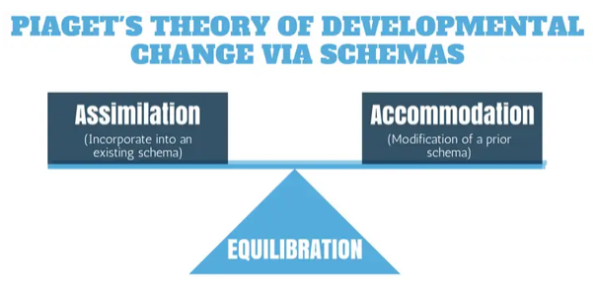

https://www.cleverism.com/piagets-theory/
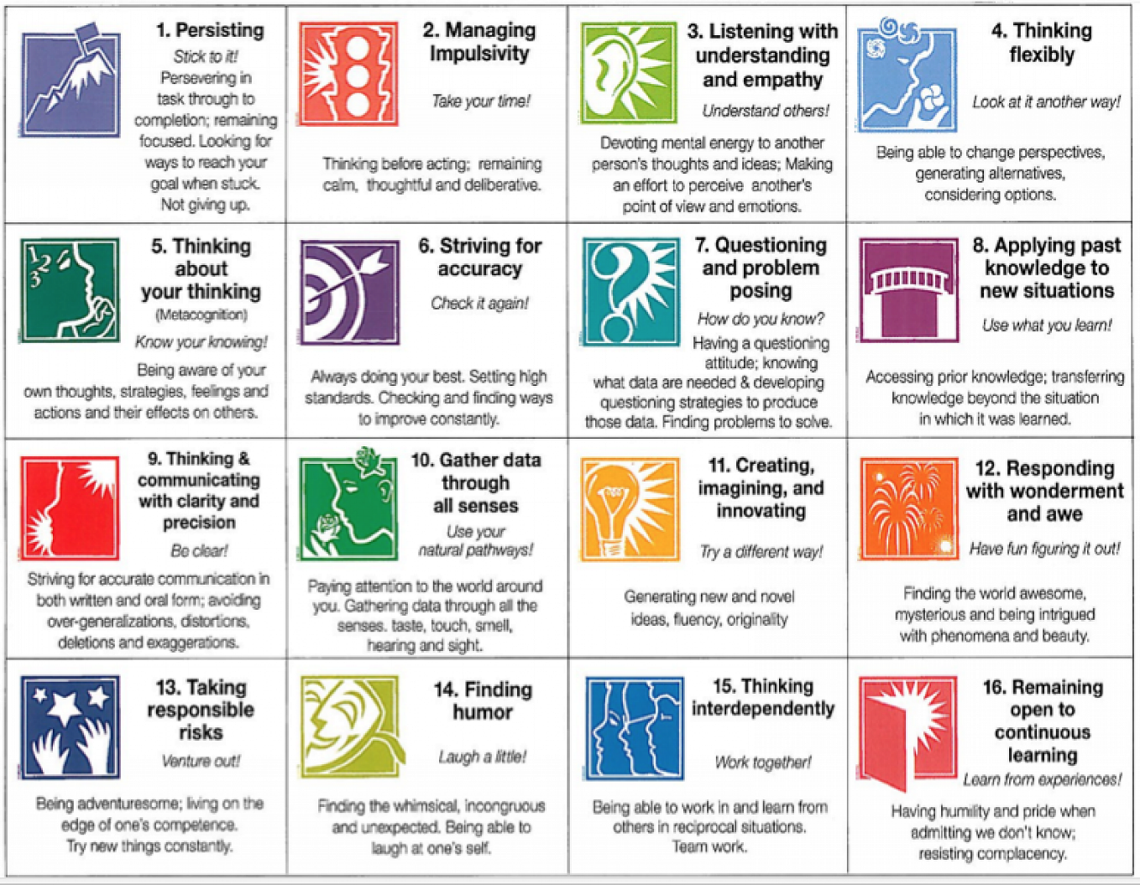
Appendices 2:
https://d2u4q3iydaupsp.cloudfront.net/CRsnh7Xoex6DiJvNoJCjo6Ql8zawqguKr4iA7fJRpIRaSyKR6mN7ZvnWx5B6xFepVL21kj9rfIYHQZUQTYZ1BSXYhUIGd4tO0Uq1ducL66zRdwFsmMUrW9qFNZETVMSU
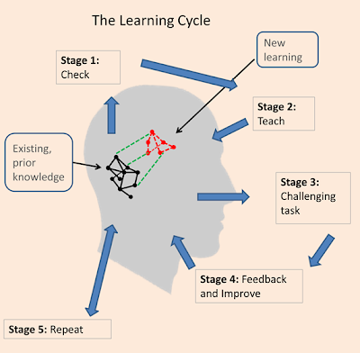
Appendices 3:

https://www.bing.com/images/search?view=detailV2&ccid=hQfcwG3%2b&id=F16FFDAC6A89D1FDE71112F3FF3D0DA401950C0C&thid=OIP.hQfcwG3-cYOZhIteseXbgAAAAA&mediaurl=https%3a%2f%2fsites.google.com%2fsite%2fnetworkebt%2f_%2frsrc%2f1448893975186%2fevidence%2fneuroscience-evidence%2flearning%2520cycle%2520s%25202015.png%3fheight%3d392%26width%3d400&exph=392&expw=400&q=Learning+Cycle+Model&simid=608054608584837080&selectedIndex=81&ajaxhist=0
Appendices 4:
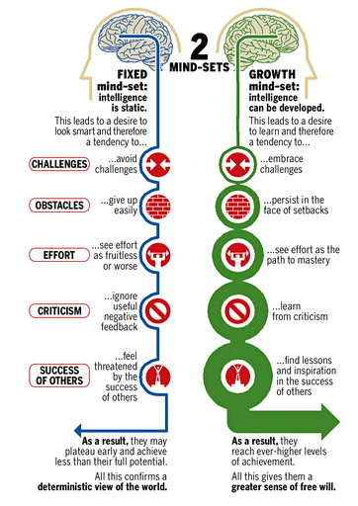

https://guidingleadersandteams.com/wp-content/uploads/2015/12/my_wish_2015_v3_mindset.png

References
Barnes, J. (2011) Cross- Curricular Learning (2nd Ed) London: SAGE Publications.
Bourne. J. (1994) Thinking Through Primary Practice London: Routledge
Bruner, M. (1966) Towards a Theory of Instruction. Cambridge, MA: Harvard University Press.
Dahlberg, G., Moss, P. and Pence, A. (1999) Beyond Quality in Early childhood Education and Care. London: RoutledgeFalmer.
Education Wales (2015) Curriculum for Wales Available at: https://hwb.gov.wales/storage/d5d8e39c-b534-40cb-a3f5-7e2e126d8077/foundation-phase-framework.pdf (Accessed: 20th March 2020)
Education Wales (2020) Curriculum for Wales Available at: https://hwb.gov.wales/curriculum-for-wales (Accessed: 23rd March 2020)
Elliott, S.N., Kratochwill, T.R., Littlefield Cook, J. & Travers, J. (2000). Educational psychology: Effective teaching, effective learning (3rd ed.). Boston, MA: McGraw-Hill College.
General Assembly (1990) Convention on the Rights of the Child Available at: https://downloads.unicef.org.uk/wp-content/uploads/2016/08/unicef-convention-rights-child-uncrc.pdf?_ga=2.10551860.1247591997.1585328214-997939782.1585328214 (Accessed: 25th March 2020).
Halinen, I. & Järvinen, R. (2008). Towards inclusive education: the case of Finland. Prospects 145. Vol 38, no 1, March 2008. (pp. 77-97). UNESCO.
Learning theory (2017) Transformative Learning Theory. Available at: https://www.learning-theories.com/transformative-learning-theory-mezirow.html (Accessed: 26th March 2020)
Malaguzzi- Dahlberg, G., Moss, P. and Pence, A. Beyond Quality in Early Childhood Education and Care. London: RoutledgeFalmer.
Malaguzzi, L. (1995) A journey into the rights of the child. London: SAGE Publications.
Montessori, M. (1936). The secret of childhood. (B. B. Carter Ed.). Calcutta: Orient Longmans.
Nzcurriculum (2015) The New Zealand Curriculum Available at: file:///C:/Users/Ellie/AppData/Local/Packages/Microsoft.MicrosoftEdge_8wekyb3d8bbwe/TempState/Downloads/NZ%20Curriculum%20Web%20(1).pdf (Accessed: 26th March 2020)
Pound. L. (2014) How children learn (Second edition) London: Practical Pre- School Books
Riley. J. (2007) Learning in the early years 3-7 (2nd Ed.) London: SAGE Publications.
Science Museum (2019) Who am I? Available at: http://whoami.sciencemuseum.org.uk/whoami/findoutmore/yourbrain/whyisyourmemorysoimportant/howdoesyourmemorywork/howdoneuronscreatememories (Accessed: 24th March 2020)
Teaching expertise (2007) Creating an outdoor learning environment for the early years. Available at: http://www.outdoormatters.co.uk/wp-content/uploads/2011/04/Article.-Creating-an-outdoor-learning-environment-for-the-early-years.pdf (Accessed: 23rd March 2020).
tes (2018) What is pedagogy? Available at: https://www.tes.com/news/what-is-pedagogy-definition (Accessed: 22nd March 2020).
Tizard, B. and Hughes, M. (1984) Young Children Learning, Fontana.
Weston. P. (2002) Friedrich Froebel. Available at: friedrichfroebel.com/ (Accessed:23rd march 2020)

