WORKSHEET 3a – QUESTION (OLYMPIC ATHLETE)

An athlete wishes to keep track of their performance in an Olympic competition – their event is the 2,000 metres (five laps of the track)

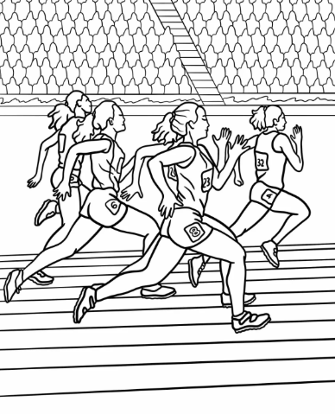

Write a program to allow the winning athlete (or their coach) to enter the time for each of the 5 laps. Store each lap time into a list. Also, ask them to enter the World Record and the Olympic Record for the event (currently WR = 283.13, OR = 285.15)

Provide the winning athlete with some statistics as follows:

- What was the overall time for the five laps?
- What was the average lap time?
- Which was the fastest lap, and what was the fastest lap time?
- Which was the slowest lap, and what was the slowest lap time?
- Did the winning athlete break the World Record/Olympic Record and if not how short of the record were they?

Enter the times for the second placed athlete into a second list.

- What was the lap time difference for each lap compared to the second place athlete? For example +1.05 seconds, -0.3 seconds etc

(Note: Sample output is shown on the next page)

Implement as many of the statistics (1-6 above) as you can for Version 1 of your code (in class), but do not worry overly if some are incomplete: remember there will be an opportunity to revisit the code when doing the test sheets (Version 2).

Use validation in your code where appropriate to prevent the user from entering inappropriate values.

Sample output:



