

Pre-Processing, Visualising and Analysing Data with Excel and SPSS

By Nikola Chakrakchiev
Student ID: 2029324
Course name: BA Business Management
Module: Data Handling and Business Intelligence (LCBB5000)
Lecturer: Khaza Ahmed

Part 1

Pre-Processing, Visualising and Analysing Data with Excel

Introduction
The data provided is collected from 200 high-school students. It reflects their ice-cream preferences and their results in videogames and puzzles. The data was used to find the relations among the various variables as the following analysis will show the findings of the research.

Relationship between the favourite ice cream flavour and the video game scores, puzzle scores and gender
For the purposes of a thorough analysis of the various relationships were used Excel’s pivot tables and charts that help in easily executing complex calculations tasks with big data sets (Miller, 2014). The research was split into two relationship combinations that reveal the entire spectre of possible variants. The relationships between ice-cream flavour and gender that will show the number of male and female respondents in the relevant flavour groups, as well as the number of respondents in the various flavour groups; and the relationship between the flavour preferences and the performance in games and puzzles.

Relationship between ice-cream flavours and gender

General distribution of responders among the various ice-cream flavour groups
Among the queried students, the male respondents who prefer chocolate ice-cream are two times less than the female ones. However, this is not the case with the other two flavours, because for strawberry and vanilla flavours we have respectively equal and almost equal (by difference of one person in favour of female respondents) number of flavour lovers when we compare male and female respondents (Table 1). However, the outcome of the research tends to contradict with the findings of Cooke & Wardle (2005) who claim that chocolate and grapes were among the 10 most preferred foods by children, regardless of gender (Zhou et al., 2019).
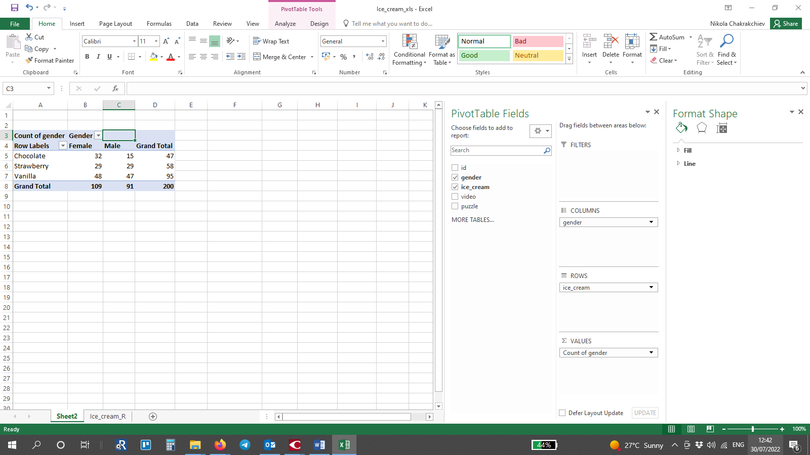
Table 1. Relations between the ice-cream flavours and gender
In respect of the total number of respondents for each category of flavour, we have respectively 47 who love chocolate, 58 love strawberry and 95 prefer vanilla (Table 1). The survey clearly shows that it is worth producing equal quantities of strawberry and chocolate ice-cream and twice as much vanilla ice-cream in order to satisfy the demand (Table 2).
Table 2 presents the particular distribution of respondents among the various flavour groups, e.g. 16% of the respondents are female who prefer the chocolate flavour and the male respondents preferring the flavour of chocolate represent 7.50% of the entire lot.
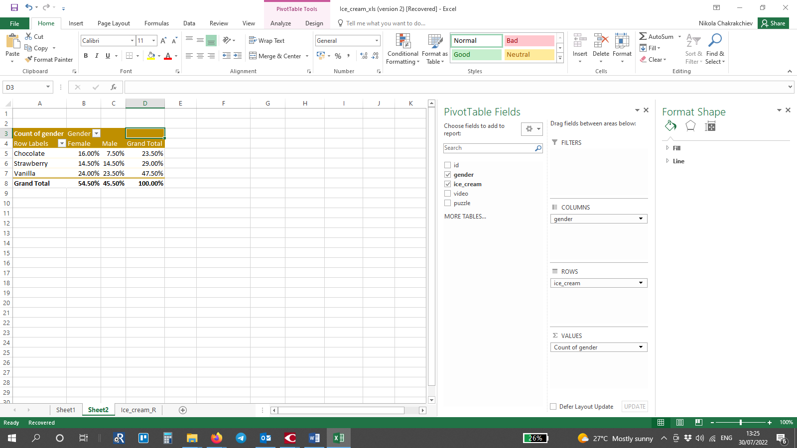
Table 2. Favourite ice-cream flavours among the respondents

Distribution of female responders among the various ice-cream flavour groups
The survey data analysis was expanded even deeper by defining the percentage of participants from the relevant gender who prefer a certain type of ice-cream. It is clear that 44 percent of the female respondents prefer the vanilla flavour against 29% who like chocolate and 26.61% who favour strawberry (Chart 1).
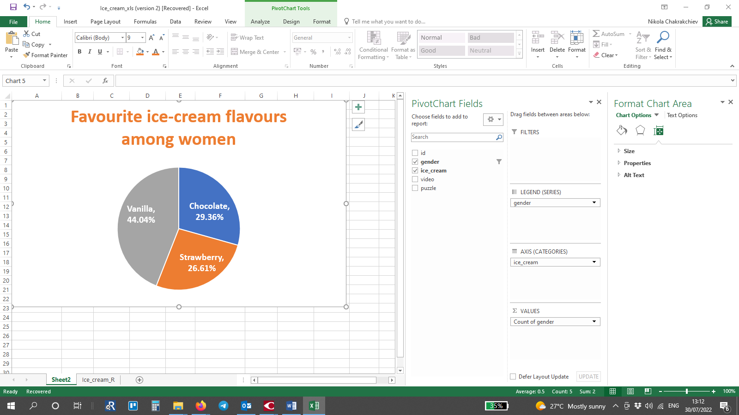
Chart 1. Favourite ice-cream flavours among female respondents

Distribution of male responders among the various ice-cream flavour groups

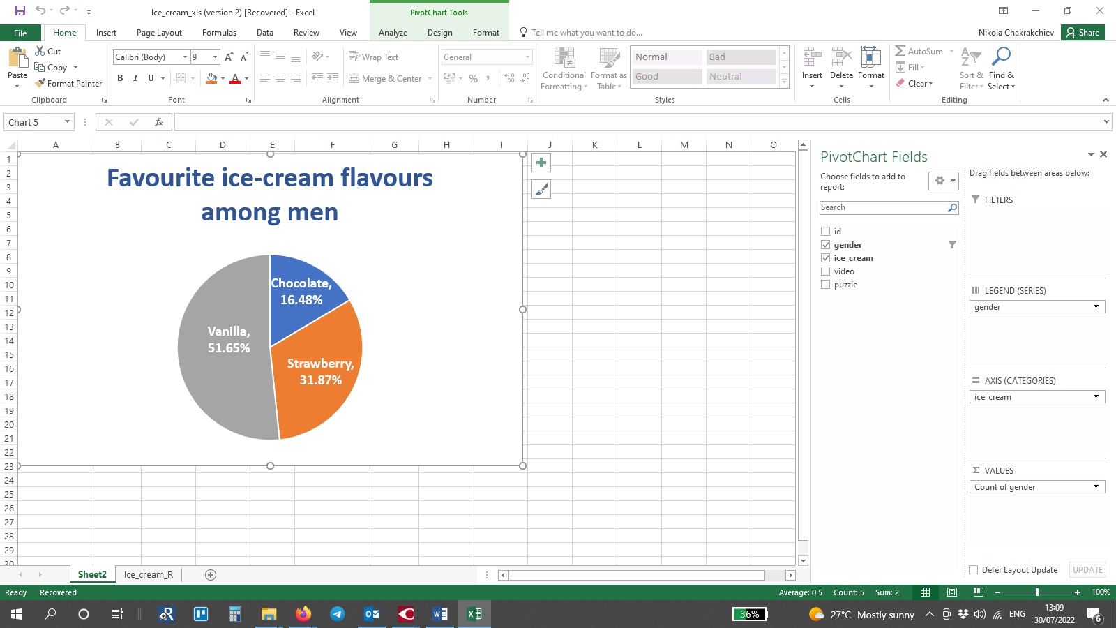
Chart 2. Favourite ice-cream flavours among men
The outcome of the research regarding the male respondents show almost the same ratios between the various flavour groups. The difference in comparison with the female respondents is that the vanilla flavour is the favourite to 51.65% of the male responders and chocolate and strawberry are respectively the favourite flavour to 16.48% and 31.87% of the male responders.

Relation between gender, average game scores and puzzle scores
The findings of the previous partition opened the opportunity for exploring further relations between the components of this research. Having the results from the video games and the puzzles played by the responders, were explored the relations between the results from the video games and gender, as well as the relations between the scores from the puzzles and gender.

Average video-games score and average puzzle score according to gender for the various ice-cream groups
After finding out the ratio between female and male responders It was easy To find the relation between gender, various ice-cream groups, video game scores and puzzle scores. Using the same pivot tables were made some adjustments and revealed the average game scores and puzzle scores according to gender per various ice cream groups. It appears that Video game and puzzle scores for female and male responders do not vary within large ranges for the particular ice cream groups. However, the differences in scores among the ice cream groups reflect some interesting variances. for example, female responders who prefer chocolate in average score 46.72in video gaming and the male responders score at 49.80. This is the difference of approximately three points. However, the difference in average scores among female who prefer chocolate and female who prefer strawberries is rather more significant, respectively 46.72 against 56.17 for video games and 49.19 against 56.48 for the puzzles.
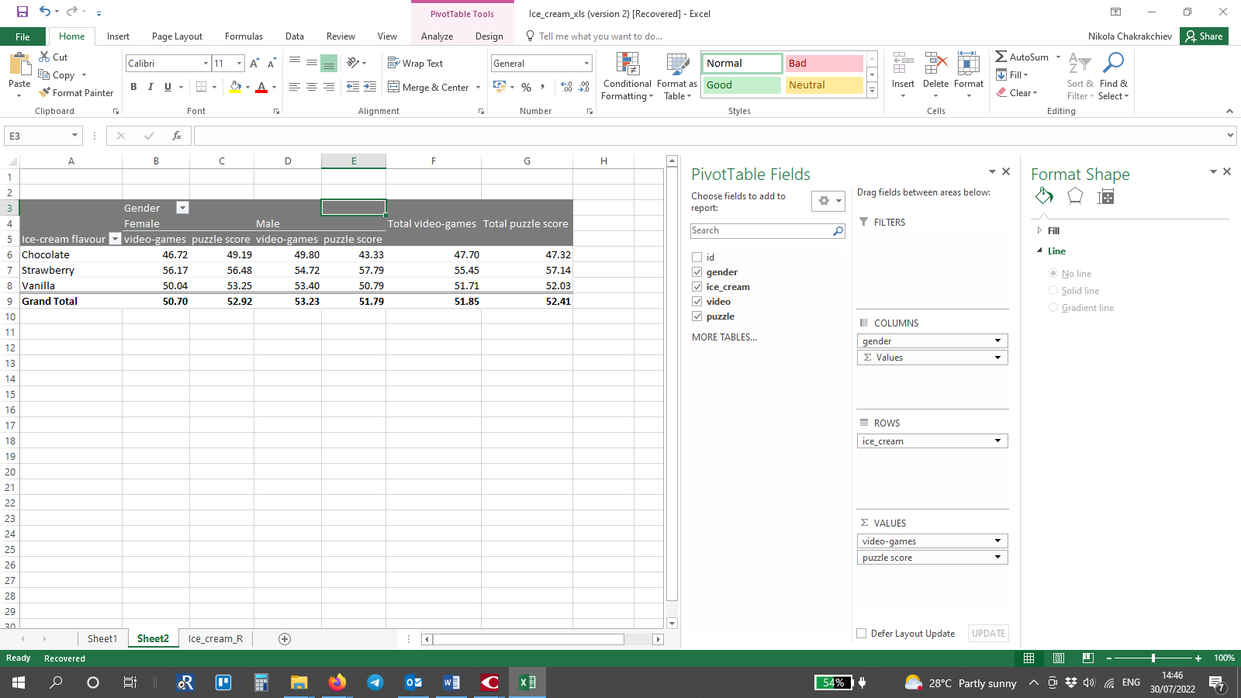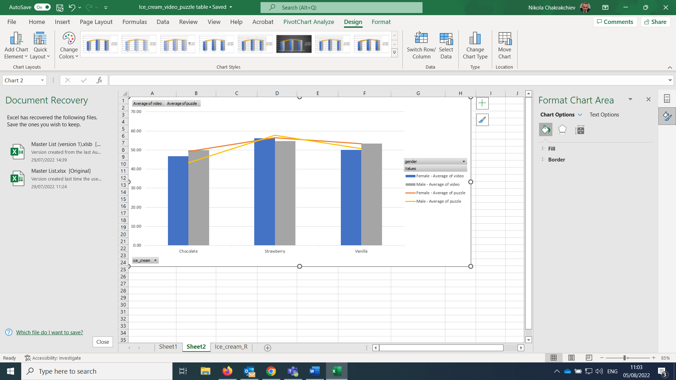
Table 3. Relation between the average game scores and puzzle scores per gender for the various groups of ice-cream-flavor lovers | Chart 3. Relation between ice-cream flavours and average videogame scores according to gender

Variances for the males are comparable – for the responders preferring chocolate - 49.80 against 54.80 in the video games and respectively 43.33 against 57.79 in puzzles. The responders who prefer the flavour of vanilla score in between the previous two groups, that is 50.04 in games and 53.25 in puzzles for the females and respectively 53.40 and 50.79 for the males (Table 3). Visualising the results made it easier to understand the relations between the three variables. On Graph. 3 is clearly visible that both male and female show common results in their videogames and puzzles scores as the responders who favour Strawberry ice-cream score the highest, followed by the ones who favour Vanilla and last come the ones who favour chocolate with a significant difference.

Minimum and maximum video games and puzzle scores for the various genders according to preferred ice-cream flavor
The findings above urged to compare the minimum and maximum scores for the various groups in order to make sure that the average values have not distorted the outcome.
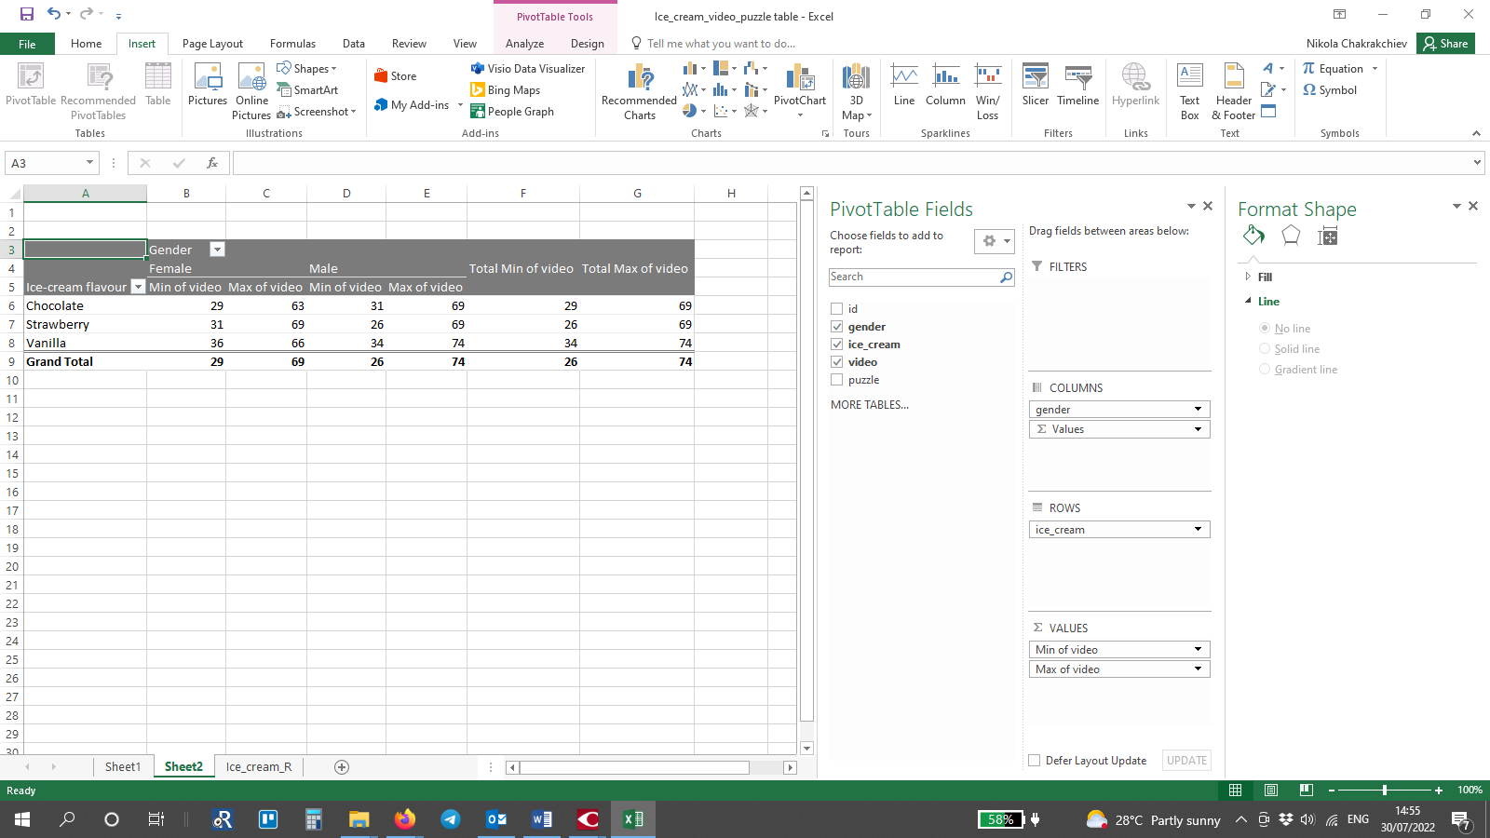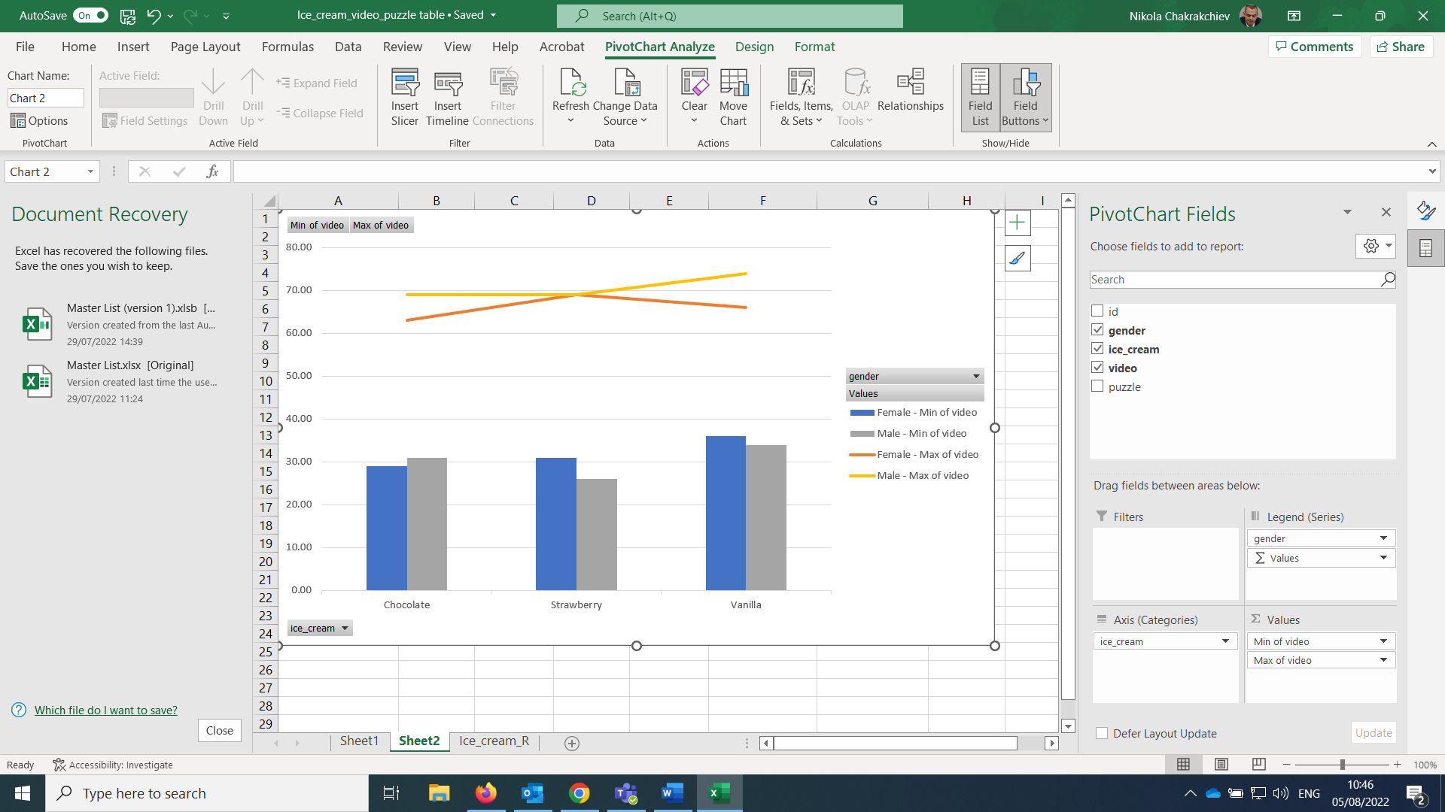
Table 4. Minimum and maximum video games and puzzle scores for the various genders according to preferred ice-cream flavor | Chart 4. Relation between the highest and lowest videogame results of female and male respondents for the various groups of ice-cream flavour lovers

It turns out that the maximum and minimum videogames scores for female and male participants in the different ice-cream groups differ from the average results. It turns out that the highest scores in videogames for the female participants comes again out of the strawberry-ice-cream group with 69 points with chocolate group having the lowest score of 63, and the vanilla-ice score of 66. However, the minimum scores for the groups show that the worse score in videogames is again for chocolate, but the second worse score comes out of the strawberry group and the least bad score is in the vanilla group, respectively 29, 31, and 36 (Table 4).
The situation with males is even more different. The lowest score obviously came from the strawberry group (26), then comes the chocolate group (31) and the highest minimum score is for the vanilla group (34). The highest score is also for the vanilla -ice-cream group (74), followed by the equal score of 69 in the chocolate and the strawberry groups.

Minimum and maximum puzzle scores for the various genders according to preferred ice-cream flavor
The difference in scaling the puzzle scores is not that drastic as it is in the videogames. The worse scores for strawberry and vanilla are equal (31), and the worst score of all is in the group of chocolate (26). The best score (71) is the same for all groups of ice-creams (Table 5).
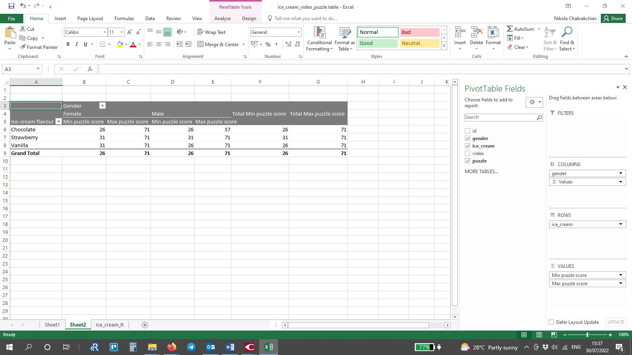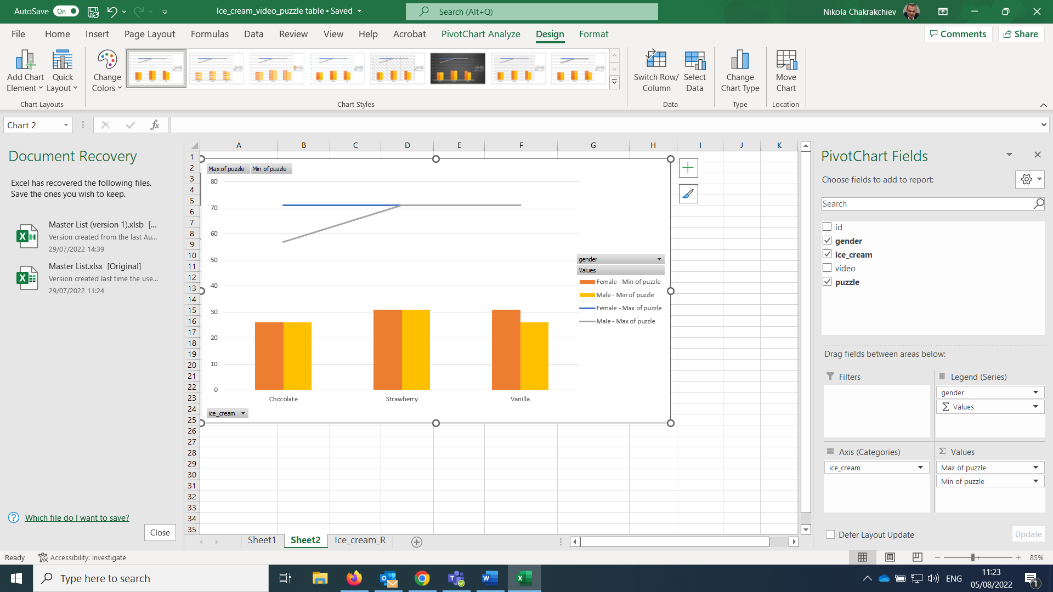
Table 5. Minimum and maximum puzzle scores for the various genders according to preferred ice-cream flavor | Chart 5. Relation between the highest and lowest puzzle scores of females against those of males for the various groups of ice-cream flavour lovers

For the males – the worse scores for the chocolate and vanilla lovers are equal (26), and the strawberry group shows the best worse result of 31. On the matter of the highest puzzle scores, the chocolate group scores lowest again with 57, which is way lower than the highest scores of 71 for the strawberry and the vanilla-ice-cream groups (Table 5). The relations are visualized in Chart 5.

Relation between the scores in the various groups of male and female participants
The data analysis shows controversial results for the various groups and activities, so we can conclude that the videogame and puzzle scores are not dependent on the gender of the participants.

Use of Excel to pre-processing, visualising and analysing data in the business world
Excel has a set of powerful tools for data pre-processing, visualizing and analysis that can prevent the user from spending endless hours in writing formulas and doing calculations (Miller, 2014).
The pivot tables and pivot charts are called like this because they can “instantly pivot data into any view that is desired” (Miller, 2014). They are capable of processing data sets of different size, make is simple, visualise it and then put it in a report. Such reports ease the management in their decision-making process. (Miller, 2014)

Part 2

COVID-19 data analysis

Introduction
Using the provided data on the COVID-19 cases in Asia, America and Europe was made a through analysis. The tool used is IBM SPSS.
“The IBM® SPSS® software platform offers advanced statistical analysis, a vast library of machine learning algorithms, text analysis, open source extensibility, integration with big data and seamless deployment into applications.”
(IBM, 2022)

Total number of Covid-19 cases in each continent (Europe, Asia and America)
Having the data for the various days on each continent it is easy to extract the total cases of COVID-19 on each of the continents. The research shows that the total cases in Europe were 21,400,012, for Asia and America, the number of cases were respectively 16,782,046 and 30,887,593. the number of cases in Asia is suspiciously small, having in mind that only in India and China live respectively 1,210,854,977 and 1,411.78 million persons. This is so because the data given by China is for a five-digit number of cases, which bring us to the idea that the Chinese government has withheld information about the actual cases of the virus in China.
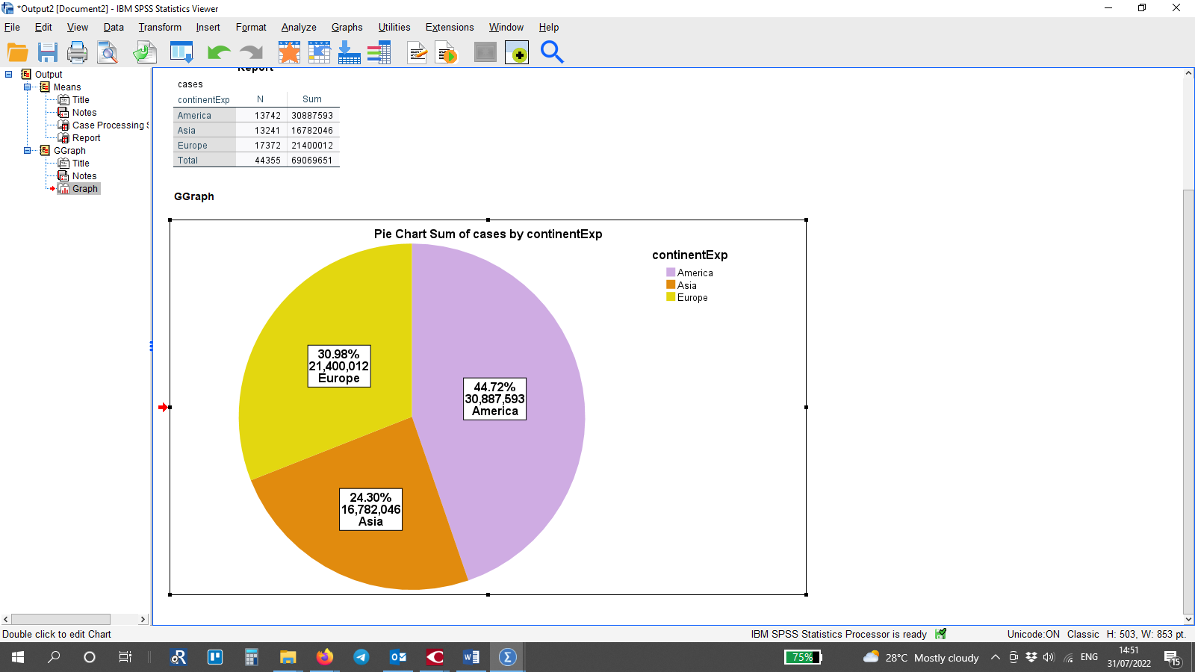
Table 1. Number of COVID-19 cases for each of the three continents and sum-total
Graph 1. Pie chart of COVID-19 cases by continent

The chart in Graph 1 is clearly showing that according to the data provided, America has the highest number of cases, followed by Europe and the lowest number of cases were registered in Asia.

Continental death rates
The data base was revised, and all the negative entries were turned into positive ones, because it does not make sense to have negative entries on this data base. Then a table for the minimum and maximum number of deaths was created (Table 2).
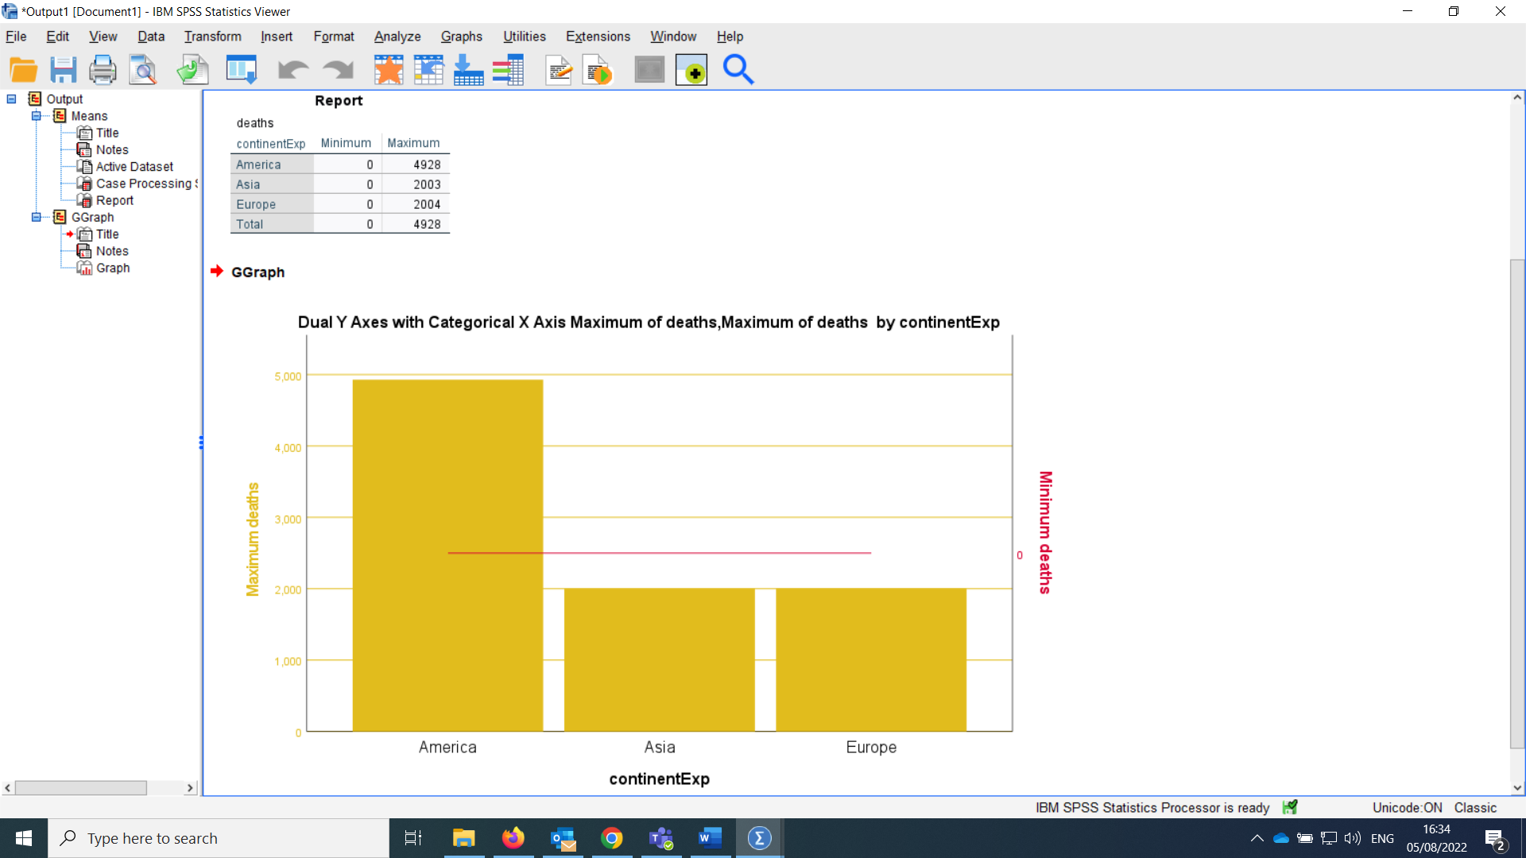
Table 2. Minimum and maximum number of deaths in the various continents
Graph. 2. Minimum and maximum number of deaths in the various continents
As expected, on all continents, the minimum number of deaths was 0. The maximum number o deaths in America was 4928, which is the highest death rate for the three continents. In Europe and Asia the highest death rates were different by one, respectively 2004 and 2003 reported deaths for one day.

Correlation between Covid-19 cases and deaths in America
For the purpose of finding the correlation between the number of cases and the deaths in America were used the correlation function of SPSS and the results were visualised in scatter charts.
The most used correlation method is the Pearson Correlation. Visible from the correlation table , the correlation between cases and deaths in America is a positive, strong correlation (.730) this means that when the cases grow, death rate will grow, too (SPSS Tutorials, 2022).
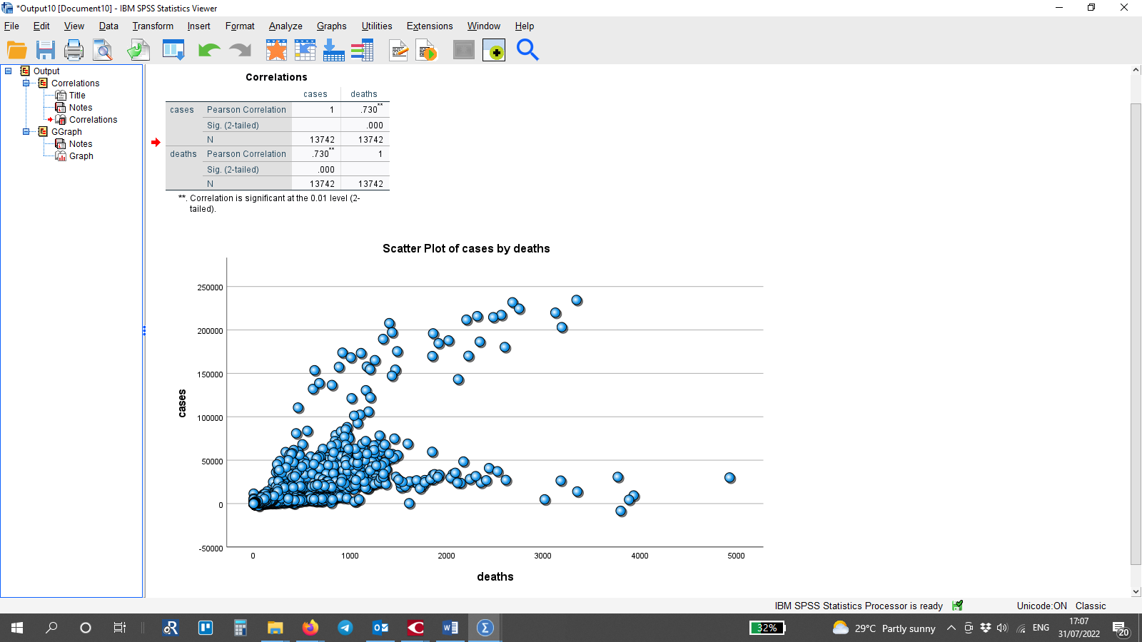
Graph 2. Scatter plot of the correlation between COVID-19 cases and deaths in America
However, visible from the scatter chart on Graph 2, is that there are several dots that are suspiciously away from the usual pattern of the general lot. It was decided to investigate the data for mistakes (Gibbs, 2014), but since it looks genuine, the investigation was transferred to adding another variable to the scatter chart and that is the data by countries. Each entry per country was coloured in a certain colour and each dot was labelled accordingly (Graphic 3).

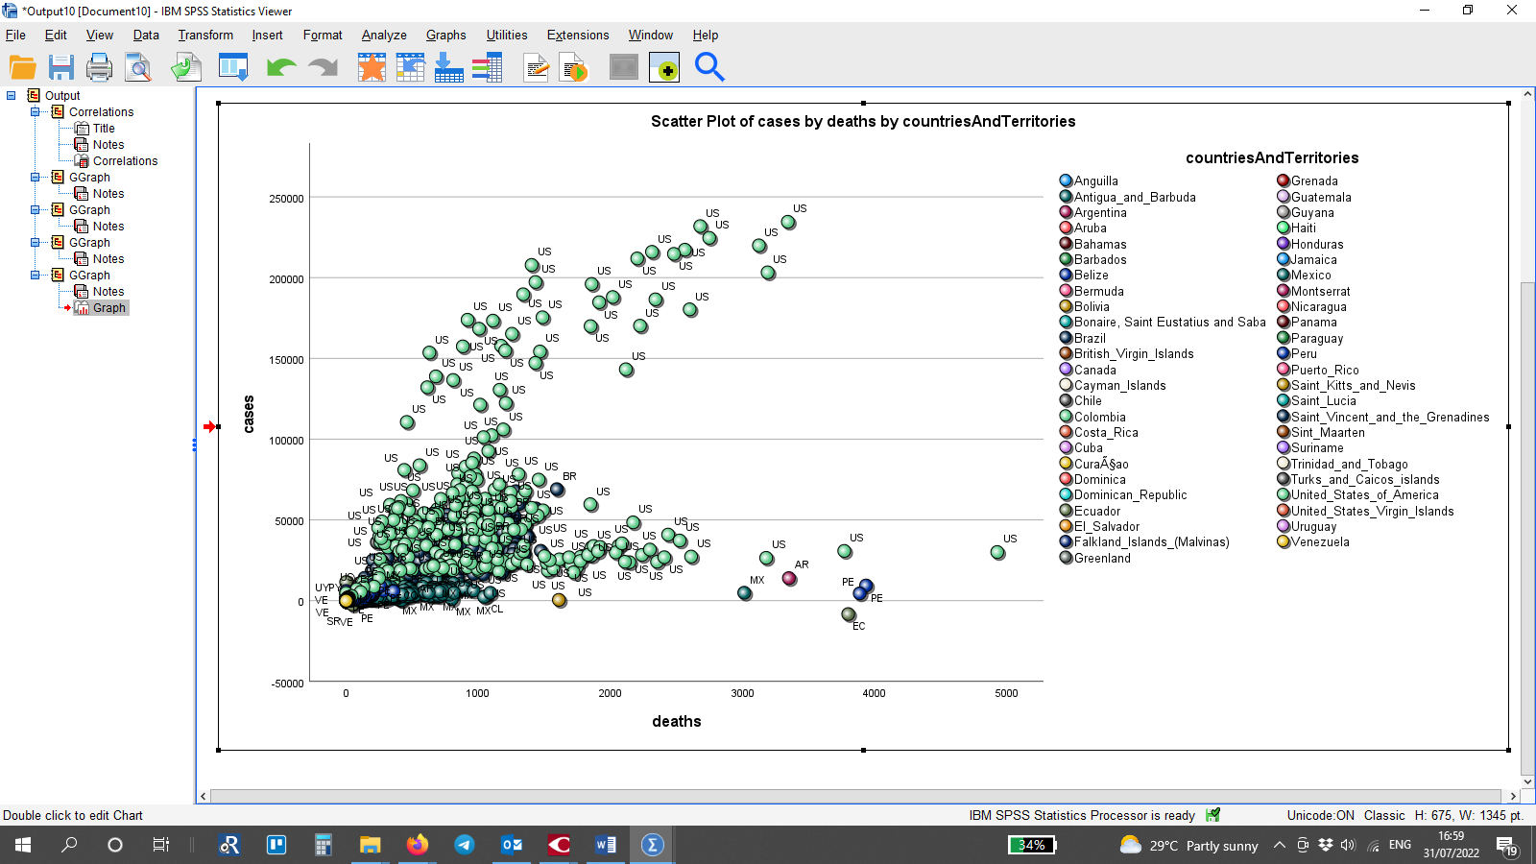
Graphic 3. Scatter plot of the correlation between COVID-19 cases and deaths in America with added markers and different colours for each separate country and territory
Still, the data is too concentrated in one part of the graphic, however, it is already clear, that the anomaly that envoked the further investigation comes from the data from the United States of America.
In order to obtain a better look over the correlation between the deaths and the cases of COVID-19, it was decided to separate the countries with the most cases (Graph 4).
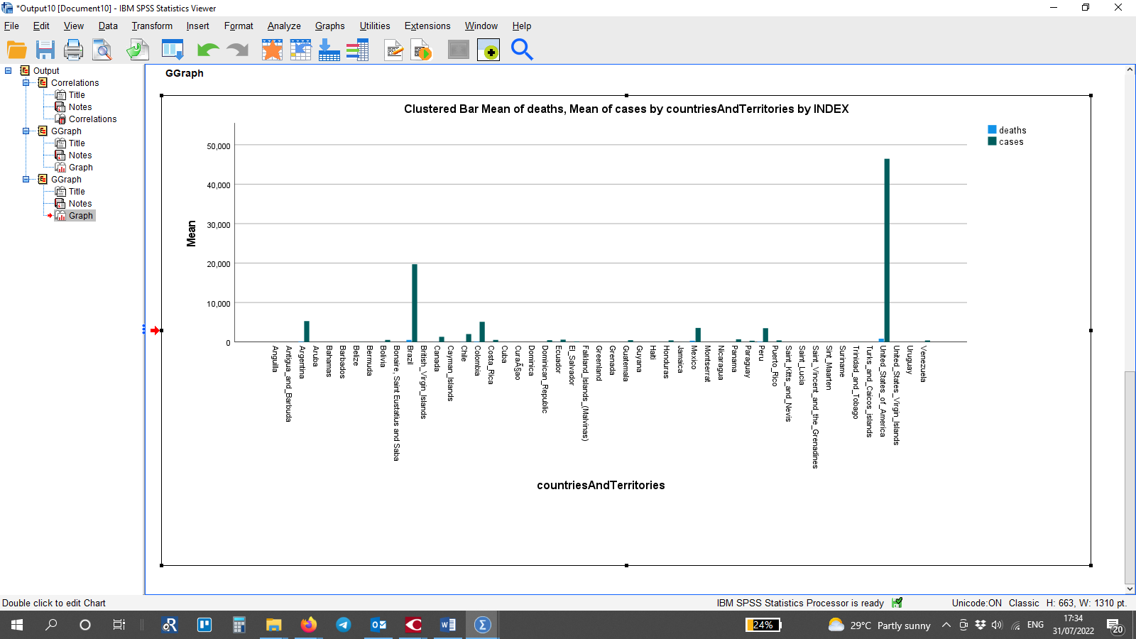
Graph 4. Mean of COVID-19 deaths and cases
Graph 4 distinguishes the United States and Brazil as the countries of the highest rates of cases and deaths, followed by Argentina. Mexico was taken by randomly in order to fil in the fourth case study.
Visible from Graph 5 a) the USA shows three patterns of clustering the dots, which Graph 2 looked like a mistake in the data. The other three graphics are clearly showing a stable pattern of the correlation between deaths and cases of COVID-19. The final result is that the correlation between these two variables is equal to .730, which means that as the cases grew, so did the deaths by Covid-19. And the other outcome of the investigation is that in the USA, the data shows three phases of development of the disease – the first phase was when the number of cases was low, so was the death rate. When the number of cases grew exponentially, so did the number of deaths, but the high levels did not last for long and were followed by an abrupt decline in cases and deaths.
It is curious that for the United States there are three dots that do not fit the common pattern, and for Mexico and Argentina – 1 per each of the countries. It was accepted that the peak of the crisis lasted 3 days in the USA and 1 day respectively for Mexico and Argentina. Such an anomaly is not observed in Brazil.
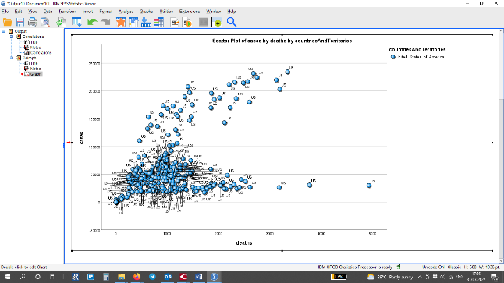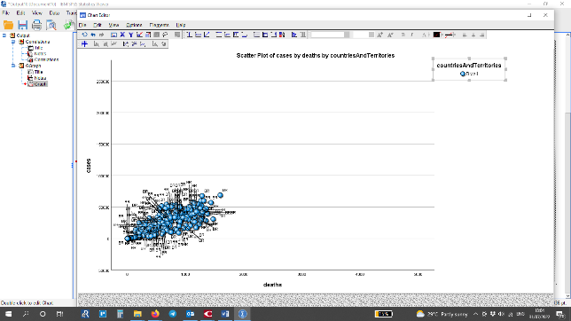
a) United States b) Brazil
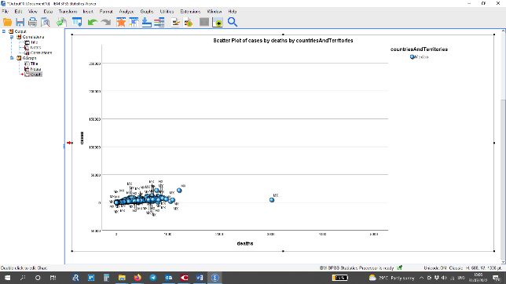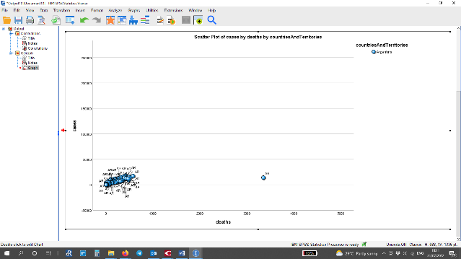
c) Mexico d) Argentina
Graph 5. Scatter plots of the correlation between COVID-19 cases and deaths in the United States, Brazil, Mexico and Argentina

Advantages and disadvantages of using SPSS and Excel
Both SPSS and Excel offer calculating statistics by menu-driven commands. In SPSS the analysis is available under the menu “Analyse”, and in Excel it is available either in a function wizard, or a data analysis tool (Proctor, 2002).
“Both SPSS and Excel allow user to write command language to calculate statistics” (Proctor, 2002). However, the method of doing so differs for the two softwares. In SPSS it is done by writing the commands in a syntax file that gives the software the way of dealing with the data file. In contrast, Excel allows the user to write the commands directly into the cell where the actual data is. This has spread the use of Excel widely and it is the common tool used for processing and analysing data in business.

References
Gibbs, G. (2014) Interpreting Pearson Correlation. Part 2 of 3 on Scattergrams and Correlation [video]. Accessible at: https://www.youtube.com/watch?v=o4OIw6bpw6Y (Accessed: 30 July 2022)
Jizhe, N (2021) Main Data of the Seventh National Population Census News Release. National Bureau of Statistics of China, May 11, Accessible at: http://www.stats.gov.cn/english/PressRelease/202105/t20210510_1817185.html (Accessed: 05 August 2022)
Miller, A. (2014) ‘Application of Excel® Pivot Tables and Pivot Charts for Efficient Library Data Analysis and Illustration’, Journal of library administration, 54(3), pp. 169–186. doi:10.1080/01930826.2014.915162.
Miller, A. (2014). ‘Introduction to Using Excel® Pivot Tables and Pivot Charts to Increase Efficiency in Library Data Analysis and Illustration’, Journal of Library Administration, 54(2), 94–106. https://doi.org/10.1080/01930826.2014.903365
Office of the Registrar General & Census Commissioner (2022) Primary Census Abstract Indicators Search upto town/village level, Accessible at: https://censusindia.gov.in/census.website/data/data-visualizations/PopulationSearch_PCA_Indicators (Accessed: 05 August 2022)
Proctor, J. L. (2002) ‘SPSS vs. excel: Computing software, criminal justice students, and statistics’, Journal of criminal justice education. Highland Heights: Taylor & Francis Group, 13(2), pp. 433–442. doi: 10.1080/10511250200085561.
SPSS Tutorials (2022) SPSS Scatterplot Tutorial Accessible at: https://www.spss-tutorials.com/spss-scatterplot-tutorial/ (Accessed: 31 July 2022)
Zhou, Z., SooHoo, M., Zhou, Q., Perez, M., & Liew, J. (2019). ‘Temperament as Risk and Protective Factors in Obesogenic Eating: Relations Among Parent Temperament, Child Temperament, and Child Food Preference and Eating’. The Journal of Genetic Psychology, 180(1), 75–79. https://doi.org/10.1080/00221325.2019.1575180

