
LEVEL 6 ASSESSMENT SPECIFICATION
Assignment 2
Student name: | Madalina Preda | Student ID number: | 2213175
Programme: | International Hotel Management (BA)
Module: | International Meetings Management for the Hotel Industry
Module code: | BMIH6007 | Contribution to Overall Module Assessment (%): | 50%
Lecturers: | Kathryn Flynn (Module Lead) Chris Wilkin | Internal Verifier: | Lisa Bassler
Assignment Title: | Assignment 2: Planning and Delivering an International Meeting/Event: Christmas Market Expo  Report Format (50%) | Word Count (or equivalent): | 2,500 Words (Report)
Submission | Friday 8th November 2024 | Return date of | Friday 6th December
deadline: | 23:59 | provisional marks | 2024 23:59pm
 |  | & written feedback: | (20 working days)
 | Draft Deadline week of:
 | 1st November 2024

PLANNING AND DELIVERING AN INTERNATIONAL MEETING/EVENT: CHRISTMAS MARKET EXPO
Executive Summary
The report covers all actions taken in the design and implementation of a Christmas Market Expo in London that aims to promote international exchange and comfort for the visitors in the season. The primary purpose is to develop a complex cultural and profitable project, building on SMART targets such as enlarging the number of international vendors by 15% and ensuring 90% satisfaction level with the attendees.
Out of the scopes of work logistics management, events personnel management and events staff furnishings will be the key. Promotion will be done both to the local market as well as the international tourist market employing web based as well as conventional media advertisement. The budgeted revenues consider rising to an amount of £160,000 while the aroused costs do not exceed £125,000 hence making a profit within the amount of £35,000 which is to be reinvested later.
In view of existing patterns, the Expo will have a special focus on sustainable development, innovative technologies and health & safety regulations. Supporting all activities with cultural considerations and using SWOT analysis, the event will focus on attracting many clients while making positive sales to the economy, especially on holidays.

Table of Contents
1. Introduction 7
2. The Event Cycle 7
3. Event Concept 9
4. Aim and Objectives of the Event 11
5. Event Management 11
6. Event Budget 14
7. Industry Trends/Issues/Impacts 15
8. Situational and Cultural Considerations 16
9. Conclusion 18
10. Reference List 19-20

List of Figures
Figure 1: The Event Cycle 8
Figure 2: Christmas sales in the United Kingdom (UK) 2016-2023 10
Figure 3: Event Management 12
Figure 4: SWOT Analysis 17

List of Tables
Table 1: Projected Income 14
Table 2: Projected Expenditure 15
Table 3: SWOT Analysis 17

1. Introduction
The focus of the report is on the Christmas Market Expo, an international trade show and the finest rendezvous intended to expose the different types of Christmas markets with local and foreign food, crafts and entertainment. This time the audience will be taken to London, one of the best cities in the world for tourism and most exciting cities, especially during the Christmas markets. The objective of the event is to attract tourists, local people and businesses who want to connect, do business and have exchange activities and cultures. The selected type of event represents festive seasonal holidays, of which is very active consumption and tourism around the world. For the spatial arrangement of the event, London was chosen in view of its geographical location as a major international city since the event expects prosperity in that regard.

2. The Event Cycle
According to Event management Body of Knowledge (EMBOK), the Event Cycle consists of the distinct stages namely, Research, Design, Planning, Coordination and Evaluation. The stages are a necessity if one is to execute an event such as the Christmas Market Expo that will attract numerous people, board international tourists, local vendors and businesspeople.
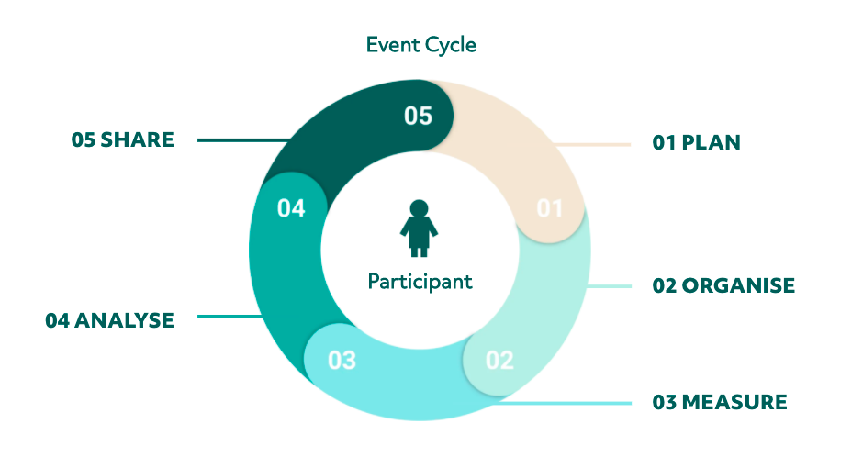

Figure 1: The Event Cycle
(Source: Wirantari et al. 2022)

Research
Investigating target audiences and researching trends is an essential part of any campaign. So, about the Christmas Market Expo, it means studying the data of holiday tourists, their expenditures in the festive season, and the vendors. Let’s take an example of Christmas markets in London that receives around 2.5 million visitors in a year at a mean expenditure of £91 per person during the festive season making it a great place to host such an event (Wirantari et al., 2022). Such research helps make the event pleasurable for tourists and locals, satisfying their expectations.
Design
In the design phase, various endeavors are made to create a festive experience that incorporates the local and foreign elements of Christmas markets. During this phase, decisions are made regarding cultural festivals, images, the arrangement of vendors to enhance visitors’ experience. Relating to the Christmas Market Expo, key activities include live shows, tasty foods served at some stalls, and hands-on earning experiences among others. As the result of design, visitor movement is effectively controlled around the focus and experience (Wahl and Walkerb, 2022).
Planning
Organizing involves all the logistical elements required to implement the event. In the case of the Christmas Market Expo, which is set in London, this includes renting a venue in the same region which has a 25,000 square meters, licensing, and bringing in 100 vendors both local and international (Wahl and Walkerb, 2022). Marketing plans to draw in as many tourists as possible and meeting the local requirements also require careful coordination.
Coordination
Coordination relates to the actions that are executed during the event, such as vendor set-up, security and crowd control management. So, the Christmas Market Expo would call for a team of 100 staff members to make sure that operations are taken care of (Dolinska, Jarząbek and Dolinski, 2020). However, at this point, it is important to provide for entertainment scheduling, and vendors coordinating in addition to safety measures in order that nothing interferes with the event in progress.

Evaluation
Feedback from attendees, vendors, and stakeholders is collected through surveys and digital forms. Success metrics include attendee satisfaction, vendor sales, and media coverage. By evaluating these aspects, organizers can measure the event's effectiveness and identify areas for improvement in future editions (Wirantari et al. 2022).

3. Event Concept
The Christmas Market Expo is envisaged to be a multi-day festival which incorporates the traditional feature of a Christmas market with diasporic outlook. This event will present an assortment of activities which will enable the attendees who are residents and those coming from far places to enjoy the festivities in a different way. The concept combines traditional Christmas spirit with eco-friendly and global flair. This strategy creates an attractive structure for families, tourists, and entrepreneurs.
Christmas Market Expo, as its name suggests, is expecting immense participation of more than 50,000 guests to maximize the benefits from cultural tourism as well as business opportunities (Obermair, Holzapfel and Kuhn, 2023).
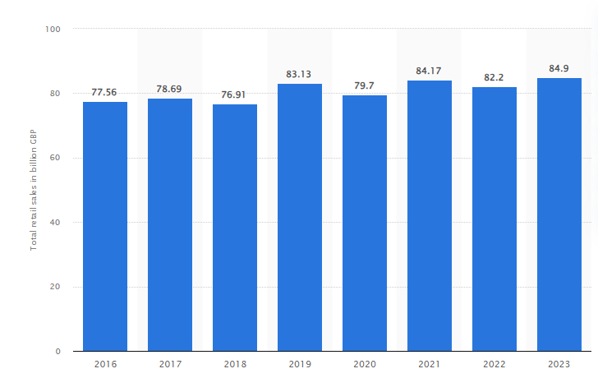

Figure 2: Christmas sales in the United Kingdom (UK) 2016-2023
(Source: Statista, 2023)
Itinerary
The Christmas Market Expo will run for five consecutive days, each day offering a distinct experience:
- Day 1: Opening Ceremony
First, a Christmas Tree Lighting ceremony will take place to mark the beginning of the event, which will be followed by performances from the local choirs. This sounds cute and the organisers hope that the Ceremonial Opening will pack them in with about 10,000 people joining the revelry.
- Day 2: Vendor Exhibitions
The second day will be dedicated to the exhibition of food, craft works and special souvenirs from different countries. This will also include sessions for the buyers and vendors to interact where the local businesses will connect with the foreign exhibitors. The vendor’s exhibition is reported to attract upwards of 150 vendors with both local and international participation (Antchak, Lück and Pernecky, 2021).
- Day 3: Interactive Workshops
This day will be characterized by hands-on activities such as creating holiday themed crafts, cooking, and workshops aimed at environmental improvement through responsible holiday shopping. It is suggested that the workshops would enlist around 2,000 participants thereby being very appealing and educational as well (Obermair, Holzapfel and Kuhn, 2023).
- Day 4: Live Performances
The public will include carolers and dancers as well as spectators from other countries who will participate in a parade which will be organized. The parade alone as noted, is expected to have about 15,000 spectators which is a significant attraction in the occasion (Statista, 2023).
- Day 5: Closing Event
The last day will focus on giving back to the community by forming partnerships with relevant local charities to create awareness and raise money for homelessness. There is a winter charity event that will aim to help the local causes whereby the Expo is looking to make a positive impact in the society.

4. Aim and Objectives of the Event
The aim of the Christmas Market Expo is to create a culturally enriching and commercially successful event that enhances international exchange, engages the community, and promotes sustainable practices during the festive season.
SMART Objectives:
- Specific: Raise international vendor participation by 15% compared to previous holiday market events in London, ensuring diverse representation from different regions (Louw and Esterhuyzen, 2022).
- Measurable: Attain a 90% satisfaction rate from attendees based on post-event surveys, focusing on aspects such as event organization, quality of vendors, and overall visitor experience (Dolinska, Jarząbek and Dolinski, 2020).
- Time-bound: Secure sponsorship from at least five major companies (e.g., food and beverage brands, retail chains) within two months prior to the event to support operations and ensure funding is in place.

5. Event Management

Figure 3: Event Management
(Source: Jiang and Yang, 2024
Operational Activities
Operational activities are crucial for the successful execution of the Christmas Market Expo. Logistics will involve coordinating the venue layout, ensuring efficient transportation for vendors and attendees, implementing security measures, and adhering to health and safety compliance regulations. The venue will be designed to facilitate smooth foot traffic, with designated areas for food stalls, craft vendors, and performance stages. Approximately 5,000 attendees are anticipated daily, necessitating robust crowd management strategies (Jiang and Yang, 2024).
Vendors and Supplies will be selected based on quality standards that align with the event's theme of sustainability. All vendors will be required to provide documentation confirming their commitment to eco-friendly practices. It is expected that at least 70% of the products sold will adhere to these sustainability criteria. Regular checks will be conducted to ensure compliance throughout the event.
Human Resources will impact positively on the outcome of the event. The organization will arrive at the the decision of coming up with a detailed training program to prepare personnel for the various functions of guest services, security services and vendor management. About 100 staff will be hired and trained with emphasis on customer service and emergency measures to improve the experience of the attendees.
Planning Activities
The ability to deal with some of the potential hurdles can be achieved through effective planning activities. Strategies for Risk Management will incorporate provision of alternative plans for unexpected weather, vendor no-shows or insufficient available attendance and many more. So if we have to come up with rising inclement weather plans, then there would be provisions to focus all outdoor activities to indoor activities if need arise as well as planning to have extra tents for more crowds.
Location
This facility in central London is spacious enough to contain stalls, attractions and activities and well built with features such as ramps and well-maintained paths for persons in wheelchairs. It is often noted that this market is well decorated hence it operates at various locations in the city center so as to provide sufficient room for vendors and visitors alike. Ramps and accessible stalls take priority.
Venue Regulations
The working hours of Christmas markets are normally from 10:00 AM to 8:00 PM with an option of extending the hours to 10:00 PM on certain days. There are certain local policies which have to be followed, particularly limitations on levels of noise, where in domestic areas, loud noise such as loud music must end by 10:00 PM and the like to avoid disturbing the peace where people ion and Parking Available in areas well serviced by public transportation like bus, train or tram. This relative convenience increases visitor numbers especially foreigners. Available parking options and plan for spaces dedicated to vendors and attendees (Gierl, 2021). For Safety and Security develop a crowd management plan which outlines entry and exit points, deploy security personnel and outline emergency procedures. If indulging in such activities it is also necessary to follow health codes especially if planning on providing food and beverages. It is worth noting safety measures regarding COVID-19 or other health issues.
Marketing will target different activities to generate attention and to increase ticket sales with an all-embracing marketing strategy. This will be achieved through targeted advertisements on social networks like Instagram and Facebook, assistance from travel agencies, or sponsorships. The marketing budget has likewise been fixed requiring the amount of £50,000 and expects the achievement of at least 200% return on investment through ticket and vendor sales (Naumov and Costandachi, 2021).
Technology will improve the visitor experience and make the operation much smoother. It will be possible to buy tickets in advance through online services, and event structure, its time, and vendors will be provided by a stand-alone application. This technology is anticipated to enhance an operational thrust and bring attendees’ participation up at a minimum rate of 30% of event download and use rate.
Marketing Activities
The target audiences for the Christmas Market Expo will be international tourists, local people and their businesses who are keen on doing business. Various marketing channels will be used most especially online such as through Google Ads and social media as well as offline such as local TV and radio and newspapers. There will also be project-specific partnerships with tourist bodies (Merz et al. 2020).
Due to the proper placement of these operational and marketing activities, the Christmas Market Expo should avoid disruptions in operations progressing, maximize external market perspectives, and make enough entertainment to full satisfaction of all levels of audience presence.

6. Event Budget
Christmas Market Expo budget has been designed and planned in a manner that is sustainable and provides the participants with a lasting experience ((Christmas Expo, 2024) corporate document 2024). The projected earnings on the occasion are estimated at £160,000, from the different avenues indicated below:
Income Source | Amount (£)
Sponsorships | 50,000
Vendor Fees (100 vendors at £250 each) | 25,000
Ticket Sales (10,000 attendees at £7.50 each) | 75,000
Miscellaneous Income (merchandise and concession stands) | 10,000
Total Projected Income | 160,000

Table 1: Projected Income

As for expenses, the total projecting costs stand at a figure of £125,000 which is spread in several important areas that are important to the organisation of the event:
Expenditure Item | Amount (£)
Venue Hire | 30,000
Security and Staff | 25,000
Marketing | 20,000
Vendor Logistics | 10,000
Entertainment and Performances | 25,000
Miscellaneous (contingency costs) | 15,000
Total Projected Expenditure | 125,000

Table 2: Projected Expenditure
The rest of the £35,000 is expected to be profit which will again be used in subsequent events, projects and donations especially in addressing local issues such as the plight of homeless people in winter. This budget compliments both the income generating initiatives and event implementation activities by making certain that the Christmas Market Expo is not only financially viable but addresses some social issues in the community (Siirila-Woodburn et al., 2021).

7. Industry Trends/Issues/Impacts
The current affairs in the meetings and events sector demonstrate a clear change in favour of sustainability, technology use, and tailor-made services. Guests now anticipate interactive, effective, and noise-resistant modes that employ best practices of technology in event execution. COVID-19 increased safety and health concerns, as well as face-to-face and online or hybrid events.

Sustainability
When preparing the Christmas Market Expo sustainability playoffs the maximum attention, targeting the ‘green’ vendors using reusable materials and energy saving technologies. This dedication seeks to minimize waste and encourage green practices which correspond to the road towards development in wider industry (Wang, 2022).
Technology
Secondly, it should be noted that technology will help improve the experience of the participants. The availability of mobile apps both for the event’s brides and for carrying out purchases without cash will diversify all operations allowing visitors to interact with the vendors and the activities more. Live streaming aspects of the event will encourage virtual attendance and inclusion.
Health and Safety
Health and safety will also be a primary concern during the Expo. Implementing crowd control measures and maintaining cleanliness will be vital to ensure attendee safety. The integration of these trends will not only enhance the visitor experience but also demonstrate a proactive approach to current industry challenges (Whitehead, 2020).

8. Situational and Cultural Considerations
A comprehensive SWOT analysis has been conducted to address situational and cultural factors pertinent to the Christmas Market Expo.
SWOT Analysis | Details
Strengths | London is a globally recognized tourism hub, attracting over 19 million international visitors annually (Hazira et al. 2022). The holiday season ensures high foot traffic, creating a vibrant atmosphere.
Weaknesses | High competition exists from other holiday markets, with over 15 competing events in the city (Visit London, 2023). Additionally, logistical challenges arise due to potential weather conditions, which can impact attendance and operations.
Opportunities | Increased consumer spending during the Christmas season, projected at £2.2 billion in 2023, provides an opportunity to promote local and international small businesses.
Threats | Adverse weather conditions and potential travel restrictions could disrupt vendor participation and attendance. Previous events have seen a 20% decline in attendance due to heavy snowfall (Wang, Zhao and Zhang, 2022).

Table 3: SWOT Analysis
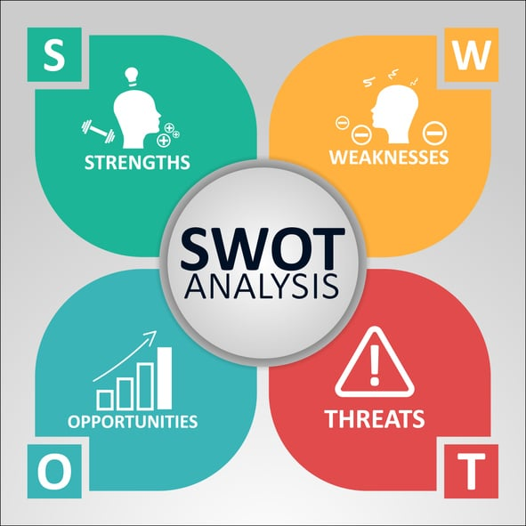

Figure 4: SWOT Analysis
(Source: Wang, Zhao and Zhang, 2022)

Culturally, the Christmas Market Expo must consider the diverse backgrounds of its attendees, ensuring inclusivity in its offerings. This includes providing non-alcoholic beverages and culturally diverse food options, accommodating dietary restrictions and preferences. Implementing such measures fosters a welcoming environment, allowing for broader participation and enjoyment.

9. Conclusion
The Christmas Market Expo aims to create a culturally enriching experience while driving economic benefits for local and international vendors. By leveraging London's strengths as a tourist hub and addressing cultural inclusivity, the event can attract a diverse audience. Incorporating sustainable practices, technology, and health protocols will enhance visitor satisfaction and operational efficiency. When planning a successful Christmas Market Expo, a number of logistical factors should be taken into consideration including the site selection, legalities concerning the location, transport and parking arrangements, and preparation of logistics.

10. Reference List
Antchak, V., Lück, M. and Pernecky, T., 2021. Understanding the core elements of event portfolio strategy: Lessons from Auckland and Dunedin. International Journal of Contemporary Hospitality Management, 33(7), pp.2447-2464.
Christmas Expo, 2024. ‘Home’ [Online]. Available at: https://virtualexpodubai.com/listen-watch/event-tracks/christmas-expo [Accessed on: 04th September 2024]
Dolinska, B., Jarząbek, J. and Dolinski, D., 2020. I like you even less at Christmas dinner! Prejudice level as a function of an approaching national or religious holiday. Basic and Applied Social Psychology, 42(2), pp.88-97.
Gierl, H., 2021. Christmas is Coming: Exploring the Effectiveness of Christmas Commercials. Transfer: Zeitschrift für Kommunikation & Markenmanagement, 67(3).
Hazira, M.N., Alagas, E.N., Amin, M., Zamzuri, N.H. and Zairul, M.M., 2022. The best practice of marketing strategies for the Malaysian business event industry from experts' perspective. Journal of Hospitality and Tourism Insights, 5(2), pp.413-434.
Jiang, R. and Yang, S., 2024, September. Cultural and Creative Attributes of Contemporary Creative Markets in China. In 2024 10th International Conference on Humanities and Social Science Research (ICHSSR 2024) (pp. 815-830). Atlantis Press.
Louw, L.B. and Esterhuyzen, E., 2022. Disaster risk reduction: Integrating sustainable development goals and occupational safety and health in festival and event management. Jàmbá-Journal of Disaster Risk Studies, 14(1), p.1205.
Merz, B., Kuhlicke, C., Kunz, M., Pittore, M., Babeyko, A., Bresch, D.N., Domeisen, D.I., Feser, F., Koszalka, I., Kreibich, H. and Pantillon, F., 2020. Impact forecasting to support emergency management of natural hazards. Reviews of Geophysics, 58(4), p.e2020RG000704.
Naumov, N. and Costandachi, G., 2021. Creativity and entrepreneurship: Gastronomic tourism in Mexico. In Innovation and entrepreneurial opportunities in community tourism (pp. 90-108). IGI Global.
Obermair, E., Holzapfel, A. and Kuhn, H., 2023. Operational planning for public holidays in grocery retailing-managing the grocery retail rush. Operations Management Research, 16(2), pp.931-948.
Siirila-Woodburn, E.R., Rhoades, A.M., Hatchett, B.J., Huning, L.S., Szinai, J., Tague, C., Nico, P.S., Feldman, D.R., Jones, A.D., Collins, W.D. and Kaatz, L., 2021. A low-to-no snow future and its impacts on water resources in the western United States. Nature Reviews Earth & Environment, 2(11), pp.800-819.
Statista, 2023. ‘Christmas sales in the United Kingdom (UK) 2016-2023’. Available at: https://www.statista.com/statistics/792411/christmas-sales-forecast-united-kingdom-uk/ [Accessed on: 04th September 2024]
Visit London, 2023. ‘Home’ [Online]. Available at: https://www.visitlondon.com/things-to-do/whats-on/special-events/london-events-calendar [Accessed on: 04th September 2024]
Wahl, J. and Walkerb, K., Leaving a Legacy Through Conferences and Exhibitions: The Enduring Value of Repeat and Globally-Rotating Events in Vancouver, British Columbia. Legacies, 2(2), pp.1-22.
Wang, L., Zhao, F. and Zhang, G., 2022. Analysis on the Impact of Large‐Scale Sports Events on Regional Economy Based on SWOT‐PEST Model. Journal of Mathematics, 2022(1), p.7769128.
Wang, M., 2022, January. The Influence of People’s Views on Chinese and Western Festivals on Festival Marketing. In 2021 International Conference on Culture, Design and Social Development (CDSD 2021) (pp. 190-194). Atlantis Press.
Whitehead, J., 2020. Comparison of Canadian Urban and Small-Town Exhibition Practices 1914–1929. TMG Journal for Media History, 23(1–2), p.1.
Wirantari, K., Aryana, I.N.R., Sutama, I.K., Mudana, I.G., Ruki, M. and Mataram, I.G.A.B., 2022. Implementation of Marketing Mix to Increase Meeting Events. International Journal of Travel, Hospitality and Events, 1(2), pp.168-175.

