

Student Name: Dhruv Sanjaykumar Patel

Student ID: 2431083

Module Name: International Marketing: Principles and Practices

Module Code: LCMB7026

Lecturer’s Name: Tushara Balendran

INTRODUCTION
This report examines BMW’s international marketing practices by analysing its operations in the United Kingdom and India, two contrasting markets that highlight the brand’s global adaptability. As a leading premium automotive manufacturer, BMW has built a strong international presence through innovation, engineering excellence, and strategic localisation. The study explores BMW’s market entry, operational background, and integration within these countries, providing an understanding of how cultural, economic, and political contexts shape its marketing decisions. Through PESTLE, cultural, social, and STP analyses, this report evaluates how BMW maintains a consistent global identity while tailoring its strategies to meet diverse market needs.

COMPANY BACKGROUND
Overview of the chosen brand and its operation in the chosen countries

1. Company Overview: BMW
Bayerische Motoren Werke AG (BMW Group) is a globally recognized premium automobile manufacturer headquartered in Munich, Germany. Established in 1916, the company initially specialized in aircraft engines before evolving into one of the most prestigious automotive brands known for engineering excellence, design innovation, and performance (BMW Group, 2025). BMW’s global operations span over 140 countries, and the firm maintains production facilities across Europe, Asia, and North America, demonstrating its strategic commitment to globalisation and local market integration (Liu, 2022).
This report focuses on BMW’s operations in the United Kingdom (Country A) and India (Country B), examining how the brand has positioned itself within these distinct markets. The discussion explores BMW’s historical entry, operational background, and localization strategies, setting the foundation for later analysis of marketing and business strategies.
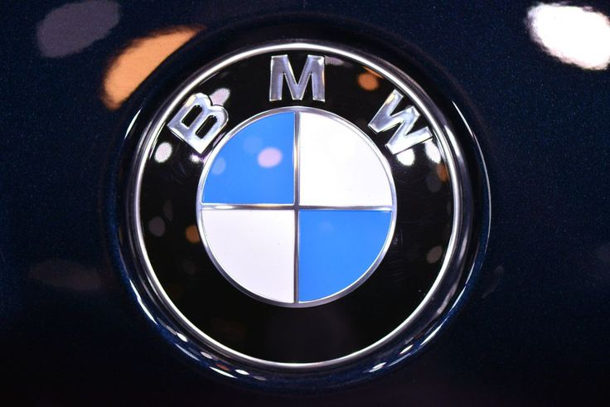
Figure 1: BMW Logo

2. BMW in the United Kingdom (Country A)
BMW’s association with the UK automotive landscape is both historic and strategic. The company formally established its British presence in the early 1980s, though its connection deepened after acquiring the Rover Group in 1994, which laid the groundwork for the MINI and Rolls-Royce brands under BMW ownership (Brailey, 2002). Today, BMW operates key facilities across Oxford, Hams Hall, and Swindon, employing thousands of workers and serving as an important contributor to the UK’s manufacturing and export economy (BMW Group, 2025).
BMW’s UK operations serve as a European hub for engineering excellence and advanced production, with MINI vehicles produced in Oxford representing a significant symbol of “British-made, German-engineered” craftsmanship (Boeriu, 2025). The company emphasizes sustainability and electrification in its UK operations, with investments directed toward EV development and supply-chain resilience to support its global carbon-neutral goals by 2030 (Dobrin, 2021). This strategic alignment underscores BMW’s intent to blend local identity with its global vision for sustainable mobility.

3. BMW in India (Country B)
BMW entered the Indian market in 2007, marking a significant milestone in the company’s expansion into Asia’s emerging luxury automotive segment (ICMR India, 2012). Its entry strategy emphasized localized assembly and premium dealership networks, positioning the brand as a pioneer in the luxury vehicle category within India’s growing middle- and upper-income demographic (Hoque and Rahman, 2021). The company established a state-of-the-art manufacturing facility in Chennai, where both BMW and MINI models are assembled, supported by an extensive sales and service network across major metropolitan cities (Sharma, 2025).
BMW’s Indian operations reflect a commitment to “Make in India” principles, integrating local suppliers and adapting vehicles to suit regional preferences, road conditions, and regulatory environments (Banerjee, 2025). The company’s focus on local electric vehicle (EV) manufacturing further aligns with India’s sustainability objectives and evolving consumer appetite for environmentally conscious luxury mobility solutions. BMW’s strategic localization illustrates how the firm effectively adapts its global business model to meet diverse market demands while retaining its brand ethos of performance, innovation, and luxury.

4. The Macroenvironment (PESTLE) Analysis BMW in the UK (Country A) and India (Country B)

4.1. Political
UK
Favourable – UK: Strong EV policies, industry incentives, and clear decarbonisation commitments support BMW’s electrification strategy (BMW Group, 2025).
Unfavourable – UK: Uncertainty around the agency sales model and regulatory delays hinder restructuring (Boeriu, 2025).
Policy clarity on net-zero and transport decarbonisation is broadly supportive of BMW’s electrification roadmap and the firm’s long-standing UK industrial footprint (Oxford, Hams Hall, Swindon) provides political goodwill and supply continuity advantages (BMW Group, 2025; BMW Group, 2025). However, the shift toward an agency sales model has been staggered, reflecting a sensitive regulatory and stakeholder environment that can delay commercial model changes even when strategically attractive—illustrating how “favourable” decarbonisation policy can coexist with “unfavourable” go-to-market frictions (Boeriu, 2025). Company stability mitigates these tensions: BMW’s established governance, brand equity, and employment base help sustain political legitimacy during transitions (Dobrin, 2021).
India
Favourable – India: “Make in India” initiatives and EV subsidies encourage localisation (Banerjee, 2025).
Unfavourable – India: Complex multi-state regulations prolong approvals and increase operational uncertainty (ICMR India, 2012).
India’s industrial and EV policies (local manufacturing, supply-chain development, and demand incentives) are favourable to BMW’s localisation strategy, including its steps toward local EV manufacturing and deeper component sourcing, boosting policy alignment and operational flexibility (Banerjee, 2025; Sharma, 2025). Yet, multi-layered permissions, periodic policy recalibrations, and state-level heterogeneity can stretch lead times, so favourable national intent may coexist with uneven execution at the sub-national level again placing a premium on BMW’s organisational stability and phased localisation playbook (ICMR India, 2012; Hoque and Rahman, 2021). Geopolitical risk stewardship, evidenced by BMW’s positions on sensitive markets, underpins political risk management in both countries (BMW Group, 2023).

4.2. Economic
UK
Favourable – UK: Stable demand for premium vehicles and high disposable income support BMW’s pricing strategy (Liu, 2022).
Unfavourable – UK: Inflation and rising interest rates reduce affordability and financing attractiveness (Dobrin, 2021).
A mature premium segment with cyclical demand and high total cost of ownership pushes BMW to defend pricing power via brand, quality, and technology while optimising local value-add through UK plants and powertrain components (BMW Group, 2025; Dobrin, 2021). Inflation and interest-rate variability tighten affordability, reinforcing BMW’s need for efficient retail models and mix management; company stability allows disciplined adaptation without over-correcting product cadence or investment levels (Liu, 2022).
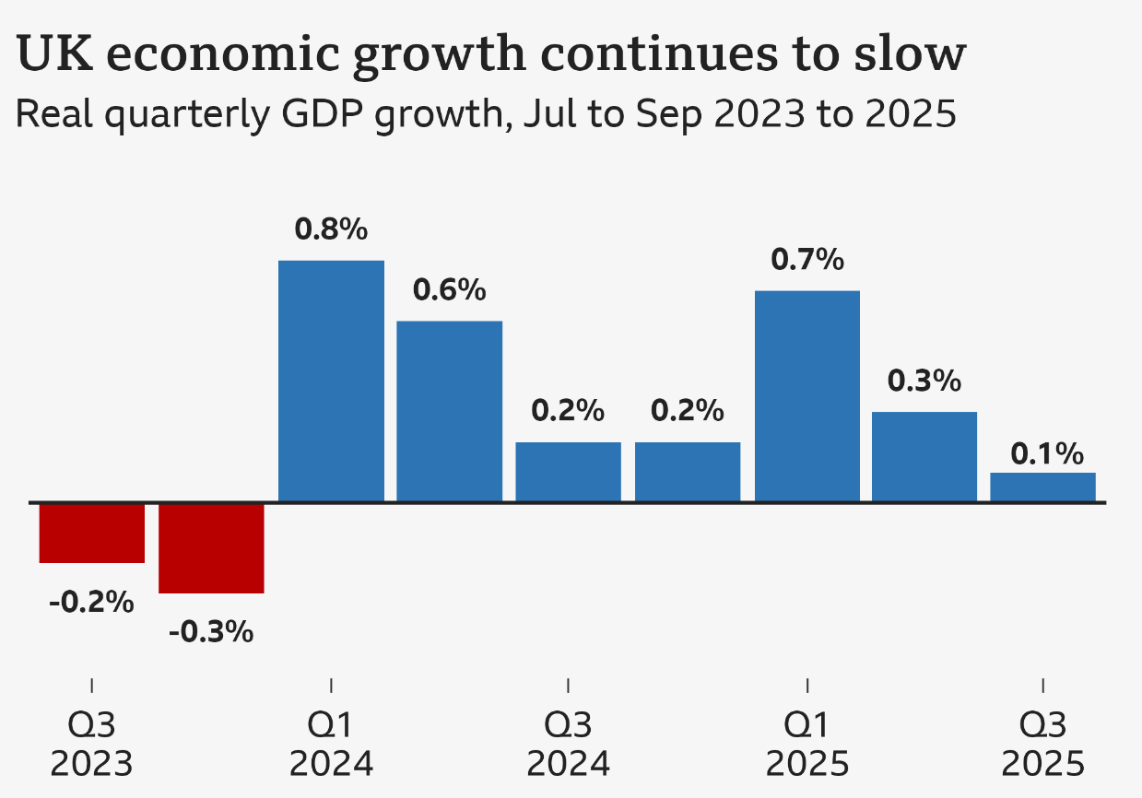
The UK chart shows fluctuating but generally slowing GDP growth from 2023 to 2025. After two quarters of contraction in 2023, growth briefly rises in early 2024 before weakening again. Although Q1 2025 shows improvement, the trend stabilises at very low rates, indicating fragile recovery and ongoing economic uncertainty.

India
Favourable – India: Rising GDP growth and expanding affluent classes increase luxury vehicle demand (Sharma, 2025).
Unfavourable – India: Import duties and currency fluctuations increase cost pressure for imported components (Banerjee, 2025).
Structural income growth and luxury market formalisation expand the upper-tier addressable base, supporting BMW’s long-run premium narrative and localisation economics (ICMR India, 2012; Hoque and Rahman, 2021). Currency volatility and import duties, however, can pressure pricing unless offset by local assembly and progressive localisation, making economic favourability conditional on execution depth an area where BMW’s stable capex planning and supply relationships are accretive (BMW Group, 2025; Banerjee, 2025).
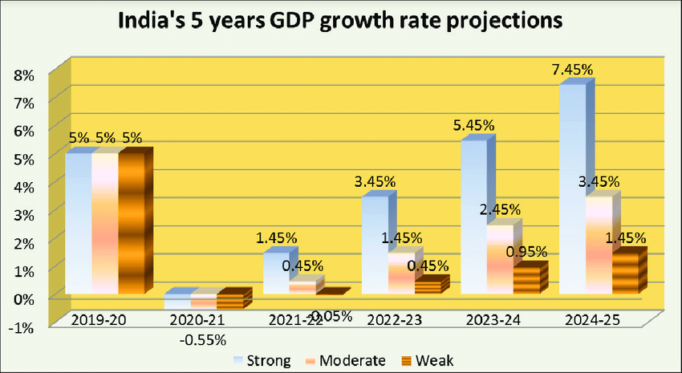
India’s projected GDP growth shows strong upward momentum from 2021 to 2025. After a dip in 2020–21, growth steadily accelerates, reaching over 7% in 2024–25. The chart highlights consistently stronger performance compared to earlier years, suggesting expanding economic resilience, rising demand, and favourable long-term growth prospects across multiple sectors.

4.3. Sociocultural
UK
Favourable – UK: High awareness of sustainability and safety aligns with BMW’s EV and hybrid offerings (Overall, 2021).
Unfavourable – UK: Declining car ownership appeal among youth poses long-term demand uncertainty.
Consumers exhibit high safety, sustainability, and digital expectations, aligning with BMW’s brand promise around driving dynamics, connected services, and lower lifecycle impact; this congruence strengthens premium positioning when paired with British manufacturing heritage through MINI and component plants (Brailey, 2002; Overall, 2021). Skepticism toward aggressive retail model shifts can surface among dealer and customer communities, meaning sociocultural acceptance is favourable for product tech, but mixed for sales innovation speed (Boeriu, 2025).
India
Favourable – India: Aspirational consumption and social prestige attached to luxury brands strengthen BMW’s positioning (Hoque and Rahman, 2021).
Unfavourable – India: Cultural diversity means consumer needs vary widely across regions.
Aspirational consumption, growing EV curiosity, and prestige-seeking in metro clusters create a culturally favourable canvas for BMW’s design and performance cues, provided products are tuned for local usage patterns (ride comfort, ground clearance, heat management) and aftersales reassurance (ICMR India, 2012; Hoque and Rahman, 2021). Preferences are diverse across languages and regions; thus, what is culturally favourable in tier-1 cities can be neutral elsewhere, which BMW addresses via curated portfolios and experiential retail an approach aided by organisational stability and consistent brand codes (Sharma, 2025).

Social Trends Analysis BMW in the UK and India
UK: Social Trends
In the UK, evolving consumer lifestyles and attitudes toward sustainability, digitalisation, and inclusivity have reshaped the automotive industry. Social consciousness about carbon emissions and ethical production has made electric and hybrid vehicles more appealing, which aligns well with BMW’s focus on sustainable mobility and premium EV design (BMW Group, 2025). The brand benefits from a customer base that values performance, innovation, and environmental responsibility, allowing BMW to reinforce its image as both technologically advanced and socially aware (Overall, 2021).
However, there are also unfavourable social trends. The growing shift among younger consumers toward shared mobility, urban living, and reduced car ownership could gradually weaken demand for premium vehicle ownership in metropolitan areas (Dobrin, 2021). Additionally, post-Brexit labour and demographic changes have influenced workforce mobility and consumer sentiment, creating uncertainty in luxury spending patterns. Despite these challenges, BMW’s stable reputation and adaptability allow it to remain relevant by integrating sustainable design, digital connectivity, and flexible ownership models suited to emerging lifestyle shifts (Kukkamalla, Bikfalvi and Arbussa, 2020).

India: Social Trends
India’s social landscape presents both vast opportunities and distinct challenges for BMW. Rising urbanisation, aspirational consumerism, and the expanding upper-middle-class segment have made luxury vehicles symbols of social status and personal success (ICMR India, 2012; Hoque and Rahman, 2021). The cultural trend of celebrating success through material acquisition strongly favours BMW’s premium positioning, while increasing environmental awareness and interest in technology support the acceptance of electric and hybrid cars (Banerjee, 2025). BMW’s investment in local customer experience centres and community engagement also aligns with social values of trust and relationship-oriented service delivery (Sharma, 2025).
Conversely, unfavourable trends include significant regional and cultural diversity in consumer behaviour. Preferences vary widely between urban elites and smaller cities, where affordability and service accessibility remain barriers (Hoque and Rahman, 2021). Moreover, social infrastructure such as EV charging awareness and safety perceptions lags behind, affecting adoption rates outside major cities. Nonetheless, BMW’s brand stability and long-term strategy of blending global luxury with local cultural resonance position it to navigate these complex social dynamics effectively (Banerjee, 2025; BMW Group, 2025).

Cultural Environment Analysis BMW in the UK and India
Hofstede Model
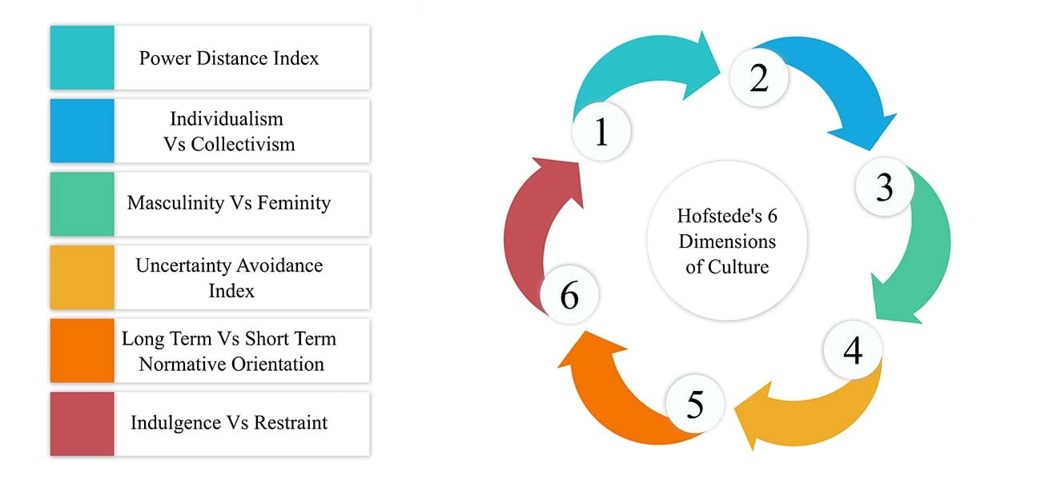
The Hofstede Cultural Dimensions Model explains how national cultures shape consumer behaviour and business practices through six dimensions: power distance, individualism–collectivism, masculinity, uncertainty avoidance, long-term orientation, and indulgence (Hofstede, 2011). These dimensions help marketers understand how people in different countries interpret authority, risk, communication, and decision-making. For example, high power-distance cultures value hierarchy, while individualistic cultures prioritise personal choice (Hofstede Insights, 2024). In international marketing, the model supports firms like BMW in adapting promotional messages, customer service approaches, and brand positioning to match local cultural expectations, improving market acceptance and customer engagement (Dobrin, 2021).

Hofstede’s Cultural Dimensions –for the UK
For BMW in the UK, Hofstede’s framework offers clear advantages by helping the company align with the country’s low power distance, high individualism, and moderate uncertainty avoidance. This understanding allows BMW to design marketing messages that emphasise independence, innovation, and personal achievement—key traits valued by British consumers (Dobrin, 2021). However, the model’s limitations also surface in the UK context, where generational and regional variations create diverse consumer mindsets. Younger, sustainability-driven buyers often differ from traditional premium car owners, meaning reliance on Hofstede’s static cultural dimensions can oversimplify evolving attitudes in an increasingly globalised and digital society.

Hofstede’s Cultural Dimensions –for India
In India, Hofstede’s model provides BMW with a valuable framework for understanding hierarchical social structures, high power distance, and collectivist tendencies, enabling effective brand positioning centred on prestige, family orientation, and social aspiration (Hoque and Rahman, 2021). It supports strategic alignment between German engineering excellence and Indian cultural values, reinforcing BMW’s premium identity. Nonetheless, the framework’s limitations are more evident in India due to vast regional, linguistic, and socioeconomic diversity (Banerjee, 2025). Overgeneralisation risks ignoring urban-rural contrasts and emerging youth segments who blend traditional values with modern, digital lifestyles, demanding more dynamic and adaptive cultural interpretation.

Comparison
Culturally, the UK market values heritage, craftsmanship, and engineering reliability, all of which align strongly with BMW’s German precision and long-standing association with high performance. The UK’s appreciation for quality-driven design and environmental consciousness enhances brand favourability, particularly as British consumers increasingly seek products reflecting ethical production and low carbon footprints (Overall, 2021; BMW Group, 2025). BMW’s incorporation of MINI and Rolls-Royce further reinforces its resonance with local pride and craftsmanship traditions, strengthening cultural integration (Brailey, 2002).
On the unfavourable side, British consumers’ pragmatic and price-conscious tendencies mean that luxury brands must continuously justify premium pricing through tangible innovation and aftersales value (Dobrin, 2021). Cultural restraint in self-expression also moderates overt displays of wealth, making marketing communications more subtle compared to emerging markets. BMW’s challenge lies in balancing luxury prestige with understated sophistication expected by British buyers.
In India, luxury consumption is deeply tied to social identity, success, and aspiration, making BMW’s brand image highly favourable among affluent and upwardly mobile consumers (ICMR India, 2012; Sharma, 2025). Cultural appreciation for international brands and German engineering enhances BMW’s desirability, while the company’s efforts to localise design and aftersales services have built strong cultural alignment. The growing acceptance of electric and hybrid technology reflects a modern, eco-conscious mindset among younger consumers (Banerjee, 2025).
However, challenges remain. In many regions, car ownership is still viewed as a family-oriented decision rather than an individual one, which may delay purchasing decisions (Hoque and Rahman, 2021). Moreover, displays of luxury can be polarising in socially diverse communities, where wealth inequality can generate mixed perceptions. BMW must therefore communicate sophistication and success without alienating potential consumers in price-sensitive segments.

Similarities and Differences in Cultural Impact
Aspect | Similarities (UK & India) | Differences (UK vs India)
Brand Perception | BMW is perceived as a premium, performance-driven brand in both markets. | In the UK, luxury is linked to quality and sustainability; in India, it symbolises social status and success.
Communication Style | Both markets value authenticity and brand heritage. | The UK prefers understated messaging; India responds to bold, aspirational storytelling.
Consumer Motivation | Innovation and reliability drive loyalty. | UK buyers prioritise efficiency and environment; Indian buyers prioritise prestige and comfort.
Cultural Hierarchy | BMW’s global brand authority is respected in both contexts. | The UK’s low power distance supports egalitarian branding; India’s high power distance enhances aspirational marketing.
Adaptation Needs | Both require localisation of marketing tone and service. | UK campaigns highlight sustainability; India campaigns highlight luxury lifestyle and family prestige.
Table 1: Similarities and Differences in Cultural Impact

4.4. Technological
UK
Favourable – UK: Robust EV infrastructure, R&D ecosystems, and skilled talent facilitate advanced vehicle integration (BMW Group, 2025).
Unfavourable – UK: Evolving cybersecurity regulations increase compliance complexity (Dobrin, 2021).
Grid decarbonisation, charging rollout, and advanced engineering talent pools are favourable for BMW’s EV and digital roadmaps, while the firm’s European R&D and UK engine/assembly assets support rapid tech diffusion and over-the-air capability maturation (BMW Group, 2025; Liu, 2022). Yet, standards evolution and cybersecurity compliance add complexity; BMW’s platform discipline and software governance reduce tech-execution risk compared with less integrated rivals (Dobrin, 2021).
India
Favourable – India: Rapid smartphone use and digital adoption support BMW’s connected services (Sharma, 2025).
Unfavourable – India: EV charging remains inconsistent outside major cities (Banerjee, 2025).
Rapid smartphone penetration, connected-car adoption, and a vibrant tech services ecosystem favour BMW’s digital customer experience and telemetry-based services; meanwhile, local EV component ecosystems are developing, narrowing the gap to global cost curves (Banerjee, 2025; Sharma, 2025). Charging infrastructure is improving but uneven, making technology favourability contingent on city clusters BMW’s modular EV architectures and phased localisation help bridge this variability (BMW Group, 2025).

4.5. Legal
UK
Favourable – UK: Predictable automotive regulations support long-term planning (Boeriu, 2025).
Unfavourable – UK: Strict emissions and data-protection rules increase regulatory workload.
Stringent safety, emissions, right-to-repair, and data-protection regimes are demanding but predictable, which is favourable for a compliance-strong incumbent like BMW; however, retail law and competition considerations can slow fast pivots in sales models (Boeriu, 2025; Dobrin, 2021). BMW’s compliance culture and UK institutional presence support stable navigation of evolving legal norms (BMW Group, 2025).
India
Favourable – India: Stricter quality laws favour premium OEMs with strong compliance such as BMW (ICMR India, 2012).
Unfavourable – India: Frequent tax reforms complicate pricing stability.
Homologation, tax, and consumer-protection requirements are increasingly rigorous, elevating quality and documentation workloads but also levelling the field against informality favourable for premium OEMs with strong compliance systems (ICMR India, 2012; Hoque and Rahman, 2021). Inter-state variability and periodic regulatory change can be unfavourable for planning; BMW’s governance depth, testing protocols, and legal resourcing stabilise execution under such conditions (BMW Group, 2025).

4.6. Environmental
UK
Favourable – UK: Strong climate regulations support BMW’s carbon-neutrality goals (BMW Group, 2025).
Unfavourable – UK: High sustainability compliance costs increase operational expenses.
Ambitious climate targets, low-emission zones, and ESG scrutiny favour BMW’s lifecycle-emissions initiatives, recycled materials, and energy-efficient plants, strengthening the strategic case for EV and hybrid portfolios (BMW Group, 2025; Overall, 2021). Compliance costs and scope-3 pressures are high, but BMW’s mature sustainability systems and supplier programmes convert environmental rigour into brand and regulatory advantages (Dobrin, 2021).
India
Favourable – India: National focus on air quality improvements promotes EV interest (Banerjee, 2025).
Unfavourable – India: Extreme weather and climate risks complicate logistics planning.
Air-quality priorities and national/state decarbonisation goals favour EV adoption and cleaner manufacturing, aligning with BMW’s sustainability commitments and local EV pathway (Banerjee, 2025; Sharma, 2025). Infrastructure constraints and climate-resilience needs (heat, flooding) present unfavourable engineering and logistics challenges; BMW’s platform flexibility and process standards mitigate these factors while building long-term environmental legitimacy (BMW Group, 2025).

4.7. Similarities & Differences After Full PESTLE Analysis
PESTLE Factor | Similarities (UK & India) | Differences (UK vs India)
Political | Both countries support BMW’s EV expansion through favourable national policies and sustainability commitments. | UK has policy stability but regulatory frictions (agency model delays); India has strong national push (Make in India) but high regulatory complexity at the state level.
Economic | Both markets show growing premium segments that support BMW’s long-term pricing strategy and localisation benefits. | UK faces inflation and interest-rate pressures reducing affordability; India faces high import duties and currency volatility but enjoys stronger GDP growth and a rising affluent class.
Sociocultural | Consumers in both countries value safety, innovation, and strong brand heritage, aligning with BMW’s premium positioning. | UK shows declining youth interest in car ownership and preference for understated luxury; India links luxury to social prestige, aspiration, and family-oriented decision-making.
Cultural (Hofstede) | BMW’s global brand authority and engineering prestige are culturally respected in both markets. | UK: Low power distance, high individualism → subtle, independence-focused messaging. India: High power distance, collectivism → aspirational, prestige-driven messaging.
Technological | Both countries favour BMW’s digital and connected-car technologies, supporting long-term innovation strategies. | UK has advanced EV charging and R&D ecosystem; India has rapid digital adoption but uneven charging infrastructure outside major cities.
Legal | Both countries maintain increasingly stringent automotive safety and environmental standards, benefitting BMW’s strong compliance systems. | UK’s regulatory system is predictable but strict (data protection, emissions); India’s frequent tax reforms and inter-state legal variability create pricing and planning challenges.
Environmental | Strong national attention to emissions and sustainability supports BMW’s EV growth strategies in both markets. | UK has advanced ESG expectations and high compliance costs; India faces climate-risk challenges (heat, flooding) and slower development of environmental infrastructure outside metros.
Table 2: Similarities & Differences After Full PESTLE Analysis
(Created by learner)

7. Comparison of BMW’s STP Strategies in the UK and India
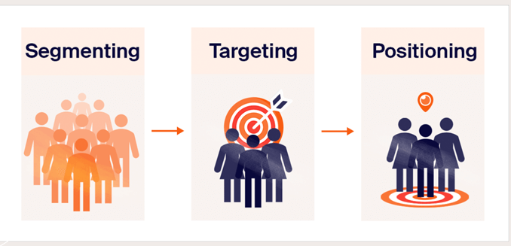
Figure 2: STP Strategies

7.1. Segmentation Strategies
United Kingdom
BMW’s segmentation in the UK is primarily demographic and psychographic, focusing on middle- to high-income professionals who value performance, innovation, and sustainability. Consumers in the UK automotive market are mature, environmentally aware, and motivated by driving experience and brand reliability (BMW Group, 2025). Therefore, BMW segments its customers based on lifestyle and environmental consciousness, targeting individuals seeking premium electric and hybrid vehicles with advanced connectivity features. The brand also considers behavioural segmentation, appealing to brand-loyal customers who associate BMW with precision engineering and cutting-edge technology (Dobrin, 2021).
India
In India, BMW applies a hybrid segmentation strategy that includes demographic, psychographic, and geographic elements. The company targets urban upper-middle-class and affluent consumers, often concentrated in metropolitan areas such as Delhi, Mumbai, Bengaluru, and Chennai (ICMR India, 2012). Psychographically, the focus is on consumers with aspirational lifestyles who view luxury car ownership as a status symbol (Hoque and Rahman, 2021). BMW also adapts to cultural nuances, acknowledging the family-oriented nature of Indian buyers and the importance of after-sales trust and reliability. Moreover, regional segmentation plays a role, with tailored marketing campaigns that reflect linguistic and cultural diversity (Sharma, 2025).

VALS-2 (Psychographic) Consumer Types
Your report lacks the required psychographic segmentation using VALS-2.
The VALS-2 framework categorises consumers based on psychological motivations and resources, helping companies understand lifestyle-driven vehicle purchasing patterns (Kotler and Keller, 2023).
In the UK, BMW primarily targets Innovators and Achievers. Innovators value new technology, EV performance, and premium design, aligning with BMW’s advanced hybrid and electric portfolio (Overall, 2021). Achievers prioritise professional success and practical luxury, which BMW addresses through safety, reliability, and brand prestige (BMW Group, 2025).
In India, BMW appeals to Strivers and Experiencers. Strivers seek status-enhancing products and use luxury brands as symbols of upward mobility (Hoque and Rahman, 2021). Experiencers are younger, lifestyle-driven consumers attracted to high-performance models such as the BMW X1 and 3 Series, as well as digital connectivity features (Sharma, 2025).
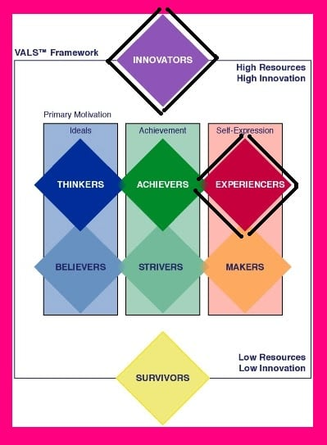
Figure 3: VALS-2 (Psychographic) Consumer Types

Segmentation Strategies for BMW in the UK and India
Segmentation Type | United Kingdom (Country A) | India (Country B)
Demographic Segmentation | • Middle- to high-income professionals, executives, and corporate fleet buyers.  • Age group 30–60 years with high purchasing power.  • Environmentally conscious buyers seeking premium EVs/hybrids. | • Upper-middle-class and affluent consumers in metros.  • Age group 28–55 years with aspirational lifestyles.  • First-time luxury buyers seeking premium yet accessible models.
Geographic Segmentation | • Urban and suburban regions with strong EV infrastructure (London, Manchester, Birmingham).  • Areas with high demand for premium mobility and charging availability. | • Major metropolitan cities such as Delhi, Mumbai, Bengaluru, Chennai, Pune.  • Tier-1 and selective tier-2 cities with rising luxury consumption.
Psychographic Segmentation | • Consumers motivated by performance, innovation, sustainability, and brand heritage.  • Tech-savvy individuals valuing digital features and connected driving.  • Lifestyle segment emphasising environmental responsibility and premium identity. | • Aspirational, status-driven consumers who associate luxury with success.  • Lifestyle-driven buyers valuing comfort, prestige, and advanced technology.  • Family-oriented decision-makers prioritising reliability and service trust.
Behavioural Segmentation | • Brand-loyal customers attracted to German engineering and consistent performance.  • Buyers seeking long-term value, safety, and premium EV experience.  • Corporate fleet customers transitioning to sustainable mobility. | • Customers motivated by emotional appeal, prestige, and social recognition.  • Buyers comparing ownership costs, financing options, and after-sales service.  • Event-driven purchasing during festivals, promotions, or milestone celebrations.
Benefit Segmentation | • Premium driving pleasure, advanced tech features, eco-friendly mobility, and lower lifetime emissions.  • Seamless digital purchasing and personalised experiences. | • Luxury lifestyle enhancement, social elevation, and international brand prestige.  • Comfortable driving, durability in local road conditions, and reliable after-sales support.
Usage Segmentation | • Regular commuters, business travellers, and high-mileage users valuing efficiency and tech integration. | • Urban professionals, entrepreneurs, and families using vehicles for daily commuting and weekend travel.
Table 3: Segmentation Strategies for BMW in the UK and India
(Created by learner)

7.2. Targeting Strategies
United Kingdom
BMW targets tech-savvy, environmentally conscious professionals who value sustainable luxury and superior driving dynamics. The emphasis is on consumers seeking a balance between performance and eco-efficiency, aligning with the UK government’s push toward zero-emission mobility. BMW’s target groups include corporate executives, high-income individuals, and fleet customers transitioning to electric mobility solutions. Targeting is achieved through personalised marketing and digital channels that reflect the UK’s mature automotive ecosystem and preference for seamless customer experiences (Boeriu, 2025).
India
In India, BMW targets affluent business owners, young professionals, and entrepreneurs who aspire to global luxury standards and technological sophistication (Banerjee, 2025). The company’s campaigns highlight emotional appeal, prestige, and social elevation, positioning BMW vehicles as reflections of success and achievement (Sharma, 2025). Unlike the UK, BMW in India also targets first-time luxury buyers, offering models like the 3 Series and X1 at accessible premium price points. Targeting in India leverages social influence and experiential marketing through dealership events and luxury lifestyle partnerships, catering to the nation’s relationship-driven buying culture (ICMR India, 2012).

7.3. Positioning Strategies
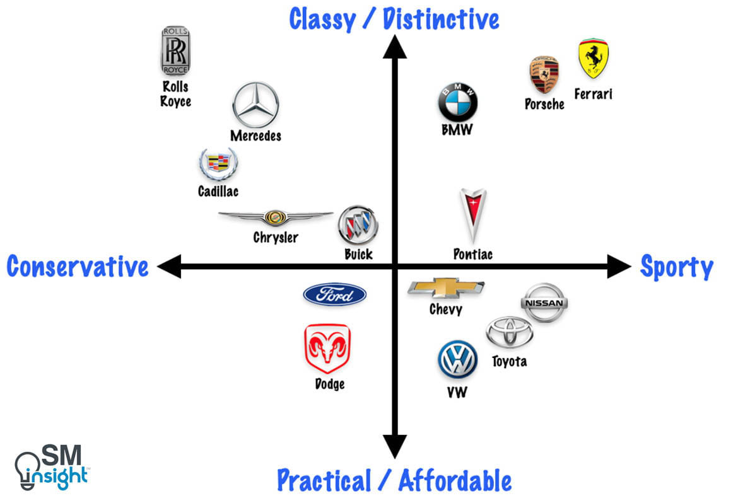
Figure 4: Perceptual map
(Created by learner)
The perceptual map compares major car brands across two dimensions: Conservative vs Sporty and Practical/Affordable vs Classy/Distinctive. Rolls-Royce, Mercedes, and Cadillac occupy the luxury-conservative segment, reflecting elegance and tradition. BMW, Porsche, and Ferrari represent the sporty-luxury segment, emphasising performance and premium identity. Brands like Ford, Dodge, Toyota, and VW fall in the practical-affordable category, highlighting mass-market appeal. Chevy, Nissan, and Pontiac balance sportiness with affordability. The map shows how brands differentiate through image, performance, and market positioning.

United Kingdom
In the UK, BMW’s positioning centres on “premium performance with sustainable innovation.” The brand emphasises engineering excellence, safety, and electrification through models like the i4, iX, and hybrid 5 Series (BMW Group, 2025). Positioning statements such as “Sheer Driving Pleasure” are complemented by BMW’s commitment to carbon-neutral production and circular economy principles. BMW projects an image of reliability, refinement, and environmental responsibility, reinforcing its reputation among discerning British consumers who value understated luxury and authenticity (Dobrin, 2021).
India
BMW’s positioning in India is rooted in luxury, prestige, and global excellence. The brand portrays itself as an aspirational choice that symbolises sophistication and international success (ICMR India, 2012). Marketing communication highlights German engineering precision and local relevance through the “Make in India” initiative (Banerjee, 2025). BMW’s tagline retains its global identity, but localised campaigns integrate emotional storytelling and cultural pride, focusing on family values and achievement. Thus, BMW in India positions itself as both a status-enhancing and lifestyle-transforming brand, bridging global luxury with local aspiration (Sharma, 2025).

8. Comparison of BMW’s Marketing Mix (7Ps) Strategies in the UK and India
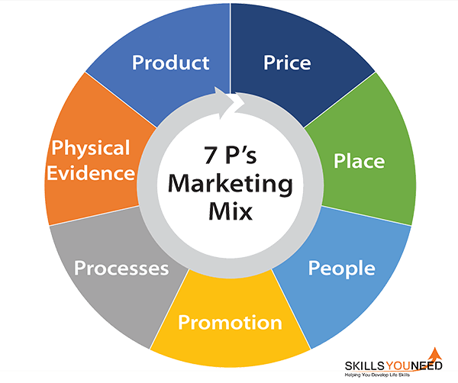
Figure 5: 7Ps Strategies

8.1 Product
Definition
A product is the total combination of features, performance, design, quality, and associated services that a company offers to satisfy consumer needs. In automotive marketing, the product includes physical attributes (engine types, body style, technology), symbolic value (luxury, status), and augmented services such as warranties, financing, and aftersales support.
UK
In the UK, BMW’s product strategy emphasises premium engineering, sustainability, advanced EV technology, and safety. The market increasingly values hybrid and electric models such as the i4, i5, iX, and MINI Electric, aligning with the UK’s environmental expectations and stringent emissions standards (Overall, 2021; BMW Group, 2025). UK buyers prioritise efficiency, driving dynamics, and refined craftsmanship, leading BMW to focus on high-quality materials, digital innovations, and environmentally responsible mobility options.
India
In India, BMW’s product strategy centres on aspirational value, luxury, comfort, and performance, reflecting the cultural importance of prestige and social signalling (Hoque and Rahman, 2021; Sharma, 2025). High-demand models include SUVs such as the X1, X3, X5 and the 3 Series, which suit local driving conditions, road surfaces and consumer preferences. Growing interest in EVs, supported by localisation of BMW’s EV manufacturing, is reshaping the product mix (Banerjee, 2025). Features such as ride comfort, ground clearance, and rear-seat spaciousness are prioritised due to family-oriented purchasing behaviour.

Product Variety, Depth & Width
Definition
Product variety refers to the range of product types offered.
Width represents the number of product lines (e.g., sedans, SUVs, EVs).
Depth refers to variations within each product line (e.g., trims, engine types, performance editions).
UK
BMW offers a broad width of product categories including hatchbacks (MINI), sedans (3 Series, 5 Series, 7 Series), SUVs (X models), EVs (i Series), and luxury models (Rolls-Royce).
Depth is high, with multiple trims, hybrid options, and performance variants (M Sport, M Performance).
Variety is extensive due to the UK’s technologically sophisticated market, strong EV demand, and cultural preference for engineering refinement.
India
BMW’s product width includes sedans, SUVs, EVs, and performance models; however, depth and variety are more selective to match price sensitivity, taxation structure, and regional market disparities (ICMR India, 2012).
SUVs receive greater depth (multiple variants in X1, X3, X5) because they dominate urban premium demand.
The iX and i7 strengthen the EV segment, but EV depth is still limited compared to the UK due to infrastructure variability (Banerjee, 2025).

Main Differences Between the UK and India
Aspect | UK | India
Variety | Very high – broad EV, hybrid, sedan, SUV and luxury range. | Moderate – focused on SUVs and selected sedans based on local demand.
Width | Wide across MINI, BMW, Rolls-Royce. | Narrower; MINI and Rolls-Royce have limited presence.
Depth | Many trims, engine types, hybrid and EV variants. | Depth concentrated in SUVs; fewer trims in sedans and EVs.
Market Drivers | Sustainability, engineering quality, EV adoption. | Prestige, comfort, road suitability, rising luxury aspirations.
Table 4: Main Differences Between the UK and India
(Created by learner)
Product Design
Definition
Product design involves the aesthetic, functional, ergonomic, and technological features that shape how consumers perceive and use the product. In luxury automotive markets, it reflects brand identity, innovation, and user experience.
UK
BMW designs for the UK emphasise aerodynamics, efficiency, EV sophistication, and understated premium styling. British consumers favour clean design, sustainability features, ergonomic interiors, and advanced digital interfaces such as BMW’s Operating System 9 (BMW Group, 2025). Emphasis on build quality, sustainability materials, and safety scoring aligns with UK sociocultural and environmental priorities.
India
Product design in India focuses on luxury presence, comfort, robustness, and practicality. Higher ground clearance, enhanced AC performance, sunroof options, and rear-seat comfort are critical due to climate conditions, traffic patterns, and family use (Hoque and Rahman, 2021). Designs emphasise bold styling, technology visibility, and premium finishes that support aspirational consumption and social signalling.

Branding Strategies
BMW adopts a globally consistent premium and performance-oriented branding strategy, yet its communication and market positioning are localised to reflect cultural differences in the UK and India. In both markets, the brand draws on its heritage of engineering excellence and emotional driving experiences, but the tone, storytelling, and consumer engagement vary according to local expectations and cultural values.
UK
In the UK, BMW’s branding strategy is shaped by consumer preference for understated luxury, technological credibility, and sustainable mobility. Marketing communication emphasises engineering precision, safety standards, and leadership in electrified mobility, resonating with a market characterised by low power distance and strong individualistic values (Hofstede Insights, 2024). The brand also leverages its historic presence through MINI and Rolls-Royce to reinforce authenticity and continuity in the British automotive landscape (Brailey, 2002). By foregrounding responsible mobility and digital innovation, BMW positions itself as a refined, trustworthy, and environmentally conscious premium brand suited to UK cultural expectations (Overall, 2021; BMW Group, 2025).
India
In India, BMW adopts a more aspirational and lifestyle-driven branding approach that aligns with the country’s high power distance and collectivist social structure. Branding focuses on themes of success, prestige, and exclusivity, positioning BMW ownership as a symbol of upward mobility and social accomplishment (ICMR India, 2012; Hoque and Rahman, 2021). Communication often highlights visible technology, performance characteristics, and luxury experiences, supported by immersive brand events such as BMW Joytown, which reinforce emotional engagement and premium identity among affluent urban consumers (Sharma, 2025). This strategy capitalises on India’s growing aspirational middle and upper-class segments, where luxury vehicles are closely tied to social identity and personal achievement (Banerjee, 2025).

8.2 Price
Definition
Price refers to the amount consumers pay for a product, determined by factors such as production costs, brand value, competition, and market demand. In premium automotive markets, pricing reflects technological sophistication, performance, customer experience, and the perceived prestige of the brand.
UK
In the UK, BMW applies a premium value-based pricing strategy supported by strong consumer purchasing power and high expectations for sustainability, safety, and digital innovation (Dobrin, 2021). Pricing emphasises brand equity and advanced EV technology, while psychological price points reinforce perceptions of refinement. BMW Financial Services provides leasing, financing, and fleet discounts to enhance affordability for corporate and retail customers, maintaining competitiveness in a mature luxury market (BMW Group, 2025).
India
In India, BMW adopts a flexible pricing strategy due to high import duties, exchange-rate volatility, and varied income levels. The brand uses market-penetration pricing for models such as the X1 and 3 Series to attract emerging luxury buyers (ICMR India, 2012). To address price sensitivity, BMW offers EMI schemes, festival promotions, buyback assurances, and customised finance packages through BMW Financial Services, balancing affordability with the brand’s premium positioning in a rapidly expanding luxury segment (Sharma, 2025).

8.3 Place (Distribution)
Definition
Place refers to the channels, locations, and logistics through which a product is delivered to consumers. It includes physical dealerships, digital platforms, supply-chain structures, and distribution strategies that ensure product availability, accessibility, and convenience across different market segments.
UK
In the UK, BMW uses an omnichannel distribution system combining authorised BMW Centres, digital retail platforms, virtual showrooms, and click-and-drive services (Boeriu, 2025). Extensive dealership networks support nationwide accessibility, while strong aftersales infrastructure enhances customer experience. The gradual adoption of the agency model enables transparent pricing, direct manufacturer ordering, and closer customer relationships, reflecting the UK’s mature automotive retail environment and consumers’ growing preference for digital, streamlined purchasing processes (BMW Group, 2025).
India
In India, BMW distributes vehicles through a network of strategically located dealerships concentrated in major metropolitan cities, supported by regional service centres to ensure nationwide coverage (Sharma, 2025). Local CKD assembly at the Chennai plant reduces delivery timelines and enhances cost efficiency. BMW supplements physical distribution with digital consultations, online booking systems, and extensive test-drive campaigns, enabling broader market reach and catering to India’s diverse consumer base while strengthening accessibility in emerging luxury clusters (Banerjee, 2025).

Direct vs Indirect Channels and Intensive Distribution – BMW in the UK and India
Aspect | United Kingdom | India
Direct Channels | BMW increasingly uses direct-to-consumer channels through the planned agency model, enabling transparent pricing, online ordering, and manufacturer-controlled customer relationships (Boeriu, 2025; BMW Group, 2025). Digital showrooms and virtual retailing further strengthen direct sales interactions. | Direct channels include BMW India’s online booking platforms, virtual product consultations, and manufacturer-managed corporate sales programmes, allowing personalised engagement and broader digital accessibility across metro markets (Sharma, 2025; Banerjee, 2025).
Indirect Channels | Traditional authorised BMW Centres continue to play a central role, operating as intermediaries that handle sales, servicing, and customer experience functions within the nationwide dealer network (Brailey, 2002). Fleet partnerships and leasing firms also act as indirect channels. | A widespread dealership network across major cities serves as BMW’s primary indirect channel, supported by franchise partners who manage retail operations, regional marketing, and aftersales services in a diverse and fragmented market (ICMR India, 2012; Hoque and Rahman, 2021).
Intensive Distribution | Distribution follows a selective–premium intensive model, ensuring broad but brand-controlled availability through strategically placed dealerships, digital platforms, and planned agency rollout to maintain quality consistency across regions (Overall, 2021). | BMW uses metro-focused intensive distribution, prioritising high-potential urban clusters with dense luxury demand while extending reach through service facilities, CKD operations, and nationwide test-drive programmes to strengthen accessibility (Sharma, 2025; Banerjee, 2025).
Table 5: Direct vs Indirect Channels and Intensive Distribution – BMW in the UK and India
(Created by learner)

Market Entry Methods (India)
BMW entered and expanded in India using a combination of wholly owned subsidiaries, CKD (Complete Knock-Down) assembly, and strategic dealership partnerships. The primary entry method is the wholly owned subsidiary with CKD assembly operations, allowing BMW to retain strategic control while adapting products and pricing to local market conditions (ICMR India, 2012; Banerjee, 2025).
BMW adopted this method because India’s luxury market requires strong brand control, local responsiveness, and cost optimisation. Establishing a wholly owned subsidiary ensures alignment with BMW’s global standards in product quality, aftersales service, and branding, while CKD operations significantly reduce import duties and support competitive pricing for models assembled in Chennai (Sharma, 2025). Dealership partnerships complement this model by extending BMW’s reach through regionally embedded distributors who understand local consumer behaviour and regulatory environments.
Advantages (India)
A major advantage is cost efficiency, as local assembly lowers import duties and enhances price competitiveness in a highly price-sensitive luxury market. This method also enables higher product localisation, allowing BMW to modify features such as suspension, air-conditioning systems, and ground clearance to better suit Indian road and climate conditions (Hoque and Rahman, 2021). Moreover, the wholly owned subsidiary structure ensures full control over brand reputation, customer experience, and long-term strategic direction in a culturally diverse market.
Disadvantages (India)
The key disadvantage is the high capital investment required to set up CKD facilities, logistics systems, and nationwide dealership networks, which limits rapid expansion into smaller cities. Additionally, India’s complex regulatory environment and frequent tax reforms can increase operational uncertainty, making strategic planning more demanding for wholly owned subsidiaries (ICMR India, 2012). Market reliance on urban luxury clusters also means return on investment may materialise gradually.

8.4 Promotion
Definition
Promotion refers to the communication strategies organisations use to inform, persuade, and engage consumers. It includes advertising, digital media, public relations, experiential activities, and sales promotions aimed at shaping brand perception, stimulating demand, and strengthening customer relationships across different markets.
United Kingdom
In the UK, BMW emphasises digital-first promotion, sustainability messaging, and heritage-based communication. Campaigns highlight EV innovation, safety, and engineering quality, resonating with a market that values responsible mobility and refined brand expression (Overall, 2021). The company integrates online configurators, virtual events, and targeted social media to reach technologically informed consumers. Partnerships with MINI and Rolls-Royce enhance corporate visibility, while retailer-led promotions complement BMW’s growing shift toward a more direct customer engagement model (BMW Group, 2025).
India
In India, BMW promotes its brand through aspirational, lifestyle-focused communication, emphasising success, exclusivity, and performance to appeal to upwardly mobile consumers (ICMR India, 2012). Promotional campaigns utilise digital storytelling, high-impact social media, celebrity associations, and experiential events such as BMW Joytown to create emotional brand engagement (Sharma, 2025). Festival offers, EMI promotions, and targeted advertising reinforce demand in a price-sensitive yet prestige-driven market, supporting BMW’s expansion in key metropolitan clusters (Banerjee, 2025).
Promotional Element | United Kingdom (Favourable/Unfavourable) | India (Favourable/Unfavourable)
Digital Advertising | Strong EV-focused content aligned with environmental norms (BMW Group, 2025). | Influencer-driven marketing impacts aspirational buyers (Sharma, 2025).
Celebrity Endorsements | Used minimally due to preference for subtle branding (Overall, 2021). | Highly favourable; boosts prestige and cultural relevance (Hoque and Rahman, 2021).
Experiential Events | Effective for EV awareness; used in store launches and test-drive events. | Strong impact; luxury lifestyle events attract high-income buyers.
Social Media Presence | Focus on sustainability, digital services, and technology updates. | Focus on lifestyle, festivals, and emotional appeal.
Sponsorship and Motorsport | Highly relevant; strengthens performance image (BMW Group, 2025). | Less influential due to niche audience; limited impact.
Sales Promotions | Used sparingly through leasing benefits and corporate offers. | Widely used: festival promotions, EMI offers, loyalty benefits.
Customer Engagement Tools | Chatbots, online configurators, virtual showrooms (Dobrin, 2021). | CRM follow-ups, personalised service calls, showroom hospitality.
Table 6: Evaluation of BMW’s Promotional Activities in the UK and India
(Created by learner)

8.5 People
Definition
People refer to the employees, sales personnel, service technicians, and customer-facing staff who deliver value and shape the customer experience. Their skills, behaviour, and service quality directly influence brand perception, customer satisfaction, and long-term loyalty in competitive automotive markets.
United Kingdom
In the UK, BMW relies on highly trained staff across authorised BMW Centres who emphasise professionalism, technical expertise, and personalised service delivery (Brailey, 2002). Employees support customers through consultative selling, EV education, and digitally enabled interactions, reflecting evolving consumer expectations for transparency and informed guidance (Overall, 2021). The shift toward the agency model enhances staff roles by centralising pricing and allowing employees to focus more on advisory support, relationship building, and seamless omnichannel service (BMW Group, 2025).
India
In India, BMW’s people strategy centres on relationship-driven service, cultural sensitivity, and high-touch customer engagement to meet aspirational consumer expectations (ICMR India, 2012). Dealership staff provide personalised consultations, test-drive facilitation, and assistance with financing options, reflecting India’s trust-based purchasing culture (Sharma, 2025). BMW also invests in technical training and aftersales expertise at its Chennai facility to ensure service quality, strengthen loyalty, and support the brand’s expanding presence in metropolitan markets (Banerjee, 2025; Hoque and Rahman, 2021).

8.6 Process
Definition (40 words)
Process refers to the systems, procedures, and service pathways through which a company delivers its offering to customers. It includes sales processes, service workflows, digital interactions, and aftersales operations that ensure consistency, efficiency, and a high-quality customer experience.
United Kingdom
In the UK, BMW’s process emphasises seamless, technology-enabled customer journeys supported by digital retailing, online configurators, virtual showrooms, and efficient dealership procedures (Overall, 2021). The planned shift toward the agency model simplifies purchasing by centralising pricing and reducing negotiation complexity, allowing staff to focus on advisory roles (Boeriu, 2025). Strong aftersales systems, scheduled servicing, and comprehensive EV support processes further reinforce BMW’s commitment to reliability, transparency, and premium service quality in the UK market (BMW Group, 2025).
Customer Complaint Process – United Kingdom
In the UK, BMW follows a structured, technology-supported complaint process that prioritises transparency, rapid resolution, and customer reassurance. Complaints are logged through dealerships, online portals, or customer service channels, where diagnostic checks and service history reviews are conducted promptly. Customers receive clear communication, status updates, and service recovery options. The evolving agency model strengthens direct accountability, ensuring consistent handling, improved follow-up procedures, and enhanced customer satisfaction across BMW Centres nationwide.
India
In India, BMW’s process combines relationship-based selling with structured dealership workflows that accommodate diverse customer expectations and purchasing behaviours (ICMR India, 2012). Digital tools support appointment booking, virtual consultations, and service tracking, while BMW’s Chennai CKD operations streamline delivery and enhance logistical efficiency (Banerjee, 2025). Aftersales processes emphasise trust, personalised communication, and long-term support through regionally distributed service centres, enabling BMW to maintain premium service standards and strengthen loyalty in a rapidly expanding luxury market (Sharma, 2025).
Customer Complaint Process – India
In India, BMW’s complaint process emphasises personalised communication and relationship-driven service. Complaints are typically routed through dealerships, customer care hotlines, or BMW’s digital platforms, where service advisors coordinate diagnostics and resolution steps. The process includes proactive follow-ups, transparency in repair timelines, and service recovery gestures to maintain trust. BMW India’s regional service centres and technical teams support escalations, ensuring consistent handling across diverse markets and reinforcing the brand’s premium ownership experience.

8.7 Physical Evidence
Definition (40 words)
Physical evidence refers to the tangible and visible elements that shape customer perceptions of service quality, including showroom environments, vehicle presentation, branding materials, digital interfaces, service facilities, and the overall physical experience customers encounter throughout their interaction with the brand.
United Kingdom
In the UK, BMW’s physical evidence includes premium showroom environments, branded BMW Centres, and state-of-the-art service facilities that reflect high engineering standards and sustainability commitments (Brailey, 2002). Digital interfaces such as virtual showrooms and online configurators reinforce brand consistency and technological leadership (Overall, 2021). Strong visual merchandising, certified used-car displays, and EV charging infrastructure enhance customer confidence, while the evolving agency model ensures uniform branding and presentation across all retail locations (BMW Group, 2025).
India
In India, BMW’s physical evidence is shaped by modern, luxury-focused dealerships, premium vehicle display areas, and regionally distributed service centres designed to deliver an aspirational ownership experience (ICMR India, 2012). Showrooms highlight advanced technology and performance features, reinforcing BMW’s prestige positioning. Digital touchpoints, including online product demos and virtual consultations, complement physical spaces, while the Chennai CKD facility strengthens trust by showcasing local assembly capability and long-term market commitment (Banerjee, 2025; Sharma, 2025).

Evaluation of Marketing Strategies
United Kingdom
BMW’s marketing strategies in the UK effectively integrate premium brand positioning, sustainability messaging, and digital transformation. The use of virtual showrooms, consistent branding across BMW Centres, and highly curated vehicle displays reinforces the brand’s engineering credibility and environmental responsibility (Overall, 2021; BMW Group, 2025). The agency model further strengthens brand consistency by ensuring uniform pricing, showroom appearance, and customer experience nationwide. These strategies successfully align with British consumer expectations for refined, transparent, and technologically advanced automotive services.
India
In India, BMW’s marketing strategies leverage aspirational physical evidence, emphasising luxury-oriented showrooms, high-end display areas, and premium digital interfaces that reflect social status and prestige (ICMR India, 2012). The Chennai CKD plant strengthens trust by demonstrating local presence and long-term commitment (Banerjee, 2025). Physical evidence supports emotional engagement by combining modern aesthetics, visible technology, and personalised attention in retail environments—strategies well-suited to India’s aspirational and experience-driven luxury market.

Profit and Sales
United Kingdom
In the UK, BMW maintains strong profitability due to stable premium demand, well-established brand heritage, and a growing EV segment supported by government incentives (Overall, 2021). Although economic pressures such as inflation affect affordability, BMW continues to secure sales through value-based pricing, strong fleet partnerships, and rising consumer interest in electrified models (Dobrin, 2021). The UK remains a highly competitive but profitable market, particularly for EVs and higher-end performance variants (BMW Group, 2025).
India
India is one of BMW’s fastest-growing markets, with record-breaking sales driven by rising disposable incomes, urbanisation, and demand for luxury SUVs (Sharma, 2025). BMW’s CKD operations enhance price competitiveness, boosting sales of models like the X1, X3, and 3 Series. EV models are gaining traction due to increasing environmental awareness. India’s luxury segment remains relatively smaller than the UK’s, but its rapid year-on-year growth makes it a high-potential profit centre for the brand (Banerjee, 2025).

Social Media Engagement
United Kingdom
BMW UK’s social media presence focuses on sustainability, engineering quality, and EV innovation, appealing to a consumer base that values responsibility and technological sophistication (Overall, 2021). Content often highlights design stories, digital mobility features, MINI heritage, and BMW’s commitment to carbon neutrality. Engagement is strong around EV launches, behind-the-scenes factory content, and safety features, reflecting British preferences for authenticity and informative communication.
India
BMW India uses aspirational, lifestyle-driven social media, featuring luxury experiences, performance showcases, celebrity associations, and BMW Joytown event promotions (Sharma, 2025). Visually rich, emotive storytelling resonates with India’s younger, ambitious, and status-driven audience. Campaigns emphasise exclusivity, ownership pride, and technological superiority. Engagement spikes around new model launches, festive promotions, and influencer-led driving experiences.

Customer Reviews
United Kingdom
Customer reviews in the UK highlight BMW’s refined driving experience, strong build quality, and advanced digital features. EV owners particularly praise charging efficiency and sustainability credentials (BMW Group, 2025). However, some customers express concerns about rising prices, complex digital interfaces, and occasional service delays. Overall satisfaction remains high due to consistent dealer professionalism, vehicle reliability, and premium brand reputation.
India
Indian customers frequently praise BMW for its luxury feel, performance, comfort, and brand prestige (ICMR India, 2012). SUVs are especially well-reviewed due to their suitability for Indian roads. Customers also appreciate personalised dealer interactions and flexible financing options. Common criticisms include high maintenance costs, spare-part pricing, and limited EV charging accessibility outside metro areas. Nevertheless, perceived status value keeps satisfaction and loyalty rates strong (Sharma, 2025).

8.8. Similarities & Dissimilarities 7Ps
Element (7Ps) | United Kingdom (Country A) | India (Country B)
1. Product | Focuses on premium hybrid and electric models (e.g., i4, iX, 5 Series Hybrid) reflecting sustainability and innovation. High emphasis on connected technology, safety, and performance engineering (BMW Group, 2025). | Product range includes locally assembled models such as 3 Series, X1, and X3 tailored to Indian road conditions. Focus on luxury, comfort, and aspirational design while introducing EVs like BMW iX1 (Banerjee, 2025).
2. Price | Employs value-based and psychological pricing, justifying premium costs through technology, brand reputation, and environmental performance (Dobrin, 2021). Occasional leasing and financing options for fleet and individual customers. | Uses a market-penetration pricing approach for entry-level luxury models to attract first-time premium buyers (ICMR India, 2012). Offers customised financing, EMI options, and ownership programs to improve accessibility (Sharma, 2025).
3. Place | Strong omnichannel distribution, integrating digital sales with showrooms and authorised dealerships across the UK (Boeriu, 2025). The upcoming agency model enhances direct consumer relationships. | Extensive dealership network in major metropolitan cities, supported by local assembly in Chennai for cost efficiency. BMW leverages digital platforms and test-drive experiences for wider outreach (Sharma, 2025).
4. Promotion | Promotion highlights innovation, sustainability, and British craftsmanship through digital advertising, sponsorships, and brand events (Overall, 2021). Focus on EV awareness and premium experience marketing. | Promotional efforts emphasise luxury, prestige, and success, using celebrity endorsements, experiential marketing, and festive-season campaigns (ICMR India, 2012). Focus on emotional storytelling and aspirational branding.
5. People | Trained sales and service teams reflect BMW’s customer-centric culture, ensuring a premium service experience (BMW Group, 2025). Staff emphasise product expertise and digital literacy. | Focus on relationship-oriented service with culturally adaptive staff interactions. Customer experience teams foster trust, reflecting India’s relationship-driven buying culture (Hoque and Rahman, 2021).
6. Process | Efficient, digitalised buying journey with online configuration tools, transparent financing, and seamless delivery. Integration of sustainability across operations (Liu, 2022). | Simplified sales process combining digital and in-person experience, ensuring personal interaction at every stage. Includes customised after-sales support and localised CRM systems (Banerjee, 2025).
7. Physical Evidence | Premium showroom layouts and digital interfaces communicate modernity, environmental commitment, and brand authenticity (BMW Group, 2025). | Showrooms designed to reflect luxury lifestyle themes, blending global aesthetics with Indian cultural hospitality. Use of visual storytelling enhances brand appeal (Sharma, 2025).
Table 7: Comparison of BMW’s Marketing Mix (7Ps) Strategies in the UK and India
BMW’s marketing mix demonstrates a consistent global identity adapted to regional expectations. In the UK, strategies revolve around technology, sustainability, and digitalisation, aligning with an advanced, eco-conscious market. In India, emphasis is placed on luxury accessibility, emotional connection, and personalised experiences, catering to aspirational and culturally diverse consumers. Both approaches strengthen BMW’s position as a premium yet locally resonant brand in their respective markets (BMW Group, 2025; Banerjee, 2025).

Similarities and differences of 7Ps
BMW’s marketing mix in the UK and India shows several similarities. In both markets, the brand emphasises premium product quality, advanced technology, and strong after-sales service, reinforcing its global identity of performance and luxury (BMW Group, 2025). BMW also uses digitalised processes, personalised customer experiences, and consistent branding to maintain competitive advantage across regions (Liu, 2022).
However, key differences reflect each country’s market context. In the UK, BMW focuses on sustainability, electrification, and value-based pricing, aligning with environmentally conscious and tech-driven consumers (Overall, 2021). Conversely, in India, BMW adopts accessible premium pricing, festival-based promotions, and relationship-oriented service to appeal to aspirational, status-driven buyers (Banerjee, 2025; Sharma, 2025). These distinctions show BMW’s ability to adapt global strategies to local expectations.

9. Ethics – India
Ethical considerations in BMW’s operations in India primarily relate to environmental responsibility, product transparency, labour practices, customer safety, and responsible marketing. As India represents a rapidly growing yet socioeconomically diverse market, BMW must navigate a landscape where luxury consumption coexists with wider social inequalities. Ethical conduct therefore plays a critical role in maintaining legitimacy and trust. One key ethical dimension concerns sustainable mobility. With rising urban pollution and limited EV infrastructure, BMW’s promotion of electric and hybrid vehicles demonstrates environmental responsibility; however, ethical obligations extend beyond product introduction, requiring investment in customer education, charging partnerships, and long-term environmental stewardship (Banerjee, 2025).
Another ethical issue relates to product and service transparency. Customers expect accurate communication about maintenance costs, warranty terms, fuel efficiency, and EV range. As luxury ownership in India is often aspirational, unclear cost disclosures may risk consumer dissatisfaction. Ensuring transparent pricing, honest advertising, and responsible financing practices, therefore, strengthens ethical brand conduct (ICMR India, 2012).
Labour and supply chain ethics also play a role. BMW’s Chennai CKD operations must ensure compliance with safety standards, fair labour practices, and responsible sourcing—critical factors in an environment where manufacturing-sector oversight varies across industries (Sharma, 2025).
Finally, BMW must ensure its marketing does not exploit aspirational behaviour. Campaigns highlighting success and prestige should avoid overpromising lifestyle outcomes, instead promoting authentic value propositions. Overall, ethical operations in India require BMW to balance aspirational marketing with responsible conduct, environmental care, transparent customer engagement, and high labour standards.

10. Recommendations
Based on the comparative analysis of BMW’s marketing strategies, macroenvironmental conditions, and customer expectations in the UK and India, several recommendations emerge to enhance BMW’s competitiveness and long-term market performance.
1. Strengthen EV Ecosystems and Customer Education
BMW should deepen collaborations with energy providers and infrastructure partners in both markets to accelerate EV adoption. In India, expanding charging partnerships and offering EV maintenance education would reduce adoption barriers. In the UK, enhanced digital EV tutorials and sustainability dashboards could strengthen customer trust in long-term operating efficiency.
2. Enhance Localisation Strategies for Product and Service Design
India requires greater product localisation, particularly in thermal management, suspension tuning, and aftersales affordability. The UK, by contrast, would benefit from expanding subscription-based ownership models tailored to environmentally conscious users. Strengthening localisation will reinforce customer satisfaction and market responsiveness.
3. Increase Transparency in Pricing and Digital Processes
In both markets, clearer communication on total cost of ownership, digital interface usability, and financing structures will support trust and reduce customer friction. This is especially important as BMW transitions toward the agency model in the UK and engages price-sensitive aspirational buyers in India.
4. Expand Experiential Retail and Personalisation
Highly curated experiences such as track events, EV discovery centres, and personalised digital journeys can differentiate BMW. While India benefits from aspirational, immersive events, the UK market may respond strongly to sustainability-themed test drives and technology showcases.
5. Strengthen After-Sales Capability and Service Accessibility
Improved service turnaround times, nationwide technical training, and predictive digital diagnostics will strengthen loyalty. India particularly requires broader regional service coverage, while the UK benefits from enhanced EV servicing infrastructure.

11. Conclusion
This report critically examined BMW’s international marketing strategies in the UK and India, integrating PESTLE analysis, Hofstede’s Cultural Dimensions (Hofstede Insights, 2024), VALS2 consumer typologies, segmentation strategies, and comparisons of product depth and width, all supported by tables (created by learner). BMW’s global vision, as outlined on its corporate website (BMW Group, 2025), guided the evaluation of how external environments, branding approaches, distribution channels—direct, indirect, and intensive—and market entry methods shape performance in both markets. The PESTLE analysis highlighted that environmental factors may be favourable or unfavourable depending on national conditions, and similarities–dissimilarities across both countries were identified. Further analysis of promotion, people, process—including complaint management and physical evidence, supported by website features, customer reviews, sales performance, and social media engagement, demonstrated how BMW adapts to culturally and economically diverse settings. Ethical considerations and targeted recommendations reinforced the strategic need for localisation, transparency, and sustainability as BMW expands in global markets.

References
Banerjee, A. (2025) ‘BMW India goes full throttle on local EV manufacturing to power future growth’, Republic Business, 21 October. Available at: https://www.republicworld.com/business/bmw-india-goes-full-throttle-on-local-ev-manufacturing-to-power-future-growth
BMW Group (2023) Company profile and statement on operations in Russia. Leave Russia. Available at: https://leave-russia.org/bmw-group
BMW Group (2025) BMW Group Report 2024. Available at: https://www.bmwgroup.com/content/dam/grpw/websites/bmwgroup_com/ir/downloads/en/2025/bericht/BMW-Group-Report-2024-en.pdf
BMW Group (2025) History of BMW Group. Available at: https://www.bmwgroup.com/en/company/history.html
BMW Group (2025) Our UK & IE Locations. Available at: https://www.bmwgroup.jobs/gb/en/location.html
Boeriu, H. (2025) ‘BMW Delays Direct Sales in the UK, but MINI Still on Track for March 2025’, BMWBLOG, 11 February. Available at: https://www.bmwblog.com/2025/02/11/bmw-agency-model-delay-uk-2026/
Brailey, B. (2002) ‘The BMW Group in the UK’, PressClub United Kingdom – BMW Group, 18 April. Available at: https://www.press.bmwgroup.com/united-kingdom/article/detail/T0016035EN_GB/the-bmw-group-in-the-uk?language=en_GB
Dobrin, I.-G. (2021) ‘Analysis of risks and opportunities in the BMW Group’, Journal of Public Administration, Finance and Law, 10(22). Available at: https://doi.org/10.47743/jopafl-2021-22-12
Hoque, M. N. and Rahman, M. (2021) An Assignment on Strategic Brand Management: Concepts and Practices in BMW. Bachelor of Business Administration thesis. Sonargaron University and Comilla University. https://doi.org/10.13140/RG.2.2.22386.11201
ICMR India (2012) BMW’s Marketing Strategy in India (Case Code: MKTG294), ICMR Case Studies Collection. Hyderabad: ICMR India. Available at: https://www.icmrindia.org/casestudies/catalogue/marketing/BMWs%20Marketing%20Strategy%20in%20India-Excerpts1.htm
Kukkamalla, P. K., Bikfalvi, A. and Arbussa, A. (2020) ‘The new BMW: Business model innovation transforms an automotive leader’, Journal of Business Strategy, ahead-of-print(ahead-of-print). https://doi.org/10.1108/JBS-02-2020-0021
Liu, Z. (2022) ‘BMW addresses business and financial implications for long-term sustainable growth based on a competitive value approach’, Proceedings of the 2022 International Conference on Economics, Smart Finance and Contemporary Trade (ESFCT 2022), pp. 1392–1403. Available at: https://doi.org/10.2991/978-94-6463-052-7_155
Overall, C. (2021) ‘New sales and marketing strategy: BMW Group optimistic about 2021 after posting record Q4 sales’ [Press release], BMW Group PressClub UK, 15 January. Available at: https://www.press.bmwgroup.com/united-kingdom/article/detail/T0324311EN_GB/new-sales-and-marketing-strategy:-bmw-group-optimistic-about-2021-after-posting-record-q4-sales?language=en_GB
Sharma, R. (2025) ‘Best-ever sales fuelled by unabated growth: BMW Group India posts best-ever sales of 11,978 units with 13% growth in Q1–Q3 2025’ [Press release], BMW Group PressClub India, 10 October. Available at: https://www.press.bmwgroup.com/india/article/detail/T0453251EN/best-ever-sales-fuelled-by-unabated-growth:-bmw-group-india-posts-best-ever-sales-of-11-978-units-with-13-growth-in-q1-q3-2025?language=en
Sharma, R. (2025) ‘Setting the pace for a successful 2025: BMW Group India delivers strong performance in Q1 with record-breaking car deliveries’, PressClub India – BMW Group, 3 April. Available at: https://www.press.bmwgroup.com/india/article/detail/T0449379EN/setting-the-pace-for-a-successful-2025:-bmw-group-india-delivers-strong-performance-in-q1-with-record-breaking-car-deliveries?language=en
Sharma, R. (2025) ‘Setting the pace for a successful 2025: BMW Group India delivers strong performance in Q1 with record-breaking car deliveries’, Business Standard – ANI Press Release, 04 April. Available at: https://www.business-standard.com/content/press-releases-ani/setting-the-pace-for-a-successful-2025-bmw-group-india-delivers-strong-performance-in-q1-with-record-breaking-car-deliveries-125040500008_1.html

