Level 4 assessment specification

Emyr Wyn Walters.

Student Number 1910881.

Site investigation Case Study.

Lecturer Allan Nantel.


Contents

- Brief History Swansea Marina
- Project Location
- Recommendation
- Foundation Analysis
- Environmental Issues
- Access and Egress.
- PPE
- Site and Public Safety
- References

1. A brief history of Swansea marina

For centuries, Swansea marina, has been an integral part to the Swansea community.
Over the years there has been vast changes made to the marina.
The marina occupies the former South Dock, opened in 1859 as Swansea experienced an industrial boom. Copper smelting had become a major activity in the lower Tawe Valley in the 18th century, thanks to the abundant supplies of high-quality coal. Copper was brought in by ships from Cornwall, Anglesey and other places. (historypoints.org)
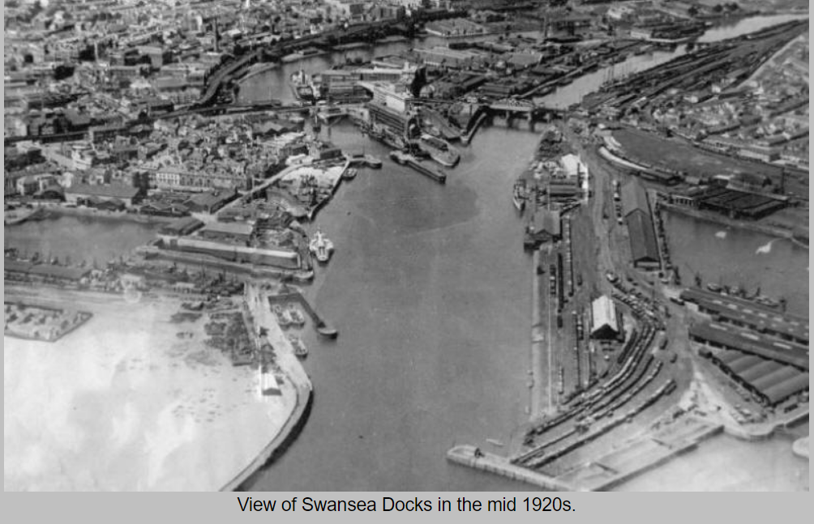
Above Image taken from (History points.org)

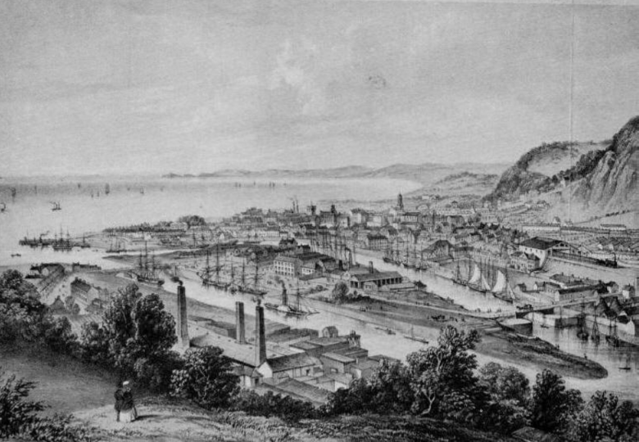
Above photo REF - http://historypoints.org/index.php?page=swansea-marina

Bigger port facilities were later developed east of the Tawe, and the South Dock closed in 1969. It lay derelict until the local authority decided to redevelop the area. The old dock reopened as a marina in 1982, with light industrial units on Fish market Quay for companies to provide services for boat owners. Today the marina has 550 berths, 185 of which were added in 2006 by extending the marina into the dock’s western end, near the Marriott Hotel.
For the first 10 or so years boats couldn't access the marina at low tide. In 1992 the Tawe Barrage was completed, with a sea lock. This allows marina access at all tides.
Swansea was also affected in WW2, on the 19th-21st of February 1941, Swansea endured Wales’s heaviest bombing raid of the Second World War. Fires raged, lighting up the night sky for miles around. 41 acres of the town centre were reduced to rubble: 857 building were destroyed and more than 11,000 properties damaged. (www.iwa.wales)
(Care and attention should be taken, with all excavations, and a thorough check should be done before any trial holes, are done)
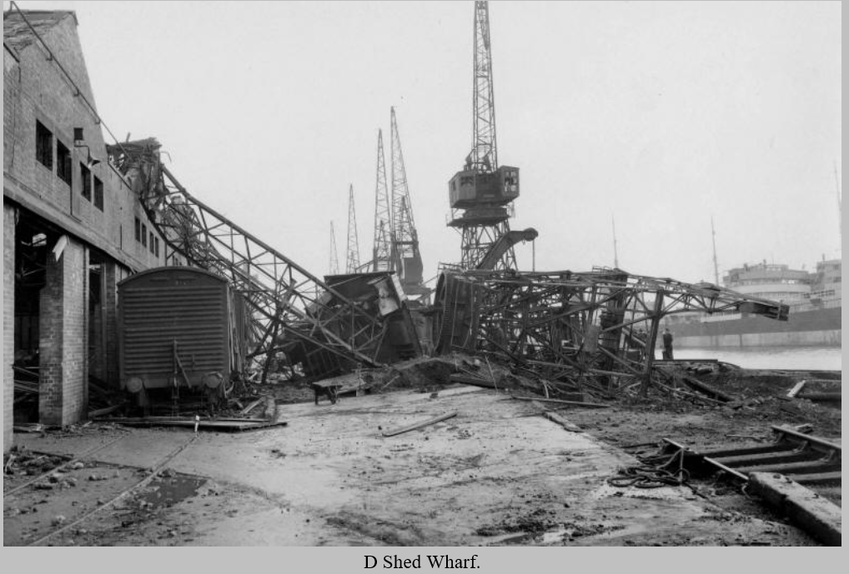
Shed Wharf in the docks, had lots of damage done during the BLITZ. Photo taken from google images.

But over the last 2 decades Swansea marina has been transformed. Now known as SA1.
The marina is now one of the leading places to be in Swansea.
There are numerus offices, apartments and waterfront restaurants.
In addition to the Quay Parade road bridge just to the north, there are two pedestrian bridges linking this area to the marina area - the Sail bridge and the lock bridge. The Sail bridge as its name suggests is designed to look like a sail shape. The lock bridge is a steel structure built over the Tawe barrage. The western section of the lock bridge is a swing bridge over the lock located on the Tawe barrage.
The water areas are not fully protected by railings. The locals have often expressed concerns over the safety of the lack of railings and indeed, over the years, the marina has seen several people drowning after having fallen into the waters by accident.

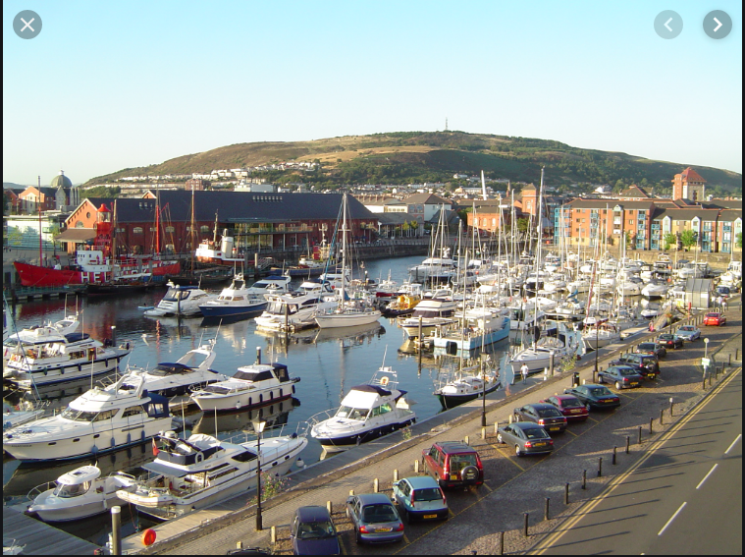

Photo above taken from http://www.swanseamarina.org.uk/
As you can see in the above image, Swansea marina has changed for the better over the years, which draws in tourists to visit the area.

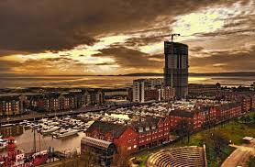
Photo above taken from google images.
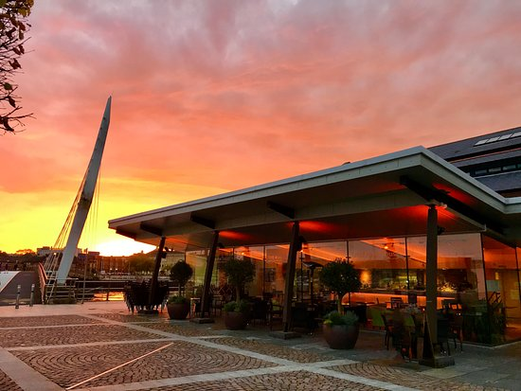
Photo above is the river house restaurant taken from trip advisor.

Above photo is just 1 of the many places people can enjoy a drink and meal looking over the marina
2. Project Information.

Site is located at rear of the Marriot Hotel Carpark, as shown below.
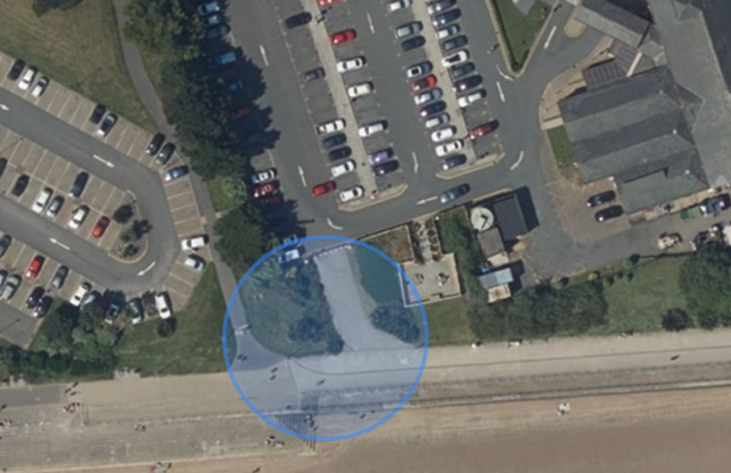 Swansea SA1 3SS
Photo taken from google maps
Grid ref, X 265401,Y 192283
Swansea Marriott Hotel

City and County of Swansea have chosen to enter into a joint agreement with Marriot Hotels to create a new restaurant and ice-cream parlour (with manager’s apartment) on Swansea foreshore, in the position indicated. The site is located between County Hall and the Marriot Hotel and is illustrated on the attached images. The building, which is to share parts of the car park of both existing adjacent facilities, is to have a GIA (Gross Internal Area) at ground floor level of approximately 300 square metres.
The building is to contain the restaurant, café bar, ice-cream parlour, kitchen, food-stores etc. At second floor level, there is to be a self-contained manager’s apartment and staff welfare facilities. This project is procured via a Design and Build contract.
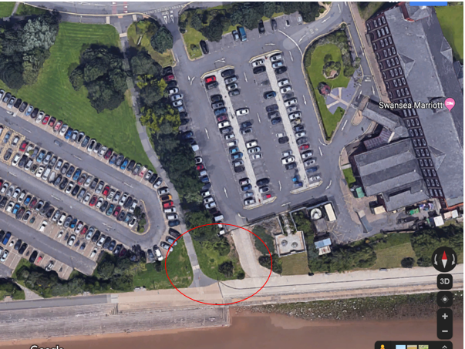
Photo taken from google maps
Photo above shown within red circle is proposed development location.
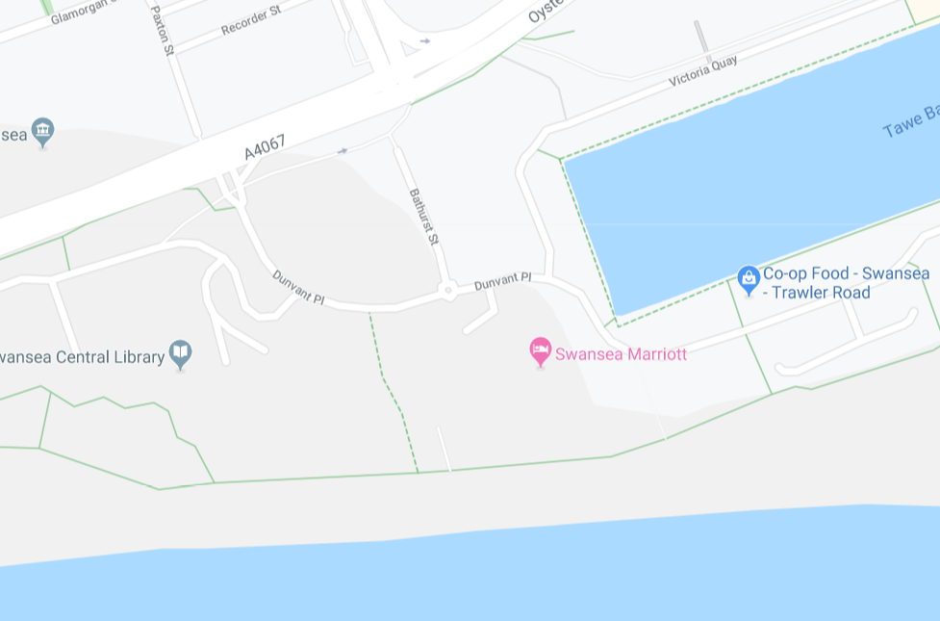
Photo taken from google maps
Photo above shows Marriot location on maps.
The purpose of the Ground Investigation is to identify the underlying ground conditions and provide geo environmental recommendations for land use.
3. Recommendation
After reviewing all the information, from the history of the area, and the proposed area of where construction is to take place. The area is approximately 5m, away from the beach.
I would highly recommend that all reports and documents available geologically and hydrogeological, maps and reports be fully investigated for the area.
Photo below shows that there is no water mains or sewer mains in the area of construction, but we must not take this for granted.
We must also get utility plans for electric, gas and BT cables, the area must be scanned prior to any site investigation

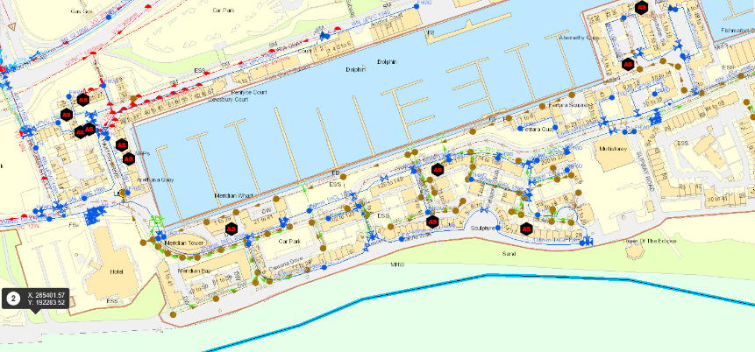
Photo above has been taken from DCWW internal GEOWEB.
The promenade is approximately 25m away from our construction site, there is a 4m drop from promenade to the beach, I would recommend that for our ground investigation we should bore hole to the depth of 8-10m. To establish what soil, we have at that depth as I would imagine the ground is very sandy.
There are also large buildings near the proposed site, and unknowingly there could be foundations from historic buildings which might include piles, and sheet piled walls, engine beds, pits, chambers and even underground storage tanks. There are often of massive construction which can be major obstacles for redevelopment. Therefore, using this bore holing Technik would eliminate these issues.
We must also put into consideration that the land could be contaminated; therefore, I recommend contamination testing by following the code (BS-10175)
The land in the Queens dock in Swansea which is considered to be a brownfield site they say ‘In conjunction with nearby sparsely-vegetated ground.’
“Regulation 3 of the Town and Country Planning (Brownfield Land Register) Regulations 2017 requires local planning authorities in England to prepare, maintain and publish registers of previously developed (brownfield) land by 31 December 2017. Brownfield sites that meet the relevant criteria must be entered in Part 1 of brownfield land registers. Sites entered in Part 2 of the brownfield land registers are granted permission in principle. Regulation 17 requires local planning authorities to review their registers at least once a year.”
(www.gov.uk)
We must also keep in mind the blitz of 1941 WW2. (Usborne,2019) stats show that figures are scant, but in 2009 the construction industry estimated that between 2006-2009 about 15000 devices had been removed from construction sites.
Therefore, the best method in my opinion would be, Open hollow stem auger method as it leaves a casing in the ground for unsupported soil and sand. In this case from a desk stop study this would be the best suited drilling system for this site.

Image below, boreholing rig.
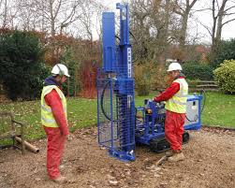
Image taken from (southerntesting.co.uk)
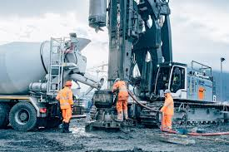
Above image taken from (iehber.com)

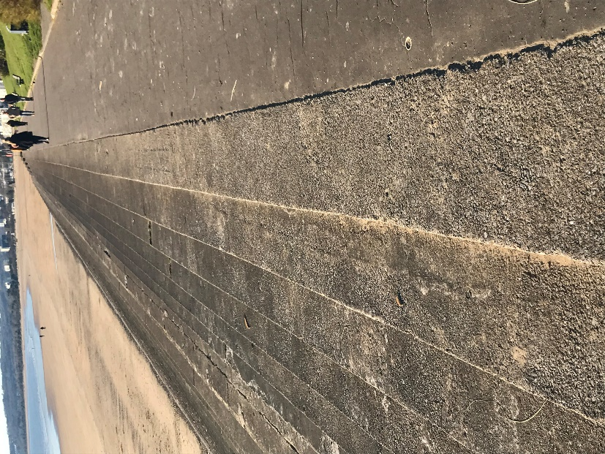

Image of promenade taken by me.
The general scope of work undertaken in the preparation of this assessment is as follows: Conduct an intrusive ground investigation as specified by the Client to ascertain environmental data for the proposed development and obtain preliminary geotechnical ground condition information... Provide an interpretative report offering recommendations on environmental issues and geotechnical issues.
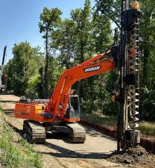

Above image shows an open auger attached to an excavator.
4. Foundation Analyse
My recommendation would be, that we use a raft foundation. A raft foundation spreads the weight of the building over the whole ground floor area of that building. The raft is laid on a hardcore, or scalping bed and usually thickened at the edges, especially in very poor ground. Rafts are most suitable when the ground is of good load bearing capacity and little work is required to get a solid foundation.
Raft Foundations are built is these following steps:
- The soil removed down to correct depth
- The foundation bed is then compacted by ramming
- Lay reinforcement on spacers over the foundation bed
- Pour the concrete over the reinforcement
The foundation may stiffen by ribs or beams built in during construction which will add extra strength and rigidity.
A raft foundation is usually preferred under several circumstances:
- it is used for large loads, which is why they are so common in commercial building which tend to be much larger, and therefore heavier, than domestic homes
- The soil has a low bearing capacity, so the weight of the building needs to be spread out over a large area to create a stable foundation
- The ratio of individual footings to total floor space is high. Typically, if the footings would cover over half of the construction area then raft foundation would be used
- If the walls of the building are so close that it would cause the individual footings to overlap, then raft foundations should be used

Above ref (understand construction.com)

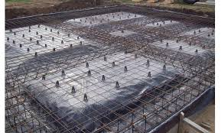

REF -https://www.google.com/url?sa=i&source=images&cd=&cad=rja&uact=8&ved=0ahUKEwjy-8ey46rmAhXsD2MBHeCPAe0QMwhwKAAwAA&url=https%3A%2F%2Fwww.labc.co.uk%2Fnews%2Fraft-foundation-basics&psig=AOvVaw23h_QS7PAOMKLRt9NOulYc&ust=1576056841622039&ictx=3&uact=3
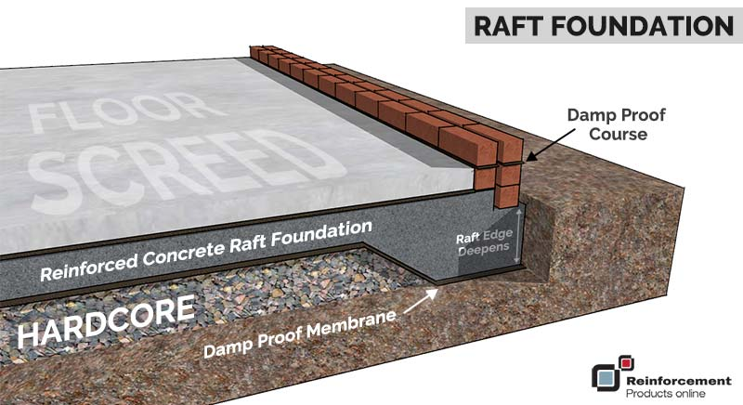
https://www.google.com/url?sa=i&source=images&cd=&cad=rja&uact=8&ved=2ahUKEwjP4vbT5KrmAhXlzoUKHZydBNwQjRx6BAgBEAQ&url=https%3A%2F%2Fwww.reinforcementproductsonline.co.uk%2Fnews%2Fraft-foundations-for-home-extensions-explained%2F&psig=AOvVaw0aYPqlyDcoQlx21hKFaXSI&ust=1576056841607594
7. Environmental Issues.

During the work, every effort and precautions necessary will be made to ensure that there will be no contamination and pollution to the water and surrounding area. All materials will be removed from site at the end of the job and disposed of in a correct and safe manner. The environmental management plan should include but not be limited to silt controls, ecological investigations and appropriate mitigations to ensure an environmentally compliant construction works.

8. Access and Egress

The Contractor shall ensure and always maintains suitable access over the entire site for emergency vehicles.

The Contractor must consider a route to and from the site for emergency vehicles for the duration of the programme, communicated through the traffic management plan.

The Contractor must ensure access for the entrance road to the residential property. Speed limits must always be maintained.

The Contractor shall not park on the road near on site to cause an obstruction. All parking shall be within the Contractor’s designated site compound.

The Contractor shall develop and maintain a traffic management plan to include, but not limited to the following:
- Access and egress to the site for Contractor’s personnel vehicles;
- Access and egress to the site for construction plant;
- Access and egress to the site for deliveries;
- Access and egress to the site for emergency services;

Due to the location of site, I feel that we would need a gate man.

As this is so close to the Marriot hotel / and beach, I believe its paramount we have one for public safety.

He must be by gates, to stop the public entering the work zone, as accidents can easily happen.

Only registered construction workers must enter site.
9. PPE.

As a minimum, the following items will always be worn :
Hard hats, Safety Foot wear, Gloves, Overalls, High visibility Jacket or vest.
When using heavy machinery we must stop, take 5 and think if more PPE is needed e.g. safety glasses breathing mask etc.
A trained first aider, must be available on site.
Nearest Hospital -Morriston Hospital, Heol Maes Yr Eglwys, Swansea, SA66NL.

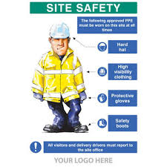

10. Site and Public Safety.

- Site must be barried off for public safety.
- If needed erect public walkways.
- Care and attention must be done to provide safety to the public and contractors.
- All work must be completed, by trained and competent operatives.
- A method statement must be approved, before work is to commence.
- The contractor shall consider the operational staff and the general public and road uses that will be within the vicinity of the working area, always during the works.
- All trial holes to backfilled before leaving site.
- All excavations adhere to (BS8008) as excavators are dangerous.
- Banksman to be with excavator and operator always, as the public are always close by.
- Anti-sociable behaviour will not be accepted in the work place.
- Site rules must always be followed.
- Spill kits must be made readily available on site, in the event of fuel leak / pollution incident.
- First aid kits, and eye wash stations must be on site.
- Safe exclusion zone.
- Spoil must be stored appropriately.

- References

(historypoints.org)
www.swanseamarina.org.uk/
Google images
REF -https://www.google.com/url?sa=i&source=images&cd=&cad=rja&uact=8&ved=0ahUKEwjy-8ey46rmAhXsD2MBHeCPAe0QMwhwKAAwAA&url=https%3A%2F%2Fwww.labc.co.uk%2Fnews%2Fraft-foundation-basics&psig=AOvVaw23h_QS7PAOMKLRt9NOulYc&ust=1576056841622039&ictx=3&uact=3

https://www.google.com/url?sa=i&source=images&cd=&cad=rja&uact=8&ved=2ahUKEwjP4vbT5KrmAhXlzoUKHZydBNwQjRx6BAgBEAQ&url=https%3A%2F%2Fwww.reinforcementproductsonline.co.uk%2Fnews%2Fraft-foundations-for-home-extensions-explained%2F&psig=AOvVaw0aYPqlyDcoQlx21hKFaXSI&ust=1576056841607594
(understand construction.com)

from (iehber.com)

(southerntesting.co.uk)

DCWW internal GEOWEB.

