
Ragulan Pulanthitan (2200662)
University of Wales Trinity Saint David

Applications of cae processes
ACHA6010: Structural & Fluid Analysis

Contents
- Introduction....................................................................................................2.
- Validation Testing…………………………………………………………………………………….3.
  - Static Structural Study…………………………………………………………………………….3.
  - Steady-State Thermal Study…………………………………………………………………….5.
- Kinematic Simulation and Structural Analysis………………………………………………8.
  - Kinematic Analysis…………………………………………………………………………………8.
- Optimization and Improvement………………………………………………………………..11.
  - Material Selection………………………………………………………………………………..11.
  - Design Changes…………………………………………………………………………………..14.
- Conclusion…………………………………………………………………………………………..16.
- References……………………………………………………………………………………………17.

Introduction
In this report, kinematic simulations and structural analysis on a CAD assembly of an engine will be carried out. Initially, validation studies will be completed using the static structural, rigid dynamics and steady state thermal analysis systems on Ansys workbench. Simple geometries will be used such as a cantilever beam and bimetallic strip to do these validation studies on. To validate these FEA studies, Use of analytical solutions derived from fundamental principles to compare with the results obtained via Ansys simulations will be performed. The investigation will then move onto a mesh independence study to assess the impact of different mesh sizes on the accuracy of the results produced. By doing this, a point of mesh independence can be found. The project will also be investigating how the boundary conditions influence the output of a simulation.
Firstly, the investigation will conduct a kinematics analysis of the engine assembly to gain a realistic set of loading conditions before using these results to perform a static structural assessment of one component within this assembly. The project will then attempt to incorporate thermal conditions that the component experiences to consider the material property degradation due to heat. After these initial studies, the study will look into optimizing the design of the selected component based on the results of FEA studies. Analysis will be done on these results to make informed alterations to meet design targets. The focus will be on improving the structural performance and fatigue life while optimizing the mass of the component. Following this, we will be discussing the use of CAE tools while describing the design process and their limitations.

Validation Testing

2.1 Static Structural Study
The first validation study performed is on a cantilever beam under a uniform load. The material assigned to the beam was structural steel. To accurately capture the geometry, a mesh size of 0.005m was used. One end of the beam was set as a fixed support and a uniform pressure of 2750 Pa was applied to the top face of it as seen in the figure below. The dimensions of my beam include a length of 1m by a width of 0.05m with a constant thickness of 0.005m. The Modulus of Elasticity for the beam is 210000 MPa.
Figure 1.1: Uniform Pressure Load on Cantilever Beam
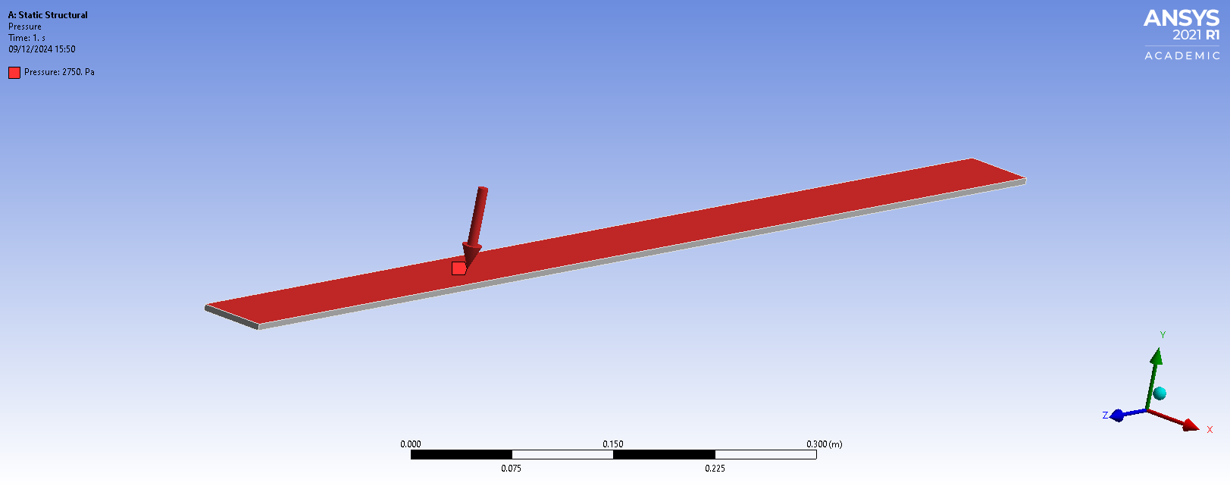
After running the simulation, contours were plotted of total deformation, maximum stress and strain to compare with analytical solutions calculated from fundamental principles.
Figure 1.2: Total Deformation of Cantilever Beam
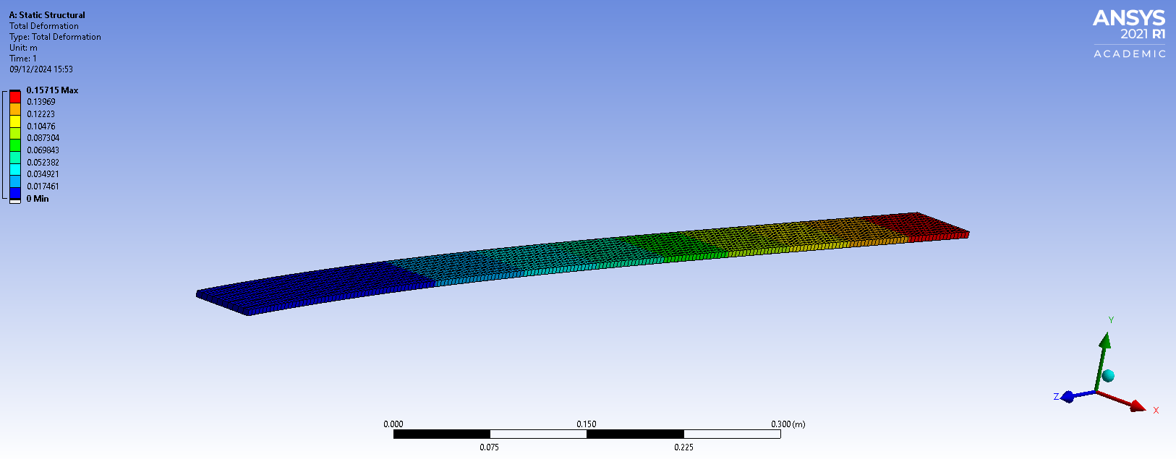
The maximum deformation observed from figure 1.2 is 157.15mm at the free end of the beam. To validate these results, maximum displacement using a series of equations will be calculated.

To begin with, the bending moment for the plate under continuous loading q = pw is defined by the equation: $M=\frac{q{\left(L-x\right)}^{2}}{2}$
By using the Euler-Bernoulli theory for slender beams under bending, the equation governing a beam subjected to a distributed load along its span can be fined as:
$M={EI}_{y}\frac{d^{2}u_{z}}{{dx}^{2}}$
Where I_{y} is the quadratic moment of a cross-section with respect to the y-axis and it is given by: $I_{y}=\frac{{wt}^{3}}{12}$
After integrating the second equation from 0 to L twice, the boundary conditions for the cantilever beam u_{z}(0) = u_{z}’(0) = 0 so the solution takes up the following form:
$$u_{z}\left(x\right)=\frac{qx^{2}(6L^{2}-4L_{x}+x^{2})}{24EI_{y}}$$
The maximum displacement occurs at the point x = L:
$$u_{z,max}=\frac{qL^{4}}{8EI_{y}}=\frac{3pL^{4}}{2Ew^{2}t}=157.143mm$$
The analytical solution of the beam shows a maximum displacement of 157.143mm which is very close to the maximum deformation output by Ansys’ solver. This is sufficient evidence to validate the static structural study conducted on the beam.

Steady-State Thermal Study
For the second validation study, effects of thermal loading on a bimetallic beam were investigated. The beam had an overall length of 100mm by a cross-sectional width of 5mm. It is made up of two metallic layers of invar and copper, both of which have a layer thickness of 1mm. Invar has a Young’s Modulus of 137000MPa with a Poisson’s ratio of 0.28. Its coefficient of thermal expansion is 1.2x10⁻⁶ °C⁻¹. In comparison, copper’s modulus of elasticity is 130000MPa and has a Poisson’s ratio of 0.354 with a coefficient of thermal expansion of 2x10⁻⁵ °C⁻¹.
The mesh size used for this study was 0.0005m which is a very fine mesh since the geometry is relatively small. One end of the beam was set as a fixed support and a thermal load of 122°C was placed over the entire beam. It is important to note that the ambient temperature is taken as 22°C so the thermal load of 100°C was added to that.
After allowing the software to resolve the study, the total deformation calculated was 7.0232mm as seen in figure 2 below.
Figure 2: Total Deformation of Bimetallic Strip
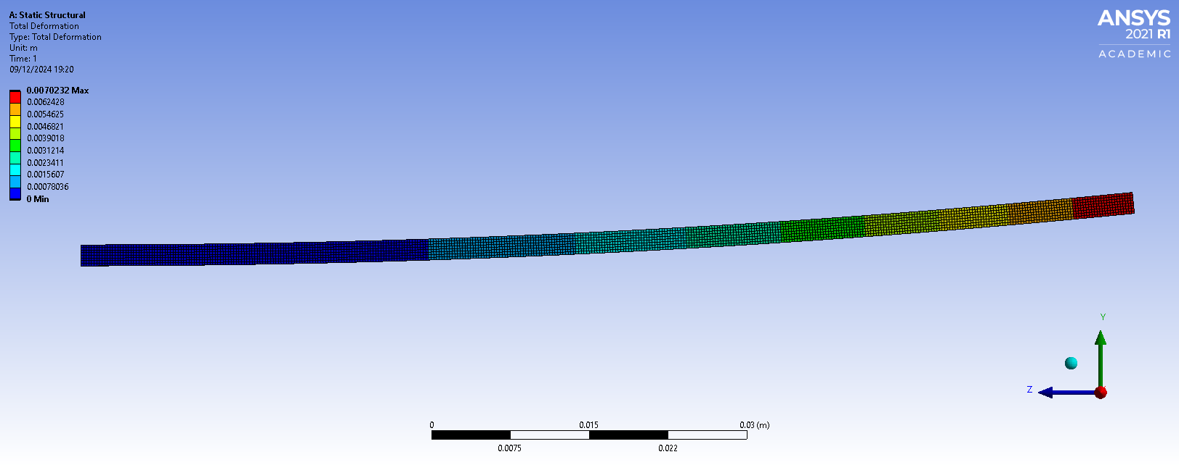
Since the bimetallic strip is made up of two different metals, they have two different coefficients of thermal expansion. They are frequently used in temperature control or measuring instruments. As the ambient temperature changes, the bimetallic strip bends, which is caused by the different elongations of the metals present. To come to an analytical solution, the following formula is used to calculate the dimensionless coefficient K₁, which can be used in the calculation for equivalent stiffness.
$$K_{1}=4+6\frac{t_{c}}{t_{i}}+4({\frac{t_{c}}{t_{i}})}^{2}+\frac{E_{c}}{E_{i}}({\frac{t_{c}}{t_{i}})}^{3}+\frac{E_{i}t_{i}}{E_{c}t_{c}}$$
The maximum displacement of the beam can be defined by the formula:
$$u_{z,max}=\frac{6\left(α_{i}-α_{c}\right)\left(t_{i}+t_{c}\right)T_{c}}{{t_{s}}^{2}K_{1}}\frac{L^{2}}{2}≈-7.049mm$$
The maximum displacement varies by 0.0258mm between the analytical solution and the calculated FEA study. To investigate the impact of mesh sizing on this deviation, the same FEA study was conducted with a range of different mesh sizes to see how different the solution’s maximum deformation values were.
Figure 3.1: Graph depicting Maximum Deformation resolved at different mesh sizes

The graph above shows how using different sizes of mesh elements impact the results of your FEA simulation. The dashed line indicates the value of maximum displacement calculated using the analytical solution from fundamental principles which was completed above. Interestingly, it is the simulation which uses an element size of 0.75mm which outputs the same maximum deformation value as what was calculated. The finer mesh sizes tend to resolve the simulation having slightly less deformation. It is usually accepted that smaller element sizing constitutes to more accurate results as there are a greater number of nodal points spread across the geometry where calculations are being made to resolve the mechanical behaviour of the component.
A second mesh study was created using another static structural study on a different cantilever beam under axial and transversal load. It can be seen from the figure below that maximum deformation has very slight deformation when altering mesh element sizes whereas the maximum stress values are consistent until a certain point of mesh independence (0.02m) where they begin to rapidly increase. By looking at stress contours on the surfaces of the beam, it can be determined that very fine mesh sizes calculate highly concentrated stress in the corners of the beam’s fixed point. This is the source of the rapid increase in maximum stress seen in figure 3.2.

Figure 3.2: Graph depicting maximum deformation and stress resolved at different mesh sizes
Point of mesh independence
Figure 3.3: Equivalent Stress using Element Size 0.025
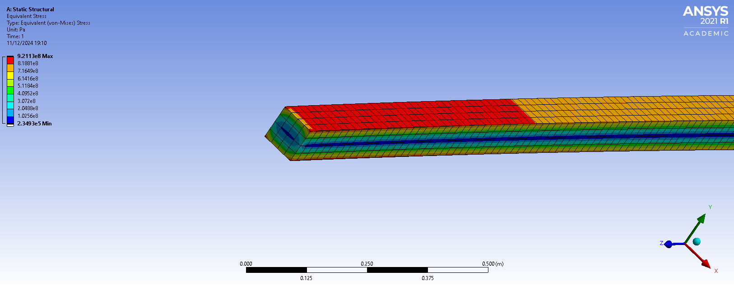
Figure 3.4: Equivalent Stress using Element Size 0.01
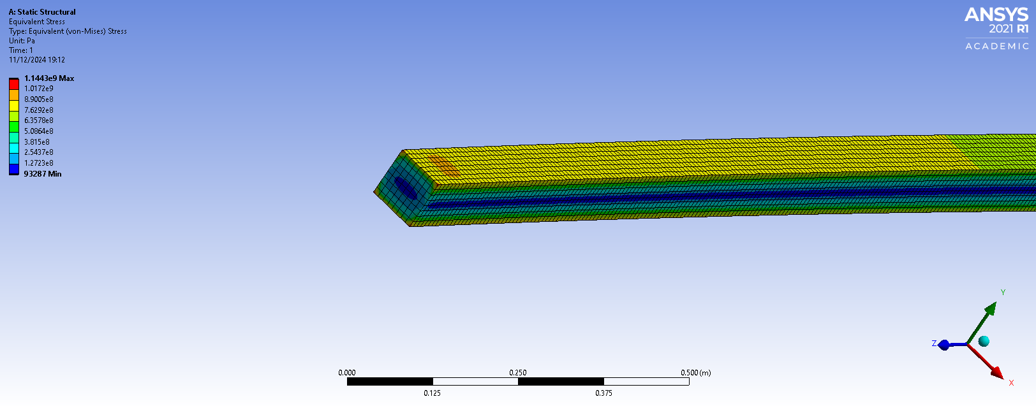

Kinematic Simulation and Structural Analysis

3.1 Kinematic Analysis
To begin this section of the investigation, an engine assembly will be used to perform a Rigid Dynamics study to gain an understanding of the motion loads produced by the mechanical system. This will then allow me to transfer results to a static structural study with thermal considerations to complete a fully linked system. Using this function on Ansys allows for a study to take all components as rigid, ignoring any deformation. The solver will only calculate motion loads from the assembly which can be exported for further use. Due to these factors, an accurate mesh doesn’t need to be generated. What is critical is the degrees of freedom. It is important that each connection joint allows for the appropriate movement or travel for each component and that the crankshaft is grounded.
Figure 4.1: Joints connecting engine assembly
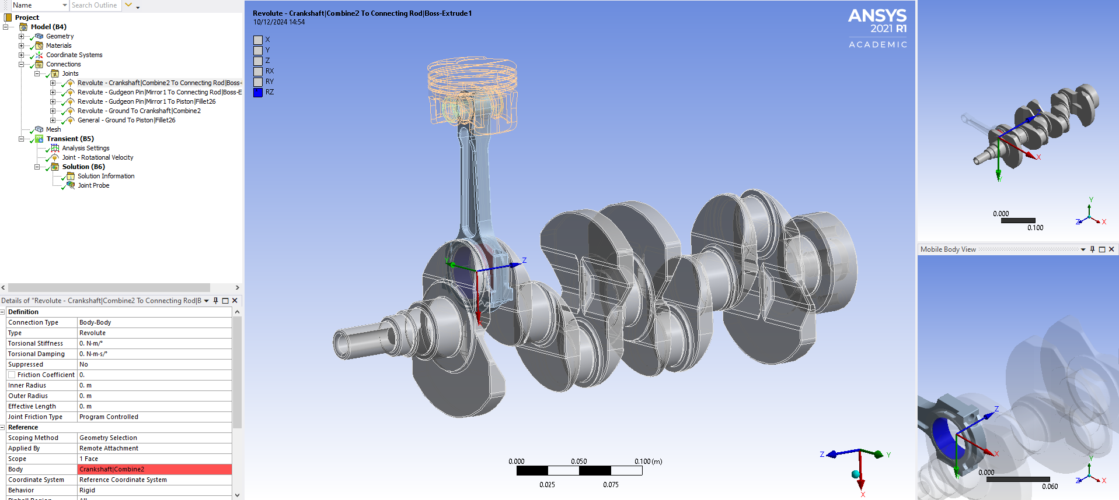
Figure 4.2: Rotational velocity of 4000 RPM applied to crankshaft
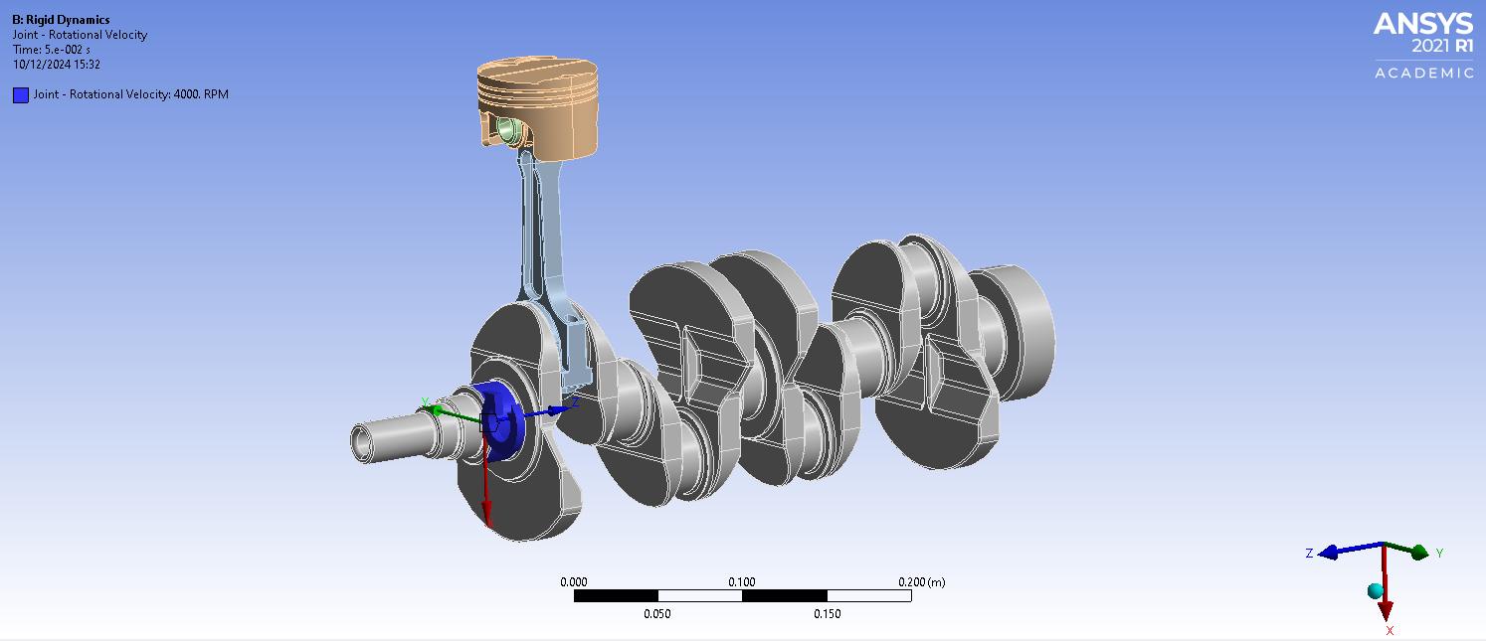
Figure 4.3: Solution Results of Rigid Dynamics Study
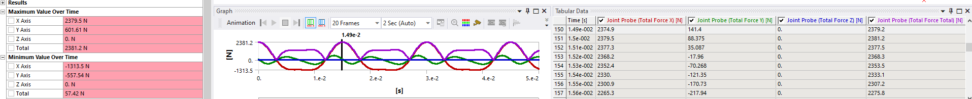
From figure 4.3, we can see that the maximum loads are produced at the peak of the purple line plot of force against time highlighting the overall total force of the joint probe. We can see this is calculated on the 150th iteration at 0.0149s into the simulated motion.

Thermal Considerations
After linking a static structural study to the rigid dynamics, I added a steady-state thermal study and linked the appropriate engineering data and geometry components to it. For this thermal analysis, the only interest is in the effects on the piston head. Therefore, the other components are suppressed. A mesh of size 0.004m (Lee and Ku, 2021) is applied to accurately capture the geometry. Convections are then set to different faces of the piston to simulate the heat it is subjected to.
Figure 5: Temperature Contours on 6061-T6 Aluminium Piston Head
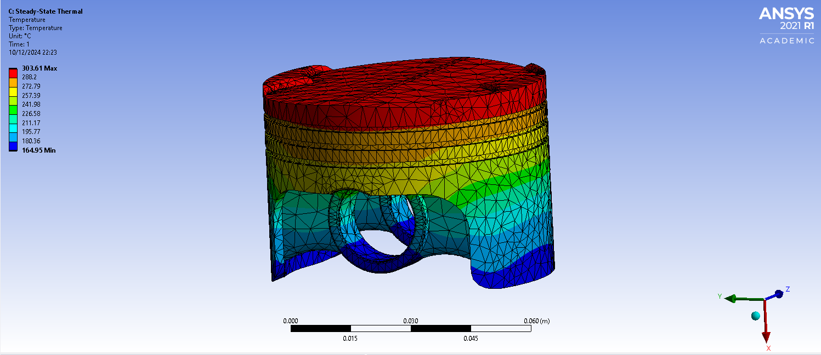
The figure above depicts the temperatures calculated on all surfaces of the geometry with a maximum of 303.61°C seen on the crown of the piston and a minimum of 164.95°C across the skirt. Using this study, the solution can be transferred into a static structural analysis taking the engineering data and geometry from the initial rigid dynamics study.

Static Structural Analysis
Following the kinematic analysis accompanied by the thermal loads, a static structural study is produced to find deformation and stress on the component. Along with the imported motion and thermal loads, a pressure of 1.05e7 Pa is applied to the top of the piston and the points of contact with the gudgeon pin is set as a fixed support before the simulation is solved. A finer mesh of element size 2mm is applied to the faces on the top side of the piston head for better resolution of those surfaces. As seen in the following figures, peak deformation is seen on the crown of the piston where minimal stress is. This is an area open to alteration when investigating the potential in optimization of the component.
Figure 6.1: Total Deformation of 6061-T6 Aluminium piston head
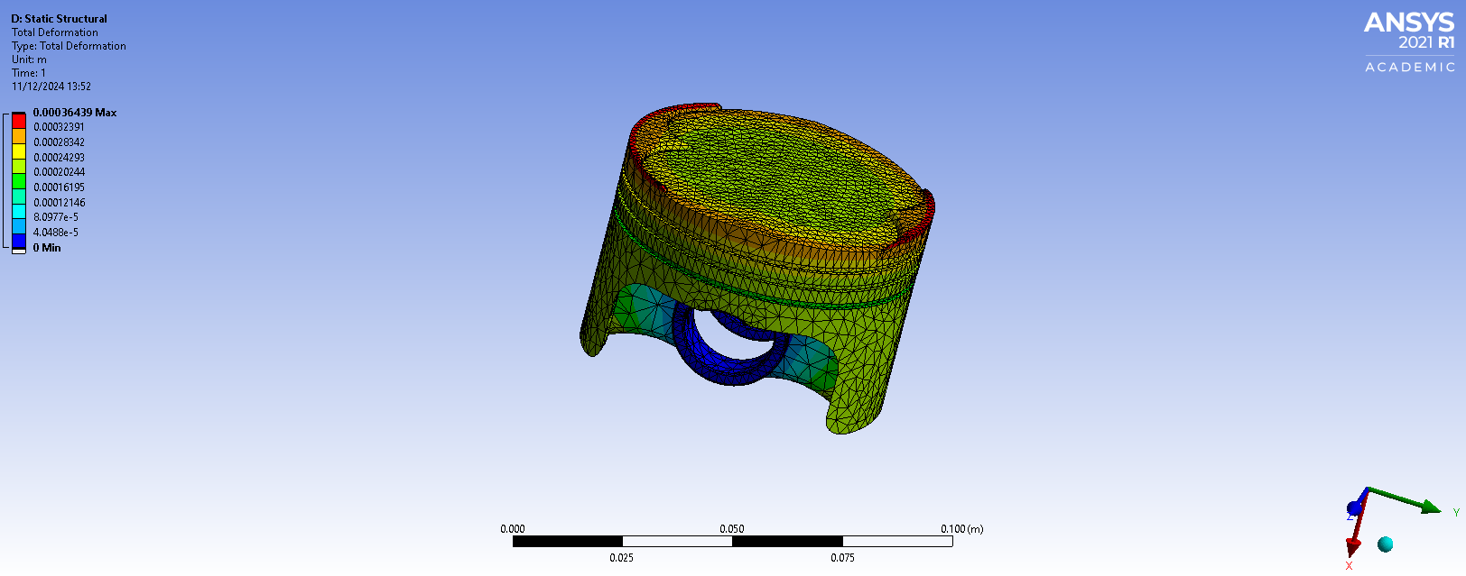
Figure 6.2: Equivalent Stress of 6061-T6 Aluminium piston head
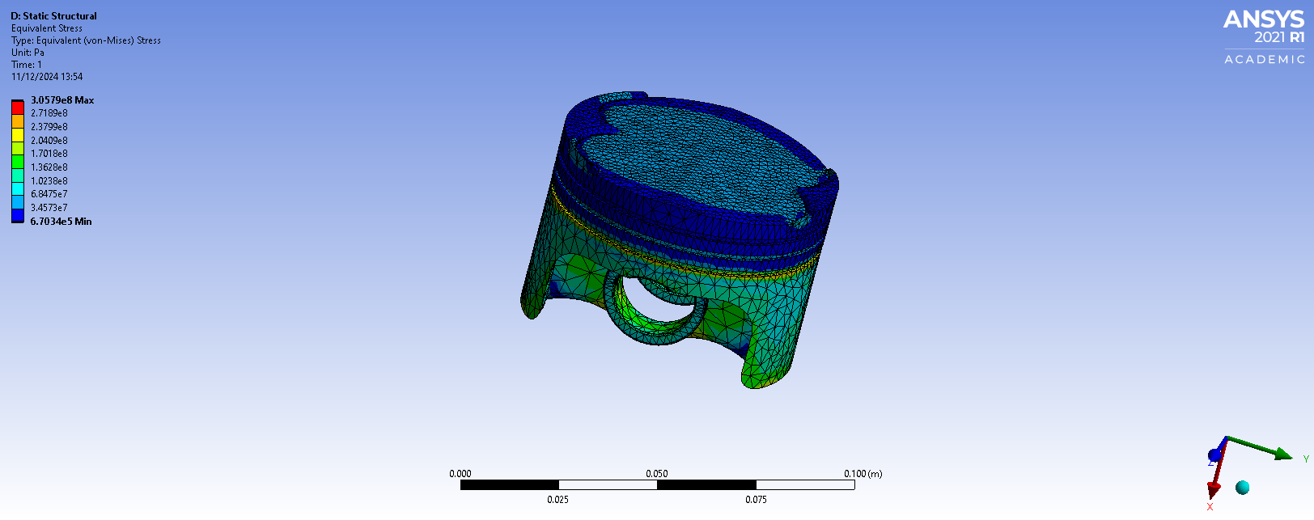

Optimization and Improvement

4.1 Material Selection
As part of the optimization for the component, different materials will be tested to see their impact on the structural characteristics of the piston head. The first iteration consisted of 2024-T36 Aluminium. Ansys allows for a separated engineering data tab in the workbench that can be tied into various studies. By adding a new material to the data tab, all other studies can read the upstream information and recalculate kinematic and thermal loadings before a static structural analysis completes the simulation to show equivalent stress values and their distribution across the surfaces of the component. Figure 7.1 shows the temperature gradient with a peak of 324.37°C surrounding the top of the piston. This is ~21°C higher than the maximum temperature observed using 6061-T6 Aluminium. The equivalent stress plot indicates higher maximum and minimum stress values that the 2024-T36 piston is subjected to, and the raised edges of the crown no longer experience minimal stress. This would prove influential to geometry changes made for structural improvement.
Figure 7.1: Temperature Contours on 2024-T36 Aluminium Piston Head
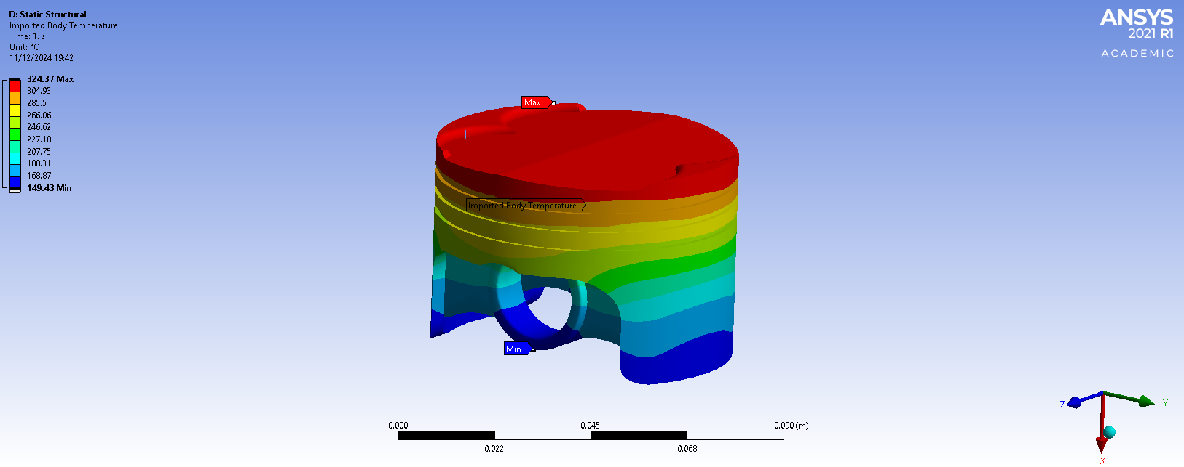
Figure 7.2: Equivalent Stress of 2024-T36 Aluminium Piston Head
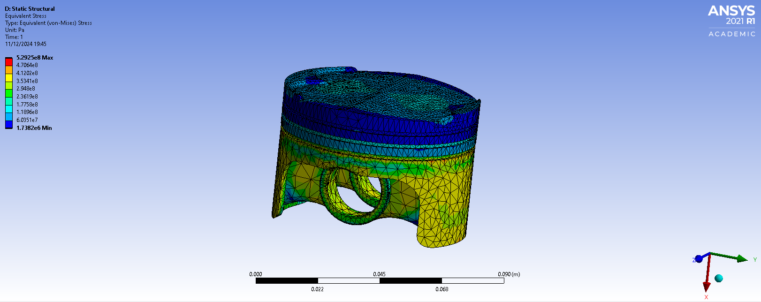
The next material of choice tested was annealed AISI 1020 carbon steel. The Young’s Modulus curve against temperature is significantly higher than those of the aluminium materials. After repeating the same process of importing the engineering data of AISI 1020 and simulating the rigid dynamics to export motion loads, the steady-state thermal analysis showed significantly higher peak temperatures seen across the top face of the piston. However, the carbon steel piston head resulted in lower stresses across the component.
Figure 8.1: Temperature Contours on AISI 1020 Carbon Steel Piston Head
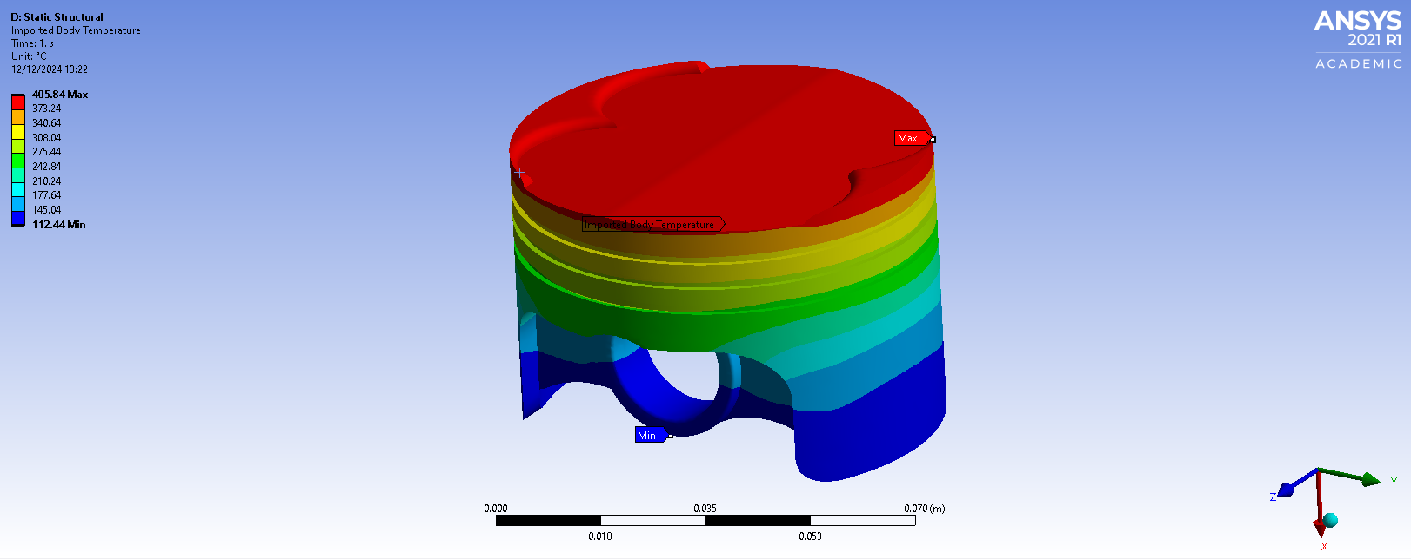
Figure 8.2: Equivalent Stress of AISI 1020 Carbon Steel Piston Head
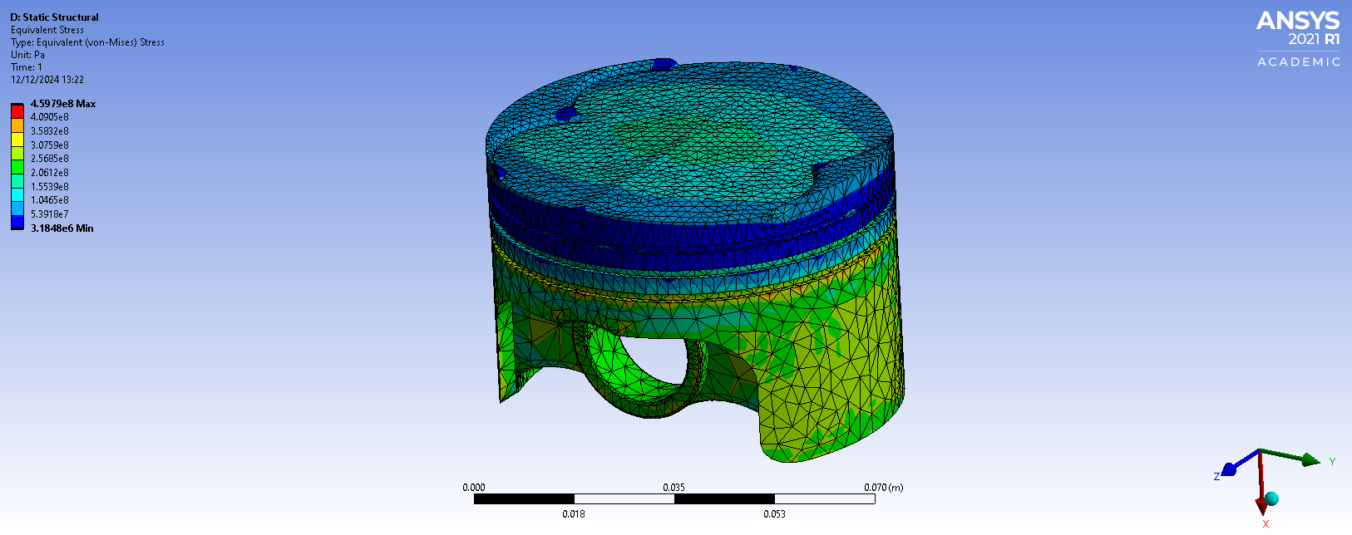
Using the Granta Edu Pack software, materials can be called from a vast database to then be imported into the engineering data section of an Ansys workbench. The following figures compare the Young’s Modulus against temperature curves for 2024-T36 Aluminium and AISI 1020 Annealed Carbon Steel. After completing another fully linked study using cast Magnesium WE43A, the temperatures and stresses can be compared across the different materials.

Figure 9.1: Isotropic Elasticity of 2024-T36 Aluminium
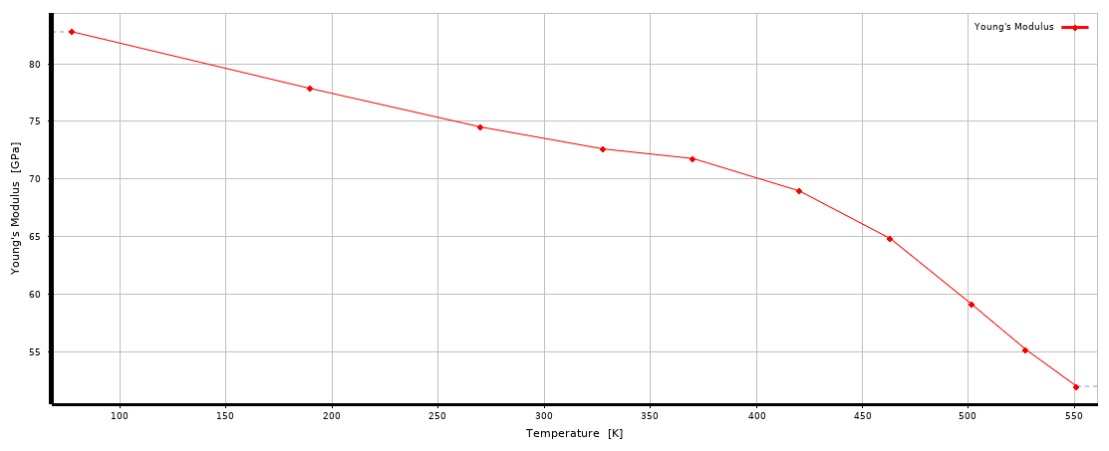
Figure 9.2: Isotropic Elasticity of AISI 1020 Carbon Steel
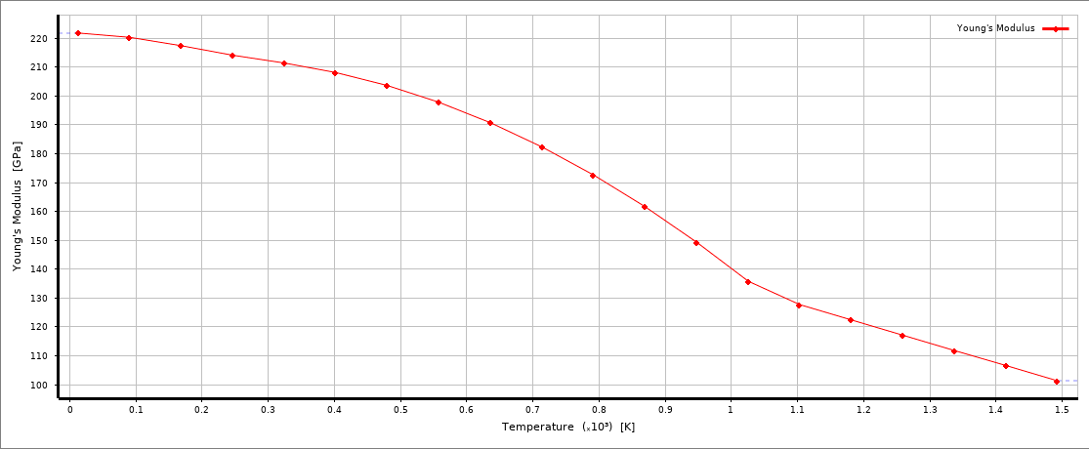
Table 1: Peak Pressure and Equivalent Stress on Piston using different materials
Material | Peak Temperature (°C) | Stress (x10⁸ Pa) | Mass (g)
6061-T6 Aluminium | 303.61 | 3.06 | 255.77
2024-T36 Aluminium | 324.37 | 5.29 | 263.35
AISI 1020 Carbon Steel | 405.84 | 4.60 | 748.37
Magnesium WE43A | 395.24 | 3.18 | 161.04

As seen in Table 1, the 6061-T6 aluminium piston head yielded the lowest equivalent stress (3.06x10⁸ Pa) whilst also experiencing the lowest peak temperature, 102°C cooler than the carbon steel piston. There is quite a bit of variation in mass using different materials with carbon steel, the heaviest, being almost 600g heavier than magnesium alloy. Optimization for this component can be done furthered with alterations to the geometry.

Design Changes
In order to further improve the structural performance of the piston head component, changes to its geometry can be made based on the results of the fully linked system analysis completed in the previous section. As seen specifically in figure 6.2, there are areas of concentrated low stress among the upper surfaces of the crown. Using this as the basis for the design change, the raised surfaces were deleted using an extruded cut to make the top of the cylinder flatter. After running the same simulations on the assembly with the modified piston, results were gathered on temperatures and equivalent stress which the following contour plots display.
Figure 10.1.1 (Left): Equivalent Stress of Modified 6061-T6 Aluminium Piston Head
Figure 10.1.2 (Right): Equivalent Stress of Modified 6061-T6 Aluminium Piston Head Underside
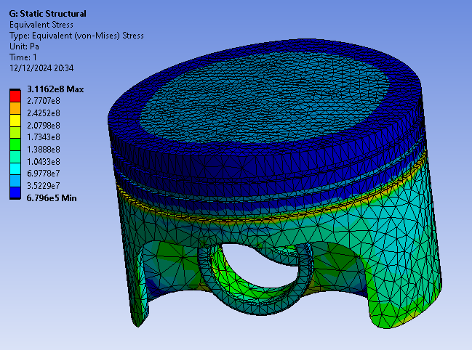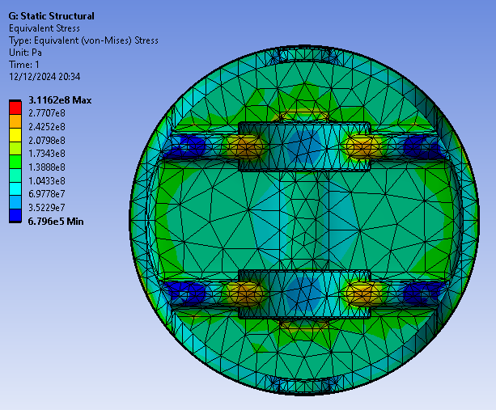
Smoothing the crown of the piston reduced the mass to 253.6g and gave similar results to the original analysis. Both studies used 6061-T6 Aluminium and yet the modified piston head produced slightly higher maximum stress values which appear to concentrate around the lower ring. There is a greater distribution of low stress around the edge of the crown. The convection heat currents produce a similar temperature profile with the peak being only 1°C lower. One of the limitations of the Ansys FEA solver is that computational processing power effects the time taken for several mesh elements capable of being used to resolve the simulation. Greater number of elements constitutes to a greater number of nodes at the vertex of each element where calculations take place. However, to improve the accuracy of the simulation, a finer mesh is desired to better encapsulate the geometry. For this reason, I conducted the steady-state thermal and static structural analysis using a finer mesh for the entire piston component. Using a mesh element size of 2mm for this entire component, the results yielded were very similar with maximum equivalent stress only having a 2.3% difference. The maximum deformation occurs around the edge of the crown.

Figure 11.1 (Left): Equivalent Stress of Modified 6061-T6 Aluminium Piston Head with finer mesh
Figure 11.2 (Right): Total Deformation of Modified 6061-T6 Aluminium Piston Head with finer mesh
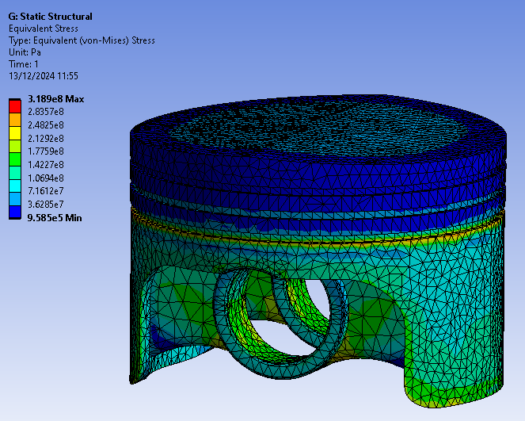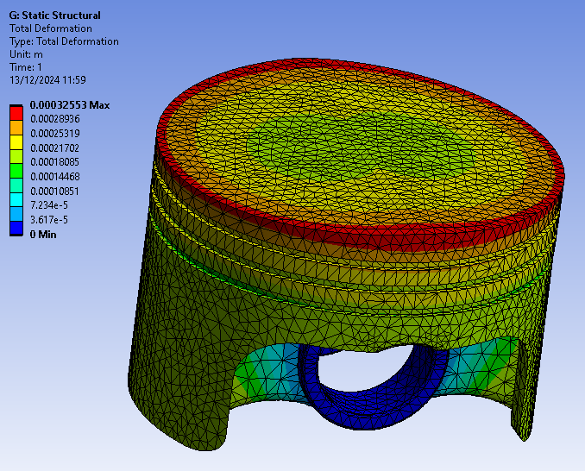

Another design alteration that can be made to the piston head is the removal of material away from the lower surfaces supporting the skirts. This design has a mass of 250g. After updating my assembly and repeating the whole process of the fully linked system, the results produced showed a slightly lower peak temperature and maximum stress with the crown of the piston seeing temperatures of up to 301.11°C. The peak stress observed is 3.153x10⁸ Pa but the lower corners of the supports to the skirts experience slightly higher stresses. Interestingly, two corners in the cutouts made are subjected to relatively high levels of stress compared to the opposite two corners where relatively low stress is experienced.
Figure 12.1 (Left): Equivalent Stress of Modified 6061-T6 Aluminium Piston Head with finer mesh 2
Figure 12.2 (Right): Body Temperature of Modified 6061-T6 Aluminium Piston Head with finer mesh 2
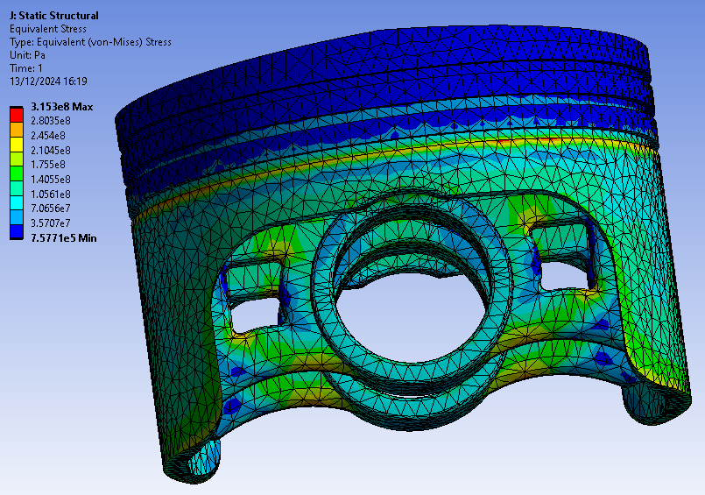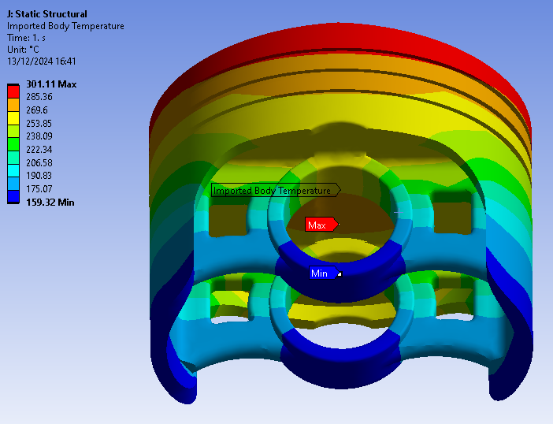
The methodology of the fully linked analysis is easily transferrable when performing multiple studies using different geometries. This repeatable process allows for easily attainable results when testing different iterations.

Conclusion
In conclusion to the report, thorough use of the Ansys finite element analysis software has been made with multiple fully linked systems consisting of rigid dynamics, steady-state thermal and static structural simulations. When conducting a kinematics analysis, the preset contact regions defined by Ansys are usually adverse to the simulation which is why it’s important to delete them and add revolve joints in their place to properly configure the degrees of freedom for each joint in the assembly. Ensuring that all bodies are rigid means that they are not deformable and allows the simulation to calculate motion loads without being concerned about stresses and deflection. Before taking the setup into a static structural study, it is important to take into account the thermal considerations by tying in a steady-state thermal analysis. The material of the piston should be checked in case it was reverted to structural steel. Being able to add convection currents to any selected surface is useful when trying to form an accurate temperature profile across the body. After transferring the solution to a static structural analysis, the piston component must be changed back to flexible whilst the other parts of the assembly are suppressed. Before solving, a fine enough mesh needs to be generated, and this is where Ansys may take an extended period of time to complete generation of the mesh depending on the desired element sizing. This can be a potential drawback considering the increase in computational resource required to resolve the stresses and deformation at each nodal point of the mesh. However, after successfully completing one iteration of the process, it is an easily repeatable simulation that can be carried out incorporating changes in material. When attempting to make iterative changes to the geometry, the model must be edited in CAD software and added to the assembly before being exported as a Parasolid or STEP file to be acknowledged by Ansys. Component mass figures can also be generated in CAD software based on the material selection. This can help influence further decisions in geometric design.

References
[1] Gupta, A. (2023). Materials Matter: Exploring Piston Manufacturing Materials. [online] Blog. Available at: https://www.atracparts.com/blog/materials-matter-exploring-piston-manufacturing-materials/.
‌
[2] Srivastav, N., Sahani, R., Kumar, A., Yadav, G., Sahani, R., Mishra, P., Kumar Pandey, A. and Bihari Lal, S. (2015). Finite Element Analysis of Piston Head by ABAQUS. International Journal of Scientific & Engineering Research, [online] 6(5). Available at: https://www.ijser.org/researchpaper/Finite-Element-Analysis-Of-Piston-Head-By-ABAQUS.pdf [Accessed 13 Dec. 2024].
‌
[3] Reddy Anugu, A., Vishnu Tej Reddy, N. and Venkateswarlu, D. (2021). Theoritical modelling and finite element analysis of automobile piston. Materials Today: Proceedings, 45, pp.1799–1803. doi:https://doi.org/10.1016/j.matpr.2020.08.741.
‌
[4] Kourav, S. and Ghagare, V. (n.d.). Design and Analysis of Piston by using Finite Element Analysis. [online] Available at: https://www.ijert.org/research/design-and-analysis-of-piston-by-using-finite-element-analysis-IJERTV4IS090411.pdf.
‌
[5] Mayandi, K., Muneendra Reddy, R., Jaya, B., Vardhan, H. and Anand Babu, Y. (n.d.). STATIC AND THERMAL ANALYISIS OF PISTON USING ANSYS WITH VARIOUS MATERIALS. [online] International Research Journal of Modernization in Engineering Technology and Science, pp.2582–5208. Available at: https://www.irjmets.com/uploadedfiles/paper/volume3/issue_5_may_2021/11073/1628083448.pdf [Accessed 13 Dec. 2024].
‌
[6] Lee, Z.R. and Ku, P.X. (2021). Geometry design and optimization of piston by using finite element method. Journal of Physics: Conference Series, 2120(1), p.012013. doi:https://doi.org/10.1088/1742-6596/2120/1/012013.
‌

