International Finance Management

Assessment 2: Case Study - The British Petroleum Corporation (BP)
Made by:
Ivan Georgiev 1914979
Iva Naydenova 1914746
Irena Dimitrova 1914044
Georgi Peychinov 1912954
Martin Aleksandrov 1913436

Executive Summary
The report made by our group of five students is a case study of BP- the global oil, gas, and energy major and an understanding of its various financial management strategies applied globally. The first part of the report critically evaluates why BP internationalised. The second part critically evaluates how country risks impact BP’s investment options in host nations. Next, a critical evaluation of how BP manages its financial risk has been discussed. Then, the evaluation of BP’s foreign exchange currency risk has been done. Lastly, BP’s working capital management has been critically evaluated. The report ends with a conclusion.

Table of Contents
Executive Summary 2
Introduction 4
Theoretical frameworks and models of international financial management 4
Forces that allowed BP to become internationalised 5
Various techniques related to financial international business 6
BP’s s Strategies For Managing Its Financial Risks 6
Analysis and Evaluation of British Petroleum’s source of finance 9
Different strategies that BP Corporation uses to manage its exposure to foreign exchange risks 11
The effectiveness of issuing stocks internationally by BP 12
Corporation in financing projects 12
Conclusion 14
References 15

Introduction
International financial management aids a company in enhancing efficiency and effectiveness across different global markets by providing harmony between key business functionalities including production, sales, and so on for achievement of the common goals (Madura, 2021). It thus helps a company in managing its financial aspects globally, including financial risks efficiently. This report will consider the case study of BP Plc (BP) the British oil and gas major established in 1909 and headquartered in London, the United Kingdom, which has now become an integrated energy company (BP, 2022). The report will critically evaluate various aspects of BP Corporation including why it internationalised, country risks for BP’s investment in host countries, strategies for managing its financial risk, evaluation of its foreign exchange risks, and working capital management.

Theoretical frameworks and models of international financial management
As per the view of Alcadipani and de Oliveira Medeiros, (2020, p. 285), International financial management has represented the investment and financial decisions confronting management in the international market due to various international activities. Investment and financial decisions have defined uncertain valuation regarding future cash flows. One of the major aspects of British Petroleum has been affected by the international context which is the exchange risk rate. Therefore, it has been analyzed that BP and other subsidiaries have been associated to engage in production, exploration, transportation, refining, and distribution regarding oil and natural gas. Along with that, this has defined the manufacturing process of synthetic fibers, chemicals, and plastics. Thus, it operates convenience stores as well as filling stations within the brand such as ARCO, Aral, BP and am/pm. In the year 2010, the company estimated more than 4.9 million barrels of oil released to the Gulf of Mexico, in the history of one of the leading marine oil spills.
Pecking order theory and extension theory has helped BP manager and investors to identify effective strategic factors which can be effective for overall business growth. Within this theory, managers have gathered information regarding company values as well as identified risk factors within outside investors. Therefore, financial sources order has been used regarding internal profits funds, debt, short-term security, and common stock factors.
On the other hand, Trade-off theory has highlighted company financial distress costs and bankruptcy within the insights of literary agencies. Thus, this theory has helped address unique capital structures for balancing tax advantages and financial debts.

Forces that allowed BP to become internationalised
British Petroleum is one of the leading oils and gas companies across the world. The company has focused on developing oil fields as well as establishing refineries in multiple countries including interest in Alaska's Prudhoe Bay in the United States and the United Kingdom. In the year 1998, BP Amoco became one of the leading petroleum companies and later the company decided to change the name to BP plc. For maintaining internationalized factors, BP has decided to follow up some strategies regarding customer engagement and increasing revenue rate. The company has focused on providing low carbon energy as well as addressing customer demand within the current market. By the year 2030, the company has set a target to fold 10 increasing rates within low carbon investment which is up to 8-fold increment by 2025. Another major aspect BP has followed up is focusing on resilient hydrocarbon business by decreasing capital intensity. This is one of the major effective projects which has defined project completes as well as continues combination to efficient focuses regarding drive earnings and ROACE growth. BP has focused on providing net-zero ambition emissions from BP operations to reduce by 30-35% within 2030 (van der Ven et al., 2022, p. 118).

Various techniques related to financial international business
The company is currently focused on providing refined petroleum products regarding refineries and supplying distinctive fuels for the customers. The company has followed up infrastructure logistics networks as well as partnerships with others for differentiated fuels business by including a lower carbon footprint (Argyridou et al., 2020, p. 1036). It has been analyzed that the company lubricants business has been defined as a premium brand for enhancing market growth. Along with that, current advanced technology and customer relationships have helped the company to maintain competitive advantages in the current market. In 2012, BP subsequently paid near about $4.5 billion in penalties and fines to the US government due to more than 14 criminal charges (bp.com.2022).

BP’s s Strategies For Managing Its Financial Risks
Being a global energy and oil major, BP has to face various financial risks as part of its global business operations. Macroenvironmental elements tend to influence the company’s financial performance. The supply and demand for BP’s products are influenced by various external factors including global economic/political developments, consumer preference for sustainable low carbon emission products, and so on. BP intends to manage its financial risks by working out strategies focussed on developing a diverse portfolio, financial framework, maintaining adequate cash liquidity, liquidity stress testing, regularly evaluating external market situations, and focussing on strategic planning and investment processes (BP Annual Report , 2021). BP’s risk management strategy shown as shown in Figure 1 is part of its overall new strategy developed in 2020 (Figure 2).
BP’s Risk Management Activities
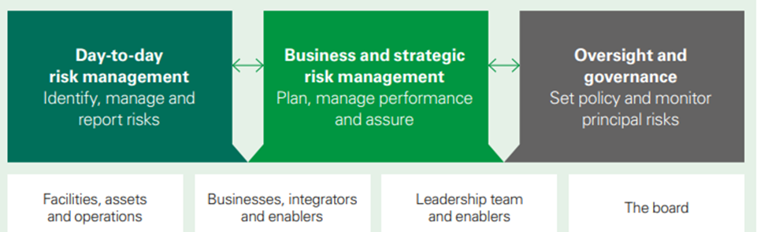
Figure 1: Source (BP Annual Report , 2021)
BP’s New Strategy
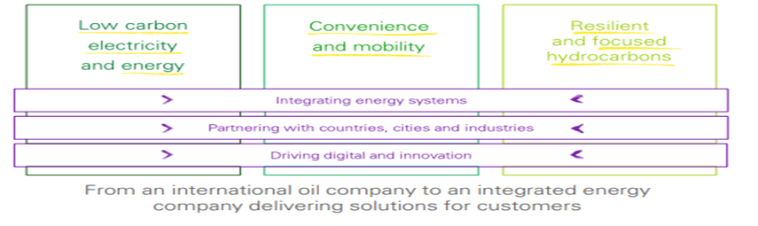
Figure 2: Source (BP Annual Report , 2021)

BP manages, controls, and reports its key risks and challenges including financial risks through a set of internal control risk management activities as shown in Figure 1. It includes the company’s structures and culture, management systems, policies, and procedures for managing the risks efficiently. BP’s risk management system functionalities include determining key risks, managing them appropriately, and reporting the same to management based on their criticality and urgency. Various risks including financial risks are determined at BP as an ongoing process owing to the dynamic and evolving global business environment in which the company operates globally. Across its investments, the BP team assesses the key financial risks relevant to the specific investment based on their significance to a project or its size. The degree of uncertainty related to such investments across the company’s cash flows is also assessed for potential financial risks in terms of future costs and revenue projections, to manage them efficiently (BP Annual Report , 2021). For instance, the company’s financial performance is deeply impacted by the price fluctuations across oil, gas, and refined products, fluctuations in exchange rates, and changes in technology and related macroeconomic factors. The various reasons could increase financial risk and volatility across BP’s margins as oil, gas, and commodity prices are related to international demand and supply (Mucci, 2015). A decrease in these prices hurts its growth, revenues, and margins, which could also impact the viability of future projects. An increase in the prices may not always have a positive impact on BP’s financial health as there could be cost inflation and so on, impacting profitability in real terms (BP Annual Report , 2021). Likewise, introducing new carbon costs tends to increase operational costs for the company impacting its revenues and profitability. Trade restrictions, international sanctions, or related strategic decisions taken by the Government like exiting operations from Russia owing to its conflict with Ukraine could also increase BP’s financial risks. BP also faces financial risk if it fails to accurately predict or work within its defined financial framework. This risk would impact their operational capability resulting in the financial loss (BP Annual Report , 2021). Overdues, unsuccessful divestments, operational issues, legal proceedings, or even geopolitical events like the ongoing Russian-Ukraine conflict could impact BP’s financial liquidity impacting its credit score. This in turn could increase its financial and reputational risk.
BP’s risk management activities as stated in its risk management framework (Figure 1) prioritise risks based on various factors including risk assessment, level of current risk measurement measures, risk management strategy to be applied, and the various legal and regulatory compliances (Oxelheim, et al., 2020). For managing and mitigating its various financial risks, BP teams identify each risk and monitor it based on its importance and the urgent action required. The critical risks get forwarded to the higher levels in the company, where as part of the annual planning process, BP leaders review and assess such risks for further action (BP Annual Report , 2021). To further strategically monitor and manage its various risks, including financial risks, and adapt to changing business needs, BP has revamped its core strategy as seen in Figure 2 during the year 2020. The strategy with a focus on restructuring BP’s renewable energy investments will help the company to have decarbonised and sustainable business operations. To achieve its new strategy, BP has revamped its existing organisational structure, leadership, work processes, and the size of its workforce to attain a lean business model (BP, 2022). BP aims to integrate business opportunities of energy transition towards environmental and societal concerns creating long-term value across its stakeholders.

Analysis and Evaluation of British Petroleum’s source of finance
The company has been issuing shares to raise capital. BP is publicly-traded with shares listed on the London Stock Exchange, the Frankfurt Stock Exchange, and the New York Stock Exchange. BP has a market capitalisation of over $90 billion. Out of total equity, the company held a $47.3 billion profit and loss reserve (retained earnings) in comparison to a $46.7 billion share capital (BP Plc., 2021). BP's retained earnings are its profits but have not been distributed to its shareholders. The retained earnings are used by the company to finance its expansion and growth.
The company’s share capital consists of ordinary shares, 8% cumulative first preference shares, and 9% cumulative second preference shares. BP's shareholders' equity as of the end of 2021 was $75 billion, while non-controlling interests accounted for about $15 billion (BP Plc., 2021). As of March 2022, major institutional shareholders in BP include BlackRock Investment Management (UK) Ltd. (3.30%), The Vanguard Group (3.22%), and Norges Bank (2.97%) (in Financial Times, 2022).
As BP plans to transition from oil to clean energy, the company seeks to sell assets worth $25 billion by 2025 (Shabong, 2021). The company plans to use the proceeds for buying back around $2 billion in shares every year. BP generates significant operating cash flows, which it uses to finance operations and pay dividends. In 2021, the company reported $23 billion in operating cash flows (BP Plc., 2021).
BP has a large debt portfolio. In 2021, its total obligations were $196 billion, while its finance debt totalled $61 billion ($55.5 long-term and $5.5 short-term). BP has debt from various sources, including commercial banks, investment banks, and other financial institutions. BP’s debt is also generated through various sources, including bonds, loans, and credit facilities.
In 2020, the company raised around 12 billion in the form of hybrid bonds as the company wrote down 10% of its value ($17.5 billion) due to the COVID crisis and accelerated shift towards clean energy (Bousso and Singh, 2020). Hybrid bonds put less stress on the company as the principal is not to be repaid and is treated as equity for accounting purposes. The bond raise was made in the US (dollars), UK (pounds), and EU (euros) to diversify the currency risks. At the end of 2021, the gearing ratio (debt-to-equity) stood at 25.3%, which is well within BP’s target of 20% to 30% (Bousso and Singh, 2020). This is a high level of debt relative to other oil companies, which typically have debt levels that are less than 20% of their market capitalisation.
BP’s debt levels have also been affected by some one-time events, such as the Deepwater Horizon oil spill in 2010, when the company raised $10 billion in bonds (Erman et al., 2010). Despite its high level of debt, its credit ratings remain investment-grade. In 2021, BP achieved its net debt target of $35 billion ahead of schedule (Shabong, 2021).

Different strategies that BP Corporation uses to manage its exposure to foreign exchange risks

The expansion of the British Corporation makes it one of the largest oil producers and sellers in the world (Madura et al., 2011). With its operations spread across several nations the revenue prospects of the company are at risk due to the volatility of the global market and the constant fluctuations in the currency of several nations. As is evident that the economic stability of a country is highly dependent on the stability of its currency value in the global market, this prospect in addition to the lack of uniformity in currency across the nations makes it difficult for international companies to effectively manage their finances. According to Eun et al., (2012), the volatility in currencies across the globe has led to the adoption of the American dollar ($), as a standard form for transactions in the global markets, this is due to the higher stability and low inflation rates attached to this currency. Subsequently, international companies like BP utilize the mechanism of Purchase Power Parity (PPP) to comprehend the value of a currency in the global markets and determine its fluctuation ratio in accordance with the standard American dollar ($). The volatility in the currency of a nation is backed by the poor economic performance of the country and the high rates of inflation prevalent there. Operations in such a scenario become unviable for the company as it has to trade off a higher amount of finances to counter the adverse effects of the economy in the region. Further, such volatility in currency exchange makes it difficult for companies to transact and maintain viability on a global scale.
Some of the strategies that the BP group implements as measures to counter the foreign risks are:
Transacting in its currency: BP PLC ensures that the major transactions that the company undertakes in the global market are carried out in the standard global currency of American dollars ($). This enables the company to ensure stability in its finances and avoid the risks associated with the volatility and Purchase Power of the currency.
Natural Foreign Exchange Hedging: This technique usage enables the company to avoid the use of financial derivatives. Since BP PLC has several subsidiary holdings across the globe it can maintain the receivables and payables with the company in denominations of the standard foreign currency, thus maintaining its viability in the volatile market of the nation.

The effectiveness of issuing stocks internationally by BP

Corporation in financing projects
International financial management is vitally important to BP in managing its investment portfolios and financing its infrastructural projects. International fiancé management refers management of finance and capital in the global context and business environment (Fernandez & Jimenez, 2019). It s achieved by trading stocks and returns from foreign currency exchange.
BP has relied on several project finance measures to finance its numerous projects. Due to the long term and uncertain natures of BP exploration and production projects in the fields, Debt financing is not always suitable for the company. BP, therefore, heavily relies on equity capital and equity funding to finance their projects, and stocks are most reliable in raising equity capital (power et al., 2019).
According to Schubert and Strych (2018), “The principal benefit of starting a public limited corporation (PLC) is that it bequests the capability to raise equity capital by issuing public stocks and shares." In 1970, the British government, which had the controlling stake at BP (100%), decided to raise capital funds that would help the company expand its exploration capabilities beyond its initial fields in Iran. To achieve this, the UK government issued public shares taken up by the public, which effectively reduced its controlling stakes to 65% only. It would, later on, sells all its remaining shares and BP PLC became a fully-fledged private entity (Power et al., 2019).
Since then, the company has continued to rely on stocks in its project finance agendas. In 2022, for instance, after the Russian invasion of Ukraine, the company announced that it would sell its 20% stake in Russia's government-controlled oil-producing company known as Rosneft and use the proceeds raised to explore and invest in other markets and projects (Ratanabanchuen & Saengchote, 2020).
Stocks and public shares have also been instrumental in financing other global projects owned by BP. Deep in the Oman deserts in the Arabian peninsula lies one of the most expensive and lucrative projects ever owned by BP. Apart from investing $650 million in profit proceedings from their previous year’s financial reports, BP also sold its stake to public investors to invest and finance its alternative and Renewable energy efforts in Oman.
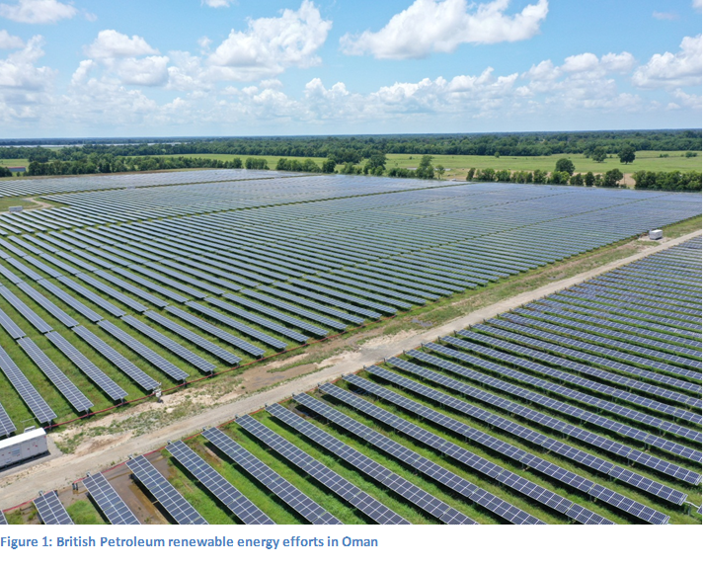
According to current BP CEO Bernard Looney, the plan is to cut BP's future non-renewable energy production by 40%. To achieve this, BP will sell $25 million worth of fossil fuel-related assets through issuing public shares and stocks and then reinvest the money in alternative and renewable projects.

Conclusion
The current report considers the case study of BP Plc (BP) to evaluate its international financial management strategies. The report has critically evaluated the reason for BP to consider internationalisation and how country risks impact BP’s investment opportunities in host nations. The analysis of how macroenvironmental factors deeply impact a company’s international business operations both in its home country and other host nations. The report also discusses the strategies adopted by BP for managing its financial risk, foreign exchange risks, and working capital management.

References
Acharya, V. V., Engle III, R. F., & Steffen, S. (2021). ‘Why did bank stocks crash during COVID-19?’ (No. w28559). National Bureau of Economic Research.

Alcadipani, R. and de Oliveira Medeiros, C.R., (2020). ‘When corporations cause harm: A critical view of corporate social irresponsibility and corporate crimes’. Journal of Business Ethics, 167(2), pp.285-297. https://link.springer.com/article/10.1007/s10551-019-04157-0

Ahmed, A. H., Eliwa, Y., & Power, D. M. (2019). ‘The impact of corporate social and environmental practices on the cost of equity capital: UK evidence’. International Journal of Accounting & Information Management.

Argyridou, S., Zaccardi, F., Davies, M.J., Khunti, K. and Yates, T., (2020). Walking pace improves all-cause and cardiovascular mortality risk prediction: A UK Biobank prognostic study. European Journal of Preventive Cardiology, 27(10), pp.1036-1044. https://journals.sagepub.com/doi/pdf/10.1177/2047487319887281

Bp.com.2022. Available at: <https://www.bp.com/> [Accessed 26 March 2022].

van der Ven, W.H., Schuurmans, J., Schenk, J., Roerhorst, S., Cherpanath, T.G.V., Lagrand, W.K., Thoral, P., Elbers, P.W.G., Tuinman, P.R., Scheeren, T.W.L. and Bakker, J., (2022). Monitoring, management, and outcome of hypotension in Intensive Care Unit patients, an international survey of the European Society of Intensive Care Medicine. Journal of critical care, 67, pp.118-125. https://www.sciencedirect.com/science/article/pii/S088394412100232X

BP Annual Report , (2021). Performing while transforming, London: BP.

BP p.l.c. Group results, (2021). BP p.l.c. Group results - Third quarter and nine months 2021, London: BP .

BP, (2022). www.bp.com.
Available at: https://www.bp.com/en/global/corporate/what-we-do/bp-at-a-glance.html
[Accessed 25 April 2022].

Madura, J., (2021). International Financial Management. Singapore: Cengage Learning.

Mucci, A. S., (2015). Managing Political and Investment Risk in the International Oil and Gas Industry, St. Louis: University of Missouri.

Oxelheim, L., Alviniussen, A. & Jankensgard, H., (2020). Corporate Foreign Exchange Risk Management. Oxford: Wiley.

Tarbell, M. I., (2020). The History of the Standard Oil Company. Alexandria: Library of Alexandria.

Bousso, R., Singh, K., 2020. BP raises nearly $12 billion in first hybrid bonds issue. Reuters. viewed March 28, 2022, from https://www.reuters.com/article/us-bp-fundraising-bonds-idUSKBN23P1OUBP.:LSE Profile. 2022. Financial Times. https://markets.ft.com/data/equities/tearsheet/profile?s=BP.:LSE

BP Plc., 2021. bp's fourth quarter and full year 2021 results - 31.12.2021 BP SEA (Q4). BP. viewed March 28, 2022, from https://www.bp.com/content/dam/bp/business-sites/en/global/corporate/pdfs/investors/bp-fourth-quarter-2021-results.pdf

Erman, M., Aubin, D., Siew, W.. 2010. BP considering debt financing options. Reuters. viewed March 28, 2022, from https://www.reuters.com/article/us-oil-spill-bp-bondoffer-idUSTRE65G44C20100617

Shabong, Y., 2021. BP hits $35 billion net debt target well ahead of schedule. Reuters. viewed March 29, 2022, from https://www.reuters.com/article/uk-bp-debt-idUSKBN2BT0IN

Bp.com 2022. Available at: <https://www.bp.com/> [Accessed 6 April 2022].

Eun, C.S., Resnick, B.G. and Sabherwal, S., 2012. International financial: global edition. McGraw Hill. https://repository.vnu.edu.vn/handle/VNU_123/82617

Madura, Jeff & Fox, Roland, International Financial Management, 2nd edition, Cengage Learning EMEA, 2011. (A more accessible and practical approach)

Fernandes, A. J., Jimenez, A., Kraak, J. M., & Tsagdis, D. (2019). Managing political risk in the oil and gas industry in a developing economy: the case of BP in Angola. European Journal of International Management, 13(5), 733-755.

Schubert, R., & Strych, J. O. (2018, July). The Real Effects of possible Stock Recalls on Acquirer Stocks: Empirical Evidence from M&A Premiums. In 31st Australasian Finance and Banking Conference.

Ratanabanchuen, R., & Saengchote, K. (2020). Institutional capital allocation and equity returns: Evidence from Thai mutual funds’ holdings. Finance Research Letters, 32, 101085.

