My Screenshots/Photos
- Please add 4–6 screenshots or photos of your digital life.
- You can use your phone or laptop.
- For each screenshot, write one or two sentences explaining what it shows.

Screenshot/Photo 1

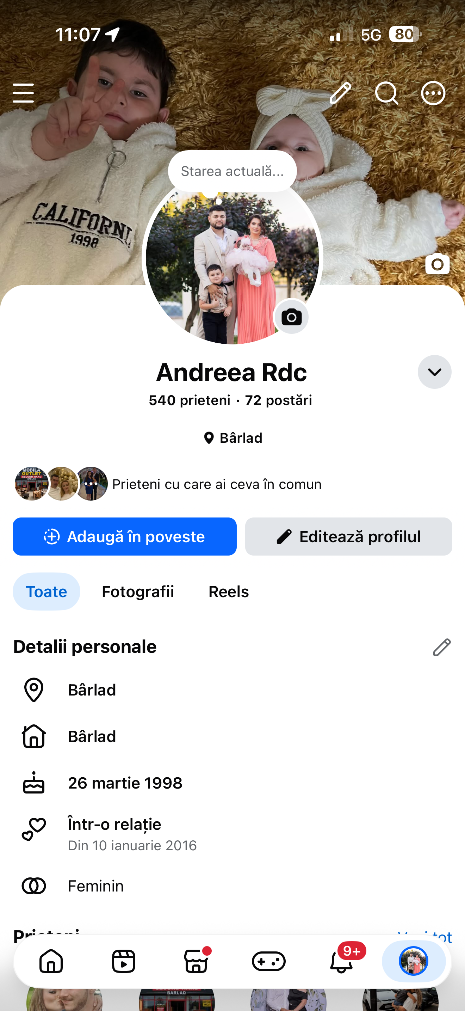
This is my Facebook profile.

Screenshot/Photo 2
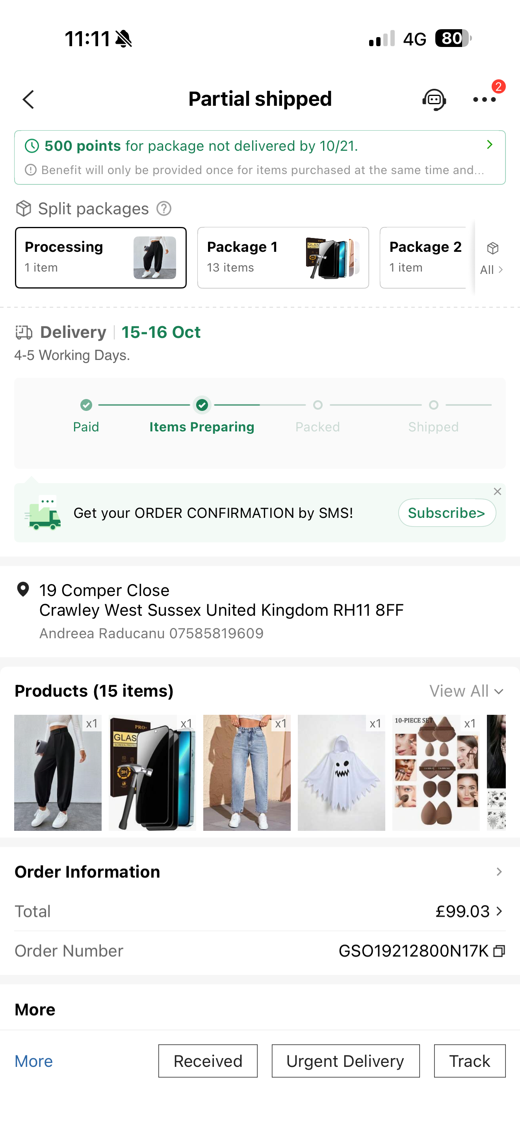
This my SHEIN order.

Screenshot/Photo 3

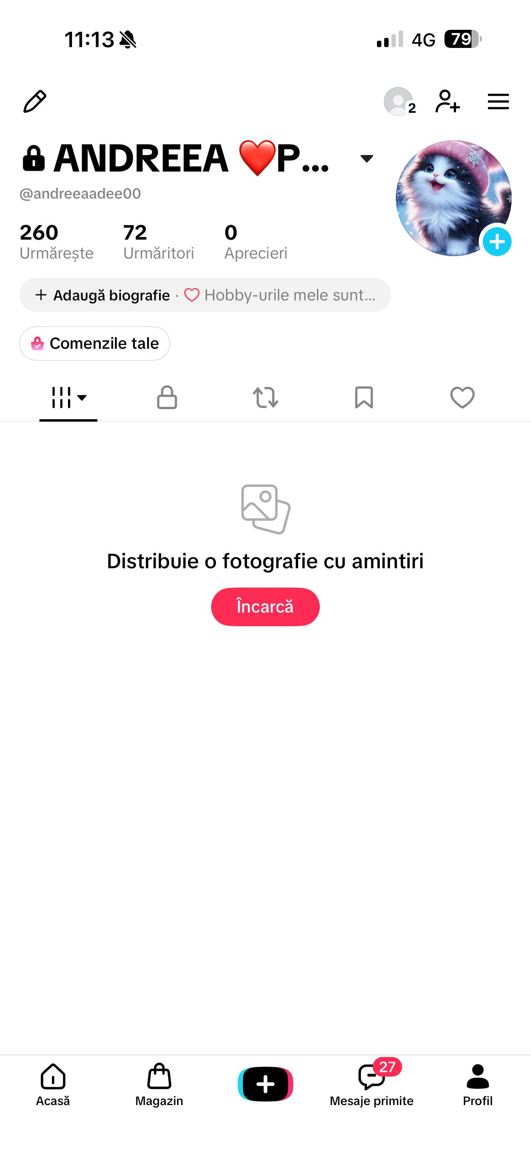
[Insert Photo/Screenshot below]
This is my TikTok profile.

Screenshot/Photo 4
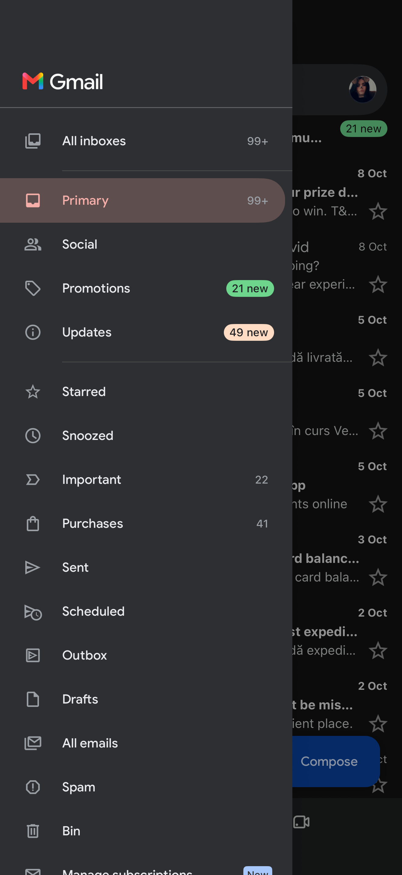
This is my email.

My Short Reflection
- Write 5–8 simple sentences about your digital life.
- You can use the sentence starters below if helpful.
I feel confident when I spoke about me.
I hope this module will help me how I understand using.
I sometimes feel nervous about my SHEIN order.
I want to improve digital skills in my future.
I use digital tools to communicate with and friends and family.

Sentence starters
- I use digital tools to …
- I feel confident when I …
- I want to improve …
- I often use these tools: …
- I sometimes feel nervous about …
- I hope this module will help me …
- Digital skills are important for me because …
You can write more if you want.

Submission Checklist
Before you submit, please check:
​​​ ☒ I added 4–6 screenshots
☒ I wrote short sentences for each screenshot
☒ I wrote my short reflection
☒ My work is my own
☒ My file opens correctly
​​☒ My file opens correctly

