

Student name: Vidhi Jayantilal Kawa
Student ID: 2109442
Module name: Strategic Management
Module code: LCMB7003
Lecturer name: Gladius Kulothungan

Table of Contents
Introduction 3
Background of the Company 3
Mission and Vision 4
Mission 4
Vision 4
Strategic Objectives 4
Success Factors 5
External Analysis 6
6
PESTEL Analysis 6
Industry Analysis 11
Industry Life Cycle 11
Introduction 12
Growth 12
Maturity 12
Decline 13
Porter Five Force Analysis 13
Bargaining Power of Suppliers 14
Bargaining Power of Customers 14
Threat of Substitutes 15
The threat of New Entrants 15
Industrial Rivalry 15
Internal Analysis 16
Financial and Business Highlights 16
Value Chain Analysis 17
Primary Activities 18
Secondary Activities 18
Swot Analysis 19
Strategic Resources and Capabilities 21
VRIO Framework 22
Strategies to Sustain Competitive Advantage 23
Growth Strategies 23
Green Strategy and CSR 24
Conclusion 25
Recommendations 25
References 26

Introduction
Netflix is a streaming service based on subscriptions which are located in America. The report states that the company's strategic objectives follow the company's internal and external analysis. It also states achieving the strategies and their advantages and disadvantages. The process of getting them done is also mentioned in the analysis, followed by the analysis of its value chain and the logistics that come from them. Finally, the CSR-based activities and the green marketing strategy of the company are also mentioned in the report. The case study used for the report states the expansion of the company into the Indian Market, specifically Bollywood. The case study also states the primary factors responsible for expanding the business in the Indian Media and entertainment market and their barriers.

Background of the Company
The company was started in the year of 1997 in August. The location for the establishment was in the Scotts Valley, California in, the US. Currently, it has over 221.6 million subscribers worldwide, and among them, 74.6 million are from the US. The company's current revenue as of the year 2021 is 29.7 billion US dollars. The income of operation is around 6.195 billion US dollars, and the net income was 5.116 billion US dollars in 2021. The total assets are around 44.585 billion US dollars, and the company's total equity is stated to be around 15.849 billion US dollars as of the year 2021. It has a total of around 12,135 employees all over the world as of the year 2021. The current divisions of the company include the US streaming services, International streaming services, and finally, Domestic DVD services. As of August 16th, 2022, the current number of subscribers is around 222 million (Netflix.com, 2022).
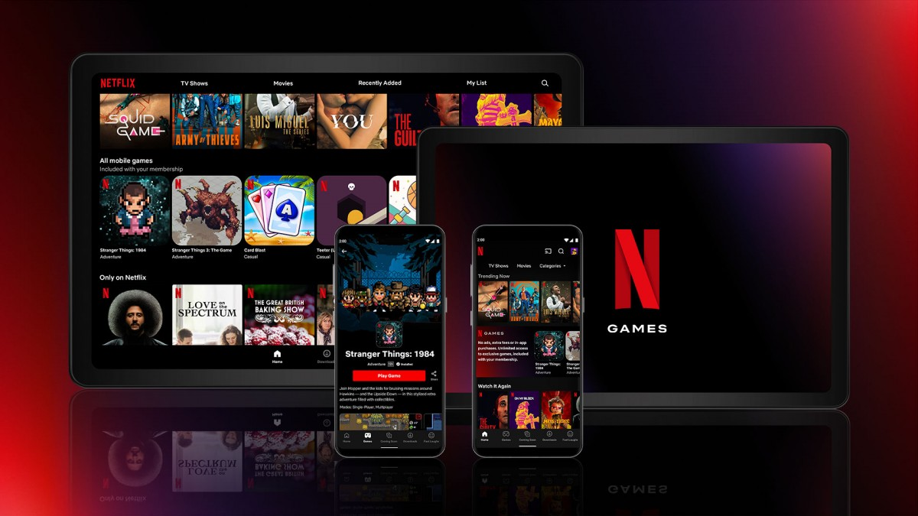
Figure 1: Netflix
(Source: Netflix.com, 2022)

Mission and Vision

Mission
The company's mission statement states that they generate a promise to their customers to provide high-level stellar service and act as a valuable partner to their suppliers. They also show their investors that they act as a prospect for sustained profitable growth, and the employees create a huge alluring impact on them. They target entertaining the entire world as much as possible.

Vision
The company's central vision is to become a worldwide distribution service for entertainment for the people. They provide licenses for entertainment services to people around the world. The markets become accessible to the people as well. Its core strategy is formed based on the vision of the company and its states the streaming subscription for both growth of the business globally and domestically as well. The ability to show the entertainment service to the people and the customers worldwide is the company's primary agenda, formed from their vision.

Strategic Objectives
The main objective of the company Netflix is to provide a high-level entertainment service to customers worldwide. The primary subscriptions for the streaming service are the company's main agenda. The company's objectives are to provide excellent service to the customers as much as possible, which is formed from its mission and vision. They extend by building a value to the suppliers who provide the primary entertainment services, thus leading to the investors creating a good prospect for the company's sustainable growth. The employees also get a good impact on the company, which is also needed for their career growth. They generally end up following a competitive strategy in both the International and the Indian market, and they have developed them into one of their generic strategic objectives (Netflix.com, 2022). They also have the objective of forming proper relationships with the production studios to expand their video library in the form of TV series and movies. They finally have the strategic objective of giving them proper access to all internet-based devices.
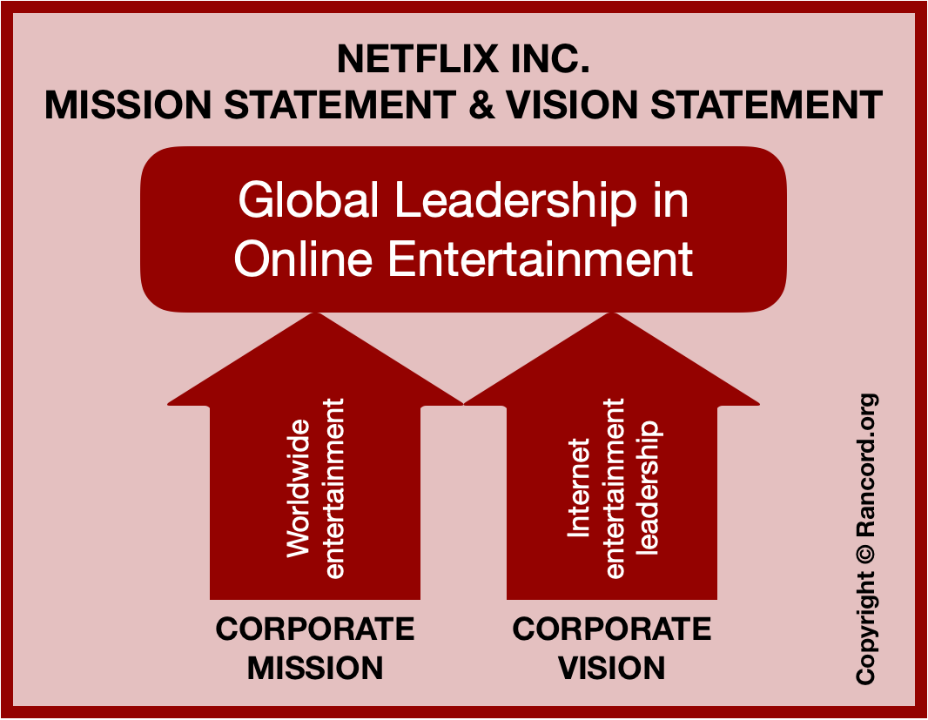
Figure 2: Netflix Objectives
(Source: Netflix.com, 2022)

Success Factors
Several Factors ae mentioned out of which some leading to the strategic success of Netflix in the Indian Market, specifically Bollywood. The most significant factor is creating and generating a substantial disruption through the technology. The disruption would generate a substantial impact on the strategies. They are flexible and will generate a good impact on the strategic formation of the company's goals. The options are of a variety in nature, and the strategy of the original content of providing three entertainment services is the main target. The content is advertisement free, and therefore, the user experience is also enhanced to a large degree. The recommendations engine is also personalized in nature, and therefore it generates a substantial success in the company's strategies in the Indian Market (Park et al. 2021). The success factors aim to ensure the company can get the most significant number of subscribers and customers in the digital platform and therefore generate a vital revenue source. It has been mentioned that the success factors play a good role in the company's management, and the customers do not feel disturbed by ongoing advertisements in the streaming service.

External Analysis

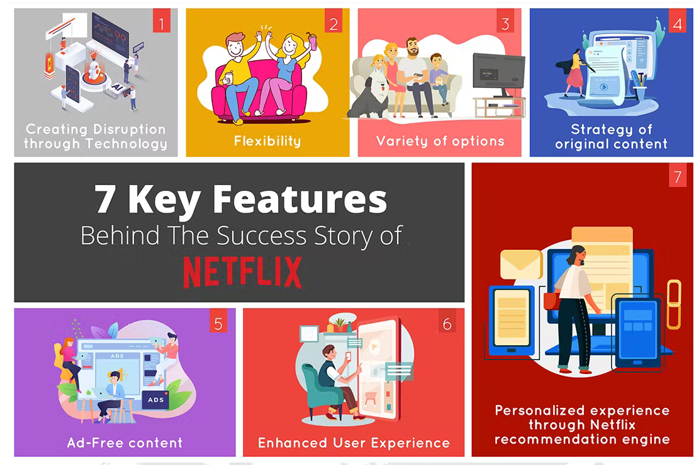
Figure 3: Netflix Success Factors
(Source: Park et al. 2021)

PESTEL Analysis
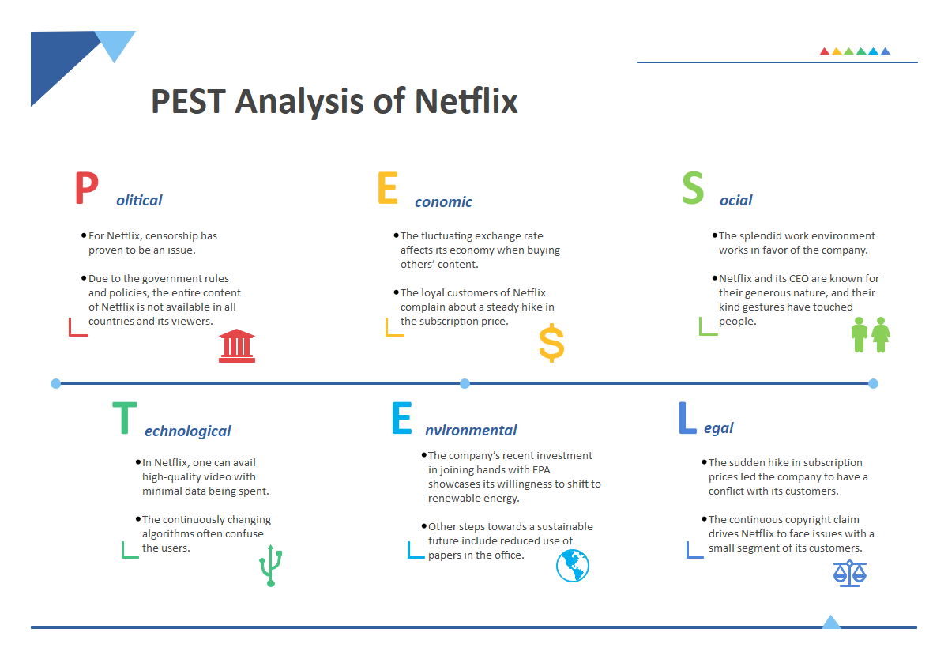
Figure 4: Netflix PESTEL Analysis
(Source: Dinh, 2019)
Factors | Impact | Effects
Political | High | - From one government to the following, the policy is made consistently. The consistency of the government is the major political factor in the analysis.  - The country's court is, to a significant part, independent in commercial and business matters.  - In an open, transparent, and stable governmental climate, Netflix Svod can prosper. The corruption degree of the country will be lowered and the rate of openness will be promoted by the institutions which are democratic in nature and it will become stronger. (Elodie, 2021).  - The strong record of track of the government in observing treaties which are international signed with numerous partners who are global. Each party's administration has gone through on previous governments' accords, ensuring uniformity in both the rule of law and regulations.  - The regulatory standards align with global norms, contributing the country's improved "ease of doing business" score.
Economic | High | - The consumption of Credit binge has ended up going to the United States because of increasing of the stagnating and pending income of the household. It has demolished the saving culture because the people do not possess the money to carry out savings. Netflix Svod should make use of caution when the development of a marketing plan is currently based on "Purchase on Credit" consumer behavior.  - The Index of Gini and the range of inequality are perfect indicators of the harmony of the society and the current growth when there is a wide disparity in income in a society, the chance of conflict and crime rises.  - The productivity of the Workforce in the country of US has risen by 25-30% over the last two decades, even as though payment has not continued. It has the potential to allow Netflix Svod to employ qualified workers at competitive wages (Matevosyan, 2020).  - It will supply a sufficient number of clients for Netflix Svod's products, and further leading to also the making of more costly for Netflix Svod for the acquirement of skilled and talented personnel.
Social | Medium | - The saving form of culture in the China and the United States is vastly different. While the rate of savings in the country of China is about 30%, further it is further stated to be far lower than in the United States, at less than 15%.  - Before new products are developed, Netflix Svod should carry out the study of the trends of demography and features which are incorporate by nature that lead to this audience(Ruiz et al. 2020).  - The birth rate is also very high, making it a good factor in the system. The stagnant economy of the birth rate is driven high, thus playing a string factor in the analysis.
Technological | High | - As E-Commerce is essential to the Netflix Svod form of the model of business, it should be able to assess its e-commerce infrastructure, technological infrastructure, etc.  - Netflix Svod should develop a plan to integrate social ideals, infrastructure, and the Netflix Svod business model.  - The licensing of IPR and other digital assets rules and culture has to be properly examined such that Netflix Svod can prevent IRP thefts and shakedowns.  - Netflix Svod should be ready to consider the context for right which are intellectual when entering a new market. (Medhat et al. 2021)  - Netflix Svod should carry out examination of the mobile phone network and internet network of the country and penetration of the mobile phone before the development of a business plan appropriate to local realities and requirements
Environmental | Low | - Netflix Svod should be aware of the amount of customer advocacy over environmental issues. It will assist Netflix Svod in producing environmentally friendly goods and overcoming public relations stumbling obstacles.  - The per capita carbon emission and the national emissions will help in the environmental impact in the analysis. The prediction of the policy is also stated in the factor.  - Often, national and local environmental policies diverge. This can assist Netflix Svod in making various choices, including the factory location, pricing strategy and product development (Figueroa López et al. 2020).  - The efforts of the Netflix Svod and the present CSR are applicable in the new market. The initiative of the new environment is from the prospective market.
Legal | Low | - Netflix is not subjected to any judicial review, and the common law does not apply to them in a good way. The judgments are also not very high, and the process of maintaining the law is also low.  - Transparency is required for consistent and equitable decision-making. Netflix Svod can plan forward with greater confidence if the method is consistent and open.  - Netflix Svod must analyze the data regulations of the country and understand the steps that must be ensured to reach compliance.  - The stock exchange and its laws do not have a high amount for the company.  - The employment laws also do not have a high enough impact on the company. The employees seem to be very happy with the labor reform and others who have made good contact in the company (Khuan, 2022).  - Netflix Svod should evaluate the amount of protection provided by the country's legal system for intellectual property rights.  - The court's independence typically reflects the country's institutional strength and reputation.
Table 1: PESTEL Analysis
(Source: Self-Created)

Industry Analysis

Industry Life Cycle
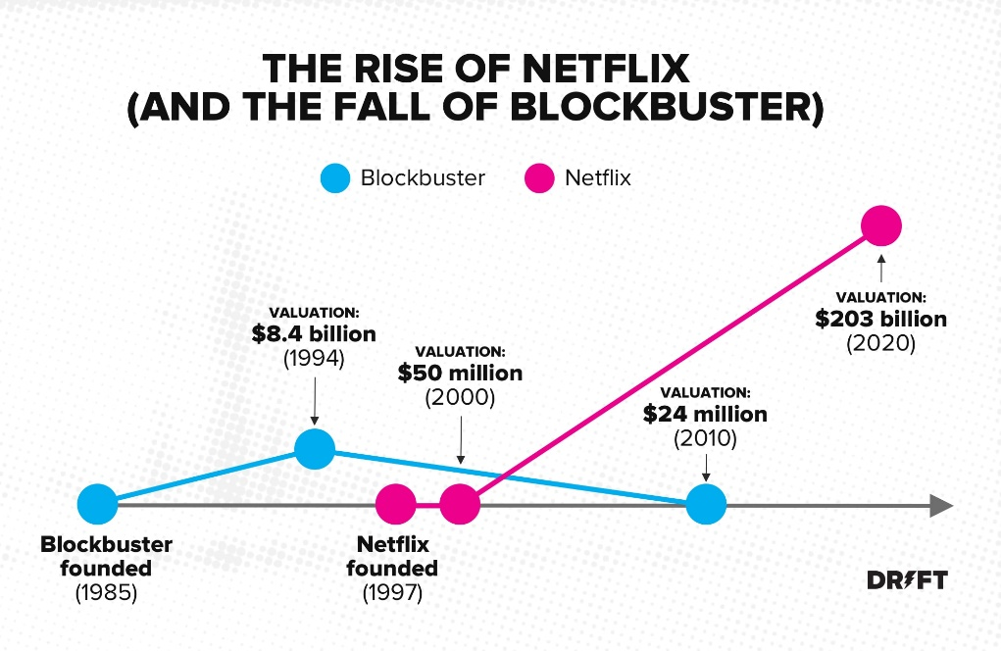
Figure 5: Netflix Industrial Life Cycle
(Source: Snyman and Gilliard, 2019)

Introduction
The first stage of the life cycle describes the start of the company. The company had started by renting DVDs for movies and Tv series to the customers in the US. The pay-per-rental system was introduced first and thus used in the life cycle's first stage. The company would post the first stage at the customers' doorstep in their homes, making payments to the company accordingly. The customers would post the DVDs back to the company once they had finished viewing them. The demand for DVD rental also started to increase slowly in the first stage, and the net subscribers also started to increase to 3.6 million people (Kokas, 2020). The streaming service started in the year 2007. The streaming service started on the online platform, and therefore the market started to increase more for the company. The increased stage allowed the market to expand and slowly entered the growth stage in 2007. The DVDs started in the first phase of the cycle and slowly developed into the cycle's growth stage accordingly. This is the first stage of the cycle.

Growth
In 2007 the DVD market of Netflix started entering the growth stage with its inauguration. The strategies' growth phase also states how the DVD business turns into a streaming service. The growth phase saw massive growth in the phase, and the competition also increased a significant amount. It has also been seen that the growth phase saw a high increase in the business grounds, which is responsible for the expansion of the business. The number of subscribers also increased to 2.3.66 million in 2013, which kept on increasing in the current years. The number of competitions in the business also kept increasing in the coming years, which has been seen further in the given field. Netflix used a "cost-plus" strategy for producing original programming, deviating from industry conventions (Burroughs, 2019). The corporation paid the total cost of production plus a premium of around 30% of the production expenses for TV series, but it kept full global rights to the programmers

Maturity
The current year of 2021 and 2022 is the timeline in which the company has reached the maturity stage. The current subscribers in the market for Netflix show that it has reached the epitome of market share and others in the current market. The current market of the subscribers in the company is the basis on which the company sets up its performance-based objectives (García López, 2020). The strategies are created and used in the following concepts to ensure they are correctly done. The current market for Netflix in the Indian domain is still moving to expand. The current policies have established them as the increased reach in the market. The maturity is also created in the current years, and it will continue to remain so in the market. IT was also mentioned that the maturity phase would allow the company to set up new ideas and keep on expanding further in the given domain. This is the target initiated by the Matoury phase in the industry life cycle of Netflix.

Decline
Netflix has not reached the decline stage in the current market. Netflix is currently dominating the streaming service entertainment market, and other platforms like Hulu and Disney + cannot compete with them. The current COVID market increased the demand for the services even further in the Indian context. Bollywood also entered the current market, which increased their demand further, allowing the company to gain a better revenue percentage in the current domain. The decline stage is not presented in the scenario, and therefore, the company has not reached the stage yet. It is also stated that it will be some time till the process by which the decline stage will be reached (Kerckhoffs, 2018). The decline stage is not present in the current market, and it is also stated that the maturity phase will continue in the current trends. The current streaming market also states that the company Netflix will continue to dominate the streaming market as much as possible in the current years, and therefore the strategic objectives are being met appropriately.

Porter Five Force Analysis
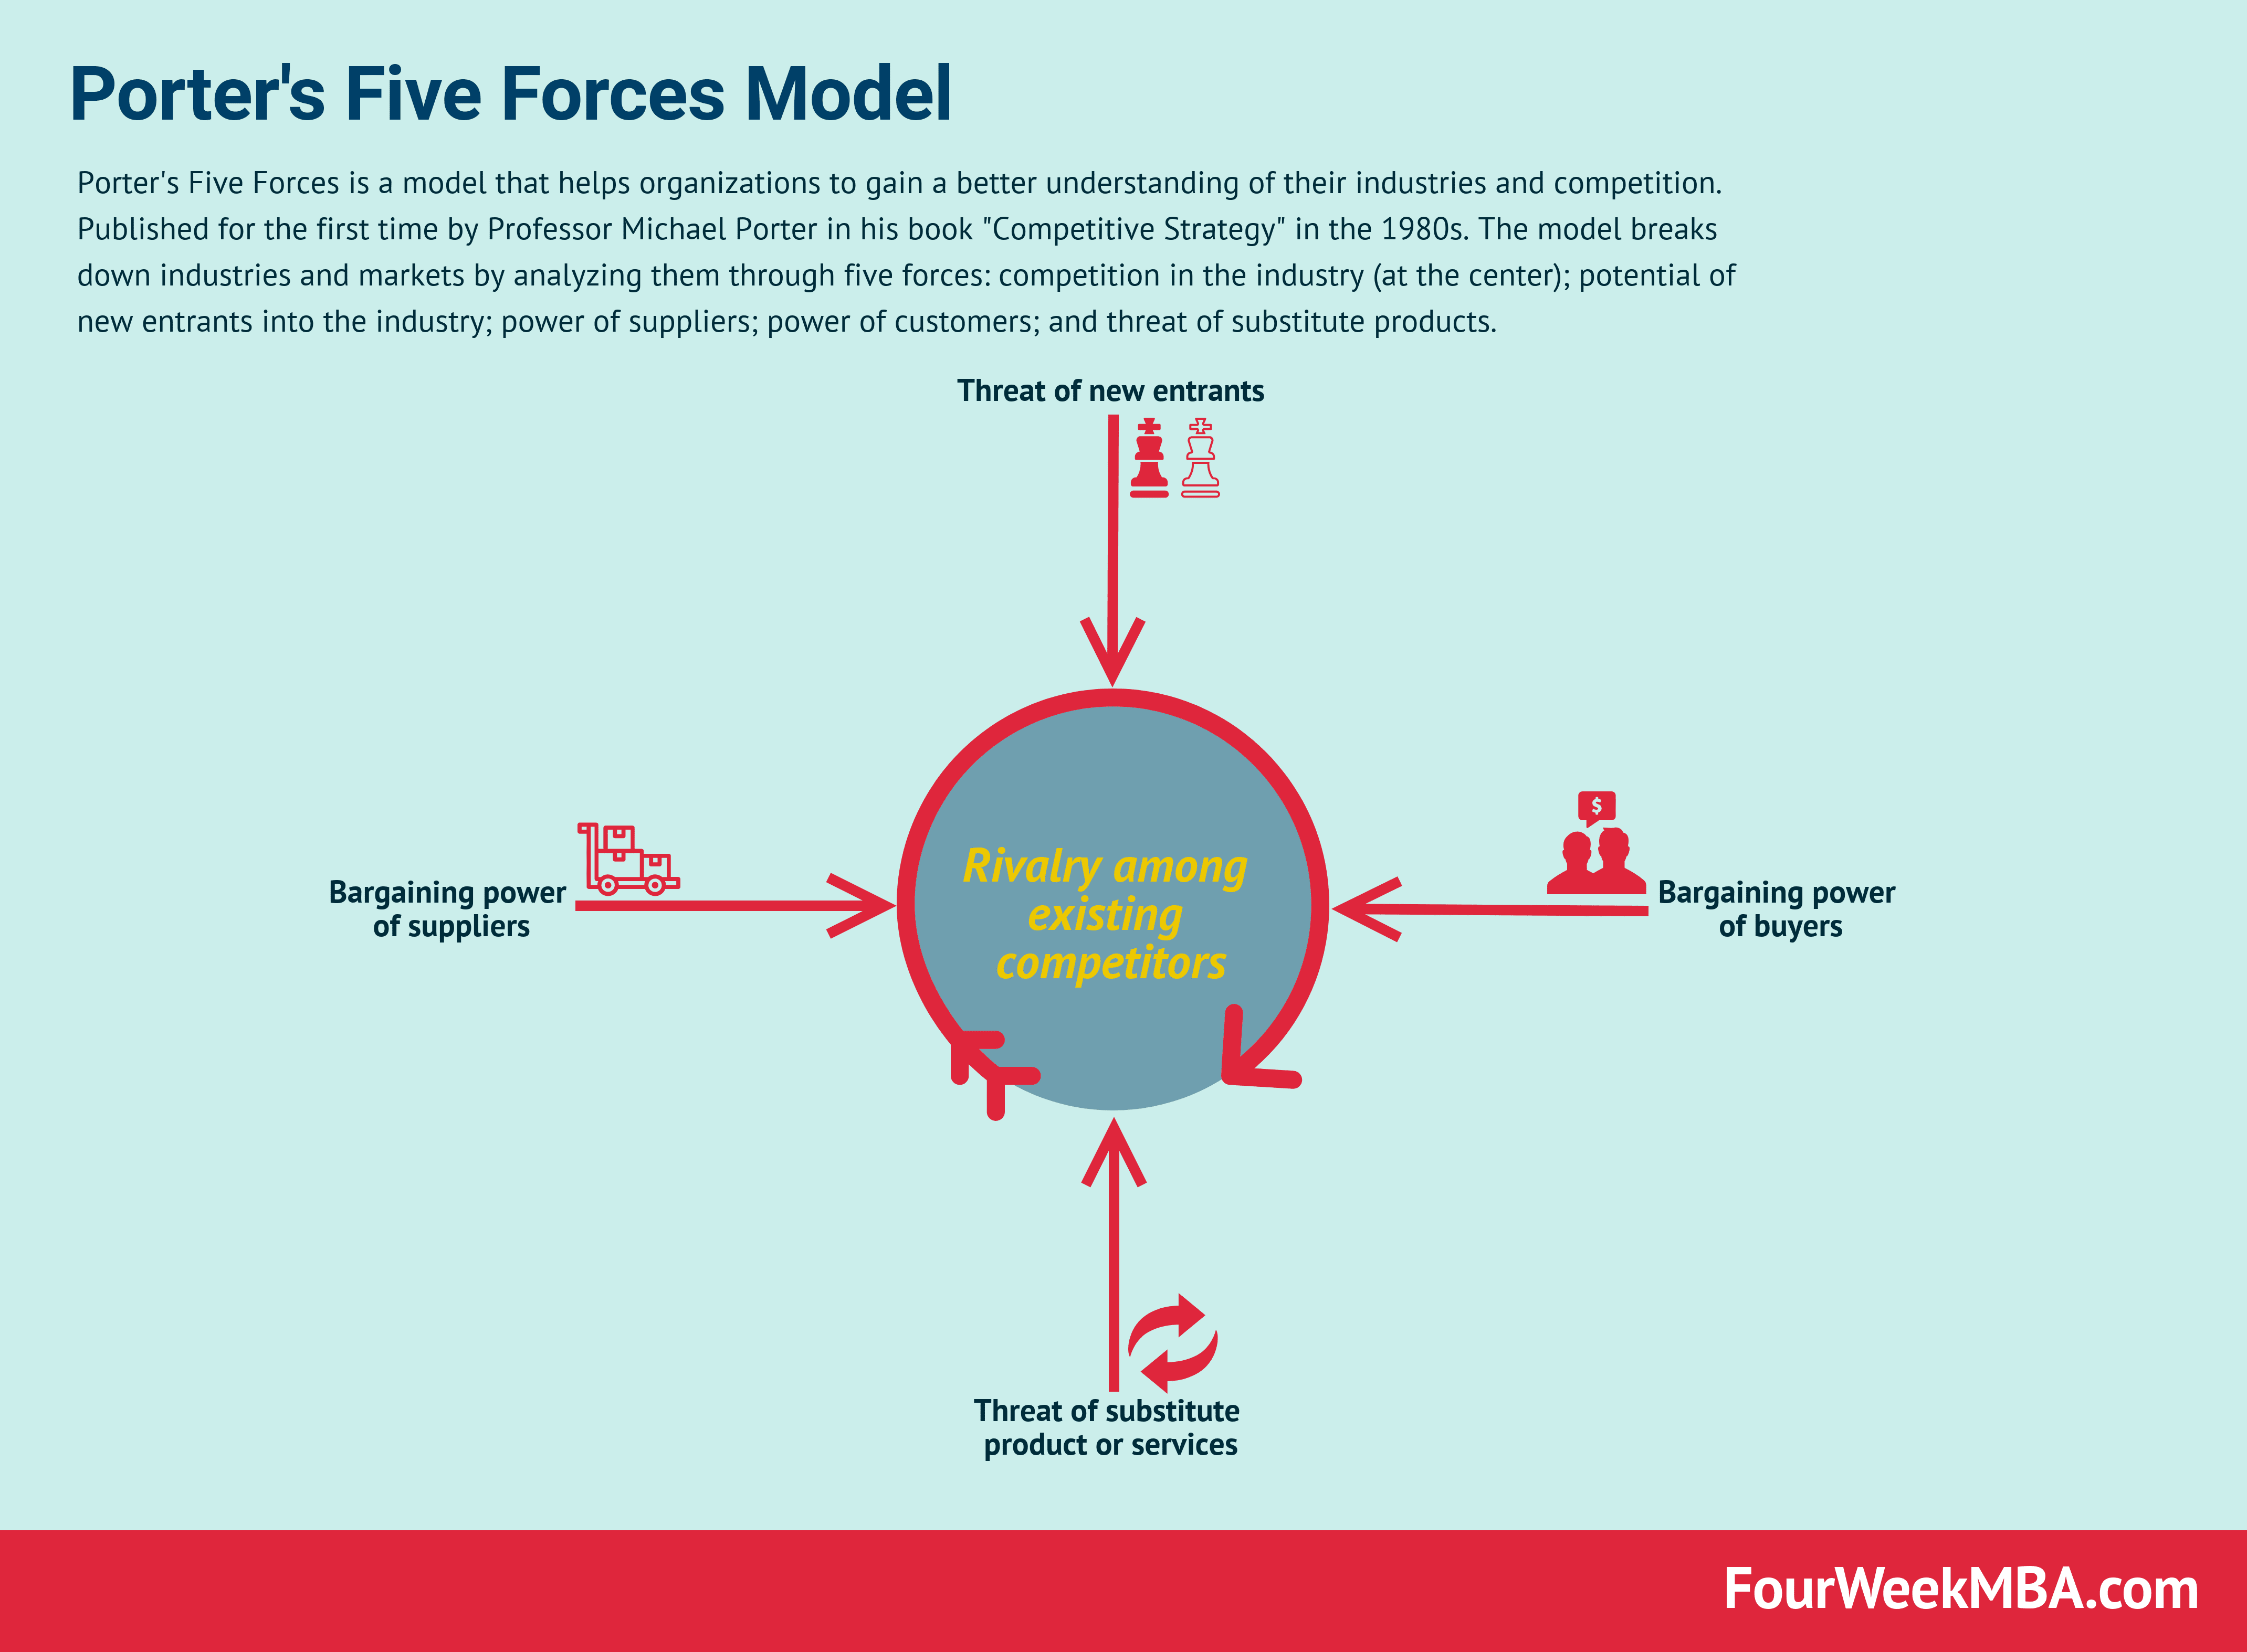
Figure 6: Netflix Porter Five Force Analysis
(Source: Kumar et al. 2020)

Bargaining Power of Suppliers
As previously said, content is crucial in terms of client acquisition and retention. Netflix obtains material through various methods, including the process licensing the content which is existing, generating new TV series, and acquiring the special and unique rights of distribution to the third-party-produced programming. Since 2013, Netflix has created 1500 originals, with roughly 58% of members citing access to the originals as the primary reason for their given subscription. Netflix is still heavily reliant on licensed programs, such as "Friends" and "The Office," the highly watched show in the year of 2020 (Kumar et al. 2020). This infrastructure is crucial. Netflix signs deal with television makers to use the Netflix button. The suppliers also play a vital role in the company's management, and the suppliers help develop them. The bargaining power of the suppliers is also done vastly in the system as well.

Bargaining Power of Customers
The number of monthly customers has the most significant impact on Netflix's income. Every consumer can cancel the service after each and every month with no resulting repercussions. The purchasing power of the Customers grows due to undivided availability of several different entertainment sources. According to Deloitte's 2021 The Trends of Digital Media study, 49 percent of the respondents stated they would stop utilizing the subscription of the video-on-demand services if the mentioned price was raised. The pricing of Netflix's is constrained by the ad-supported of the video-on-demand suppliers that cover their expenses through the advertisements and commercials but does not c give any extra charge membership fees. (Gregory, 2021). After a certain number of months, the majority of clients renew or return. The customers, therefore, have a vital role in the management of the system, and they will help develop the critical skills in the arrangement of the program. The power of the customers is also given highly in the system, and they will help further in the scale.

Threat of Substitutes
With the spread of technology, the entertainment sector has revolutionized. DVD rentals followed theatrical performances, and now streaming is available. Social media and video games are posing severe competition to movie viewing. According to Deloitte's 2021 The Trends of Digital Media report, Genz likes to listen to music, use social media, as well as play video games, while older generations prefer to watch movies. Adults spend 8.45 hours a week on average playing video games, and the gaming business is expected to reach $270 billion by 2025. Microsoft just paid roughly $70 billion for Activision to develop a gaming streaming network. Spotify, which provides tailored music recommendations, will surpass one billion downloads in May 2021 and have 232 million active users (Matevosyan, 2020). If the popularity of alternative entertainment channels continues, Netflix may risk replacement. Gaming poses a massive threat because, with the arrival of AR and VR, users can participate in ways that movies cannot. The rate of the increasing substitutes also causes significant problems in the system, and therefore they have caused significant problems in the growth of Netflix.

The threat of New Entrants
The content is the primary differentiator for every streaming platform. The expense of developing or licensing new software and the associated dangers are considerable. Furthermore, as a leading platform, Netflix has an unrivaled ability to bargain with producers, something a newcomer does not have. Though not as strictly controlled as conventional films, Netflix's original programming is subject to stringent screening to ensure unsuitable content is not shown. The material has caused some disagreements with local officials. The Netflix Recommendation Engine saves the company roughly a billion dollars each year and is highly successful at keeping consumers hooked. It is tough to create this patented technology. Over the years, Netflix has earned great confidence in the market and customers (Kannisto, 2019). Through its originals, it is regarded as a premium content supplier. Scale economies are non-existent. It has been seen that the new entrants are also increasing vastly with the help of the local channels and other such media.

Industrial Rivalry
Disney Plus, Amazon Video, and HBO Max Plus are the three main competitors, with over 100 million members. The most popular series on Netflix series include The Office and Friends. When Warner Media, which currently owns "Friends," launched "HBOMAX" and Comcast, which owns "The Office," launched "Peacock Premium," it lost the rights to stream them. Netflix has currently given apaid a huge price for these streaming rights fights. Every month, customers choose between subscriptions based on the material they want to read. The absence of switching costs boosts competition. The subscription video-on-demand sector is expected to increase at a CAGR of 12.2 percent between 2021 and 2026. This rapid expansion will allow enterprises to capitalize on and balance industry rivalry (Roig Telo et al. 2021). The Netflix Porter Five Forces Analysis above demonstrates the numerous aspects that influence its competitive environment (Galiotto, 2018). This understanding aids in evaluating numerous external business issues for any corporation. Examine the Porter Five Forces Analysis of other brands and companies comparable to Netflix. This section includes a wide range of brands and corporations.

Internal Analysis

Financial and Business Highlights
Netflix has just dominated the streaming service and cut deals with Japan to produce and stream Anime viewing services in the current times and year. Netflix is currently dominating the streaming service market and moving into all states of the required service. They also state that the current methods and strategies are mainly responsible for the company's current growth. Many such investors have started to invest more in the Netflix shares, as stated in the Wall Street journal. The shares reach new heights (Iordache, 2021). The operating avenue stated earlier is the leading financial highlight that the company is going through. However, the competition in the market also accounts for the 30% subscriber loss seen in the market. The Indian market is still growing further with the expansion of the services, and new additional shows and channels are being set up to grab the attention of the consumers and viewers. These are the business and financial heights of the company.
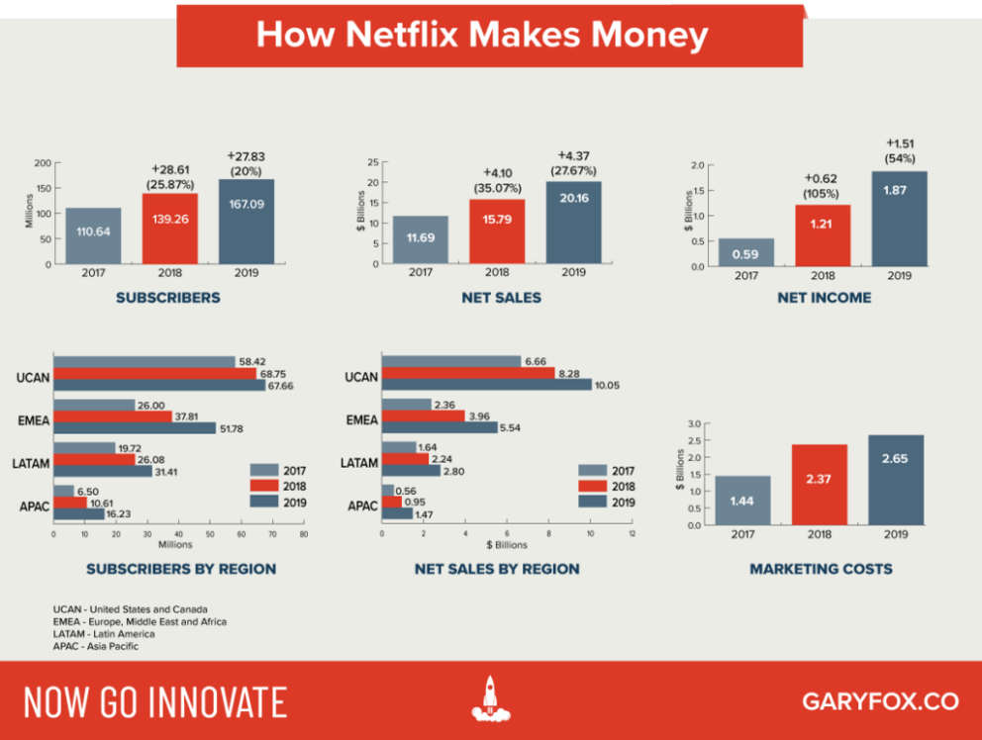
Figure 7: Netflix Business Highlights
(Source: Iordache, 2021)

Value Chain Analysis
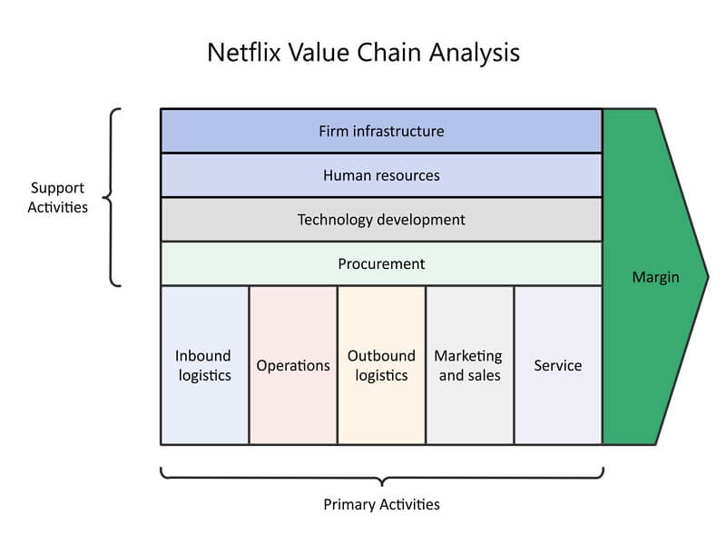
Figure 8: Netflix Value Chain Analysis
(Source: Ramasoota and Kitikamdhorn, 2021)

Primary Activities
The primary activities of Netflix include Operations, Inbound Logistics and Outbound logistics, services, sales and marketing. In the value chain of Netflix, inbound logistics refers to acquiring, storing, and dispersing product which are inputs. The Digital media is currently the information source in the value chain analysis of Netflix. Netflix currently has excellent working connections with content creators such as Warner Brothers and many more. The Servers of Netflix, which help to contain the material, employ cloud architecture (Burgess and Stevens, 2021). The consumers and Users can start and use the servers of Netflix from a variety of devices. All of these processes are supported by a dependable cloud infrastructure. It has search and organization capabilities. Netflix's marketing expenditure has grown dramatically in recent years. Netflix spent USD 2.65 billion only on marketing in the year of 2019. Netflix offers the best and most timely after-sales care to its clients. Its support team responds to clients' real-time questions about account or payment concerns (Ramasoota and Kitikamdhorn, 2021).

Secondary Activities
The secondary activities of the value chain analysis mainly constitute those framed by the infrastructure, the human resource management, the development of the required technology, and finally, the critical procurement activities. The company strategy is unique in that there are no physical storefronts. Employee incentive programs are another great way to motivate your staff (Rahe et al. 2021).

Swot Analysis
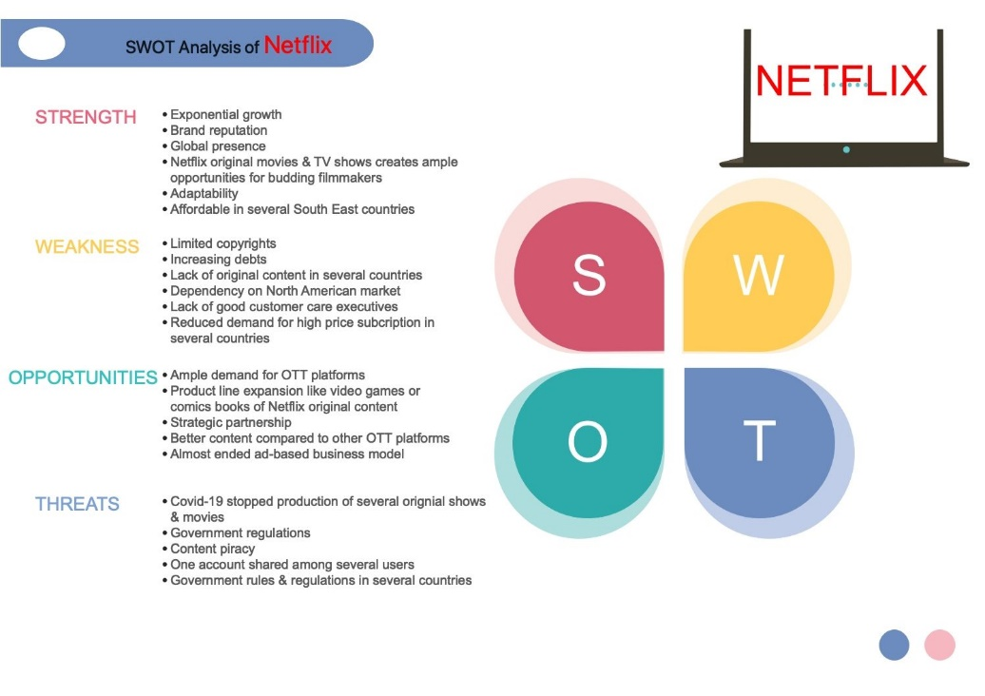
Figure 9: Netflix SWOT Analysis
(Source: Sakal et al. 2019)
Strengths | Weaknesses
- It has a firm brand name and image in the market. The reputation of the market is also very high in the market. The top-rated television programs have been substituted in the Indian market by Netflix shows and streaming services. The growth in the recent tears has also been shown to be very high.  - They are generally very affordable to the customers and clients in southeast Asian countries like India. They have an added advantage in the market. This helps them a fabulous good result in the market scenario (Wu and Zhou, 2021).  - The original TV series and movies are of high priority in the market. The ample opportunities in the market are great in India's current and recent market. The theme of the movies and the shows is also highly anticipated by the customers, and they seem to enjoy them highly in the current market.  - The adaptability rate of the company is very high. The company can adapt to the current market trend and develop shows and series with good stories depending on the new themes. The viewer’s choice is also modified based on the market's high demand, especially in India. | - The copyright of the company is also very much limited in the market. The company is also increasing the series of debts. The debt is also increasing in the company, causing a significant weakness in the market.  - The original content is also not very high in the market, and several countries end up showcasing the Tv series of movies from other countries. Some countries do not have helpful original content in their market, which has caused one of the major weaknesses. Many customers do not accept the high subscription prices in developing countries, which has been stated to be a significant weakness. The demand also ends up decreasing based on the high process (Maddodi, 2019).  - The company market for customers is very niche as it mainly involves the North American customer base. The North American customer base is minimal, another major weakness in the system.  - The customer care executives that other companies have are not present on Netflix. This is one of the company's most significant weaknesses, which prevents them from working and operating correctly in the target markets.
Opportunities | Threats
- The expansion options of the company have increased highly in the current market. The high demand for OTT platforms, especially for Bollywood shows in the Indian market, has led to the high opportunities presented to them in the market. The high demand for market-based practices for OTT platforms also increased the opportunities.  - Netflix is in the process of signing in for the Netflix-only content in the market. The product lines for their video games, comics books, and such have also increased the demand in the opportunity market. Netflix creates the opportunity to sell them as well.  - The global presence of the market for Netflix is very high. The strategic partnerships created for them by Netflix are very high, and the markets help to get it done. The local market would therefore be prime for their business (Shi and Zhou, 2021).  - The company can choose to create and sell new business concepts in the market. This will allow them to operate further in the given field. They changed the traditional advertising model highly by them, and now they work on their models based on digitization (Sakal et al. 2019). | - The production of new original shows has been stopped due to the ongoing COVID 19 pandemic. The pandemic condition is the primary reason for the company's problems right now. It is losing its competitive edge without new shows, and the viewers are switching to other OTT platforms. This is the biggest threat the company is currently facing. The normalization will take a reasonable amount of time for the company, which is caused further in the current context.  - The regulations imposed by the government on Netflix prevent the expansion of the company further. The current barriers to the expansion are the primary reason for their regulations.  - Content piracy is the reason for the problems for the company. The content is stolen by pirates and sold to other people in the other entertainment market. The pirated version is watched more by the viewers, and therefore they are losing customers in the current market (Onyusheva and Baker, 2021).  - The final threat is that accounts are used by multiple people simultaneously. This is another significant threat that the company had not anticipated in the current market.
Table 2: SWOT Analysis
(Source: Self-Created)

Strategic Resources and Capabilities
The company's strategic resources ensure that high competencies are met in the right direction. The company's profitability is also stated in the VRIO framework analysis, which is done later. The core competencies are identified from the analysis of the company's capabilities. The streaming services of the company's substantial brand equity has been stated to non-substitutable as no replacement perfectly matches the brand's value (Mier and Kohli, 2021). There is no very comparison based replacement for the benefit of owning this giant digital content which is a platform, that is challenging to scale to the global size that the firm already possesses. Netflix's massive production and consumer platform provide a long-term competitive edge (Wagener, 2020). The company's value proposition is given importance in the channel by which the company's strengths are stated.

VRIO Framework
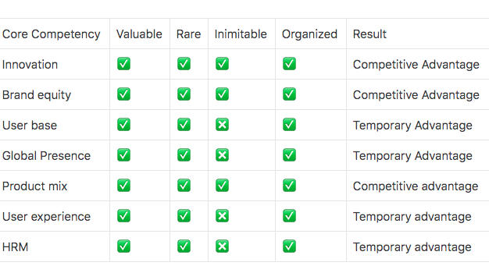
Figure 10: Netflix VRIO Analysis
(Source: Madewa, 2018)
The VRIO framework is an acronym for the many success metrics that apply to your organization. It consists of worth, rarity, imitability, and organization. A VRIO/VRIN study of Netflix Inc. reveals that the company's brand, platform, and content creation are vital competencies (resources and capabilities) that enable long-term competitive advantage. Despite growing competition, Netflix Inc.'s critical skills sustain corporate success (Madewa, 2018). The temporary competitive advantage of the market has been stated in the framework. The core competencies and high equality have been the result of the framework.
Furthermore, the company's worldwide web platform, which has been built on the mentioned VRIO architecture, is a significant competency. This platform, for example, is tough to mimic in terms of scale and market reach to a vast subscriber base. As a critical capability, the platform allows the organization to assure the efficacy of its value chain in delivering the streaming service (Fleischman et al. 2021).

Strategies to Sustain Competitive Advantage
According to Porter’s generic strategies, the company uses the cost leadership strategy. They help to create a competitive advantage in the market. The minimized costs and frequently and adequately minimized selling prices are the most significant source of a competitive advantage shown in the company in the current market. The cost leadership strategy also states the corresponding ability to sell to the customers (Amoroso et al. 2021This is how the differentiation strategy is applied to them in the sustainable market. The competitive market background is initiated and controlled by them in the market. The competitive market is also controlled by them, considering Porter’s forces. The strategies this formed help them stay on the market and develop the necessary sustenance to compete with the external competition (Rataul et al. 2018). These are the strategies implemented by Netflix in the current competitive market.

Growth Strategies
As stated in the Ansoff Matrix, this strategy of expansion includes the sales of more of the streaming services of the internet firm in markets where the company has already generated a presence. The target of this plan of growth, that is to increase the revenues and shares of the market, depends on how the generic approach of Netflix keeps back the competitive advantages in present areas to capture and keep additional subscribers. The development of the Market is carried out by marketing the company's current online service of streaming and content which is unique in nature to the new markets. One of the aims of Netflix in growth implementation, for example, is to increase the business by entering more countries that can serve as new potential markets (Camarero, 2021). The company's generic approach of cost leadership adds to the completion of this aggressive increase plan of making the online service user friendly and likeable based on the affordability of price. Netflix employs a generic competitive advantage approach to effectively create new material for the customers who are existing members, whose valuable time spent in watching such relevant content helps in the earnings of the company. This forceful expansion plan has the target of expanding the core business of the company of streaming on the internet content which is original as development by the launching of new ventures. ns (Al-Jabri et al. 2021).
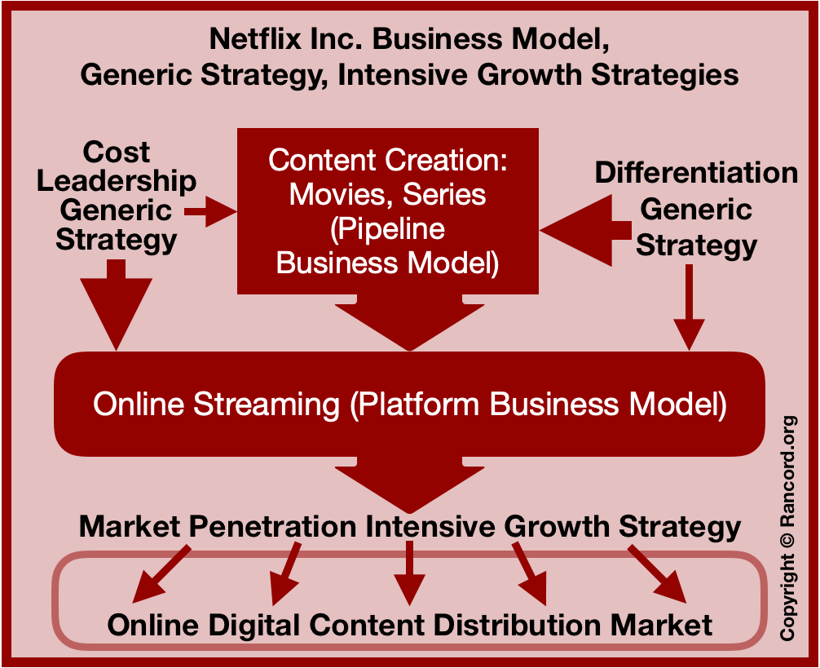
Figure 11: Netflix Porter Generic Strategies
(Source: Camarero, 2021)

Green Strategy and CSR
By 2022, Netflix will achieve net-zero greenhouse gas emissions. They have initiated several strategies to reduce greenhouse gas emissions to reach the target. The internal emissions have reduced by 45% as of 2019, and they have the target of reaching 0 emissions by the end of 2022. This has shown to be one of the most significant targets based on the green strategy which they have created (Wayne and Castro, 2021). Netflix also initiates and carries out several strategies for CSR-related events to ensure they have the people's support and, therefore, profits are arranged, and stable formations are created. The formation of the profits and other relevant information is one of the significant events we have seen in the forthcoming event. The green strategy initiative is thus one of the largest and most significant events and startups that the company has started, and they are funding significant projects to make sure these targets are reached in the coming years (Morgan, 2018).
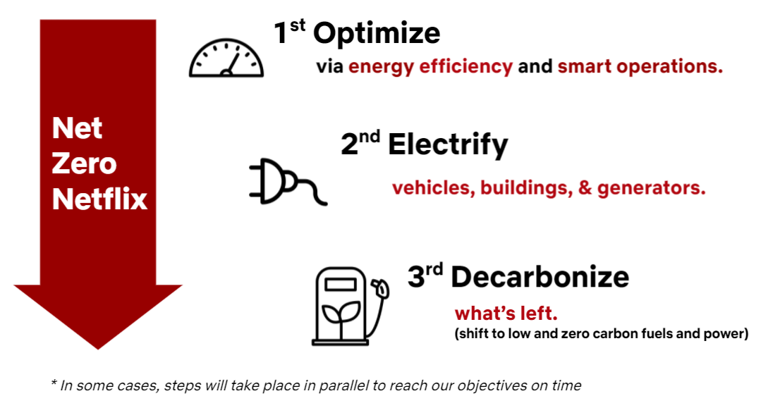
Figure 12: Netflix Green
(Source: Ramasoota and Kitikamdhorn, 2021)

Conclusion
It can be concluded that the Netflix strategies and the process by which they get it done have been stated in the given report. The analysis frames the basic concepts and working process of the company and how they manage to create the proper recommendations., The green strategy and the intensive growth strategies have bene mentioned in the analysis of the report. it has also bene stated the process by which they are installed in the company and how they carry it out. the external and internal analysis of the company have also been done and the final report states the ways in which they have been installed and modelled after. Therefore the conclusion gives rise to the recommendations which are then followed by the company.

Recommendations
It can recommend that Netflix keep using the digital marketing strategies which they have bene using currently. The recommendations is also done to make sure they have the proper strategies implanted in the right track. It is recommended for Netflix to enter the Indian market and promote more on the Bollywood shows as they will help them gain better profit margin. The Indian market is relevelled new but the demand is very high. The pandemic increased the current demand for Netflix shows in the market and therefore they should carry out more expansion. The high expansion in the Indian market will allow for much better responses from the audience and this will lead to better profit which they gain. The theme of the shows are also appreciated by the audience of India and Bollywood would be the primary catalyst for the expansion. This is the biggest recommendation for the company in the current market.

References
Al-Jabri, H., Allawzi, A. and Abushmaes, A., 2021. A comparison of euphemistic strategies applied by MBC4 and Netflix to two Arabic subtitled versions of the US sitcom how I Met Your Mother. Heliyon, 7(2), p.e06262.
Amoroso, S., Pattuglia, S. and Khan, I., 2021. Do Millennials share similar perceptions of brand experience? A clusterization based on brand experience and other brand-related constructs: the case of Netflix. Journal of Marketing Analytics, 9(1), pp.33-43.
Burgess, D. and Stevens, K., 2021. Taking Netflix to the Cinema: National Cinema Value Chain Disruptions in the Age of Streaming.
Burroughs, B., 2019. House of Netflix: Streaming media and digital lore. Popular Communication, 17(1), pp.1-17.
Camarero, E., 2021. A Media Format on the Rise. The Journalistic Investigation Documentary on Netflix and Prime Video. Медиаобразование, (3), pp.415-425.
Dinh, T.M.T., 2019. A marketing strategy for sustainable growth: case study Sky-media company limited.
Elodie, G., 2021. Matrice McKinsey-Netflix. Publications Études & Analyses.
Figueroa López, R.B. and Uriarte Mori, J.A., Analizar el incremento de suscriptores de Netflix con respecto a la competencia desde el 2010 hasta lo que va del año 2020.
Fleischman, B., Ondracekº, J., Saeed, M. and Bertsch, A., 2021. Netflix: Strategizing Corporate Resources and Capabilities.
Galiotto, F., 2018. Innovation: a study of Netflix and its impact on film industry.
García López, P.J., 2020. Análisis estratégico e implementación CMI en la empresa Netflix.
Gregory, A., 2021. Complete Analysis of Netflix, Inc.
Iordache, C., 2021. Netflix in Europe: four markets, four platforms? A comparative analysis of audio-visual offerings and investment strategies in four EU States. Television & New Media, p.15274764211014580.
Kannisto, K., 2019. The motivations for Netflix to vertically integrate its business model.
Kerckhoffs, N.N.J.H., 2018. Is the “Netflix model” favorable for the audio streaming industry (Bachelor's thesis, University of Twente).
Khuan, H., 2022. ANALYSIS OF COMPETITIVENESS FOR MARKET SHARE EXPANSION OF PT BANK JAGO TBK. Journal Of Social Research, 1(3).
Kokas, A., 2020. Chilling Netflix: financialization, and the influence of the Chinese market on the American entertainment industry. Information, Communication & Society, 23(3), pp.407-419.
Kumar, J., Gupta, A. and Dixit, S., 2020. Netflix: SVoD entertainment of next gen. Emerald Emerging Markets Case Studies.
Maddodi, S., 2019. NETFLIX bigdata analytics-the emergence of data driven recommendation. Srivatsa Maddodi, & Krishna Prasad, K.(2019). Netflix Bigdata Analytics-The Emergence of Data Driven Recommendation. International Journal of Case Studies in Business, IT, and Education (IJCSBE), 3(2), pp.41-51.
Madewa, C.R., 2018. ANALYSIS ON NETFLIX’S COMPETITIVE ADVANTAGE AND CHALLENGES AND ITS FUTURE PROSPECT (Doctoral dissertation, UAJY).
Matevosyan, E., 2020. Valuation of Netflix, Inc. using Selected Valuation Methods.
Matevosyan, E., 2020. Valuation of Netflix, Inc. using Selected Valuation Methods.
Medhat, W., Fawzi, S., Fahmy, O., Hassan, G., Ramadan, M., Abdelbary, A. and Hassan, A., 2021, October. Impact of COVID-19 on Information Technology Sector in Egypt. In 2021 3rd Novel Intelligent and Leading Emerging Sciences Conference (NILES) (pp. 436-439). IEEE.
Mier, J. and Kohli, A.K., 2021. Netflix: reinvention across multiple time periods, reflections and directions for future research. AMS Review, 11(1), pp.194-205.
Morgan, J., 2018. Netflix: Reed Hastings.
Netflix.com, 2022 “Netflix” available on 28/04/2022 available from: https://www.netflix.com
Onyusheva, I. and Baker, A.S., 2021. NETFLIX: A CASE STUDY ON INTERNATIONAL BUSINESS STRATEGY DEVELOPMENT. The EUrASEANs: journal on global socio-economic dynamics, 6(31), pp.40-52.
Park, S., Park, J., Kang, J. and Rhee, B., 2021. An Empirical Study of Personalized Thumbnail Curation of Netflix. Journal of Digital Convergence, 19(10), pp.265-274.
Rahe, V., Buschow, C. and Schlütz, D., 2021. How users approach novel media products: Brand perception of Netflix and Amazon Prime video as signposts within the German subscription-based video-on-demand market. Journal of Media Business Studies, 18(1), pp.45-58.
Ramasoota, P. and Kitikamdhorn, A., 2021. “The Netflix effect” in Thailand: Industry and regulatory implications. Telecommunications Policy, 45(7), p.102156.
Rataul, P., Tisch, D.G. and Zámborský, P., 2018. Netflix: Dynamic capabilities for global success. SAGE Publications: SAGE Business Cases Originals.
Roig Telo, A., Clares Gavilán, J. and Sánchez Navarro, J., Netflix fictional feature film originals: an analysis of release strategies [Largometrajes originales de ficción de Netflix: un análisis de las estrategias de estreno].
Ruiz, C.A.D., Baker, J.J., Mason, K. and Tierney, K., 2020. Market-scanning and market-shaping: why are firms blindsided by market-shaping acts?. Journal of Business & Industrial Marketing.
Sakal, D.V., Rebić, P., Zrilić, A., Gracin, A., Bubalo, D. and Borovac, J., ANALYSIS OF NETFLIX INC. STUDENT INVESTITOR 2019.
Shi, Y. and Zhou, J., 2021, October. Analysis of Foreign Video Streaming Service Entering Chinese Streaming Media Market: A Case Study of Netflix. In 2021 International Conference on Public Relations and Social Sciences (ICPRSS 2021) (pp. 337-343). Atlantis Press.
Snyman, J.H. and Gilliard, D.J., 2019. The streaming television industry: mature or still growing?. Journal of marketing development and competitiveness, 13(4), pp.94-105.
Wagener, M.C., 2020. The effect of Netflix on movie piracy and its impact on the movie industry (Doctoral dissertation).
Wayne, M.L. and Castro, D., 2021. SVOD global expansion in cross-national comparative perspective: Netflix in Israel and Spain. Television & New Media, 22(8), pp.896-913.
Wu, X. and Zhou, J., 2021. The Influential Factors of Developing Better in the Global Stream Media Market: An Analysis of Netflix.

