

Student name: Hamida Sultana
Student ID: 1605984
Module Code: SBUS 5109
Project Management
Lecturer’s Name: Molly Jack

Introduction
A project refers to set of activities that organising and planning by the project management that the project can complete required goal. A project may variety from a couple of days to months or a year to complete depending on types of work and amount of works involved. Project management principle is to make sure that the project is implemented successfully and it analyse the circumstances and also implement plans and organise and require objectives applicable to the project by the schedule. Many projects are delays, over budget, lower budget and do not meet the needs causing cancellation of the project because of the poor management. According to Morrano, R. (2003), the success of any organisation or a significant project depends on a complete study of the major description of the project and also appropriate management of the project.
We have given a wedding project to complete by 6 months. In this period we’ll doing this project with the management team and members. We have given tasks separately to other members. We have to complete by the deadline with our efficiency of work to give every effort to achieve the final destination.

Project Goals
Atkinson (1990) splits project achievement into three groups as use the right direction of method, getting into the right system and getting the benefits right.
The wedding project’s goals is use the right direction with organising and managing each and every task follow the system and get the expectable result by the specific time and budget and quality of work with client satisfaction as we are following the triangle scope management.
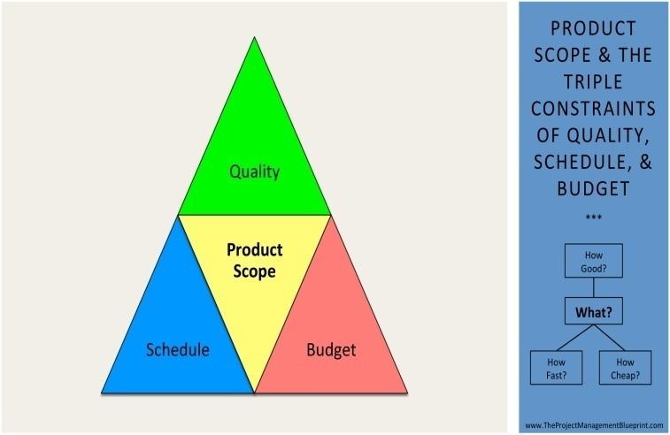
Image from Google

Project objectives
Duration is six months time before the wedding and each and every task must be completed by the deadline.
Budget is the first thing to decide with client and the management with both party’s consideration.
Cost should be reducing as within the decided budget. We can reduce cost by the research, for example search the wedding hall as many as we can and choose the good one but less expensive.
Efficiency is getting more and more information as much as possible, like how the wedding arrangement will be as the client wants.
Relationship with client makes project arrangement go smoothly as good communication prevent misunderstanding.
Skilled and qualified staffs involves in to the project to accomplish by the time.
Quality of the services, processes, experiences should be on most concentration.
Spacey, J. (2018).
Critical success factors
According to Slevin (1986) and Pinto (1987), the ten critical success factors are:
- Project goals and direction as we have our wedding project goals and processing with the direction.
- For the success of the project need to get support from the top management.
- Specific description of the project with planning. For example, what colour of the decoration in the hall, what type of music will be, what type of food to order etc.
- Communication, discussion and listening to all involved in the project, like stakeholder, team members and management.
- For the project if we need we can recruit and train if necessary but it might be delaying our project.
- Availability of the technology expert to accomplish the necessary technical action.
- Acceptance of the client.
- Processing, monitoring and feedback.
- Good communication with every member of the team and stakeholder/client.
- Able to handle any unexpected situation/crisis.

Project Scope
Project scope introduces to the task that must be finished to deliver the product, service or result with specific time and quality of the job. Product scope introduces to the task and performance that identify a product, service or result (project scope management, project skills. 2014).

How to start the project? At the beginning management will discuss the project, planning and organising to set the project with the project team members and the client. Then set up the tasks and task will be divided and given to the members of the team that individual can handle specific task with the time given and if individual need partner then they can have partner to do the task together. The team leader has the responsibility to monitoring and reporting to the line manager what tasks have done. Members should know what to do by the requirements and actively performing and will have to have the target to accomplish the project by the deadline given.

Work Breakdown Structure (WBS)
WBS is the category of the work engages in a project sets in the direction of the deliverables that identify the total scope of the project. This scope of the project advance breaks down the total work essential for the project into separate task and set them into a coherent hierarchy (Rev E. 2013).
In order to develop our schedule, we first need to identify the activities, progress them in the right order, and estimate the required funds and the period to complete the tasks (Bpayne and Adrienne Watt. 2014)
As the wedding plan following activities into the WBS figure to show how the work items decompose into activities.
- Budget
- Print cards
- Guest list
- Invitation
- Wait for RSVPs
- Book wedding hall
- Hire photographer/videographer
- Shop for wedding
- Tailoring
- Book a beautician
- Book for cater
- Choose and confirm menu
- Choose bouquet
- Arrange wedding car
- Music

Project Risks/ Risk Analysis/ Prevent Risk
We have to keep monitoring every task and analysis any risks that have done or reported by the other team members. If we do not analyse the risk factors and precaution then project will delay and budget could be arise as according to Ewusi-Mensah, (1997), project delays and budget arise because of lack of the system for measuring and controlling the risk of project.
For example,
- if in the wedding have 300 guests and we cater for 300 guest but to make sure that food ordered more as if we have more guest then food will be enough for extra.
- Food should be served with consideration of vegetarian, allergies, alcohol, sugar (who have diabetic), as if some guest have certain food allergy if served by unknowingly, this is the risk we have to keep in mind and have to prevent risk as we have to mention if there is some allergen ingredient/sugar/vegetarian/alcohol etc.
- If power fails on the wedding program, we must have the alternative arrangement, like generator system.
- If dancing arrangement in outside the hall, we must keep in mind about unexpected weather condition. We can arrange the dance party inside or if outside we have to arrange for water proof cover.
- If expenses over the budget, we have to discuss with other team members and the client and reduce expenses as discussed. For example, may be items 4/5 types of drink reduced to 3 types, less expensive wedding car hired rather than posh expensive car.
- Wedding dress/Groom’s suit, shoe and ring trial before the wedding day, prevent fittings disappointment.

It is necessary to look for the possibility of risks and identify and response to reduce problems and it may needs considerations and arrange alternatives to achieve the project’s goals (Keil and Montealegre, 2000).

Roles and Responsibilities/ Hierarchy

Wedding management, responsibilities of planning, processing, resource management, prepare and implement risk management plan.
Event coordinator responsible for organising with all event specialist and ensures that business process are well-organized and effective.
Information manager’s responsibilities, manage information get through different sources. All documentation of operations carried out pre-event, at-event and post-event, maintaining record of suppliers, delegates, organisers, guests, sponsor, partners, target audience, media people. He formulates, prepare and implement the risk management plan.
Logistic manager implementing the security plan and strategies: protect delegates, guests, service provider, organiser, sponsors, partners, client, and target, goods and merchandise and risk management plan.
Communications manager’s responsibilities are resource management, setting up and take apart of the communications for the whole event. Seating arrangements, stage design/setup, electricity, water and phone, conservancy/cleaniness, risk management plan (Sharma, H. 2007-2017).
Prince2
PRINCE (Projects IN Controlled Environments) is a managing project effectively with control. It includes all the basic ideas and processes which are essential for operating and managing project. PRINCE2 uses the system based on start to progress and to manage project which classify the required management activities through the entire method of project management (Zeng, 2007).
Manager will control the project and every team members will report to the manager what task have done and how much left.
According to Zhang Lianyinga, at al. (2011), P2CMM is based on PRINCE2 project management approach that contains 8 management processes:
- Starting up a Project (SU): arrange meeting with the project team and discuss about the project.
- Initiate a Project (IP): to begin the project, start with clear ideas.
- Directing a Project (DP): clear understanding about project and direction how to proceed.
- Controlling a Stage (CS): reported every task to the manager and manager control how and when to do the process.
- Managing Product Delivery (MP): if one task has finished then manager will check carefully if there any lack of its task.
- Managing Stage Boundaries (SB): managing the project with agreed cost and quality, if above the cost then manager will have the control that the task should continues or stop or moderate.
- Closing a Project (CP): effectively effort to finish and closing the project.
- Planning (PL): completed the project and plan to deliver the product.

Stakeholders Involvement

Project Planning with Milestone
Gantt chart for Wedding Event
Task | Duration 6 months
Starting the project, booking a hall, church, making guest list, book music(DJ, bands etc) | 1st month
Order for bride’s /groom’s suit, dress, ring, shoes, bride maids dresses and groomsman’s suits, print cards, book decorators |  | 2nd month
Book for beautician, order other jewelleries, cater and finalise menu, order wedding cake |  |  | 3rd month
Making list for gifts, checking the processing, distributing cards, Waiting for RSVPs, order flowers |  |  |  | 4th month
Check with decoration, trial bride’s dress/groom’s suit, ring and shoes, alteration if needed, wrapping gifts |  |  |  |  | 5th month
Beginning of the month checklist: hall, church, music band, dresses/suits, rings, shoes, beauticians, florist, cater, cake, decorations |  |  |  |  |  | 6th month

Budget
Budget | List | cost | labour
£25,000 | Hall | £10,000
Extra | cater | £3,000 | £1,000
£5,000 | Decoration, cards | £500+£1000 | £500
 | Dress/suits | £1000
 | alteration |  | £100
 | cake | £500
 | ring | £2000
 | Bride maids/groom men’s cloths | £1,000
 | Music band | £500
 | Beautician | £500
 | Florist | £500
 | Church | £300
 | Gifts | £500
 | Wrapping |  | £200
 | Shoes and other jewelleries | £1500
Total= £24,600

Conclusions
The wedding project we handled completed by the deadline and within the budget. Our team members have done their task effectively and completed the project. We managed every single task within direction given and prepare the project and processed with instruction and always discuss tasks with team members to do right direction.

References
CAR, Morano R, 2003,. Application of Risk Analysis Techniques in Construction Projects. 2003. 206 f. Dissertation (Master in Civil Engineering)
Project fundamentals student guide. 2013 - Report Georgia Technology Authority, USA
Saladis, F. P., & Kerzner, H. R. (2011). Bringing the PMBOK guide to life: a companion for the practicing project manager. John Wiley & Sons.
PROJECT MANAGEMENT PRACTICES Work Breakdown Structure (Rev E, June 2003)
Illustration from Barron & Barron Project Management for Scientists and Engineers, http://cnx.org/content/col11120/1.4/
https://opentextbc.ca/projectmanagement/chapter/chapter-10-project-schedule-planning-project-management/
The Project Management Maturity Model and Application Based on PRINCE2 Zhang Lianyinga*, He Jinga, Zhang Xinxinga
aSchool of Management, Tianjin University, Tianjin 300072, China
farzana asad mir, Ashley h pinnington 2013 exploring the value of project management: linking project management performance and project success
http://www.free-management-ebooks.com/dldebk-pdf/fme-project-scope.pdf

Spacey, J. (2018). 21 Example of Project Objectives
https://simplicable.com/new/project-objectives
Slevin, D.P., & Pinto, J.K. (1986). The project implementation profile: New tool for project managers, project management journal, 18, 57-71.
(Variation in critical success factors over the stages in the project life cycle. Jeffry K. Pinto university of cincinnaty. John E. Prescott university of Pittsburgh. (1988).
http://www.theprojectmanagementblueprint.com/?p=244 (image)
Journal of Information Technology (2000) 15, 317–327 Risk factors in enterprise-wide/ERP projects MARY SUMNER School of Business, Southern Illinois University, Campus Box 1106, Edwardsville, IL 62026, USA
http://www.eventeducation.com/event-organizers.php (Event management and planning guide).

