Name: Safina Bibi
Student Number: 2243482
Module Code: BMHP6029
Assignment Title: Component 2 : Written Assignment (Report)
Lecturer: Kennedy Obohwemu

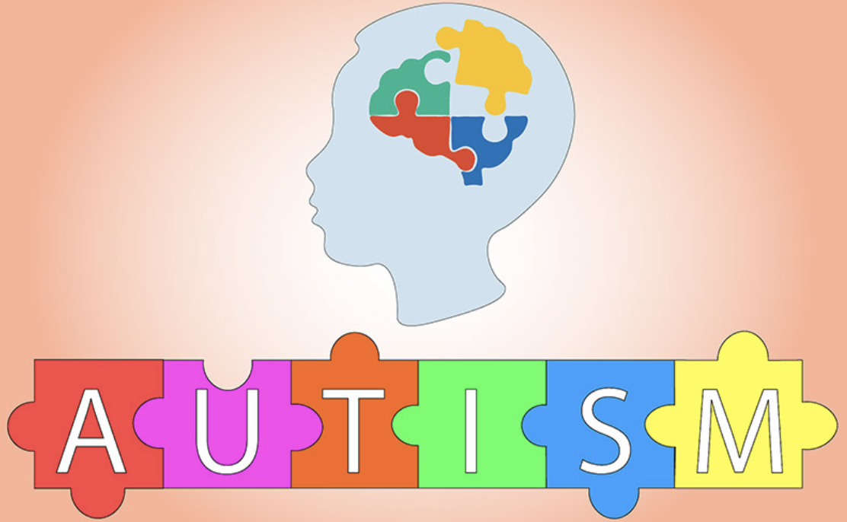
(CASS Counselling, n.d.)

Content Page:

Introduction……………………………………………………………………………………3-4

Classification and Diagnosis………………………………………………………………..4-5
Treatment Approaches………………………………………………………………………5-6
Current Debates, Policy, and Data on Autism Spectrum Disorder in the UK………….6-7
Recommendations……………………………………………………………………………7-8

Conclusion…………………………………………………………………………………….8
References…………………………………………………………………………………….9-12

INTRODUCTION

The National Autistic Society, (2024) states that Autism Spectrum Disorder (ASD) is a neurological condition that affects a person's ability to communicate, connect with others, and understand their environment. The condition manifests in a wide range of abilities, strengths, and challenges that necessitate personalised care. In the United Kingdom (UK), it is estimated that over 700,000 adults and children are autistic, which means that more than one out of every hundred people is on the autism spectrum (National Autistic Society, 2024).
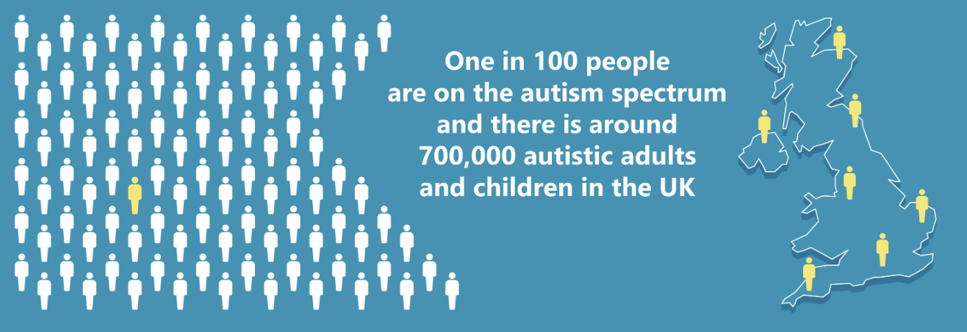
Figure 1. (Blue Stream Academy, 2024)

According to research, males are diagnosed with autism more frequently than females, reflecting both biological factors and potential diagnostic biases (Fleet et al. 2023). Early detection and timely intervention are critical because they can significantly improve long-term outcomes in the social, educational, and occupational domains.

ASD research is significant due to the increasing prevalence, the lifelong support requirements, and the social and economic consequences for individuals, families, and public services (WHO, 2025). The UK has implemented a number of policies and guidelines, including the National Institute for Health and Care Excellence (NICE, 2021) guidance on ASD assessment and interventions, the NHS Long Term Plan for autism services (NHS England, 2019) and statutory protections under The Equality Act (2010). Despite these frameworks, challenges remain in timely diagnosis, access to appropriate interventions, and the integration of health and social care services ( NHS, 2023).

This report critically examines ASD through UK-specific practices, exploring its classification, diagnosis, treatment, rehabilitation, and long-term management. It also takes into account current debates, policy and legal frameworks, and statistical data to highlight ongoing challenges and opportunities for improving service delivery. Finally, practical recommendations are made to improve autistic individuals' diagnosis, treatment, and support within the UK healthcare system.

CLASSIFICATION AND DIAGNOSIS

The International Classification of Diseases, 11th Revision (ICD-11) classifies ASD as a neurodevelopmental disorder under code 6A02.0 (WHO, 2025). It is described as a lifelong condition that influences how people communicate, interact with others, and perceive the world. People with ASD exhibit repetitive behaviours or strong interests, and they may struggle with social communication and routine change (National Autistic Society, 2024). The term "spectrum" is used in the ICD-11 because autism manifests differently in each individual. It also allows healthcare professionals to determine whether a person has learning or language difficulties in addition to autism. This provides an increased understanding of their needs and strengths (Greaves-Lord et al. 2022).

The Diagnostic and Statistical Manual of Mental Disorders, Fifth Edition (DSM-5) classifies autism as a single spectrum that includes older diagnoses such as Asperger's syndrome and childhood autism. The DSM-5 has more detailed symptom descriptions and requires signs to appear early in life, even if they are not recognised until later (Autism Speaks, 2025). While ICD-11 and DSM-5 are similar, there are some minor differences in how they define and evaluate symptoms. As a result, depending on the system in place, people may receive a diagnosis more easily in one country than in another (First et al. 2021).

Professionals in the UK usually employ ICD-11 to diagnose autism because the National Health Service (NHS) is based on the World Health Organization's system (NHS, 2023). However, NICE (2017) guidelines incorporate information from both the ICD-11 and the DSM-5. NICE proposes a team of healthcare professionals, including psychologists, psychiatrists, occupational therapists, and speech and language therapists, complete autism assessments. Instead of relying entirely on short tests or questionnaires, these assessments examine a person's development, communication, behaviour, and daily life (NICE, 2017).

According to Keating et al. (2023) there are debates about how autism should be described. Many people in the autistic community prefer terms such as “autistic person” or “autism spectrum condition” instead of “disorder,” as these sound more positive and less medical. However, the word “disorder” is still used in ICD-11 and DSM-5 to keep consistency in clinical and research work (Stein et al. 2020).
Obtaining an autism diagnosis remains difficult in the UK. According to Crane et al. (2018) many people face lengthy wait times to be assessed, and there are significant differences between regions in how quickly services are available. This can cause frustration and delays in receiving support. These issues highlight the importance of fair, accessible, and person-centred diagnostic services that reflect current understandings of autism (Crane et al. 2018).

TREATMENT APPROACHES

Treatment for ASD in the UK is multidisciplinary and focusses on improving quality of life rather than "curing" core autistic traits (Department of Health and Social Care (DHSC), (2019). Psychological and behavioural interventions are the foundations of care, with medication used selectively to treat specific co-occurring issues.

Psychological and behavioural treatments

According to Fuller and Kaiser (2020), early structured behavioural and psychosocial interventions provide the most promising evidence for improving social communication, adaptive skills, and reducing learning-impairing behaviours. Common interventions for young children include parent-mediated programs, social skills training, speech and language therapy, and occupational therapy for sensory and daily living skills (Fuller and Kaiser, 2020). Adapted Cognitive Behavioural Therapy (CBT) can effectively reduce anxiety and depression in older children and adults, especially when sessions are structured with clear goals, visual aids, and concrete examples as suggested by (Spain and Happé, 2020). While psychosocial interventions are generally effective, the quality of evidence varies according to the intervention type, intensity, and age group.

Pharmacological approaches

There is no medication that can treat the core social or communication difficulties associated with ASD. Pharmacological treatment is primarily used to treat associated symptoms such as irritability, aggression, self-injury, and co-occurring disorders such as depression and ADHD (Manter et al. 2025). Second-generation antipsychotics (e.g., risperidone, aripiprazole) have the strongest evidence for reducing challenging behaviours in some children and adolescents, but they must be closely monitored due to side effects such as weight gain and metabolic issues (Manter et al. 2025). Melatonin can help with sleep problems, but it should be used only after other behavioural approaches have been tried (Manter et al. 2025). Medication is typically used for a short period of time, to treat specific symptoms, and in conjunction with psychosocial interventions.

UK management and access to care

National Institute for Health and Care Excellence (NICE) (2018) recommends a personalised, multidisciplinary package of care that focusses on evidence-based psychosocial therapies supported by specialist input. The NHS supports ASD care through Child and Adolescent Mental Health Services (CAMHS), community learning disability teams, and adult mental health services (NHS England, 2023). The NHS Improving Access to Psychological Therapies (IAPT) programme offers talking therapies for co-occurring conditions. The Mental Health Act (1983, amended 2007) establishes the legal framework for compulsory treatment, but it is rarely applied to autistic people unless there are co-occurring mental disorders and risks. It also provides access to advocacy and the review of mandatory measures. Government initiatives like the NHS Long Term Plan seek to improve diagnostic access, post-diagnostic support, and community care (The King’s Fund, 2019). Despite progress, services are still fragmented, with long wait times and limited specialist provision (Fulceri et al. 2023). Continuous investment, workforce training, and integrated care pathways are required to ensure equitable, person-centred rehabilitation to individuals on the autism spectrum (Fulceri et al. 2023).
CURRENT DEBATES, POLICY, AND DATA ON ASD IN THE UK
Current Debates & Emerging Issues
In the UK, there is a debate regarding ASD classification, treatment, and societal understanding. As suggested by Kamp-Becker, (2024) the ICD-11 uses a dimensional approach to highlight variability in ASD, in contrast the DSM-5 employs a similar spectrum model. This has sparked debate about diagnostic thresholds and the need for inclusive frameworks that acknowledge diverse presentations (NHS England, 2023). The neurodiversity movement challenges conventional medical models, arguing that autism is a natural variation rather than a disorder to be "cured" (NHS England, 2023). This has had an impact on treatment priorities, emphasising support and accommodation over behavioural "normalisation."
According to The King’s Fund, (2019) policy changes, such as the NHS Long Term Plan, are aimed at improving autism diagnosis and post-diagnosis support. However, implementation varies by region, and resource shortages limit service effectiveness (NHS Digital, 2025). The Equality Act of 2010 requires reasonable adjustments in education and the workplace for autistic people, but inconsistent enforcement undermines equitable access (Equality Act, 2010).

Policy & Legal Framework
Autistic individuals in the UK are legally protected under the Equality Act 2010, which requires reasonable adjustments and anti-discrimination measures. The Mental Health Act of 1983 (as amended in 2007) applies to those who have co-occurring mental disorders that pose a risk, outlining safeguards for compulsory treatment. The Care Act of 2014 requires local governments to assess and meet social care needs while promoting well-being, independence, and integration with health services (Care Act, 2014). Despite these safeguards, service variability, a lack of trained professionals, and budget constraints make timely support difficult, raising ethical concerns about autonomy and care quality.
UK Data & Statistical Evidence
NHS Digital (2025) reports 224,382 patients with open referrals for suspected autism, with nearly 90% waiting more than 13 weeks for an assessment. These lengthy wait times can impede access to interventions. Socioeconomic disparities have an impact on care, with those in low-income areas facing greater barriers. According to NHS England, (2023) autistic individuals are more likely to suffer from mental health issues such as anxiety and depression, which are increased by social isolation and discrimination. Although the UK has strong autism policies and frameworks in place, there are still significant disparities in service access and delivery across regions (Care Quality Commission (CQC), 2024).
In summary, ASD management in the UK reflects ongoing debates about classification, treatment, and neurodiversity, as well as legal safeguards and statistical evidence highlighting persistent barriers to access, equity, and timely support.
RECOMMENDATIONS
Improving the diagnosis and management of ASD in the UK necessitates a multifaceted approach that considers both service delivery and legislative frameworks. First and foremost, reducing long assessment wait times should be prioritised. According to NHS Digital (2025), nearly 90% of autism referrals are open for more than 13 weeks, causing delays in accessing critical interventions. Increasing the number of trained clinicians and incorporating early screening into primary care could help significantly speed up diagnosis (NHS England, 2023).
Secondly, treatment should take a more personalised and neurodiversity-positive approach. The NICE guidelines (2021) recommend evidence-based psychosocial interventions tailored to individual needs, which includes social communication support, cognitive-behavioural therapy for co-occurring anxiety, and family guidance. Autistic adults frequently experience gaps in mental health care, and tailored support from services, informed by guidance and resources from charities such as Mind and the National Autistic Society, can help make services more accessible and responsive to their needs (Mind, 2025).
Thirdly, policies and legislation must be strengthened to ensure equity in care. The Mental Health Act has been updated to increase patient autonomy and reduce unnecessary compulsory treatment (Department of Health and Social Care (DHSC), 2022). Aligning social care provision under the Care Act (2014) with health services can provide continuous, integrated support, especially for people with complex needs.

Finally, the Equality Act of 2010 requires systematic enforcement of workplace and educational accommodations in order to reduce social and occupational disadvantages. Raising awareness among employers and educators, along with guidance from national autism organisations, is critical for effectively implementing reasonable adjustments (NHS, 2023)

CONCLUSION
This report examined key aspects of ASD in the UK, such as classification, diagnosis, treatment, rehabilitation, and the policy framework that supports autistic people. Debates about neurodiversity raise questions about traditional medical approaches and emphasise the importance of personalised, supportive interventions. Despite legal protections under the Equality Act (2010), the Mental Health Act 1983 (as amended in 2007), and the Care Act, (2014), adults and individuals from low-income families continue to face barriers to timely diagnosis, equitable treatment, and integrated care.
Future research should prioritise assessing the effectiveness of neurodiversity-informed interventions, reducing systemic disparities in service delivery, and developing evidence-based strategies for early diagnosis and support. Policy changes, such as the NHS Long Term Plan initiatives and proposed amendments to the Mental Health Act, have the potential to improve service integration, patient autonomy, and care quality. However, adequate funding, workforce expansion, and increased accessibility are required to ensure that these reforms result in real changes in mental health outcomes. Addressing these gaps is critical to providing equitable, effective, and person-centred care for autistic people throughout the UK.

REFERENCES
Autism Speaks, (2025) Autism diagnostic criteria: DSM-5. Available at: https://www.autismspeaks.org/autism-diagnostic-criteria-dsm-5 (Accessed: 22 October 2025).
Blue Stream Academy, (2024) Autism Awareness Day | Health and Care. Available at: https://www.bluestreamacademy.com/NewsItem?Header=Autism-Awareness-Day-%7C-Health-and-Care-4566 (Accessed: 29 October 2025).
Care Quality Commission (CQC), (2024) Care for autistic people and people with a learning disability: The 2023/24 state of care. Available at: https://www.cqc.org.uk/publications/major-report/state-care/2023-2024/areas-of-concern/ld (Accessed: 30 October 2025).
CASS Counselling, (n.d.) ADHD and ASD. Available at: https://casscounselling.co.uk/autism-adhd/ (Accessed: 30 October 2025).
Crane, L., Batty, R., Adeyinka, H., Goddard, L., Henry, L. A., & Hill, E. L. (2018) Autism Diagnosis in the United Kingdom: Perspectives of Autistic Adults, Parents and Professionals. Journal of autism and developmental disorders, 48(11), 3761–3772.
Department of Health and Social Care (DHSC), (2022) Health and Care Act 2022: summary and additional measures impact assessment. Available at: https://assets.publishing.service.gov.uk/media/6363d911e90e0705a8c35457/health-and-care-act-2022-summary-and-additional-measures-impact-assessment.pdf (Accessed: 30 October 2025).
Department of Health and Social Care (DHSC), (2019) Core Capabilities Framework for Supporting Autistic People. Available at: https://www.autismhampshire.org.uk/assets/uploads/Autism_Capabilities_Framework_Oct_2019_1.pdf (Accessed: 30 October 2025).
First, M.B., Gaebel, W., Maj, M., Stein, D.J., Kogan, C.S., Saunders, J.B., Poznyak, V.B., Gureje, O., Lewis-Fernández, R., Maercker, A., Brewin, C.R., Cloitre, M., Claudino, A., Pike, K.M., Baird, G., Skuse, D., Krueger, R.B., Briken, P., Burke, J.D., Lochman, J.E., … Reed, G.M. (2021) ‘An organization- and category-level comparison of diagnostic requirements for mental disorders in ICD-11 and DSM-5’, World Psychiatry, 20(1), pp. 34–51.
Fulceri, F., Gila, L., Caruso, A., Micai, M., Romano, G. and Scattoni, M.L. (2023) ‘Building bricks of integrated care pathway for Autism Spectrum Disorder: A systematic review’, International Journal of Molecular Sciences, 24(7), p. 6222.
Fuller, E.A. and Kaiser, A.P. (2020) ‘The effects of early intervention on social communication outcomes for children with Autism Spectrum Disorder: A meta-analysis’, Journal of Autism and Developmental Disorders, 50(5), pp. 1683–1700.
Fleet, B.G., Elliott, A., Orwin, M., Spencer, M. and Sedda, L. (2023) ‘Autism trends in a medium-size coastal town of England’, PLOS ONE, 18(6), p. e0287808. Available at: https://journals.plos.org/plosone/article?id=10.1371/journal.pone.0287808 (Accessed: 21 October 2025).
Greaves-Lord, K., Skuse, D. and Mandy, W. (2022) ‘Innovations of the ICD-11 in the field of Autism Spectrum Disorder: A psychological approach’, Clinical Psychology in Europe, 4(Spec Issue), p. e10005.
Keating, C. T., Hickman, L., Leung, J., Monk, R., Montgomery, A., Heath, H., & Sowden, S. (2023) Autism-related language preferences of English-speaking individuals across the globe: A mixed methods investigation. Autism research : official journal of the International Society for Autism Research, 16(2), 406–428.
Kamp-Becker, I. (2024) ‘Autism spectrum disorder in ICD-11 – a critical reflection of its possible impact on clinical practice and research’, Molecular Psychiatry, 29(3), pp. 633–638.
Legislation.gov.uk, (2025) Equality Act 2010. Available at: https://www.legislation.gov.uk/ukpga/2010/15/ (Accessed: 21 October 2025).
Legislation.gov.uk, (2025) Mental Health Act 2007. Available at: https://www.legislation.gov.uk/ukpga/2007/12/contents (Accessed: 29 October 2025).
Legislation.gov.uk, (2025) Care Act 2014. Available at: https://www.legislation.gov.uk/ukpga/2014/23/contents (Accessed: 30 October 2025).
Manter, M.A., Birtwell, K.B., Bath, J., Friedman, N.D.B., Keary, C.J., Neumeyer, A.M., Palumbo, M.L., Thom, R.P., Stonestreet, E., Brooks, H., Dakin, K. and Hooker, J.M. (2025) ‘Pharmacological treatment in autism: a proposal for guidelines on common co-occurring psychiatric symptoms’, BMC Medicine, 23(1), p. 11.
Mind, (2025) Autism and mental health. Available at: https://www.mind.org.uk/information-support/tips-for-everyday-living/autism-and-mental-health/ (Accessed: 30 October 2025).
National Institute for Health and Care Excellence (NICE), (2018) Multidisciplinary team meetings: evidence review from NG94. Available at: https://www.nice.org.uk/guidance/ng94/evidence (Accessed: 28 October 2025).
National Institute for Health and Care Excellence (NICE), (2021) Autism spectrum disorder in adults: diagnosis and management (CG142) – recommendations. Available at: https://www.nice.org.uk/guidance/cg142/chapter/recommendations (Accessed: 30 October 2025).
National Institute for Health and Care Excellence (NICE), (2021) Autism spectrum disorder in adults: diagnosis and management (Clinical guideline CG142). Available at: https://www.nice.org.uk/guidance/CG142 (Accessed: 22 October 2025).
National Autistic Society, (2024) What is autism? Available at: https://www.autism.org.uk/advice-and-guidance/what-is-autism (Accessed: 21 October 2025).
NHS England, (2019) Autism. Available at: https://www.england.nhs.uk/learning-disabilities/about/autism/ (Accessed: 22 October 2025).
NHS Digital, (2025) Autism statistics, April 2024 to March 2025. Available at: https://digital.nhs.uk/data-and-information/publications/statistical/autism-statistics/april-2024-to-march-2025 (Accessed: 30 October 2025).
NHS England, (2023) A national framework to deliver improved outcomes in all-age autism assessment pathways: guidance for integrated care boards. Available at: https://www.england.nhs.uk/long-read/a-national-framework-to-deliver-improved-outcomes-in-all-age-autism-assessment-pathways-guidance-for-integrated-care-boards/ (Accessed: 22 October 2025).
NHS England, (2023) Meeting the needs of autistic adults in mental health services. Available at: https://www.england.nhs.uk/long-read/meeting-the-needs-of-autistic-adults-in-mental-health-services/ (Accessed: 30 October 2025).
NHS England, (2023) Reasonable adjustments in the workplace for autistic people. Available at: https://www.england.nhs.uk/south/2023/03/27/reasonable-adjustments-in-the-workplace-for-autistic-people/ (Accessed: 30 October 2025).
Stein, D.J., Szatmari, P., Gaebel, W., Berk, M., Vieta, E., Maj, M., de Vries, Y.A., Roest, A.M., de Jonge, P., Maercker, A., Brewin, C.R., Pike, K.M., Grilo, C.M., Fineberg, N.A., Briken, P., Cohen-Kettenis, P.T. and Reed, G.M. (2020) ‘Mental, behavioral and neurodevelopmental disorders in the ICD-11: an international perspective on key changes and controversies’, BMC Medicine, 18(1), p. 21.
Spain, D. and Happé, F. (2020) ‘How to optimise Cognitive Behaviour Therapy (CBT) for people with Autism Spectrum Disorders (ASD): A Delphi study’, Journal of Rational-Emotive & Cognitive-Behavior Therapy, 38, pp. 184–208.
The King’s Fund, (2019) The NHS long-term plan explained. Available at: https://www.kingsfund.org.uk/insight-and-analysis/long-reads/nhs-long-term-plan-explained (Accessed: 29 October 2025).
World Health Organization (WHO), (2025) Autism: fact sheet. Available at: https://www.who.int/news-room/fact-sheets/detail/autism-spectrum-disorders#:~:text=reactions%20to%20sensations.-The%20abilities%20and%20needs%20of%20autistic%20people%20vary%20and%20can,profound%20impairment%20to%20superior%20levels (Accessed: 22 October 2025).
World Health Organization (WHO), (2025) ICD-11 for Mortality and Morbidity Statistics: 6A02.0 Autism spectrum disorder. Available at: https://icd.who.int/browse/2024-01/mms/en#334423054 (Accessed: 22 October 2025).

