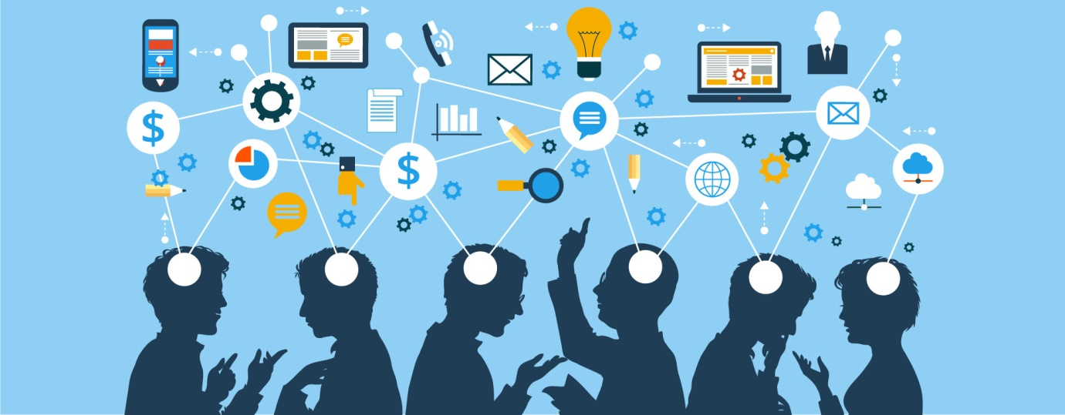

BMSW50006
Buddi Pathak
Zia Khan 1713348
Knowledge and Information management for the workplace
Deadline: 20/03/2020
Data are raw facts and statistics or even observations considered as little value for some, or no value at all. Once data is processed and then transformed into information then the data would have some value. Information is then organised this would include examples like bank statements, bus timetables that is when we know the information is useful, the knowledge being an interpretation of the information.
Information systems are used when the data is captured, organised stored and then retrieved examples of definitions are:
- Numbers, series of non-random symbols words or values
- Facts obtained by research and observation or researched and recorded
- Non-random facts collected
- A record of a fact or an event

Picture 1
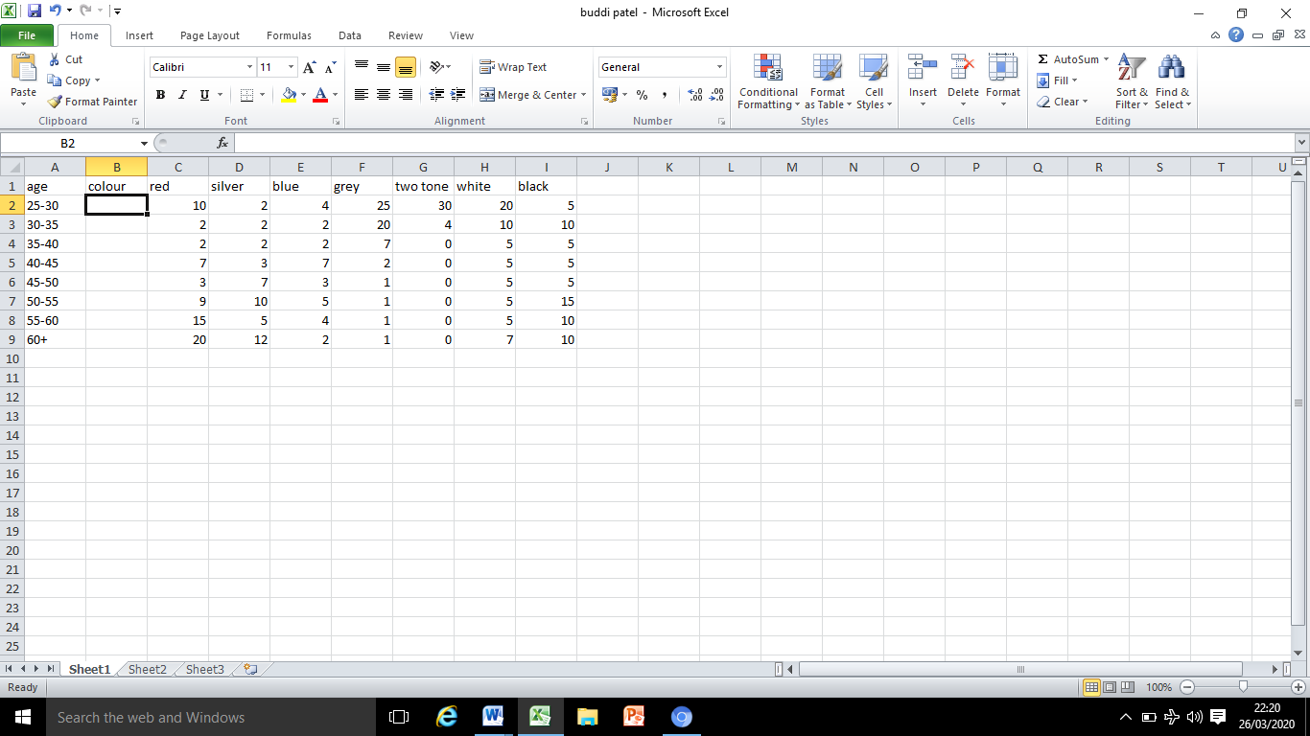

In picture one we see colours of cars and with ages below this we class as data to the author who knows what he was looking towards (me) surveying a number of the population to get what I colours I would most likely need for the new car I am planning on inventing. It is with little or no value for some unless it is processed and transformed into information.
Pic 2

Picture 2 shows the same data but in a graphical way so that it could be easily structured and identified, so if I was to send this as a report it would be easier for the recipient to look at and in a more professional business perspective. At this stage we class it as organised data that would mean something to any person who observes it making the raw data we seen in picture one now more organised, other examples would be banks statements bus timetables etc.

Finally I would do a report and set it up using the company systems and put on the database for the company to keep reflecting to it. In this way colleagues will have knowledge of what colour cars to make and what age groups it’s aimed for so managers could make right decisions towards the company needs. At this stage it’s more of knowledge based criteria where we have the opportunity to interpret the information we got in picture one and picture 2.
These formats would be used within the company using the information systems for example you have ASDA who work through their own information system called Wal-Mart one where all company information is stored and could be broken down up until a certain stores sales planner. Obviously to certain levels you could only have authorised access due to the fact that there would be personnel information about people or even information about the business that colleagues do not need to know. Plus with the GDPR data privacy regulations in place companies and people need to be more careful on holding or giving others’ information.

What’s the difference between data and information?
Data and information may look similar but have lots of differences between them. The symbols, numbers, words would mean nothing if we was to send someone names numbers or symbols next to them it may not mean nothing, but if we was to send the same numbers and symbols to a recipient who this had a meaning to then they would transfer the raw facts into data so that they can be used as information as it is processed in forms of information systems. Examples are computers, organisation databases, online systems credit card machines etc. A national insurance number card we may see that as raw data if we was to see the sequence, but for the United Kingdom administration the purpose of the letters and numbers is for the social security systems and for the purposes of the UK tax system also known as a ‘personnel account number’ by the government. The format used in a national insurance number card is two prefix letters six digits and one suffix letter. After the prefix letters the six digits are issued sequentially mostly from 00 00 00 to 99 99 99. You could then term this as knowledge due to the fact that it is vital information for an individual and to the government. This information is used as a reference for organisations and the government through their information systems once this is given as a reference this would be typed up on the systems and all the information like name address telephone numbers place of work etc. will all come up on the systems making it easier to track down the individual for response.

How does ‘knowledge’ differ from ‘data’ and ‘information’?
Information would be nothing that would matter to anyone unless it is refined by the form of data, and then it would be helpful and more understanding by the meaning to who it may concern. So knowledge is commonly, used as relevant and objective information, which would help into drawing conclusions, so the data when it is compiled within the meaningful context provides the necessary information.
How is data information and knowledge similar?
Observation of data is difficult leaving information understanding deduced from the hard observation. As data and information are collected the knowledge becomes the prediction of an event. Intelligence would play a major part whilst looking into aspects.

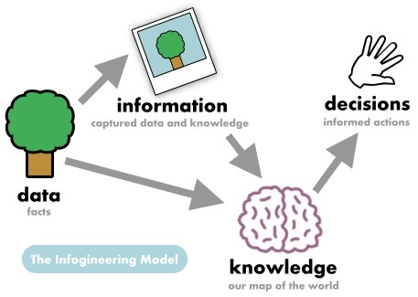
Data
- Given fact, number, picture
- Representation of something in a real world
- Raw materials in production of information
Information
- Context of a meaningful data
- Data related
- Manipulated data
Knowledge
- Familiarly awareness and understanding of something
- Learning or experiencing
- For humans unlike data and information
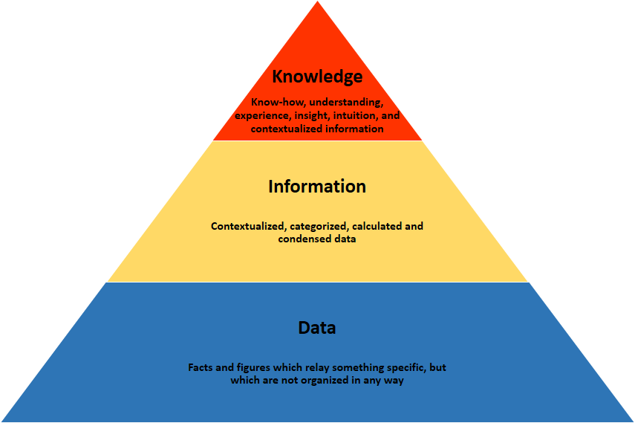

Does a player in a card game use tactic or explicit knowledge?
‘Knowledge is power’ Sir Francis Bacon
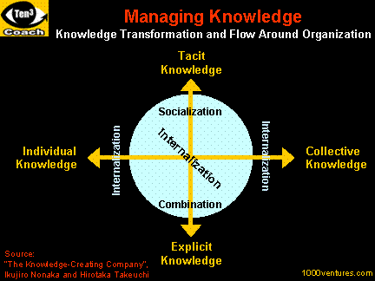

Explicit Knowledge (expressive knowledge) is knowledge that could be put into words or arranged into systematic codes stored and accessed. It is more of a complementary to tactic knowledge. Forms of explicit knowledge can be stored in certain media. Explicit knowledge is more of a (knowing-that) digital in memos, reports and books. It could be easily identified, shared and employed. Knowledge is easily captured and could be stored within documents and media.
More
What are the properties of explicit knowledge?
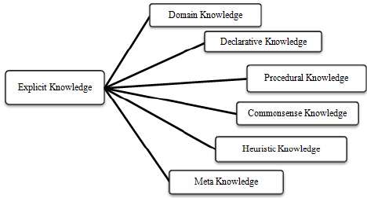
Explicit knowledge is more of a ‘teach’ or ‘train’ method of knowledge, organisations may use explicit knowledge reproduce, access and re apply throughout the organisation. It used as an ability to systematise and the ability to organise translating a vision to a mission statement for an organisations operational guidelines. It is a definition to transfer the knowledge via services products and documented processes.
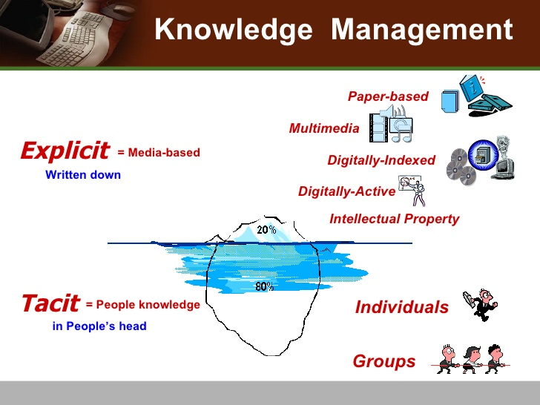
What is knowledge management?
Knowledge management is used in organisations to make the right knowledge available for the right people so that as an organisation they can learn, retrieve and use the knowledge as and when required using company applications.
Products and services by companies are improved upon by the knowledge the teams hold, knowledge on customer needs would give the ability to effectively engage and provide value. Best business and operational practices by a team is driven by internal processes. Without knowledge existence the tams wouldn’t deliver properly.
Knowledge management is a systematic process of communicating, documenting, storing and applying all of this knowledge to your organisations various processes. Knowledge would refer to on board activities, goals processes, workflow and communication protocols, or even HR-and personnel-related information.
For example when new recruits join company the trainers of the organisation will have their knowledge and experience to train the recruits using their documentation of their operational guidelines in order to train the recruits to the company compliance standards and the rules and regulations. This is known as knowledge management and it is collecting knowledge and converting it into an organisation front ready to be shared across the organisation. The key point though is that the process involves the tactic knowledge and the converting of it into explicit knowledge.
What is tactic knowledge?

Tactic knowledge can be used in the meaning of observations, as humans what we know others can’t say and what we do cannot be described. For example we know to ride a bike but find it difficult to explain how to ride it. These scenarios are called tactic knowledge (philosopher Michael Polayni) Tactic knowledge drives everything from bicycle riding, knowledge, education, science, art and management to input and our information with technology.
That’s why in a card game a player uses more of tactic knowledge rather than an explicit knowledge due to the fact, that the game is based on a players experience and knowledge of the game. As the more experience player will do better than the beginners. Tactic knowledge in terms is that we could ‘know more than what we can tell’ (Michael Pologni 1988 personnel knowledge) can be described as skills, ideas and experiences that people have in their minds therefore difficult to access not necessarily easily expressed. With tactic knowledge people are often not more of the knowledge they possess or how it could be valuable for others acquiring personnel contact during affective transfer of knowledge during regular interaction and trust. This knowledge is only revealed through practice on a particular context and transmitted through social networks. A person could have tactic knowledge without language or apprentice. For example working with their mentors and learn craftsman ship not by language but observation. The key for explicit knowledge is experience, without the experience it’s impossible for people to share their thinking process and is then as ‘know how’ so I am extremely confident to say that explicit knowledge is used by a player in a cards game.
Five decisions I have made today determining the data, information and knowledge involved in the decisions
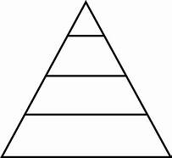

I better stop the car

The traffic light I am turning to has turned red

South traffic lights turned red on Caldmore Road

Red

In this model it shows a decision I made today starting from the bottom the raw facts (data) is red which wouldn’t mean anything to anyone if it was the only data available there. We then get the information (meaning) of traffic lights turning red on a road, when we get to the knowledge (context) part we may get more of the knowledge. Finally wisdom (applied) is where you find out why the final decisions were made where DIKW model means more sense.

I am wearing my jacket when I go out tonight
o
Its 12 degree Fahrenheit in Birmingham at 7.40 pm
12 degree Fahrenheit
Weather

In the model below the raw (data) has got 4 sequences of numbers on there, the information (meaning) has four names on there, the knowledge (context) gives us the numbers next to the names and finally the wisdom (applied) are the eldest and youngest of the family of four.

Donald is the eldest in the family and Ben is the youngest of the family

Ben aged 24, Alan aged 33, Sarah aged 38, Donald aged 44

Ben, Alan, Sarah, Donald

24, 33, 38, 44

Below the DIKW model shows me getting up for work using data, information, knowledge and wisdom.

Getting up for work
The alarm has gone off at 9am
Alarm @ 9am
time
This model shows my decision as I intend to shop from ASDA for drinks.
Going to ASDA for coke
Coca cola 3 bottles for £5
ASDA offers on drinks
ASDA
Wisdom is more of a way a person has the ability to know what is right or to know what is true, a person’s collection of knowledge and common sense. ‘The best mind altering drug is the truth’ wisdom involves righteousness; wise people are knowledgeable about the way (TAO)
Maxwell’s (1984) idea of wisdom as ‘including knowledge and judgement of value for better ways of living better institutions and social relations’. To be wise a person must be knowledgeable, nut being knowledgeable don’t make a person wise. Knowledge isn’t sufficient but is necessary for wisdom.
Knowledge acquisition
Using a source the process of structuring, extracting and organising knowledge is called knowledge acquisition usually human experts, can be used in software such as ES.
Different ways of Knowledge acquisition are:
- Machinery and equipment
- Databases
- New employees
- Existing employees acquiring new knowledge from external environment
- Consultancy
- Acquisitions
- Mergers
- Outsourcing research and development
- External training programmes

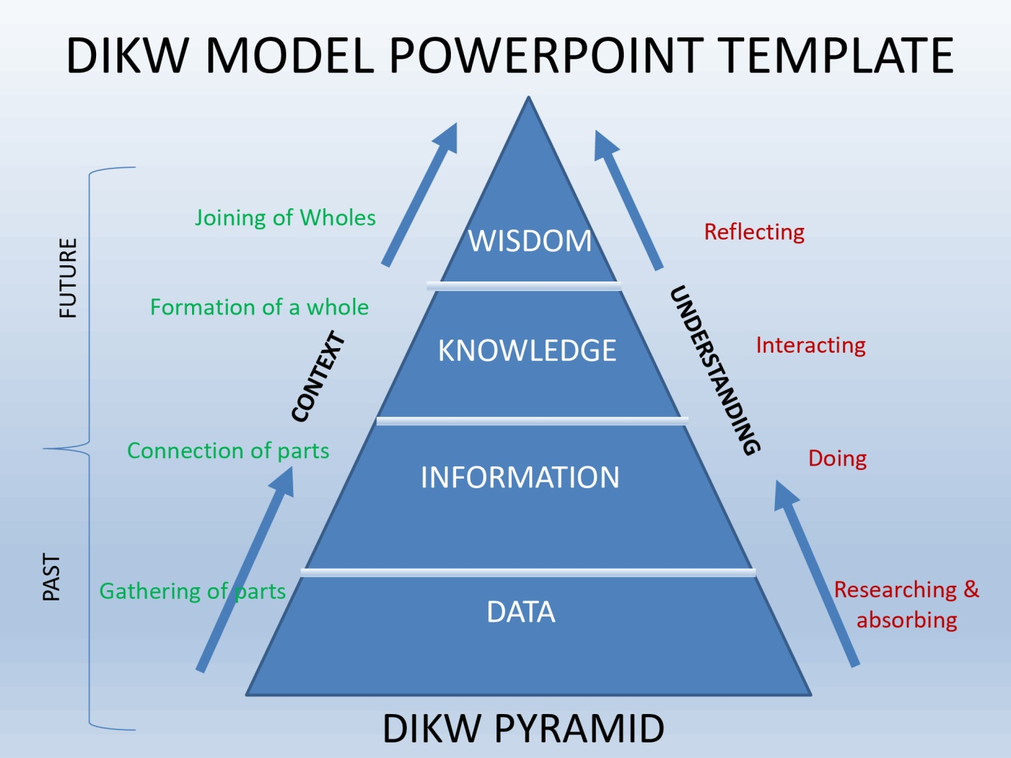
What is the DIKW model?
This model is used for knowledge management explaining ways of moving data to information, knowledge and wisdom with actions and decisions to be made by a person or as a team. It is used as a way of extracting value and insights of whatever data it may well be fast data, small data, slow data it doesn’t really matter what forms of data. The DIKW model is used in any forms and shapes looking of value and meaning of data information.
The use of this model captures accurate data, adding context for reviewing data to transfer it into information and only data that adds value being captured.
The model is used by entrepreneurs by managing the context that adds value. Moving information easily captured, query, find and re-use so they have learned from experiences so duplication is reduced and so they don’t make the same mistakes again.
Certain information processed in a mental understanding is knowledge, to make a good decision from a business prospective wisdom is particularly the ability to use their knowledge help managers make the right decision.
Benefits of wisdom
Good judgement Solving problems seeing better results and moving forward are the benefits of a person with good judgement. A good judgement comes from experience, and a lot of that comes from bad judgement’. The challenges that arise from leaders is better handled if that leader has wisdom.

Geographical data, from a sample population of a new product, and how I will use the data to convert it to information, and possibly knowledge for promoting the product.

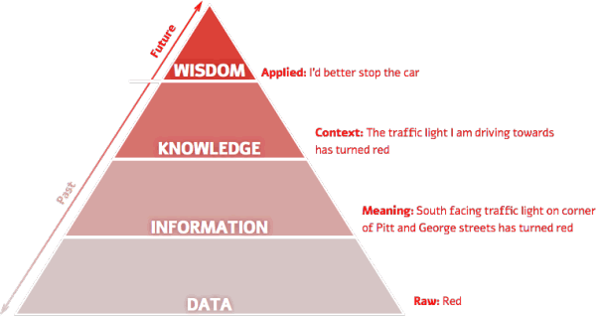

Definition of information systems
The role of an information system are categorized in 3 different types you have enterprise systems decision support system also a specialised business information system. Under enterprise the information system s that are used are e-commerce, m-commerce and e-procurement.
E-commerce
With the use of internet facilitating business and transactions is called e-commerce, the real name being ‘electronic commerce’. Examples are the way ASDA do online shopping where you have online transactions, electronic payments in place where customers can order online, click and collect and have shopping delivered for their convenience. Types of e-commerce are businesses’ to businesses’, consumer to consumer and business to consumers. The benefits of e-commerce are the fact that it saves a lot of time for buyers and geographical distance. E-commerce lowers costs in the process and streamlines operations.
M-commerce
M-commerce is a short name for mobile commerce where avenues have opened for e-commerce due to the rapid penetration of mobile devices with brilliant internet access. These days companies have apps where customer’s information is stored once they set the application up for instance, there name, address, contact details, payment details, email, and telephone numbers. At ASDA for example on the app with one click of a button you can manage to place click and collect orders or arrange for delivery on the slots you prefer during customer busy schedules and lifestyle suits.
Electronic-procurement
Short for electronic procurement this is known for the orders and purchases of goods and services with the use of internet from business to business. For example local small shops will use online warehouses to order large quantity off goods instead of doing the hassle of placing phone orders or even going to the warehouses to collect the goods e-procurement is the quick and efficient way to pay and receive goods.

SABRE (semi-automated, business, research environment) computer reservation system.
SABRE computer system
This system is known as a global organisation system owned by the SABRE Corporation. You can search, book prices, book tickets, as a travel service provided by airlines, hotels, car rental companies, rail providers and also tour operators. SABRE combines travel buyers, hotels, airlines, Offline, and online travel agents all together.
SABRE eventually became a computerised reservation system (CRS) Apollo was the competitor back in the 1980’s in the airline industry. For 30 years American airlines handcrafted computer systems. Their skills in hardware evaluation, and the project management for software development and the integration of software gave them a boost in the competition. They decided to buy more hardware and software from third party vendors and get them tailored to their business needs.
Building the economies of scale American airlines using index cards and blackboards wasn’t enough to cope with the volume of reservations so in the 1950’s they decided to work on a computerised reservation system. When SABRE debuted it processed data related to 20,000 ticket sales, 85,000 phone calls and 40,000 confirmed reservations.

Generic strategies of porters are related to difficult airline companies using strategies to make them more profitable. The generic strategies involved in the airlines are ‘focus differentiation’ and ‘cost leadership’. The airlines will try to position themselves for low-cost, no-frills airline, a small company which have specific routes to what other companies may not have. When a company like American airlines try to set out the lowest cost airline in the industry this relates to cost leadership as the company is leading its competitors in low fares. When it comes to economic fares they are cost readers whatever they have exclusive access to raw materials to fly their planes i.e. Fuel or whether it’s using proprietary technology. Certain attributes that they would offer but other airlines don’t offer like free meals offered on airlines or overseas flights or even offering customers sleeping facilities too is the differentiation setting the airlines apart.
Porter’s five forces analysis on American Airlines
What are the threats of new entrants?
The challenges faced by American airlines and to build effective barriers to safeguard its companies edge is by providing for its customers, new value propositions, lowering pricing strategy and reducing costs. As new entrants they would innovate new ways of doing things for their customers in order to put pressure on.
How would the airlines tackle the threat of new entrants?
- They would have to build the economies of scale and lower fixed costs per unit
- Spend money on research and development, as keeping standards regularly would make it difficult for new entrants to enter the dynamic industry
- Creating new products and services giving a choice for old customers to keep buying, and also bringing in new customers.
What is the bargaining power of the suppliers?
Raw materials in the industry are available by a lot of suppliers margins can decrease within the airlines by suppliers who are dominant. Suppliers in the service sector who are bigger suppliers could demand higher prices from airline firms. The impact of bargaining power is possibility overall for the airlines.
How can the airlines tackle bargaining power of its suppliers?
- Making their supply chains more efficient with a lot of different suppliers
- Using different materials to do experiments on the product designs so in the future if prices go high on one raw material they have the option to buy from another
- To choose dedicated suppliers who depend on American Airlines so could have the power of bargaining.
Bargaining power of buyers
Every company wants to buy best offerings available to buy at the best possible price, as buyers are a very demanding lot. If the customer base being smaller and most powerful of the airlines then the higher the bargaining power of customers, and a greater ability they would have to seek offers and discounts.
Tackling the bargaining power
- Reductions of the bargaining power of buyers would be the outcome by building a large customer base and then the airlines will have the opportunity to streamline its sales and production process.
- By reducing the defection of the airlines existing customers by new products and services against its competitors
- If the airlines keep coming with new products it will limit the bargaining power of buyers, as customers often seek discounts in established products, so rapidly innovating new products would be ideal.
Threats of substitutes
New services or products meeting similar needs for customers, the probability of the industry could suffer. If a value proposition is offered, compared to present offers of the industry, then the threats of substitutes would be high.
Tackling threats of substitutes
- For the airlines to be more service oriented rather than just product oriented
- Not what customers are buying but to understand their needs
- Switching cost increases for the customers
Rivalry amongst existing competitors
Existing rivalry amongst competitors in the airline industry will drive prices down making profitability poor towards the industry. The airline industry is a very competitive industry so the competitors rely on long term profit of the organisation.
Tackling the rivalry amongst existing airlines
- Compete in the industry by building a scale
- Sustainable differentiation build-up
- Rather than competing with small market collaborating with competitors to increase market size.
Generic strategies
Generic strategy is when an organisation acquires a high market share looking towards price sensitive and cost-conscious customers. To do this they will have the lowest price in competitive market, r the best perceived value for a product or service comparing to the prices charged.
Cost leadership
Cost leadership would involve using factor like lowering prices by having a competitive advantage in the industry, for example companies like Primark and LIDL who keep their cost low as possible or ensuring that they have the large market share with ore average prices. The consumer price would be a different story the point is to keep the costs low. That’s why LIDL and PRIMARK concentrate on internal processes and low cost of labour, LIDL who do this by manufacturing like for like products using own brands and PRIMARK getting their clothing made in Bangladesh to saving material costs and the use of cheap labour.
Differentiation
This is where a company like apple would target high demand with their unique features of products and services attracting and exclusive as possible compared to competitors like Samsung. Apple had to use good development and research and delivering at high quality. They would make the market understand the benefits of their unique product and was aware of the adaptability and were flexible in market change. They had a creative approach and were most focused on the outside world.
Cost focus
In this strategy you can tend to choose a niche market of little competition and you understand consumer demands and understanding and ways of keeping cost low, good example being the airline industry.
Niche
The niche market would be companies like Lamborghini/Bentleys/Porsche who have a value chain and produce final goods and services responding by customer needs. Being online and having better values for customers and allowing customers to create the interior exterior designs via computers.

What is Block chain and benefits for American airlines?
Block chain is a secure way of making agreements, recording transactions and contracts being a digital leader of making recordings and verifications of these factors taking place in an industry. The data is shared amongst networks of computers encompassed by hundreds and thousands of people or even just a handful of users. Getting bigger over time the network creates a long list of transactions for the ledger.
How is blockchain used?
As new transactions are made the blockchain computer software operating behind the scenes automatically distributes information to the databases. Individual users will not be able to alter a transaction when it’s recorded onto a ledger as that individual will not see a blockchain performing. Blockchain software is still in experimentation today it is estimated that $15 billion was invested in the blockchain technology alone in 2016.
American airlines biggest blockchain opportunities
As long as the airline meets the criteria in relevance towards blockchain systems like:
- Has intermediaries with a complex ecosystem relying on third party intermediaries due to airlines not trusting each other whilst operating in a relevance of players
- Adding to the complexity of data management having the data spreading across a variety of different databases and systems. Contractual transactions must be added or retrieved as different players engage in contractual transaction.
- In a permanent and secure way contracts, transactions, records, shared data need to be recorded by airlines so they are fully traceable and auditable as data security is critical.
How can American airlines use blockchain systems?
Ticketing
Information that usually would be printed on a paper ticket would be stored on a massive database and then printed in form of an e-ticket.
Loyalty
In the industry of air travel loyalty plays a major part, limited on where customers spend they are recognised by a loyalty points scheme as the loyalty points on the blockchain the travellers get instant value if they redeem them on the spot.
Security and identity
Flight manifests, crew information and passenger records is a privacy issue so protecting the data blockchain technology is less risky ways of managing and sharing information through the use of authorised access requirements.
Maintenance
Every part of the plane would go on the blockchain technology as maintenance logs can be set-up so all records are on the system every time maintenance logs have been authorised and by whom, taking practice of maintenance, safety and aircraft security to new levels.
Types of enterprise systems
To support processes within an organisation like procurement, product development, manufacturing or sales enterprise resource planning systems are implemented. The ERP system could be extended for service with enterprise systems across organisations such as customer relationship management (CRM) supplier relationship management (SRM) and supply chain management systems.
The ERP manages the company’s information no matter of the size of the company, mainly organisations with over 500 companies on the same network connection. With only one thing in common they manage information reducing efforts required by managers and employees. Accessible from one place the enterprise systems integrate the information and processes used throughout the organisation.
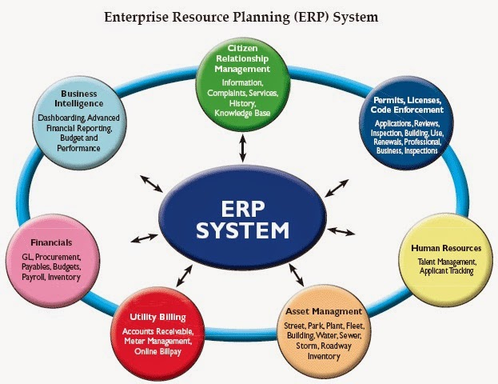

A typical example of an ERP system showing different categories used within an organisation where everything is managed and all information is available for colleagues managers certain categories may require authorisation to access the information like the finance part for instance, and with laws in place there could be certain restrictions to what information could be kept on the system and for how long.
What types of companies use ERP systems?
- Aerospace and defence
- Hospitality
- Construction
- Technology
- Retail
- Manufacturing
- Pharmaceutical
- Distribution

ERP software for American Airlines
During past decades only a specific category of people used to travel by means of air, like rich families, business people and high profile government officers. Nowadays, we can all fly from one place to another at affordable costs. The competition in the industry has become important for the airlines to reduce costs by streaming their process efficiently, benefitting their customers by reducing their operational costs. ERP solutions would assist the travel agency by:
- Whole supply chain
- Total quality managed
- Discrete production
- Electronic data interchange
- Manufacturing management
- Human capital management
It’s important for the airlines to provide values to their customers and also the stakeholders. With this digital system and advanced tool management they are bombarded with loads of data every minute. With the ERP it’s easier to get information required instead of double checking metrics and data saving the company a lot of time. The airline gains accurate and timely decisions so that the operational efficiency is enhanced.
Real time data
American airline authorities could assist by making fast decisions and optimise resources helping capture opportunities.
Inventory management
The ERP software offers inventory modules to the airlines and the rest of the industry providing notifications of the levels off re-order.
Expenses accounting
The airlines management had a clear and accurate picture of its costs as the ERP software helped by tracking on the costs and the expenses in a systemically way.
Reports
ERP gives the reports enabling management to evaluate workers performances; the reports were available to help management to take strategic decisions on time.
Multicurrency accounting
ERP helped the company with multiple transactions currencies enabling the airlines controlling transactions and giving the flexibility to clear global transactions smoothly.
Data security
The airline could customise the use of data according to their needs. Saving confidential data, from other employees, so ERP software is secure for them.

Conclusion on information and management for the workplace
Weather we looking at small or larger enterprise knowledge has a very important impact with each individual, with a solid and clear management system in place. Unnecessary faults are also minimised as well as making the enterprise lead to better performances. Based on existing data of knowledge we have learnt that the manager has the most important task in a company. They have to lead others the best way possible using their skills to analyse, leading and understanding them having the influence with employees and staff in the company. The manager would make the working condition more of a friendly and a comfortable environment to help colleagues work in the best of conditions. The company itself should have suitable compensation policies go with the contributions made towards the company. This would boost motivation of employees in the company so that updating knowledge and to earn new things every day and have better contributions towards their future.
The use of information systems for entrepreneurs has major effects on the impacts on businesses’ gathering information which would be useful for the planning leading organising and controlling towards the success of business needs, with the decisions made on a strategic level with CEO and directors at the top level, managers and team leaders at the middle level and finally the important operational staff like shop floor, checkouts etc.

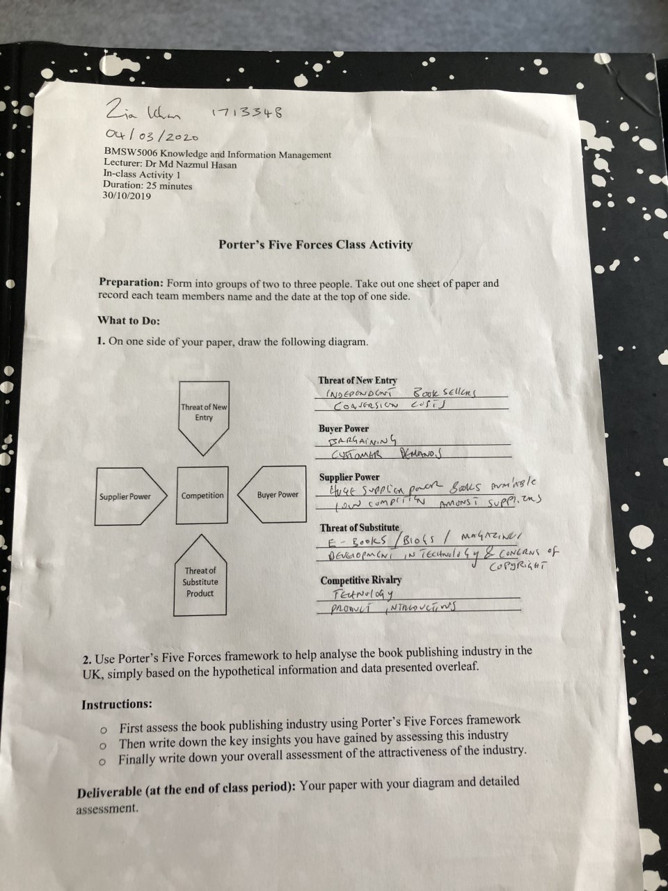

References
https://www.quora.com/what’s-the-difference-between-data-information-and-knowledge-in-machine-systems-Or-is-there-a-difference

Porter, M.E. (1980). Competitive strategy: techniques for analysing industries and competitors. New York: free press.
Porter, M.E. (1985). Competitive advantage: creating and sustaining superior performance. New York: Free press.
The DIKW model for knowledge management and data value extraction https://www. i-scoop.eu/big-data-action-value-context/dikw-model/

