

Programme: Certificate of Higher Education in Skills for the Workplace & Health and Social Care

Module: Problem Solving and Decision Making

Module code: BMSW 4004

Assignment Title: Task 2 – Final report

Student name: - MARIAN TANCOS

Student ID number: 2120437

Internal Verifier: Yohan Mendis

Nature and Impact of the Complex Problem

Nature of the Problem on the Organizations
While the pandemic has taken a toll on the physical and mental health of various people, it has also taken quite the toll financially and economically on several nations and its citizens. Needless to say, this toll has caused many troubles for numerous organizations as well.
The pandemic not only instigated lockdowns for homes, but it also did so for offices and business operations. Not to mention, several other problems followed right after the pandemic, which didn’t produce good consequences for the organizations.
For instance, the UK has been facing inflation for quite a while now, which has forced multiple organizations to raise the prices for sustainability and profitability. Moreover, organizations that do not supply essential goods and services are failing to sustain their businesses at a higher rate.

Nature of the Problem on the Employees
Employees depend on their respective organizations for survival; a huge number of employees ran their households and took care of their regular expenses from paycheck to paycheck. So, when the organizations were heavily impacted by the complex problem, so were the employees. First of all, due to the pandemic, a lot of full-time employees were either laid off, or had a percentage of their salaries cut. Not to mention, many employees were also dealing with health issues or with the loss of their loved ones due to covid-19, which made it difficult for them to handle their career.
Now, even after the pandemic, the aftereffect is still quite daunting for many of the employees. Due to the increase in inflation in the UK, many employees are still finding it difficult to bear their household costs with their current income - standards of living have dropped gradually, if not significantly.

Impact of the Problem on the Organizations
The complex problem, which is a combination of the pandemic as well as inflation, turned out to be quite detrimental for various organizations. However, it has impacted retailers of non-essential goods a lot more severely.

Supply chain issues have not been fully recovered yet, and many businesses were forced to shut down due to the pandemic. However, things have slightly, if not significantly, improved for some of the organizations.
Others are still struggling to make ends meet with the grueling rise in inflation in the UK - customers are more aligned towards cutting costs and prefer getting goods at a lower price than spending a lump sum on them. Hence, they are boycotting premium products, or ones that they do not need, which in turn is causing the organizations to become less sustainable.

Impact of the Problem on the Employees
With the suffering of organizations, entails the suffering of employees as well. If organizations become less successful, they will start laying off workers or cutting off their salaries. And that is the exact result of this complex problem - the pandemic has already increased the unemployment rate, whereas the inflation is keeping the employees underpaid.
Not to mention, with inflation, the purchasing power of the employees has also reduced, so they will surely need more income to sustain their standards of living. But with the reduction in salaries, that is barely possible for them anymore.
This has resulted in the employees having lower motivation to work, little to no commitment and poor mental and physical issues as well. Overall, this is affecting the overall performances of the organizations as well.

PESTLE Analysis

Political
Due to the pandemic and the rise in inflation, the UK government has lost some of its stability. And the loss of stability is not evident for the UK government only, this has been the case for all the countries impacted by the covid-19 pandemic, followed by inflation and dissolution for many companies.
This unforeseeable instability has caused various organizations to fall apart; and in the case of the shirtmaker, it resulted in declining profitability - a seemingly booming business that had more than 150 shops worldwide.

Economic
The economic growth in the UK has not been improving ever since the pandemic hit. In fact, we could say that the growth has been declining. Due to the dissolution of various companies, employees were laid off as well, which led to an increased unemployment rate.
Inflation has reduced consumer confidence as well as purchasing power right after the pandemic affected the economy of the UK. Hence, companies that sell non-essential goods such as Torque brands, are facing a massive decline in sales, which is in turn decreasing their profitability.

Social
Since the economy and the government of the UK were affected due to the situation, some social factors also got worse. For instance, the income distribution has become more unequal - as this situation has made the rich even richer, and the poor even poorer.
The lifestyles of various people were also compromised - which led to them purchasing less and less non-essential goods. This in turn harmed the profitability of the shirtmaker, and made it even difficult for them to sell their goods in such conditions.

Technology
The pandemic has surely brought in the trend of work from home in several countries - and the UK is one of those countries. While it is easy for tech-based organizations to adjust to this change and work accordingly, it cannot be the same for all organizations - at least not one such as the shirtmaker.
Even though all the countries are shifting back to their traditional way of working, it can be said that the impact of this new technological revolution has surely left some impact on the way organizations work.

Legal
The situation has compromised the health and safety for various individuals; but it has been controlled in the UK through vaccination and by taking other measures as well. Not to mention, there hasn’t been any significant changes in the legal aspects despite the economic situation of the country.

Environment
The attitude of the consumers and the overall regulations and restrictions can also impact the profitability of a company. And in this case, we can see that the attitude of the consumers is not positive anymore - given the company focuses on selling non-essential goods, something the consumers will not buy unless they absolutely need it.
Even though, after the pandemic, the sales have increased to some extent, but due to inflation, consumers are being picky about what they should spend on and what they should not. From the looks of it, convincing consumers otherwise has become difficult.

Cause-and-Effect Analysis
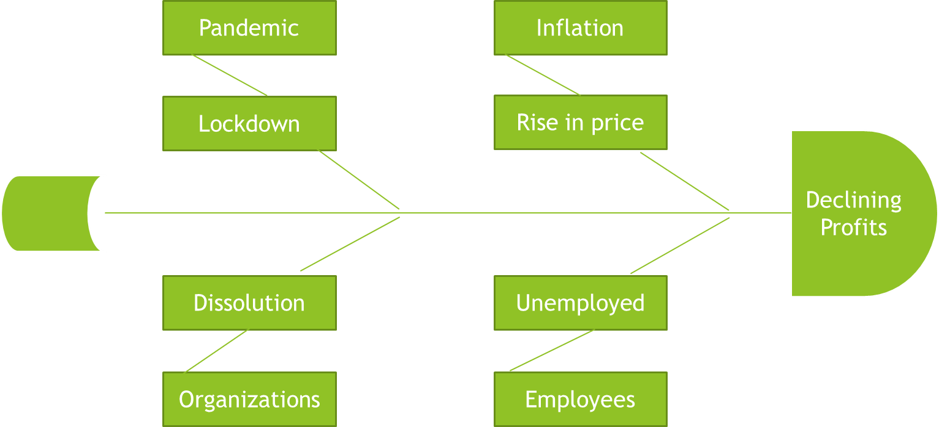

The first cause that we can see from this fishbone diagram is the pandemic; the pandemic caused various problems, but the main link to all those problems related to organizations was the lockdown. Due to the lockdown, many organizations had to shut down - many couldn’t operate anymore, and many couldn’t get profits even after continuing their operation. Work from home was also hectic for some companies that required the employees to be present.

The second cause that we can see is inflation. The inflation was followed by the pandemic, which decreased the purchasing power of employees - and hence, increased their budgetary

constraints. Due to this rise in price, many people had to drop their standards of living, which resulted in them boycotting many products that are not essentials - again, resulting in a loss for organizations.

The third part shows the dissolution of organizations, which might have been a result of both the pandemic and the rise in inflation. With higher operating costs, more restraints and barriers and less resources, it became difficult for many organizations to sustain - let alone to make profits. The same goes for torque brands, which have been struggling to make profits despite having 150 shops all over the world.

The fourth part shows the effect on employees - and we can see that the unemployment rates have increased both due to the pandemic and the rise in inflation. Many employees have been laid off whereas others simply faced a pay cut. This resulted in the drop of their standards of living, since they were also earning less and even had less purchasing power. The increase in unemployment rates have also affected the economy of the UK gravely.

So overall, all of these factors have caused the profits of the torque brands to decline. They are struggling to sustain as their goods are known to be non-essential goods, something people only tend to buy when there is an occasion or when formalwear is necessary. Such a turn of events have become detrimental for the business of torque brands.

Solution to the Problem

Alternative 1 - Rebranding
Torque brands already has a brand for itself - and it is pretty famous, given it has 150 shops worldwide. However, the pandemic has hit the business pretty hard, and now, inflation is not doing any justice to it either.
But one of the most prominent reasons behind that is - men’s formalwear is taken as a non-essential good and that is how the brand image has developed so far. Hence, when people think of torque brands, they think of it as a brand that provides wants and not needs.
Hence, torque brands should focus on rebranding themselves. They should change their marketing strategies, and apart from that, they should also focus on presenting themselves as a

brand that provides essential goods. New marketing strategies will help them reach new target groups, and hence, increase their sales.

Alternative 2 - Investing in Staff
The workforce of a company determines how well the company is going to perform - no matter which industry it is that we are talking about. And since torque brands sell men’s formalwear, something that requires both handiwork and communication with consumers, the workforce stands to be even more important here.
Therefore, to improve the quality of their services and to attract more consumers, they should invest in their workforce. By investing in the workforce, they will also be able to hire more creative individuals who will be providing more insights on how to improve their business.
Not to mention, with an improved service and quality, consumers might get attracted naturally. However, with the rise in inflation, this method can be rather costly for the company as a better workforce will require more pay as well.

Chosen Alternative with Implementation
Since we have determined that the second alternative is going to be a rather expensive option for the company now that its profits are declining, we will be going with alternative 1. Surely, some investment will be required for rebranding as well, but it will be more worth it.
Here are the steps to how this will be implemented:

Step 1: Choose the New Criteria of Branding
When rebranding, the first thing that the company should be identifying is what elements from the last brand image caused the problem and how they want to change it now.
Hence, choosing the new criteria of branding should be the first step - what they want the brand to be and how it should be presented to the potential consumers.

Step 2: Choose the Forms of Marketing
In this world of technology, there are various forms of marketing that can be chosen from. Digital marketing, print ads, billboards and what not. Now, the company should choose a form of marketing that goes with their brand.

Since they operate in shops and sell men’s formalwear, it would be wise to start with print ads, and then they can move to digital marketing from there.

Step 3: Select a Target Group
Does the company want the previous target group or do they want to target another group? Not to mention, they can also keep the old target group and target a new one.
But before forming the marketing strategies, it is important to have a clear cut idea on who their target group is going to be.

Step 4: Form the Marketing Strategies
After selecting the target group, the company should then think about the marketing strategies. This can include campaigns, events, etc.
It depends on the company as to which strategy they would like to follow to rebrand themselves.

Step 5: Implement the Strategies
Now, it is time to implement the strategies, by creating a timeline of when the strategies will be implemented and how.

Success Indicators
There are a few success indicators that the company can keep in mind to measure the effectiveness of the solution.
At first, the company should evaluate the solution to scope to see how feasible it is going to be. It is important to see how easy it is to implement a solution in order to get an idea of its effectiveness.
Then the solution specifications should be evaluated. This is to review the details of the solution
- how useful they are, how those will be helping, etc.
The budget for this solution should also be analyzed because that will determine whether the company can invest on it or not.
The revenue growth then gives the company an idea about how effective the solution was and whether investing in it is going to be worth it or not.
Lastly, and most importantly, the company should use client satisfaction as an indicator to check whether the solution has actually made a positive impact on the clients or not.

References
Nersisyan, Y. and Wray, L., 2022. What’s Causing Accelerating Inflation: Pandemic or Policy Response?. SSRN Electronic Journal,.
Stride, M., Renukappa, S., Suresh, S. and Egbu, C., 2021. The effects of COVID-19 pandemic on the UK construction industry and the process of future-proofing business. Construction Innovation,.
Barone, R., 2022. The Pandemic Caused Significant Economic Impacts; Not All Inflation Is Related. [online] Forbes. Available at:
<https://www.forbes.com/sites/greatspeculations/2021/10/16/the-pandemic-caused-significant-e conomic-impacts-not-all-inflation-is-related/> [Accessed 13 October 2022].

