Name: Marilam Akhtar 2240547
Programme: BSc Health and Social Care
Module:
Module: BMHP5016
Lecturer: Precious Igbinigie
Assignment title: Component 2: Written Assignment (Report)

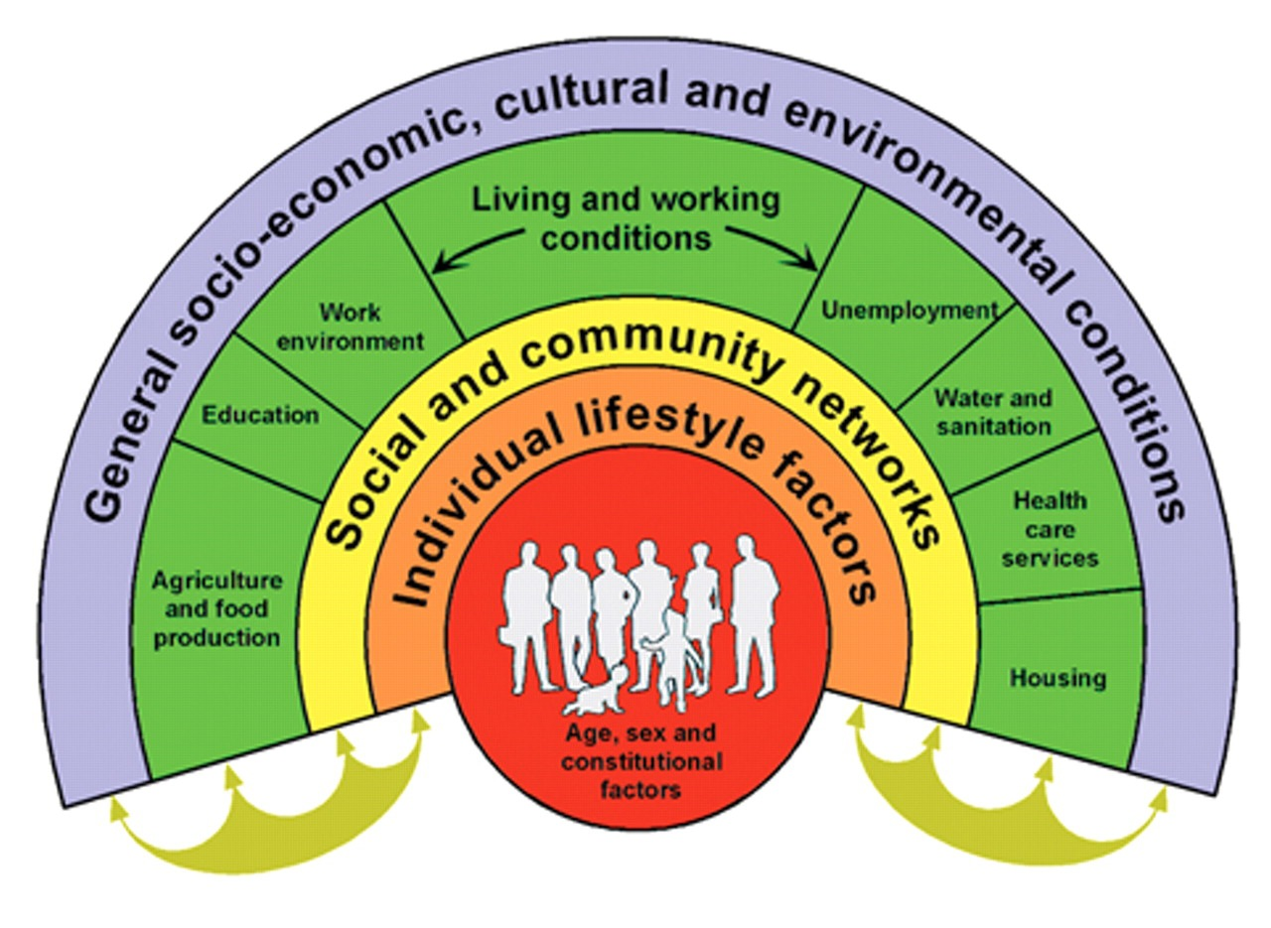
This Photo by Unknown Author is licensed under CC BY-SA-NC

Abstract
This report evaluates PCC and PW community mental health services. Person-centred care (PCC) and partnership working (PW) in community mental health services are examined in this report. The report uses Rogers' humanistic theory empathy, empowerment, and understanding lived experience to examine how PCC promotes dignity, autonomy, and personal choice. The study highlights how PCC has improved satisfaction, communication, and health, as well as resource scarcity, moral dilemmas, and communication issues.
Collaboration and decision-making are affected by the four ethical precepts: autonomy, beneficence, non-maleficence, and justice. The report also discusses PW and how Integrated Care Systems (ICSs) can improve NHS, local government, and nonprofit collaboration. Improved continuity and reduced redundancy are discussed alongside unclear roles and competing organisational priorities.
The report examines UK laws and policies to show how they affect PCC and PW. The report recommends evidence-based digital integration, worker training, and sector to sector cooperation to support PCC and PW's UK growth.
The report recommends digital integration, staff training, and cross-sector collaboration to improve community mental health services with PCC and PW.

Component 2 – Written Assignment (Report) 50% weighting – 2,000 words (+/-10%)
Introduction
Approaches like person-centred care (PCC) and partnership working (PW), which emphasise individual needs, collaborative practice, and ethical accountability, are increasingly influencing health and social care practice in the UK, especially in community mental health services. Person centred care (PCC) has appeared as a fundamental principle of superior care, highlighting dignity, autonomy, and respect for personal preferences (Brooker and Latham, 2016). PCC is underpinned by humanistic theories, notably Rogers' work, which emphasises the significance of empowering persons to engage actively in decisions about their care (Rogers, 1961). In conjunction with PCC, partnership working (PW) has become vital for providing coordinated, comprehensive support across professional and organisational boundaries (Glasby and Dickinson, 2014).
This report will delineate PCC and analyse its advantages and drawbacks, thereafter, engaging in a critical examination of a pertinent theory that supports person-centred methodologies. The ethical principles essential to Health and Social Care practice, including autonomy, beneficence, non-maleficence, and justice, will be examined (Beauchamp and Childress, 2019). The study will subsequently assess collaborative efforts and examine their implementation in a selected practical context. The pertinent UK policies and legislation that affect PCC and PW will also be studied. Ultimately, proposals will be provided to facilitate the future advancement of PCC and collaborative efforts around the UK. This report focuses on the application of Person centred care and Partnership working within community mental health services.

Define person centre care and identify the main benefits and limitations of this practice.
Person centred care prioritises patient health and well-being. It promotes dignity, respect, autonomy, and personal values, preferences, and experiences (Brooker and Latham, 2016). PCC prioritises service user participation, collaborative decision making, and comprehensive support for physical, emotional, social, and cultural needs. Humanistic theory, particularly Rogers' belief that patients should participate in their care (Rogers, 1961), underpins this approach.
Many health and social benefits from PCC. Priority-based care enhances communication, therapeutic relationships, and patient satisfaction (NICE, 2012). It improves treatment adherence, autonomy, and health. Considering social and emotional factors in health promotes holistic care.
However, PCC has practical limitations. Time, staffing, and workload pressures may prevent professionals from providing fully personalised care (Glasby and Dickinson, 2014). Individuals may face cognitive or linguistic barriers that hinder decision-making, and inflexible organisational policies may limit personalised approaches. Practitioners must also balance autonomy and safety to avoid ethical conflicts (Beauchamp and Childress, 2019). Practitioners in community mental health teams may involve service users with severe depression in shared decision-making about their care plan. If the patient is too distressed to communicate, the practitioner may need to take a directive approach to prevent harm, adhering to the ethical duty of non-maleficence (Beauchamp and Childress, 2019) and Care Act (2014) safeguarding responsibilities. This illustrates how real-world constraints can limit the practical application of PCC.
PCC is best practise, but it needs resources, communication, and organisational commitment to be consistent (Health Foundation, 2021). PCC empowers community mental health patients to participate in their recovery plans, reflecting Rogers' (1961) emphasis on autonomy and personal agency. This approach aligns with NICE (2021) guidance, emphasising shared decision-making for better engagement and outcomes. Legal frameworks like the Care Act (2014) and Human Rights Act (1998) emphasise dignity, respect, and personalised support. PCC supports recovery focused practice in community mental health settings by providing holistic care tailored to individuals' psychological, social, and cultural needs (NHS England, 2023).

Critically examine a relevant theory or model of care of your choice which underpins PCC.
Carl Rogers' Humanistic Person-Centred Theory underpins person centred care. When raised with empathy, genuineness, and unconditional positive regard, Rogers (1959) says people naturally want to develop and fulfil. In line with modern Person centred Care (PCC) in Health and Social Care, this approach puts the person before the disease or condition (NHS England, 2023). Rogers' methodology emphasises understanding each person's subjective experience, promoting autonomy, and allowing people to actively participate in care decisions.
Rogers' model advantages include supporting meticulous and caring practice. Professionals should build trust and communicate empathetically to create a safe space where service users feel valued and understood (Mind, 2020). This improves engagement, contentment, and emotional health. It supports shared decision making, a cornerstone of person centred care (PCC) and widely supported in UK policy and recommendations (NICE, 2021).
There are drawbacks to the idea. Critics say Rogers' approach may be difficult to apply in high-stress environments where staff have little time to form therapeutic relationships (Health Foundation, 2021). The paradigm assumes everyone can and will express their needs, which may not be true for people with cognitive disabilities, communication issues, or severe discomfort. Some professionals say it's hard to show unconditional positive regard to complex or troublesome service users. Despite these limitations, Rogers' paradigm still shapes person-centred care today. It encourages community mental health professionals to prioritise empathy, active listening, and shared decision making to help patients feel valued, understood, and healed. In modern mental health practice, where therapeutic relationships are essential to recovery focused care, Rogers' emphasis on empathy and unconditional positive regard is consistent.

Analyse the ethical fundamentals of health and social care.
Key ethical principles in health and social care include autonomy, beneficence, non-maleficence, and justice (Beauchamp and Childress, 2019). Person Centred Care (PCC) and autonomy share the emphasis on choice, control, and respect for individual preferences (NICE, 2021). Community mental health patients may refuse medication. Respecting autonomy means acknowledging their choice while using Partnership Working (PW) to discuss concerns and create a safer, collaborative plan.
Beneficence promotes wellbeing and serves the person's best interests, supporting PCC. A mental health nurse may suggest therapy to reduce distress but must respect the patient's preferences. Non-maleficence, or “do no harm,” ensures safe and risk aware care. The Care Act (2014) states that if a vulnerable adult discloses abuse and requests confidentiality, non-maleficence requires breaching confidentiality to prevent harm.
Justice means fairness and access. Interpreters or reasonable adjustments may be needed to ensure equitable care for all service users.
Principles often conflict, creating ethical dilemmas. Service users may value autonomy while practitioners value safety, and families may disagree. PCC and PW promote shared decision making, open communication, and collaborative problem solving to balance perspectives.

Evaluate partnership working in health and social care.
Cooperation between professionals, agencies, and service users to provide high quality care is Partnership Working (PW) according to SCIE (2023). PW improves when the NHS, local authorities, and voluntary organisations work together to improve population health and reduce inequalities (NHS England, 2022).
PW can harm mental health ethics. When patients lack capacity or are at risk, practitioners must balance autonomy with non-maleficence and follow the Care Act (2014) (Beauchamp and Childress, 2019).
PW is vital for community mental health service users who need support from nurses, GPs, social workers, psychologists, housing teams, and voluntary organisations. Effective PW treats mental, social, and practical needs. Communication, duplication, and Person-centred care are improved by PW, according to NICE (2012).
PW advantages are clear. CMHTs collaborate with psychiatrists, nurses, occupational therapists, and social workers to improve continuity and recovery. Healthy Foundation (2021) found that person-centred, collaborative approaches increase engagement and satisfaction.
PW faces challenges. Communication issues, unclear roles, and competing organisational priorities can hinder collaboration. Multiple IT systems across agencies cause delays and confusion, and staffing shortages and time pressures limit collaboration, according to SCIE (2023).
Explore the application of partnership working in a practical health and social care setting of your choice.
Many important laws and regulations affect health and social care providers' Person-centred Care (PCC) and Partnership Working (PW). Healthcare Act 2022 enabled Integrated Care Systems (ICSs). The NHS, local governments, and nonprofits must collaborate to improve health and reduce health disparities (NHS England, 2022). Ensuring services work together improves PW.
The Health and Social Treatment Act of 2012 promotes PCC by giving people a say in their treatment. This is done by emphasising patient choice and team decision making (DHSC, 2012). The Care Act of 2014 requires local governments to work with health care providers to prevent demand from rising and provide coordinated, complete care, which helps PW.
Human rights and equality laws affect how things are done. The 1998 Human Rights Act safeguards PCC dignity, freedom, and respect. The 2010 Equality Act prohibits discrimination and requires services to make reasonable accommodations for all patients.
These rules affect community mental health operations. The 2014 Treatment Act requires mental health nurses and social workers to evaluate patients and share information to create a single treatment plan. ICS frameworks ensure that general practitioners, mental health teams, housing services, and nonprofits collaborate to help complex patients. This reduces emergency hospital visits and ensures consistent care.
Some policies may be difficult to implement. The 2012 Health and Social Care Act increased competition between services, making it harder for them to collaborate. PW can be difficult because groups have different goals and money responsibilities.
Policy and rules greatly affect PW and PCC distribution. They ensure community mental health patients receive complete, rights-based, and coordinated care.
Partnerships are used in community mental health services for MDT meetings, shared care plans, collaborative risk assessments, and coordinated crisis responses. Mental health nurses, social workers, GPs, psychologists, housing officers, and volunteers help complex patients. A psychiatrist may review a service user's medication, a mental health nurse may provide emotional support, a social worker may provide housing support, and a voluntary organization may provide peer support. In real world settings, PW provides comprehensive, person centred care.
Discuss and examine relevant policy and legislation in relation to PCC and PW. Include recommendations for future development of PCC and partnership working in the UK.
Despite policies that support PCC and PW, there are problems with community mental health care. Information not being shared, service users not participating, and aid not always being available are among the issues. To address this, the UK should improve its digital integration. Electronic records should be shared by the NHS, social services, and nonprofits. Improved communication and reduced duplication would be advantageous for Integrated Care Systems (ICSs), which were created under the Health and Care Act 2022 (NHS England, 2022). It is challenging to exchange data between IT platforms that do not work together.
Second, enhance staff training on PCC and collaborative practice. Employees with NICE mental health training are better equipped to collaborate with other agencies and include service users in decision-making (NICE, 2022). Because of staffing and time constraints, it might be challenging to implement.
We need to work with community organisations and nonprofits more. According to SCIE (2023), working with housing, advocacy, and peer support services improves complex needs. This may be hampered by shifting organisational priorities and unstable funding.
through a shared care plan, these proposals would guarantee coordinated, comprehensive care for community mental health. In addition to addressing service disparity and fragmentation, this fortifies PCC and PW. Even with these frameworks, service users may still receive fragmented care due to regional variations in implementation.
Enhancing co-production with service users making sure that people with lived experience are involved in creating, assessing, and enhancing mental health services is another crucial suggestion.

Conclusion
Person-centred Care (PCC) and Partnership Working (PW) are crucial to providing high quality, moral, and collaborative health and social care, according to the study. PW uses humanistic theory and ethical principles like autonomy, beneficence, non-maleficence, and justice to coordinate support across professional boundaries.
PW allows coordinated support across professional boundaries, while PCC promotes collective and shared decision-making. The Health and Care Act 2022 and Care Act 2014 influenced these approaches in the practical setting.
The findings suggested better digital systems, staff training, and cross sector collaboration. Poor communication and inconsistent implementation were also found. PCC and PW must be strengthened to meet changing individual and community needs. Care quality depends on integrating these two approaches.
Person-centred care and partnership working must be strengthened to improve community mental health outcomes and maintain compassion, coordination, and responsiveness to individual needs.

References

Beauchamp, T.L. and Childress, J.F. (2019) Principles of Biomedical Ethics. 8th edn. New York: Oxford University Press.
Brooker, D. and Latham, I. (2016) Person-Centred Care for People with Dementia: Making Services Better. 2nd edn. London: Jessica Kingsley Publishers.
Care Act (2014) Care Act 2014. London: The Stationery Office.
Department of Health and Social Care (DHSC) (2012) Health and Social Care Act 2012. London: The Stationery Office.
Department of Health and Social Care (DHSC) (2021) Integration and Innovation: Working Together to Improve Health and Social Care for All. London: DHSC.
Equality Act (2010) Equality Act 2010. London: The Stationery Office.
Glasby, J. and Dickinson, H. (2014) Partnership Working in Health and Social Care: What Is Integrated Care and How Can We Deliver It? 2nd edn. Bristol: Policy Press.
Health Foundation (2021) Person-centred care made simple. Available at: https://www.health.org.uk (Accessed: 11 February 2026).
Human Rights Act (1998) Human Rights Act 1998. London: The Stationery Office.
NHS England (2022) Integrated Care Systems. Available at: https://www.england.nhs.uk/integratedcare/ (Accessed: 12 March 2026).
NHS England (2023) Personalised care. Available at: https://www.england.nhs.uk/personalisedcare (Accessed: 11 February 2026).
NICE (2012) Patient experience in adult NHS services (CG138). London: National Institute for Health and Care Excellence.
NICE (2021) Shared decision making (NG197). Available at: https://www.nice.org.uk/guidance/ng197 (Accessed: 11 February 2026).
NICE (2021) Person-centred care. Available at: https://www.nice.org.uk (Accessed: 25 February 2026).
NICE (2022) Mental health: Quality standards and training guidance. Available at: https://www.nice.org.uk (Accessed: 11 February 2026).
Mind (2020) How to build a therapeutic relationship. Available at: https://www.mind.org.uk (Accessed: 11 February 2026).
Rogers, C.R. (1959) A theory of therapy, personality and interpersonal relationships, as developed in the client-centred framework. In: S. Koch (ed.) Psychology: A Study of a Science. Vol. 3: Formulations of the Person and the Social Context. New York: McGraw-Hill, pp. 184–256.
Rogers, C.R. (1961) On Becoming a Person: A Therapist’s View of Psychotherapy. Boston: Houghton Mifflin.
SCIE (2023) Partnership working in health and social care. Available at: https://www.scie.org.uk (Accessed: 8 March 2026).

