AFFECTITY LOW COST ENERGY FOR YOOR HOME AND BUSINESS
Paul Roseway No: 2127271,
(Certhe) Integrating Project Sem2
Model: (ACHA4008)
Certificate of High Education in Skills for
Electronics (Level 4)
University of Wales Trinity Saint David.
May 24/04/2023.

Form of consent
I Paul Roseway hereby consent that my Project, presented in candidature for the Certificate of Higher Education in Skills for Electronics (Level 4) degree if successful, may be made available for inter library loan or photocopying (subject to the low of copyright), and that the title and abstract may be made available to outsider organisations.

Table of contents
Form of consent
- Abstract
- Introduction
- Article
- Tips of Renewable Energy
- Renewable Energy
- Things you should consider about renewable.
- Advantages of renewable energy
- Disadvantages of renewable energy
- Solar Power
10. Solar system instalment Solar
11. power chart Tinkercad stimulation
12. Solar diagram components

Table of contents
14) Solar drawing
15) Wind power
16) Hydropower system
17) Geothermal energy
18) Biomass energy
14) Solar drawing
Conclusion
- Reference

Abstract
(According to the International Energy Agency expects solar energy to be the greatest source of electricity by the middle of the century). In recent years, the cost of renewable energy materials has decreased, giving them a more economical choice for homeowners. Besides, Governments are supplying incentives and tax credits to encourage the installation of renewable energy, making them even more appealing. However, it’s important to note that may not be suitable for every location or energy requirement. Therefore, conducting thorough research and consulting with a professional is crucial before deciding whether renewable energy is suitable for your needs. The setting up of a solar power system can be a strain on the budget at first, once installed you can generate electricity for years to come, but the long-term benefits will reduce your energy bills, and you will see a return on your investment, and it take minimal maintenance.

[1]
Introduction
Inflation is one of the driving forces behind rising economic cost, energy inflation affects and reduces individuals spending, buying power also living standard. It is an essential resource that we use every day, the constant increasing cost of energy is concerning to everyone., this affects most householders budgets as they must cut back on holidays or going out for a meal to cut cost. When Inflation on energy increase for Businesses, this led to higher Goods, services, production, and transportation cost, that leave the consumers budget constraints. There are ways you can generate your own electricity, and more alternative methods available to generate your own low-cost energy for your home and business that is affordable and economic friendly. Renewable energy’s sources are becoming more popular to Optane electricity at your business or your home. By using renewable energy resources for power your home and business you can save on your energy bills and be more independent from the grid. We cannot create energy or destroyed, this energy that is around us, can we convert it into useful electric energy? yes, I think we can.

[2]

Article
[1] “In March, UK electricity Grid, achieved a new record of producing 83% zero carbon electricity sources. This was done by renewable energy, which account for generate almost haft of UK total electricity. Wind power achieving a new milestone while coal contributed 0.5%”. “The country achieved a new milestone by celebrating 213 consecutive hours without relying on coal, make a significant increase from the previous month’s achievement of 73 consecutive hours”.

[3]
Types of Renewable energy

1] Solar energy
2] Wind energy
3] Hydro energy
4] Geothermal
5] Biomass energy
6] Tidal energy

[4]

Renewable energy
Investing in your own renewable energy is a fantastic way to go for the future. it is crucial to explore alternative sources of energy that are both cost effective and sustainable. Renewable energy is an effective way to achieve your goal, it has an advantage when it comes to lower your energy bills. Renewable energy is a natural source that can make your more sustainable at home, this is a fantastic way to achieve your goal and to be independent from the electrical grid. If you are far away from the national grid or in remote areas, you can generate your own Low-cost energy source by going renewable energy.
Renewable energy is especially important, because it is a source of clean increasingly competitive energy that is abundance and is everywhere for your use, Renewable energy produces zero greenhouse, and it is good for the environment.

[5]

Before thinking about renewable, consider,
- Government guidelines, Laws, and regulations in your area the laws and licences regulations around renewable.
- Consider your surroundings, space you and the environment your budget and maintenance.
- Consider battery store for unused energy for when you need it
- You should consider a qualified person with knowledge, understanding and licences to do the job
- Get a quote for the items you need for your installation, so you can be prepared

[6]

Advantages of renewable energy

• Renewable energy is free to use and its always there to use, you only need a power bank to store the extra energy for later use
• It reduces your reliance on the grid, reduce your energy bills
• Renewable energy is cost effective, dependable, and predictable
• It reduces carbon emissions and environmentally friendly
• It also Boots economic growth
• You can store the excess energy for when you need it to be used
• Low in maintenance, do not need to replace parts often and a long lifespan

[7]

Disadvantages of renewable energy

Renewable energy is new to some individuals in the energy feel, renewable energy lock of adequate knowledge on way of exploit the energy. There are lots of education and information on using renewable energy for your home or business. before going Renewable energy there are things you should consider.
- Using a solar panel or wind turbines you will face challenges, you may not have sunlight always, depending on the Weather pattern.
- Wind turbine requires minimum wind speed to run turbine blades.
- micro hydro requires Constants flow of water to generate electricity, and dams need rain fall to fill it

Solar panels are one of the most used renewable energy technologies for generating electricity, the cost is going down significantly however, it’s important to note that it can be expensive. there are other resources available online to guide you through the process. Once installed, renewable energy can generate electricity for many years with little maintenance needed.

[8]

Solar Power
Solar power has become increasingly popular in recent years due to their efficiency and affordability. Solar panel otherwise known as photovoltaic or [PV] is used to convert the sunlight into electricity. Has the sunlight hit the solar panel cells, this cause electrons to release direct current [DC], this then create a flow of electricity, this electric energy move to the inverter, converts it into alternative current AC.

[9]
Solar power Installing
Solar panels can be installed on rooftops in a Sunny area or an open space and easy to support. things you will need when installed.
- Solar panels, Charge controller, on & off switch, wires and Battery-power, and Inverter charger
- DC panel Board
- Distribution AC
- First, calculate the amount of energy your property required during the days, and the amount of sunlight for the year to work out the voltage and Watt power you need. How it works,
- this included solar panel, wires, connected to the charge controller then to the battery bank, then to the converter which raise the voltage from DC to AC current, you need a On & Off swich to control the energy, at the end you get electricity for your appliances.

[10]

Solar Power charts
SUN

Charge controller
connection wire
Solar panel Array

LED
DC Load
DC Panel Board
12v
Battery bank

AC
output
distribution Board (AC)
Inverter

[11]
Tinkercad stimulation
There is a small example of how a solar power system works without battery on Tinkercad.
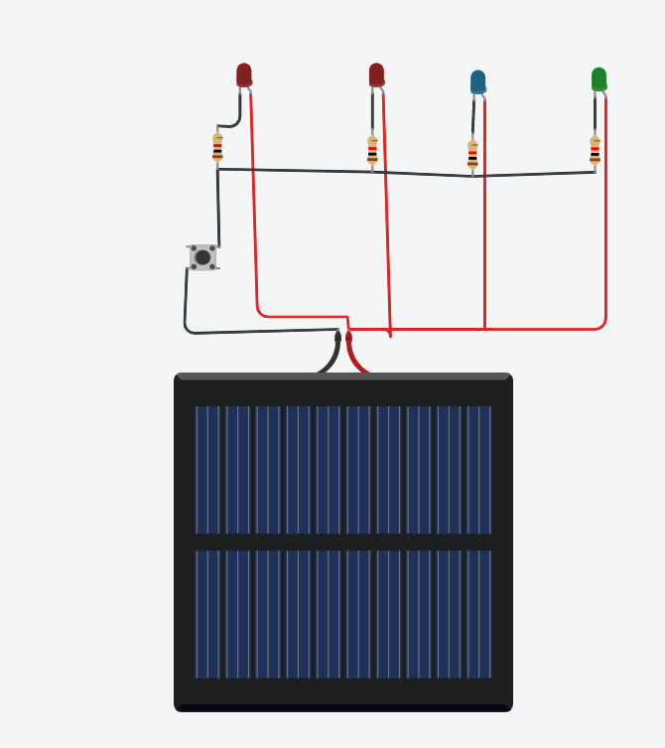

[12]
Solar power diagram components Tinkercad

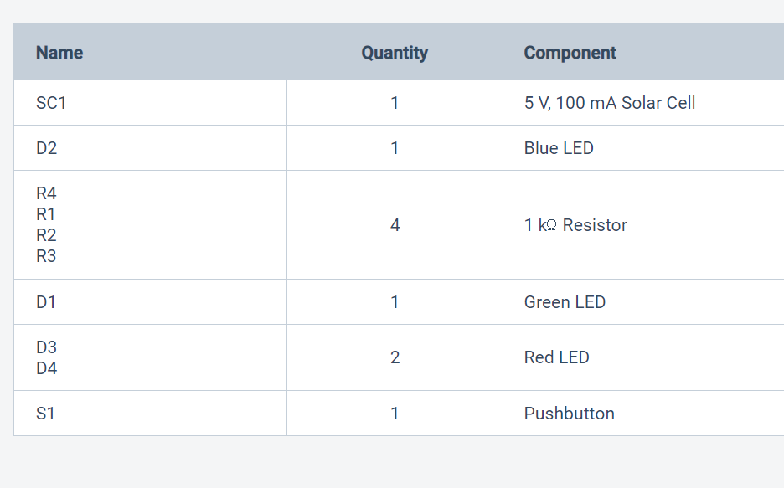

[13]
Solar power diagram from Tinkercad

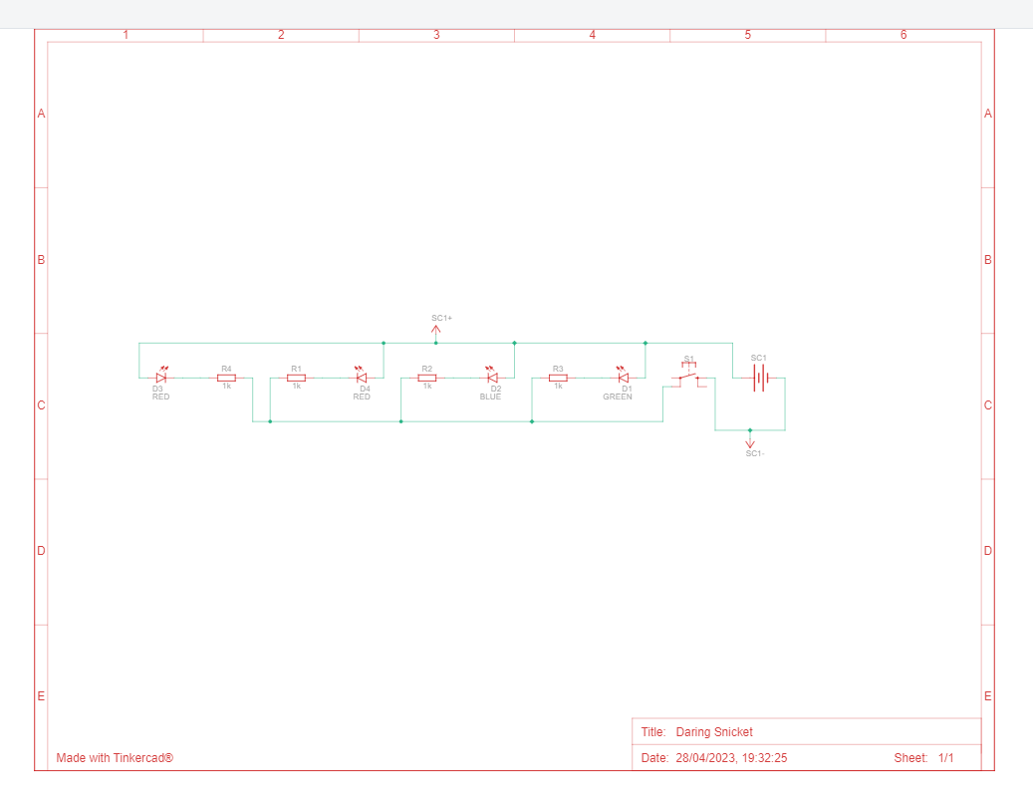

[14]
Wind power
Wind power is a renewable energy source that is abundant, clean, and freely available.
A wind turbine system consists of several components that work together to harness the power of the wind and convert it into usable electricity.
Wind Turbine blades, they capture the wind energy and spin the rotor.
The Rotor connect to the turbine blades that spins when the wind blows the turbine rotate. The Gearbox connects the rotor to the generator that converts the rotation that is suitable for generating electricity.
The control system checks the wind speed, adjusts the position of the rotor, and regulates the electrical output of the generator.

[15]
Hydropower system,
Hydropower is considered a renewable source of energy; This source of energy is generated by diversion of a river, dam, or a stream to alter the flow of the water. A small hydropower system can Produce enough electricity to power your home and your appliances.
A hydropower system works when water flows downstream, it creates a potential energy, the hydropower system converts potential energy into kinetic energy in the turbine. The turbine activates a generator which produces electricity. The more water flowing through the turbine and the higher the water pressure, that pressure turn the generator at the end you get electricity.

[16]

Geothermal Energy
Geothermal power generation involves harnessing the earth's internal heat to generate electricity. Geothermal power plants typically use deep wells to access hot water and steam from underground reservoirs. The hot water steam used to spin turbines and generate electricity.
The high-pressure hot water pumped to the surface and then released into a lower pressure environment, causing it to turn into steam. The steam directed towards the turbine blades, causing them to spin and generate mechanical energy. After passing through the turbine. The steam is directed towards a cool tower when it is condensed back into water, the water is then returned to the understanding reservoir, where it can be reheated and used again to generate electricity. Geothermal energy is a reliable and sustainable source of renewable energy. As it uses a naturally occurring resource that is constantly replenished by the earth’s internal heat. This renewable energy is limited to areas where there is significant geothermal activity, such as geysers or hot spring.

[17]
What is Biomass Energy
Bioenergy generated from all Organic matter such as animals waste, plants, industrial and human waste. Biomass is considered a source of renewable energy, it is any organic matter that can be burn, can produce electricity.
In the combustion process, biomass incinerated with a designated chamber.
The heat generated from burning biomass transferred to a boiler, cause water to turn into steam. This steam, now under pressure, then sent to power turbines. The steam rotates turbine, which drive the alternator and at the end, it produces electricity.
Renewable energy is environmentally friendly
Renewable energy comes from a natural source
Renewable energy is better than fossil fuels

[18]

Tidal energy
This from of hydro energy uses turbine generator driven by tidal currents that occur twice a day. Unlike other hydro energy source, tidal flow is not constant, but it can be reliably predicted and therefore can make up for the time when the tide current is low.

[19]
Project time scope chart

[20]

CONCLUSION
The cost of renewable has come down significantly in recent years, making them a more affordable choice for homeowners. Government offering incentives and tax credits for installing renewable making them an even more attractive way. However, it is important to note that renewable can be expensive to install and may not be suitable for all locations or energy needs. It is important to do your research and consult with a professional before deciding if renewable is right for you.

[21]

References
Read up online!
Renewable energy, Un.org United Nations
National Geographic Science Renewable Energy
Biomass Energy
GEP Environmental
(17) Geothermal Energy
gove.com energy white paper powering our net zero.
energy saving trust.
E. ON UK plc 2023

[22]

