PORTAL

INTENDED PLATFORMS | Windows (steam), Xbox 360 and PlayStation 3.

TARGET AGE / DEMOGRAPHIC OF PLAYERS
Target age: twelve and up due to violence from turrets and death.

Target demographic: Broad, catering to casual and hardcore gamers who like challenging puzzle games.

INTENDED PEGI / ESRB RATING


Intended ESRB rating is TEEN due to blood and mild violence.
Intended PEGI rating Is 12 due to Mild violence from turrets Including blood splatters and death from various floor traps.

SECTION 2: GAME OUTLINE

GAME STORY SUMMARY
Portal is a single player, first person puzzle – platformer. The story follows Chell, a silent protagonist, that must navigate a multitude of test chambers whilst trapped inside the aperture science facility, under the constant guidance/monitoring of a passive-aggressive AI known as GLaDOS. Using the unique ‘Aperture science handheld portal device’ to create two linked portals, Chell solves physics-based puzzles of increasing difficulty inside the facility. As these tests become increasingly dangerous Chell realizes that GLaDOS intends to kill her leading to an escape attempt through the facilities hidden sections.

SECTION 3: MAIN CHARACTER(S)
& PLAYER CONTROLS

CHARACTER APPEARANCE


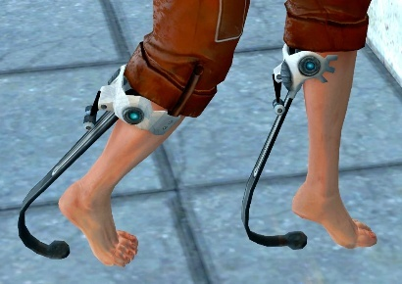

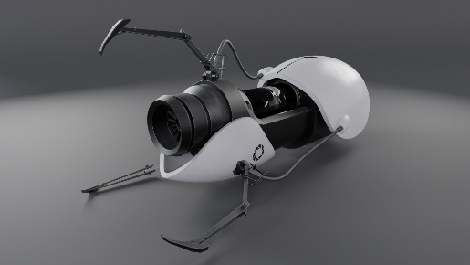

CHARACTER DOSSIER / DETAILS
NAME: | Chell
GENDER: | Female
SPECIES: | Human
AGE: | Late twenties early thirties
Height: | 5’6”
Eye colour: | Icy blue
Enhancements/Weapons: | Advanced Knee Replacement, Handheld Portal Device

CHARACTER’S BACKSTORY
Chell’s background is vague and mysterious however Lore could suggest that she was an orphan sent to an aperture science facility who later, due to her resilience and persistent refusal to give up sees her at the top of the aperture test subject list, or the child of an aperture scientist who is present during the activation of GLaDOS, through a bring your child to work day, this unfortunately leads to her entrapment as GLaDOS could instantly take over the aperture facility as hinted to in further game play. The Aperture science handheld portal device or ASHPD will help Chell navigate the test chambers through being able to place to linked portals on flat surfaces, allowing Chell to move to seemingly unreachable areas or avoid environmental traps.

CHARACTER CONTROLS / PLAYER CONTROLS
Action | PC | PlayStation 3 | Xbox 360
Move forward or back  Strafe left or right | 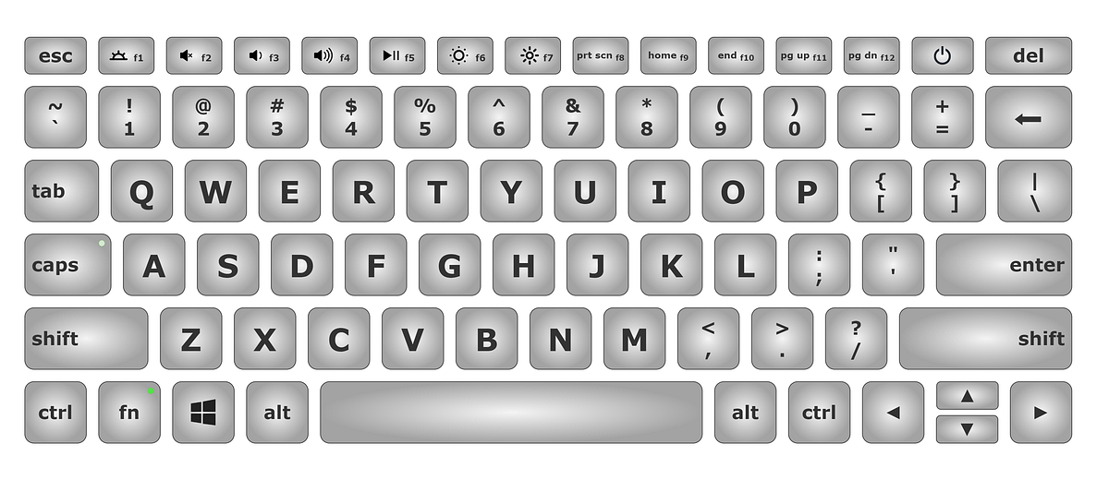
Look

Fire blue portal.

Fire orange portal.

Interact  Pickup/use object |  | or | or
Jump | SPACE | or | or
Crouch |  | or | or
Pause game

Toggle close caption sound effects | Unassigned by default | N/A | N/A
Quit game | Unassigned by default | N/A | N/A
Capture screen shot | F5 | N/A | N/A
Quick save | F6 | N/A | N/A
Quick load | F9 | N/A | N/A
Toggle developer console | ` | N/A | N/A

SECTION 4: GAMEPLAY

SEQUENCE OF PLAY

Core Gameplay

Portal is a first-person puzzle-based game built around a single, innovative mechanic: the ability to place two linked portals that connect separate points in space. Gameplay challenges players to think creatively and logically as they manipulate space, momentum and physics to navigate controlled test environments.

This experience is designed to emphasize:

- Logical problem solving over combat.
- Player experimentation and discovery.
- Mastery of physics-based movement.
- Consistent rules that encourage creative solutions.

the player should feel:

- Curious when entering a new test chamber.
- Clever when discovering a solution.
- Confident as they master increasingly complex mechanics.

The player can:

- Move freely in first person (walk, run, jump, crouch).
- Fire two distinct portals: blue portals and orange portals.
- Pick up, carry and place objects.
- Activate environmental objects such as buttons or switches.

Movement interactions are kept simple to keep focus on the puzzle solving rather than dexterity.

Core mechanics

Portals

- The player may place one blue portal and one Orange Portal at any time.
- Entering one portal instantly exits the other.
- Momentum, direction and velocity are preserved.
- Portals can only be placed on specific flat surfaces.

This consistent set of rules allows players to build intuition and experiment confidently.

Physics

- All objects will obey realistic physics.
- Objects, energy and the player can pass through portals.
- Momentum based traversal becomes a key advanced strategy.

Environmental elements

- Weighted buttons and switches.
- Moving platforms.
- Energy hazards and automated defences.
- Timed challenges requiring planning and execution.

Each element will be introduced individually before being combined.

Objectives

Primary objective:

- Reach the exit door of each test chamber.

Secondary objectives:

- Learn and master newly introduced mechanics.
- Use tools efficiently and creatively.
- Progress through increasingly complex tests.

Narrative information is delivered passively through environment design and AI dialogue.

Challenge and progression:

Difficulty is based on:

- Gradual introduction to the mechanics
- Increasing spatial complexity
- Combining previously learned concepts in new ways

The challenges are intellectual rather than reflex driven. Players are encouraged to think outside the box and learn from outcomes.

Feedback and clarity

The game provides constant feedback through:
- Strong visuals (portal effects, surface indicators).
- Audio cues from the environment and AI controller.
- Immediate feedback to players actions.

This ensures players understand why something works, not that it just works.

What makes it fun?

- Players feel a sense of accomplishment by solving problems on their own.
- A Single tool creates vast possibilities.
- Solutions feel earned not handed out.
- Dark humour and personality enhance engagement without disrupting gameplay.

The gameplay turns simple actions into moments of insight and satisfaction.

Game play summary:
Portal’s gameplay is defined by one mechanic expanded through thoughtful level design and consistent rules. The result is a puzzle experience that is intuitive, deep and memorable offering players the satisfaction of discovery in every test.

UNIQUE SELLING POINTS (USPs)
- Portal is built entirely around one tool, the portal gun. Avoiding overwhelming the player with multiple abilities the game focuses on a single intuitive mechanic that becomes more interesting as the game progresses.
- Portal will challenge players to think in terms of space, momentum and perspective instead of traditional puzzle logic. Solutions feel discovered rather than taught creating strong ’aha’ moments.
- Unlike most puzzle games that are presented from overhead or side view, portal delivers puzzles entirely in first person, increasing immersion and making problem solving feel physical.
- Traditional combat is replaced with environmental problem solving, obstacles are overcome through intelligence and creativity rather than reflexes, appealing to players who enjoy thoughtful gameplay.
- Narrative and humour are delivered through an AI overseers dialogue and environmental storytelling, maintaining pacing while giving the game a distinct tone.
- Instant resets and low penalties for failure encourage players to experiment freely. This design supports learning through play and reinforces curiosity rather than frustration.

SECTION 5: GAME WORLD

GAME WORLD
Portal takes place within the Aperture science enrichment centre, a sterile and highly controlled scientific testing facility. The environment is designed to feel clean, artificial and slightly unsettling reinforcing the players role as a test subject.
The game world tells its story subtly through design and environmental details with contrast between controlled spaces and hidden areas.

TEST CHAMBERS
The primary locations within portal are a series of enclosed test chambers designed for scientific experimentation. These rooms feature clean white walls, observation glass, buttons, platforms and clearly marked surfaces for portal placement. Each chambers exists to teach and test a specific concept reinforcing the idea that the player is part of a structured experiment.

OBSERVATION/CONTROL AREAS
Behind the scenes of the test chambers are cameras, control rooms and mechanical systems, these areas suggest constant monitoring and reinforce the presence of an unseen authority watching the player’s progress.

MAINTENANCE/BACKSTAGE AREAS
As the game progresses the players are slowly exposed to hidden maintenance corridors, broken walls and industrial spaces not meant for test subjects. These areas feel darker and more chaotic, contrasting with the clean test chambers and hinting that the facility is not perfect or as in control as it may appear.

HAZARD ZONES
Certain areas include dangerous elements such as toxic liquids, automated defences and energy fields. These areas add tension and reinforce the idea that the enrichment centre values test results over player safety.

GAME FLOW
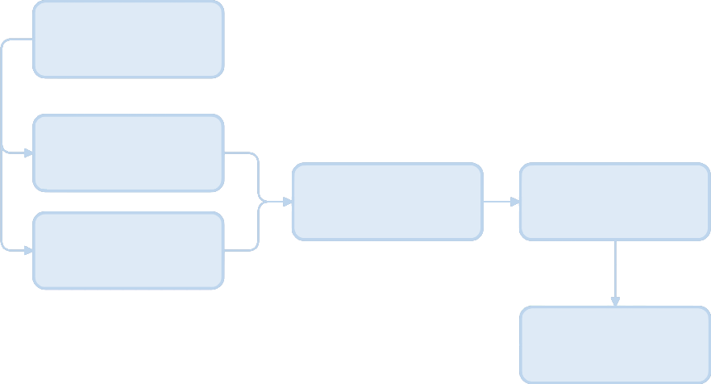
Intro and basic movement

Single portal test chambers

Advanced challenges/escalation
Core puzzle progression
Double portal test chambers

Narrative climax and escape

Portal features a primarily linear game flow designed to support gradual learning. Players are introduced to mechanics slowly before being challenged to combine then in increasingly complex ways. This structure ensures accessibility for inexperienced players while allow experienced players to explore more creative solutions.

SECTION 6: GAME EXPERIENCE

GAME EXPERIENCE
Portal’s experience is built on contrast:
- Clean, calm spaces with quiet unease underneath
- Humour that feels friendly then threatening
- Intelligence rewarded instead of aggression

Portal delivers a thoughtful and subtly unsettling experience built around humour, curiosity and problem solving. The game presents a clean, calm testing environment that feels safe on the surface while gradually revealing an underlying sense of isolation and unease. This tone blends light-hearted, dry humour with moments of tension encouraging players to relax, experiment and think creatively even as the environment becomes increasingly dangerous. Rather than relying on action or fear the experience focuses on making players feel clever, curious and slightly uncomfortable as they uncover the true nature of the facility.

Overall, portal aims to create a memorable experience that is intellectually satisfying and emotionally engaging balancing comedy and threat.

WHAT EMOTIONS ARE MEANT TO BE INVOKED BY THE GAME?
Portal is designed to guide the player through a gradually evolving emotional experience. Early gameplay encourages feelings of calm curiosity, allowing players to explore mechanics in a safe and controlled environment. As the player progresses, they should feel more confident and clever as their understanding of the game deepens, while a growing sense of unease is introduced through environmental story telling and AI dialogue. In later stages the emotional tone shifts toward tension and determination, as the environment becomes more dangerous. Overall, the game aims to balance humour, curiosity, unease and achievement to create a memorable and engaging experience.

HOW ARE MUSIC AND SOUND GOING TO BE USED?
- Music is used sparingly with prolonged periods of silence to reinforce sterile and controlled atmosphere of the testing facility.
- Environmental sound effects such as machinery, portals and ambient facility noises are prioritised to support immersion and player awareness.
- AI dialogue is used as a key audio element to deliver tone, humour and narrative without interrupting gameplay.

SECTION 7: GAMEPLAY MECHANICS

GAMEPLAY MECHANICS
Mechanics
- Portals – players link two portals on valid surfaces to allow them to move themselves, objects or energy through space.
- Momentum – speed and direction are maintained when travelling through portals, allowing advanced traversal.
- Weighted buttons and switches – used to activate doors, platforms and machinery.
- Physics objects- objects such as weighted cubes can be carried, placed and moved to solve puzzles.
- Moving platforms – platforms that transport the player or objects across spaces.
Hazards
- Toxic liquids – instantly harm or kill the player on contact.
- Automated turrets – fire at the player when detected acting as environmental threats rather than intelligent enemies.
- Energy fields – block movement, destroy carried objects or disable portals.
- Timed traps – hazards that require precise timing or creative portal placement to bypass.
Power ups / collectibles
- Portal does not include traditional powerups or collectibles.
- Player progression is based on learning and mastering mechanics rather than gaining upgrades or items.

MECHANIC DETAILS
NAME: | Portal placement
WHAT DOES IT LOOK LIKE? | Two oval shaped portals. One blue and one orange, placed on flat light-coloured portal compatible surfaces. Each portal visually shows the space connected to the other.
EFFECT ON PLAYER: | Allows the player to move themselves, objects and energy instantly between two locations. Momentum, direction and velocity are preserved allowing creative traversal and puzzle solving.
WHEN WILL IT FEATURE IN THE GAME? | The portal gun will be introduced gradually during early test chambers, initially limited in complexity then expanded throughout the game as new mechanics are introduced.

HAZARD DETAILS
NAME: | Toxic liquid
WHAT DOES IT LOOK LIKE? | Large pools of glowing liquid found at the bottom of test chambers, the liquid is visually distinct and clearly separated form safe walking surfaces.
EFFECT ON PLAYER: | Instantly kills the player on contact requiring the player to avoid it at all costs using careful movement or the creative use of portals.
WHEN WILL IT FEATURE IN THE GAME? | Introduced early in game as a clear environmental threat and used throughout later test chambers in increasingly complex scenarios.

SECTION 8: ENEMIES

LIST OF ENEMIES
Portal will not feature traditional enemies that the player defeats through direct combat, instead opposition is presented through environmental threats and automated systems that function as puzzle elements.

In game threats include:
- Automated turrets – stationary defence units that detect and fire at the player when in line of sight.
- AI overseer – acts as the primary narrative antagonist, influencing the player indirectly through dialogue and control of the testing environment.

Enemies in portal are designed to be overcome through problem solving and manipulation of the environment rather than combat, reinforcing the games focus on creativity and intelligence over reflex based gameplay.

ENEMY DETAILS
NAME: | Automated turret
WHAT DOES IT LOOK LIKE? | A small white tripod mounted robot with a central targeting system. Turrets are usually placed in controlled areas like the test chambers and are usually in clear areas.
ATTACKS: | Fires rapidly when the player enters its line of sight.
WHEN WILL IT FEATURE IN THE GAME? | Introduced during mid game test chambers and used throughout later sections as part of more complex puzzles.
HOW DOES THE PLAYER DEFEAT IT? | Turrets are not defeated through direct combat instead players can disable them by using portals to reposition/knock them over, block their line of sight or redirect environmental hazards.
WHAT DOES THE PLAYER EARN FOR DEFEATING THEM? | No direct rewards are given. Defeating a turret allows the player to safely progress past the area it was monitoring.

LIST OF BOSS CHARACTERS
Portal will feature a single primary boss like character who serves as both the antagonist and the final gameplay challenge.
The artificial intelligence that oversees the aperture science facility acts as the games central antagonist controlling the testing environment and guiding the player though dialogue while gradually revealing hostile intent.
Rather than relying on multiple boss encounters, portal builds towards a single climactic confrontation that tests the players understanding of the core mechanics. This approach reinforces the games focus on problem solving and narrative payoff than repeated encounters.

BOSS CHARACTER DETAILS
NAME: | GLaDOS
WHAT DOES IT LOOK LIKE? | A large, suspended artificial intelligence core composed of mechanical parts, cables and robotic modules housed within a central chamber of the aperture science facility.
ATTACKS: | Uses environmental hazards rather than direct physical attacks, these include activating turrets, deploying energy hazards and manipulating the test environment to threaten the player.
WHEN WILL IT FEATURE IN THE GAME? | Appears throughout the game via dialogue, with direct contact occurring at the end of the game as a final challenge.
HOW DOES THE PLAYER DEFEAT IT? | The player will work to defeat GLaDOS by using portals and their surroundings to remove and destroy key cores, gradually disabling the AI.
WHAT DOES THE PLAYER EARN FOR DEFEATING THEM? | Completion of the game and narrative resolution. No items or upgrades are awarded reinforcing progression through achievement.

SECTION 9: BONUS MATERIALS

BONUS MATERIALS
- Portal includes optional achievements and challenges that encourages players to replay test chambers and experiment with alternate solutions.
- Players are rewarded for creative problem solving, speed and unconventional use of mechanics rather than progression based unlocks.
- Hidden areas and environmental details provide optional narrative discoveries encouraging exploration without affecting core progression.

Additional content
- Portal is designed as a single player experience with no multiplayer modes at launch.
- The game does not include downloadable content as part of its core design maintaining a focused and complete experience.
- Future content, if developed, would expand on puzzle challenges rather than introducing new systems or monetization.

REPLAY VALUE
- Players are encouraged to replay test chambers to experiment with alternative solutions and creative uses of the portal mechanics.
- Mastery of momentum and spatial awareness allows players to complete puzzle more efficiently.
- Optional achievements or self-imposed challenges such as speed runs or minimal portal solutions provide additional incentives for replay.
- Hidden areas and environmental details reward exploration and deepen the players understanding of the game world.
- The games short length and focused design make repeat playthroughs accessible without becoming overly repetitive.

