Carmarthenshire County Museum: Issues, Challenges and Simple Solutions.

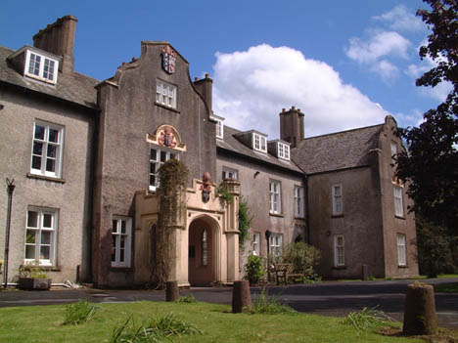
Name: F. Alajmi
Student ID: 1700526
Module Code: HPAR5003
Date: 19th July 2019


Acknowledgment
Many thanks to the management of Carmarthenshire Museum and all the staff and volunteers there for their kind help and guidance in gathering the needed information for this report.

Table of content:
Abstract 4
Introduction 5
1. Infrastructure, plan and space management: issues and suggested solutions. 6
2.Human resources: management, challenges and issues. 9
3.Funding and grants 11
Conclusion 13
References List 14
Figures 15

Abstract:
Carmarthen County museum is an important place in Carmarthen to visit. The museum holds an important value to Carmarthen and it is a home for different types of historical collections. The museum is run and funded by Carmarthenshire County Council and it is also funded by other bodies. As any other museum, Carmarthenshire museum face many challenges and issues in which some of them cannot be solved easily. The museum needs more attention when it comes to infrastructure and plan. The palace needs infrastructural improvements as well as an upgraded plan for displays and showrooms. Both the palace and the garden needs maintenance and reconstruction. The museum has six full-time payed staff that also work elsewhere. The museum lack staff members that hold important jobs such as a security guard and a cleaning team. Carmarthenshire County museum has a total number of 10 volunteers that are not limited to volunteering there. Despite them working elsewhere as well, the volunteering team are doing a great job with their given tasks. However, their tasks are limited to certain jobs and the number of human resources is not enough. The museum needs to upgrade the staff structure and capacity. The museum also needs to improve its financial situation. The funding the museum receives is not enough for it to be developed and maintained. It needs an up to date marketing, managing and improvement plan for it to compete with other museums today and attracts more visitors.

Introduction:
Carmarthenshire museum is a public sector museum that is located in Abergwili, Carmarthenshire SA31 2JG (James & Moore 2009: 192). The museum is open four days a week and it is run and funded by Carmarthenshire County Council (James & Moore 2009: 192). Since 1972 the council took in charge of the palace and make it a home for Carmarthen’s history. Before that, it was a palace for the Bishops of Saint David from the beginning of the 1500s (Jenkins 1936: 47). The palace has a long history that goes back to the Late Medieval (Jenkins 1936: 49). It was first founded in 1283 as the College of Priests before the college moved to Brecon in 1541 (James & Moore 2009: 192). The foundation of the college was discovered on the South-East side of the palace in 1935. Not to mention that there was the first time that the New Testament and the Book of Common Prayer ever translated to the Welsh language in 1567 (Jenkins 1936: 49).
The museum is full of interests, beginning from its amazing historical architecture, the park, the walled garden to the historical and valuable items the museum holds within. Not only that, but the Bishop’s Pond shown in Figure 1 is a Site of Special Scientific Interest (Tywi Gateway Trust 2019). The park also contains old trees and a wonderful landscape which is filled with daily visitors. The museum has different galleries such as the Prehistoric Gallery and the Farmers Gallery (Carmarthenshire County Council 2019). It also has a chapel that is called Laud's Chapel after the Bishop William Laud who was there from 1621 to 1626 (Jenkins 1936: 48). The chapel is open for the public at the museum’s first floor.
Carmarthenshire County museum is a home for wonderful antiquity. It also gets a lot of material and historical donations such as books, artefacts and paintings. People also go there to know more about their personal historical findings. The museum staff also does the job in following back old donated items and tie them with their original owner. Carmarthenshire museum house different events for the public as well.
1.Infrastructure, plan and space management: issues and suggested solutions.
The museum of Carmarthenshire is mainly based at the Bishops palace. It is a home for different types of artefacts and historical items. In this case, it is important to preserve the building as it was as much as they can for its historical value. Figure 2 and Figure 3 show the previous use of the palace and how the museum is currently using the space. In Figure 3, the purple unnumbered spaces are not for the public use. In fact, the rooms marked in purple are for the staff, management and storage. This leaves the rest of the yellow and pink areas for the public. As the building plan cannot be transformed that much, Carmarthenshire museum face some difficulties in managing the space. Not only that, but in the first floor there are some areas – not shown in Figure 3- that are left without use. The areas are falling apart and need reconstruction which makes it is a major health and safety issue. The attic needs improvements as well and the place is lacking a proper risk management. Not only that, but the chapel and other galleries need maintenance and attention. In addition, from my observations, the museum needs to pay attention to some of the minor issues too. These minor issues in the plan can be solved by the simplest solutions. The visitors often face confusion on which way to go first. It is important that the museum leads your way through it. For example, at the Firing Line Museum in Cardiff Castle, there was a similar issue with the way display cases are planned. It is supposed to follow a chronological order of war events, but the plan of the display cases created confusion as it is shown in Figure 4. The solution was simple and efficient, they used floor footprint stickers to lead the way throughout the museum as shown in Figure 5. At Carmarthenshire museum, the layout show that there are many doors to begin with. It is hard to figure which door to take first. A simple solution as the floor footprints stickers can eliminate this confusion and lead the visitors’ way through the museum.
Area G1 shown in Figure 3 is supposed to be the starting point and the prehistoric gallery. This area contains small display cases of zoology, stone tools and fossils. An important issue to remember is that the display cases are not managed properly. Many of the objects are not labelled, where the labelled objects inside them are numbered as shown in Figure 6. The visitors have to get the information from a leaflet that is placed near the display case. The problem is that they have several display cases next to each other and all of there objects are numbered starting from number 1 and the issue is that all of the leaflets are placed together. Again, this way of exhibiting creates confusion and makes the information hard to reach. There are different solutions for this problem, there are solutions that would elevate the museums’ exhibition management but require funding such as installing bigger and better display cases and changing the plan of the area. However, there is a simple and temporary solution that would not require funding and barely an effort. It is basically to stop numbering the object starting from number 1 but make the numbers run continuously if the leaflets are going to be at the same place. In general, the museum needs to upgrade the displays as it has not change for more than a decade. Keeping up with time and other museums can attract more people in, otherwise the place in going to look neglected and for some people depressing.
Another thing to point out is that area G2 shown in Figure 3. It is a great thing that Carmarthenshire museum is a family friendly place and that they have area G2 as children’s play area. It is important that museums play an educational role and provide a fun way of delivering information and knowledge (Hooper-Greenhill 1992). Experiencing this can challenge the kids’ curiosity, make them love discovery and encourage them to visit museums more often (McRainey & Russick 2010). However, making the children’s play area as the second place to visit on the way can be a mistake. The issue – from what I have witnessed as well- is that it is too soon and it distracts them from viewing the rest of the museum. In fact, children need their place to be at the very last especially in a small museum like Carmarthenshire’s. The reason for that is to help them apply what they have learnt from the museum on their activities and it can be a place for them to rest, eat and take their time in playing. Unfortunately, the chapel in the first floor is the final destination at the museum. From what I have seen, kids usually stay there longer than the play area, because they are forced to leave it in order to view the rest of the museum. The kids energy are put unleashed at the chapel where they are not suppose to run, play nor eat at. My suggestion is to make the café area in the ground floor as the kids area instead. I have witnessed people visiting the café at the end of their tour around the museum. In contrast, the room is small for it to be both a café and a kids play area. Hence, I suggest that the café should be moved outside.
Spending some time at Carmarthenshire museum and observing everything made me realise that the majority of the visitors are not actually inside, but outside the palace. The garden attracts people more because it is spacious and beautiful. The average number of visitors in a month that I have counted suggests that at least fifteen people a day visit the garden while four would visit the museum. People often go to the garden to walk their pets or play with their kids. The problem here is that there is not enough attention to the garden as the spaces is not managed properly and feel neglected. The museum can gain profits if they take advantage of the garden space in order to attract more people. The museum needs a strategic plan that can ensure that they meet the visitors’ needs, bring profit to the museum and help with marketing (Hooper-Greenhill 1996). For example, they can use the space to open up a café and a seating area. However, this idea in itself needs funding. The temporary solution would be putting a small booth outside that can sell a percentage of the actual café’s inventory to the visitors of the garden. This way they would ensure the selling of their inventory, the making of profit and set the place for an outside café in the long run. Another solution to ensure gaining profit and managing the space is to rent out an area of the garden for a small business like a café with a seating area. They can also rent the space for events such as the farmer’s market and etc. An investment like that can attract small businesses and lift the burden from marketing and funding issues.
2.Human resources: management, challenges and issues.
Carmarthenshire county museum is a very lovely and welcoming place. The visitors do not usually know how this place is run and how many efforts do the people working there put in to guarantee the survival and the opening of this place in a daily basis. Having the opportunity to work with the people there helped me learn how much they sacrificed to keep this beautiful historical place running. I can see that the people working there share the love for this place and this town, and it is what makes the museum even more special. Despite the love and care, the people there face challenges and which some cannot be easily solved.
Mr. Gavin Evans is the curator at the museum for over than twenty years now. He is doing an amazing job, but it sometimes feels overwhelming to witness. He is pouring all of his energy in this place to the level that sometimes he is seen managing the front disk. This is not a part of what curator does, but why does Gavin do it (Moore 1994)? Simply because there are not enough staff working there. The museum has six full-time payed staff; however, they are not limited to Carmarthenshire county museum. The six staff members work for another three museums in which two of them are closed now. The staff basically manage the museums’ collections such as assembling, cataloguing and managing the donated items. In addition, the museum lacks certain job positions that are absolutely important to any similar type of business which a security guard and a cleaning staff (Moore, 1994). In an incident I mentioned earlier, kids usually run around and play in the chapel get into the restricted area and touch valuable and historical items that they are not supposed to be close to. This made me question why there is not a security guard that can prevent any banned actions inside the museum. Not only that, but to ensure the survival and safety of these valuable and historical items. Kids are curious little humans that like discovering and touching things and indeed they need to be watched by their parents or carers all the time, but sometimes it is hard to do that especially when they are pupils on a school trip. This is also a concern of the kids’ safety, because a lot of the exposed objects around the museum are sharp or heavy, which can threaten the kids’ lives in case the objects fall on them or reach their hands Like the gold cross in the chapel shown in Figure 7 or the objects in the Farmer’s Gallery in Figure 8. Speaking of the same incident as an example, there were no place for the kids to eat. Their teachers decided that it is alright for them to eat at the chapel. I was there but I could not tell them not to or intervene because I wanted to observe if an action is going to be taken by the staff. No action was taken after the kids left, and I mean that the chapel was filled with food crumbs and plastic wrappers. Two days have passed, and no one came to clean, then I asked the staff if they have someone to clean and they mentioned that the cleaner retired and the museum cannot afford to hire another one. After that, I grabbed the book in Figure 9, read it and cleaned the chapel with the proper tools. As soon as I started, I noticed that the chapel has not been cleaned in a very long time. Unfortunately, it was filled with spider webs, dust and dirt which can affect the wood badly. Not only that, but the museum has mould and dust all around it. The galleries are all dusty and the bathrooms are dirty and in desperate need of attention. In this matter, the museum needs someone to take care of this job and keep the place clean.
The museum has ten volunteers that are a group of retired amazing people that have the passion and the love for this place. They describe themselves as ‘on and off’ volunteers because they are volunteering elsewhere as well. The volunteers have a clear team schedule of tasks that can be rotated amongst them, and jobs that are specifically to them individually. The tasks include researching, sorting, handling items and following the owners of these items, checking on the collection and cleaning the children play area. Mrs Jill Davies is an eighty year old retired teacher and she is a volunteer at the museum that is mainly responsible of the library. She comes three days a week and she handles specific jobs that no one else does. Every Tuesday, Jill does the cataloguing using a system she called CALM. All of the specific details of the books including the colour their covers are put on that system by her alone. CALM is a software that is built as a collection system aimed to manage archives and records nationally (Collection Trust 2018). Jill uses the front desk’s computer for that because there is not another working computer that has this software. I have tried to use this system and found that it is really hard and require at least two people to do it. In this matter, the museum needs more capacity and upgraded equipment for these kinds of jobs to be done.
It is true that this museum is mostly run by volunteers and they are very well managed and organized, but the museum still lacks human resources. It is important to remember that both the staff and the volunteers are not limited to Carmarthenshire museum and they work elsewhere as well. The average number of human resources at the museum is six persons and the majority of them are working behind the scene, meaning; there are usually two people working in the front desk and guiding tours. The museum needs a new plan that include a capacity for more staff in the future. Not only that, but the volunteering opportunity must include young people to help them in having an experience and pouring their energy in the place.
3.Funding and grants:
Carmarthenshire County museum is funded by Carmarthenshire County Council. It is a responsibly to the council amongst other museums and services. The museum is located near a hospital and a school which get more attention than the museum. Because the museum is not a priority to the council when it comes to funding; the museum also receives grants from different bodies. Between these bodies is a registered charity called Friends of Carmarthenshire County Museum (Charity Commission UK 2018). This charity is built by a group of people whom share the same interest in Carmarthenshire history and aim to save it and insure its survival (Friend of Carmarthenshire Museum 2018). The charity aims to raise funding in order to achieve certain goals for the museum. A lot of the issues that I have discussed earlier in this report is related to poor funding and this charity is trying to solve some of them. As their website state, their goals are:
​To promote the Museum in which every way possible in order to maintain the function and standard of the services provided. To assist in the purchase of items not afforded by the Museum itself, but of great value and interest to the visitors, and of extreme local historical value. To fundraise money towards the maintenance and upkeep of the exhibits , and to support the employed staff at the Museum. Finally, to support each of the members of the Friends in their work linked to the Museum.
(Friend of Carmarthenshire Museum 2018)
The charity was doing and still doing its best to help the museum by fund raising. However, since 2014 the funding income has decreased dramatically as it is shown in Figure 10. Not only that, but the spending rate has reached a higher level than the income rate. In comparing the spending to the annual return shown in Figure 11, it appears that in the recent years the spending rate is increasing. Some of their spending is going towards buying valuable items for the museum to show, and in my opinion, the museum storage area is already filled with important and valuable items. In general, this shows that not only the museum is struggling with finance, but the charity supporting it is struggling too. In addition, the Tywi Gateway Trust is currently doing a project on the Bishop’s walled garden (Tywi Gateway Trust 2019). They have also done an archaeological investigation on the garden and would like to continue their work there (Tywi Gateway Trust 2019). The Tywi Gateway Trust received funding and support from different bodies such as the National Lottery Heritage Fund, Carmarthenshire County Council, Welsh Government Rural Communities Rural Development Programme and Allchurches Trust (Tywi Gateway Trust 2019). The work of the trust is well organised and managed, and I had the chance to work with them and see for myself as well. They are also hosting events to bring more people in to help in sharing the knowledge about the museum as well as spreading awareness of the status of the museum and its garden (Tywi Gateway Trust, 2019). They are also aiming in bringing more people to help whether by volunteering or donating (Tywi Gateway Trust, 2019). However, the project still needs to fill in the funding gap in order to achieve their goals and to secure management of the park in the long run (Tywi Gateway Trust, 2019). They have launched a fundraising page through Localgiving.org that can be shared throughout social media and has specific details on what each donated amount can benefit the project (Localgiving 2019).
The decrease of the funding and the poor financial return of the museum and its sectors is challenging. This is slowly pushing it to be a marketplace that has to compete with other growing and successful museums to ensure its survival (Moore 1994). The current plan of the museum needs to be upgraded for it to guarantee a proper finance and sponsorship. Otherwise, it is going to face closing like the Museum of Speed that has been shut down until it becomes under investment and development (Carmarthenshire County Council 2019).
Conclusion
The Carmarthenshire County museum is a home for Carmarthen and Welsh History. It has interesting galleries that reflect Carmarthen's long past. The museum has lots of potentials whether it is the Bishops Palace, the Walled Garden or the public Park. The museum in run by amazing people that are both full-time payed staff and volunteer who out all of their love and energy to make it happen. Carmarthenshire County museum is like any other museum in the world that serves the public and shape their knowledge. As it is a public sector with free admission the museum face different levels challenges and issues. Some of these issues can be solved with the simplest efforts while other problems need way more than that. In general, most the discussed issues come down to one solution; funding. The museum needs proper funding to help fill in the gap in certain job positions that are essential to the museum. Not only that but getting a proper funding can help in maintaining the historical building and its value. It is also a way to help elevating the management and bringing more visitors. Not to mention that the museum needs risk management, renovation and upgrading. The museum also needs a marketing plan that can ensure the income and sponsorship that can help the museum in competing with other museums.

References List

Carmarthenshire County Council, 2019. Theatres, Arts & Museums. [Online]
Available at: https://www.carmarthenshire.gov.wales/home/council-services/theatresartsmuseums/
[Accessed 4th July 2019].
Charity Commission UK, 2018. Friends Of Carmarthen County Museum. [Online]
Available at: https://beta.charitycommission.gov.uk/charity-details/?regid=1108560&subid=0
[Accessed 2nd July 2019].
Collection Trust, 2018. Calm. [Online]
Available at: https://collectionstrust.org.uk/software/calm/
[Accessed 1st July 2019].
Friend of Carmarthenshire Museum, 2018. Aims and Objectives. [Online]
Available at: https://www.friendsofcarmarthenshiremuseum.co.uk/about.html
[Accessed 2nd July 2019].
Griffin, D., 2013. BBC- My Paintings. [Art] (BBC).
Hooper-Greenhill, E., 1992. Museums and The Shaping of Knowledge. 1st ed. London: Routledge.
Hooper-Greenhill, E., 1996. Museums and their Visitors. 2nd ed. London: Routledge.
James, H. & Moore, P., 2009. Carmarthenshire and Beyond: studies in history and archaeology in memory if Terry James. 1st ed. Carmarthenshire: Carmarthenshire Antiquarian Society.
Jenkins, D., 1936. Abergweli: Parish Church of St. David's. 1st ed. Carmarthen: W. Spurrell & Son.
Localgiving, 2019. The Tywi Gateway Trust. [Online]
Available at: https://localgiving.org/charity/the-tywi-gateway-trust/
[Accessed 3rd July 2019].
McRainey, L. & Russick, J., 2010. Connecting Kids to History with Museum Exhibition. 1st ed. Michigan: Left Coast Press.
Moore, K., 1994. Museum Managment. 1st ed. London: Routledge.
Tywi Gateway Trust, 2019. Bishop's Park. [Online]
Available at: https://tywigateway.org.uk/
[Accessed 3rd July 2019].

-Figures:
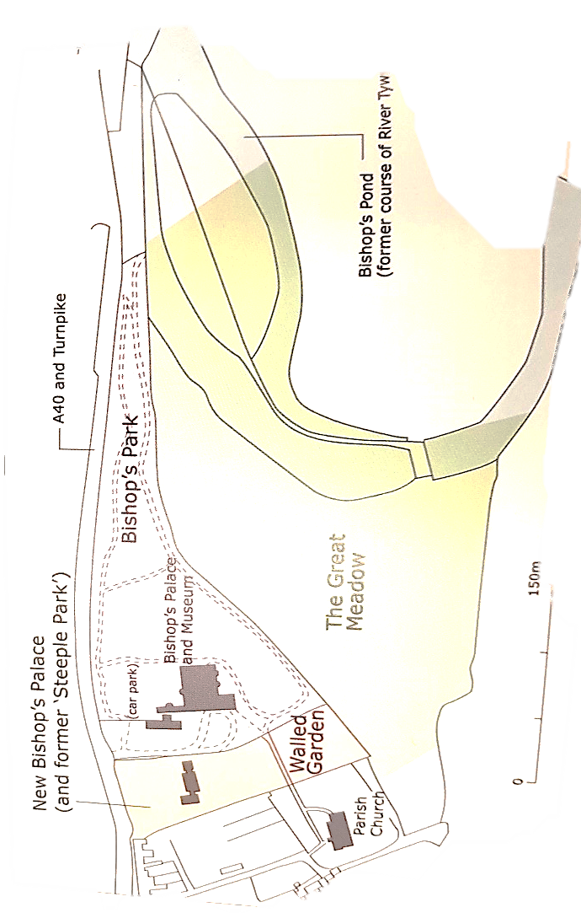
Figure 1- Plan of the palace and park at Abergwili (James & Moore 2009: 192).
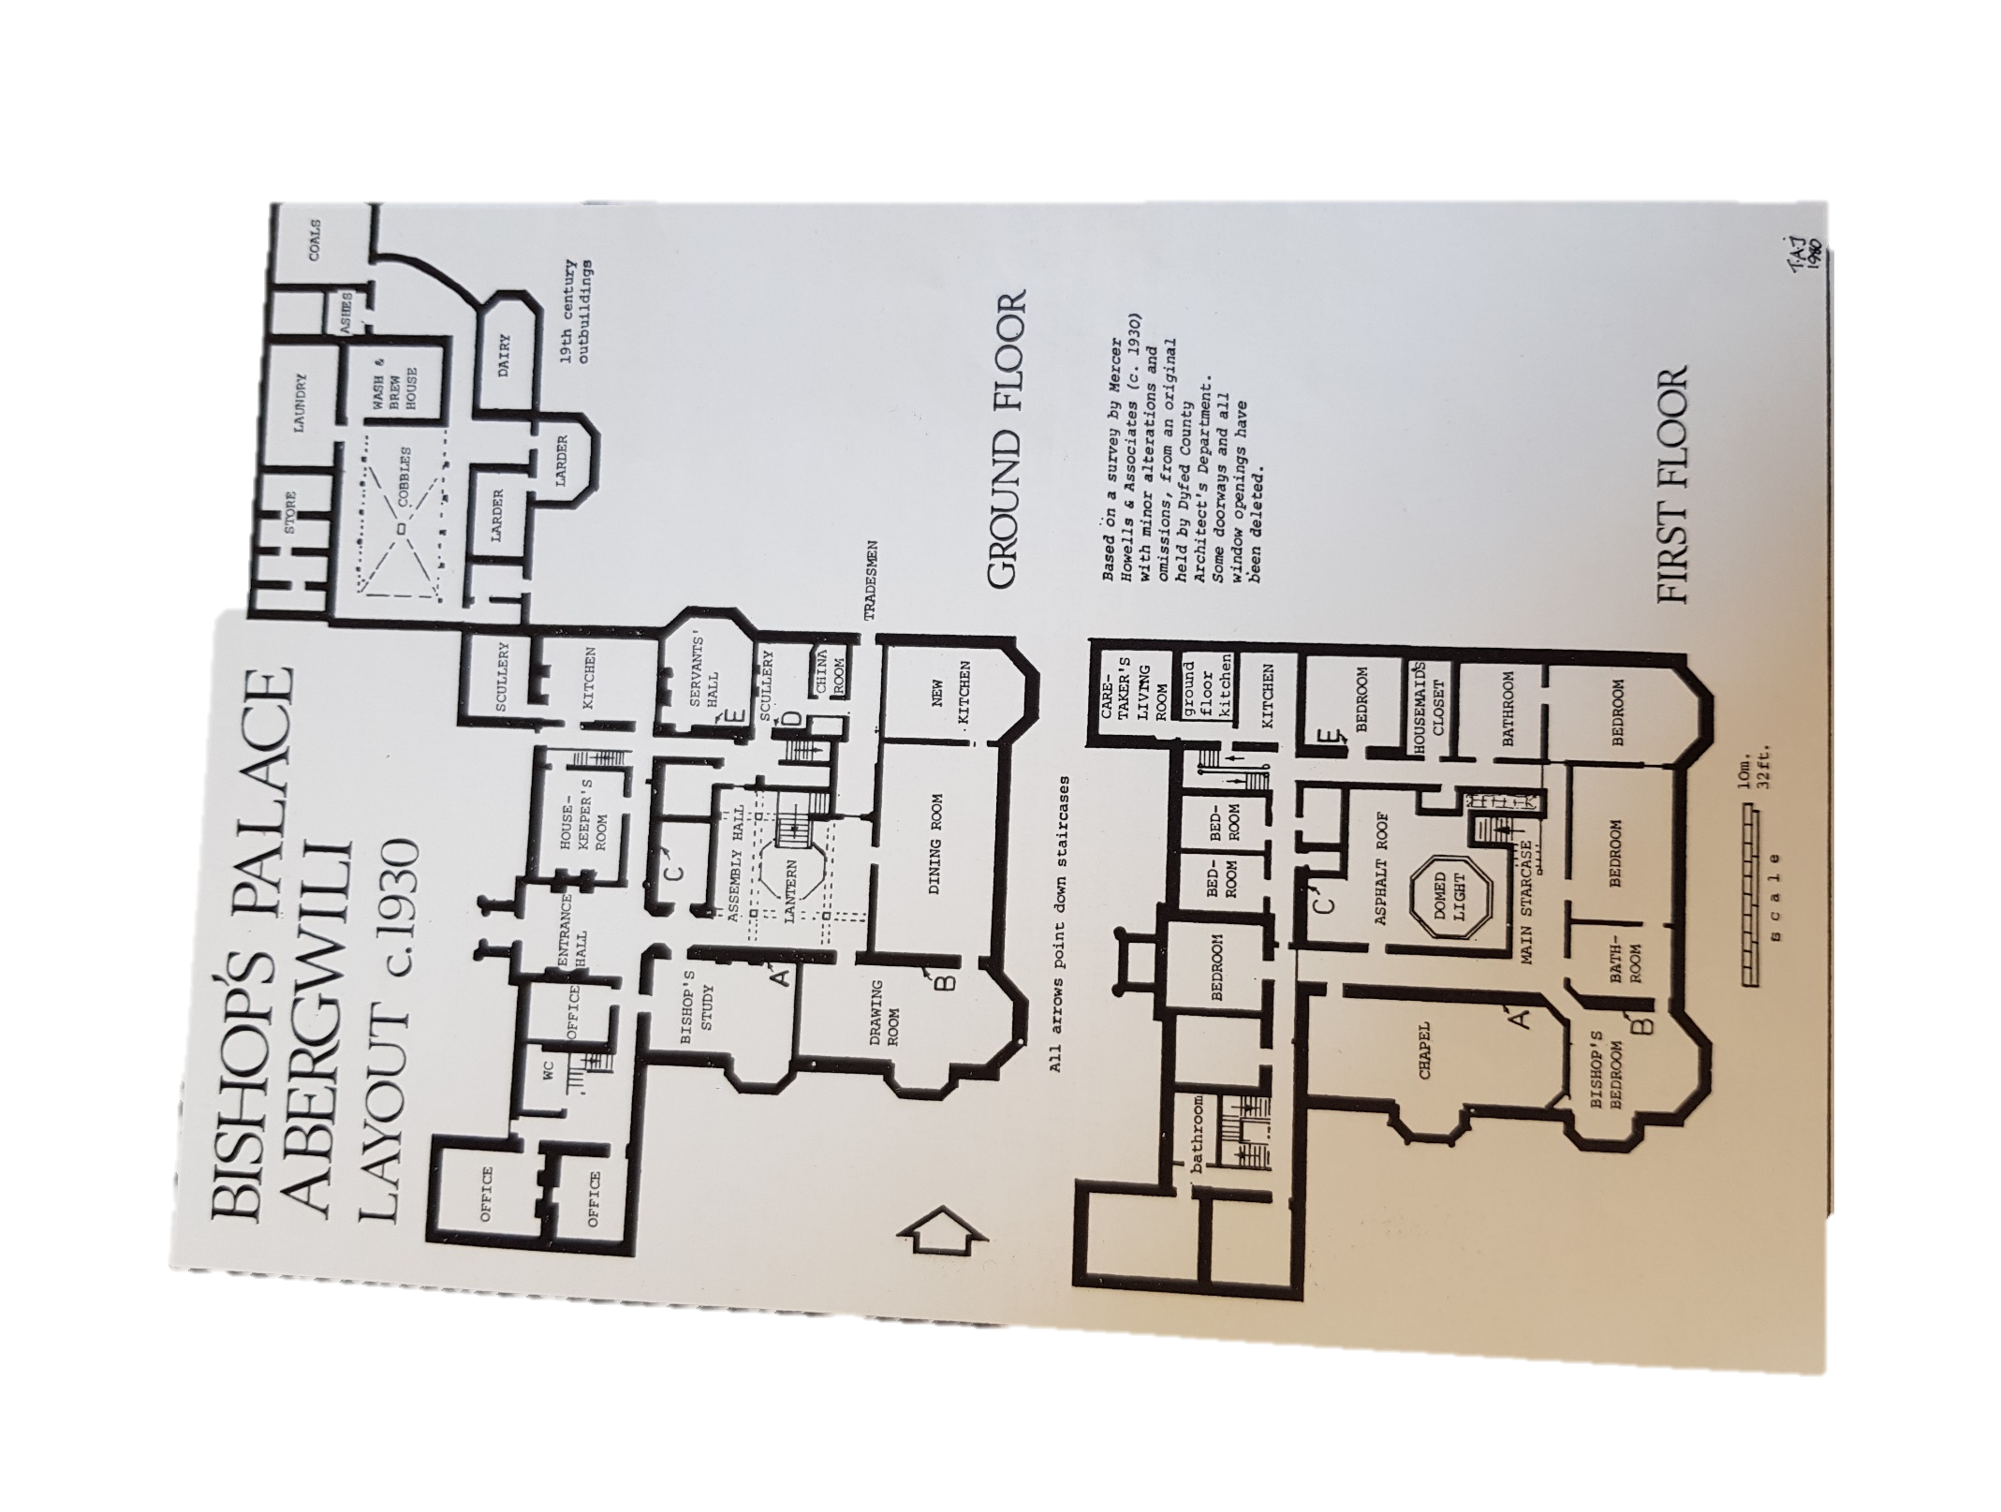
Figure 2 The palace layout and function in 1930- (By the permission of Carmarthenshire Museum- (personal photo)).
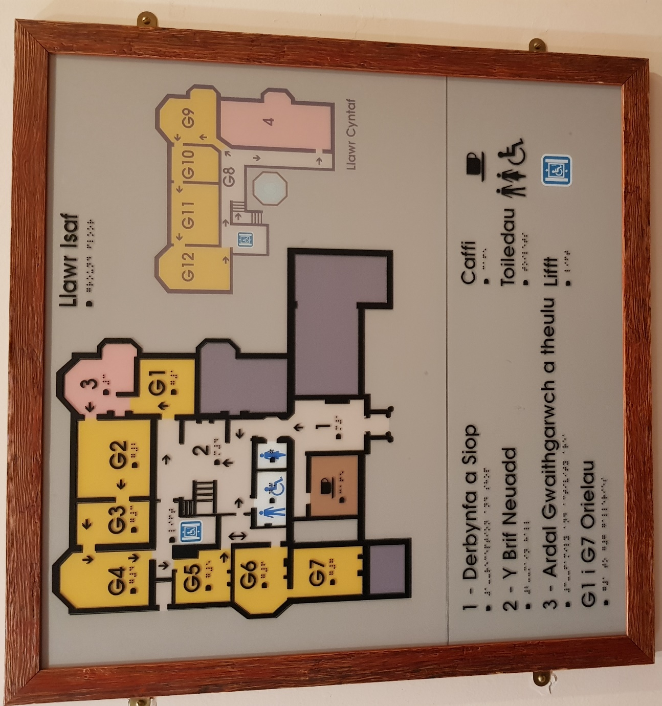
Figure 3-Current museum floorplan (personal photo).
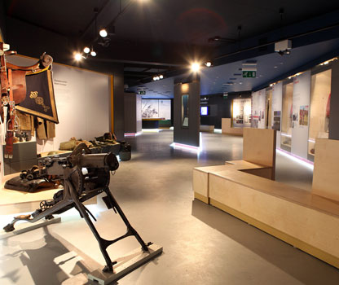
Figure 4- Fire Line Museum- Cardiff Castle.
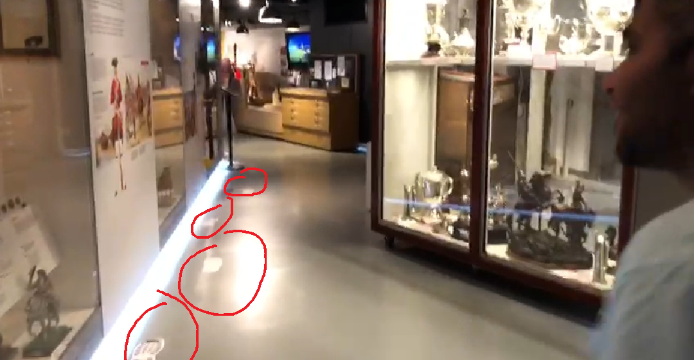
Figure 5- Footprints floor stickers circled in red at the Fire Line Museum- Cardiff Castle (personal photo).
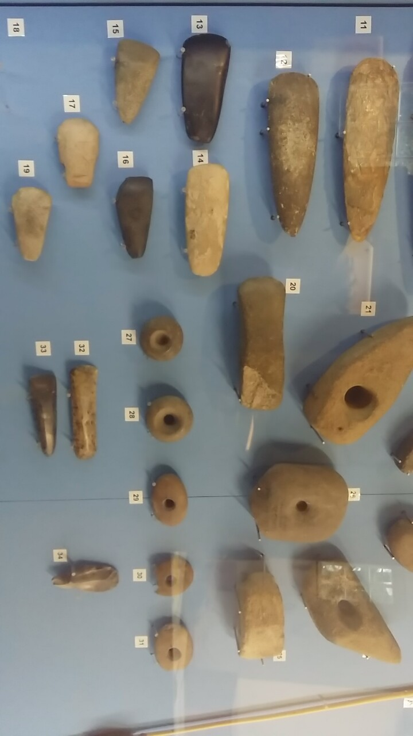
Figure 6- A display case of stone tools in area G1- Carmarthenshire Museum (personal photo)
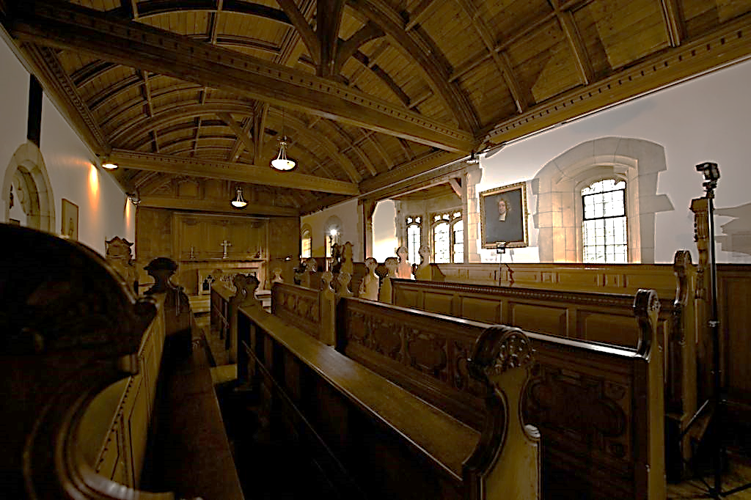
Figure 7- The Bishops Palace chapel- Carmarthenshire County museum (Griffin, 2013)
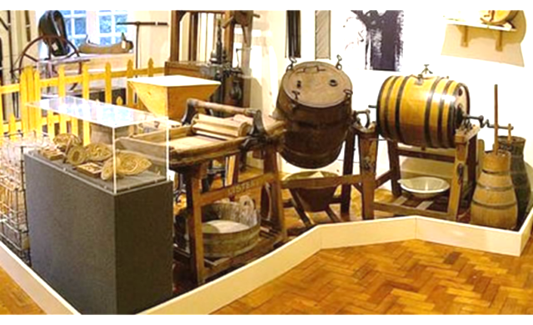
Figure 8- The Farmer's Gallery at Carmarthenshire County museum (personal photo)
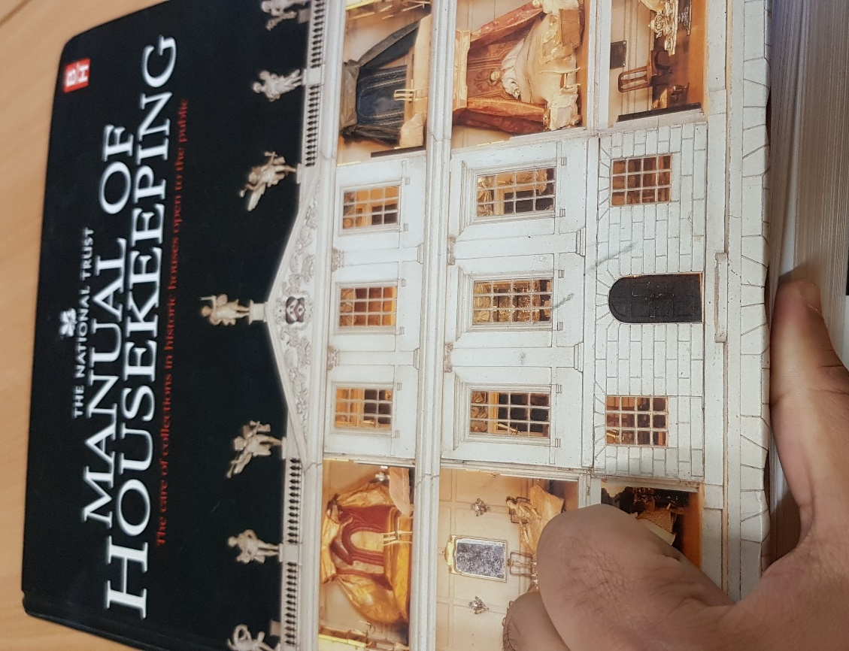
Figure 9- The book that I have read part of before cleaning the chapel (personal photo).
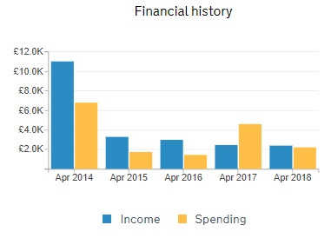
Figure 20- The financial history of Friends of Carmarthenshire County Museum (Charity Commission UK, 2018).
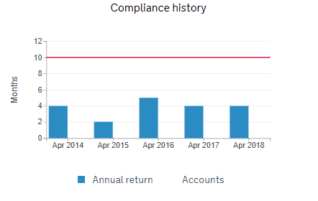
Figure 11- The annual return of Friends of Carmarthenshire County Museum charity (Charity Commission UK, 2018).

