Social Network Sites and business use
- Definitions
While Facebook, BEBO are obvious sites for you to check out, see also B2B SNS sites like
Hootsuite
http://signup.hootsuite.com/pro/?ad=ga&gclid=CMGV3vHd-7QCFbB3cAod1Q8AzA
Bloomfire
http://www.bloomfire.com/lp/social-networking-software/?seg1=ppc&seg2=gog&seg3=free-trial&_kk=business%20social%20networking%20sites&_kt=8d1adc7a-479c-4418-b256-19420ab0c820&gclid=COma_Ize-7QCFbB3cAod1Q8AzA
Note also that many commercial sites, which were designed to serve other functions, could become a SNS e.g. the SMU email system or a commercial site like Amazon.
Using Gaming sites also allows user communication and can act as another channel for promotion and brand development e.g. fans of World of Warcraft (WOW).
Therefore you have potentially a wide possibility of analysing very diverse sites.
A good basic guide below, for definitions. (The BBC is not a totally unbiased source, but is an acceptable source, if analysed with care. Wikipedia remains officially banned for academic sourcing).
http://www.bbc.co.uk/webwise/courses/social-media-basics/
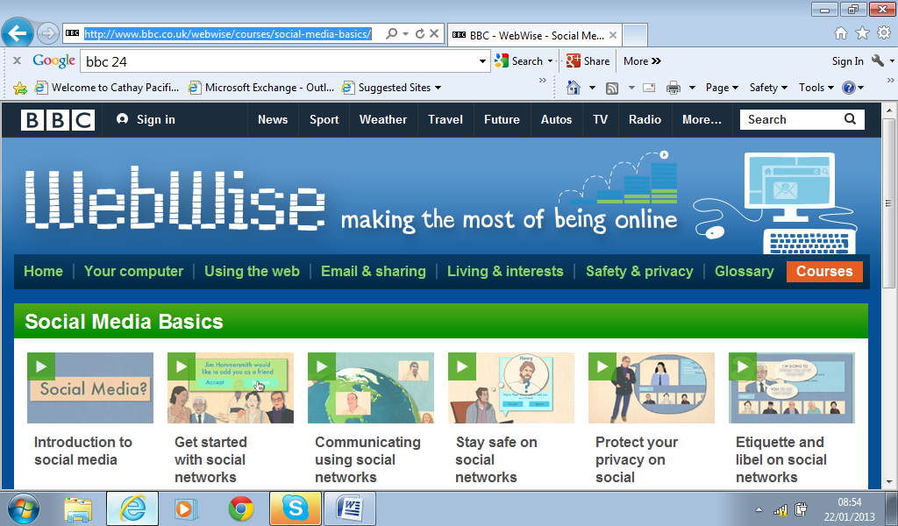
Other BBC help sites.
Look out for ethical behaviour (netiquette), security, legal, privacy, cyber bullying and other issues that we have discussed in class sessions.
http://www.bbc.co.uk/webwise/guides/mobile-web
http://www.bbc.co.uk/webwise/guides/mobile-safety-security

- The power of independent hackers?
20 January 2012 Last updated at 11:06 GMT Help
Hackers have targeted the US government and copyright organisations following the shutdown of the Megaupload file-sharing website.
The Department of Justice (DoJ), FBI and the Motion Picture Association of America (MPAA) among others have been bombarded with internet traffic.

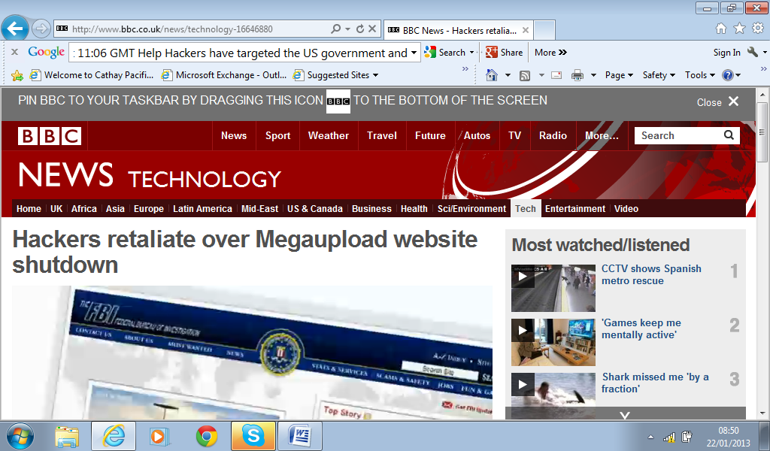
Web links have been distributed which, when clicked, make the user's computer part of the attack.
A statement attributed to Anonymous claimed responsibility.
- Kim Dotcom takes the BBC into his NZ home
http://www.bbc.co.uk/news/business-21115237
21 January 2013 Last updated at 03:22 GMT Help
In New Zealand the controversial internet tycoon, Kim Dotcom, has launched a new file-sharing business just a year after he was forced to close a similar website.
His previous venture Megaupload.com accounted for more than 4% of the world's internet traffic, but authorities in the United States claim the site facilitated massive online piracy.
Kim Dotcom, who denies wrongdoing, faces up to 20 years in prison if he is convicted.
The BBC's Greg Ward met the tycoon at his mansion and sent us this report from Auckland.
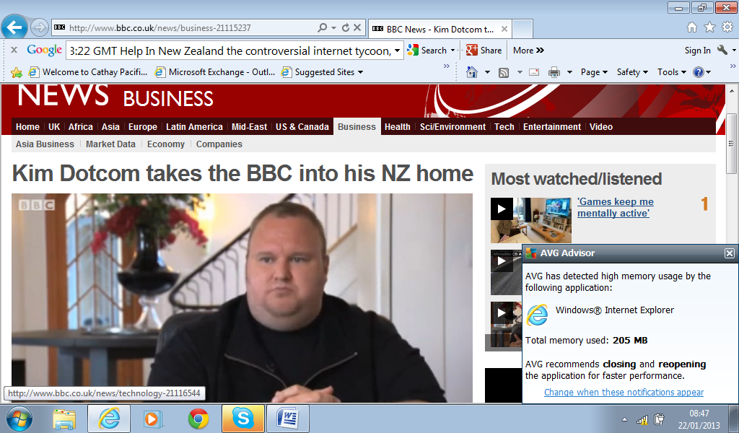

- Catholic Church 'into social media in a big way'
What language should you use on your use of SNS?
http://news.bbc.co.uk/today/hi/today/newsid_9786000/9786627.stm (Accessed 21-01-13)
Pope Benedict Tweets in Latin...a flexible language for universal communications?
Pope Benedict XVI has started tweeting in Latin from his @pontifex account.
The messages are part of the Vatican's effort to support a revival in the ancient language.
Speaking to the Today programme, the BBC's David Willey in Rome said: "The Catholic Church is into social media in a big way. They've set up a new department to deal not just with tweeting but with bloggers, and they have the Pope on YouTube.
"They're very sophisticated about this, they think social media is a great way of spreading the gospel message."
Peter Jones, co-founder of Friends of the Classics charity and author of the Ancient and Modern column in The Spectator, explained that the Latin for tweet would be "pagina publica breviloquentis", meaning "the public page for someone speaking briefly".

2.5 million on his main site. 6,000 followers in Latin site

5. Playboy TV fined £100,000 by UK broadcasting regulator

http://www.bbc.co.uk/newsbeat/21045715 (Accessed 20-01-13)
Page last updated at 18:10 GMT, Wednesday, 16 January 2013

Playboy TV has been fined £100,000 by Ofcom for failing to protect children from potentially harmful pornographic material.
Ofcom says there wasn't a system in place on Playboy's on-demand programmes services and they didn't have "acceptable controls in place to check that users were aged 18 or over".
The broadcasting watchdog concluded that "Playboy's failure to protect children from potentially accessing these sites was serious, repeated and reckless."
Ofcom says it happened between 31 May and 24 July 2012 and it concerned the Playboy TV and Demand Adult websites.
The Authority for Television On Demand (ATVOD) in conjunction with Ofcom say Playboy broke rule 11 of ATVOD's guidance.
Ofocm said because of the serious nature of the breaches, it fined Playboy's Demand Adult £65,000 and Playboy TV £35,000.
Last December, Ofcom also fined the online adult content website, Strictly Broadband, £60,000 for failing to have effective controls in place to verify that users of the site were aged 18 or over.
- Protection of Children

There are many internet safety sites for looking after children. You might want to evaluate how good the advice is.

http://www.bbc.co.uk/blogs/cbeebiesgrownups/2012/02/internet-safety-tips-1.shtml

Internet Safety Tips
Tuesday 7 February 2012, 13:29
Lois CBeebies
Comments
Tuesday 7th February is Safer Internet Day - check out Alex's top tips for helping your children prepare to enjoy the internet safely:
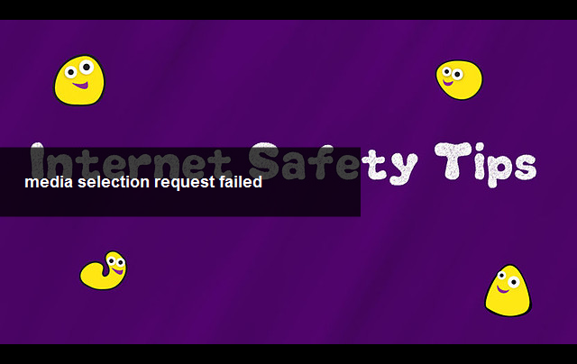
Thanks to these people from creative commons: tm22, Wilson (Army Gal), Joint Base Lewis McChord and Pusteblumenland .
The Internet can be a great source of fun and learning for your child, and you needn't be frightened of your child using it if you follow some simple rules.
Always sit with young children when they use the Internet.
With an older child who wants to explore on their own, it is a good idea to keep the computer in a family room or a place you share.
Be aware you can adjust browser settings and filters to protect children from unsuitable sites. For more help with this check out the Net SMART rules.
Talk to your child about how to stay safe and let them know they can speak to you if they find themselves in any sort of trouble.
There are plenty of safe places for children to play and learn on the web, get to know them and maybe save these as short-cuts in your favourites folder.
Social networking sites aimed at grown-ups, such as Facebook, YouTube and Twitter, are not suitable for children. The suggested minimum age for most social networking sites is 13.
Here are some useful links if you want to find out more about keeping yourself and your children safe online:
NSPCC - Keeping your child safe online
Thinkuknow -Child Exploitation and Online Protection (CEOP) Centre
CBBC's Stay Safe - for children 6+
BBC Health - Internet Safety
Share Take Care - Tips from BBC Webwise about keeping you and your children safe online

- Over protection of children?

However there is a feeling by some including academic Frank Furedi formerly Prof of Sociology at University of Kent, UK (“Culture of Fear”, “Moral Panic”, defender of academic freedom of speech, etc.), that there is s a danger of overprotection of children and that we need to let them experience risk and some controlled danger, to learn effectively. Over protection will lead to children being at risk of big problems, when they are finally confronted with the real world.

See his personal website and Blog, below. It is interesting to debate that normally Blogs might be considered an unreliable source, but is this still true if the blogger is a serious and respected academic? It shows how important it is to drill down to establish the provenance of statements and the credentials of the writer.



http://www.frankfuredi.com/

This is also reflected in more media coverage

Child Protection Legislation | 12 Oct 2006
http://www.bbc.co.uk/radio4/womanshour/02/2006_41_thu.shtml
Suspicious minds – does child protection now go too far?
New laws to protect children are reaching the final stages of their passage through Parliament. If passed they’ll lead to a strict and wide reaching vetting procedure being introduced for those who work with children. But critics argue it’s going too far – they say millions of people will be vetted unnecessarily, it will put volunteers off working with youngsters and it sends an alarming message to children that all adults are not to be trusted.
Reporter Angela Robson talks to dance critic with the Sunday Express and co-chair of the National Dance Awards, Jeffery Taylor, about the impact ‘no touch’ child protection guidelines are having on ballet standards in the UK and the nature of the pupil-teacher relationship in this sector of the arts.
Miriam O'Reilly is joined in the studio by Elaine Peace from the Children’s charity NCH and Heather Piper, author of ‘Parents, Professionals and Paranoia’ to discuss the wisdom of these latest child protection proposals.
- Regulation
It is inevitable that you will discuss regulation, if only as a “solution” to the case that you will be analysing in section 2 of your assignment.
Regulation can take many forms, but there is a crucial debate on self-regulation or regulation by authorities.
Self-regulation could be by the company, profession, management group, industry etc
External regulation might be by government, industry /government appointed body, self regulation NGO (which will still be external to the company).
Keep in mind the idea that in the long run some writers still believe the Internet (including SNS) is UNCONTROLLABLE (see your notes on this of our class discussion).
Some campaigning groups have interesting articles see the Open Rights Group below
http://zine.openrightsgroup.org/features/2013/censoring-pirate-sites-doesnt-work Accessed 01-01-13
These are not unbiased and are often highly politicised.
Make an effort to access groups who think the opposite. For example
http://www.theregister.co.uk/2012/06/29/citizen_jim_oops/ Accessed 21-01-13
This site fears the digital divide will frustrate the hope for digital democracy, making the Internet a tool for oppression rather than channel to encourage participatory democracy.
http://newscenter.berkeley.edu/2011/06/07/digital-democracy/
See also the perceptive and respected book by Morozov (2011) full details on the Hyper reality bibliography
Morozov, E. (2011) The Net Delussion How not to Liberate the World, London, Penguin
- Business Use of SNS

http://www.guardian.co.uk/small-business-network/2012/oct/22/roundup-live-chat-social-media-for-business (Accessed 20-01-13)

How to use social media to win new business - Q&A roundup
Last week a panel of experts shared their tips on how small businesses can use social media to increase clients and customers. Here are the highlights
- Sirena Bergman
- Guardian Professional, Monday 22 October 2012 10.58 BST

Twitter is a great way to ‘be social’ and conversational, says Lynsey Sweales of SocialB. Photograph: M4OS Photos / Alamy/Alamy
Jennifer Begg is a digital media consultant and trainer
Actively seek out your customers through social media: To make sure your social media activity is translating into revenue, I would set up goals on Google Analytics. Use the social referral tool to help you see how much traffic social is getting you, and use the goals to see how much of that traffic is getting to the 'thank you for your custom' page. That way you can also see where you are losing potential customers on your site, and make appropriate changes to those pages.
As far as building offline customers using social media is concerned, I find Twitter and LinkedIn invaluable business development tools.
Now when I meet potential clients, at an event for example, it's easy for me to stay in front of them without being intrusive. Before I would have had to rely on phone and email conversations. Now, I can share an article I think might be interesting or useful, or have a quick conversation around their own tweets and updates.
Google+ could be helpful for your business: Things like Hangouts and Events mean it holds great value some businesses. It's a good idea to use any network in a personal capacity first so that you can get a feel for it eccentricities before making the decision for your business. Also, find out if your audience is there.
Top tips for social media use: Listen (both to the words and to the stats) and respond, as it is your first line of defence in a negative situation and the best way of building a relationship with positive commenters. Your digital activity should be in a constant state of evolution so never take anything for granted.
What you shouldn't do: Don't feel the need to jump on every platform because you feel you have to - be there for the right reasons. Don't just broadcast - your followers will get bored. Don't make presumptions about platforms and their users, and use the data available to make decisions.
Rachel Fershleiser works in strategic outreach for Tumblr
Learn from others: I always think the best advice for getting started on a platform, whether it's Twitter or Tumblr or Facebook or anything, is to first just listen. Be a consumer. Learn from companies and people you think are interesting and see what they are doing that you think works.
What if you started by following brands and individuals you are genuinely interested in hearing from? Then pay attention to your feed, reply and participate, and soon you will have useful engagement. Twitter is not a megaphone; it's a conversation.
Even the most unlikely businesses can develop a social media presence: The whole vibe of this social revolution is: "Tell your stories! Your experiences count! We can all relate!" Planned Parenthood has a great Tumblr presence where they answer questions about birth control and STDs. They are straightforward and engaging and unjudgmental, and it's hugely popular.
Are you selling yeast infection cream? Start a blog called It Happens To Everyone and let people send in their most embarrassing stories (yeast-related or not) and then let other people upvote embarrassing things they totally relate to. People love to feel they're gossiping about something taboo - make your brand the best place to do it.
Zak Edwards is the managing director of Prezzybox
Using social media for SEO (search engine optimisation): SEO basically means getting to the top of Google searches, and Google wants brands. You need to become an authority in your space. Add great content to your site, build up and engage with social followers, focus on what you do well and become an expert in that field. Get links to your site from other authoritative websites in your space, and work on becoming an authority in your space on social media.
Try and generate interest in your brand organically before you go down the advertising route: Consumers tend to have a general fascination with the workings of companies and social networks are a great place for you to really bring your brand alive and create loyal advocates.
Try running competitions on Facebook and Twitter encouraging people to share or retweet your content. Ask questions that will provoke a reaction from your followers. Post funny pictures or stories - anything relevant to your business that people will like to engage in.
Lynsey Sweales is the CEO of SocialB
Think about which social networks your customers and prospects are using: You may not have the time setup and manage profiles across every network, so choose those most likely to get you in front of as many of your target audience as possible. Think also about how you'll use each channel. Facebook is great for posting rich content like pictures and videos. Twitter is a great way to 'be social' and conversational. It's a soft sell so don't go in with a hard sell until you've established rapport.
Nathan McGurl is interim digital and social media manager at Lloyds TSB Commercial
Reach people when they're in the right mindset: This is the difficulty for B2B. I might be interested in your products nine to five, but if this is the weekend and we're on Facebook the chances are that I'm not thinking about work.
Video is a great medium for web. We will spend far longer watching a video than we will reading a page. A picture may be worth a thousand words, but a video is 24 pictures a second!
Beware of turning a Twitter feed into a customer services site: For me, as a consumer, if I rant on Twitter, it is a soapbox moment in 140 characters and then it's done. If I have a complaint or customer service issue I want resolved I'd send an email or pick up the phone. The brand getting involved in every conversation may just prolong a comment that should have passed as soon as it appeared.
Samantha Russell is a Facebook strategist
Use an on-site blog well to increase social traffic: A good blog will have a clear layout, bold headings and lots of images. The most important place to have social share buttons is at the top, as this catches the people who won't read all the way to the bottom. It's good to have them at the bottom too though, for the people who do.
Add a very clear call-to-action at the bottom of each post. What do you want people to do with that information? Click a link to purchase something, leave a comment or share on their social networking site of choice? Make sure the text stands out, use a box or have a different colour background so its stand apart from the post and is eye catching.
To read the full Q&A click here.
This content is brought to you by Guardian Professional. To receive more like this you can become a member of the Small Business Network here.

A personal reflection with good links
http://www.forbes.com/sites/kellyclay/2012/11/30/why-businesses-should-use-social-media-for-customer-service/
(Accessed 12-12-12)

- 
Bottom of Form

Kelly Clay, Contributor

11/30/2012 @ 2:29PM |10,616 views

Why Businesses Should Use Social Media For Customer Service


Several years ago I first joined Twitter after a terrible customer experience at a retail store. After failing to find jeans in my size at three different locations of the same store, I gave up and purchased something else to satisfy my desire to just buy something. At the bottom of the receipt was an invitation to tweet at the store’s CMO, and though I had been blogging for several years by that time, I had not yet joined the ranks of Twitter.
Within an hour, I had written a scathing personal blog post about my experience, signed up for Twitter, and sent a tweet to that CMO with a link to the blog. Much to my surprise, I had a DM from the company within minutes, and by the end of the week the store had followed up with several phone calls – and even shipped a gift card so I could buy that pair of jeans in my size online.
I was completely surprised at that level of customer service, and have since advocated that both brands leverage the power of Twitter as a platform to connect with customers – and for customers to leverage this channel to connect with brands that are ready to listen and take action in ways that most call centers don’t.
Dozens of businesses notably use Twitter well to communicate with customers, but one big brand that has done an exemplary job of using social media as a customer service channel is Zappos. The company, which was founded on a principle of providing “WOW” customer service in general, leverages almost every online platform to communicate with customers to ensure they are receiving the best level of customer service possible.
Graham Kahr, a social scientist at Zappos who will be speaking about social media at at the SMX Social Media Marketing Conference in Las Vegas next week, explained that “We are really thinking about social as a way to deliver a highly curated experience for our customers while allowing us to deliver the Zappos level of service.” Currently, most of Zappos’ focus is on Facebook, Twitter, Google+ and Instagram, and the company has developed some unique tools to help both Zappos and its customers leverage these platforms to provide a better experience. For example, they developed Pinpointing, a new tool designed to allow users to input any Pinterest username and we return Zappos items that are related to pins the user has pinned to Pinterest. Kahr also notes that “We are using Instagram to help tell the story of our style shoots with behind-the-scenes photography, style tips, trends from the stylists and little pieces of Zappos culture along with creating social user-generated-content campaigns around Instagram hashtags.”
Zappos also has a strong Twitter strategy with an account dedicated to 24/7 customer service. Kahr explains that 25 people (who are based in the customer loyalty department) help manage the account, with one person at a time driving the conversation. However, all Zappos employees are taught about Twitter during new hire training as a way to keep employees connected to one another because, as Kahr says, “Zappos is a live, work, play company. When the company first started using Twitter, it was a way we could stay connected while also helping our customers if they needed it.”
Kahr explains that “Since conversations with our customers can often be casual and not about a specific transaction, social channels are a great way for us to WOW our customers with content.” He adds that “a lot of brands ignore customers like that and they don’t direct respond – we think that our customers are super valuable. We want to talk to them every way that they talk to us.” As part of this mission, he revealed that Zappos is developing strategies to connect with customers other platforms in 2013 such as Tout, Pose, Tumblr, Polyvore, Reddit, Medium, and SocialCam.
As the social web keeps growing, it’s important for brands to realize that more consumers are turning to social platforms – especially the most mainstream such as Facebook and Twitter – with customer service issues. The brands that are listening and responding are not only providing another outlet for customers to reach them, but providing a level of customer service that drives intense customer loyalty – which is critical in today’s world where customers can more easily choose to shop elsewhere than ever before.
See other handouts on whether the Internet has given too much power to complainers (Online customer complaints pack).
- Dehumanisation
You might analyse the way some critics view SNS communications as unreal and dehumanisation and that we are being drawn into unsocial, remote, unsatisfying, psychologically damaging behaviours, in our obsessions with SNS. See my work on hyperreality, including the books:
These two books state the great advantage of using digital media to transform our lives
Qualman, E. (2010) Socialnomics: How Social Media Transforms the Way We Live and Do Business, London, John Wiley & Sons
Tapscott, D. & Williams. A.D. (2008) Wikinomics, How Mass Collaboraton Changes Everything, London, Atlantic Books

These books identify our “loneliness” despite the 100s of internet contacts, unbiquitous computing, our constant digital communication of superficial information, in our dehumanised world , dominated by increasing concentration in the companies that feed us information which we live our lives by. (Google has 98% of search traffic).

Keen, A. (2012) Digital Vertigo: How Today’s Online Social Revolution is Dividing, Diminishing and Disorienting Us, London, Constable

Lanier, J. (2011) You are not a gadget: A Manifesto, London, Penguin

Turkle, S. (2011) Alone Together, Why we expect more from technology and less from each other, New York, Basic Books

John Naughton has a balanced view, recognising the dangers and advantages of the Internet, but also an undecided conclusion about whether good or bad will be the overall result.
Naughton, J. (2012) What you really need to know about the Internet, London, Quercus

- Academic sources
Please note that the more refereed academic journal articles you use the better. These are the academic “Gold standard”. By all means use the Abstracts/summaries to get a general idea of what the authors think. Read the full article to get more depth or to “borrow” diagrams, tables or copies of survey questions.
Andreas M. Kaplan & Michael Haenlein
Users of the world, unite! The challenges and opportunities of Social Media, Business Horizons, Volume 53, Issue 1, January–February 2010, Pages 59–68

Abstract
The concept of Social Media is top of the agenda for many business executives today. Decision makers, as well as consultants, try to identify ways in which firms can make profitable use of applications such as Wikipedia, YouTube, Facebook, Second Life, and Twitter. Yet despite this interest, there seems to be very limited understanding of what the term “Social Media” exactly means; this article intends to provide some clarification. We begin by describing the concept of Social Media, and discuss how it differs from related concepts such as Web 2.0 and User Generated Content. Based on this definition, we then provide a classification of Social Media which groups applications currently subsumed under the generalized term into more specific categories by characteristic: collaborative projects, blogs, content communities, social networking sites, virtual game worlds, and virtual social worlds. Finally, we present 10 pieces of advice for companies which decide to utilize Social Media.
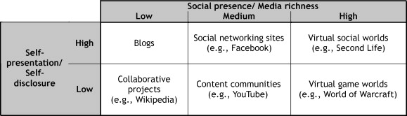

Creating successful cause-brand alliances: The role of cause involvement, perceived brand motivations and cause-brand alliance attitude
Myers, Beth; Kwon, Wi-suk & Forsythe, Sandra

Journal of Brand Management, suppl. Special Issue: Branding non-profit and commercial20. 3 (Jan 2013): 205-217.

Under increasing pressure from consumers to be socially responsible, more brands than ever are engaging in cause-brand alliances. Two challenges facing brands are how to choose a nonprofit partner for the alliance and the impact of the brand's perceived motivations for engaging in the alliance on consumers' responses to the alliance. Using a theoretical framework based on the congruity theory and the theory of reasoned action, this study examines the influence of consumer cause involvement, perceived brand motivations and cause-brand alliance attitude on consumers' intentions to purchase the product associated with a cause-brand alliance. Hypotheses were tested in the context of mock cause-brand alliance press releases in an online survey administered to 742 US college students. Findings indicate that perceived brand motivations partially mediate the relationship between cause involvement and cause-brand alliance attitude, and that cause-brand alliance attitude positively influences purchase intentions. Managerial implications are discussed

Generative team learning in Web 2.0 environments
London, Manuel

The Journal of Management Development32. 1 (2013): 73-95.

Purpose - The purpose of this paper is to examine how teams work and learn in Web 2.0 environments. Web 2.0 technologies enable geographically dispersed teams to work in synchronous and nonsynchronous modes of interaction in dynamic, self-directed ways, within and across team boundaries, thereby avoiding some of the limitations of earlier generations of electronic communication. Design/methodology/approach - The paper explores how Web 2.0 technologies that are user-controlled and team-driven allow multiple modes of communication and team member active learning. Cases and an examination of team web-based work processes and learning outcomes are examined. Findings - Web 2.0 functionality differs from traditional, primarily face-to-face modes of work and learning. Web 2.0 technologies can promote generative learning processes in which team members are open to new ideas, explore new ways of interacting, and apply their learning. Practical implications - Potential outcomes are the emergence of emotional intelligence in on-line settings, virtual communities of practice, and innovative results. Originality/value - The paper offers directions for research as well as ways to lead productive virtual teams and support continuous learning, at the individual and team level.

Achieving customer service excellence using Lean Pull Replenishment

Kumar, Sameer, Choe, David & Venkataramani, Shiv.

International Journal of Productivity and Performance Management62. 1 (2013): 85-109.
Purpose - The purpose of this study is to highlight a key strategic initiative within the former ADC Company (now part of TE Connectivity) called "Lean Pull Replenishment", designed and implemented to achieve Six Sigma customer service excellence. This case study would also help facilitate problem-based learning pedagogy. Design/methodology/approach - The study showcases implementation of the Lean Pull Replenishment approach using the define, measure, analyze, improve and control (DMAIC) framework. Key input variables were analyzed that contributed to historically inconsistent and unsatisfactory customer delivery performance. Analysis resulted in improving the allocative efficiency of critical input variables through pilot programs on strategic value streams by deploying dozens of kaizen events, and sustaining the gains through leveraging best practices and effective change management principles. Findings - The study presents a strong case for the team work and the cultural transformation that occurred during the course of implementing this initiative across ADC supply chain. The paper also summarizes the improvement in customer service metrics and financials of the company. Originality/value - Through this study, it has been established that with consistency of purpose, using the right tools for solving problems and through teaching Lean principles, remarkable results can be achieved, which can be sustained for the long-term and become a self-sustaining business philosophy.

GEs Colab Brings Good Things to the Company
Berkman, Robert. MIT Sloan Management Review54. 2 (Winter 2013): 1-4.
In an interview, Ron Utterbeck discusses an internal social network at GE that is mimicking all the good things that people get outside in their social lives with Facebook: quick responses, connections with people they know and coordination with people they didn't even know were out there. One of the key people vital in making this happen, Utterbeck is the CIO for GE Corporate and the Advanced Manufacturing Software Technology Center in Michigan. Utterbeck began GE Colab by strategically introducing it to the firms already known power users as a way to speed word of mouth around the enterprise and encourage early high levels of activity. He and his team then found that the best way to further increase quick growth was to make it simple to get feedback and suggestions from the early users and add desired new functionality this then spurred even more users and activity. He said Colab is harnessing the power of about 115,000 brains right now.
Tribal mattering spaces: Social-networking sites, celebrity affiliations, and tribal innovations.
Hamilton, Kathy
Hewer, Paul
Journal of Marketing Management; Mar2010, Vol. 26 Issue 3/4, p271-289, 20p, 4 Charts
In this paper, we explore the opportunities and possibilities of Web 2.0 through the theoretical lens of tribes and fandom, arguing that social-networking sites centring on iconic celebrities provide a rich context to explore notions of tribal identities and their forms of interaction, connectivity, and creativity. Employing what we term a Netnographic Imagination, we seek to explore the nature and character of this tribal context to provide insights into the tribal mattering spaces that are constructed around celebrity brands. Our analysis highlights the passions and enthusiasms within such emotional communities and the investments they make in celebrity brands, along with the forms of critique they construct around their associated marketing practices. Finally, we draw attention to the tribal innovations that emerge from the sense of togetherness and belonging made explicit through such tribal affiliations
Edited by: Joshua L. Brunty, Katherine Helenek and Larry S. Miller 

Social Media Investigation for Law Enforcement
Copyright © 2012 Elsevier Inc. All rights reserved.
ISBN: 978-1-4557-3135-0
While this book might be too specialist, its introduction could help you do a quick review of the phenomena of SNS
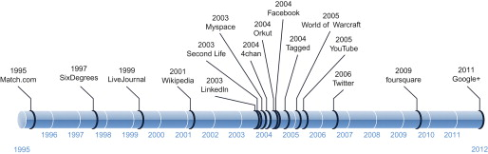

The Role of Social Networking Sites in Civic Activism in Russia and Finland. Europe-Asia Studies; Oct2012, Vol. 64 Issue 8, p1375-1394, 20p
Gladarev, Boris & Lonkila, Markku
This essay compares the role of the social networking sites, Facebook in Finland and Vkontakte in Russia, in organising civic activism. It is based on data collected about two successful campaigns mobilised by local residents against urban building projects in St Petersburg and Helsinki in 2009. Though in both cities these sites were important channels for transmitting information and organising and coordinating the campaigns, their role was clearly limited in terms of impartial, democratic discussion of the issue of common concern: the sites were rather used to build and reinforce emerging collective identities and to create consensus within the movement. In contrast to the situation in Helsinki, Vkontakte also had a central role in creating and maintaining ties between formerly isolated campaigns against building projects elsewhere in St Petersburg, thereby helping to build a ‘network of grassroots resistance’ in the city. We thank Jeremy Morris, Natalia Rulyova, Vlad Strukov, Tuomas Ylä-Anttila, the anonymous reviewer of Europe-Asia Studies and the members of the Helsinki Research Group for Political Sociology seminar for useful comments on the essay. The research has been supported by the Academy of Finland
Bridging the work/social divide: the emotional response to organizational social networking sites.
Koch, Hope, Gonzalez, Ester & Leidner, Dorothy
European Journal of Information Systems; Nov2012, Vol. 21 Issue 6, p699-717, 19p
The Use of Social Networking Sites in the Restaurant Industry: Best Practices. DiPietro, Robin, B.Crews, Tena B., Gustafson, Cathy & Strick, Sandy
Journal of Foodservice Business Research; Jul-Sep2012, Vol. 15 Issue 3, p265-284
Social media and the use of social networking sites are defined as Internet applications that help consumers share opinions, insights, experiences, and perspectives (Kaplan & Haenlein, 2009). The current study analyzes data relevant to the use of social media sites with the largest chain restaurants in the U.S. and the managers' perceptions of the usefulness of such sites for their organization. The current research shows there are no consistent social networking sites restaurant chains use, there are no consistent uses for these sites, and managers have differing opinions about their overall usefulness in restaurant operations and marketing. One consistent theme is that social networking sites are useful for advertising and marketing a restaurant brand at an inexpensive cost to the restaurant. Managerial implications are discussed, current best practices are shared, and future research recommendations are made to further explore social networking in the restaurant industry
- Questions
- How might your analysis be different depending on whether you are looking at a personal compared with a B2B SNS? You might like to review the B2C v B2B debate in marketing textbooks, but remember the viability of other relationships is offered by digital communications, C2C, C2B, G2C (Citizen), C2G, C2C (Citizen)
- If you choose to focus on a functional application of use of a SNS, discuss the possible different checklist of things that you would be looking for e.g. marketing compared with HRM, production, supply chain management etc.
- If you are looking at an incident or case study e.g. the use of SNS to promote a business event, new product launch, what data will you need to collect to analyse the ethical dimension in the case? Think of an example.
- If you choose to look at internal communications or internal marketing and the use by an organisation of its own SNS, intranet or site on a commercial SNS, what types of relevant issues could you be analysing?
- If you choose to evaluate the changes in power relations between consumers, companies, government, campaigners, online complainers etc., how would you manage the discussion and what data will you need to investigate?

