
Strategic Marketing Analysis of Tesco PLC:
A Critical Evaluation of Segmentation, Targeting, Positioning and Marketing Mix Effectiveness

Module Title: Principles of Marketing / Module Code: LCBB5015 BA (Hons) Business Management Lecturer: Ivan Rodriguez Hernandez Submission Date: 29th March 2026
Group leader: Ateeq Ur Rehman / STUDENT ID: 2322964
Group members
Mohammad Imran / 2313646
Paulica Barbu / 2319977
Sadaf Safdar / 2313180

Table of Contents
Introduction 2
Segmentation Analysis 3
Theoretical Framework 3
Targeting Analysis 8
Theoretical Foundations of Targeting 8
Positioning Analysis 10
Theoretical Foundations of Positioning 10
Strategic Strengths of Tesco’s Positioning 13
Marketing Mix Strategies (4Ps) 14
Integration of STP and Marketing Mix 18
Conclusion and Strategic Recommendations 18
References………………………………………………………………………………….20
Appendix A 22
Strategic Alignment of STP and Marketing Mix 22

Introduction
Tesco PLC is the largest grocery retailer in the United Kingdom, operating in the highly competitive food and general merchandise retail sector. Established in 1919, Tesco has evolved from a market stall into a dominant multichannel retailer serving millions of customers weekly through hypermarkets, superstores, convenience outlets, and digital platforms (Tesco PLC, 2024). The UK grocery market is characterised by intense price competition, increasing private-label penetration, rising supply chain and labour costs, and expanding discount competitors such as Aldi UK and Lidl (Mintel, 2024; Euromonitor, 2024).
Tesco maintains market leadership through economies of scale, supply chain optimisation, and data-driven customer insights generated via its Clubcard loyalty programme (Johnson, Scholes and Whittington, 2020). These advantages support cost efficiency and personalised marketing initiatives. However, market saturation and margin pressure have intensified rivalry, making sustained competitive advantage more challenging. Porter (1985) argues firms must adopt a clear strategic position—cost leadership or differentiation—to avoid being “stuck in the middle.” Tesco’s broad market coverage and tiered product architecture suggest a hybrid strategy that requires careful management to avoid brand dilution or inconsistency.
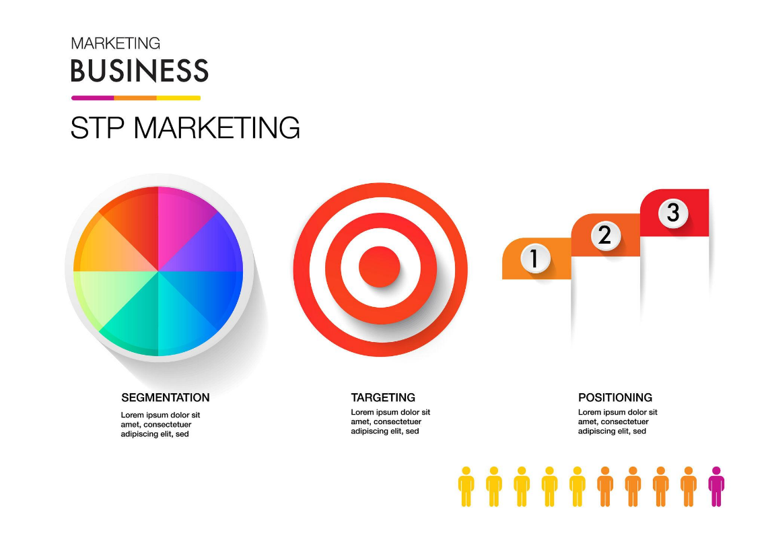
Within this context, segmentation, targeting and positioning (STP) strategies are central to Tesco’s long-term competitiveness.

Figure 1: Segmentation, Targeting and Positioning (STP) Framework
Source: Adapted from Kotler and Keller (2016)

As illustrated in Figure 1, the STP framework represents the strategic process through which organisations identify market segments, select target customers, and develop a distinctive market position. Effective segmentation identifies consumer groups with distinct needs, while targeting and positioning enable efficient resource allocation and customer value creation (Dibb and Simkin, 2018; Kotler and Keller, 2016). Aligning STP decisions with the marketing mix (4Ps) is also essential for strategic coherence and performance sustainability.

This report critically evaluates Tesco’s current STP strategies and marketing mix decisions. The analysis applies key academic frameworks, including Dibb and Simkin’s (2018) segmentation theory, Kotler and Keller’s (2016) STP model, Porter’s (1985) competitive strategy framework, and Keller and Swaminathan’s (2020) brand equity model, to assess the effectiveness and long-term sustainability of Tesco’s marketing strategy within the UK retail environment.

Segmentation Analysis

Theoretical Framework

Market segmentation involves dividing a heterogeneous market into distinct groups based on shared characteristics, needs, or behaviours to enhance marketing effectiveness (Dibb and Simkin, 2018). Effective segmentation must satisfy key criteria, including measurability, accessibility, substantiality, differentiability, and actionability (Kotler and Armstrong, 2020).



Figure 2: Bases of Market Segmentation
Source: Adapted from Kotler and Armstrong (2020)

As illustrated in Figure 2, segmentation typically incorporates demographic, geographic, psychographic, and behavioural variables.

In highly competitive markets such as UK grocery retailing, segmentation is a strategic necessity rather than a purely tactical exercise (Hooley, Piercy and Nicoulaud, 2020). Tesco adopts a multi-dimensional segmentation strategy, enabled by data analytics to achieve granular customer profiling (Chaffey and Ellis-Chadwick, 2019). However, while this enhances market coverage, it also introduces strategic complexity and risks weakening brand coherence.

Demographic Segmentation

Demographic segmentation classifies consumers based on income, age, and household characteristics (Lamb, Hair and McDaniel, 2020). In grocery retailing, income is particularly significant due to price sensitivity.

Tesco implements demographic segmentation through a clearly structured private-label hierarchy, comprising its Value, Core, and Finest ranges, each targeting distinct income groups. This enables the company to serve both price-sensitive consumers and premium-oriented shoppers simultaneously.

Strategically, this approach demonstrates Tesco’s use of differentiated market coverage to maximise reach while maintaining competitive advantage within a saturated retail environment (Wilson and Gilligan, 2019). However, a key limitation is the potential dilution of brand identity, as operating across both low-cost and premium segments may weaken the perceived exclusivity of higher-end products (Keller and Swaminathan, 2020).

This reflects a broader strategic challenge identified by Porter (1985), where combining cost leadership and differentiation can create positioning ambiguity if not carefully managed.

Geographic Segmentation

Geographic segmentation divides markets based on location and population density (Blythe and Martin, 2019). Tesco adopts a format-based strategy, as illustrated in Figure 3:

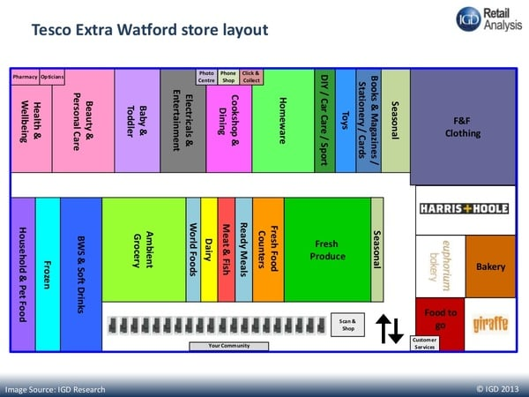

Figure 3: Tesco Store Format Strategy (Extra, Superstore, Express, Online)
Source: Adapted from Tesco PLC (2024) and publicly available store format documentation

- Tesco Extra (suburban hypermarkets)
- Superstores (weekly shopping)
- Tesco Express (urban convenience)
- Online platforms (national accessibility)

This reflects an intensive distribution strategy aimed at maximising accessibility (Kent, 2022). Omnichannel integration further enhances convenience (Chaffey and Ellis-Chadwick, 2019).

However, geographic diversification increases operational complexity. As large-format stores experience declining footfall and online fulfilment costs rise (Euromonitor, 2024), Tesco faces structural cost pressures. Therefore, while geographic segmentation strengthens reach, it requires continuous optimisation to sustain profitability.

Psychographic Segmentation

Psychographic segmentation focuses on consumer lifestyles, values, and attitudes (Solomon et al., 2017). Tesco targets key psychographic groups, including health-conscious consumers, sustainability-oriented shoppers, and time-constrained professionals.

This aligns with the growing importance of values-driven consumption (Kotler, 2017). Tesco’s sustainability initiatives and convenience offerings reflect responsiveness to these trends.

However, psychographic segmentation is difficult to measure and may not always translate into purchasing behaviour (Hague, 2019). During economic uncertainty, price sensitivity often overrides ethical preferences. This creates tension between Tesco’s sustainability positioning and its value-based strategy, limiting its effectiveness as a primary segmentation tool.

For instance, Tesco’s initiatives to reduce plastic packaging and achieve net-zero emissions reflect increasing consumer demand for sustainable practices. However, during periods of economic pressure, such ethical considerations may be secondary to price, limiting their influence on actual purchasing behaviour.

Behavioural Segmentation

Behavioural segmentation focuses on consumer actions such as loyalty, usage rate, and purchase patterns (Schiffman and Wisenblit, 2019). Tesco’s strongest capability lies in its data-driven behavioural segmentation, enabled by the Clubcard programme. 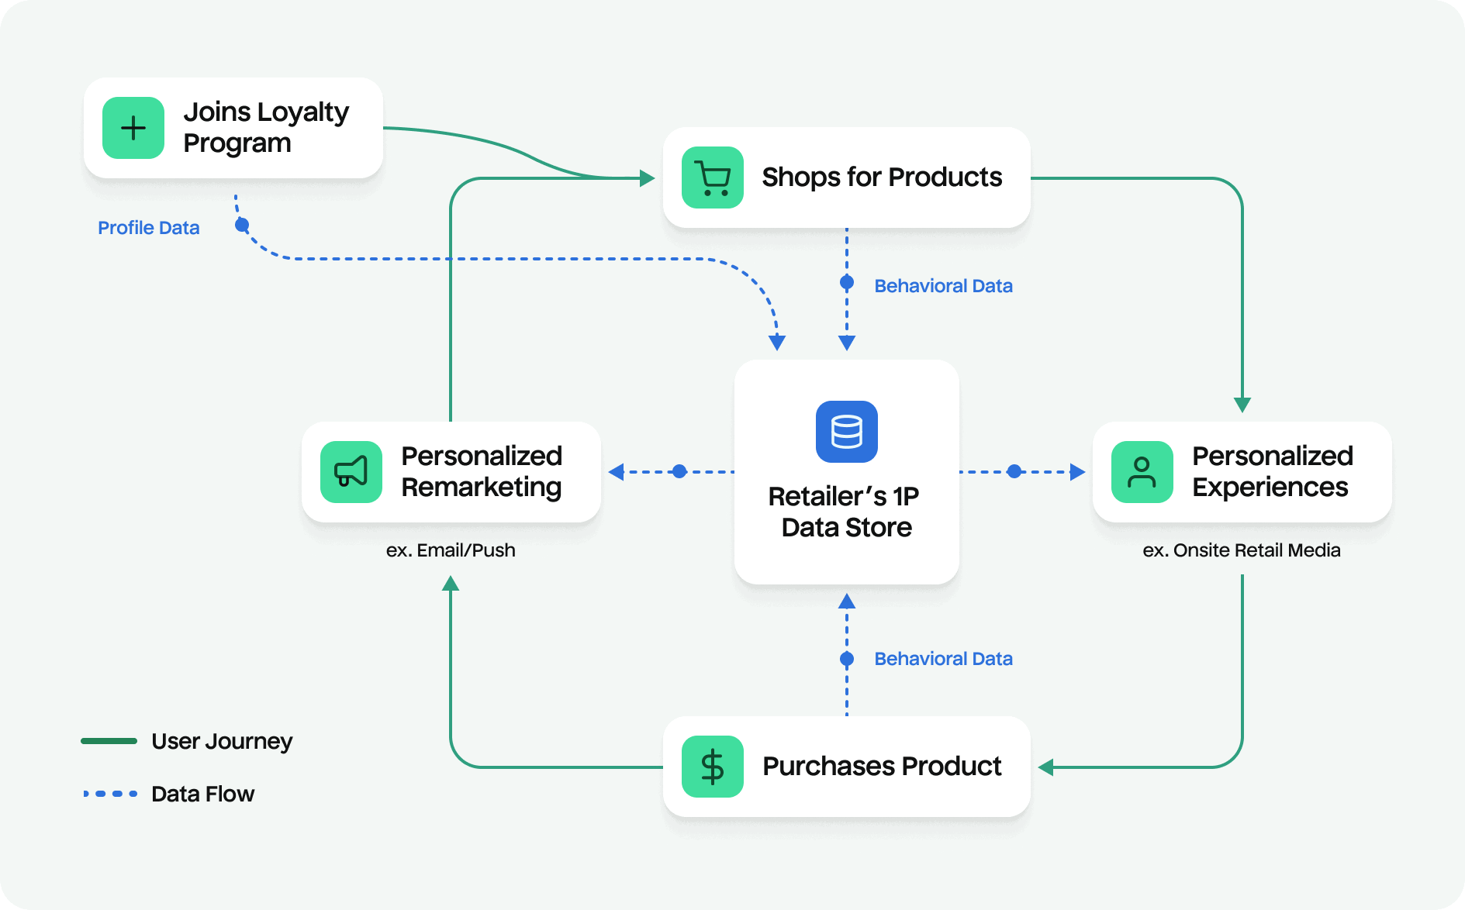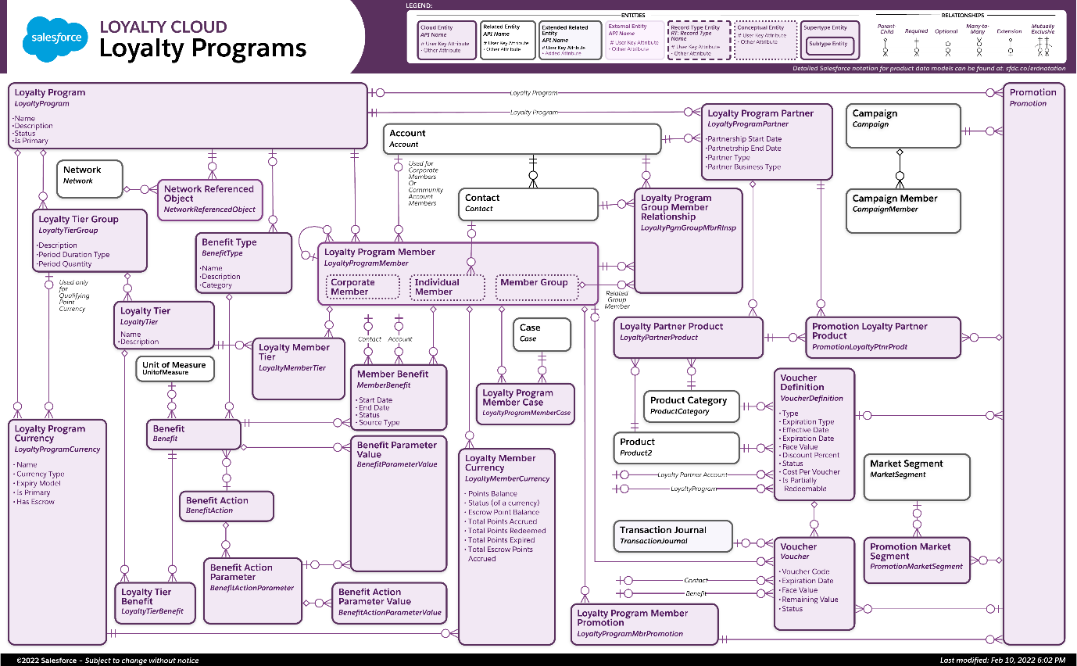

Figure 4: Tesco Clubcard Data and Personalisation Process
Source: Adapted from Zhang (2019) and Tesco PLC (2024)

As shown in Figure 4, Clubcard data supports personalised promotions and predictive analytics, enhancing customer retention (Zhang, 2019). This aligns with relationship marketing theory, which emphasises long-term customer value (Christopher, Payne and Ballantyne, 2016).

Customer Lifetime Value (CLV) can be calculated as:

CLV = Average Purchase Value × Purchase Frequency × Customer Lifespan
(Zhang, 2019)

While behavioural segmentation enhances precision, reliance on price-based incentives may create transactional rather than emotional loyalty (Doyle, 2012). Nevertheless, Tesco’s data-driven approach provides a significant competitive advantage through micro-targeting.

Overall Segmentation Evaluation

Tesco demonstrates advanced segmentation capability through its integrated use of demographic, geographic, psychographic, and behavioural variables. Figures 2–4 collectively illustrate how segmentation supports both broad market coverage and targeted engagement.

However, this breadth introduces strategic complexity and potential brand dilution. The key challenge lies in maintaining a coherent brand identity while serving diverse segments. Long-term success will depend on Tesco’s ability to balance segmentation depth with strategic clarity, ensuring that expanded reach does not undermine positioning consistency.

Targeting Analysis

Theoretical Foundations of Targeting
Targeting involves evaluating identified segments and selecting those that offer the greatest strategic value to the organisation (Kotler and Keller, 2016). Segment attractiveness is typically assessed according to size, growth potential, competitive intensity, accessibility, and alignment with organisational capabilities (Hooley, Piercy and Nicoulaud, 2020). Effective targeting ensures that segmentation translates into actionable strategic focus rather than excessive market dispersion.
Kotler and Armstrong (2020) identify four primary targeting strategies: undifferentiated, differentiated, concentrated, and micromarketing. Tesco adopts a differentiated targeting strategy, serving multiple segments simultaneously through varied product tiers, store formats, and pricing structures.
Tesco’s Target Market Portfolio
Tesco strategically targets several key consumer groups:
Price-sensitive households – competing directly with discount retailers.
Mainstream middle-income families – core volume drivers
Premium quality-seeking consumers – targeted via Tesco Finest
Urban convenience shoppers – served through Tesco Express
- Digitally engaged consumers – targeted via Clubcard and online platforms.
This broad targeting approach reflects Tesco’s ambition to maximise market coverage and sustain market leadership (Statista, 2024). By serving multiple segments, Tesco reduces dependency on any single demographic group, thereby enhancing resilience during economic fluctuations.
Evaluation of Segment Attractiveness

Price-Sensitive Segment
This segment has grown significantly during cost-of-living pressures (Mintel, 2024). It is large and price elastic, making it attractive in terms of volume. However, it is highly competitive, with strong rivalry from discount retailers. Profit margins are typically lower, requiring operational efficiency to remain viable (Grant, 2022).

Mainstream Middle-Income Segment
This segment represents Tesco’s traditional core market. It offers stable demand and moderate profitability. Tesco’s scale advantages and broad product range create competitive barriers for smaller retailers (Johnson, Scholes, and Whittington, 2020).

Premium Segment
The premium segment offers higher margins but is more limited in size. It is also more vulnerable to economic downturns, as consumers may trade down during financial uncertainty (Euromonitor, 2024). Competing retailers such as Marks & Spencer maintain stronger premium brand associations.
Strategic Tension: Hybrid Positioning
Porter (1985) argues that firms must avoid being “stuck in the middle” between cost leadership and differentiation. Tesco’s targeting strategy appears hybrid: it seeks to compete on price while also offering premium differentiation.
However, contemporary strategy literature suggests hybrid strategies can succeed if supported by operational excellence and data-driven segmentation (Grant, 2022). Tesco leverages supply chain efficiencies and analytics capabilities to sustain competitive pricing while maintaining differentiated product tiers.
Nevertheless, strategic complexity increases managerial risk. Serving multiple segments requires precise brand communication to prevent confusion or erosion of positioning clarity (Keller and Swaminathan, 2020).

Data-Driven Micro-Targeting
A distinctive feature of Tesco’s targeting approach is its reliance on behavioural analytics. The Clubcard programme enables personalised pricing and promotion based on purchase history (Zhang, 2019). This reflects a shift from broad segmentation toward micro-targeting.
Chaffey and Ellis-Chadwick (2019) highlight those digital analytics enhances targeting precision, improving marketing ROI. Tesco’s ability to tailor promotions increases customer retention and lifetime value.
However, Doyle (2012) cautions that excessive price-based incentives may erode perceived value. Additionally, heavy reliance on data-driven targeting raises data privacy considerations and requires sustained technological investment.
For example, Tesco’s Clubcard pricing strategy offers exclusive discounts to loyalty card holders, encouraging repeat purchases while enabling highly personalised marketing. However, this approach may also create a perceived “two-tier pricing system,” where non-members face higher prices, potentially undermining customer trust and brand fairness
While Tesco’s differentiated targeting strategy enables broad market coverage, it also increases operational and brand management complexity. The coexistence of value-led targeting and premium differentiation requires clear perceptual boundaries to prevent consumer confusion. An alternative strategic approach could involve greater concentration on mid-market dominance while allowing premium sub-brands to develop more independently, thereby strengthening brand clarity. However, such concentration would reduce diversification benefits and increase vulnerability to price competition. Therefore, Tesco’s current hybrid targeting strategy represents a calculated trade-off between clarity and coverage.

Overall Targeting Effectiveness
Tesco’s targeting strategy demonstrates several strengths:
Broad market penetration
Risk diversification.
Economies of scale
Data-enabled precision
However, weaknesses include:
Strategic complexity
Margin pressure in value segments
Brand dilution risk in premium segments
Overall, Tesco’s differentiated targeting remains effective in maintaining market leadership. Its integration of behavioural analytics enhances targeting sophistication beyond traditional demographic methods. Nonetheless, long-term sustainability will depend on maintaining clear brand architecture and reducing excessive reliance on price competition.
Positioning Analysis
Theoretical Foundations of Positioning
Positioning refers to how a company designs its offering and image to occupy a distinctive place in the minds of target consumers (Kotler and Armstrong, 2020). Effective positioning requires a clear and differentiated value proposition that aligns with customer expectations while remaining defensible against competitors (Hooley, Piercy and Nicoulaud, 2020).
Keller and Swaminathan’s (2020) Customer-Based Brand Equity (CBBE) model suggests that strong positioning contributes to brand equity through salience, performance, imagery, and resonance. For Tesco, positioning must therefore extend beyond functional value toward emotional differentiation.
Tesco’s Core Positioning Strategy
Tesco positions itself around:
Value for money
Convenience and accessibility
Broad product range
Customer-centricity through Clubcard
The slogan “Every Little Helps” reinforces a value-based positioning focused on incremental consumer benefits. This reflects benefit-based positioning, emphasising both functional and emotional advantages (Kotler and Keller, 2016).
Tesco’s positioning is primarily functional and reliability-driven, aiming to be perceived as a dependable and accessible supermarket for mass-market consumers. While this supports broad appeal, it limits aspirational brand differentiation.
Competitive Positioning Context
Tesco operates within a highly polarised market, as illustrated in Figure 5, where competitors adopt more focused strategies:
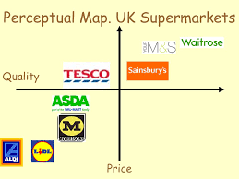
Figure 5: Competitive Positioning Map of UK Supermarkets (Price vs Quality)
Source: Adapted from Mintel (2024) and Euromonitor (2024)
Discount retailers (e.g., Aldi, Lidl) → cost leadership.
Premium retailers (e.g., Marks & Spencer) → differentiation
Mid-market retailers → balance of quality and price
Tesco occupies a middle-ground position, combining moderate pricing with moderate-to-high perceived quality. This enables wide market appeal but creates strategic vulnerability.
For example, Aldi’s consistent focus on cost leadership, supported by a limited product range and operational efficiency, contrasts sharply with Tesco’s hybrid positioning. This highlights Tesco’s vulnerability to competitors with clearer strategic identities, as consumers may perceive stronger value propositions from retailers that specialise in either low cost or premium quality. As a result, Tesco’s middle-ground positioning, while broad in appeal, may lack distinctiveness in an increasingly competitive and polarised market.
From a strategic perspective, this reflects Porter’s (1985) concept of being “stuck in the middle.” Tesco’s hybrid positioning exposes it to competitive pressure from both lower-cost and higher-quality rivals. Unlike Aldi’s clear price leadership or Marks & Spencer’s premium differentiation, Tesco relies on breadth rather than distinctiveness.
Evaluation Using Keller’s Brand Equity Model
Applying the CBBE framework highlights Tesco’s positioning effectiveness:
- Brand Salience: Tesco demonstrates strong brand awareness due to its extensive store network (Statista, 2024).
- Brand Performance: High reliability, accessibility, and product availability support functional value (Johnson, Scholes and Whittington, 2020).
- Brand Imagery: Primarily practical rather than aspirational, limiting emotional appeal.
- Brand Resonance: Clubcard enhances behavioural loyalty, but emotional attachment remains moderate (Doyle, 2012).
This suggests Tesco achieves strong functional brand equity but weaker emotional differentiation, which may limit long-term competitive advantage.
Strategic Strengths
Tesco’s positioning offers several advantages:
Broad appeal across multiple segments
Strong alignment with value-based consumer needs
Reinforcement through loyalty programmes and omnichannel access
During economic downturns, value-oriented positioning becomes particularly effective (Mintel, 2024), strengthening Tesco’s competitive resilience.
Strategic Weaknesses and Risks
However, several limitations emerge:
Price Anchoring: Heavy emphasis on price may reduce perceived quality and limit premium growth (Tybout and Calder, 2018).
Hybrid Vulnerability: Middle-ground positioning increases exposure to focused competitors (Porter, 1985).
Limited Emotional Differentiation: Weak emotional branding compared to premium retailers reduces long-term loyalty (Kotler, 2017).
These challenges indicate that Tesco’s positioning, while effective in the short term, may lack distinctiveness in an increasingly competitive market.
Overall Positioning Evaluation
Tesco’s positioning successfully supports mass-market appeal through value, accessibility, and reliability. As illustrated in Figure 5, its middle-ground position enables broad coverage but creates strategic ambiguity.

While this positioning sustains market leadership, it relies heavily on functional benefits rather than strong differentiation. To maintain long-term competitive advantage, Tesco must strengthen emotional branding, enhance premium positioning, and reduce reliance on price-based competition.
Marketing Mix Strategies (4Ps/7Ps)
The marketing mix represents the tactical implementation of segmentation, targeting, and positioning decisions (Kotler and Keller, 2016).
As illustrated in Figure 6, the 4Ps framework provides a structured approach to delivering customer value.
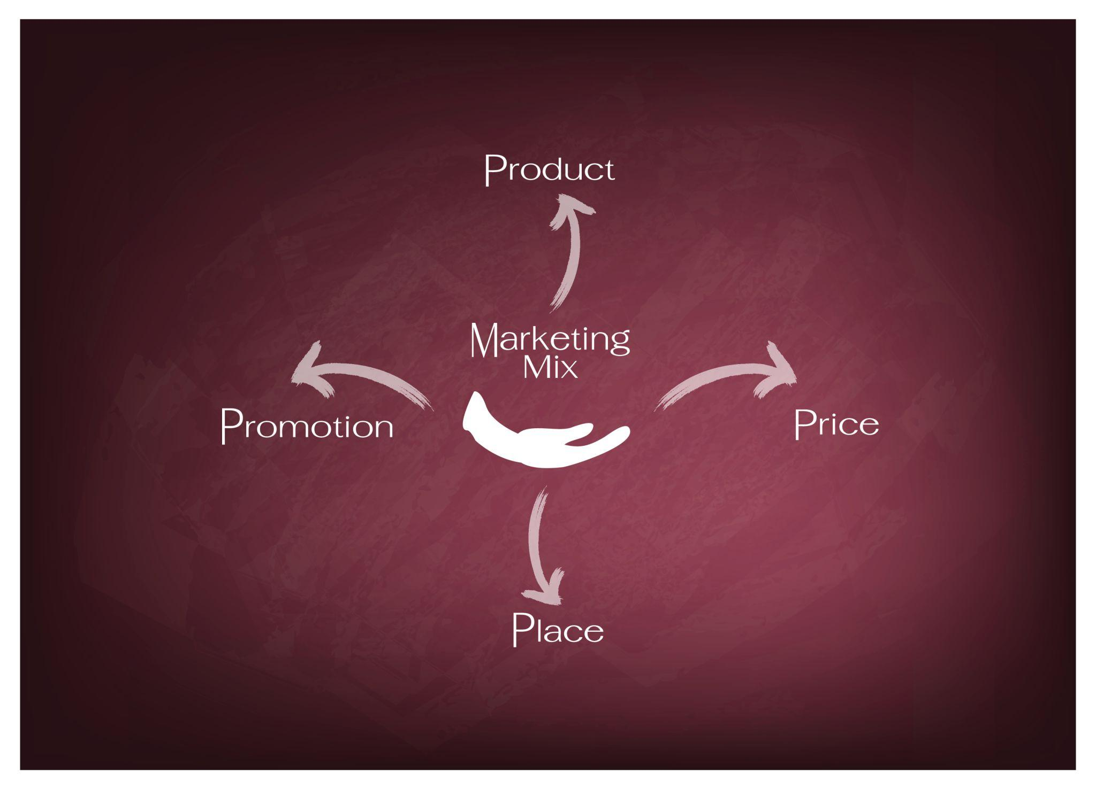

Figure 6: The Marketing Mix (4Ps) Framework (Product, Price, Place, Promotion)
Source: Adapted from Kotler and Keller (2016)
For Tesco, the marketing mix must reinforce its value-based positioning while supporting differentiated targeting across multiple segments.
Product Strategy
Tesco offers a highly diversified product portfolio, including:
- Private-label ranges (Value, Core, Finest)
- Branded goods
- Clothing (F&F)
- Financial and telecom services
This reflects a broad differentiation strategy, increasing share of wallet and reducing dependency on single categories (Grant, 2022). The tiered private-label structure aligns closely with demographic segmentation, enabling Tesco to serve price-sensitive and premium consumers simultaneously.
Product strategy is further enhanced by behavioural segmentation through Clubcard data, allowing tailored promotions based on purchasing patterns (Zhang, 2019).
However, extensive product breadth introduces operational complexity and potential brand dilution. Premium ranges risk being undermined by frequent price promotions, reducing perceived exclusivity (Keller and Swaminathan, 2020). Therefore, while Tesco’s product strategy supports market coverage, it requires careful brand differentiation to avoid internal competition.
Price Strategy
Price is central to Tesco’s competitive positioning. The company employs:
Competitive pricing
Promotional discounts
Price matching
Clubcard-exclusive pricing
This reflects a value-based pricing strategy, supported by economies of scale (Grant, 2022). The introduction of Clubcard pricing represents a shift toward data-driven price discrimination, enabling personalised offers and enhancing customer retention (Chaffey and Ellis-Chadwick, 2019).
However, excessive reliance on discounting creates several risks. Doyle (2012) argues that frequent promotions may erode brand equity and normalise lower price expectations. Additionally, price competition limits differentiation, reinforcing Tesco’s dependence on cost efficiency rather than unique value creation.
Thus, while Tesco’s pricing strategy effectively supports short-term competitiveness, it may weaken long-term brand positioning if overused. For example, Tesco’s Clubcard pricing model has been widely promoted as a way to deliver personalised value to customers. However, it has also attracted criticism for creating a perceived pricing disparity between loyalty members and non-members. This may condition consumers to rely on discounts, ultimately reducing perceived product value and reinforcing price sensitivity rather than brand loyalty
Place (Distribution) Strategy
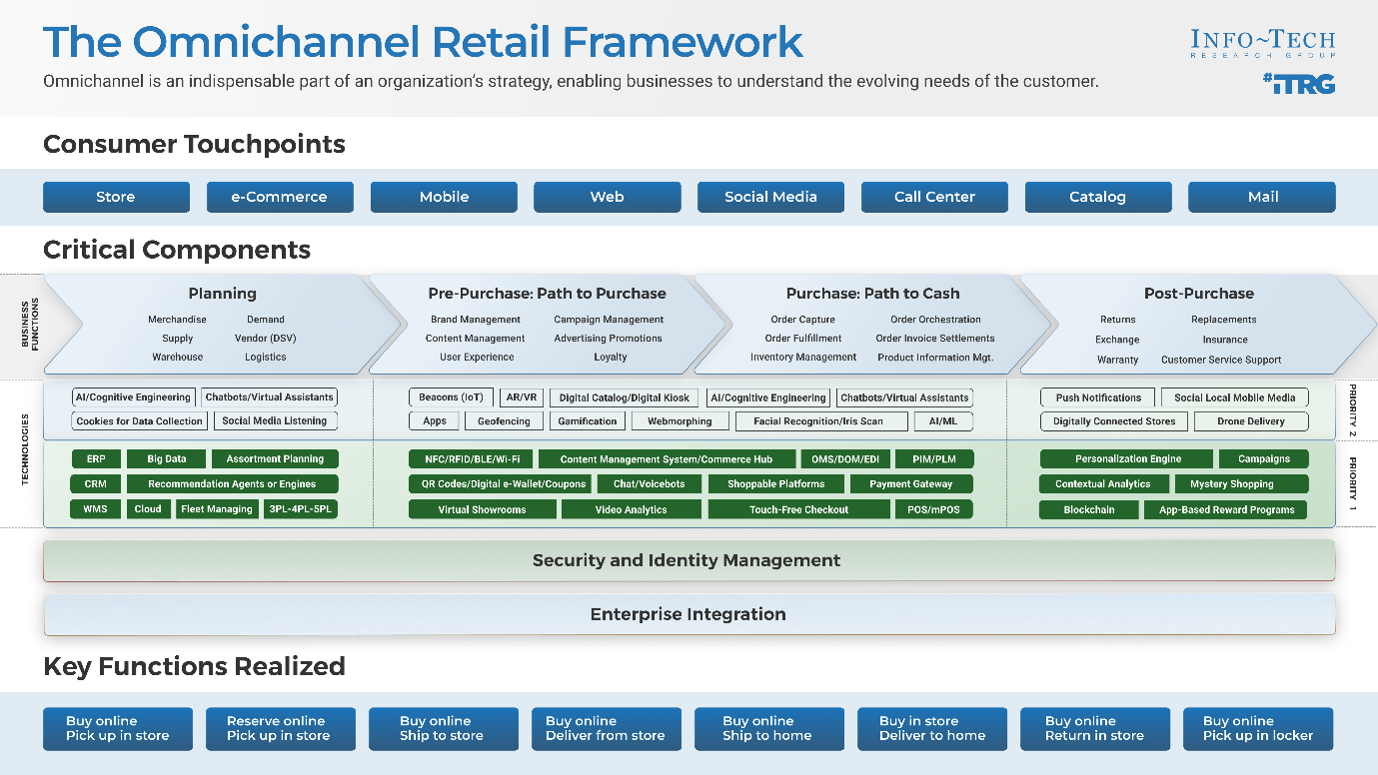
Tesco’s distribution strategy is a key competitive strength. The company operates an omnichannel model, as illustrated in Figure 7, including:

Figure 7: Tesco Omnichannel Distribution Model (Stores, Online, Click & Collect)
Source: Adapted from Chaffey and Ellis-Chadwick (2019)
- Tesco Extra (hypermarkets)
- Superstores
- Tesco Express (convenience stores)
- Online platforms and click-and-collect services
This reflects an intensive distribution strategy, maximising accessibility and supporting geographic segmentation (Kent, 2022). Omnichannel integration enhances convenience, allowing seamless interaction between physical and digital channels (Chaffey and Ellis-Chadwick, 2019).
However, this approach increases logistical complexity and cost exposure. Online fulfilment and last-mile delivery significantly raise operational costs, while large-format stores face declining footfall (Euromonitor, 2024). Consequently, Tesco must continuously optimise its store portfolio to balance accessibility with profitability.
Promotion Strategy
Tesco adopts an integrated marketing communications (IMC) approach, including:
- Television and digital advertising
- Social media campaigns
- In-store promotions
- Personalised Clubcard offers
This ensures consistent messaging across channels (Parment and Armstrong, 2021). The slogan “Every Little Helps” reinforces Tesco’s value-oriented positioning and customer-centric approach.
Promotional activity is closely linked to behavioural segmentation, with personalised offers improving targeting precision and marketing efficiency (Zhang, 2019).
However, Tesco’s promotion strategy is heavily price-focused, emphasising discounts rather than emotional engagement. Tybout and Calder (2018) argue that overreliance on rational appeals may limit brand differentiation. As a result, Tesco’s communication reinforces functional value but does not strongly enhance emotional brand attachment.
Extension to 7Ps: Service Elements
Tesco’s strategy also reflects elements of the extended marketing mix:
- People: Staff interactions influence service quality and customer satisfaction (Christopher, Payne and Ballantyne, 2016).
- Process: Self-checkout systems and mobile apps improve efficiency and convenience.
- Physical Evidence: Store layout, packaging, and digital interfaces reinforce brand perception (CIM, 2019).
These elements enhance customer experience and support Tesco’s positioning as a convenient and reliable retailer.
Overall Marketing Mix Evaluation
Tesco’s marketing mix demonstrates strong alignment with its STP strategy. As illustrated in Figures 6 and 7, product, pricing, distribution, and promotion collectively reinforce its value-based positioning and broad market coverage.
However, the strategy is heavily dependent on price competitiveness, which may limit long-term differentiation. While the marketing mix effectively supports short-term performance, future success will require greater emphasis on experiential value, premium differentiation, and emotional branding.
The strategic alignment between Tesco’s segmentation, targeting, positioning, and marketing mix decisions is summarised visually in Appendix A.
Conclusion and Strategic Recommendations
This report has critically evaluated Tesco PLC’s segmentation, targeting, positioning (STP) strategies and marketing mix within the UK grocery retail market. The analysis demonstrates that Tesco employs a sophisticated multi-dimensional segmentation approach, integrating demographic, geographic, psychographic, and behavioural variables. In particular, its data-driven behavioural segmentation through the Clubcard programme represents a key competitive advantage, enabling personalised marketing and enhanced customer retention.
Tesco’s differentiated targeting strategy supports broad market coverage and economies of scale, contributing to its market leadership. However, this approach creates structural tension between cost leadership and differentiation, increasing strategic complexity. While Tesco’s value-based positioning remains effective—particularly during periods of economic uncertainty—it lacks strong differentiation compared to both discount and premium competitors, as illustrated in Figure 5.
The marketing mix shows strong alignment with STP decisions. Product tiering supports demographic segmentation, while Clubcard pricing reinforces behavioural targeting. Tesco’s omnichannel distribution strategy (Figure 7) enhances accessibility and convenience, strengthening its competitive position. However, heavy reliance on price-based promotions risks eroding brand equity and reinforcing transactional rather than emotional loyalty.
To enhance long-term competitive advantage, several strategic recommendations are proposed. First, Tesco should strengthen premium differentiation by improving the visibility and perceived value of its Tesco Finest range, thereby enhancing brand imagery and emotional engagement. Second, the company should reduce its dependence on discount-led promotions and instead focus on value-added benefits to build deeper customer relationships. Third, continued investment in data analytics and AI-driven targeting would further improve marketing efficiency and personalisation. Finally, Tesco should elevate sustainability from a supporting initiative to a core positioning element, aligning more closely with evolving consumer values.
In conclusion, Tesco’s current strategy effectively supports market leadership through scale, accessibility, and data-driven targeting. However, future success will depend on transitioning from price-led competition toward stronger differentiation, enhanced emotional branding, and clearer strategic positioning within an increasingly polarised retail landscape.
References
- Blythe, J. and Martin, J. (2019) Essentials of Marketing. 7th edn. Harlow: Pearson.
- Booms, B.H. and Bitner, M.J. (1981) ‘Marketing strategies and organisation structures for service firms’, in Donnelly, J.H. and George, W.R. (eds.) Marketing of Services. Chicago: American Marketing Association, pp. 47–51.
- Chaffey, D. and Ellis-Chadwick, F. (2019) Digital Marketing. 7th edn. Harlow: Pearson.
- Chartered Institute of Marketing (CIM) (2019) Marketing and the 7Ps: A brief summary of marketing and how it works. Available at: https://www.cim.co.uk/media/4772/7ps.pdf
- Christopher, M., Payne, A. and Ballantyne, D. (2016) Relationship Marketing: Creating Stakeholder Value. 2nd edn. London: Routledge.
- Dibb, S. and Simkin, L. (2018) Market Segmentation: Concepts and Applications. 3rd edn. London: Sage.
- Doyle, P. (2012) Value-Based Marketing: Marketing Strategies for Corporate Growth and Shareholder Value. 2nd edn. Chichester: Wiley.
- Euromonitor (2024) Grocery Retailing in the United Kingdom. Available at: https://www.euromonitor.com
- Grant, R.M. (2022) Contemporary Strategy Analysis. 11th edn. Oxford: Wiley.
- Hague, P. (2019) Market Research in Practice. 4th edn. London: Kogan Page.
- Hooley, G., Piercy, N. and Nicoulaud, B. (2020) Marketing Strategy and Competitive Positioning. 7th edn. Harlow: Pearson.
- Johnson, G., Scholes, K. and Whittington, R. (2020) Exploring Strategy. 12th edn. Harlow: Pearson.
- Keller, K.L. and Swaminathan, V. (2020) Strategic Brand Management: Building, Measuring and Managing Brand Equity. 5th edn. Harlow: Pearson.
- Kent, T. (2022) Retailing. 4th edn. London: Bloomsbury.
- Kotler, P. (2017) Marketing 4.0: Moving from Traditional to Digital. Hoboken: Wiley.
- Kotler, P. and Armstrong, G. (2020) Principles of Marketing. 18th edn. Harlow: Pearson.
- Kotler, P. and Keller, K.L. (2016) Marketing Management. 15th edn. Harlow: Pearson.
- Lamb, C.W., Hair, J.F. and McDaniel, C. (2020) MKTG. 13th edn. Boston: Cengage.
- Mintel (2024) UK Supermarkets Market Report. Available at: https://www.mintel.com
- Parment, A. and Armstrong, G. (2021) Marketing: An Introduction. 14th edn. Harlow: Pearson.
- Porter, M.E. (1985) Competitive Advantage: Creating and Sustaining Superior Performance. New York: Free Press.
- Schiffman, L.G. and Wisenblit, J.L. (2019) Consumer Behaviour. 12th edn. Harlow: Pearson.
- Solomon, M., Bamossy, G., Askegaard, S. and Hogg, M.K. (2017) Consumer Behaviour: A European Perspective. 6th edn. Harlow: Pearson.
- Statista (2024) Market Share of Grocery Retailers in the United Kingdom. Available at: https://www.statista.com
- Tesco PLC (2024) Annual Report and Financial Statements 2024. Available at: https://www.tescoplc.com/investors/reports-results-and-presentations/
- Tybout, A.M. and Calder, B.J. (2018) Kellogg on Branding. 3rd edn. Hoboken: Wiley.
- Wilson, R.M.S. and Gilligan, C. (2019) Strategic Marketing Management. 4th edn. London: Routledge.
- Zhang, J. (2019) ‘Data analytics and retail performance’, Journal of Retail Analytics, 15(1), pp. 22–34.

Appendix A: Strategic Alignment of STP and Marketing Mix
This appendix provides a structured summary of how Tesco’s segmentation, targeting, positioning, and marketing mix strategies are aligned to support competitive advantage.
Table A1: Alignment of STP and Marketing Mix
STP Element | Strategy | Marketing Mix Application
Segmentation | Multi-dimensional (demographic, geographic, behavioural) | Tiered product ranges (Value, Core, Finest)
Targeting | Differentiated targeting across multiple segments | Personalised pricing (Clubcard), multi-format retailing
Positioning | Value-based, convenience-focused | Competitive pricing, omnichannel distribution
Behavioural Focus | Data-driven micro-targeting | Personalised promotions and loyalty rewards
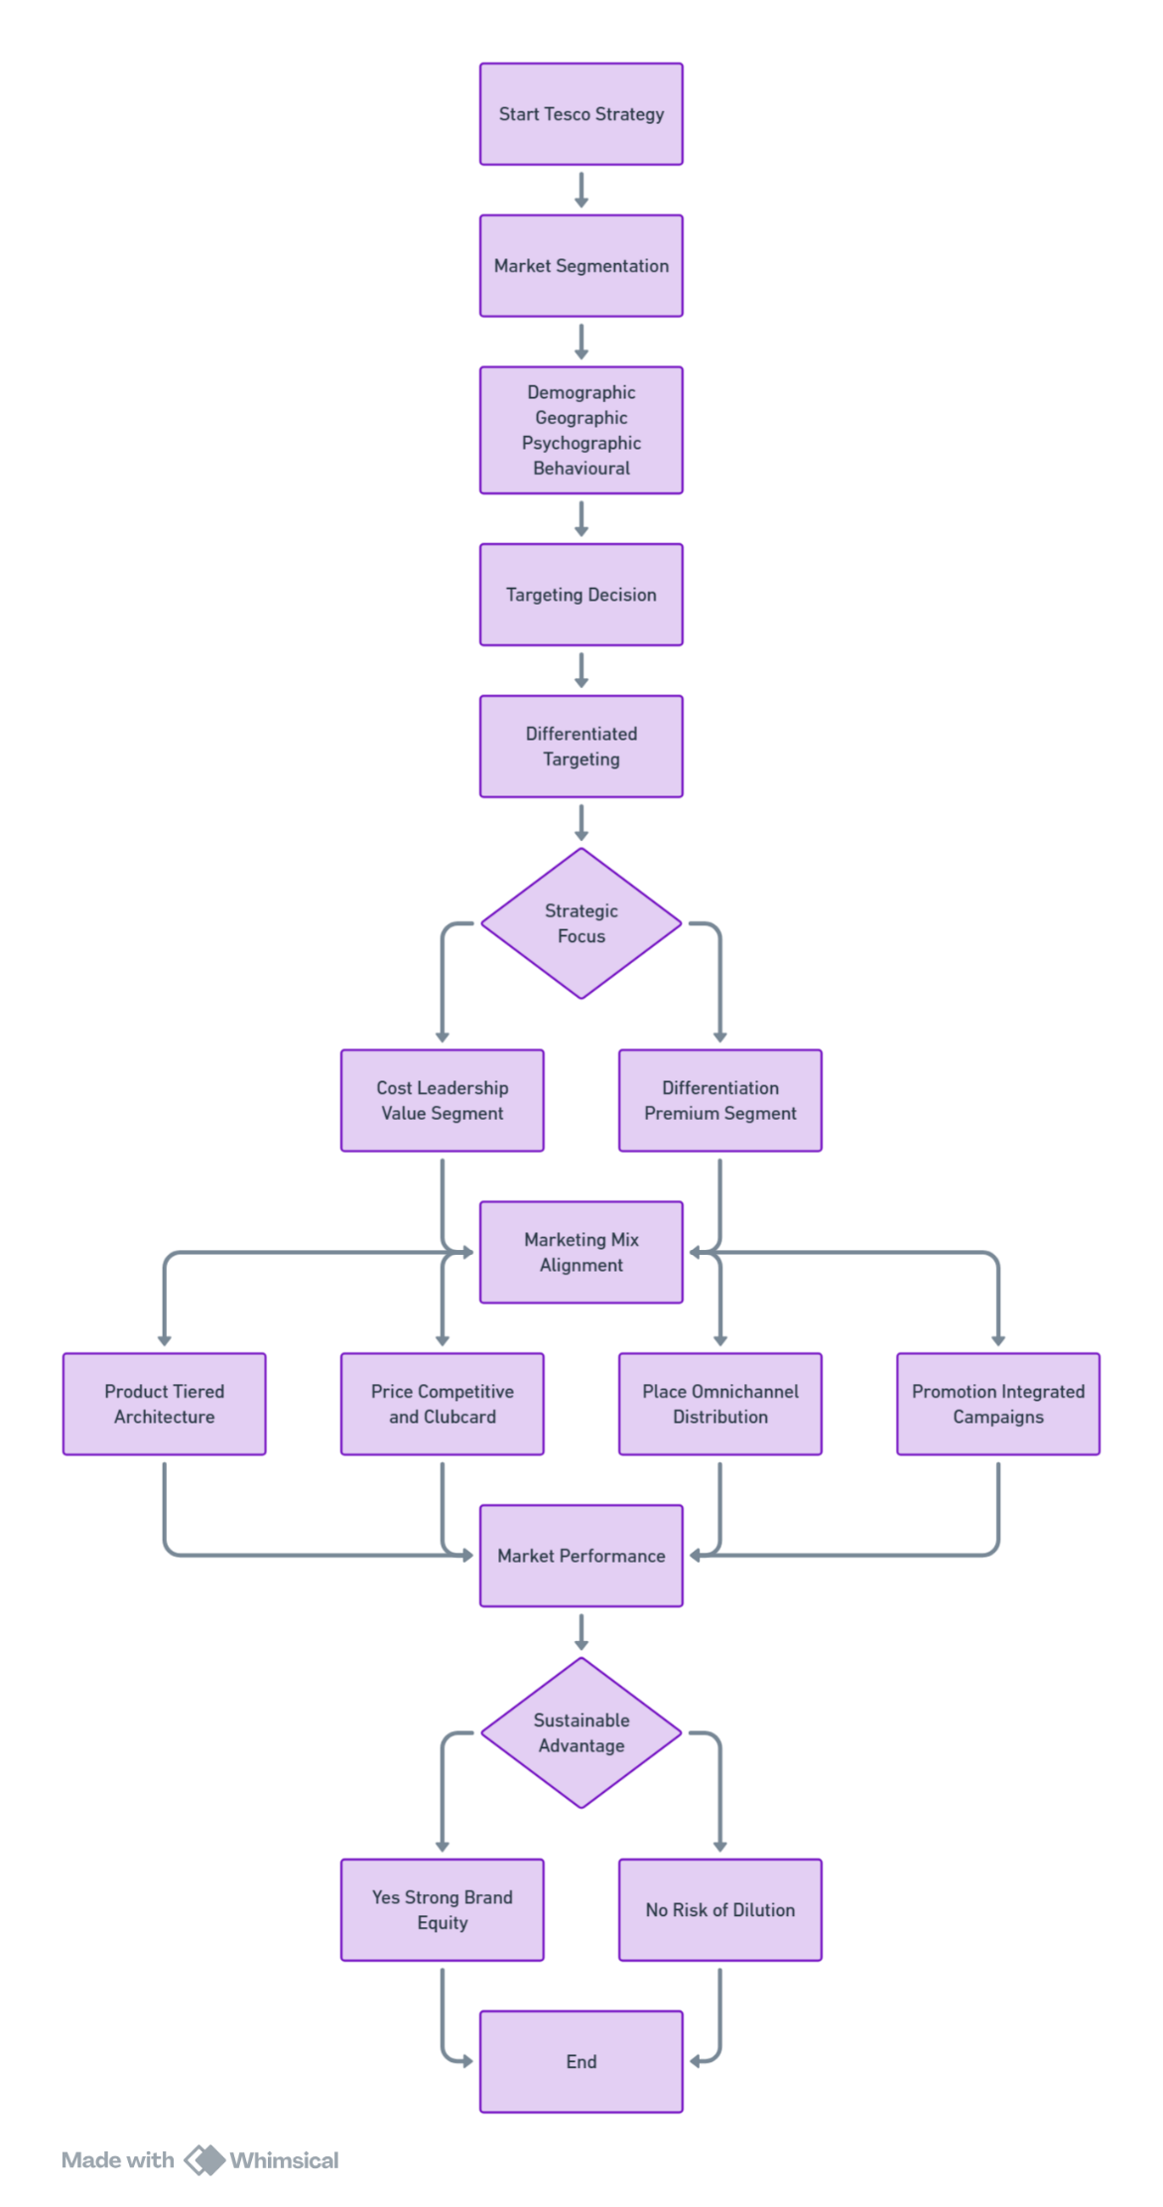

Figure 8: Strategic Alignment of STP and Marketing Mix
Source: Author’s own illustration

