Dissertation Proposal

“The Motivational Factors of Entrepreneurs in West Wales”

Business inquiry and research BMSP5007 Dr Alex Bell

Natalie Emma Male 1702161

Table of Contents

Introduction 1
Justification and literature research 2
Methodological approach 3
Planned Data Analysis and Presentation 4
Research planning and ethical considerations 5
Outcome 7
References 8

Introduction

The conceptual area for this dissertation proposal is Entrepreneurship with the working title “The motivational factors of Entrepreneurs in West Wales”. This is an area that has many innovative businesses and a high degree of sustainability, for a relatively small geographical area. Entrepreneurship is a growing field, enabling individuals to adapt to a changing economy, particularly with the current covid-19 pandemic.
This local area will enable research to be undertaken in a cost effective and simple way. However, time will be the biggest consideration in collection of the data. A previous interview with an entrepreneur in the area, provided an interesting aspect for further investigation. (Williams, 2020) stated that “I think it is because we are on the very edge of Wales, sometimes you have to make your own opportunities to live in an area if there are fewer job opportunities than there are in the cities. Also, Pembrokeshire itself is a very attractive county and so attracts certain people who perhaps get a lot of inspiration from the local area”. This interview piqued my interest in the subject area.
The research objective is to discover answers to the following questions:
Is motivation place dependant. Is sense of place for individuals a high priority in the opening of a new enterprise?
Is there a need to create opportunities to remain or return to the area?
Is motivation influenced by previous entrepreneurs in the family?
Is motivation influenced by a parent or guardians work ethic?
Do we have individuals who are able to spot an opportunity?
Does educational background have an influence on motivation?
How has the current covid-19 pandemic affected or influenced business practises?
It is likely that the questions will need to be looked at again. In order to fine tune and gain the information required. Entrepreneurship is a vast field, however for this study motivational factors are the underpinning topic. Literary investigation will assist in determining the key aspects of the study. The research will aim to interview around 10 to 15 entrepreneurs, to discover similarities in the data for interpretation. The aim of the research is to seek meaning from the data for comparison and analysis.

Justification and literature research

The research aims to discover the motivations of entrepreneurs in this geographical area. With an interest in sense of place as a prerequisite to motivational considerations. Entrepreneurship is a field of growing research interest. Many theorists have researched the motivation and characteristics, of individuals who start their own businesses. David McClelland proposed that anyone could learn to be an entrepreneur. Developing the Achievement Motivation Theory in 1967, recognising entrepreneurs need for achievement and power. He sought to discover why some societies were more economically successful than others. (Achievement motivation theory of entrepreneurship, 2020)
What makes this field most interesting is the vast difference of opinion. Many theorists believe entrepreneurship is innate and can not be learned. Although, this does not explain why many individuals that no family background in business have are able to be successful. Furthermore, if this was indeed the case then enterprise and entrepreneurship would not be a subject of study in Universities.
An empirical study by Barba-Sánchez & Atienza-Sahuquillo, (2012) using a qualitative data method by way of survey, found that there were motivational differences between the rest of the population and entrepreneurs. Furthermore, finding that motivational content does influence the start up of businesses and recognising that education plays a role of great importance. Indeed, (Room , 2020) owner of Swansea business BRD Gravity, attended a Steiner school and despite this alternative method of education stated that, Completion is innate, we are built to be competitive.
This literacy evidence supports the hypothesis that the subject field is still widely discussed and studied. With changes in sustainability new motivational factors will become present moving forwards. Entrepreneurship will continue to change and evolve, due to economic and environmental developments.

Methodological approach

There is little research of entrepreneurship in West Wales at present. The selection of an appropriate methodology is key to the quality of the research. There are both advantages and disadvantages of qualitative and quantitative methodology. Though ethical considerations remain similar. Rahman, (2017) study found that each methodology has its merits when used in the appropriate context. Determining that ethical considerations are crucial and pertinent to any research project
Qualitative data is often considered to be less scientific. Though, it can provide insights that quantitative data cannot. Quantitative data is concerned with measurement and can be statistically analyzed through numerical comparisons. There is a further ability for presentation in graphs and charts.
Quantitative data is the research methodology selected for appropriateness in this dissertation proposal. (Bazeley & Jackson , 2013) suggest that a qualitative methodology is selected in cases where a comprehensive understanding of an experience or process is required. The rationale for selecting a qualitative method, rests mainly on the subject matter and research questions. Additionally, it can be difficult to quantify areas of human behaviour. There is an element of uncertainty with this process, it is time consuming and previous experience recognizes that people change their minds and declined to be interviewed. Seeking new candidates requires additional time.
Although, the area of research is entrepreneurship, and many will wish to share their wealth of experience. Communication is likely to have been key in the development of their businesses. (du Plessis, 2014) suggests that “Entrepreneurs that fail to share information find it difficult to access appropriate knowledge therefore investment in accessing and gaining of knowledge is critical”
Quantitative research will aim to determine individuals thoughts, feelings and perspectives. It will require an interpretivist approach to seek meaning from the data. This method is open to interviewer bias, so this must be a consideration in the overall process. Ethical permission will be sought from the university. Individuals will be approached, and an ethics form and overview of the research proposal will be provided. A copy of the questions will not be provided, unless requested, keeping the subject natural and unrehearsed. Once permission has been received, a semi structured interview will be used to gain a rich insight into the individuals experiences., perspectives and opinions. (Rabionet , 2011) proposes that “There is no doubt that qualitative interviewing is a flexible and powerful tool to capture the voices and the ways people make meaning of their experiences”. An audio recorder will be used, this will ensure that the information is stored and accessible. This method ensures the interview can flow freely without trying to take notes.

Planned Data Analysis and Presentation

When all the data has been collected, it shall be transcribed in full and exact detail. In order to begin the process of analysis. The drawback to this qualitative method, is that it can be a very time-consuming task. The data will then be introduced into thematic tables, to distinguish emerging themes for interpretation. Themes are often referred to as codes. Obtaining a good number of themes, over four, is desirable. Although there is no way to determine this from the outset. The more themes that emerge shows a commonality between participants. (Mohammed Ibrahim, 2012) attains that “Thematic Analysis is considered the most appropriate for any study that seeks to discover using interpretations. It provides a systematic element to data analysis.”
Qualitative data requires deeper analysis and can go further than just identifying themes. A more comprehensive model may be sought by linking the themes, challenging generalisations and creating models, matrices and flow charts. (Bazeley, 2016)
The aim of the research is to gain answers to the proposed questions. In the hope of determining some of the key factors:
Is entrepreneurship innate as suggested by some theorists or can it be learned? In gaining an insight into entrepreneur’s background, it may be possible to determine where motivation comes from.
Does a sense of place have a factor on motivation? In an area of fewer job opportunities is the pull factor, to stay or return to the area a factor.
As suggested, does motivation have any educational consideration’s? How much of the entrepreneur’s education has assisted the success of their business? Or are they motivated from witnessing a strong work ethic?
The findings of the data will possibly support some concepts and theories whilst refuting others. New emerging themes could identify current events not considered previously, including the coronavirus and its effect on entrepreneurial practices.

Research planning and ethical considerations

Ethics will be given the highest priority in all aspects of this study. (Oliver, 2010) suggests that “It is important to consider ethical issues from the early stages of a research project. From the beginning of the design process, provisional decisions are usually taken about the nature of the research sample and of the methodology”. Participants will be well informed and are welcomed to withdraw at any time. Adults of capacity will only be considered for this study, reducing any further ethical considerations.
Confidentiality is another important consideration, though interviews are face to face, there is little oppertunity for anonymity. The safe storage of information in this case is a priority and will only be shared with the University and staff. Previously gender has proved to be a difficult variable to anticipate, where possible a representative sample of the genders will be sought. This is dependant on the number of male and female entrepreneurs available in the area.
Ethical considerations link to the covid-19 pandemic and sensitivity must be given to its future impact. Some businesses are likely to suffer, whereas others such a food outlets and cleaning are likely to thrive. (McEwan, 2020) states that “Those entrepreneurs who have developed a personal resilience will see opportunity to emerge stronger, with the pandemic threat promoting a sense of entrepreneurial enthusiasm”. Consideration must be given to this in light of any findings, adding a new dynamic to the research. Peer reviewed Journals, case studies and appropriate web information will be utilised in this literary review. They will provide underpinning knowledge and of the subject area.
With regard to sustainability, meeting the time constraints of the subjects interviewed, it is possible to use other methods of communication if acceptable. A skype call or facetime for instance is engaging face to face, however, does not require the need for travel, providing a small amount of disruption. This method may prove useful if social distancing continues. Furthermore, observation is not key in this study, this could provide a time saving solution. Where possible interviews will be conducted face to face in quiet, relaxed and comfortable environment.
There will be some travelling costs involved in the research. The aim will be to keep the budget as small as possible. In order to manage time effectively, a proposed timetable outlining all the stages of the dissertation is displayed in Image 1. The timetable has been developed using a Gant chart. Although there is a plan in place, this is likely to change and adapt throughout the process. Planning assists to maintain focus and meet deadlines.

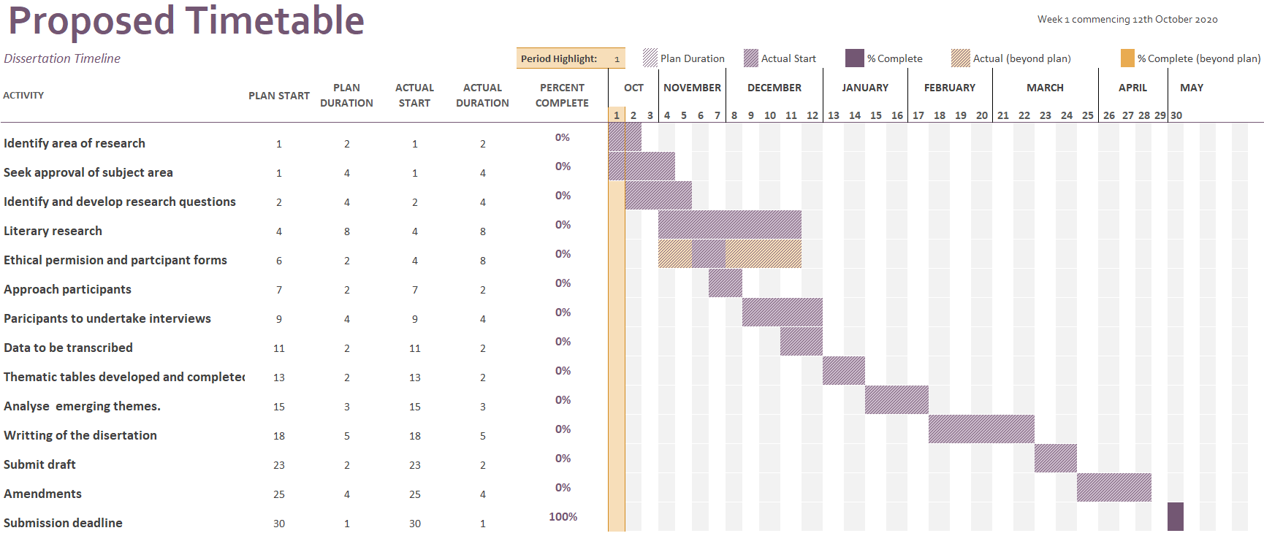

Image 1

Outcome

It is difficult to predict the outcome of the research. Planning and implementation of all stages is important to ensure good data collection and analysis. This proposed research seeks to gain answers to set questions although, it is possible that further information will emerge. This is due to the flexibility of the semi-structured interview. The qualitative study aims to give a rich insight into the background and motivations of entrepreneurs in the area. This will provide the background for further research in this field. Quantitative methodology could assist in gaining further insight and analysis, this could be considered for further or additional research.

References

Achievement motivation theory of entrepreneurship. (2020, May 19th ). Retrieved from entrepreneurshiptheories: https://entrepreneurshiptheories.blogspot.com/2017/08/need-for-achievement-achievement.html
Barba-Sánchez, V., & Atienza-Sahuquillo, C. (2012). Entrepreneurial behavior: Impact of motivation factors on decision to create a new venture. Investigaciones Europeas de Dirección y Economía de la Empresa, 132-138.
Bazeley , P., & Jackson , K. (2013). Qualitative data analysis. London: Sage.
Bazeley, P. (2016, November 1st). Analysing qualitative data: More than 'Identifying Themes'. THE MALAYSIAN JOURNAL OF QUALITATIVE RESEARCH, pp. 1-22.
du Plessis, D. J. (2014). Human Capital and Knowledge Sharing in Entrepreneurship to Enhance Competitive Advantage: Some Empirical Evidence. International Journal of Managerial Studies and Research, 47-56.
McEwan, G. (2020, May 20th). Fight or flight? An entrepreneurial response to COVID-19. Retrieved from Elevator UK: https://www.elevatoruk.com/about-us/blog/fight-or-flight-an-entrepreneurial-response-to-covid-19/
Mohammed Ibrahim, A. (2012). THEMATIC ANALYSIS: A CRITICAL REVIEW OF ITS PROCESS AND EVALUATION. West East Journal of Social Sciences, 39-47.
Oliver, P. (2010). The Student'S Guide To Research Ethics. London: Open University Press.
Rabionet , S. E. (2011). How I Learned to Design and Conduct Semi-structured Interviews: An Ongoing and Continuous Journey. The Qualitative Report, 563-566.
Rahman, M. (2017). The Advantages and Disadvantages of Using Qualitative and Quantitative Approaches and Methods in Language “Testing and Assessment” Research: A Literature Review. Journal of Education and Learning, 102-112.
Room , B. (2020, February 26th ). Guest Speaker . Entreprenaurship. Carmarthen : UWTSD.
Williams, J. (2020, March 11th ). The Pembrokeshire Beach Food Comapny. (N. E. Male , Interviewer)

