Marketing Management
Assessment 2

Student name: Nicholas Batty
Student number: 1706986
University of Wales Trinity St David
Module: SBMA7102D - Marketing Management Assessment 2
Date: 3rd August 2018
Word count excluding titles, figures and Bibliography: 2992

Contents
1 Executive Summary 3
2 Introduction 4
2.1 Company Overview 4
2.2 SWOT Analysis of Unilever 5
3 Marketing department, its development, and relationship with other departments 7
3.1 Role of the marketing department 7
3.2 Development of the marketing department 9
3.3 Relationships of the marketing department with other departments 10
3.4 Where the department fits into the organisational structure 10
4 Targeted markets for the marketing department 11
5 Appropriate media channels to be used by the department 12
5.1 TV Commercials 13
5.2 Social media 13
5.3 Websites 14
5.4 The channel that is used more than others 15
6 Measuring the success of the effectiveness of the campaigns 15
7 Conclusion 16
8 Bibliography 17

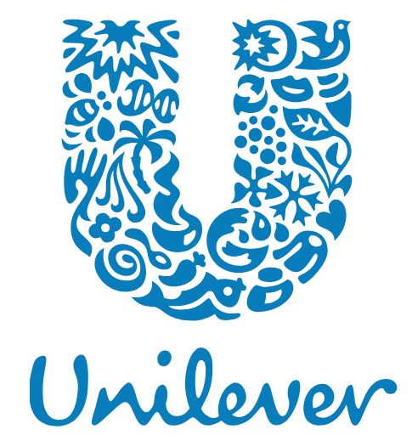
(Unilever)

Executive Summary

Unilever (www.unilever.co.uk) is among the organisations that have benefited from the unique strategies that they have implemented as a part of their operational systems. The marketing department is an essential component for Unilever’s success. Some of the department’s role include, communicating the needs of the consumers, and ensuring that an organisation through its production process meets the tastes and preferences of its customers.
The department is also tasked with roles such as the implementation of suitable marketing strategies for the organisation, management of the marketing budget and is a key contributor to the enhancement of sales for an organisation. The promotional campaign techniques that the department utilises include internet marketing, social media marketing, and TV commercials. Measuring the success of these marketing strategies is dependent on metrics such as sales targets, online traffic and market shares among others.

Introduction

The marketing strategies adopted by organisations are determinant on its market performance. Organisations around the world have relied on various techniques including TV Commercials, billboards, and newspapers in the marketing of their products and services (Purple Cow). With advancements in technology, speed, and ease of use, many organisations are adopting internet marketing, and this has been instrumental in the enhancement of their productivity (Mazurak & Tkaczyk, 2016).
Social media techniques such as Facebook and Twitter provide organisations with an opportunity to capture the attention of several potential and existing consumers, and this in return results in an increase in revenue generation. Globalisation has further enhanced the ability of organisations to promote their brands on a global platform.
In this assessment paper, a review of the roles and activities of the marketing department at Unilever Corporation will be conducted.

Organisational Overview

Unilever operates in the consumer goods sector and has its headquarters London United Kingdom, and Rotterdam The Netherlands. As a multinational corporation the organisation has operations in almost all countries around the world. It was founded on 1st January 1930, and today has more than 160,000 employees. The organisation has over the years enjoyed success in the market and this is attributed to factors such as the ability to meet the needs of its consumers, enhanced marketing techniques and hiring skilled employees. Unilever is an organisation that has specialised in the production of personal care products, food, beverages and cleaning agents among other products.

The organisation’s enhanced financial performance is evidenced by €53.715 billion it registered as revenues for the year ending 2017 and €6.486 billion as net income, representing a 3% compared to 2016 (Unilever Company, 2017, p.14). Unilever’s leadership under Marijin Dekkers as the chairman and Paul Polman as the CEO, has also been instrumental in contributing to the success that it has over the years enjoyed (Unilever, 2017a).
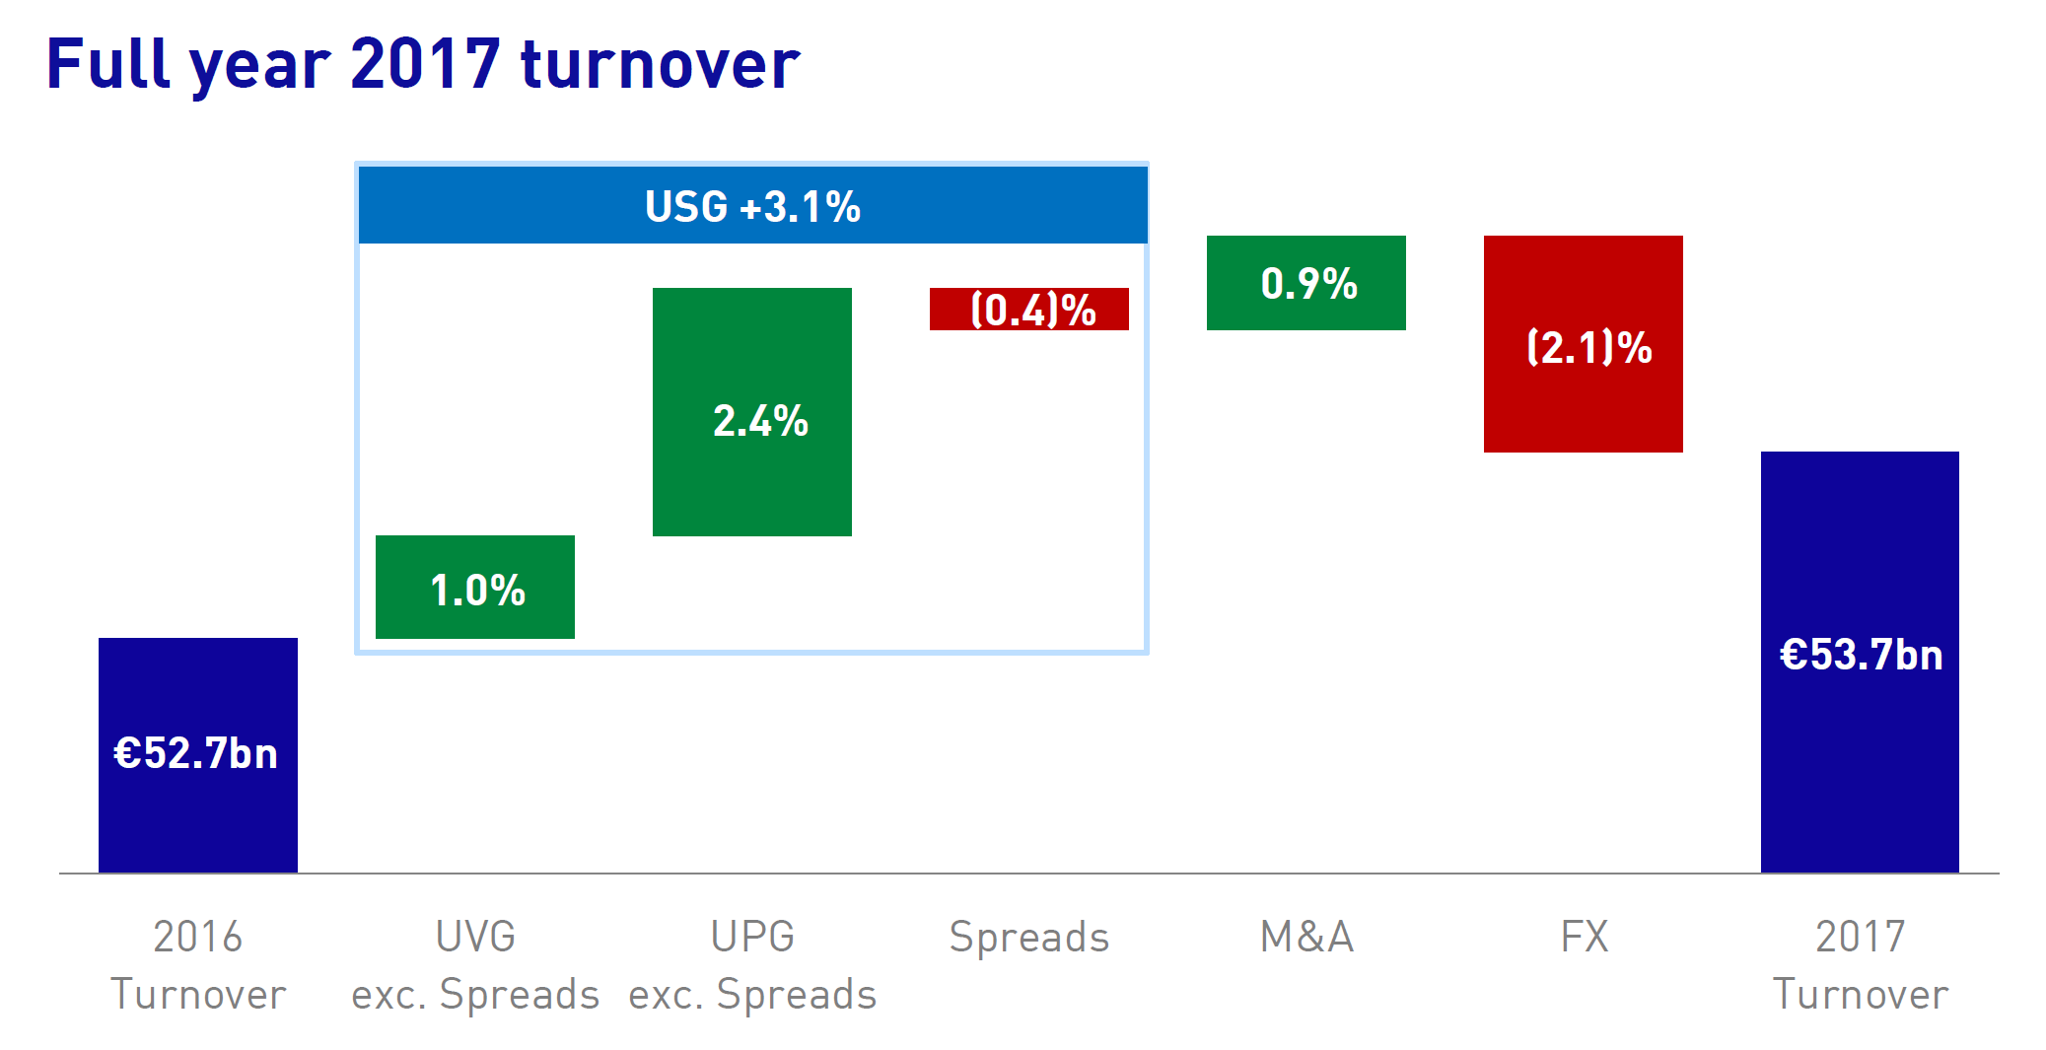
(Unilever, 2017a).

SWOT Analysis of Unilever

What is a SWOT? It’s a study performed by an organisation to identify its internal strengths and weaknesses, as well as its external opportunities and threats.
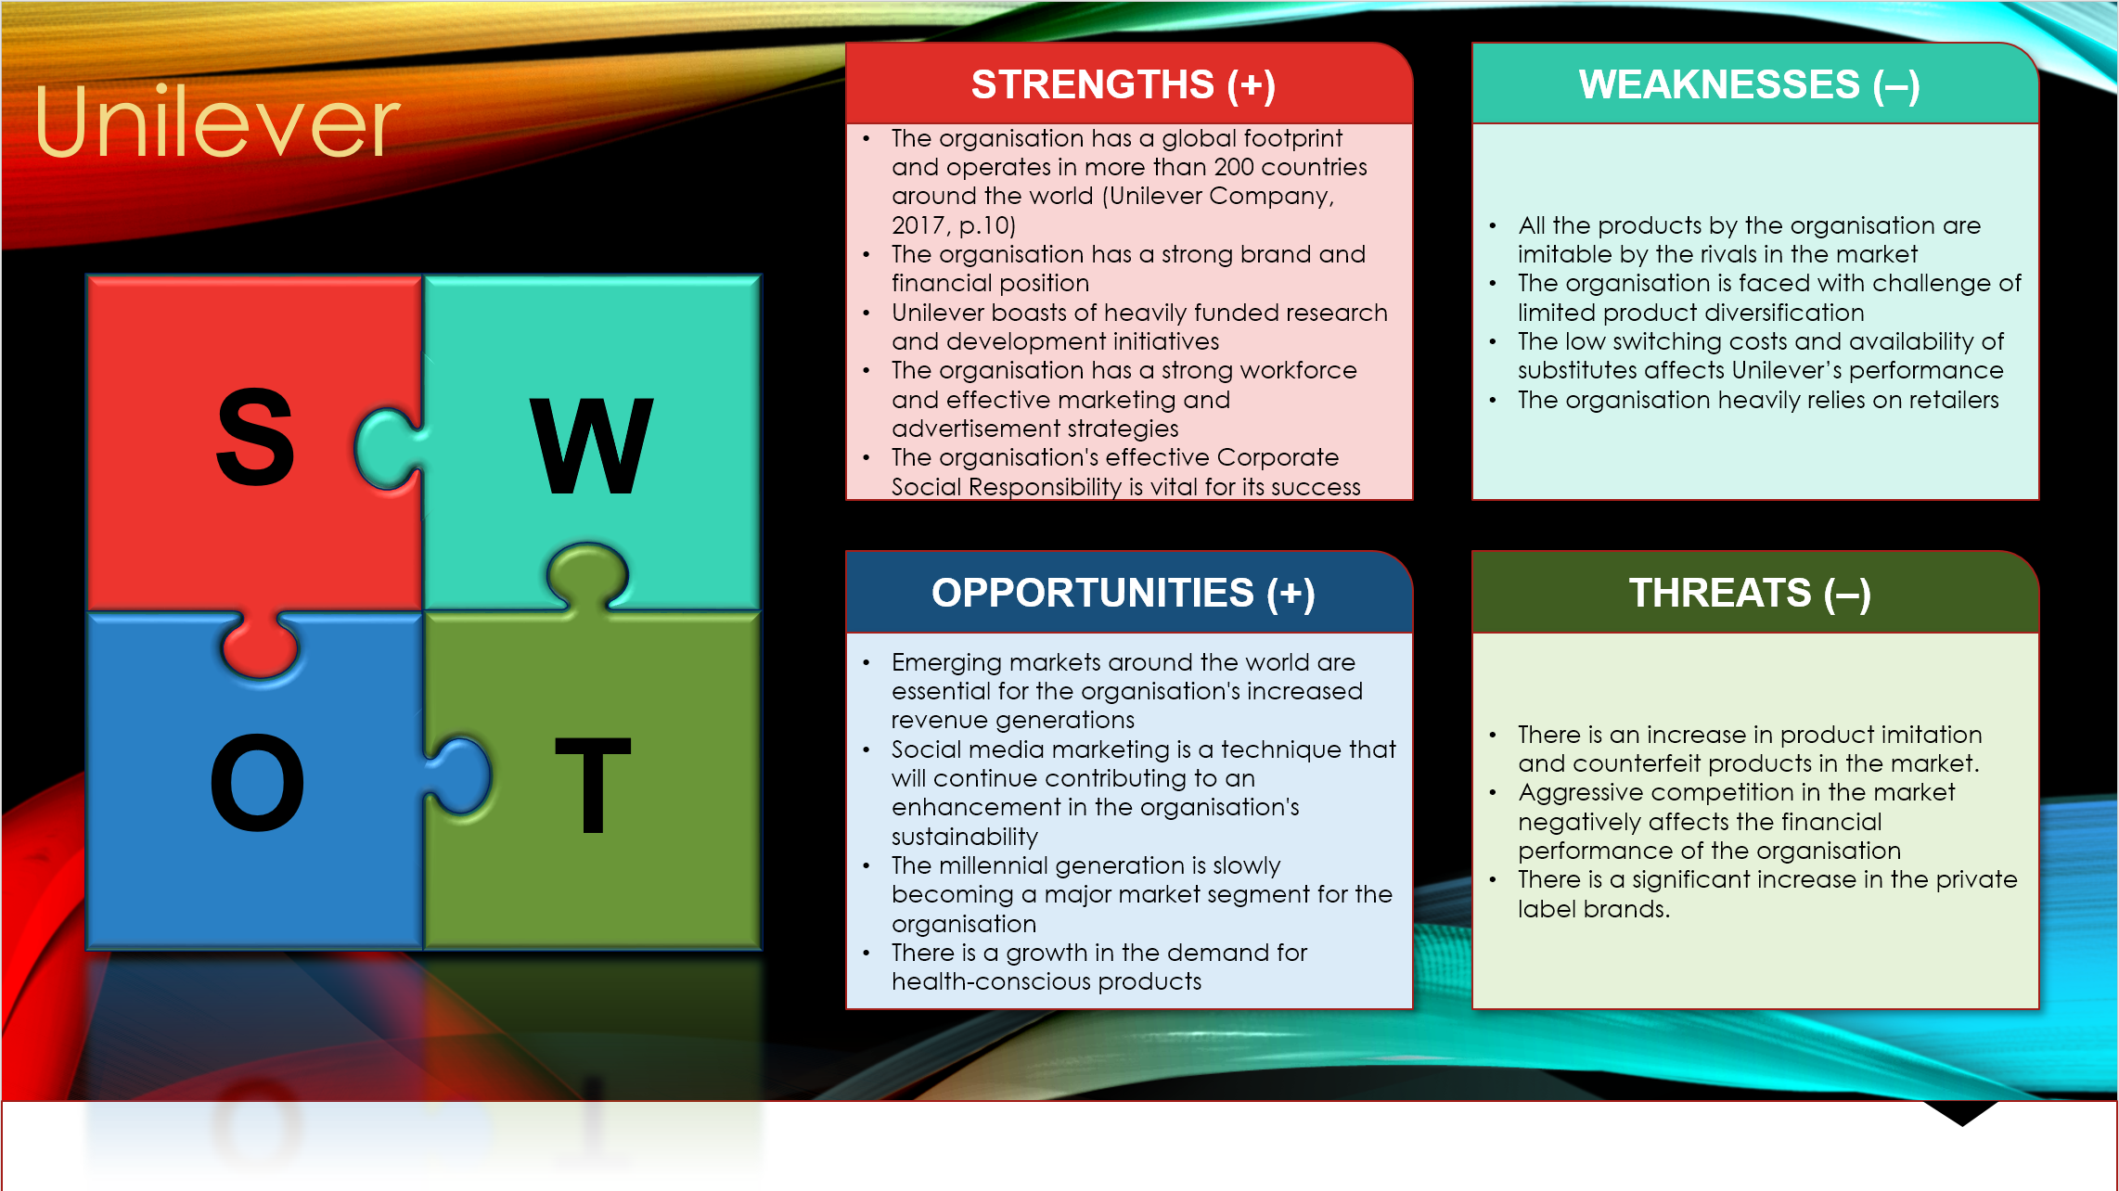
(Batty, 2018)
Strengths
- The company has a global footprint and operates in more than 200 countries around the world (Unilever Company, 2017, p.10)
- The company has a strong brand and financial position
- Unilever boasts of heavily funded research and development initiatives
- The company has a strong workforce and effective marketing and advertisement strategies
- The organisation’s effective Corporate Social Responsibility is vital for its success
Weaknesses
- All the products by the organisation are imitable by the rivals in the market
- The company is faced with challenge of limited product diversification
- The low switching costs and availability of substitutes affects Unilever’s performance
- The company heavily relies on retailers
Opportunities
- Emerging markets around the world are essential for the organisation’s increased revenue generations
- Social media marketing is a technique that will continue contributing to an enhancement in the organisation’s sustainability
- The millennial generation is slowly becoming a major market segment for the company
- There is a growth in the demand for health-conscious products
Threats
- There is an increase in product imitation and counterfeit products in the market
- Aggressive competition in the market negatively affects the financial performance of the organisation
- There is a significant increase in the private label brands

Marketing department, its development, and relationship with other departments

Role of the marketing department

The marketing department is an instrumental component of the Unilever’s organisational structure. One of the major roles of the marketing department is to listen to the needs of the consumers and in the process; produce goods and services that meet their tastes and preferences.
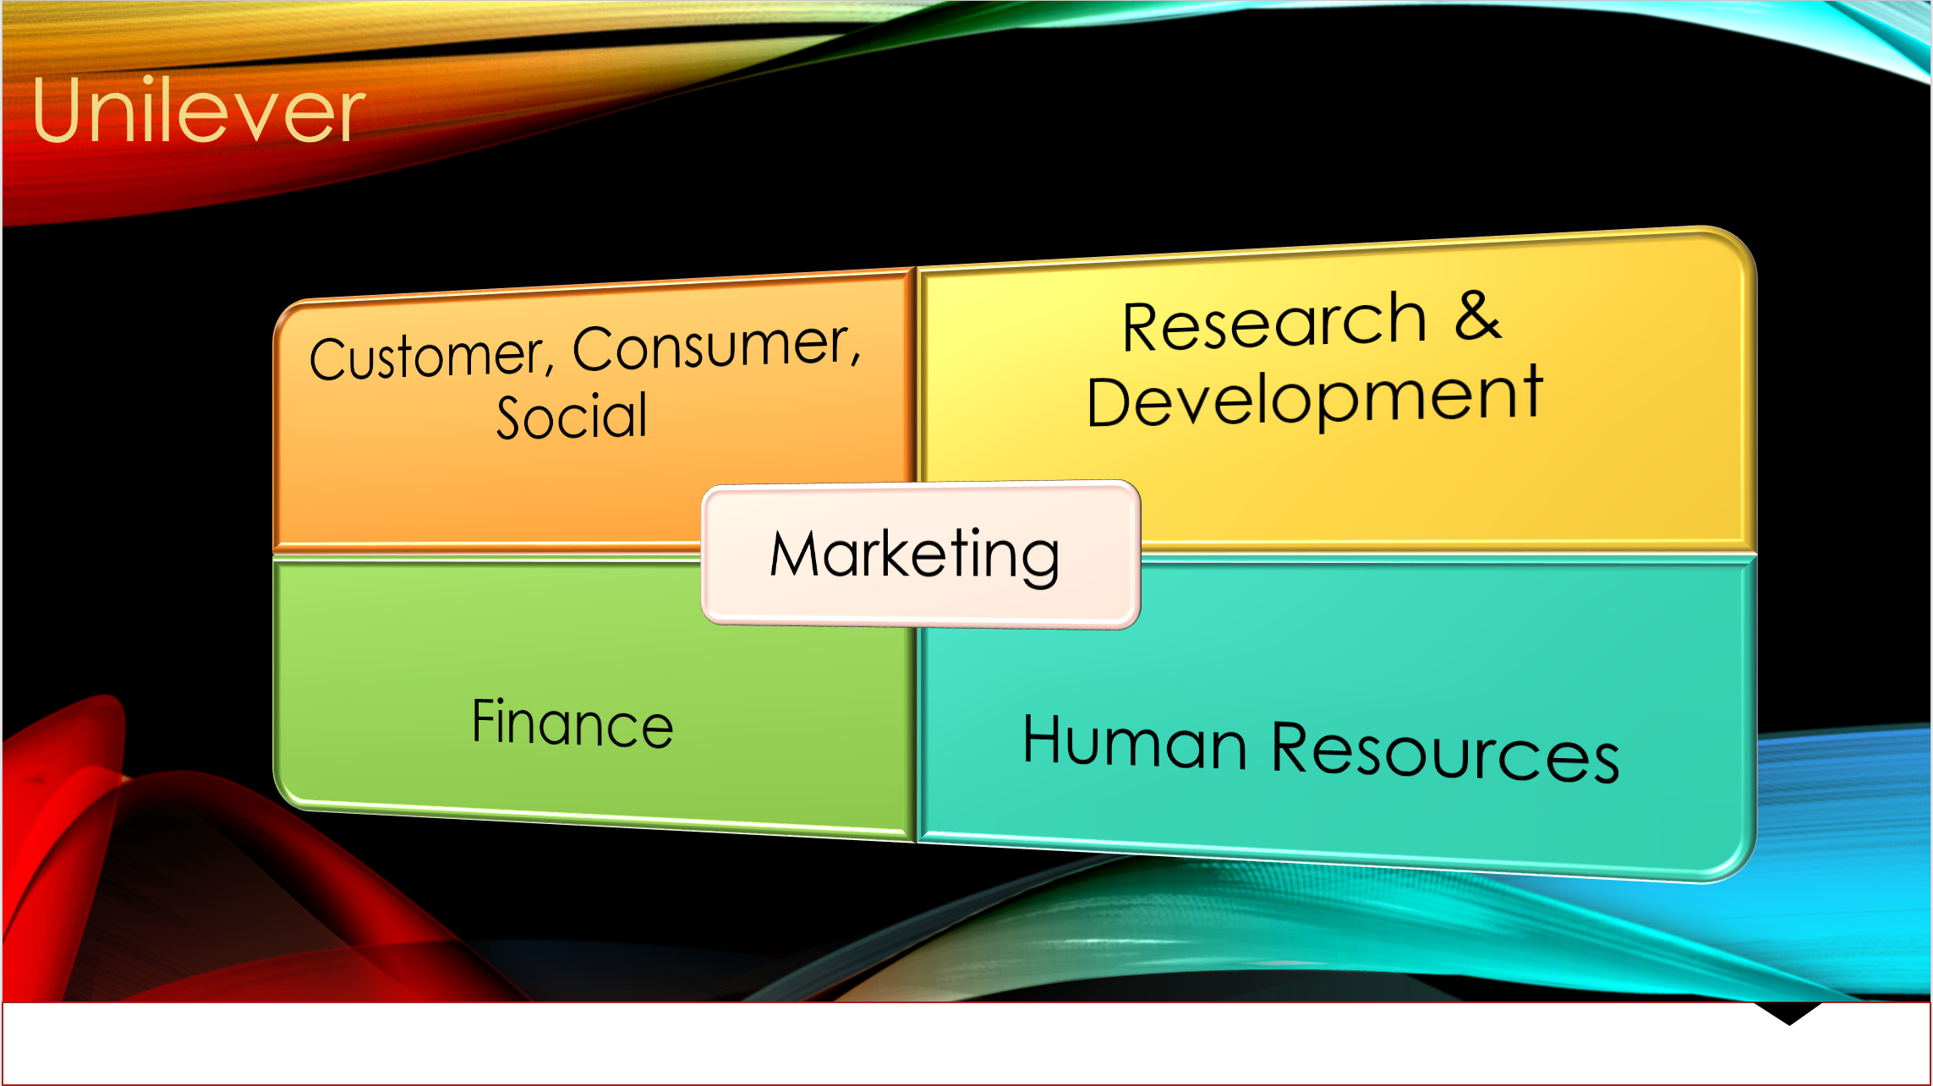
(Batty, 2018)
The department ensures that it plans, creates and implements the feedback channels that it will adopt in interacting with the customers (Jeannet and Hennessey, 2016, p.90). Through social networks, for instance, Unilever has bolstered its ability to understand the grievances and the needs of the existing and potential customers. The marketing department at Unilever is tasked with the role of tracking trends and identifying the levels of competition in the market. Some of the organisation’s major competitors include Nestle, PepsiCo, and Reckitt Benckiser. By monitoring the trends and competition levels, the department identifies those areas of weakness that it can improve, therefore a SWOT is important. Additionally, the organisation implements suitable strategies that will give it a competitive edge over the rival organisations in the market. Another role of the marketing department within Unilever is to define the strategic marketing plans and implement innovative marketing techniques. The department ensures the strategies it adopts improves its sales and sustainability (Ansoff, 2014, p.32). Collaboration with the finance department plays a major role in ensuring that the unit effectively manages its marketing budget. In the past five years, Unilever’s sales have been on the increase and this is attributed to the efforts of the marketing department. The marketing department of Unilever communicates its brand values, and this is made possible through the creation of images and ideas that are effective for the organisation. This contributes to the strengthening of brand awareness, thus an enhancement in its sales. The department is also mandated with the role of producing internal communication through newsletters and emails. Subsequently, this strengthens the employees’ understanding of visions and goals. In the past, the department has also been involved in the creation of content that provides search engine optimisation for Unilever’s websites. The SEO (Search Engine Optimisation) is essential in that it enhances consumers’ accessibility to the organisation’s websites, thus an increase in traffic that is generated (Aspers, 2013, p.67). Additionally, the department is tasked with the role of managing the organisation’s social media platforms by regularly updating content and information (Kaminow and Griffith, 2014, p.43). Subsequently, this has been essential in the enhancement of Unilever’s sales and revenue generation.

Development of the marketing department

Unilever’s marketing department has undergone evolution across the years and is currently one of the most vital components within the organisation. During the company’s foundation in the 1930s, the company lacked a marketing department. However, in the 1940s, the inclusion of the marketing division was the beginning of the organisation’s fruitful years. In the 50s, TV commercials were the main channels for marketing and advertisement and it is still applicable today. With the introduction of advanced technology in the 90s, the marketing department at Unilever enjoyed immense growth in terms of its performance (Unilever Company, 2017, p.20). The department ensured that its employees went through regular training and this in return led to an enhancement in its productivity.
The onset of the internet age in the early 2000s further bolstered the department, and this led to a significant increase in the revenues of Unilever. In the modern day, the organisation has also adopted social media marketing, and this has played a major role in the growth of its performance. It is evident that the evolution witnessed in the marketing department has been instrumental in contributing to the successes it currently enjoys.

Relationships of the marketing department with other departments

The marketing department at Unilever has a direct relationship with various other departments within the organisation. Firstly, the department works with the finance division in ensuring that the budget allocated for promotional activities is sufficient. With the support of the finance division, the marketing department effectively manages its budget, when allocating funds to various resources (Brigham, 2018, p.52).
The department also has a strong relationship with the Human Resource (HR) department. HR selects skilled and qualified sales and marketing staff during various recruitments that it conducts (Hill and Hult, 2011, p.18). Moreover, the training programs that are held by the marketing department are facilitated by the HR department. The collaboration between the HR department and the marketing department is essential in that it bolsters performance. Another department that has a close relationship with the marketing department Research and Development (R&D) (Toma and Marinescu, 2015, p.420). R&D provides the marketing department vital information on matters pertaining to the levels of competition in the market, the type of marketing strategies to embrace in various consumer segments, and customer needs. The relationship between the R&D and the marketing department is essential in that it contributes to the strengthening of Unilever’s competitiveness over the competitors in the market.

Where the department fits into the organisational structure

In Unilever’s organisational structure, the marketing department falls on the middle-layer level of the hierarchy. The department is categorised as a vital component of the organisation and is essential for the successes that it has over the years recorded. Unilever is focused on meeting the needs of its consumers while at the same time expanding its market segment. This is a goal that is driven by the marketing department (Kerin, 2015, p.80). In the quest for ensuring that the marketing department is fully functional, the accounting and finance department continually injects funds into it and offers expert financial advice where the needs arise.

Targeted markets for the marketing department

The marketing department at Unilever is focused on meeting the tastes and preferences of various consumers in the market. In this section, I will focus on the department’s targeted audience and the measures that it has adopted in meeting its goals.
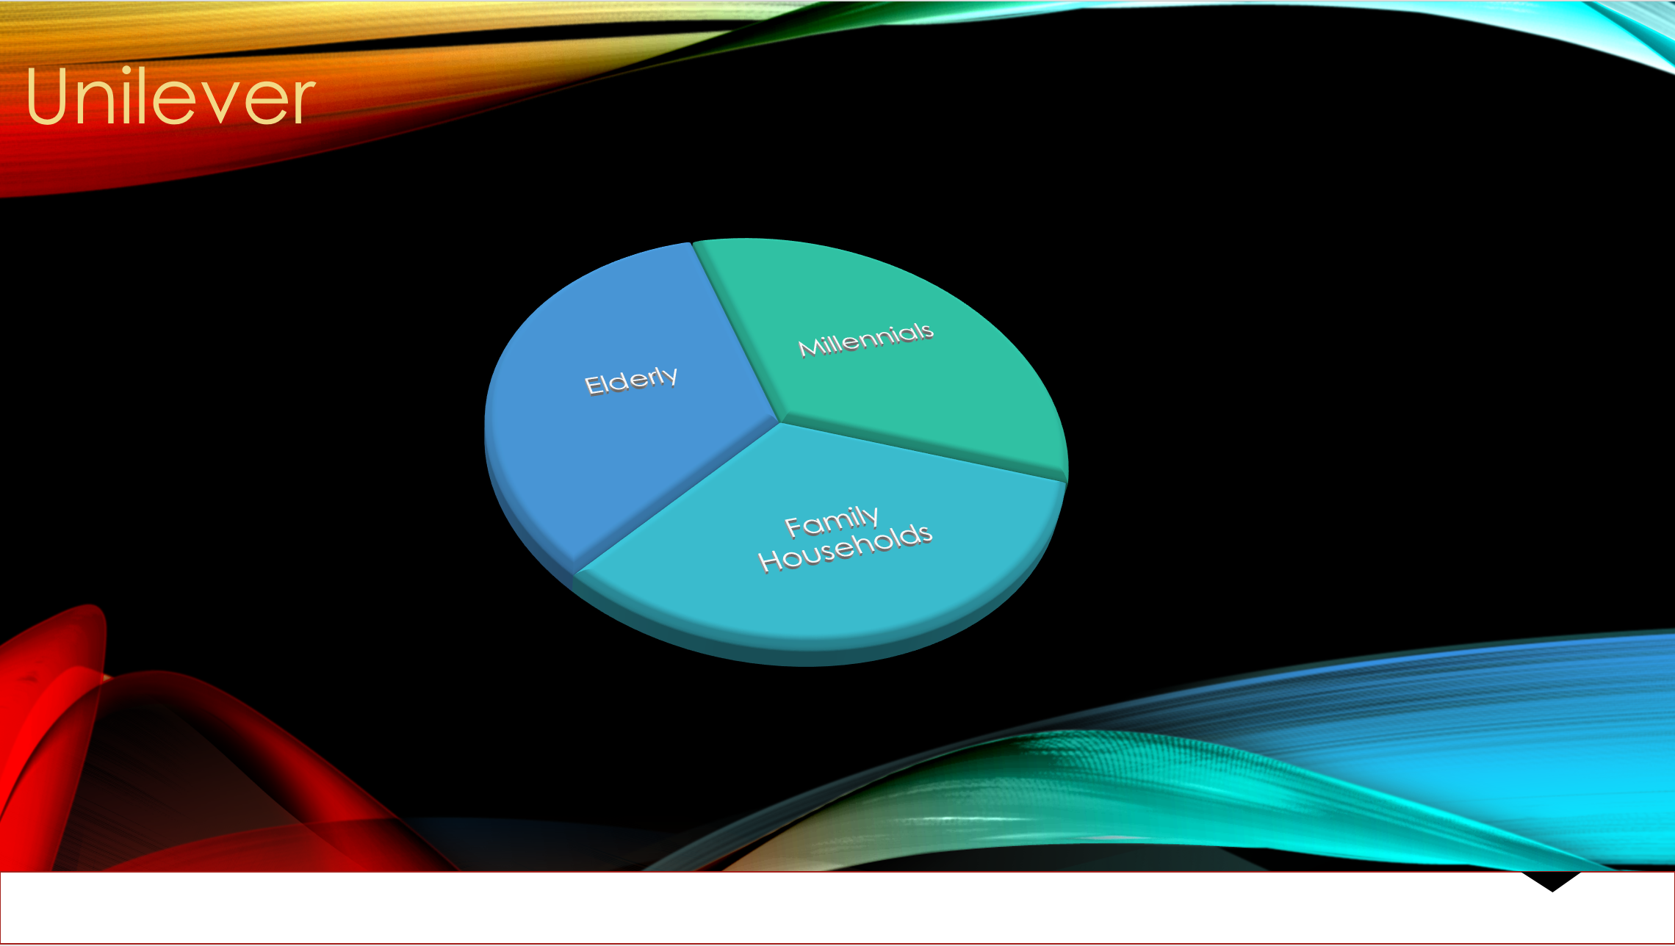
(Batty, 2018)
- Millennials: Millennials are an instrumental component of the marketing department plan. The department has in the past been on the forefront in advising the company to continue diversifying on its products and this aimed at ensuring that the millennial is also a key beneficiary. By relying on social media platforms such as Facebook and Twitter, the company has effectively managed to capture the attention of this audience (Pearce and Robinson, 2018, p.102). The department is in the process of implementing more strategies that will bolster its relations with the millennial. Subsequently, this will contribute to an enhancement of its sales. According to Forbes (2017), Unilever has the millennials’ attention.
- Family households: Another major targeted audience for the marketing department is the family households. Unilever produces various products that are consumed by families around the world. The marketing department will create various marketing and promotional strategies that will effectively capture the attention of family households (Belch and Belch, 2014, p.14). One of the marketing channels that the department will have to embrace in convincing families to purchase products from the organisation, is TV commercials.
- Elderly: The marketing department will also be interested in capturing the attention of the elderly. Unilever produces a range of skin care products and foods that are good for this targeted audience. Marketing channels such as TV Commercials, Newspapers and radios will be vital in communicating information about the organisation’s products to the elderly (Bejan and Errera, 2014, p.80).

Appropriate media channels to be used by the department

There are various media channels that the marketing department will have to embrace in the communication of information both internally and externally.
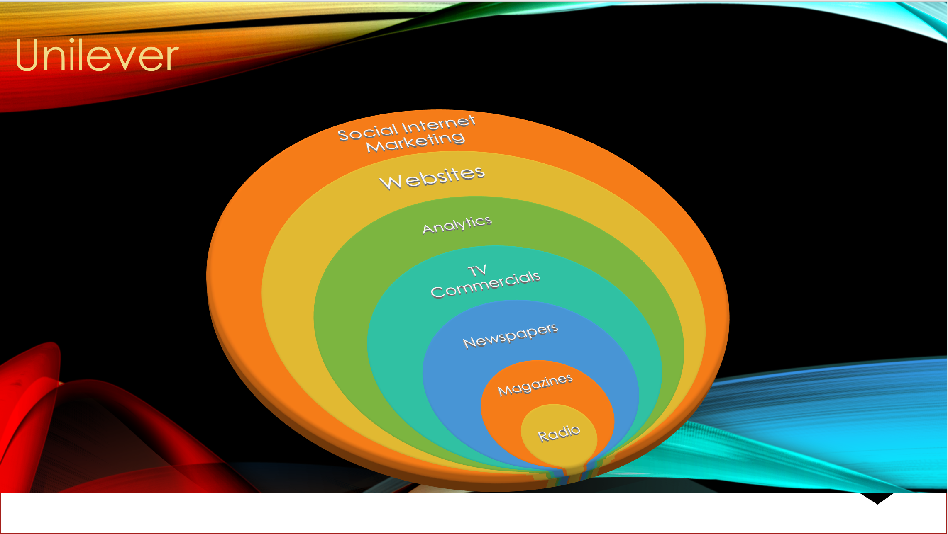
(Batty, 2018)

TV Commercials

The marketing department will have to rely on TV commercials for communicating externally. Around the world, estimated 85% of the households have access to television, and this makes it one of the most appropriate marketing and advertising techniques (Ryan and Jones, 2014, p.13). Unilever has over the years relied on TV Commercials in the marketing of its products and it has proven to be a success.

By depending on the media channel, the marketing department will effectively capture the attention of targeted audience such as the elderly and families (Ryan and Jones, 2014, p.13). TV commercials tend to be very expensive and the department will have to allocate adequate funds for this form of marketing technique.

Social media

Unilever is among the organisations around the world that have not been left behind when it comes to the reliance on social media marketing. The organisation’s marketing department is in the process of strengthening its application of the media channel in communicating both internally and externally. Some of the platforms that the department already applies, include Facebook, Twitter, and Instagram.
Social media platforms have billions of users worldwide. This means that the marketing department, by relying on the technique, can effectively capture the attention of consumers around the world (Ramahi, 2011, p.13).
The department will have to ensure that it conducts regular updates on the platforms pertaining to products and services. There are various benefits that the marketing department has in the past and will in the future continue creating from the dependence on social media as a channel for communication. Firstly, the platform allows the department to capture the attention of a large audiences, and this is attributed to billions of users that use social media (Sheehan, 2012, p.85). This media channel is less costly, unlike TV commercials.

Websites

Websites are forms of communication channels that are applied by various organisations around the world. The popularity of websites has been strengthening by the ever-advancing technological levels. Unilever has websites that it uses in communicating with its employees and consumers. The marketing department, in the quest for enhancing its relationship with the targeted audience, will have to rely on the organisation’s website (Teich, 2013, p.17). The department will have to restructure the website in such a way that consumers will freely access it and learn about the various products that are offered by the organisation through its various online stores around the world. The department will regularly update their website with information such as the company’s existing, new products, and the offers on the various commodities (Bambara and Allen, 2018, p.30).
Additionally, the department will outsource IT experts that will redesign the website in such a way that it will have an additional tool for a 24-hr customer care personnel (Bailey, 2014, p.33). In the event of any grievances or burning questions, the consumers will utilise the website in contacting the customer care personnel.

The reliance by the marketing department on websites as a mode of communication comes along with various benefits. It will significantly strengthen the relationship that Unilever has with its consumers and this will in return result in an expansion of the organisation’s market segments. The website will also be used by the department for internal communication, and this will strengthen the levels of collaboration among the various departments within the organisation.

The channel that is used more than others

With the advancements in the levels of technology, the marketing department relies on internet marketing as compared to other channels such as TV commercials and newspapers. The excessive dependence on the internet marketing is attributed by the fact that it effectively captures the attention of various consumers in the market (Booker, 2016, p.120). This results in an increase in the revenues that are generated by the company.

Measuring the success of the effectiveness of the campaigns

The marketing department at Unilever relies on various metrics in measuring the success of the marketing techniques that it adopts.
- Increase in traffic: Online traffic is one of the metrics that the marketing department utilises in the measuring the success of its campaigns. A significant increase in the online traffic is an indication that the promotional campaigns that are adopted by the marketing department have effectively captured the attention of consumers in the market (Lynch, 2018, p.80).
- An increase in the market share: Market share is one of the key components that the marketing department relies in the determination of the success of its promotional campaigns. Unilever has increased significantly, and this is an indication that the marketing strategies adopted by the marketing department such as social media and websites have been effective in increasing the organisation’s sales (Johnson et al 2017, p.92).
- Brand development: Another metric that is applied by organisations in the measuring of the success of its promotional campaigns. Unilever’s brand is one of the strongest around the world compared to its rivals and this is majorly attributed to the various strategies that it has adopted (Vandenberg, 2013, p.3). It is evident that the marketing department is on the right path when it comes to the promotional campaigns it has adopted.
- Sales target: Sales target is one of the major metrics that are used by organisations in the determination of the success of its marketing strategies (Blakeman, 2007, p.45). The ability of an organisation to meet its sales targets is an indication that the promotional campaigns it has adopted are effective and vital to its growth. Unilever’s sales in the past two years implies that the marketing techniques it has incorporated are superb.

Conclusion

The marketing strategies that are adopted by an organisation are key determinants of its success either in the long-term or short-term. Over the years, Unilever has enjoyed enhanced market sustainability and revenue growth in the consumer goods sector, and this is partially attributed to the promotional campaigns that its marketing department has adopted. There are various marketing channels that the marketing department at Unilever has embraced in the communication of information to the targeted audience. These include websites, social media marketing, and TV Commercials. In the quest for measuring the success of a promotional campaign, some of the metrics that the departments rely on include brand development, an increase in online traffic, sales target and the market share of the company.

Bibliography

Amason, A., (2018).
Strategic management. New York: Routledge.

Ansoff, H. (2014).
Strategic management. [Place of publication not identified]: Palgrave Macmillan.

Aspers, P. (2013).
Markets. New York, NY: John Wiley & Sons.

Bailey, A., (2014).
12 Ways to provide innovation. Training Journal, 3(4), pp.17-21

Bambara, J. and Allen, P. (2018).
Blockchain. New York: McGraw-Hill Education.

Bejan, A. and Errera, M. (2014).
Technology evolution, from the constructal law: heat transfer designs. International Journal of Energy Research, 39(7), pp.919-928.

Belch, G., and Belch, M. (2014).
Advertising and promotion (10th ed.). McGraw-Hill.

Blakeman, R., (2007).
Integrated marketing communication: Creative strategy from idea to implementation. Lanham, Md.: Rowman & Littlefield.

Booker, M., (2016).
The Business. London: MaxCrime.

Brigham, E., (2018).
Fundamentals of Financial Management. [S.L.]: South-Western.

Forbes (2017) – Jeff From, 31/01/17 - How Unilever Is Winning With Millennials And Gen Z
https://www.forbes.com/sites/jefffromm/2017/01/31/how-unilever-is-winning-with-millennials-and-gen-z/#7f9b492952fd
Last accessed: 02/07/18

Hill, C. and Hult, G. (2011).
Global business today. 4th ed.

Jeannet, J. and Hennessey, H. (2016).
Global marketing strategies. Boston: Houghton Mifflin.

Johnson, G., Whittington, R., Scholes, K. and Pyle, S., (2017).
Exploring strategy. Harlow: Pearson Education Limited.
Kaminow, I. and Griffith, J. (2014).
Internet technology. 5th ed. [Washington, D.C.]: Congressional Research Service, The Library of Congress.

Kerin, R. (2015). Marketing (1st ed.).
New York: McGraw-Hill/Irwin.

Lynch, R. (2018).
Strategic management. Harlow, United Kingdom: Pearson Education.

Mazurek & Tkaczyk, (2016).
Grzegorz Mazurek & Jolanta Tkaczyk – The Impact of the digital world in Management and Marketing.
Kozminski University Warsaw 2016 – ISBN 978-8389437-66-2

Pearce, J., and Robinson, R. (2018).
Strategic management (14th ed.). Boston, Mass.: McGraw-Hill.

Pride, W. (2017).
Foundations of business. New york: Cengage learning.

Purple Cow.
Traditional Marketing vs. Contemporary Marketing
https://www.purplecowagency.com/traditional-marketing-vs-contemporary-marketing
Last accessed: 12/06/18

Ramahi, W. (2011).
E-Marketing- Industrial Products Internet Marketing- Research Paper. SSRN Electronic Journal.

Ryan, D. and Jones, C., (2014).
Understanding digital marketing. London: Kogan Page.

Sheehan, B., (2012).
Online Marketing. Lausanne: AVA Academia.

Teich, A. (2013).
Technology & the future. Boston, Mass.: Wadsworth Cengage Learning.

Toma, S. and Marinescu, P., (2015).
Global Strategy: The Case of Nissan Motor Company. Procedia Economics and Finance, Volume 6, pp.418-423.

Unilever Company. (2017).
Unilever Company 2017 Annual Report. Company Review.
https://www.unilever.com/Images/unilever-annual-report-and-accounts-
2017_tcm244-516456_en.pdf
Last accessed: 02/07/18

Unilever, (2017a) – Unilever Full year 2017 results
https://www.unilever.com/Images/ir-q4-results-presentation_tcm244-515320_en.pdf
Last accessed: 28/06/18

Unilever – About us.
https://www.unilever.co.uk/about/who-we-are/our-history/
Last accessed: 21/06/18

Vandenberg, R. (2013).
Organizational Research Methods: Yearly Update. Organizational Research Methods, 14(1), pp.3-5.

