Prepared for:
Rhodri Thomas

Programmes
Project Planning
Date Completed: 16th April 2024

Word Count: 2624 + Gantt Chart

Luke Hunt
Table of Contents
1.0 - Plans and Elevations for project 2
2.0 - Method Statement 1 – Excavation 4
3.0 – Method Statement 2 – Substructure 6
4.0 - Method Statement 3 - Superstructure 9
5.0 – Critical Path 12
5.1 – Gantt Chart 13
6.0 - Site Specific Report for Time 14
6.1 - Site specific Report for Cost 15
6.2 - Site Specific Report for Resources 17
7.0 - References 19

1.0 - Plans and Elevations for project

Planning consent has been permitted for a developer to begin work on a new development in Hendrefoilan, Swansea. This section of the new development consists of 15 new build timber frame houses with external brick cladding.
Figure 1 shows the floor plans and site elevation plans, whilst Figure 2 and Figure 3 shows an existing and proposed site location plan of the development.
This piece of work will provide method statements for three major activities that relate to this project, including the excavation, sub-structure, and super-structure in order to identify major section of the critical path for this development.
There will also be a detailed breakdown of work structure from start to completion, providing time, cost and resource breakdowns and reports for the developer.

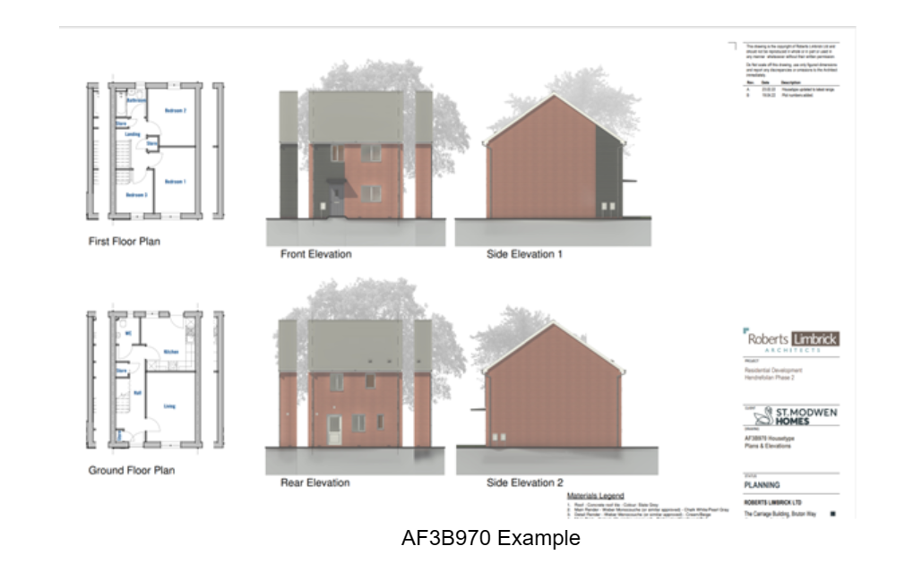
Figure 1 (2024)

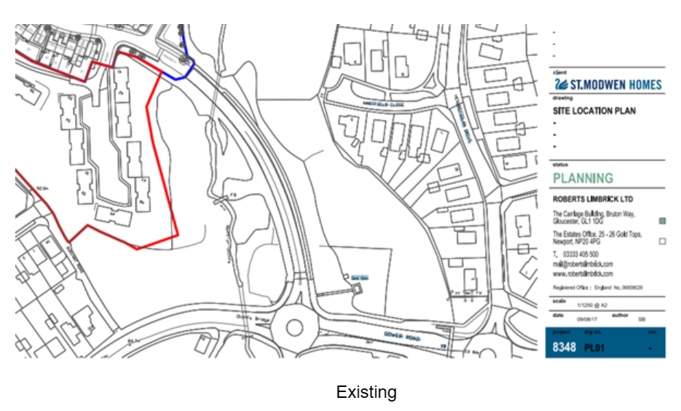
(2024)

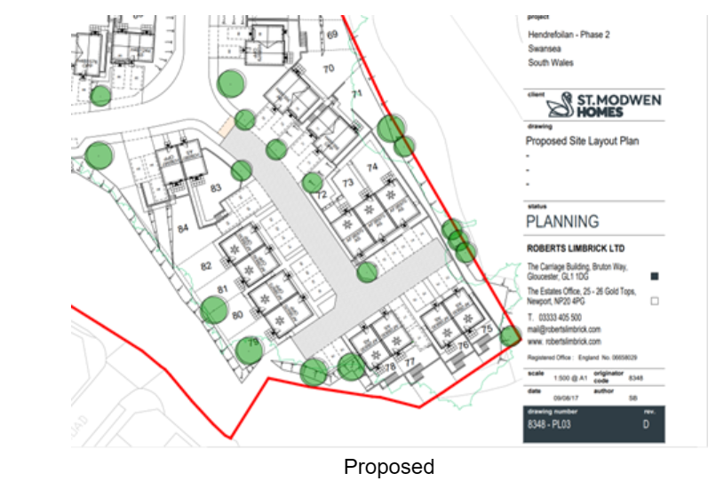
(2024)

- Method Statement 1 – Excavation
Objective – The purpose of the Method Statement is to give a breakdown of the excavation phase of construction. This objective aims to discuss the procedures, safety measures and quality control when implementing the project (2019).
Scope – The method statement ensures that all excavation activities for the residential buildings such as site preparation, excavation, soil management, and safety precautions are covered (2019).
Responsibilities:
- The site engineer will ensure that activities on site are implemented correctly using the method statement.
- The excavation work will be carried out under the supervision of the site engineer.
- Safety measures will be adhered to on site throughout the excavation process, all under the supervision of safety officers.
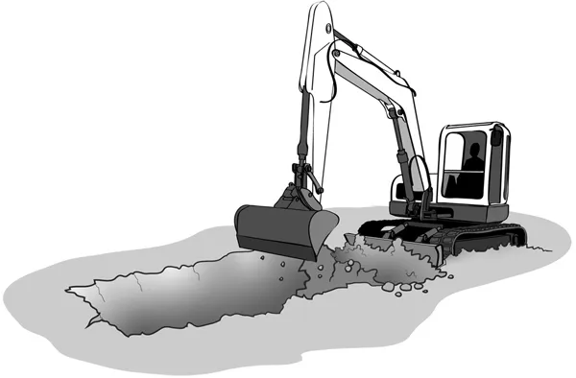
Materials and Equipment:
- Excavation equipment - excavators, backhoes
- Surveying equipment - total station, leveling instruments
- Shoring and bracing materials (if needed)
- Safety signage and barriers
- Personal protective equipment (PPE) for workers - hard hats, gloves, safety boots (2019)

Methodology

- Site Preparation:
- Clear the construction site of any debris, vegetation, or obstructions.
- Mark the boundaries of the excavation area according to the construction drawings.
- Erect safety barriers and signage around the excavation area to prevent unauthorised access.
- Ensure that utilities such as gas, water, and electricity are properly located and marked before excavation begins. (2024)

- Excavation:
- Mobilise the excavation equipment to the site and ensure it is in good working condition.
- Excavate the soil to the required depth and dimensions as specified in the construction drawings.
- Excavate in layers if necessary, taking care to maintain the stability of the excavation walls.
- Use sloping or benching techniques as required to prevent cave-ins and ensure worker safety.
- Regularly inspect the excavation for stability and integrity throughout the process.
- Stockpile excavated soil in designated areas for reuse or disposal as needed. (2023)

- Soil Management:
- Classify excavated soil according to its type and characteristics (clay, sand, rock).
- Stockpile soil of similar types separately to facilitate reuse or disposal.
- Dispose of excess soil in accordance with local regulations and environmental guidelines.
- Ensure that soil stockpiles are located away from the excavation area and do not pose a hazard to workers or the public. (2024)

- Safety Precautions:
- All personnel involved in excavation work must wear appropriate PPE, including hard hats, gloves, and safety boots.
- Excavator operators must be trained and competent in operating the equipment safely.
- Barricades, warning signs, and lights must be installed around the excavation area to alert workers and the public to potential hazards.
- Regular inspections must be conducted to monitor the stability of excavation walls and detect any signs of instability or collapse.
- Emergency procedures must be established and communicated to all personnel in case of accidents, cave-ins, or other emergencies.

- Quality Control:
- Regular inspections will be conducted to ensure that excavation work is carried out according to the construction drawings and specifications.
- Any deviations or discrepancies must be reported and addressed promptly to maintain the integrity of the excavation. (2024)

- Environmental Considerations:
- Excavation activities must be carried out in a manner that minimizes environmental impact, including erosion control measures and proper disposal of excavated soil.
- Spills or leaks of hazardous materials must be contained and cleaned up promptly to prevent contamination of soil or water sources.

- Communication:
- Effective communication among project team members is essential to ensure that excavation work proceeds smoothly and safely.
- Any changes or updates to the excavation plan must be communicated promptly to all relevant personnel.

- Approval:
- This method statement must be reviewed and approved by the project manager and safety officer before excavation work commences.

3.0 – Method Statement 2 – Substructure

Objective – The purpose of the Method Statement is to give a breakdown of the Substructure phase of construction. This objective aims to discuss the procedures, safety measures and quality control when implementing the project.
Scope – This method statement covers the construction activities related to the substructure, including excavation, footing installation, foundation wall construction, waterproofing, and backfilling.

Responsibilities:
- The site engineer will ensure that activities on site are implemented correctly using the method statement.
- Construction workers will carry out the construction activities according to the specified procedures.
- Safety officers will ensure that all safety measures are adhered to throughout the process.

Materials and Equipment:
- Excavation equipment - excavators
- Concrete
- Reinforcement bars - rebar
- Formwork
- Waterproofing materials - membranes, coatings
- Compaction equipment - compactors, rollers
- Surveying equipment - total station, leveling instruments

Methodology (2024)

- Footing Installation:
- Prepare the excavation area by removing any loose soil and debris.
- Install formwork for the footings according to the specified dimensions and alignment.
- Place and secure reinforcement bars within the formwork as per structural drawings.
- Pour concrete into the formwork, ensuring proper compaction and consolidation.
- Level and finish the concrete surface to the required specifications.
- Allow the concrete to cure adequately before proceeding to the next step. (2024)

- Foundation Wall Construction:
- Install formwork for the foundation walls, taking care to ensure proper alignment and bracing.
- Place and secure reinforcement bars within the formwork as per structural drawings.
- Pour concrete into the formwork, ensuring proper compaction and consolidation.
- Regularly check the alignment, level, and verticality of the foundation walls during pouring.
- Remove formwork after the concrete has cured sufficiently.
- Waterproof the exterior surface of the foundation walls using appropriate materials and methods.

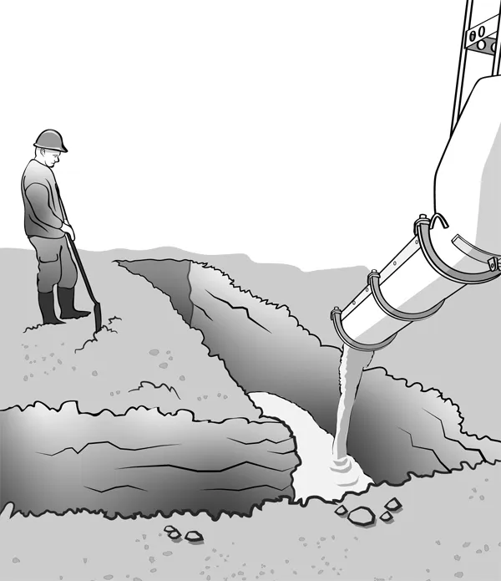
- Waterproofing:
- Apply a waterproofing membrane or coating to the exterior surface of the foundation walls.
- Ensure that all joints, corners, and penetrations are properly sealed to prevent water infiltration.
- Inspect the waterproofing application for any defects or deficiencies and address them promptly.

- Backfilling:
- Backfill the excavated area around the foundation walls with suitable fill material.
- Compact the backfill material in layers to achieve the required density and stability.
- Ensure proper drainage around the foundation to prevent water accumulation.
- Grade the backfilled area to direct surface water away from the building.

- Safety Measures:
- All personnel must wear appropriate personal protective equipment (PPE) such as hard hats, gloves, and safety boots.
- Excavation work must be conducted in accordance with relevant safety regulations and guidelines.
- Adequate shoring and support systems must be in place to prevent cave-ins.
- Confined space entry procedures must be followed when working in excavations.

- Quality Control:
- Regular inspections will be conducted to ensure compliance with construction drawings and specifications.
- Concrete quality and placement must meet the required standards and specifications.
- Waterproofing materials must be applied according to manufacturer guidelines and industry best practices.

- Environmental Considerations:
- Construction activities must be carried out in a manner that minimizes environmental impact, including proper waste disposal and erosion control measures.

- Emergency Procedures:
- In case of emergencies such as cave-ins or accidents, all personnel must evacuate the site immediately and follow established emergency procedures.
- First aid kits and emergency response equipment must be readily available on site.
- Communication:
- Effective communication among project team members is essential to ensure smooth coordination of activities and timely resolution of issues.

- Approval:
- This method statement must be reviewed and approved by the project manager before implementation. (2024)

4.0 - Method Statement 3 - Superstructure

Objective – The objective of this method statement is to outline the procedures, safety measures, and quality controls to be followed during the construction of the superstructure for the residential buildings.

Scope – The method statement ensures that all construction activities for the residential buildings such as erection of timber frame walls, installation of timber roof trusses, fixing of timber floor joists, application of sheathing and insulation, roof installation, window and door fitting, and interior wall framing.

Responsibilities:
- The site engineer will ensure that activities on site are implemented correctly using the method statement.
- Workers will carry out the construction activities according to the specified procedures.
- Safety officers will ensure that all safety measures are adhered to throughout the process.

Materials and Equipment:

- Timber frames and components.
- Roof trusses
- Floor joists
- Nails, screws, and fasteners
- Sheathing boards
- Insulation materials
- Power tools
- Ladders and scaffolding
- Personal protective equipment (PPE)

Methodology (2024)

- Site Preparation:
- Ensure the construction site is clear of debris and obstructions.
- Set up safety barriers and signage to demarcate the work area.
- Check weather conditions and postpone work if conditions are unfavourable. (2024)

- Erection of Timber Frame Walls:
- Lay out the wall positions according to the construction drawings.
- Assemble timber frame panels on the ground.
- Lift and secure panels into position using appropriate lifting equipment.
- Plumb and brace the walls to ensure stability.
- Install temporary bracing until roof trusses are in place.

- Installation of Roof Trusses:
- Position roof trusses according to the design specifications.
- Secure trusses in place using appropriate fixings.
- Ensure trusses are aligned and spaced correctly.
- Install bracing and temporary supports as required.

- Fixing of Timber Floor Joists:
- Lay out floor joists according to the floor plan.
- Fix joists in position using nails or screws.
- Ensure joists are level and securely attached to supporting walls.

- Application of Sheathing and Insulation:
- Attach sheathing boards to exterior timber frame walls using appropriate fixings.
- Install insulation material between timber studs.
- Seal joints and penetrations to prevent air leakage.

- Health and Safety:
- All workers must wear appropriate PPE, including hard hats, safety glasses, gloves, and steel-toe boots.
- Ensure all power tools are used by trained personnel following manufacturer's instructions.
- Use caution when working at heights and ensure proper fall protection measures are in place.
- Regularly inspect scaffolding and ladders for stability and integrity.
- Maintain good housekeeping practices to minimize trip hazards and clutter.

- Quality Control:
- Conduct regular inspections to ensure timber frame components are installed according to specifications.
- Check for proper alignment, spacing, and fastening of timber members.
- Inspect sheathing and insulation for proper installation and coverage.

- Environmental Considerations:
- Minimize waste generation by optimizing timber cuts and recycling excess materials.
- Properly dispose of waste materials in designated areas.
- Implement erosion control measures to prevent soil erosion and sediment runoff.

- Emergency Procedures:
- Ensure all workers are familiar with emergency procedures, including evacuation routes and assembly points.
- Keep firefighting equipment readily accessible and regularly maintained.

- Communication:
- Maintain open communication channels between workers, supervisors, and subcontractors.
- Conduct regular toolbox talks to discuss safety, quality, and progress updates.

- Completion:
- Upon completion of superstructure works, conduct a final inspection to ensure compliance with design specifications and quality standards.
- Obtain sign-off from the client or relevant stakeholders.

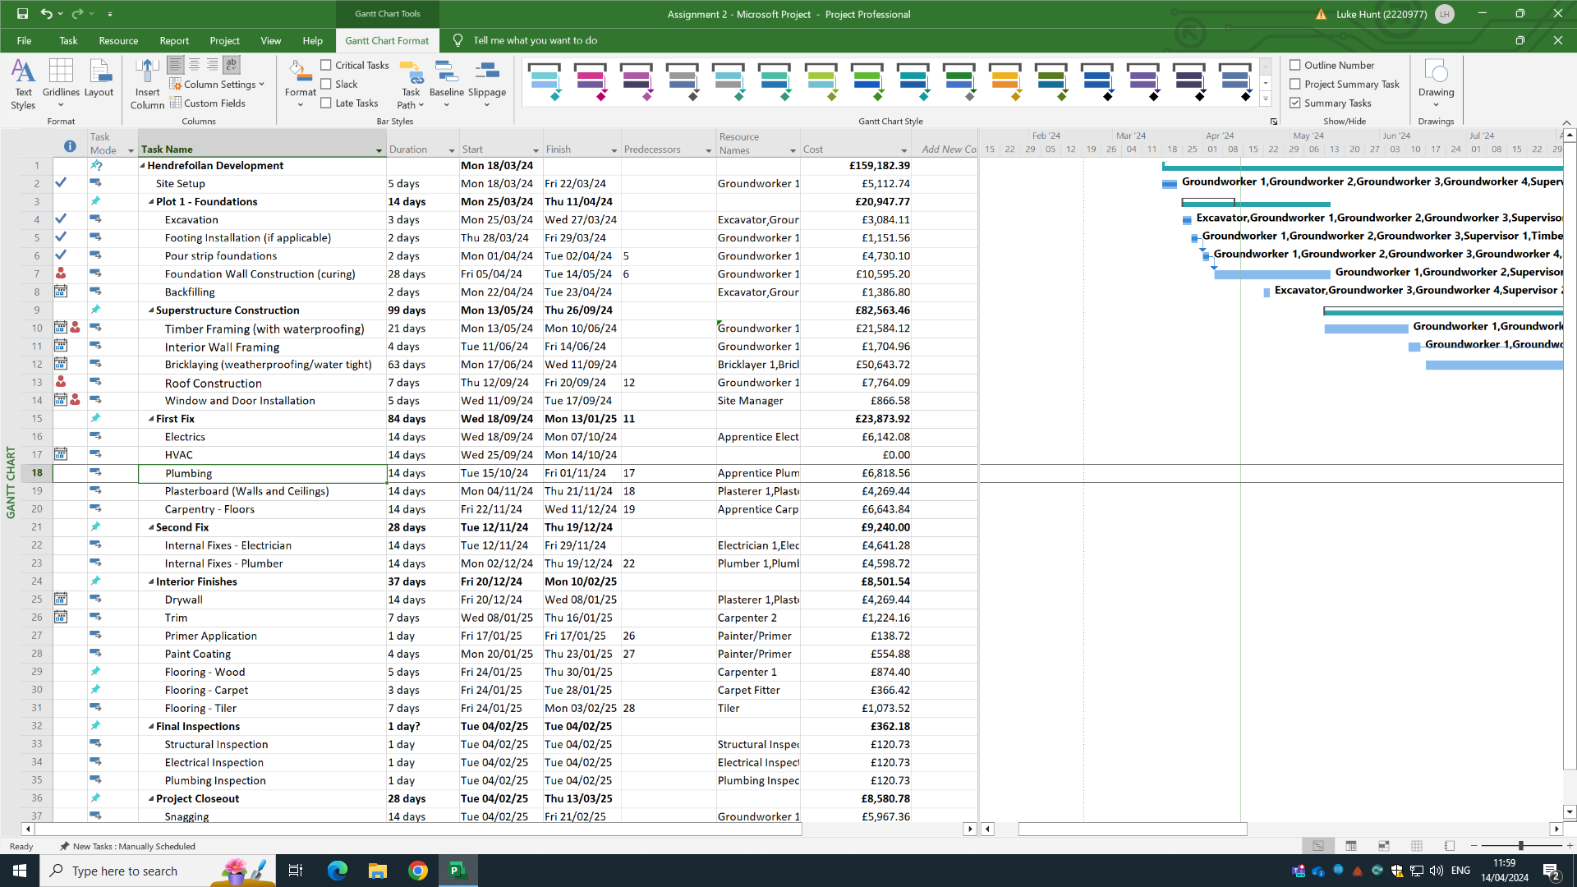
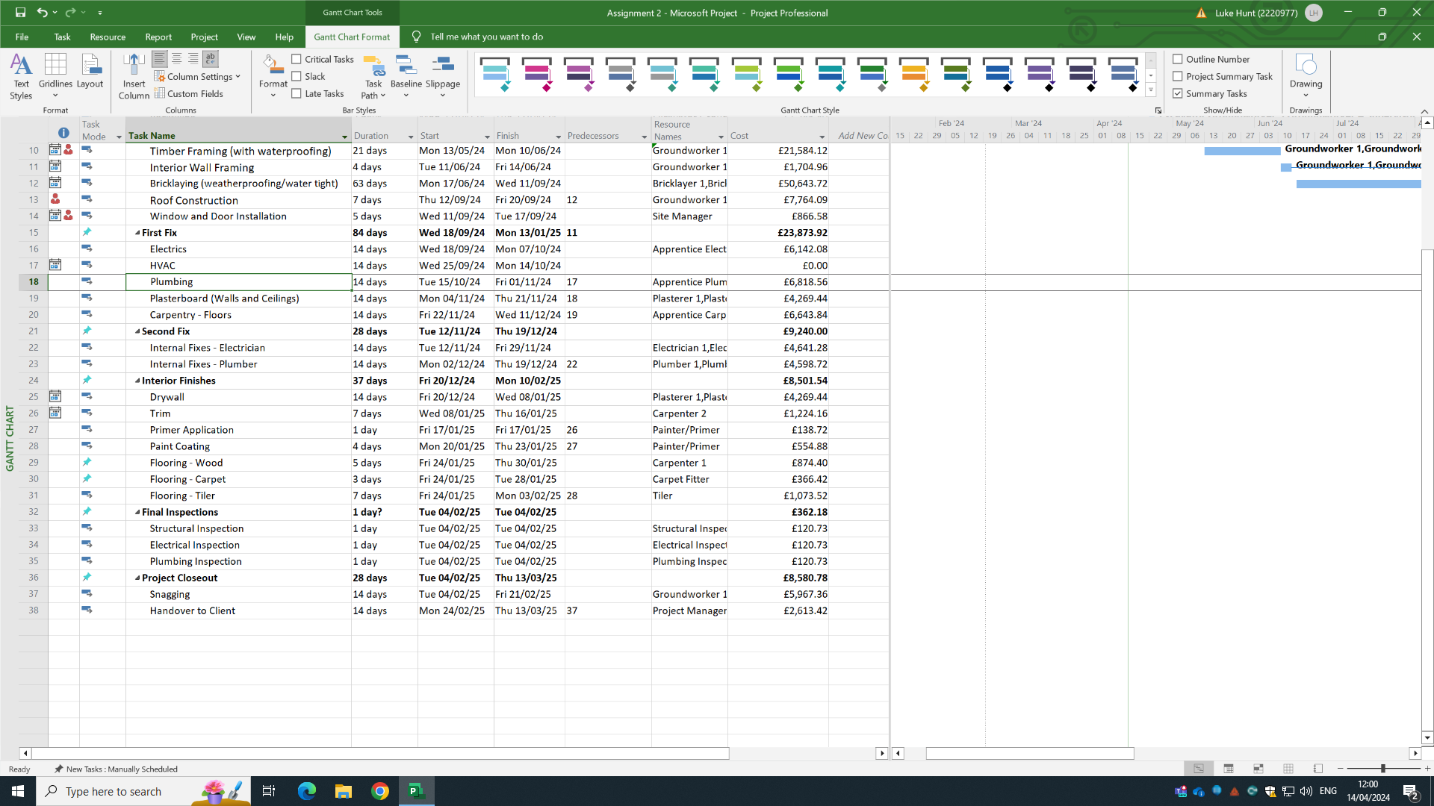
5.0 – Critical Path

The spreadsheet above shows a breakdown of all the major activities related to the construction of this project, Hendrefoilan Development, from start to completion. Each bold heading identifies the critical path of the project, with a detailed breakdown of each section below.
The first column shows blue ticks at the beginning of this project. This identifies what tasks have been completed, but also what is yet to be achieved. There are also red persons in this column. This shows when there is a clash between workers and times in which they are working. However, in the case of this spreadsheet, it is the Site Manager that is flagging this clash, and that is down to two separate tasks taking place on the same day, thus, the site manager would be able to support both tasks, but this has flagged up as an overallocated person.
The fourth column along provides a breakdown of the how long each period will take, in days. The next two columns after this show these number of days in terms of calendar days, showing the sequential order of the project from the start date.
The seventh column identifies the predecessors to each task. This means that some jobs cannot take place before its predecessor task has been completed. Some jobs can take place before or at the same time as other jobs, so does not show a predecessor.
The eighth column allocates the resources needed for each task and when they are needed site.
The final column summates all the costings of the materials, labour, and plant for each task, with a total cost at the top of the column.

5.1 – Gantt Chart

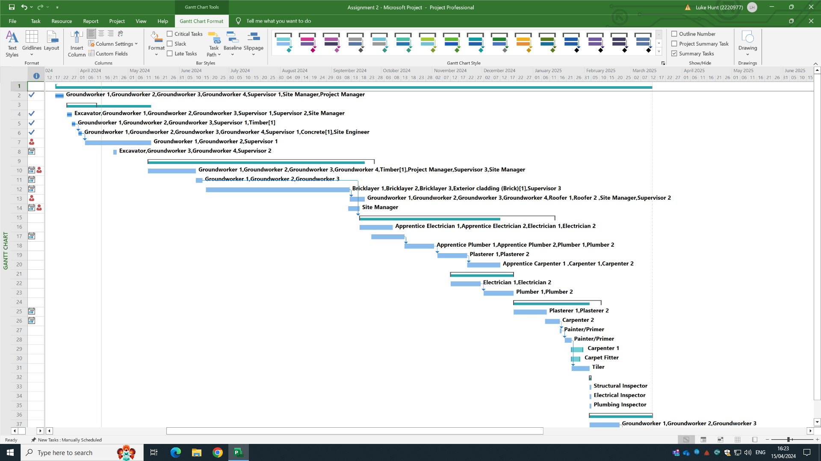

As the data is put into the spreadsheet, shown on page 12, it creates a Gantt chart that matches to the dates and durations of the tasks from start to completion. The green bar at the top of the chart shows the full duration of the project. However, as you going down the chart, it provides a breakdown of each critical path section and how long they will take. Under each of these green bars is a further breakdown of the activities that are to be completed by the shown date at the top of the chart. This chart allows the reader to see the project with a more visual perspective, showing what tasks start when.
This Gantt chart shows the critical path for just one of the houses being built on the project. As the project begins to make progress, and tasks are complete, it allows for groundworkers, for example, who have completed the foundations of the first house to move onto the foundations of the next house. So, although it does not show on this Gantt chart, the foundations of the second house could begin, allowing the superstructure of the first house to continue, whilst progress on the second house is being made. This would generate an efficient and more productive way of working than starting and finishing one house at a time.

6.0 - Site Specific Report for Time

The time report above gives indication to the hours worked and the hours that will be worked on site, if the project follows the strict critical path. The blue shows the work that has been completed, whilst the orange shows the work that remains for the professionals when on site.
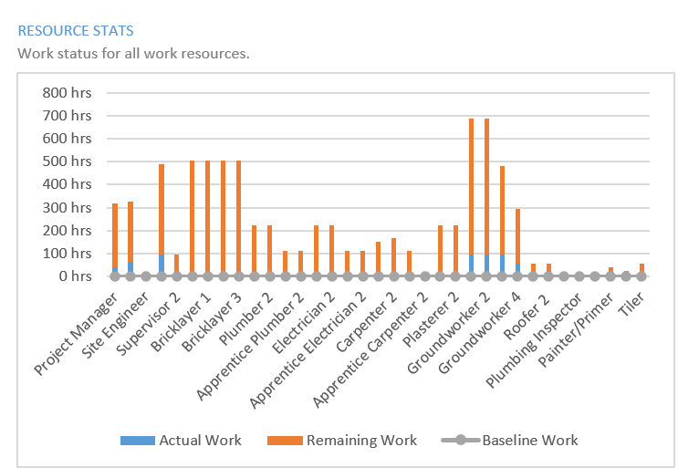
This report would allow the project manager to gauge whether work is on track, and whether more hours may need to worked in order to keep on the critical path.

6.1 - Site specific Report for Cost

This pie chart report shows the split between work paid and material costs. This is only to give an indication into how cost would be split between each sector of work. Due to the lack of data in the spreadsheet, this report only shows a basic cost report, however, it does provide a good visualisation of how costings are split for the project. It would also ensure that there is a good balance the cost of work and materials.
This cost report breaks down each professional and the amount of money paid for their work. It identifies that all persons have a baseline cost, shown in green, with the overall cost shown as a bar. Each bar is split into what has been paid and what remaining cost is to be paid on for each job.
This would give a good indication for both the quantity surveyor and project manager as they can see the progress of the cost and remain on track.

6.2 - Site Specific Report for Resources
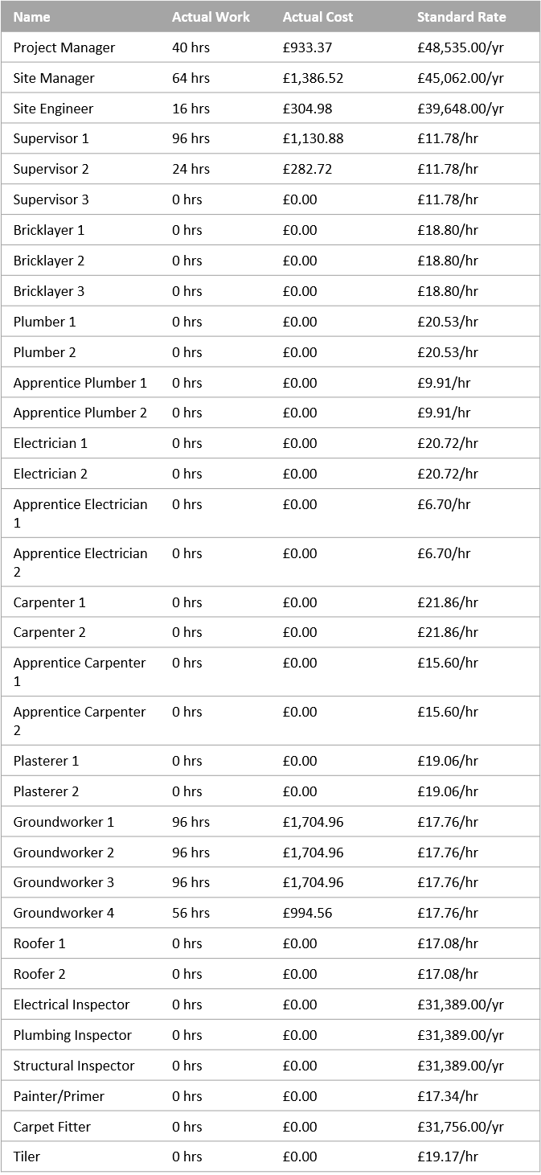

The resource report above provides a good split between the professionals, the cost of work and the hours worked. It allows for the project manager and QS to identify the costings efficiently. This shows a partially completed report due to the fact that some of the professionals have completed hours on the project, whilst others are yet to start on site. However, it indicates well to the reader the cost at which the professionals will be paid and what hours have been worked.

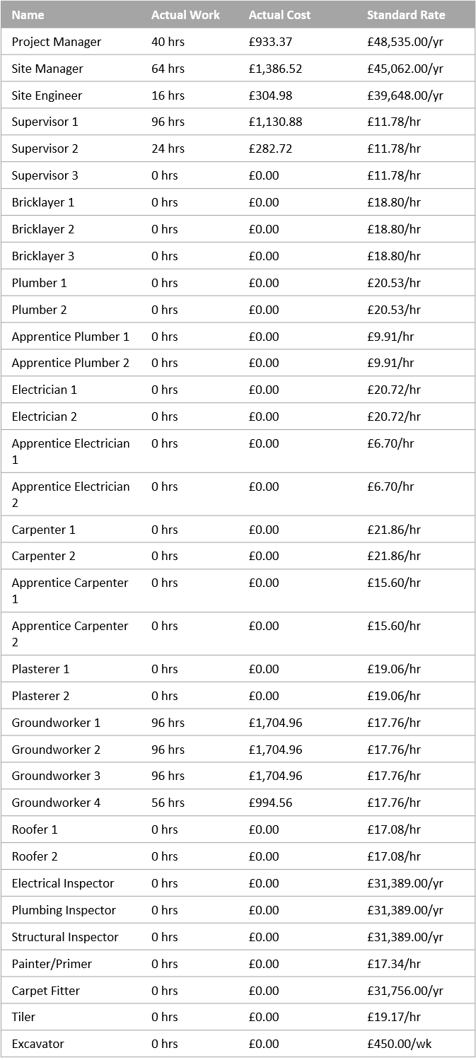
Resource Cost Overview
COST STATUS
COST DISTRIBUTION
COST DETAILS
Cost status for work resources.
How costs are spread out amongst different resource types.
Cost details for all work resources.

7.0 - References
Teams (2024). ACBA5001_CW2_SEM2_23_24. Available at: https://uowtsd.sharepoint.com/:w:/r/teams/ACBA50012324ProjectPlanningforConstruction_GRP/_layouts/15/Doc2.aspx?action=edit&sourcedoc=%7B2f1f0d39-d53f-4a62-91c0-1c6c41bcfbf5%7D&wdOrigin=TEAMS-WEB.teamsSdk_ns.rwc&wdExp=TEAMS-TREATMENT&wdhostclicktime=171231 . [Accessed 20th March 2024].
Timber Frame Timeline - Saint-Gobain Self-Build (2024). A typical timeline for a timber frame self-build. Available at: https://build.saint-gobain.co.uk/blog/2021/06/typical-timeline-timber-frame-self-build. [Accessed 20th March 2024]
Window and door installation - Window, M. (2023). How Long Does Window Installation Take for A New Home? Available at: https://millerwindow.com/how-long-does-window-installation-take-for-a-new-home/#:~:text=Window%20installation%20for%20a%20new [Accessed 15 Apr. 2024].
External Brickwork - Metcalf. H (2020). Construction duration estimation. Available at: https://www.granddesignsmagazine.com/self-build/construction/construction-duration-estimation/#:~:text=Brick%20and%20block. [Accessed 20th Mar. 2024].
Drywall – Kupty. A. (2023). Understanding Drywall: Timeline, Types, and Techniques. Available at: https://www.propaintandfinish.com/articles/drywall-timeline-types#:~:text=The%20time%20taken%20to%20drywall [Accessed 20th Mar. 2024].
Flooring - Doyle, C. (2023) How Long Does Flooring Installation Take? -https://valorhomeservices.com/. Available at: https://valorhomeservices.com/how-long-does-flooring-installation-take/#:~:text=The%20Space%20Size [Accessed 20th Mar. 2024].
Trim - Electrician Talk. (2014). How long does it take to trim out a house by yourself? Available at: https://www.electriciantalk.com/threads/how-long-does-it-take-to-trim-out-a-house-by-yourself.70017/#:~:text=It%20takes%20me%20about%207 [Accessed 20 Mar. 2024].
Painting - Paint World. (2024). How Long Does It Take to Paint a House? Available at: https://www.paintworld.com.au/pages/how-long-to-paint-a-house#:~:text=How%20long%20to%20paint%20your. [Accessed 20th Mar 2024].
Primer – Obringer. D. (2023). How Long Does an Interior House Painting Project Take? Available at: https://www.obringerspaintingandremodeling.com/how-long-does-an-interior-house-painting-project-take#:~:text=Once%20these%20steps%20are%20complete [Accessed 20th Mar. 2024].
Plumbing Inspection - My CMS. (2013). Plumbing Inspection Service & Is it a good idea to get an inspection. Available at: https://www.emergencyplumber.uk.com/plumbing/plumbing-inspection/#:~:text=In%20most%20cases%20a%20basic [Accessed 21st Mar. 2024].

Electrical Inspection – MyTrustedExpert (2021). How Long Does an Electrical Safety Check Take? My Trusted Expert. Available at: https://mytrustedexpert.com/blog/electrical-safety-check/#:~:text=The%20precise%20length%20of%20the [Accessed 21st Mar. 2024].
Structural Inspection – simplifyengineering (2023). How long does a pre-purchase structural inspection/report take? Structural Engineer - Simplify Engineering. Available at: https://simplifyengineering.co.uk/how-long-does-a-pre-purchase-structural-inspection-report-take/#:~:text=The%20actual%20length%20of%20time [Accessed 21st Mar. 2024].
Roof Construction - MoneySavingExpert Forum. (2021). New build completion date - roof to completion timeline. Available at: https://forums.moneysavingexpert.com/discussion/6237146/new-build-completion-date-roof-to-completion-timeline [Accessed 21st Mar. 2024].
Wall Foundation - ALLEN, K. (2011). How Long After a Foundation Is Poured Can You Build? Available at: https://www.hunker.com/13401550/how-long-after-a-foundation-is-poured-can-you-build. [Accessed 21st Mar 2024]
Handover - designingbuildings. (2022). Handover of the construction site to the client. Available at: https://www.designingbuildings.co.uk/wiki/Handover_of_the_construction_site_to_the_client. [Accessed 21st Mar 2024]
Cost of brick/square metre - Constructionrates. (2016). Brickwork, Construction Rates Prices Building specification and cost data sub-contractors trades units. Available at: http://www.constructionrates.co.uk/Rate_Gen/Brickwork%40constructionrates.co.uk.html [Accessed 21st Mar 2024]
Cost of Concrete /cubic metre - Checkatrade. (n.d.). How Much Does Concrete Pouring Cost in 2021? Available at: https://www.checkatrade.com/blog/cost-guides/concrete-pouring-cost/. [Accessed 21st Mar 2024]
Excavator hire - Chase Plant Hire. (2016). Prices - Chase Plant Hire - Mini Digger Hire. Available at: https://www.chaseplanthire.com/prices/. [Accessed 21st Mar 2024]
Cost of bricks – Quora. (2019). How many bricks do you need for a 4-bedroom house? Available at: https://www.quora.com/How-many-bricks-do-you-need-for-a-4-bedroom-house#:~:text=To%20determine%20the%20number%20of [Accessed 21st Mar. 2024].
Timber - Forest Research. (n.d.). Timber Price Indices. Available at: https://www.forestresearch.gov.uk/tools-and-resources/statistics/statistics-by-topic/timber-statistics/timber-price-indices/#:~:text=In%20the%20Softwood%20Sawlog%20Price%20Index&text=The%20average%20price%20for%20softwood [21st Mar. 2024].
Woods. D. (2020). Timeline For Building a Timber-Framed Home. timberhomeliving.com. Available at: https://www.timberhomeliving.com/articles/timber-home-timeline. [Accessed 19th Mar. 2024].

Indeed. (2024) UKindeed.com. Available at: https://uk.indeed.com/career/groundworker/salaries?from=top_sb [Accessed 22nd Mar. 2024].
‌Indeed. (2024) UKindeed.com. Available at: https://uk.indeed.com/career/plumber/salaries?from=top_sb [Accessed 22nd Mar. 2024].
Indeed. (2024) UKindeed.com. Available at: https://uk.indeed.com/career/apprentice-plumber/salaries?from=top_sb[Accessed 22nd Mar. 2024].
Indeed. (2024) UKindeed.com. Available at: https://uk.indeed.com/career/electrician/salaries?from=top_sb[Accessed 22nd Mar. 2024].
Indeed. (2024) UKindeed.com. Available at: https://uk.indeed.com/career/apprentice-electrician/salaries?from=top_sb[Accessed 22nd Mar. 2024].
Indeed. (2024) UKindeed.com. Available at: https://uk.indeed.com/career/carpenter/salaries?from=top_sb[Accessed 22nd Mar. 2024].
Indeed. (2024) UKindeed.com. Available at: https://uk.indeed.com/career/carpenter-apprentice/salaries[Accessed 22nd Mar. 2024].
Indeed. (2024) UKindeed.com. Available at: https://uk.indeed.com/career/brick-mason/salaries?from=top_sb[Accessed 22nd Mar. 2024].
Indeed. (2024) UKindeed.com. Available at: https://uk.indeed.com/career/roofer/salaries?from=top_sb[Accessed 22nd Mar. 2024].
Indeed. (2024) UKindeed.com. Available at: https://uk.indeed.com/career/site-supervisor/salaries[Accessed 22nd Mar. 2024].
Indeed. (2024) UKindeed.com. Available at: https://uk.indeed.com/career/project-engineer/salaries[Accessed 22nd Mar. 2024].
Indeed. (2024) UKindeed.com. Available at: https://uk.indeed.com/career/project-manager/salaries?from=top_sb[Accessed 22nd Mar. 2024].
Indeed. (2024) UKindeed.com. Available at: https://uk.indeed.com/career/structural-engineer/salaries?from=top_sb[Accessed 22nd Mar. 2024].
Indeed. (2024) UKindeed.com. Available at: https://uk.indeed.com/career/civil-engineer/salaries?from=top_sb[Accessed 22nd Mar. 2024].
Indeed. (2024) UKindeed.com. Available at: https://uk.indeed.com/career/mechanical-engineer/salaries?from=top_sb[Accessed 22nd Mar. 2024].
Indeed. (2024) UKindeed.com. Available at: https://uk.indeed.com/career/electrical-engineer/salaries?from=top_sb[Accessed 22nd Mar. 2024].
Indeed. (2024) UKindeed.com. Available at: https://uk.indeed.com/career/plasterer/salaries[Accessed 22nd Mar. 2024].
Indeed. (2024) UKindeed.com. Available at: https://uk.indeed.com/career/site-engineer/salaries?from=top_sb[Accessed 22nd Mar. 2024].
Indeed. (2024) UKindeed.com. Available at: https://uk.indeed.com/career/site-manager/salaries?from=top_sb[Accessed 22nd Mar. 2024].

