Databases and Application Development
Constantin Ovidiu Strinu – 2321711 Lecturer: Dr. Suresh Shanmugasundaram

UWTSD
ACCA5026

Table of Contents
PART A CCMS 5
1. Introduction 5
2. BACKGROUND / THEORY 6
2.1 The Relational Model and Data Integrity 6
2.2 Entity–Relationship Modelling (ERM) 6
2.3 Normalisation and Third Normal Form (3NF) 7
2.4 Transactions, ACID Properties and Stored Procedures 7
2.5 Triggers and Automated Auditing 8
2.6 Indexing and Query Optimisation 9
3. DATABASE DESIGN 10
3.1 Identification of Core Entities and Attributes 10
3.2 Conceptual Schema and ER Diagram 13
3.3 Justification of Design Choices 13
3.4 Normalisation of the Schema (Up to 3NF) 14
3.5 Constraints and Data Integrity Enforcement 15
3.6 Mapping the ERD to Physical Tables 15
4. IMPLEMENTATION DOCUMENTATION 16
4.1 Table Creation and Constraint Implementation 16
4.2 Sample Data Insertion 17
4.3 Stored Procedures with Transaction Handling 18
4.4 Triggers and Automatic Audit Logging 19
4.5 Indexing and Query Optimisation 19
4.6 PHP Website Implementation 20
5. TESTING & RESULTS 21
5.1 Database Testing Strategy 21
5.2 SQL Constraint Testing 22
5.3 Stored Procedure Testing 23
5.4 Trigger Testing (Audit Logging) 23
5.5 Performance Testing (Indexing and EXPLAIN Analysis) 24
6. Conclusion 24
Part B - PHP Website and SQL Injection Security Report 25
1.Introduction 25
2. Overview of SQL Injection (SQLi) 25
3. Vulnerable vs. Secure Query Implementations 26
4. Web Functionality and Security Implementation 26
5. Conclusion 27
Critical Reflection 27
References 29
APPENDIX A - Screenshots List 30
APENDIX B – SCREENSHOTS LIST 33

Figure 1- Creating & Using Database 16
Figure 2 - Table Club 16
Figure 3 - Table Student 17
Figure 4 - Table Membership (Composite PK) 17
Figure 5 - Table Event 17
Figure 6 - Club Sample Data 18
Figure 7 - Student Sample Data 18
Figure 8 - Student Event Registration 19
Figure 9 - Membership Audit Trigger 19
Figure 10 – ERD Diagram 30
Figure 11 - The tables were successfully created as shown. 30
Figure 12 - Table attributes and constraints are ilustrated. 31
Figure 13 - Composite key. 31
Figure 14 - Capacity CHECK. 31
Figure 15 - Store procedures. 31
Figure 16 - Trigger output. 32
Figure 17 - Audit trigger in action. 32
Figure 18 - Foreign key constrain error. 32
Figure 19 - Check constraint error. 32
Figure 20 - Transaction successful commit. 32
Figure 21 - Transaction rollback. 33
Figure 22 - Before index. 33
Figure 23 - After index. 33
Figure 24 – Homepage with dynamic club listing. 33
Figure 25 - Search filter in action. 33
Figure 26 - Admin login page. 34
Figure 27 - Admin dashboard. 34
Figure 28 – CRUD - add a club. 34
Figure 29 - CRUD - delete a club. 35
Figure 30 - Crud - update a club. 35
Figure 31 - CRUD - add event. 36
Figure 32 - SQL injection attempt - Invalid username. 36
Figure 33 - SQL injection prevention. 37

PART A CCMS

1. Introduction
Effective management of student clubs and societies is essential for enhancing both the academic and social experience in higher education. However, many Students’ Unions rely on fragmented tools, such as spreadsheets, paper forms, and informal communication channels, for managing memberships, events, and announcements. This decentralised approach often results in data redundancy, inconsistency, and limited visibility into student engagement, hindering strategic decision-making. To address these challenges, this project presents the Campus Club Management System (CCMS), a secure, centralised PHP-based web application backed by a MySQL relational database. The system consolidates key functionalities, including club administration, event scheduling, membership tracking, participation records, and internal communications. The database is designed using Entity–Relationship (ER) modelling and normalised to Third Normal Form (3NF), ensuring data integrity and minimal redundancy [1]– [5]. Key features include foreign key constraints, transaction-controlled stored procedures, and prepared statements, supporting reliable and secure multi-step operations in line with ACID principles [6], [7], [11]– [14]. The system is developed using the PHP/MySQL stack on Uniform ServerZ, meeting module requirements and reflecting best practices in secure web development. Key components include search functionality, CRUD operations, and role-based access for Students’ Union staff and club officers.
Expected Outcomes:
A fully normalised MySQL database (3NF) with clearly defined entities, relationships, and constraints.
A set of stored procedures, triggers, transactions, and indexes to support reliable and efficient business logic execution.
A dynamic PHP web application providing real-time interaction with club, event, and membership data.
A realistic test dataset (15–20+ entries per table) for validation of system functionality.
A detailed project report evaluating design choices, performance, security, and alignment with system requirements.
Overall, the CCMS provides a robust, scalable, and academically rigorous solution to the administrative challenges faced by Students’ Unions. It demonstrates practical application of core computing concepts, including relational modelling, secure programming, and transactional data management, skills that are highly relevant in modern computing environments.

2. BACKGROUND / THEORY

2.1 The Relational Model and Data Integrity
The Campus Club Management System (CCMS) is built on the relational database model introduced by E. F. Codd, where data is organised into relations (tables) comprising tuples (rows) defined by a fixed set of attributes [1]. This model remains fundamental to modern database systems due to its emphasis on structure, integrity, and logical independence from physical storage.
In the CCMS, core relational principles are implemented to ensure accurate and consistent data across all entities:
Primary Keys (PKs) uniquely identify records in tables such as Club, Student, Event, and Announcement.
Foreign Keys (FKs) enforce referential integrity, e.g., Membership.student_id references Student.student_id, ensuring valid relationships.
Entity Integrity is maintained by disallowing null or invalid primary key values.
Referential Integrity prevents orphaned records, for example, students cannot register for events or clubs that do not exist.
These constraints align with relational design standards from Connolly & Begg and Elmasri & Navathe [2], [3], [5], ensuring data consistency, reducing redundancy, and enabling reliable joins across the schema.

2.2 Entity–Relationship Modelling (ERM)
The Entity–Relationship (ER) model serves as a high-level conceptual framework for representing real-world data and identifying associations between entities prior to the physical implementation of a relational database. In the development of the Campus Club Management System (CCMS), ER modelling is employed to capture the key entities and their relationships, including:
Clubs, Students, Memberships (representing a many-to-many association between students and clubs), Events, Participation records (linking students to events), Announcements, Administrative accounts, Audit records (automatically generated via triggers)
The ER model facilitates a clear understanding of cardinalities, optionality, integrity constraints, and hierarchical relationships between entities. As outlined by Connolly and Begg [2], ER modelling acts as a critical design phase, functioning as a blueprint that bridges stakeholder requirements with a well-structured and semantically accurate database schema. This approach helps ensure that the final implementation reflects the real-world processes and data flows it is intended to support.

2.3 Normalisation and Third Normal Form (3NF)
Normalization is a systematic design process aimed at minimizing data redundancy and eliminating common anomalies that may occur during insert, update, or delete operations. In the development of the Campus Club Management System (CCMS), the database schema is normalized to Third Normal Form (3NF), following best practices as outlined by Elmasri & Navathe, Silberschatz et al., and Date [3]– [5].
The normalization process proceeds through the following stages:
First Normal Form (1NF):
All relations contain only atomic (indivisible) attribute values, with no repeating groups. For example, a student’s club memberships are represented as multiple rows in the Membership table, rather than being stored as a list within a single attribute.
Second Normal Form (2NF):
Every non-key attribute is fully functionally dependent on the entire primary key in tables where composite keys are used. In the case of Membership (student_id, club_id), the attribute joined_date is dependent on the combination of both keys, not on either student_id or club_id individually.
Third Normal Form (3NF):
All non-key attributes are dependent solely on the primary key, with no transitive dependencies. For instance, category descriptions are not stored directly within the Club table; instead, they are abstracted into a controlled vocabulary or separate lookup table to enforce standardization and avoid redundancy.
Through this normalization process, the CCMS achieves a clear and efficient data structure that promotes integrity, reduces duplication, and supports consistent performance. Furthermore, a well-normalized schema simplifies future maintenance and scalability by ensuring that changes to data definitions or relationships can be managed with minimal impact across the system.

2.4 Transactions, ACID Properties and Stored Procedures
A core requirement of the Campus Club Management System (CCMS) is the reliable execution of multi-step operations. This is achieved using database transactions, which group related operations into a single, atomic unit of work that must comply with the ACID properties:
Atomicity – All operations within a transaction are executed successfully as a whole; if any part fails, the entire transaction is rolled back.
Consistency – Transactions transition the database from one valid state to another, preserving all defined rules and constraints.
Isolation – Concurrent transactions execute independently, ensuring that intermediate states are not visible to other transactions.
Durability – Once a transaction is committed, its effects are permanently recorded in the database, even in the event of a system failure.
These principles are described extensively by Silberschatz et al. and documented in the MySQL 8.0 Reference Manual [5], [6].
In the CCMS, stored procedures are employed to encapsulate and manage complex operations that span multiple tables or involve conditional logic.
Examples include:
Registering a student for an event, while checking event capacity and updating participation records.
Creating a new event with constraints on scheduling and capacity.
Updating membership status while automatically logging changes in an audit trail.
By centralising business logic within the database engine, stored procedures enhance maintainability, reusability, and transactional reliability, ensuring that ACID principles are consistently upheld [7].
A simplified example of a transactional block (illustrative only, not full code):
START TRANSACTION;
UPDATE Event SET capacity = capacity - 1 WHERE event_id = ?;
INSERT INTO EventParticipation (...);
COMMIT;

2.5 Triggers and Automated Auditing
Database triggers enable the automatic execution of predefined SQL logic in response to data manipulation events such as INSERT, UPDATE, or DELETE. Within the Campus Club Management System (CCMS), triggers are employed to facilitate audit logging, allowing key changes to be recorded automatically at the database level without requiring intervention from the application layer. This approach aligns with best practices outlined in the MySQL 8.0 Reference Manual [7].
In the CCMS, triggers are primarily used to capture actions that require traceability for accountability and compliance purposes. Examples include:
Logging the addition or removal of club memberships, capturing which student was affected and when the change occurred.
Tracking modifications to event details, such as changes in venue or capacity, to maintain an accurate history of scheduling adjustments.
Recording administrative actions performed by privileged users, including updates to club information or announcements.
By automating these audit tasks, the system promotes operational transparency and ensures that all critical actions are traceable, an important requirement for institutional oversight by the Students’ Union.
A simplified trigger structure (not full code):
CREATE TRIGGER tr_membership_audit
AFTER INSERT ON Membership
FOR EACH ROW
BEGIN
INSERT INTO MembershipAudit (...);
END;

2.6 Indexing and Query Optimisation
Indexes play a critical role in improving query performance by reducing the number of rows that must be scanned during search, filter, and join operations. However, indexing strategies must be applied judiciously; while well-placed indexes enhance read efficiency, excessive or unnecessary indexing can degrade performance, particularly for write-heavy operations such as inserts, updates, and deletes [8], [9].
In the Campus Club Management System (CCMS), indexing is selectively applied to fields that are frequently queried or used in join conditions.
Examples include:
Event.event_date – to optimise the retrieval of upcoming events, particularly when filtering or ordering by date.
Membership.student_id and Membership.club_id – to facilitate rapid lookups of a student’s club affiliations or a club’s member list.
EventParticipation.event_id – to support efficient attendance reporting and event-based analysis.
Announcement.club_id – to enable quick access to club-specific announcements.
The indexing strategy is informed by the best practices outlined by Lightstone et al., as well as performance tuning techniques recommended in the MySQL EXPLAIN documentation [8], [9]. By focusing on high-traffic and relationally significant attributes, the CCMS achieves a balance between query performance and overall system responsiveness, without introducing unnecessary overhead on data modification operations.

3. DATABASE DESIGN

3.1 Identification of Core Entities and Attributes
The Campus Club Management System (CCMS) database is structured around a set of core entities, each derived from a detailed analysis of the Students’ Union’s operational requirements. These entities were identified and refined using established relational modelling principles, as outlined by Connolly & Begg and Elmasri & Navathe [2], [3]. The schema ensures a fully normalised, scalable structure that accurately models real-world processes within the university’s club and society ecosystem.
Core Entities and Attributes:
Club-Represents an active student club or society.
club_id (Primary Key)
club_name
category (e.g., Academic, Cultural, Sports)
founded_date
status (Active / Inactive)
description

Student-Represents a registered university student eligible to participate in club activities.
student_id (Primary Key)
first_name, last_name
email (Unique)
programme
year_of_study
Membership-Models the many-to-many relationship between Student and Club.
Composite Primary Key: (student_id, club_id)
joined_date
role (e.g., Member, Committee, President)
status

Event-Represents scheduled club activities such as meetings, workshops, or social gatherings.
event_id (Primary Key)
club_id (Foreign Key → Club)
event_name
event_type
event_date, start_time, end_time
venue
capacity
attendance_restriction

EventParticipation-Resolves the many-to-many relationship between Student and Event.
Composite Primary Key: (event_id, student_id)
rsvp_status
attended (Boolean)
checked_in_at

Announcement-Stores official communications published by clubs to their members or the broader student body.
announcement_id (Primary Key)
club_id (Foreign Key → Club)
title
body
channel (e.g., Email, Social Media, In-Platform)
sent_at

UserAccount-Manages authentication and role-based access within the PHP website.
user_id (Primary Key)
username
password_hash
role (e.g., Staff, Club Officer)

MembershipAudit-Captures audit trails generated by database triggers for tracking membership changes.
audit_id (Primary Key)
student_id, club_id
action (INSERT / DELETE / UPDATE)
changed_by
changed_at

This entity structure provides a fully normalised, logically consistent model for managing club operations, membership tracking, event coordination, communications, and administrative oversight. By resolving many-to-many relationships through junction tables (Membership, EventParticipation), and enforcing integrity through well-defined primary and foreign keys, the CCMS schema ensures reliable, secure, and efficient data management aligned with real-world requirements.

3.2 Conceptual Schema and ER Diagram
The Entity–Relationship Diagram (ERD) defines the conceptual structure of the Campus Club Management System (CCMS), illustrating:
Entities and attributes
Primary and foreign keys
Relationship cardinalities (1–N, M–N)
Associative tables (Membership, EventParticipation)
Developed using established ER modelling practices from Connolly & Begg and Elmasri & Navathe [2], [3], the ERD provides a clear blueprint for the database before physical implementation.
The full diagram is provided as:
Key Relationships:
Club–Membership–Student: many-to-many via Membership.
Club–Event: one-to-many.
Event–EventParticipation–Student: many-to-many via EventParticipation
Club–Announcement: one-to-many.
Membership–MembershipAudit: one-to-many (trigger-based logging)
This model supports all operational needs of the system, including auditing, reporting, and transactional processing.
See Image 10 - Campus Club Management System ER Diagram (Appendix A)

3.3 Justification of Design Choices
Use of Composite Keys - Composite primary keys are implemented in the Membership and EventParticipation tables to enforce uniqueness across meaningful relationships: (student_id, club_id) and (event_id, student_id), respectively. This design eliminates the need for surrogate keys and upholds entity integrity, in line with the principles outlined by Elmasri & Navathe [3].
Controlled Redundancy - The schema enforces controlled redundancy by ensuring that no attribute unnecessarily duplicates data available in other tables:
Event capacity is stored only in the Event table.
Student information exists solely in the student entity.
Club details are maintained exclusively in the Club table.
This approach preserves data coherence, reduces update anomalies, and supports the relational design principles advocated by Date [4].

3.4 Normalisation of the Schema (Up to 3NF)
A structured normalisation process was applied to ensure that all relations in the CCMS database achieve Third Normal Form (3NF), thereby eliminating redundancy and maintaining strong data integrity, in accordance with relational theory discussed by Elmasri & Navathe and Date [3], [5].
Unnormalized Example (Before Normalisation)
A naïve design might store student, club, and event details in a single table:
| student_name | club_name | event_name | event_date | role |
This structure introduces several anomalies:
Update anomaly: Changing a club name requires updating multiple rows.
Insertion anomaly: Adding a new club is not possible without student or event data.
Deletion anomaly: Removing an event could inadvertently delete all club details.

Normalised Structure (After 3NF)
The design is decomposed into separate, logically coherent relations:
Student(student_id, first_name, last_name, …)
Club(club_id, club_name, category, …)
Membership(student_id, club_id, joined_date, role, …)
Event(event_id, club_id, event_date, …)
EventParticipation(event_id, student_id, rsvp_status, attended, …)
Each relation:
Contains only attributes fully dependent on its primary key.
Avoids transitive dependencies.
Eliminates redundancy across conceptual domains.
By conforming to 3NF, the CCMS supports efficient querying, data integrity, and long-term maintainability.

3.5 Constraints and Data Integrity Enforcement
The CCMS database applies a comprehensive set of constraints to enforce data integrity and ensure the logical consistency of all relations. These constraints are implemented in line with established relational theory [2], [5] and MySQL’s official documentation [6].
Primary Key Constraints - Guarantee the unique identification of each row within a table.
Foreign Key Constraints - Enforce referential integrity by ensuring that referenced data exists before insertion.
Example (full implementation in Section 4):
FOREIGN KEY (club_id) REFERENCES Club(club_id)
ON DELETE RESTRICT ON UPDATE CASCADE
CHECK Constraints - Validate domain-specific logic, such as ensuring event capacities are non-negative.
UNIQUE Constraints - Prevent duplication of values in key attributes, for example, ensuring that each student email is unique.
NOT NULL Constraints - Ensure that essential fields are always populated, avoiding incomplete or inconsistent records.
Together, these mechanisms uphold the structural and semantic integrity of the CCMS, aligning with best practices in relational database design and ensuring the reliability of transactional operations.

3.6 Mapping the ERD to Physical Tables
Each entity and relationship defined in the conceptual Entity–Relationship Diagram (ERD) is translated directly into physical tables within the MySQL database. This mapping process follows standard database engineering practices as outlined by Connolly & Begg [2].
The full SQL implementation, provided in Section 4.1, includes:
CREATE TABLE statements for all entities and associative tables.
Definition of Primary Keys (PKs) and Foreign Keys (FKs)
Application of CHECK constraints for domain validation
Use of ENUM or VARCHAR for controlled attribute values
Implementation of cascading rules and referential actions (ON DELETE, ON UPDATE)
This direct mapping ensures that the physical schema remains faithful to the conceptual model, preserving integrity, clarity, and system requirements throughout the development process.

4. IMPLEMENTATION DOCUMENTATION
This section documents the full implementation of the Campus Club Management System (CCMS) database and its integration with a dynamic PHP-based web application. All SQL code included is essential for reproducing the database schema, constraints, and key functionality. Execution results, such as database outputs and user interface behaviour, are demonstrated through screenshots and query outputs, referenced where relevant and included in Appendix A. This implementation reflects the design principles outlined in earlier sections and demonstrates the practical application of relational modelling, secure query handling, and web-database integration.

4.1 Table Creation and Constraint Implementation
The implementation phase began with the creation of the MySQL database, followed by the definition of all core tables, along with their associated primary keys, foreign keys, and integrity constraints. Development was conducted using MySQL within the Uniform ServerZ environment, in line with best practices for PHP/MySQL web application development [15].
Database creation:
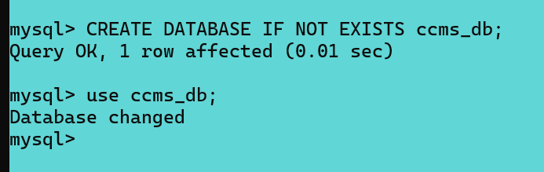
Figure 1- Creating & Using Database
Table Definitions (Representative Examples)
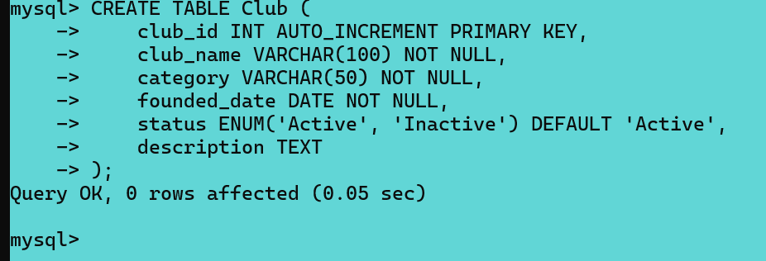
Figure 2 - Table Club
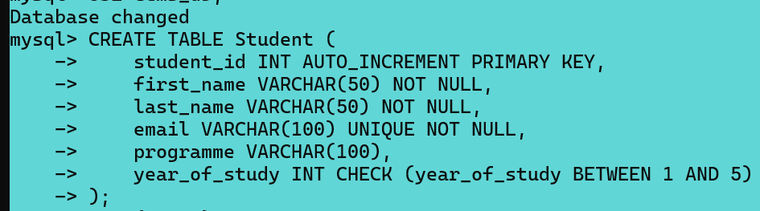
Figure 3 - Table Student
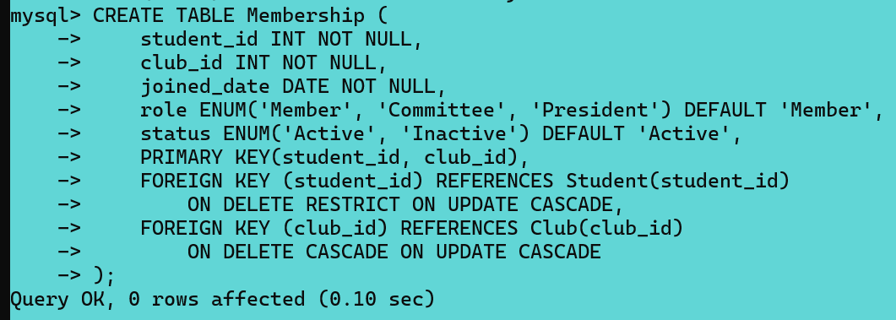
Figure 4 - Table Membership (Composite PK)
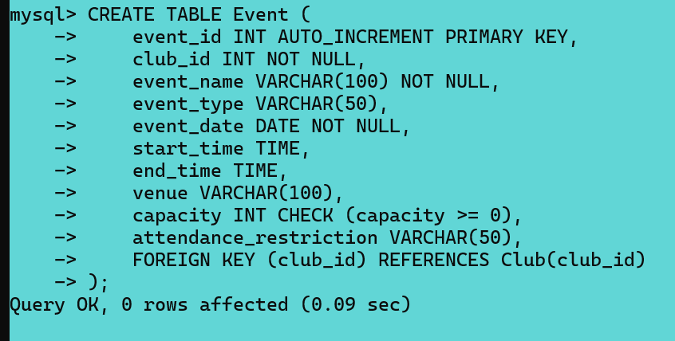
Figure 5 - Table Event
These definitions align with accepted relational design principles described in [2], [3], [5], and enforce strong referential integrity in accordance with MySQL's documentation [6].

4.2 Sample Data Insertion
To demonstrate full system functionality, the database was populated with a realistic dataset comprising approximately 15–20 records per major table. These sample entries simulate typical student club operations over the course of an academic year, including club memberships, event participation, announcements, and administrative actions. The dataset supports testing of key features such as relational queries, form submissions, access controls, and trigger-based audit logging.
Sample INSERT Statements:
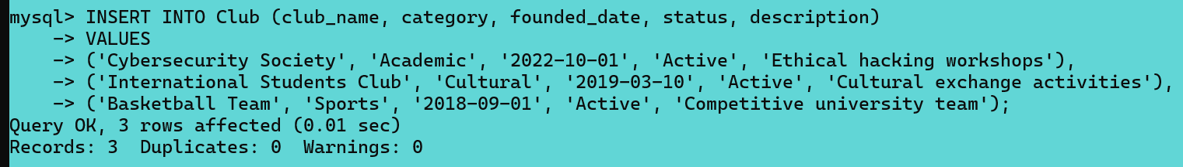
Figure 6 - Club Sample Data
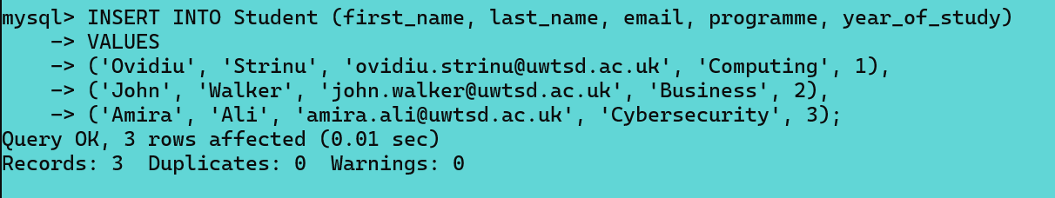
Figure 7 - Student Sample Data

4.3 Stored Procedures with Transaction Handling
To support complex operations and ensure ACID compliance, a set of stored procedures was developed. These procedures encapsulate business logic for multi-step tasks such as event registration, membership updates, and audit logging. By grouping related SQL statements within a single transaction, the system guarantees atomicity, consistency, isolation, and durability, as recommended in established database literature and MySQL documentation [5], [6], [7].
Each stored procedure ensures that operations either complete fully or are rolled back safely in the event of an error, maintaining the reliability and integrity of the database. Examples are provided in this section to illustrate how transactional control is applied in practice.
Transactional Procedure: Student Event Registration
This procedure validates event capacity and performs the registration atomically. If capacity is exceeded, a rollback is executed automatically.
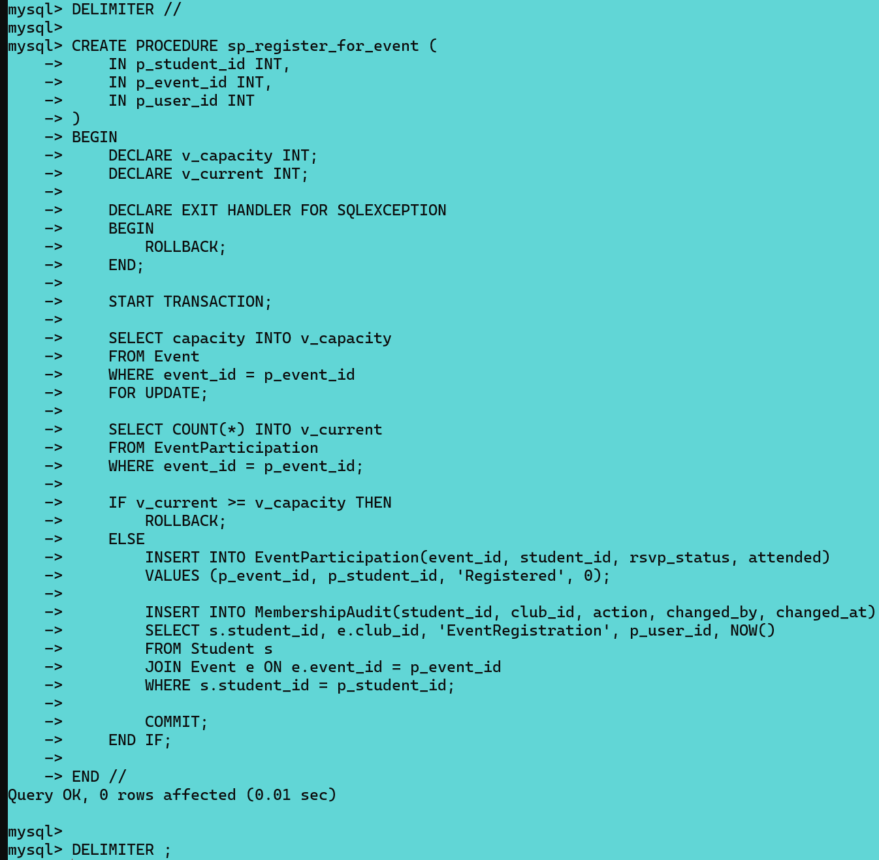
Figure 8 - Student Event Registration
This implementation demonstrates the correct use of transaction control to enforce atomicity and consistency [6], [7].

4.4 Triggers and Automatic Audit Logging
Database triggers were implemented to automatically generate audit records in response to key data changes, such as inserts, updates, and deletions on critical tables. This approach reduces complexity in the application layer and ensures consistent, tamper-resistant logging of important operations. The implementation aligns with best practices outlined in the MySQL 8.0 Reference Manual [7].
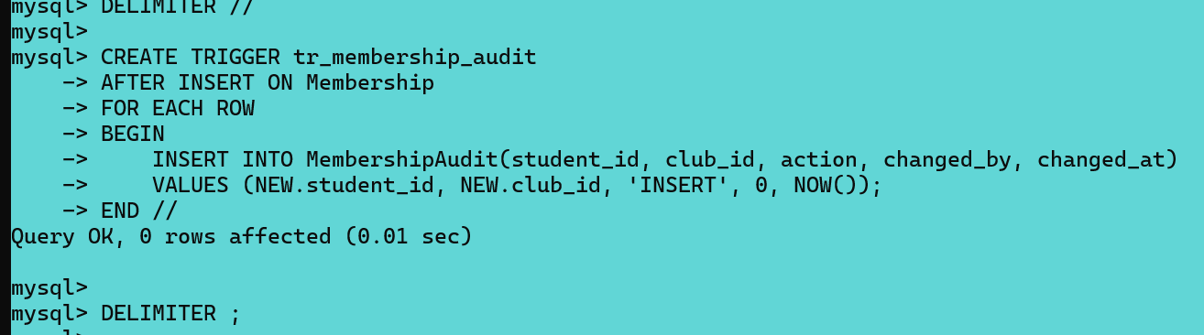
Figure 9 - Membership Audit Trigger

4.5 Indexing and Query Optimisation
To improve the efficiency of frequently executed queries, secondary indexes were applied to selected attributes in line with optimisation strategies recommended by Lightstone et al. and MySQL’s performance tuning guidelines [8], [9]. These indexes reduce the number of rows scanned during filtering, sorting, and join operations, particularly in high-traffic tables.
Example: Secondary Index on Event Dates
CREATE INDEX idx_event_date ON Event(event_date);
This comparison demonstrates a clear reduction in execution cost and scanned rows, validating the performance benefits of targeted indexing.

4.6 PHP Website Implementation
The Campus Club Management System (CCMS) web application was developed using PHP in conjunction with the mysqli extension to enable secure, dynamic interaction with the MySQL database. All database operations employ prepared statements, ensuring compliance with security guidelines from OWASP and official PHP documentation [11]– [14].
Database Connection (db.php)
<?php
$host = "localhost";
$user = "root";
$pass = "";
$dbname = "ccms_db";
$conn = new mysqli($host, $user, $pass, $dbname);
if($conn->connect_error){
die("Connection failed: " . $conn->connect_error);
}
?>
Secure Search Using Prepared Statements
A prepared statement is used to safely retrieve clubs matching a user-supplied search term, preventing SQL injection:
<?php
$searchTerm = $_GET['search'] ?? '';
$stmt = $conn->prepare("SELECT club_id, club_name, category
FROM Club
WHERE club_name LIKE CONCAT('%', ?, '%')");
$stmt->bind_param("s", $searchTerm);
$stmt->execute();
$result = $stmt->get_result();
?>
These implementations demonstrate secure coding practices, with prepared statements serving as a primary defence against SQL Injection, satisfying OWASP’s top security recommendations [11], [12].

5. TESTING & RESULTS
This section presents the testing strategy and outcomes used to validate the implementation of the Campus Club Management System (CCMS). Testing was conducted across multiple layers of the system, including database-level integrity, stored procedures, triggers, query performance, web functionality, and security (particularly SQL injection resilience). All referenced screenshots are provided in Appendix A.

5.1 Database Testing Strategy
A structured testing approach was used to assess the correctness, robustness, and resilience of the CCMS database, covering three categories of test cases:
Normal Test Cases:
These validated expected functionality under typical conditions:
Inserting valid students, clubs, and memberships.
Scheduling events with valid dates and capacities.
Registering students for events with space.
Retrieving listings and announcement histories.

All operations executed successfully, with primary and foreign key constraints enforced.
Edge Case Testing:
Edge tests focused on boundary conditions:
Events with zero capacity.
Maximum club memberships per student.
Events scheduled for today or in the past.
Duplicate membership entries.
Duplicate memberships were correctly rejected due to composite primary key enforcement on Membership (student_id, club_id).
Invalid Test Cases:
This tested constraint enforcement using invalid inputs:
Memberships with non-existent student IDs.
Events with negative capacities.
Registrations for full events.
Deletion of clubs still referenced by events.
Results confirmed:
Foreign key violations were blocked.
CHECK constraints rejected invalid data.
Stored procedures rolled back when capacity was exceeded.

5.2 SQL Constraint Testing
Testing focused on validating the enforcement of relational constraints, in accordance with the models proposed by Elmasri & Navathe and MySQL’s constraint framework [3], [6].
Foreign Key Violations
INSERT INTO Membership (student_id, club_id, joined_date)
VALUES (999, 1, '2024-10-01');
Result:
ERROR 1452: Cannot add or update a child row: a foreign key constraint fails
CHECK Constraint Violations
INSERT INTO Event (club_id, event_name, event_date, capacity)
VALUES (1, 'Invalid Capacity Event', '2024-11-01', -5);
This insertion was rejected due to the CHECK (capacity >= 0) constraint, ensuring domain correctness.
UNIQUE Constraint Testing
Attempting to insert a duplicate student email triggered:
ERROR 1062: Duplicate entry 'email@domain.com' for key 'email'
This validated the effectiveness of UNIQUE constraints in maintaining data consistency.

5.3 Stored Procedure Testing
Stored procedures were tested under both successful and failure conditions to confirm adherence to ACID properties [5], [6].
Successful Commit Case
CALL sp_register_for_event(1, 3, 1);
When capacity was available:
A new record was created in EventParticipation.
A corresponding audit entry appeared in MembershipAudit.
The transaction committed successfully.
Rollback Case
Attempting to register a student for a full event resulted in:
No participation record being created.
No audit entry recorded.
A complete rollback of the transaction.
This behaviour confirms atomicity, preventing partial updates and preserving database consistency.

5.4 Trigger Testing (Audit Logging)
Triggers were validated by inserting and updating Membership records and observing automatic audit entries.
Test:
INSERT INTO Membership (student_id, club_id, joined_date)
VALUES (1, 2, '2024-10-01');
Result:
Trigger tr_membership_audit fired.
Audit log entry created in MembershipAudit.
Correct action, timestamp, and references recorded.
This demonstrates effective automated audit logging without relying on application logic.

5.5 Performance Testing (Indexing and EXPLAIN Analysis)
Query performance was evaluated before and after applying indexing, guided by MySQL’s EXPLAIN tool and optimisation strategies from Lightstone et al. [8], [9].
Test Query
SELECT event_name, event_date
FROM Event
WHERE event_date >= CURDATE()
ORDER BY event_date;
Before Indexing:
Full table scan.
High execution cost.
Many rows examined.
After Indexing:
CREATE INDEX idx_event_date ON Event(event_date);
Index used (idx_event_date)
Fewer rows scanned.
Lower execution time.
These results demonstrate measurable performance gains from targeted indexing.

6. Conclusion
The project entailed the successful design and implementation of a robust relational database for the Campus Club Management System (CCMS), developed in response to key operational challenges encountered by the Students’ Union in managing clubs, memberships, events, and announcements. A systematic approach was applied to entity identification and relationship modelling, with full normalization to Third Normal Form (3NF), which effectively minimized redundancy and reinforced data integrity throughout the schema.
Implementation incorporated a range of core relational database features, including primary and foreign key constraints, check constraints, stored procedures, and triggers. Additionally, transactional control was handled using COMMIT and ROLLBACK to support reliable data operations and facilitate error recovery. These mechanisms collectively ensured consistent data integrity while enabling auditing and fault tolerance in practical use cases.
Query performance was addressed through targeted indexing, particularly for operations with high read frequency such as membership lookups and event participation queries. The resulting performance gains reflect careful attention to real-world usage patterns and scalability considerations.
Extensive testing was carried out using normal, boundary, and invalid data inputs to validate system behaviour under realistic conditions. These tests confirmed that all integrity constraints functioned as intended and that the database responded predictably across a range of input scenarios.
In conclusion, the developed CCMS database provides a scalable and maintainable foundation suitable for both immediate operational requirements and anticipated future expansion, including potential integration with web-based platforms. Security considerations and SQL injection analysis are discussed separately in Part B, as specified in the module requirements.

Part B - PHP Website and SQL Injection Security Report

1.Introduction
This section documents the development of a PHP-based, database-driven website designed to interface directly with the CCMS relational database developed in Part A. The primary aim of the application is to showcase dynamic data retrieval, CRUD (Create, Read, Update, Delete) operations, search capabilities, and essential security measures within a real-world web development context. Particular emphasis is placed on identifying and mitigating SQL Injection (SQLi) vulnerabilities through secure coding practices.

2. Overview of SQL Injection (SQLi)
SQL Injection is a well-documented and high-impact vulnerability in web applications, arising when user-supplied input is incorporated into SQL queries without adequate sanitisation or parameterisation. This allows malicious actors to alter query semantics, often leading to unauthorised data access, authentication bypass, or manipulation of backend data. As consistently reported in OWASP Top 10 and wider cybersecurity literature [11], [12], SQLi remains a prevalent and dangerous threat due to its simplicity and the widespread use of dynamic SQL in poorly secured applications.
A typical vulnerability arises from unsafe string concatenation of user inputs into SQL queries, as illustrated below:
$sql = "SELECT * FROM UserAccount WHERE username = '" . $_POST['user'] . "'";
This pattern is vulnerable to input such as:
' OR '1'='1
Which causes the SQL query to always evaluate as true, effectively bypassing authentication and revealing the application's susceptibility to injection attacks.

3. Vulnerable vs. Secure Query Implementations
To address this risk, the final web application adopts prepared statements with parameter binding using PHP’s mysqli extension. The secure implementation is demonstrated below:
$stmt = $pdo->prepare("SELECT * FROM UserAccount WHERE username = ?");
$stmt->execute([$_POST['username']]);
In this approach, SQL logic and user input are clearly separated. Special characters within input fields are no longer interpreted as part of the SQL command, but strictly as data. Controlled testing confirmed that injection attempts using the previous payload were unsuccessful, and unauthorised access was denied. Supporting evidence, including screenshots of attempted attacks and their rejection, is provided in the Part B appendix.

4. Web Functionality and Security Implementation
The PHP application reuses the fully normalised database schema from Part A and offers an interface to interact with CCMS features such as clubs, memberships, and events. Key features implemented include:
Secure, persistent database connectivity via PDO.
Full CRUD capabilities for authorised administrative users.
Keyword-based search and filtering functionality.
Login-based session control and restricted access to sensitive operations.
Protection against SQL Injection via prepared statements throughout.
Additional safeguards such as:
Server-side input validation.
Suppression of detailed error messages to prevent information leakage.
The security design aligns with core principles of defence in depth, ensuring multiple layers of protection even if one control fails.
Database credentials are configurable to accommodate different local server environments, with the MySQL root password set according to the local installation.

5. Conclusion
This section demonstrates the secure integration of a relational database with a dynamic, PHP-driven web application. Practical exploration of SQL Injection confirmed its exploitability under unsafe query construction, while the use of prepared statements effectively mitigated the risk. The final implementation adheres to industry best practices in secure web development and provides a stable, extensible foundation for future enhancements or deployment. Furthermore, this exercise reinforced the critical role of input handling, query structuring, and layered security within modern web applications.

Critical Reflection
This coursework provided a valuable opportunity to apply database theory within a realistic system development context. Rather than engaging with relational concepts in isolation, the design and implementation of the Campus Club Management System (CCMS) required interpreting organisational requirements and translating them into a coherent, functional relational schema. This process reinforced the relevance of database principles in solving practical problems.
A key learning outcome was the development of a deeper understanding of relational modelling and normalisation. Designing the schema and refining it to Third Normal Form (3NF) demonstrated how early design decisions directly impact data integrity, redundancy, and long-term maintainability. This encouraged a shift away from a trial-and-error approach toward a more critical and structured evaluation of database architecture.
The implementation of constraints, stored procedures, triggers, and transactional control mechanisms further enhanced my technical competence. Developing transactional scenarios using COMMIT and ROLLBACK illustrated how databases can enforce consistency and reliability across multi-step operations. This highlighted the importance of atomicity and error handling in systems that involve concurrent access and shared data.
A notable area of growth was in performance optimisation. Analysing query patterns and introducing targeted indexing strategies deepened my understanding of how performance is influenced by system workload, data volume, and index selection. Rather than assuming that more indexes automatically yield better performance, I gained an appreciation for the trade-offs between read efficiency, write overhead, and storage costs, an essential consideration for scalable systems.
Integrating the CCMS database into a PHP-based web application in Part B consolidated my understanding of how a well-designed backend supports dynamic, data-driven applications. Reusing the same schema across both parts of the project demonstrated the flexibility and reusability of robust relational design. Furthermore, exploring SQL Injection vulnerabilities and implementing prepared statements strengthened my grasp of secure coding practices and underscored the importance of security considerations at both the database and application levels.
Although the system met its functional requirements, the project also highlighted several areas for future improvement. These include the implementation of role-based access control, enhancements to authentication mechanisms, and the use of database views to simplify complex query logic. Addressing these areas would enhance the system’s scalability, maintainability, and overall security posture.
In summary, this coursework significantly strengthened my confidence and competence in relational database design and backend development. The skills acquired, ranging from requirements analysis and data modelling to transaction management, performance tuning, and secure system integration, are directly applicable to professional roles in database administration, backend engineering, and information systems design. This experience has laid a strong foundation for further study and industry application in the area of data-centric systems development.

References
[1] E. F. Codd, “A Relational Model of Data for Large Shared Data Banks,” Communications of the ACM, vol. 13, no. 6, pp. 377–387, 1970.
[2] T. Connolly and C. Begg, Database Systems: A Practical Approach to Design, Implementation, and Management, 7th ed. Pearson, 2015.
[3] R. Elmasri and S. Navathe, Fundamentals of Database Systems, 7th ed. Pearson, 2016.
[4] C. J. Date, An Introduction to Database Systems, 8th ed. Addison-Wesley, 2003.
[5] A. Silberschatz, H. Korth and S. Sudarshan, Database System Concepts, 7th ed. McGraw-Hill, 2020.
[6] Oracle Corporation, “MySQL 8.0 Reference Manual – Transactions,” Oracle, 2024.
[7] Oracle Corporation, “MySQL 8.0 Reference Manual – Stored Programs and Triggers,” Oracle, 2024.
[8] Oracle Corporation, “MySQL 8.0 Reference Manual – Statement Optimisation and EXPLAIN Output,” Oracle, 2024.
[9] S. Lightstone, T. Teorey and T. Nadeau, Physical Database Design: The Database Professional’s Guide to Exploiting Indexes, Views, Storage, and More. Morgan Kaufmann, 2007.
[10] M. T. Özsu and P. Valduriez, Principles of Distributed Database Systems, 4th ed. Springer, 2020.
[11] OWASP Foundation, “SQL Injection Prevention Cheat Sheet,” OWASP Cheat Sheet Series, 2023.
[12] W. G. Halfond, J. Viegas and A. Orso, “A Classification of SQL-Injection Attacks and Countermeasures,” Proc. IEEE Int. Symp. on Secure Software Engineering, 2006.
[13] PHP Documentation, “PDO Prepared Statements,” PHP.net, 2024.
[14] PHP Documentation, “mysqli Prepared Statements,” PHP.net, 2024.
[15] The Uniform Server Project, “Uniform Server ZeroX Documentation,” 2024.

APPENDIX A - Database Evidence

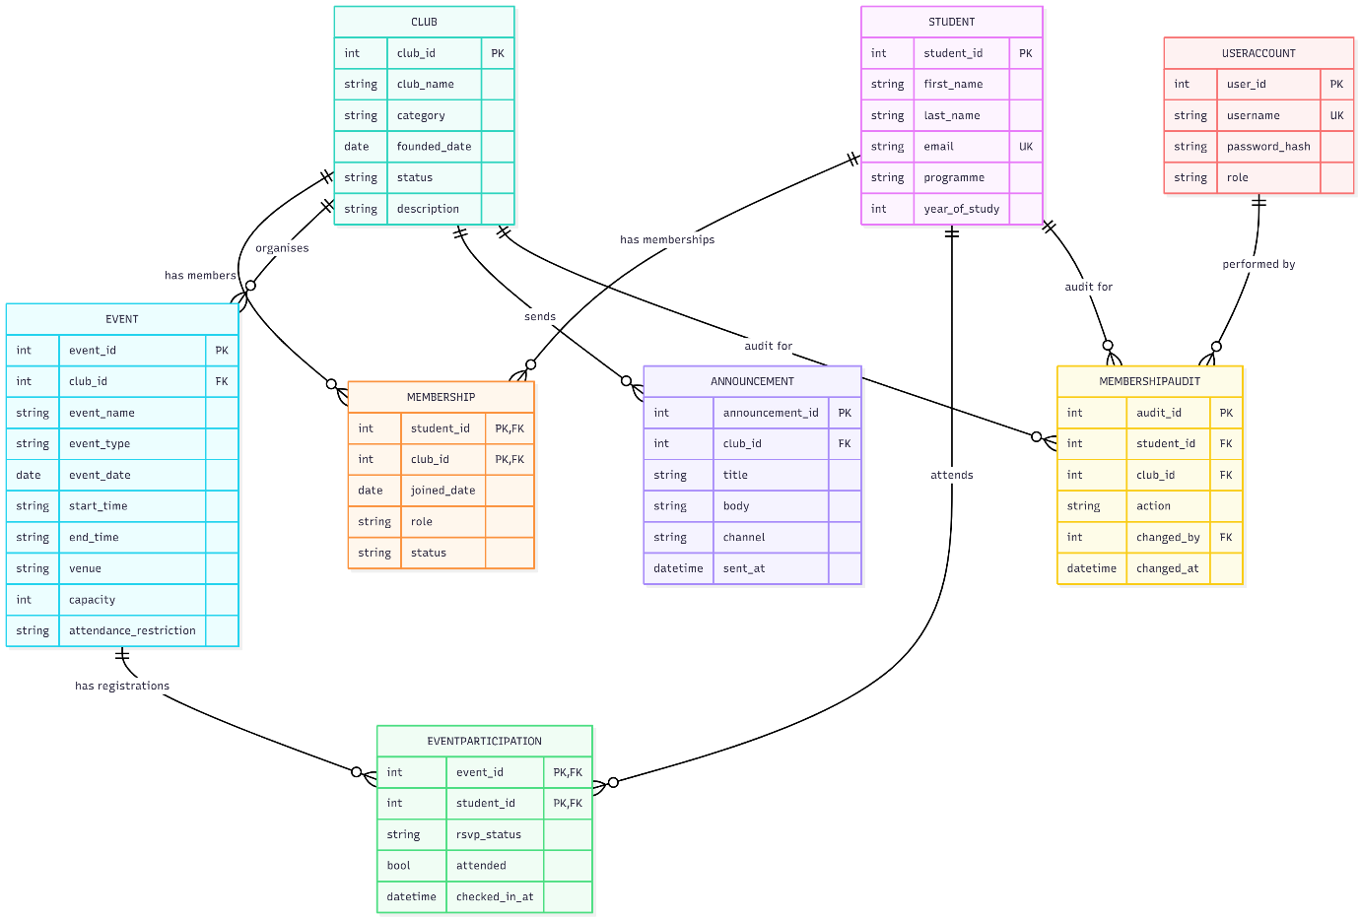
Figure 10 – Campus Club Management System ER Diagram
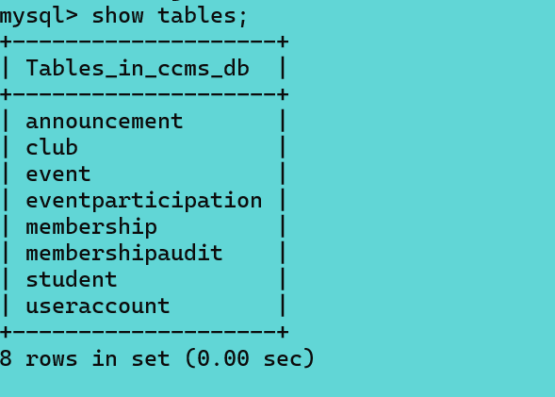
Figure 11 - The tables were successfully created as shown.
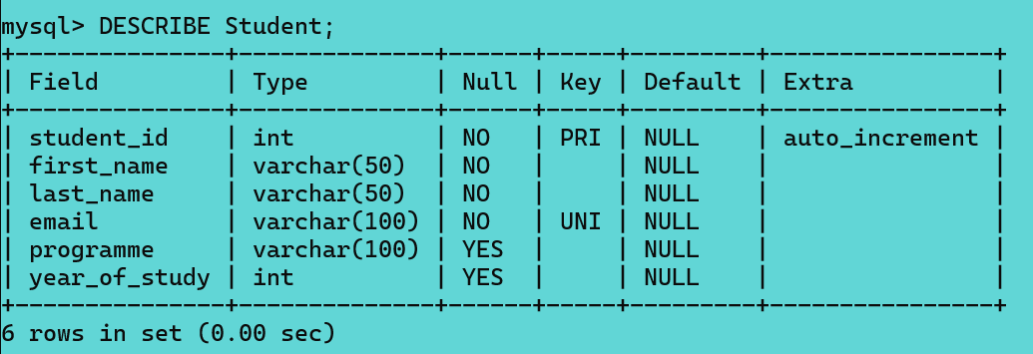
Figure 12 - Table attributes and constraints are illustrated.
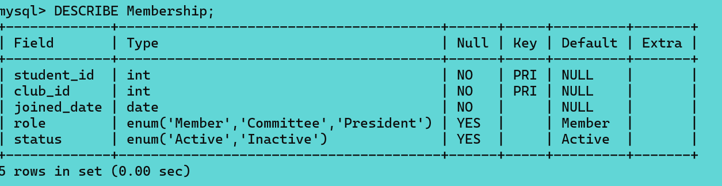
Figure 13 - Composite key.
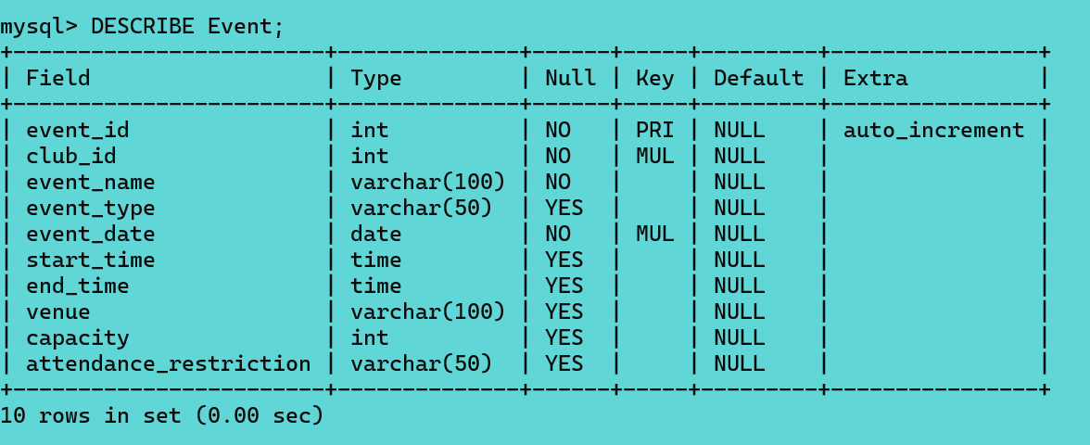
Figure 14 - Capacity CHECK.
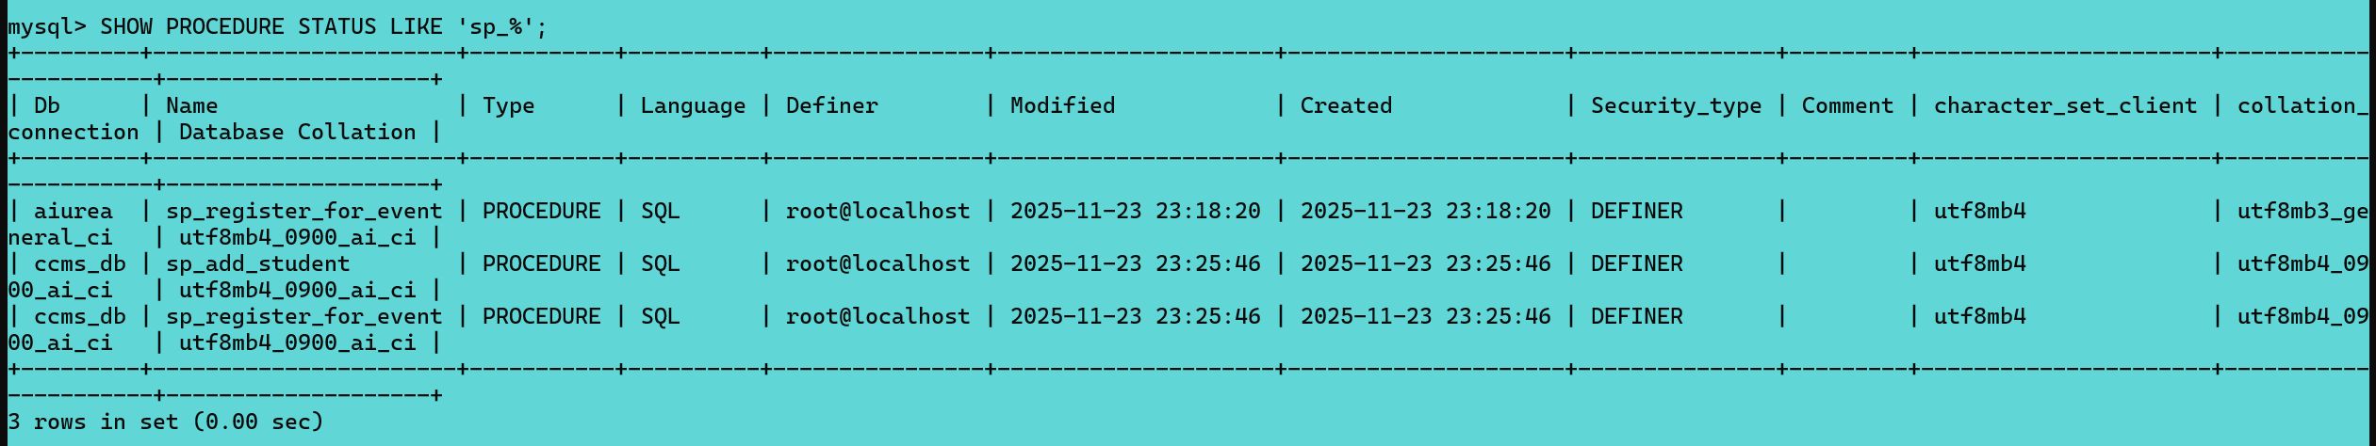
Figure 15 - Store procedures.
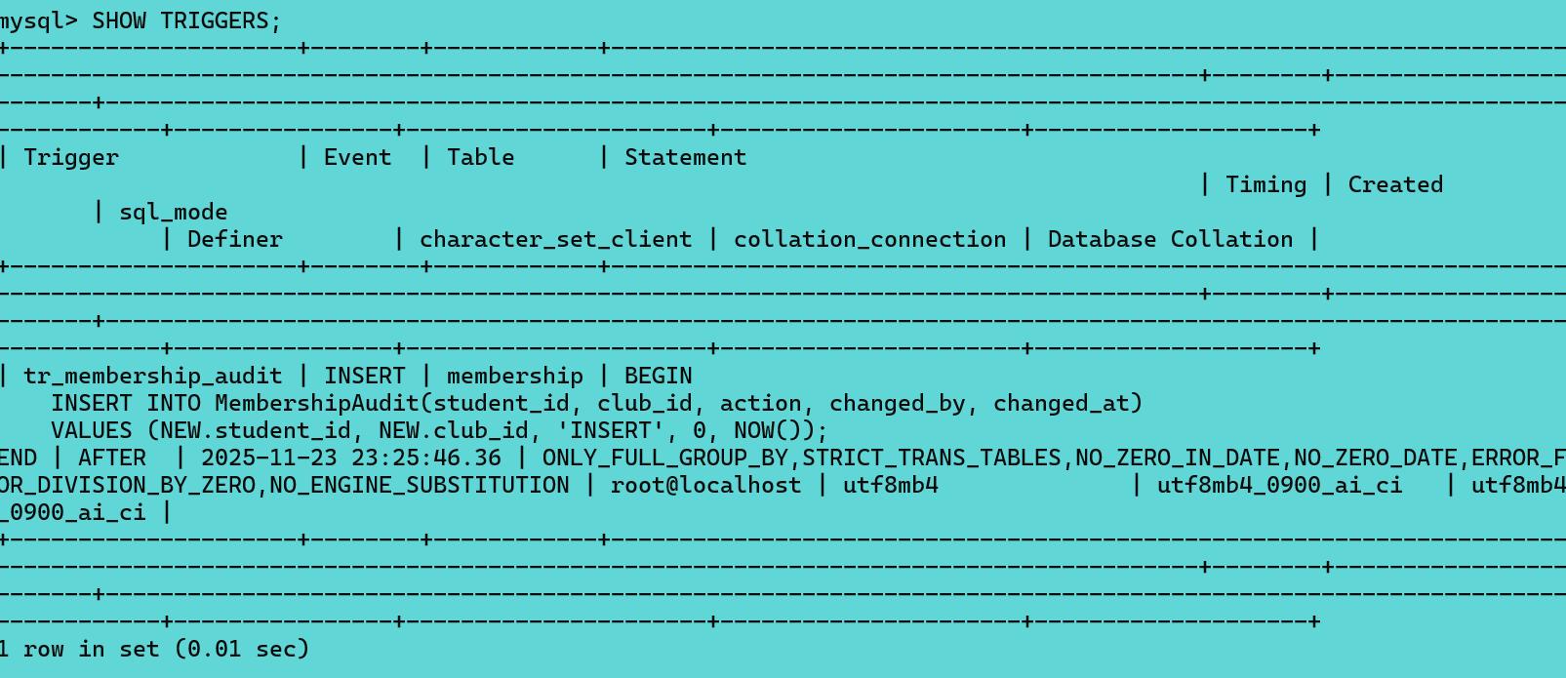
Figure 16 - Trigger output.
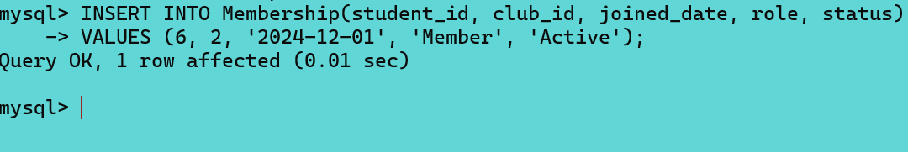
Figure 17 - Audit trigger in action.
Figure 18 - Foreign key constrain error.
Figure 19 - Check constraint error.
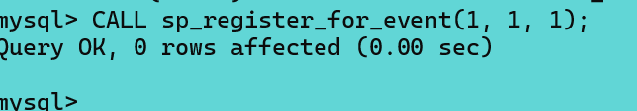
Figure 20 - Transaction successful commit.
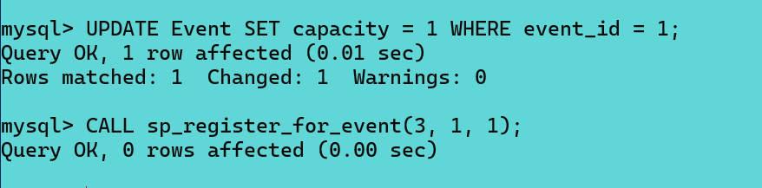
Figure 21 - Transaction rollback.
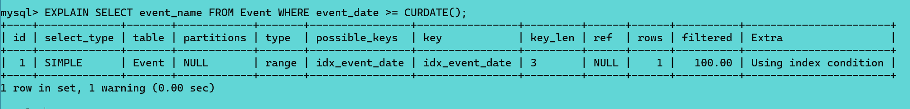
Figure 22 - Before index.
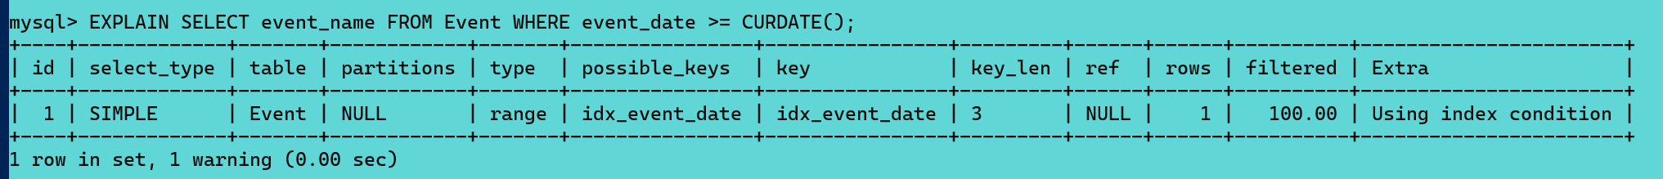
Figure 23 - After index.

APPENDIX B – Website & Security Evidence
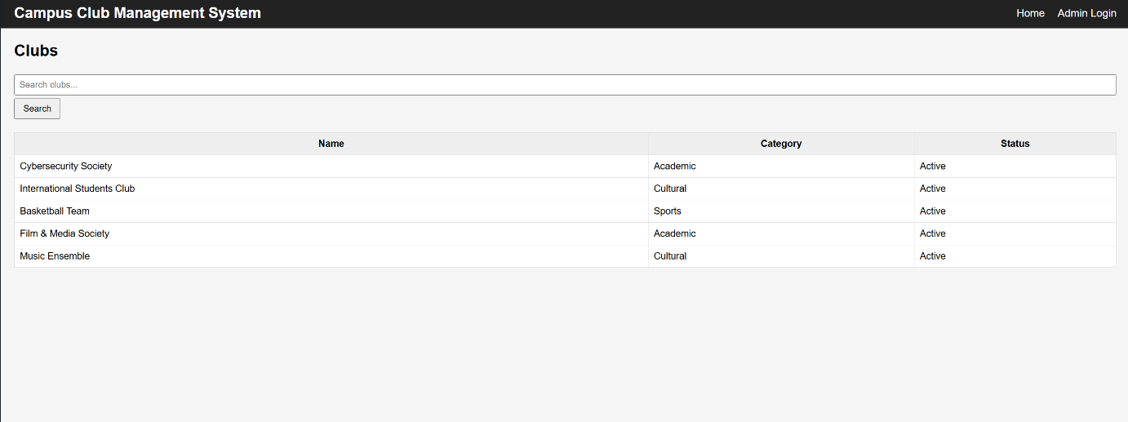
Figure 24 – Homepage with dynamic club listing.
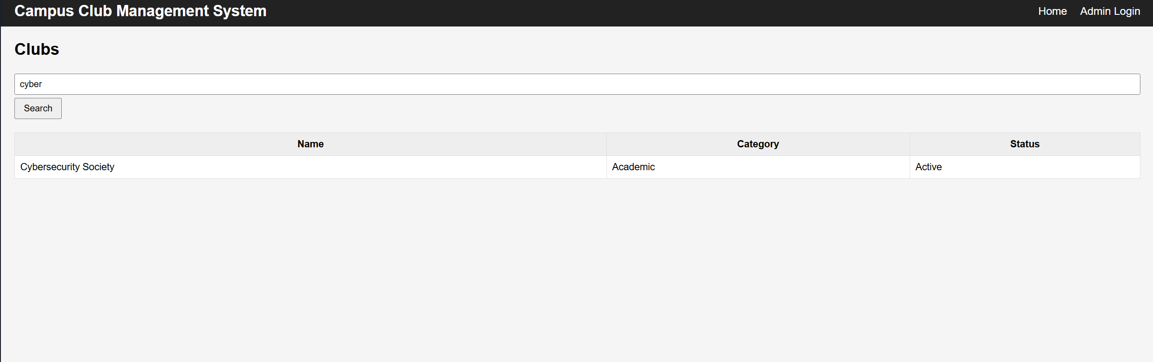
Figure 25 - Search filter in action.
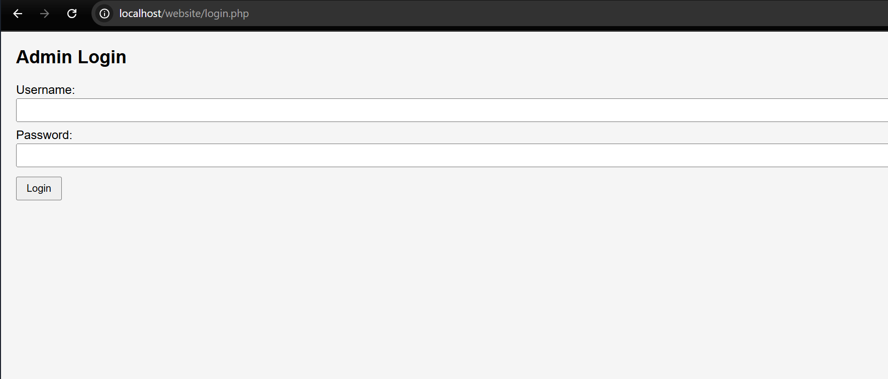
Figure 26 - Admin login page.
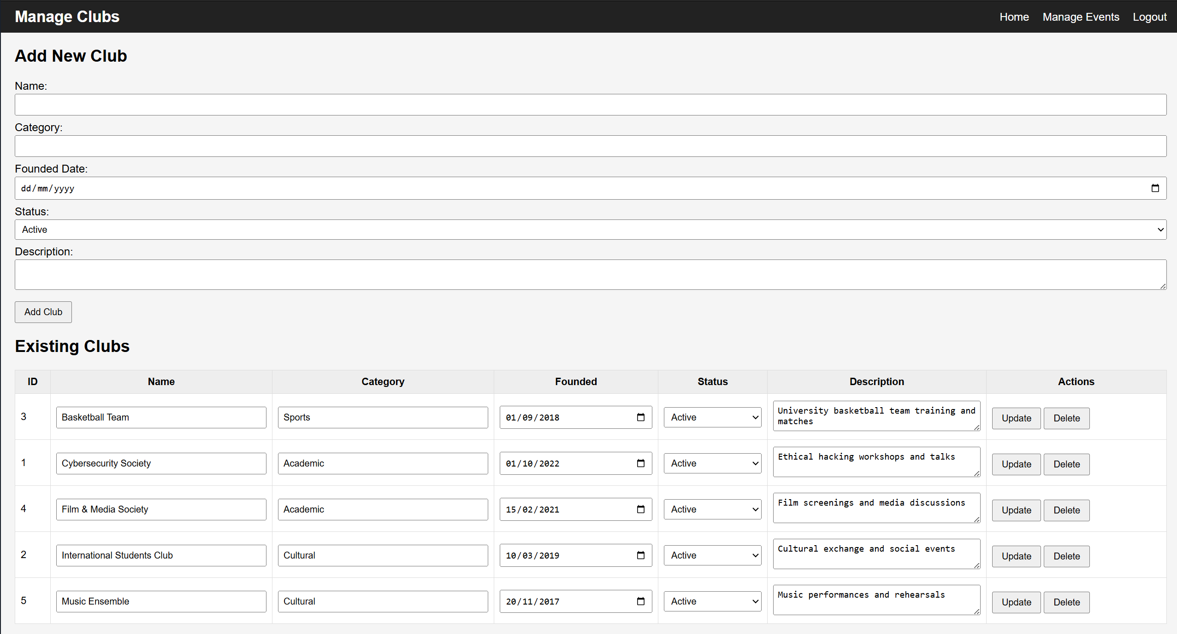
Figure 27 - Admin dashboard.
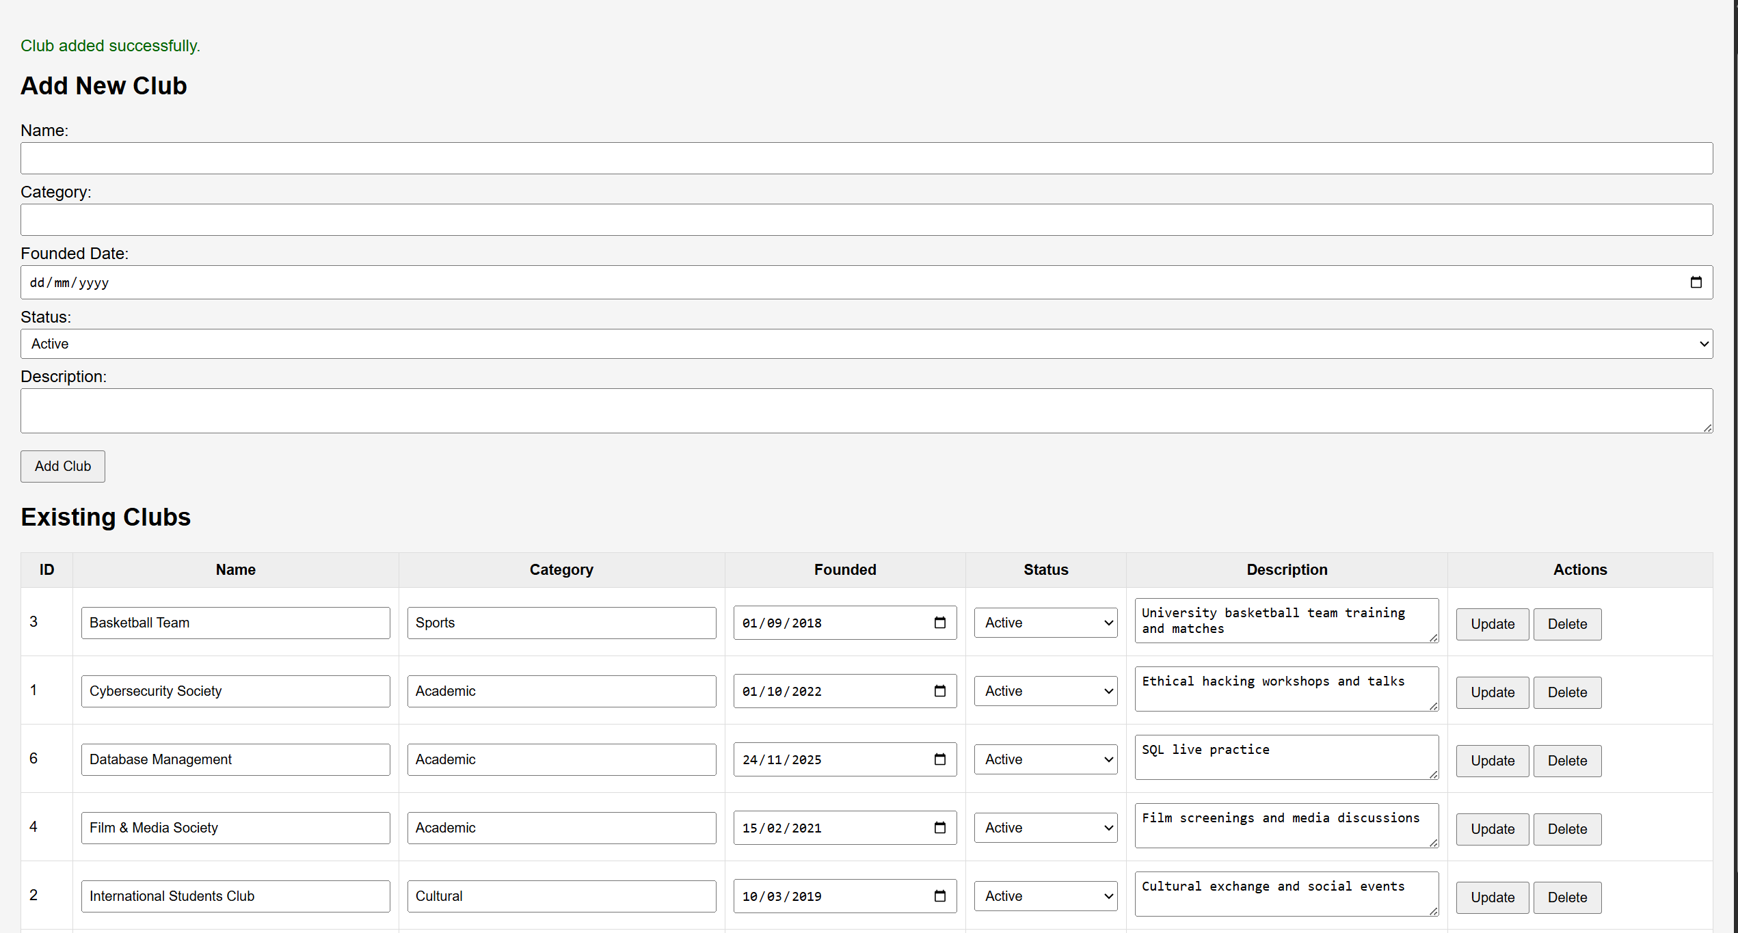
Figure 28 – CRUD - add a club.
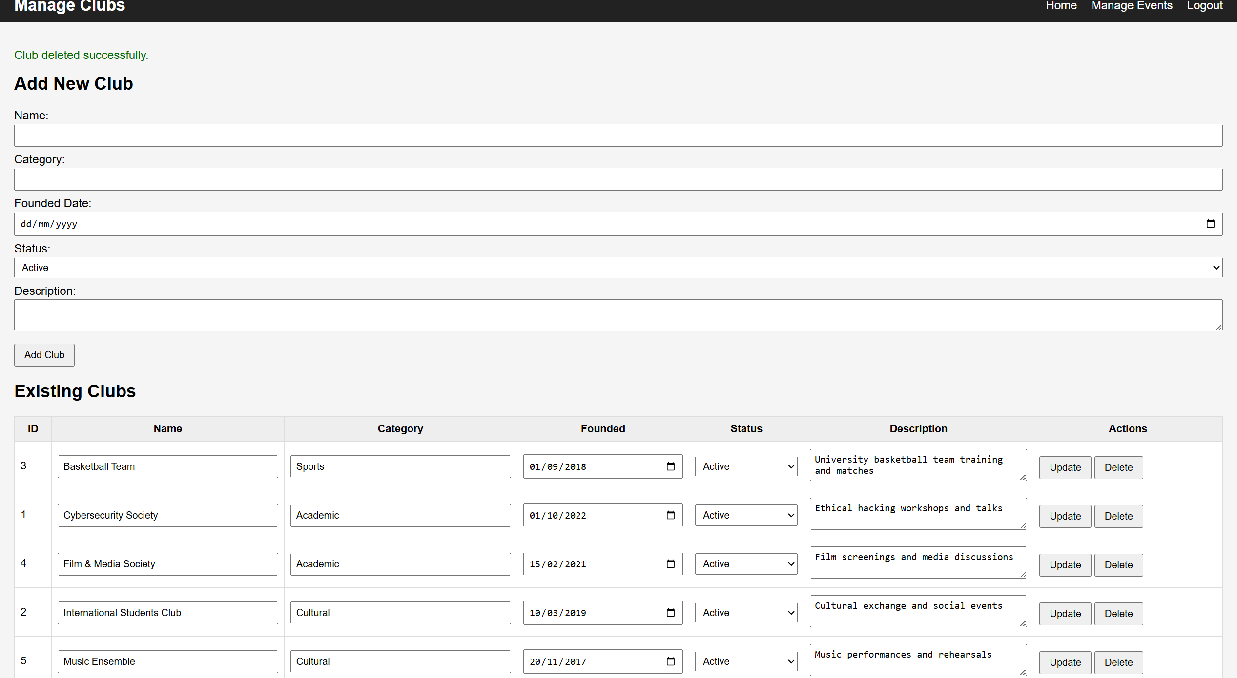
Figure 29 - CRUD - delete a club.
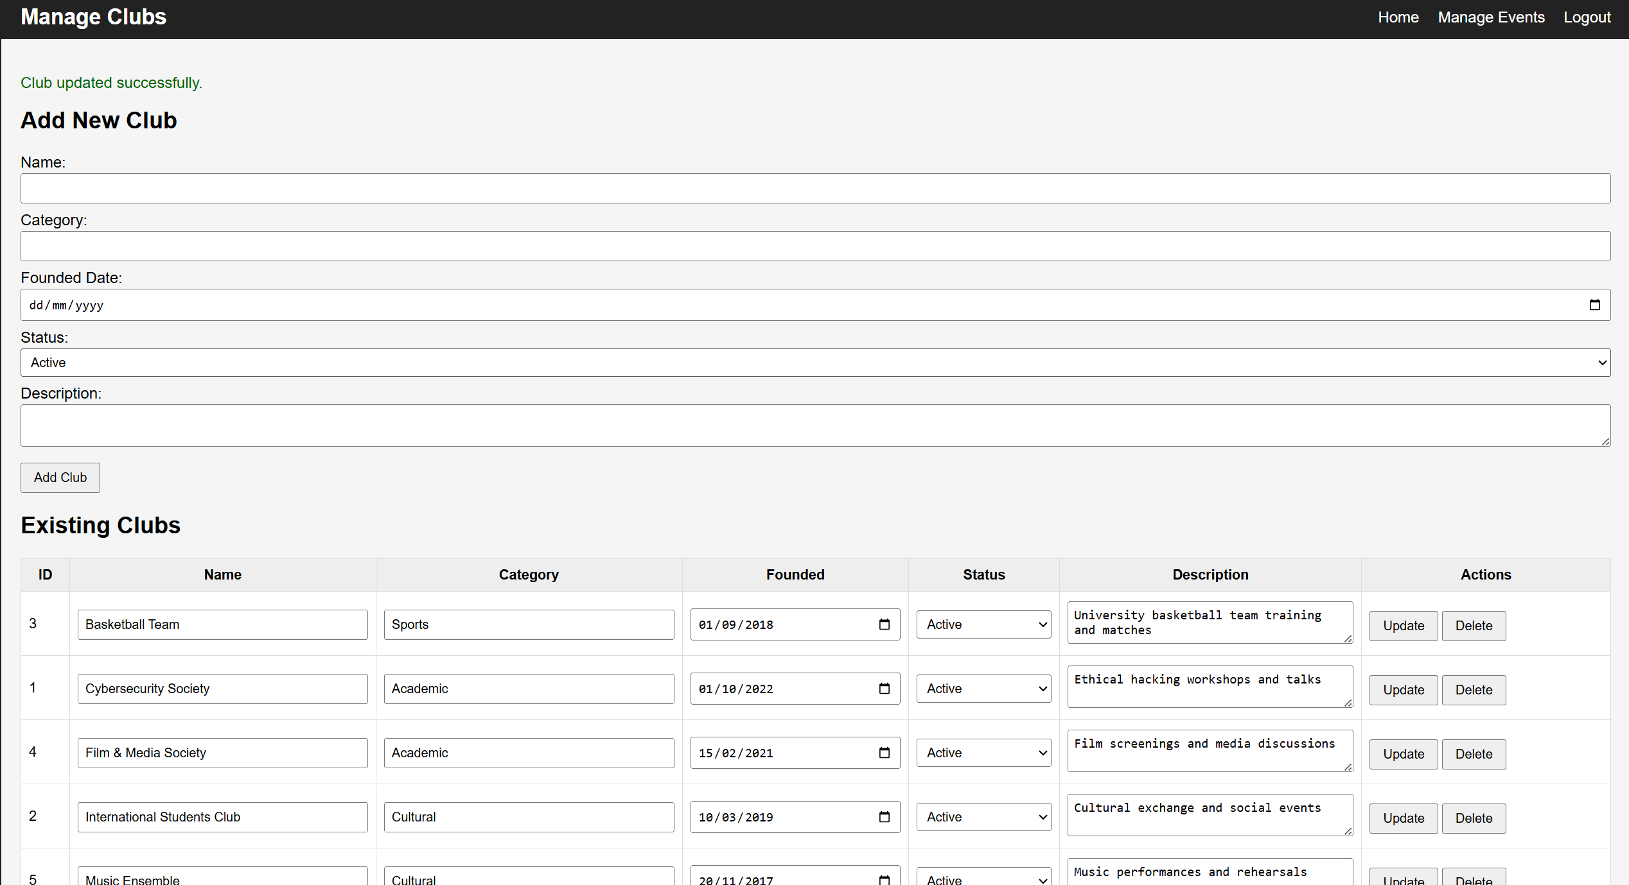
Figure 30 - Crud - update a club.
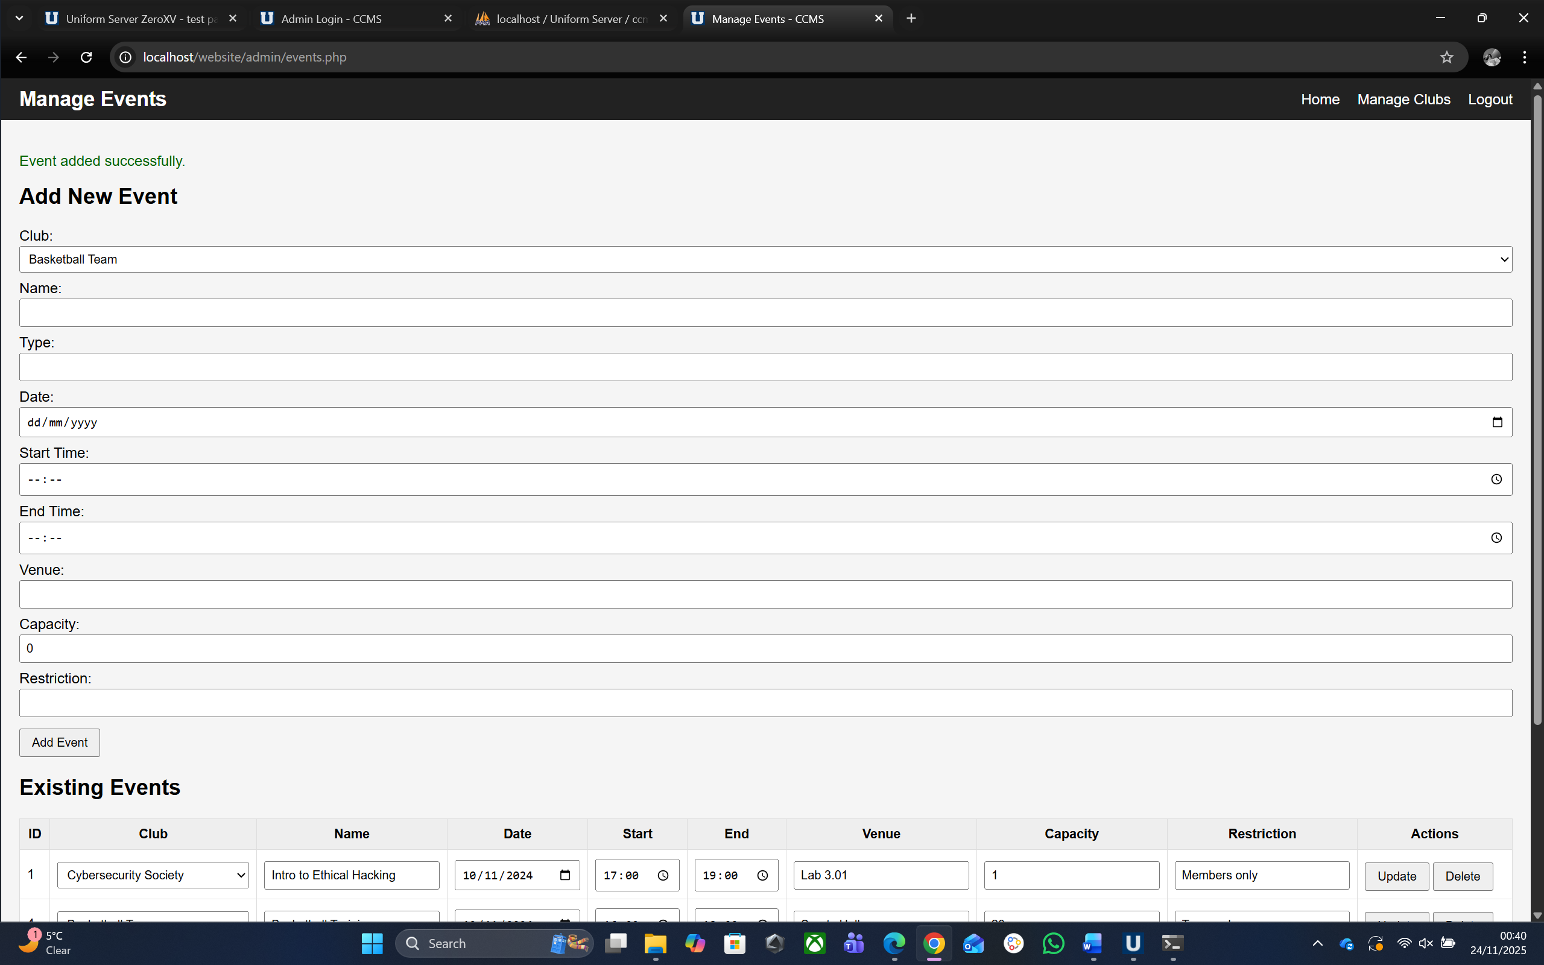
Figure 31 - CRUD - add event.
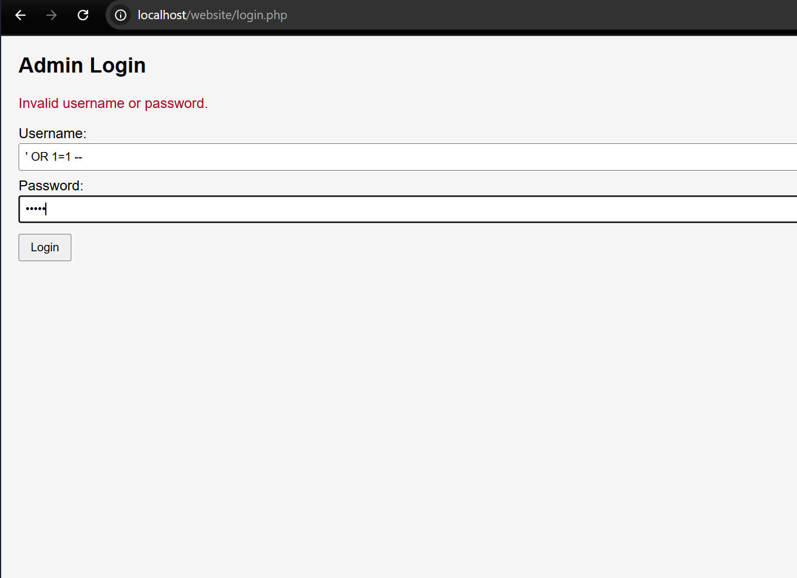
Figure 32 - SQL injection attempt - Invalid username.

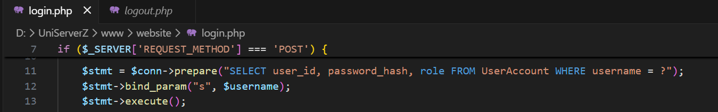
Figure 33 - SQL injection prevention.

