Advanced Industry 4.0

Reflective Essay

MSc Industry 4.0 Advanced Manufacturing

Module Code: ACPA7001

Supervisor: Gareth Frost

17th July 2023

Student: Lee Price

Email:Pricey_lee@yahoo.co.uk / Lee.Price@safran group.com




Contents
- Introduction
- Main content
- AR within manufacturing
- AI integration with AR
- Cultural change within industry
- Conclusion
- References

Introduction
The goal of this reflection report is to look at how argumentative reality (AR) and artificial intelligence (AI) could operate in the aircraft sector, with a focus on the 21G environment.
The AR review will be around how this can used to work more efficiently within the build cycle world of our manufacturing facility. This maybe within the build itself looking at how product non value added time can be removed along with implementing a right first time approach, in addition this will also review other areas like the conformity or first articles as part of our AS91002 requirements. This will then also look at the boundaries of where AI can fit into supporting these areas with focus on the algorithms that can create the discussions that provide the best outcome with the reduction of human intervention. (iqmotion, 2022) delicately reviews the way in which human error must be reduced in an effort to progress a company forward with precision and accuracy, algorithms via AI over human decisions are the correct way forward as the are clearly defined without emotional involvement.
An additional part of this reflective paper is to consider the challenges of embedding these changes with a transformation plan that will be bought into by all levels of the business. More often than not radical changes are not well received if not communicated correctly, a large percentage of the work force believe that a heavy change like AR or AI are placed in a business to reduce the workforce in an attempt to streamline the business.
The business is regulated through AS91000 along with guidance from the CAA and FAA of 21G, within this we must be careful that new technology does not hide traceability that requires to be demonstrated. The majority of audits require justifications against guidelines that do not have boundaries, there are clear scopes of what is acceptable to create conforming product that is eligible for flight. AI must have these elements taken into consideration so regulatory compliance can be achieved to produce airworthiness certificates.

Main Content
As many companies are striving towards industry 4.0 we find that there is still an analogue state present, by this we mean limited IT infrastructure. In our instance one example is the paper format on how working instructions are provided to our build operators. (Keating, 2022) highlights industry 4.0 is the move to digital and away from the analogue era however there is more than just the change in culture that is at stake, (Keating, 2022) as suggests “Industry 4.0 offers the potential for significant economic growth, with the EC estimating that digitalisation of manufacturing could add €110 billion per year to Europe’s industry base.” The current A3 sized instructions which are printed from an excel file, these are difficult to control with updates along with revision levels. The introduction into this area with AI would be a benefit in multiple ways, not only would it eradicate the previous discussed issues but also help simplify the way of working and the environments. The current set up has multiple parts to the process, not only is the working instruction a guide on how to build the product but also provides the instructions of what tools to use, consumables i.e glues / cleaning products but also customer requests i.e acceptable tolerance with gaps and steps for fitment but also safety precautions. The manufacture of these documents require the copy and paste of multiple documents into one file as previous there is no way of adding information and disseminating it in a quick / controlled manner. More often than not this is where audit findings are raised as several hundred of documents are scattered throughout the final assembly floor, this can also lead to customer complains when products are not manufactured to the correct design definition.
To resolve the above the integration of AR can support, having virtual reality under pined with real world backgrounds can show where key components or key characteristics should be. On the build line within the final assembly line of future state or embedded 4.0 we see that items like the HoloLens2 are being used. This technology provides integration of model data, working instructions, customer requirements, tooling and safety related items all at the finger tips through a peripheral lens system. (Sokolowsky, 2019) shows how Airbus has taken this technology to eliminate waste and up skill their production teams. There clear goals were to manufacture quicker, allow more support, utilize remote or off site parties which intern would provide additional capital for the company to progress and become a leader in the field. The key to this system is not only to provide data all in one place but also provide online instance support for situations that are not clear, this touches on the culture change as it provides the operator with confidence that translates to appositive work attitude. The system is not costly the payback and value of the software will out way the investment within a year, for example the headset and software is approximately £1500 per operative. The efficiency gain would provide 30 minutes more value added time available and this would provide a return per of £2500 per operative giving a payback time of 0.6 of a year. In addition to this the hardware hold value as the software can be changed to utilize other model data to support different manufacturing platforms. This is not the only platform that is available, below is an clear picture of what a company called Vuforia have developed. This provides the operator with a clear step by step guide of where items need to be placed visually overlapped as well as a written step by step guide. This product has been used not just on the final build lines but also used in the training schools to prep new starters to perfect there skill set to product right first time defect free assemblies.
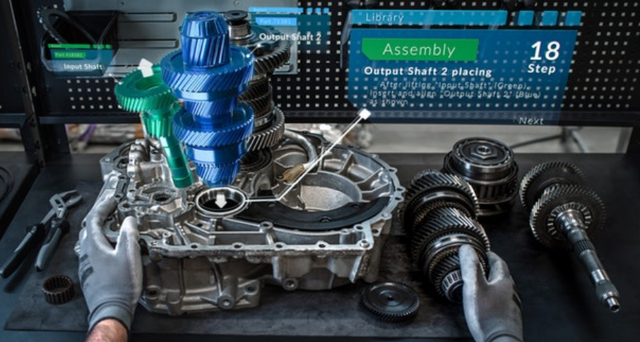
There is also an environmental change that is also affected when implementing these types of technology into the business, this come in the form of energy saving and material waste. The current workstations that are within our industry have several monitors that have data ports and power connects that are permanent. These lens systems in the form of glasses only require limited charge which are at an evening at a reduced cost in addition the paper waste from printing multiple guidelines and compliance documents are now eradicated, this help reduce the carbon footprint that support the carbon neutral goals set within modern companies. (Timperley, 2021) suggests that one flight produces as much C02 as several people in a year. This industry is a major factor to global warming, with this in mind this is why we need in innovate and evolve our products to reduce mass through structural parts, wiring and layup materials such as carbon and composite.
When we look to support the final assembly line with AI the first thoughts in many are robots taking over the work being carried out by humans. This is not the case, most areas use AI in machines to support developments in areas by allowing them to make data driven choices to learn which allows them to carry out tasks more efficiently. An example of this would be to fit a panel on an aircraft seat with the correct panel gaps as specified by the customer, the AI would continually fit the pats using algorithms to find the most effective and efficient way to complete the task. (HARRIS, 2022) highlights an additional phase to the above is adding a digital twin, this is where we can adapt a production line in a virtual state, changing processes without impacting the daily production. As this is a full replication of the production line any changes will quickly provide bottlenecks or an increase in flow process, overall this tool helps to balance the production line and test improvements to show the most efficient way of integration. When moving on to a future part the previous algorithm made up of processes, patterns and predictions would be used. This is where we would see the learnings within the robots, this is however the AI developing and if allowed we can support the learning by opening up the data access to learn by connecting the AI fully to the internet or addition IoT devices.
When we look to mix AI with AR as discussed above for an operator on the final assembly line we can start to open up new options, for example with the AI already knowing the customer requirements and understanding the time elements required to achieve a task the AI will provide the best approach to carry out the task. The operator will then have the interaction from the AR to visually see how to complete the task selecting the correct tools and methods to complete the action. If the same operations is completed at a later date we may find the AI takes a new approach and this again is down to the algorithmic studies that the AI is carrying out in an aim to become more efficient. (+ableau, 2023) provides guidance on how complex AI algorithms are, these are learning algorithms that are either supervised or un-supervised. The base level of data is created by the originator however after this the algorithm can learn and grow making choices based on calculations. A common algorithm used is called the decision tree, this is a structured level system where decision can be made however there are breaks where checks can be carried out to check on evolution and direction, this is deemed as a safe practice. As the AI progresses in the final assembly line we find that the more content available to the system the more suggestions to the operator from the AI, this might be in the format of visual creation or adding to the AR that is available or embedding different methods that has been found in other content.
As mentioned the aim is to manage integration of this new technology into the business verse the risk that it may have, detailed research on both AR & AI for the specific areas is needed to have a seamless transition.

Culture change within industry
AR in the workplace is seen as a benefit which is why it is widely accepted by operators and their teams in the workplace. The technology provides a clear picture with little risk to jobs and security, it is seen as and add on to current tooling providing a work smarter not harder ethic. This in some cases is not the message that AI has and primarily this is down to fictional presence in films, books & conspiracies. As present as this week there are headlines in the news around AI regulation in the workplace and how it can be used. Many topics have been reviewed in this era of technology so far examples are the hiring and firing using AI without human interaction in addition financial benefits, promotions and salaries have been defined by the algorithms of AI. (Harbert, 2022) looks at how ready companies are ready to regulate AI with their companies, over 92% of companies said they were ready to invest in AI for there business however only 44% said they had well established policies and practices available to deal with the integration of AI. The main concerns highlighted are around privacy laws ensuring that the algorithms are set in such a way that they do not cross the boundaries and use this information on decisions. If the algorithms are set at unrestricted the AI will not only make decisions on this but also log this for all future decisions, this is where the rights on human choices maybe come conflicted.
The above is one of many reasons why AI is feared in the workplace, the positives around recruiting the correct person quickly, understand the best way to support an operator through efficiency and even bringing in clear diversity, equality and inclusion is moved to one side.
With the correct controls in place and the correct communications the fear factor can be undone, there will always be the first step in the algorithm which is the programmer which is the human and as such can define what is acceptable and what is not. With these being governed, audited and controlled.

Conclusion
Adding AR and AI into a business as above can provide advances in many areas transforming the business within its various key milestone areas for success, however AI needs to be controlled and developed with understanding in the correct areas.
These technologies have a great relationship in complementing one another, they have abilities to lean one another to shape a business and how operators or any production staff will integrate to provide innovation.
The investment in both areas needs to be understood, also a clear road map needs to be in place prior to implementation. (Shacklett, 2019) highlights that there is not just the cost of the software or development packages to consider but also the up-keep of the technology. This may come in the form of upskilling current employees, also power requirements, cloud costs and the evolving developments of packages that will be needed.
In our current state this technology would provide a leap in the advancement of the operational field, not only would it support the influx in workload but also start the journey of future proofing the business. At our present pace we are seeing small incremental improvements which will not provide the innovation required to grow but will see the business decline. Both areas have their abilities, simple first steps of integration could be around AI recruiting the correct staff and AR providing the training application on current product. If clear benefits are seen in this area the business is taking a step forward in the correct direction.
As always and has been seen over the industry generations we can also look to how 4.0 can move to industry 5.0. AI for instance has no limitations on how it runs, AI does not have to factor in breaks for sleep, food or toilet stops. Neither does it require lighting, heating or any other amenities, the speed at which multiple tasks can be achieved will also push this technology into the business as many will want to become the leader in this field. Certain business which are start ups will have an advantage over adapting companies, this is down to the integration being much more clear. With companies that are adapting the operational team that it effects will go through a transition which may mean relocation of job roles or even location depending on the size of the organization. However this can be where new opportunities and the development of staff throughout the business will create innovations that may not be seen by the higher management team.
Overall both technologies should be taken seriously in today’s world if economic growth is to prevail within a business. The detriment of not progressing will see a decline in growth as the speed of the current technology is extensive.
References
+ableau, 2023. Artificial intelligence (AI) algorithms: a complete overview. [Online]
Available at: https://www.tableau.com/data-insights/ai/algorithms
[Accessed 12 7 2023].
Harbert, T., 2022. Regulations Ahead on AI. [Online]
Available at: https://www.shrm.org/hr-today/news/all-things-work/pages/regulations-ahead-on-artificial-intelligence.aspx
[Accessed 18 7 2023].
HARRIS, A., 2022. AI in Manufacturing: How It’s Used and Why It’s Important for Future Factories. [Online]
Available at: https://redshift.autodesk.com/articles/ai-in-manufacturing
[Accessed 11 7 2023].
iqmotion, 2022. Can Human be Replace by Artificial Intelligence?. [Online]
Available at: https://www.iqmotion.ai/human-vs-ai/#:~:text=No%20matter%20how%20well-programmed%20AI%20machines%20are%20to,connecting%20with%20others%20is%20vital%20to%20business%20growth.
[Accessed 1 7 2023].
Keating, M., 2022. Is Industry 4.0 driving Digital Transformation?. [Online]
Available at: https://actionpointtech.co.uk/is-industry-4-0-driving-digital-transformation#:~:text=Industry%204.0%20or%20%E2%80%98The%20Fourth%20Industrial%20Revolution%E2%80%99%20refers,big%20data%2C%20IoT%2C%20robotics%20and%20other%20technological%20trends.
[Accessed 3 7 2023].
Shacklett, M., 2019. The true costs and ROI of implementing AI in the enterprise. [Online]
Available at: https://www.zdnet.com/article/the-true-costs-and-roi-of-implementing-ai-in-the-enterprise/
[Accessed 18 7 2023].
Sokolowsky, J., 2019. Airbus reaches new heights with the help of Microsoft. [Online]
Available at: https://news.microsoft.com/europe/features/airbus-reaches-new-heights-with-the-help-of-microsoft-mixed-reality-technology/#:~:text=HoloLens%20helps%20Airbus%20designers%20virtually%20test%20their%20designs,substantially%2C%20decreasing%20the%20time%20spen
[Accessed 5 7 2023].
Timperley, J., 2021. From switching the fuel they use to changing flight plans so they produce fewer contrails, airlines are searching for ways to cut their impact on the climate.. [Online]
Available at: https://www.bbc.com/future/article/20210525-how-aviation-is-reducing-its-climate-emissions
[Accessed 9 7 2023].

