Programme | BA International Hotel Management
Module | Managing Hotel Administration
Module code | BMIH6004
Student ID | Syeda Shafna Begum (2128508)
Word Count | 1293

Table of Contents

Introduction 3
Section 1: Reflection on Experience and Personal Development using Gibbs' Reflective Cycle 3
Section 2: Critical Analysis of Work-Based Skills and Technical Knowledge 5
Section 3: Reflection on Organisational Issues 6
Conclusion and Action Plan 6
References 8

Introduction
In the Holiday Inn system, the administration of the hotel is also very important so that there is effective management in running the hotel. These consist of the Front Office Department, Sales and Marketing Department, and the Finance Department which give vital support to the vital activities of hotel, check-in, bookings, payments, etc. In my 10 weeks’ attachment, I was able to accompany a supervisory position in the hotel and thus experience the working environment of the hotel industry of the United States of America including operations, management and customer service aspects at first hand.
Learning Objectives:
- Acquire a broad vision of the overall practices in the administrative course.
- Sharpen the communication, inter and intrapersonal skills and cordial interaction with professional guests.
- Develop teaming and collaboration competencies by relieving peer contact.
- Develop better organizational competencies to effectively perform multiple administrative assignments.
- Gain experience of what kinds of duties are associated with supervisor and managerial positions.

Section 1: Reflection on Experience and Personal Development using Gibbs' Reflective Cycle
Gibbs' Reflective Cycle (1988) is a framework that encourages a structured approach to reflection, comprising six stages (Hayes, Ninemeier and Miller, 2017). A road map that is comprised of the following components – Description, Feelings, Evaluation, Analysis, Conclusion, and Action Plan. This was the perspective I employed when engaging the reflection-model for the activity of shadowing a supervisor and the experience as a self- and interpersonal development.
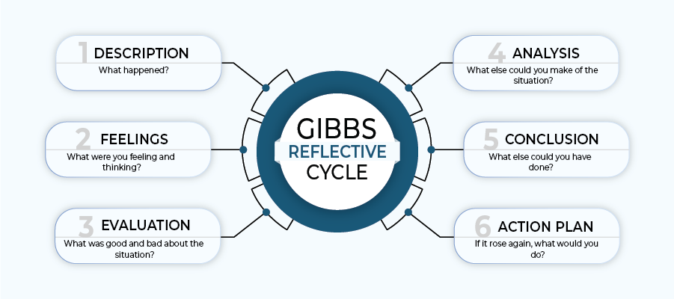
Gibbs Reflective Cycle (Walker, 2021)
Description: In my practical assignment, I followed the supervisor to be able to observe different activities, which are crucial for management of a hotel. Such jobs included responding to clientele’s inquiries, booking and liaising with other departments to guarantee satisfactory customer experience (Walker, 2021). For instance, in the Front Office, I learned how the supervisor handled complaints from the guests and kept on checking on the housekeeping and maintenance departments. This was also an opportune time to get to perform most of a clerk’s tasks in the practical setting of a hotel setting with lots of guests and activities.
Feelings: When I got the placement, I was a little happy but at the same time I was also a little worried because I was expecting that I must do more customer service jobs and at the same time maintain operations of the company. But getting to practice it as a supervisor seeing how he tackles different difficulties was very helpful in boosting the confidence level. I had a good feeling each time I was able to answer guest questions, or schedule some of the tasks. But over the years it has developed into a keen interest to learn more and to be the most effective part of the team.
Evaluation: The advantages and disadvantages were observed when I was shadowing the supervisor. On the positive side I learned how to handle relations with guests professionally and without getting easily annoyed. The concepts taught me about guests needs and having empathy while offering solutions while a guest was precipitate were superb for my communication skills. But the most difficult tasks were dealing with the rate of work, that was very high, and the need for immediate decision-making. This forced me to work on my organizational and time management and skills as well as ability to handle many tasks at the same time which are essential skills when working for any hotel.
Analysis: I was also able to understand concepts learnt in my management and customer service academic courses like priority of guests and proper functioning of an organization. However, the placement offered a richer idea of how these principles could be implemented. For instance, through my experience I realised that for efficient operations to be achieved, especially during busy days of the guests, effective and efficient communication should be enhanced.
Conclusion: This made me realize how important communication, working with others and planning and organizing tasks are to the administration of a hotel. I also acknowledged the need to be flexible when dealing with challenges since it directly impacted on guest satisfaction. In a similar context if I have an opportunity to plan and do this again then I will also pay more attention to planning strategies for dealing with busy hours. As an overview of my experiences over the course of shadowing a supervisor, I have gained a far deeper understanding of how a hotel functions and what it takes to be a successful member of this industry.
Action Plan: In the future, I will try to advance this experience in such way as to improve my communication and organizational skills. To enhance the technical aspect, I want to pursue more practical experience on property management systems. Furthermore, I will focus on developing confidence in decision-making and management of tasks which are crucial when taking supervisory positions, especially in the hotel system.

Section 2: Critical Analysis of Work-Based Skills and Technical Knowledge
The placement enables me to realise the importance of acquiring work-related skills and knowledge of administration in a hotel. These soft skills include Prioritization of tasks, Communication and Problem solving were deemed relevant in handling of administration challenges (Ouyang, Wei and Chi, 2019). For instance, I noticed that using property management software, work processes such as booking, and guest details management as well as room status became easier and more efficient. This technical knowledge is critical to determine if the expected standards of guests’ experience and organizational flowing are met.
Furthermore, the placement also demonstrated the significance of communication theory, since effective and effective forms of communication including guest and team member interaction improve the guest experience. Applying 5 Ps (People, Process, Product, Price, and Promotion) (Fayol, 2016) model at the Sales Office was helpful to ascertain more generic customer services perspectives and showed that a specific focus on the elements helps to improve guest satisfaction and loyalty.

Section 3: Reflection on Organisational Issues
The problem that I see is poor communication between the departments, especially during periods of high occupancy between the Front Office and Housekeeping departments. Miscommunication sometimes causes delays on the side of guest check-ins, and this dilutes the guest experience. Not only did it interfere with business processes, but it also instilled pressure on overworked team members.
They had learnt that communication in such a system required the establishment of efficient communication protocols. See for example how the supervisor addressed this problem by acknowledging the efforts of the organisation in the use of a common technologically shared medium for inter-department updates in real time; an aspect underpinning the significance of structure in the running of a hotel.
Proposed Solution: Cross departmental meetings should be conducted frequently particularly during busy periods to ensure that there is a common understanding of the state of the rooms and guests’ needs (Bathla, Rana and Singh, 2019). Furthermore, introducing an effective working tracking system in an organization that can be accessed by all departments who require access might be useful. This idea seems to be supported by Herzberg’s Two-Factor Theory that states that the factors which increase the rate of job satisfaction equally improve job performance when communication and stress are minimized.

Conclusion and Action Plan
The Holiday Inn work placement was an informative academic and personal development trip. Based on what Gibbs’ Cycle provided me with, I was able to generate a deeper insight into the experiences from the module focusing on communication, tasks, and teamwork skills. This gave me rich experience of supervisory role at a hotel and the feeling of the job, which helped me to gain more focus on extending my career in hotel administration.
In my future professional growth, I will work on improving my technical and organizational competencies, and learn about various useful programs, as well as on developing communication strategies. I also need to increase guest relation competencies in terms of customer relations and conflict solving to prepare for supervisory positions in the future administration of hotels.

References
Akel, G. and Noyan, E., 2024. Exploring the criteria for a green and smart hotel: insights from hotel managers' perspectives. Journal of Hospitality and Tourism Insights.
ASET., 2017. Good Practice Guide for Workbased and Placement Learning in Higher Education. Sheffield: ASET.
Bathla, G., Rana, S. and Singh, A., 2019. Exploring the gaps between hotel management education and industry expectations. Journal of Management Research and Analysis, 6(2), pp.250-252.
Chan, E.S., Okumus, F. and Chan, W., 2018. Barriers to environmental technology adoption in hotels. Journal of Hospitality & Tourism Research, 42(5), pp.829-852.
Fayol, H., 2016. General and industrial management. Ravenio Books.
Gallo, P., Timková, V., Šenková, A. and Karahuta, M., 2018. Use of dashboards in predicting the development of the company using neural networks in hotel management. GeoJournal of Tourism and Geosites, 22(2), pp.307-316.
Gido, J., Clements, J. and Baker, R., 2018. Successful project management. Cengage Learning.
Hayes, D.K., Ninemeier, J.D. and Miller, A.A., 2017. Hotel operations management. Pearson.
Henschel, U.K., Gruner, A. and Von Freyberg, B., 2018. Hotelmanagement. Walter de Gruyter GmbH & Co KG.
Keller, G., 2018. Statistics for management and economics. Cengage Learning.
Nain, A., 2018. A study on major challenges faced by hotel industry globally. International Journal of Creative Research Thoughts, 6(1), pp.561-571.
Ouyang, Z., Wei, W. and Chi, C.G., 2019. Environment management in the hotel industry: does institutional environment matter?. International Journal of Hospitality Management, 77, pp.353-364.
Shin, H., Perdue, R.R. and Kang, J., 2019. Front desk technology innovation in hotels: A managerial perspective. Tourism Management, 74, pp.310-318.
Walker, J.C., 2021. Introduction to Hospitality. 8 th Ed. Harlow: Pearson Education Limited.

