Task 1: Locating Sources
Identify and locate three different sources (a report, a journal article, and a website) related to the question
“What employability skills do business graduates need to succeed in the modern workplace?”
Show how you used keywords, search terms, and Boolean operators to find them, and explain how you know which type of source each one is and why it is appropriate for the research question.

Source Type & Why It Is Appropriate | URL/DOI | What search engine did you use? Google/Online Library/Library AI Assistant | Keywords/Boolean Operators Used
Journal Article. | https://librarysearch.uwtsd.ac.uk/permalink/44WHELF_UWTSD/1bmis16/cdi_emerald_primary_10_1108_HESWBL-10-2019-0148 | UWTSD Online Library. | "employability skills" AND "workplace" AND "graduates"

Task 2: Evaluating Information (CRAAP Test)
Your colleague has forwarded you a source from a peer reviewed journal, and they are not sure whether it is appropriate to use and has asked for your help. Your task is to evaluate the source by using the CRAAP Test to assess its appropriateness.
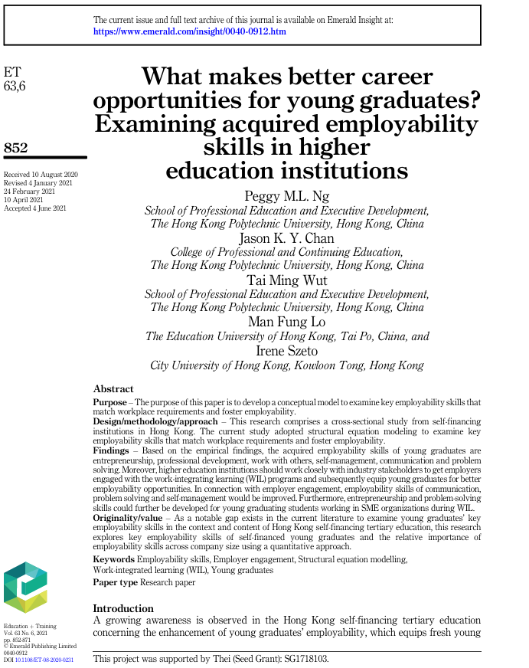

CRAAP Test
Currency | The journal articles timelines of its revision and publishing fall between the years of 2020 and 2021. Due to these dates occurring within a 10-year timespan to the present year, the journal article can be evaluated as amply current.
Relevance | Both the abstract and title contain keywords and terms which relate to the overarching question, those being “employability skills”, “graduates”, and “career opportunities”. As these terms are present, the article can be considered extremely relevant to answering the question.
Authority | There are five authors who collaborated on compiling information in this journal article. Each author has their role in university listed. Their respective roles indicate a shared yet extensive bound of knowledge concerning the continuation and development of higher education.
Accuracy | Due to this article being revised and published within a journal, it is highly likely that this article is accurate to the best of the authors knowledge. This is due to the exhaustive peer-review process the article undergoes by other critics or experts within the field of study.
Purpose | The authors clearly state the purpose to be derived from the article. In essence, the authors wish to provide a fully conceptualised model which allows newly gradates to be equipped with the most desirable skills required in the workplace.

Task 3: Source Analysis
Your manager has provided you with a short extract from a source and has asked you to analyse the source by Identifying one strength, one weakness, and providing a brief explanation of the strength and weakness identified.
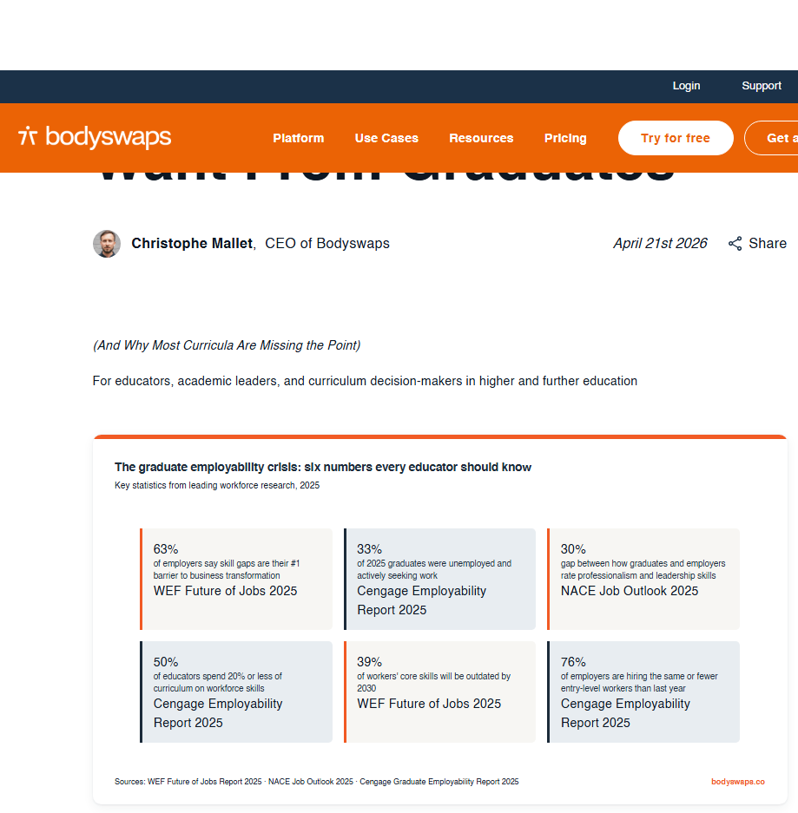
.

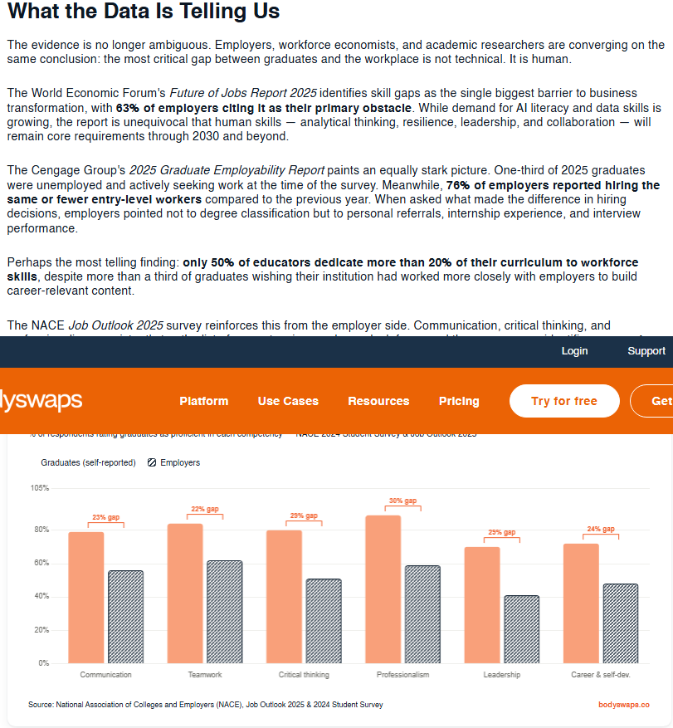

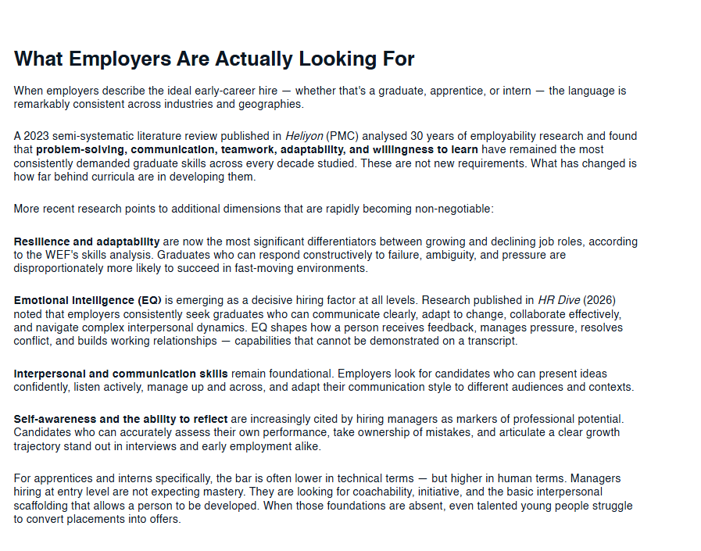

Please click the link, if you wish to read the article online.
What Employers Actually Want From Graduates

Strength of the Source:
The source provided is a webpage. An underappreciated strength this source provides is its absolute accessibility to the public, meaning the information uploaded can now reach a wider audience who are not inhibited from accessing information due to paywalls.

Weakness of the Source:
Unfortunately, webpages often go completely unvetted by external sources. They do not undergo and exhaustive peer-review process and so, the accuracy and credibility of the text can go under scrutiny. The authors may contain bias and have the desire to purposefully spread misinformation or disinformation in hopes to sway a wider audience, or in this case, purchase their offered services.

