Lesson Plan Phase 1

Lesson Plan – Step 1 Cynllun Gwers – Cam 1

Student-teacher |  | Class: | 8.1
AoLE or Subject | Geography | Date: | 08.11.19 L5
Lesson Focus: | Antarctica
Meaningful links to Curriculum | Weather, Climate and Ecosystems  Identifying and describing features of an unfamiliar landscape in an unfamiliar place.
Meaningful links to:  Cross Curricular Responsibilities | Literacy – Pupils will think of adjectives to describe an unfamiliar place.
Personal Targets (Linked to QTS and identified in weekly review)
N/A

Learning Objectives (focus on Learning- use accessible vocabulary):
The pupils will learn to:

- Find the language to describe Antarctica
- Compare descriptions of Antarctica

Success Criteria (clearly linked to each Learning Objective and related to the process and/or product of learning) | Assessment of Pupils’ Learning  Evidence  (What have the learners to say/write/do/produce – to demonstrate learning)
- Complete adjective wheel to describe images of Antarctica  - Peer assess adjective wheel to develop language.  - Compare explorer’s description to their own description of Antarctica | - Peer assess partner’s adjective wheel.  - Adjective bingo to compare adjectives used to describe Antarctica.

Time | Activities/Methodology/Key Concepts  (Teacher’s Role – including key teaching points, differentiation strategies and key questions) | Pupil Tasks  (Pupils’ role –including differentiation, engagement in formative assessment and homework) | Resources  (Including Health and Safety requirement)
Opening phase  5 mins | Incidental Welsh – greetings, date etc  Ask class where they think a photo was taken, and how do they know.  Show Learning Objectives on board | Identify Antarctica from a photograph.  Antarctica was introduced with a short video clip the previous lesson. | Photograph of penguins on ice in Antarctica.
Teaching & Core Learning  15 mins  5 mins  10 mins  5 mins  10 mins  5 mins | Images of Antarctica to be shown by Powerpoint.  Instruct class to list adjectives on their adjective wheel worksheet to describe the images.  Tell class to swap with a partner.  Instruct class to add adjectives to partner’s adjective wheel to develop the language of the pupils.  Explain that Antarctica is a place of extremes – show superlative words that emphasise this.  Play video of Palin’s journey to Antarctica. Explain ‘Adjective Bingo’ to class.  A second Youtube Video if time allows.  Ask class how many adjectives they matched with Palin’s. | As the images are being shown, class to list adjectives that describe the images of Antarctica on an adjective wheel.  (MAT to fill outer circle)  Swap adjective wheel with partner.  Pupils to add additional adjectives to the wheel with purple pens.  Class to add superlatives to their adjective wheel.  Class to glue adjective wheels worksheets into their exercise books.  Class to play ‘Adjective bingo’ whilst watching video, circling the adjectives they have written in their wheel as they hear them used by Palin.  Hands up to however many they matched. | Powerpoint images of Antarctica.  Adjective wheels x 29+  Purple pens x 29+  Powerpoint slide with superlatives  Glue  Exercise books  https://www.youtube.com/watch?v=on1Xdy_PmWQ  Video clip of Michael Palin’s Pole to Pole Episode 8, Scenes 3 & 4  https://www.youtube.com/watch?v=X3uT89xoKuc  National Geographic Kids Youtube Video  Antarctica – Destination World
Plenary  5 mins | What have we learned today? | Pupils to raise hands to suggest what we have learned about Antarctica today.

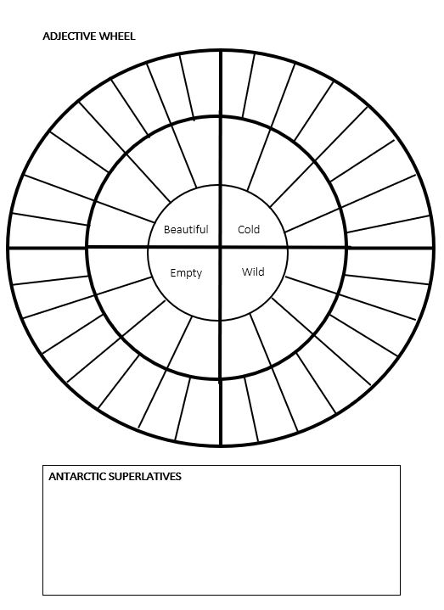

Lesson Plan – Phase 1
Evaluation of the Learning Experience
(include references to QTS)

Evaluation of Pupil Learning

Evidence of Learning (including attitude to learning over time)
Next Steps for Progress

Reflective Analysis of Teaching and Strategies For Development – including justification/rationale for pedagogical choices

Evidence of my Effective Practice

Areas for my Development

Personal Targets for Progress

