
Master of Business Administration
International Business pathway



Contemporary employability skills
Assessment 1: Individual report. Weight: 100%

Module name: International Business Concepts
Module code: LCMB7034
Lecturer name: Dr. Charles Oham

Student name: Yagnik Nayak
Student ID: 2532710

Word count: 5400 Approx.
Submission date: 14th Aug 2026

Acknowledgement 1: ChatGPT (OpenAI) – Research Support
I acknowledge the use of ChatGPT (OpenAI) in August 2026 to support background research for my analysis of 7-Eleven’s potential entry into Germany. I used the prompt(s):
- Summarise 7-Eleven’s international business model and global strategy, including its organisational structure and international expansion approach.
- Analyze the key political, economic, legal and cultural factors affecting 7-Eleven’s potential entry into Germany.
- Explain Dunning’s OLI paradigm and evaluate suitable entry modes for 7-Eleven in Germany, including licensing, franchising, joint ventures and direct investment.
I confirm that I have not presented any AI-generated text as my own work. I used ChatGPT only to support my research, and the final analysis was based on the sources referenced in my assessment.

Acknowledgement 2: ChatGPT (OpenAI) – AI Image Generation
I acknowledge the use of ChatGPT (OpenAI) in August 2026 to generate illustrative images and diagrams used to visually support my assessment. I used the prompt(s):
- Generate a professional 3D-style visual illustrating 7-Eleven’s international business strategy and Bartlett and Ghoshal’s organisational typology.
- Generate professional supporting visuals for 7-Eleven’s potential entry into Germany, including Germany’s macro-environment, Späti convenience-store culture and Dunning’s OLI framework.
- Generate a professional 3D visual illustrating 7-Eleven’s recommended market-entry strategy into Germany, with Berlin as the proposed initial market.
I confirm that the AI-generated images were used only as supporting illustrations and not as substitutes for academic evidence or analysis

7-Eleven's entry into Germany

Table of Contents
Acknowledgement 1: ChatGPT (OpenAI) – Research Support 2
Acknowledgement 2: ChatGPT (OpenAI) – AI Image Generation 2
INTRODUCTION 5
1. ORGANISATIONAL CLASSIFICATION AND GLOBAL STRATEGY 6
2. MACRO-ENVIRONMENTAL APPRAISAL AND MARKET ATTRACTIVENESS 9
2.1 Host Country Analysis 9
2.2 Market Entry Synthesis: Dunning's Eclectic Paradigm (OLI) 15
3. ENTRY MODE STRATEGY AND STRATEGIC SYNTHESIS 18
3.1 Historical Pattern Recognition 18
3.2 Strategic Fit and Justification 19
3.3 Conclusion and Recommendations 21
SECTION 2: REFLECTIVE ACCOUNT 23
Description 23
Feelings 23
Evaluation 24
Analysis 24
Conclusion 25
Action Plan 25
REFERENCE 26

INTRODUCTION

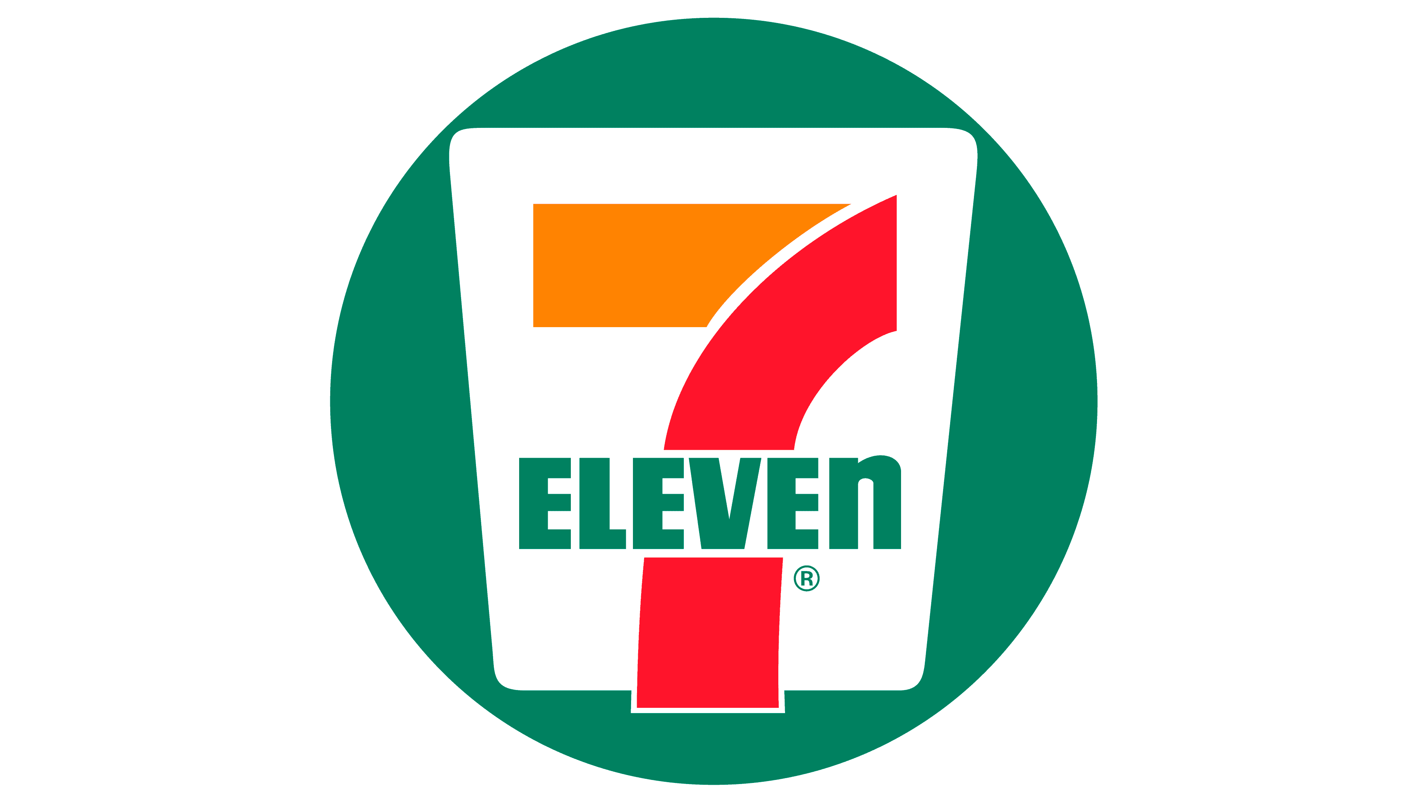

7-Eleven, Inc. logo (used for identification purposes only). © Seven & i Holdings / 7-Eleven, Inc.

- 7-Eleven is part of the Japanese convenience store group, Seven & i Holdings, with over 80,000 stores in 20 countries and regions worldwide. The brand was established in Texas in 1927 and later acquired by its Japanese licensee in 1991, with most of its revenues coming from Japan and North America – Seven & I Holdings reported total assets of ¥7.32 trillion in FY2024 with 7-Eleven, Inc. (Seven & I Holdings, 2025). It is based on a mainly franchise-based network, high stock turnover and a new product concept which has been developed over decades in Japan and increasingly in the export markets.

- This size, however, and as of June 2026, 7-Eleven has no presence in Germany. The company acknowledges this directly, as it states in its own strategic disclosure in February 2024 that it is “absent from the UK, France, Germany and Italy, advanced economies that are members of the G7” (Seven & i Holdings, 2024). This is a useful case for analysis as the German market has been named by 7-Eleven's own management as a priority market, and attempts made to enter the market, such as the 2004 licensing agreement, and the 2023 recruitment franchise initiative have seen nothing opened.

- This report classifies 7-Eleven at a global level, assesses the macro-environment attractiveness of Germany and then summarizes a proposed entry mode strategy into Germany.

1. ORGANISATIONAL CLASSIFICATION AND GLOBAL STRATEGY
Strategic Categorization

- If we follow Bartlett and Ghoshal (1989) typology, 7-Eleven is not easily placed into one type of store, and this uncertainty is, too, a useful analytical category. A pure Global strategy is immediately rejected: the company explicitly does not have products that are standardised centrally but designed in each country, such as Spam musubi in Hawaii, chef-designed meals in Thailand and bubble tea in Taiwan. This high local responsiveness could rather mean adopting the Multinational (federative) model whereby national units are run as quasi-entrepreneurs. Seven & i also has centralised support programmes that cover all area licensees in Singapore, China, Vietnam, Thailand and Korea, with standardised approaches to site selection, product quality, and distribution, which is not a true federation. Most tellingly, innovation flows in more than one direction: operational practices pioneered in Japan, such as data-driven, weather-responsive merchandising, are now being actively transferred into the US business via the newly developed 7-Eleven Global Technology (7GT) platform, while insights from established Western and Asian markets simultaneously inform Group-wide strategy (Seven & i Holdings, 2024). This is the hallmark of the Transnational model of Bartlett and Ghoshal (1989): a two-way capability transfer and high product adaptation.

- This categorization should be used with caution and not taken as a given. Empirically, Leong and Tan (1993) found that transnational status was the least often self-reported organisational form amongst 131 executives surveyed, with organisational forms at multinational and global firms more closely following than transnational ones the model's predictions. The organization's evolution is more appropriately seen as one that is moving toward a transnational form, characterized by a premium on Japanese administration than one that has reached the ideal state of the balanced multidirectional network that Bartlett and Ghoshal identify.

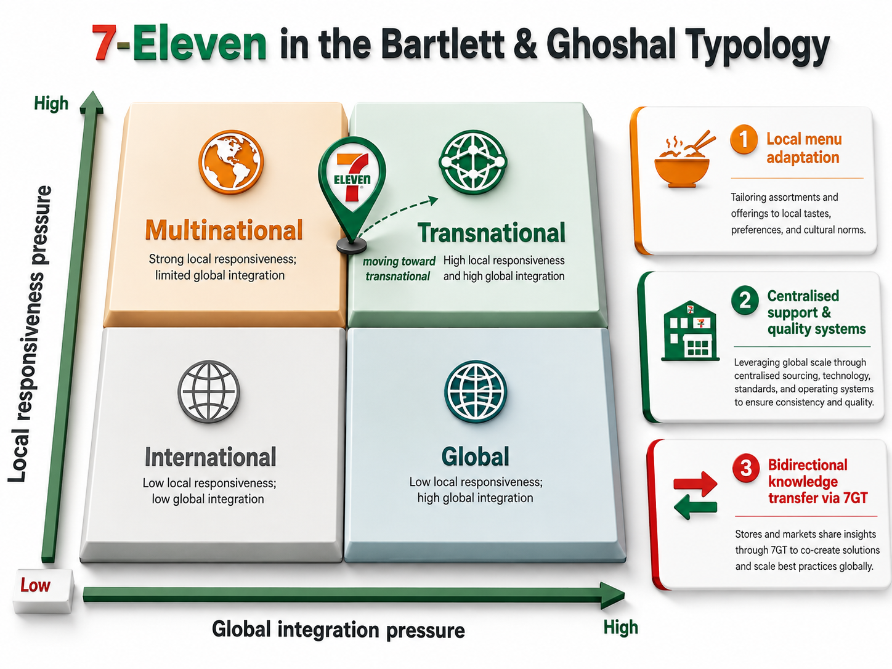
Figure 1: 7-Eleven positioned within Bartlett and Ghoshal's (1989) typology (Author's own, generated with ChatGPT image generation, 2026).

Global Configuration:

7-Eleven's global presence is far from uniform; in fact, most stores are in Japan and North America: 7-Eleven, Inc. had total assets of ¥7.32 trillion and 12,963 stores in FY2024 (Seven & I Holdings, 2025). Acquisitions have also been part of the Footprint expansion, with 7-Eleven Australia acquired in November 2023, adding over 20 times more revenue (Seven & I Holdings, 2025) for 7-Eleven International LLC to their fiscal 2024 (FY24) results of ¥459.5 billion (Seven & I Holdings, 2025). The logistics network is important to 7-Eleven's fresh-food proposition because it is dense and high-frequency – which is directly tied to scale – and the overwhelmingly franchise-heavy business model means that the company can quickly expand its geographical footprint after a market is penetrated with low capital investment. Value creation, rather, does not come from geographic breadth but from the ability to replicate a successful operating model in markets the Group feels capable of supporting its density dependent operating model – the strategic question it is facing in Germany.

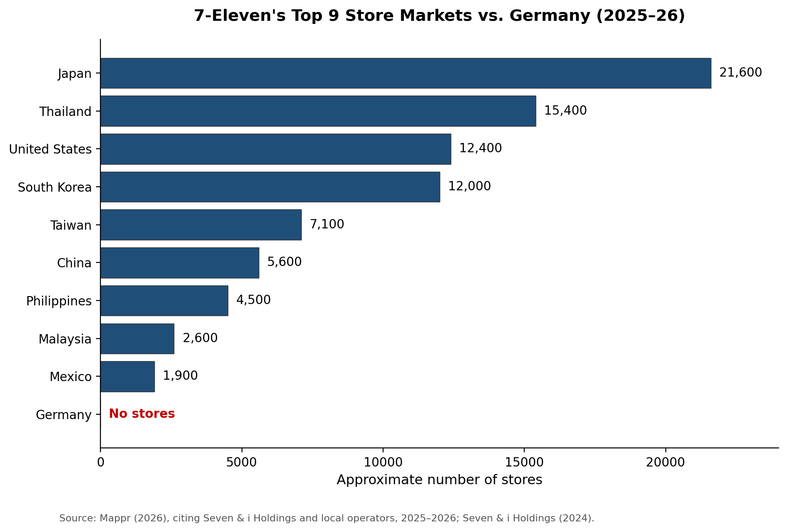

Figure 2: 7-Eleven's top 9 store markets vs. Germany (Author's own, 2026).

2. MACRO-ENVIRONMENTAL APPRAISAL AND MARKET ATTRACTIVENESS
The political, economic, legal and cultural dimensions of greatest relevance to 7-Eleven's convenience retail and franchise business model in Germany are critically analysed before all these findings are synthesised to determine its overall attractiveness for market entry based on Dunning's (1988) eclectic (OLI) paradigm.

2.1 Host Country Analysis
Political

The political control of trading hours is the single most important political issue in the life of a 24-hour convenience retailer—and it's more politically split than people think. The German federalism reform (2006) removed the responsibility for implementing the closing of the shops from the federal level to the 16 Länder (states) and the results vary significantly. In 2006, Berlin enacted its own Ladenöffnungsgesetz, which allows shops to be open around the clock, from Monday to Saturday (Eurofound, 2007). Bavaria, on the other hand, did not adopt its own state law until July 2025, following the more restrictive federal-era rules, and has tougher restrictions (Law Library of Congress, 2025). The political appeal of Germany can only be measured at state and metropolitan level and strongly hinges on what state and metropolitan area 7-Eleven would pick up as its first base. Yet another political restriction, irrespective of this devolution, is the constitutionally guaranteed principle of Sonntagsruhe (Sunday rest), which ensures that almost all retail outlets are closed on Sundays - the exceptions are hardly numerous, for example petrol stations, bakeries and shops in transport hubs (Lifetimes Deutschland, 2026). The Sunday restriction is different from the weekday/Saturday hours as it really is not something that is subject to negotiation at state level and can only be seen as a constraint on the otherwise all night 7-Eleven business model. Partially offsetting that is the political element, however, as Seven & I Holdings itself has publicly identified Germany as one of its focus G7 markets for its future expansion (Seven & i Holdings, 2024), which indicates more strategic intent than opportunistic interest but one that has yet to be realised in a working store network despite two prior attempts.

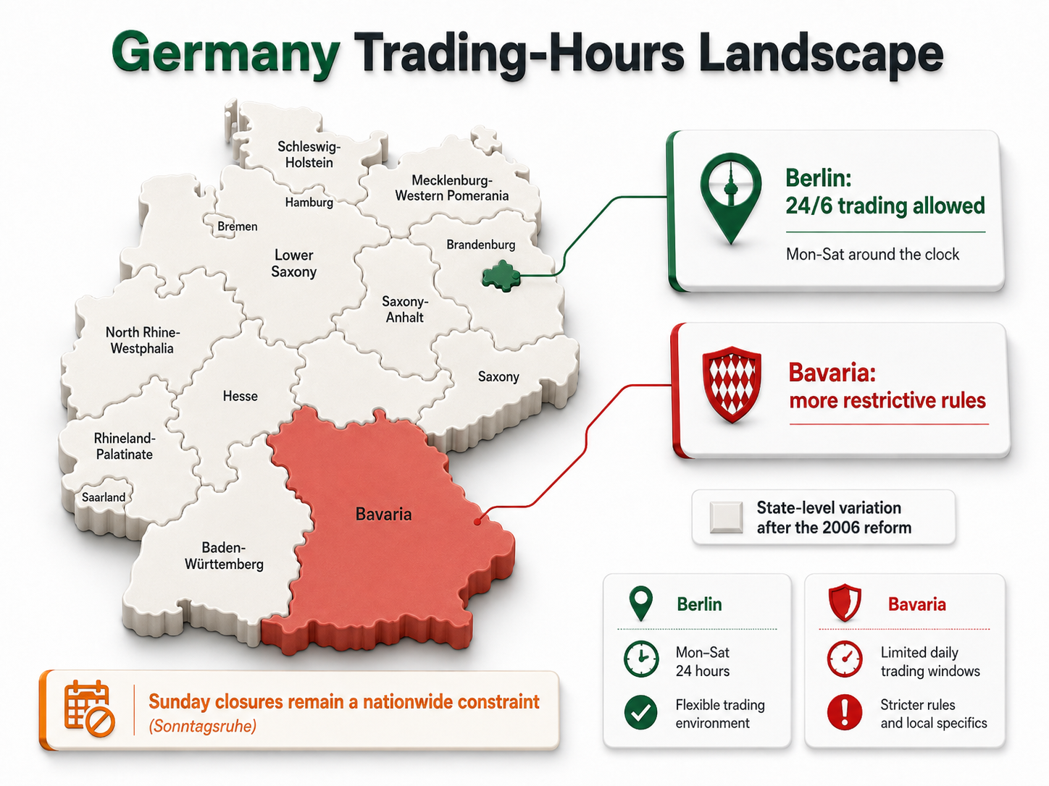
Figure 3: Germany's state-level trading-hours landscape (Author's own, generated with ChatGPT image generation, 2026).

Economic:
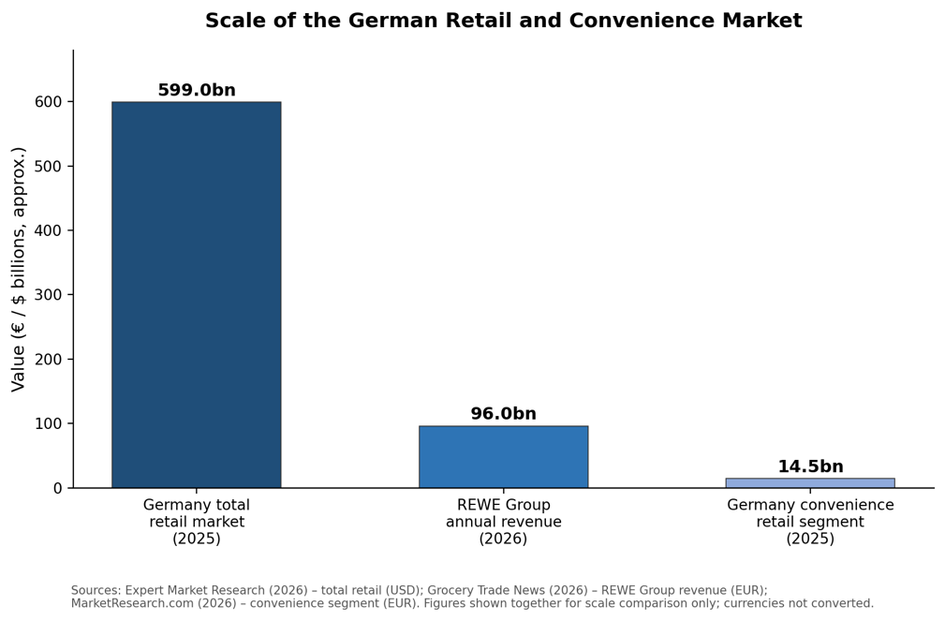
Figure 4: Scale of the German retail and convenience market (Author's own, 2026).
- In principle, the retail market is large in Germany with its total value estimated to be around USD 598.96 billion in 2025 and is expected to grow at a rate of 3.00% CAGR until 2035 (Expert Market Research, 2026). While it may be smaller, it's still a significant slice of the pie, and German convenience stores are expected to generate EUR 14.5 billion in sales in 2025. The growth has, however, slowed in this period of what is termed as a 'challenging macroeconomic environment' and Germany's overall GDP growth has remained low (MarketResearch.com, 2026). It's a combination of scale but decelerating growth that's important for entry timing: a big addressable market would support the argument for entry in principle, and a declining convenience segment would imply that 7-Eleven would be entering a market with a more slowly expanding pool of spend. The competitive scenario adds to the difficulty of this situation. The REWE Group leads grocery retail with more than EUR 96 billions of external revenue in all its market formats (supermarket, discount and convenience), while supermarket chains, including Aldi and Lidl as hard discounters, have lost visit share due to their strong performance in these sectors (Grocery Trade News, 2026; Accurat, 2025). What 7-Eleven would specifically target for its late-night, small-basket convenience stores is already being catered to by thousands of small, independent Spätis, most densely in Berlin and other former East German cities like Dresden and Leipzig (Grokipedia, 2026). Other cautionary economic indicators are from the surrounding business models: Getir's and its subsidiary Gorillas exited Germany in 2024, following high investment in the venture-backed market but failing to make a profit, while the only model remaining in the market, leader Flink, only became profitable on an EBITDA basis in March 2026 after raising the average basket size to over EUR 45 (E-commerce Germany News, 2026). This highlights that a convenience-retail concept has a real and recent risk of commercial failure in Germany even if the project is well capitalised, pertinent to the economic risk assessment of 7-Eleven's convenience-retail concept.

Legal

Germany offers a favorable regulatory landscape for franchise entry, in addition to the trading hours regulation. Germany does not have a special statute for franchise relationships; instead, the franchise relationship is regulated by general contract and competition law, and case law has laid obligations on the franchisor to disclose and act in good faith in a manner which is broadly favorable to franchisees when compared to less regulated markets. Germany, as an EU member nation, also has EU competition law restrictions regarding 7-Eleven's use of exclusive territory and non-competes in master franchise arrangements as compared to some markets in Asia where 7-Eleven operates. Another factor of concern for a retail sector that relies heavily on labor and operates with a high frequency is the protection afforded by German working time law and night-shift compensation law around working time and dismissals, as well as the statutorily established minimum wage, which has been considerably increased: EUR 13.90 per hour from 2026, followed by a further increase to EUR 14.60 per hour for 2027 (Mercans, 2026). One of the biggest annual rises since the minimum wage was introduced in 2015, this directly increases the costs of a labour-intensive 24/7 store format compared to the shorter hours format that is used by German incumbents. One more legal factor is gaining in its materiality, which is data protection: 7-Eleven's competitive model is based on loyalty and payment applications like 7REWARDS or Seven & I Holdings via 7-Eleven Wallet (2024), which must meet the requirements of the EU's General Data Protection Regulation, with its stricter obligations for consent, data minimisation and enforcement, than in 7-Eleven's home markets in Japan and the United States. Each of these legal considerations is not on its own a barrier to replication but add up to make a fixed cost and complexity to replicate 7-Eleven's labour, franchise and digital operations as they are in Asia or North America.

Cultural

- The biggest obstacle to 7-Eleven's entry is probably not so much regulatory as cultural. The Späti has already claimed the cultural and functional space a convenience store would be interested in, it's not just a commercial alternative, it has a social meaning. From 1950, Spätis were informal social spaces, mainly immigrant owned, offering a Wegbier (a beer to take on the go), which began as Spätverkaufsstellen in East Germany for shift workers, but grew into a place to drink and socialise outside on plastic crates after German reunification (Grokipedia, 2026; Live in Germany, 2026). This is a different kind of customer relationship than 7-Eleven's data-heavy, digitally integrated one, which relies on apps like 7NOW and 7REWARDS (Seven & i Holdings, 2024). A brand name chain from the U.S. and Japan – one that is brand-y and corporate – is in danger of being read as a faceless, family-less, standardized and commercialized version of what is local and valued for its informality. That is further exacerbated by proof of German consumer opposition to the ‘Americanisation’ of retail and labour standards, as voiced in past discussions about longer hours in shops (YaleGlobal, 2004). Another, more practical, cultural clash is payment behaviour: cash is still the main payment option in Germany for just the kind of smaller, low-value transaction that is central to convenience retail—according to the latest published data from the Bundesbank (Stripe, 2025), 76% of stationary retail transactions fell under EUR 5 and were paid cash. That doesn't align neatly with the increasingly digital, app-led strategy that 7-Eleven has adopted in its core markets, which have a much higher mobile payment penetration rate, so any German operation would require a more cash-heavy point-of-sale strategy. The attractiveness of 7-Eleven therefore lies in one's awareness of the possibility of a foreign branded convenience store chain competing with a local one, which already has a 100-percent German connotation and payment-behaviour match with its customers.

- One cultural factor that partly mitigates the effect is the growing internationalisation of the German population, as the Eurostat data indicates that by December 2025, the foreign-born population in Germany is already at around 17.15 million (Trading Economics, 2026). Many of these residents, especially from Asian-Pacific and North American backgrounds, will be able to navigate a familiar brand that is well known from their countries of origin, and thus may have an initial customer base available for this brand that is not overly loyal to Späti. This doesn't solve the key cultural conflict outlined above, but it does indicate that an entry play focused on international, transient or younger urban demographics, rather than directly challenging the existing Späti custom, is more feasible.

- Looking at the four host country factors together, the overall picture of Germany is a high absolute market potential combined with a high execution difficulty. The country isn't a single entity shooting down 7-Eleven's model, but a complicated one, because political and legal decisions must be made on a state-by-state basis, not one national decision. Germany seems to be a place of real scale, but with category growth cooling off, and a recent and credible example of a player with sound investment in convenience stores becoming a complete failure. Culturally, the main obstacle is not a lack of German consumer interest in convenience retail, which the Späti proves is high, but the fact that an incumbent already occupies the emotional and social space 7-Eleven would need to claim. None of these can be used individually to conclude that an entry isn't warranted, but they do explain why two previous lower commitment entries have not yielded one open store, and why one might want to apply a more stringent test of the appropriateness of the entry mode than the size of the market might suggest.
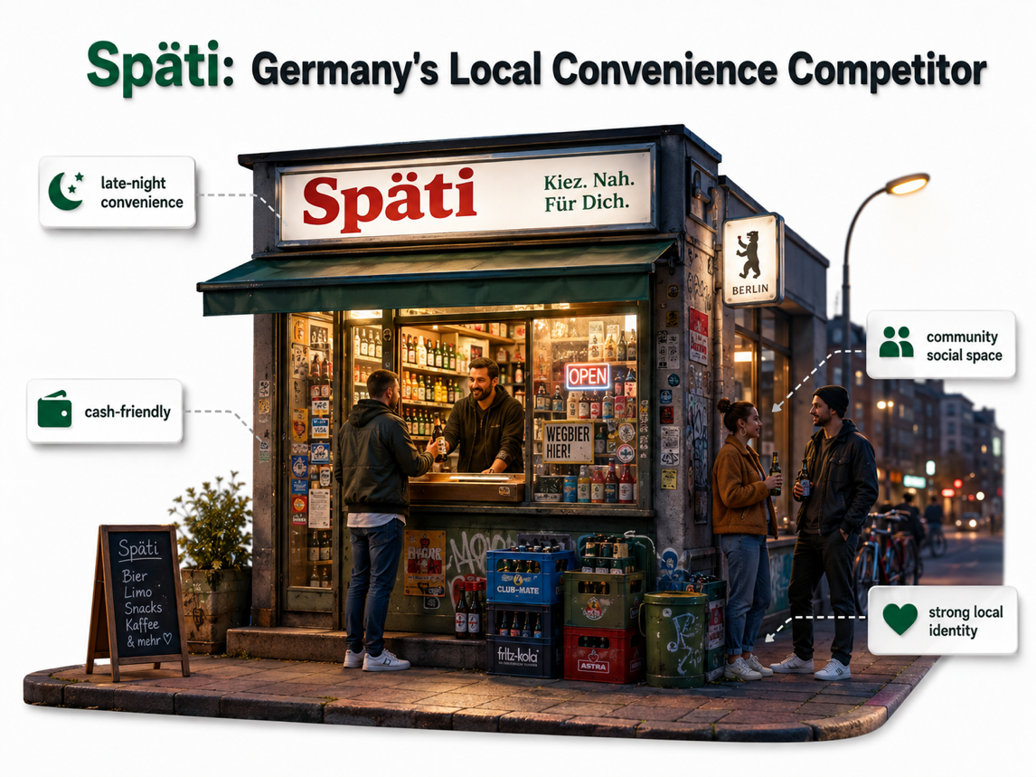
Figure 5: The Späti — Germany's incumbent convenience-retail competitor (illustrative, AI-generated, 2026).

2.2 Market Entry Synthesis: Dunning's Eclectic Paradigm (OLI)
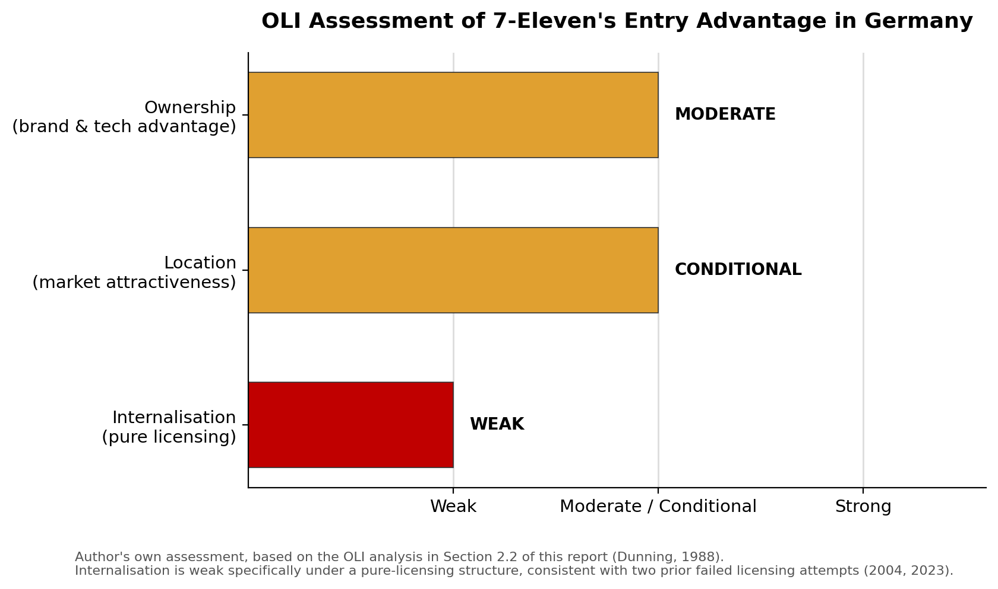
Figure 6: OLI assessment of 7-Eleven's entry advantage in Germany (Author's own, 2026).

However, Dunning (1988) argues that a firm will only look at foreign direct investment if it has all three of the following advantages: Ownership, Location and Internalisation. Often, an alternative entry mode such as licensing or franchising will be more suitable if one or more of these advantages is lacking (Umbrex, 2025).

Ownership advantages

7-Eleven has a few genuine, transferable ownership advantages, namely its 7-Eleven Global Technology (7GT) platform, its ‘Hero Product' methodology for fast, locally resonant fresh food creation and a globally recognised brand (Seven & i Holdings, 2024). But these benefits are less pronounced in Germany than in 7-Eleven's traditional Asian and North American markets as the brand is not well known, and the convenience food benefit of fresh, regularly replenished convenience food is somewhat offset by convenience sub-formats offered by German supermarket chains. The digital ownership advantage also appears less strong than usual in this market because of the somewhat cash-preferring, small-basket payment behaviour of Germans. Therefore, ownership advantage exists but is not significant.

Location advantages

- Locational advantages: Germany provides real locational advantages in terms of market size (the EUR 14.5 billion convenience part of a USD 598.96 billion retail economy) and in terms of the fact that trading is already legal in at least one locationally very favourable regulatory jurisdiction (Berlin) (Eurofound, 2007). Those benefits are tempered by slowing category growth, a fragmented 16-state regulatory landscape, a near-universal Sunday closure constraint, and the recent failure of well-funded competitors such as Getir and Gorillas to sustain profitability in this market. The location advantage is therefore positive but hinges on a very specific, metropolitan-focused entry, rather than a national penetration strategy as Seven & i has also indicated as its Europe approach, with focus on a single, major metropolitan area and not national stores.

- A comparison of the metros against this logic strengthens the arguments for Berlin in particular. Munich, the capital of Bavaria, would inherit that state's comparatively restrictive trading-hour rules, while Hamburg and other major cities operate under their own, separately varying state regimes. Berlin is the only major German city that combines a large, dense urban population with an already-legal 24/6 trading environment, and, paradoxically, the highest concentration of the Späti competitor 7-Eleven would need to differentiate against. This is not a simple advantage/disadvantage balance; it is a real dilemma–easier regulation, more difficult competition—which is addressed in greater detail in the entry mode recommendation in Section 3.

Internalisation advantages

- Internalisation is the most decisive factor for Germany specifically. Two previous arm's length licensing deals with Norway's Reitan Group in 2004, and an international franchise recruitment campaign planned in 2023, were unsuccessful in opening a store. This suggests pure licensing carries a weak internalisation advantage here: an independent franchisee unfamiliar with Germany's fragmented regulation and entrenched Späti culture is poorly placed to execute the brand consistently on fresh-food quality and digital integration. This reflects the same trends Seven & i has seen elsewhere – a shift from license to direct investment and joint ventures to Vietnam in 2023 as a licensing-only strategy was not delivering the speed or quality of store openings needed, and the acquisition of its Australia licensee in 2023 for the same reason (Seven & i Holdings, 2024). This weak internalisation advantage under pure licensing, twice proven unsuccessful in Germany, points toward a higher-control entry mode than 7-Eleven has traditionally defaulted to.

- Overall, based on the OLI analysis, one can conclude that there are some real location and ownership advantages, but they are mitigated by competitive and cultural entrenchment, by payment-behaviour misalignment and by an existing convenience-retail failure precedent in this market. This is consistent with the general academic criticism of the eclectic paradigm which states that OLI advantages are not generally strong or weak, and that, in practice, firms often enter the market despite a weaker profile of OLI advantages, if they can be managed and not reduced to zero (Umbrex, 2025). Applied to 7-Eleven, market attractiveness should not be read as a simple enter-or-avoid decision, but as a call for the specific weakness identified, internalisation, to be directly tackled by any entry strategy. Most important, the advantage of internalisation is limited in the context of the two models that 7Eleven has tried in Germany: either an independent third-party operator or, in the majority of cases, a loyalty-app that has to meet GDPR standards, out-compete an established player with a long-standing presence in its market and at the same time absorb a steadily rising minimum wage. Thus, a high-control entry mode is suggested before detailed entry mode evaluation in Section 3 as 7&i has already started to implement in Vietnam and Australia.

3. ENTRY MODE STRATEGY AND STRATEGIC SYNTHESIS

3.1 Historical Pattern Recognition
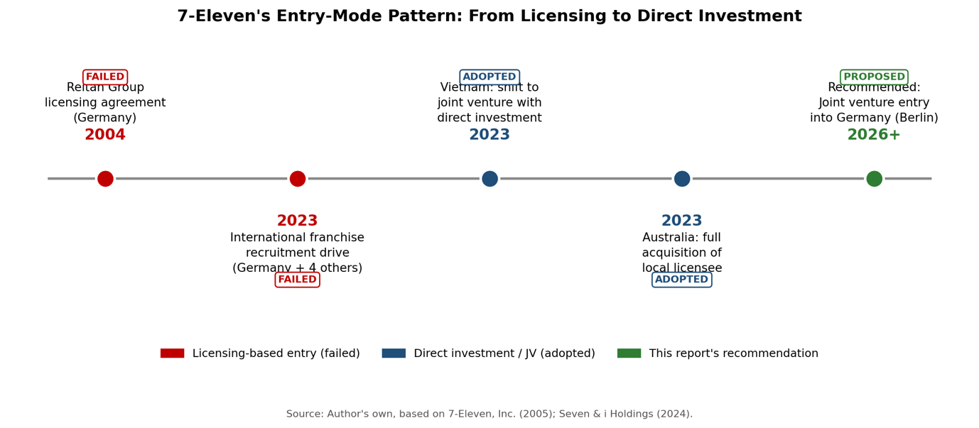
Figure 7: 7-Eleven's entry-mode pattern, from licensing to direct investment (Author's own, 2026).

- The primary historical approach to expanding overseas has been area licensing, meaning as of December 2004, 7-Eleven had area license agreements that covered 21,717 of the stores it operated overseas; these area licence agreements are built and run by an independent local licensee who does not invest the parent's own capital, resources or credit (7-Eleven, Inc., 2005). While this approach reduces 7-Eleven's own capital risk and relies on a licensee's existing local market expertise, regulatory connections, and property networks, it also relinquishes control of day-to-day operations and introduces an added layer of complexity – brand execution needs to rely on the competence and commitment of a third party.

- The licensing-first approach also had been tried in Germany twice – once in 2004, with a licensing deal with Reitan Group of Norway, and again in 2023 through an international franchise recruitment campaign to Germany in addition to France, Italy, Spain, and the UK. Both had no open store. However, over the past few years there has been a definite move by Seven & i from pure licensing to direct capital involvement in markets it sees as strategically significant but operationally challenging, according to its own strategic disclosures. For instance, the company shifted from a licence-only business in Vietnam to a joint venture with direct strategic investment and secondment of Japanese and American staff, since the pure licence model was not allowing for the stores to be opened quickly enough or properly (Seven & i Holdings, 2024). It took things up another notch in November 2023 when it outright acquired its Australian licensee. These decisions were made on the same basis internally, both since licensing alone did not seem to be as effective in transferring know-how and operational standards in markets characterized by high execution risk and because the decisions were made by local companies.

3.2 Strategic Fit and Justification
- This historical pattern leads to an obvious conclusion about Germany: in this particular market the mode of in-use 7-Eleven has twice failed to work, a mode of in-use that is known as arm's-length licensing; the mode of in-use that the company has started using elsewhere, direct investment or joint venture, has not been tried in Germany at all. This is more than just a theory--it is supported by the revealed strategic behaviour of 7-Eleven in similar markets that are equally challenging. The idea of sticking with the default German licensee position is a poor one, because Germany's problems are not only resourcing related – even a well capitalised licensee cannot fix the problem of regulatory fragmentation among the 16 states – but also the fact that 7-Eleven's app-based loyalty program is subject to GDPR compliance requirements, and, most significantly, it is a problem of being outgunned by a competitor who's been in the same market for a long time and for whom loyalty is a core part of the business.

- Germany should use a joint venture approach, just as Vietnam did. To make it happen, 7-Eleven International LLC would have to invest in a newly established local operating company, preferably in partnership with an existing German retail or franchise player that could bring local regulatory and property knowledge and would not need to hire an unaffiliated franchisee as was done in 2004 and 2023. It directly tackles the internalisation weakness in Section 2, as it allows 7-Eleven to continue to meet brand, fresh-food and digital standards using equity control and staff secondment without losing out on the local market knowledge that would have been afforded by a pure license and the forgoing of a greenfield entry altogether. Compared with licensing, resource commitment is greater but not as great as direct investment, and the structure allows for an increasing ownership stake over time as exemplified in Vietnam and Australia where it ultimately grew in size after initial performance is established. Geographic concentration is the primary way in which risk should be managed, not through diversification: consistent with Seven & i's own stated European strategy and location analysis in Section 2, entry should be limited to the one major German capital city in which 24/6 trading is already legal, namely, Berlin, and not attempted in multiple states with materially different regulatory regimes at the same time.

- This is not to be taken for granted and an alternative should be recognised. As broadly described in the international joint-venture literature, a joint venture demands a more time-consuming and resource-intensive vetting process for the identification of a credible partner than an independent franchisee and the sharing of the power of control can become a source of strategic friction, if the partners' goals clash. The lower commitment option is a structured, well-supervised master franchise with new central support where 7-Eleven operates licensee support programmes in Asia, instead of the full equity co-investment. This would eliminate 7-Eleven's capital exposure but would not address the key internal problem that spelled doom to the previous two attempts in 2004 and 2023 as the decision to execute the operation would still be left to an outside party. Overall, a joint venture provides better control than a licensing agreement, and, while it is more expensive at the outset and more complex, it is certainly more strategic.

3.3 Conclusion and Recommendations
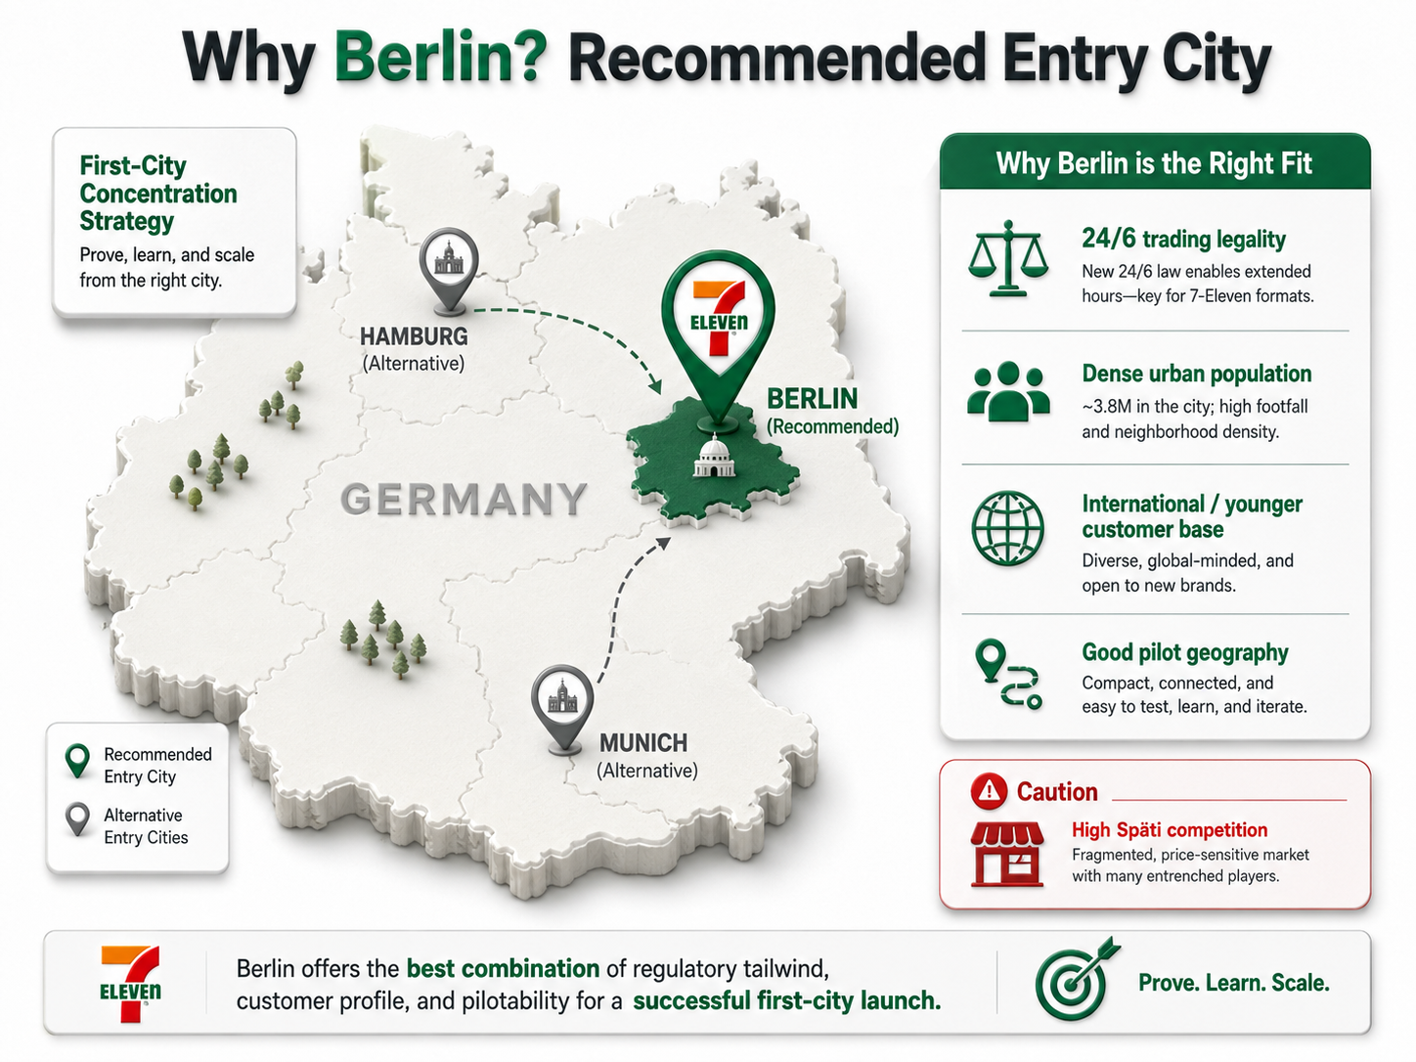
Figure 8: Recommended entry city — Berlin vs. alternative markets (Author's own, generated with ChatGPT image generation, 2026)

This report suggests that 7-Eleven is a firm on the way to Bartlett and Ghoshal's (1989) transnational model, which is a mix of high local product adaptation and increasingly centralized, bidirectional knowledge transfer. Germany is an attractive market in terms of scale, but a challenging one in terms of execution: while OLI analysis for Section 2 indicates a lack of internalisation advantage, it points to a specific challenge that can be addressed: two previous failed entry attempts. This does not mean that it is not justified to give up on Germany or to try and replicate culture a third time, it means that it is reasonable not to, but to enter there via a capital invested joint venture with an experienced local partner that, albeit with initial efforts focused on Berlin, is different from the Späti incumbents in that it integrates digital loyalty into the model, and is not bound to the usual fresh-food quality that the local market seeks, whereas it is reasonable to expect cash preferring payment behaviour, state-level regulatory variation, and the constitutionally fixed constraint of Sunday closure as part of the mix. If this highly targeted entry is successful, the same approach of a staged, direct investment in Vietnam and Australia could be a viable plan for later expansion in other large cities in Germany.

SECTION 2: REFLECTIVE ACCOUNT

Description
This reflective account follows Gibbs’ (1988) Reflective Cycle, structured around six stages: Description, Feelings, Evaluation, Analysis, Conclusion, and Action Plan.
This assessment involved selecting a multinational corporation, a country that the company doesn't have a significant presence in, and then using Bartlett and Ghoshal's organisational typology, a host country macro-environmental analysis, and Dunning's eclectic (OLI) paradigm, then recommending an entry mode strategy. I picked 7-Eleven and Germany. But I had to determine with certainty that 7-Eleven was not at all meaningful in Germany as of the date of the assessment (June 2026) if I was going to spend any time writing it. Then one by one I tried to search for each framework and explain it in a specific way for 7-Eleven, Germany, and not just generically and cross-checked every fact against the source that I found.

Feelings
In the beginning I was not sure of my own research, but I was unsure. What seemed like a positive sign of 7-Eleven's presence in Germany came up when I typed its name into the search bar of the Yelp website: a listing titled "Top 10 Best 7-Eleven in Berlin. Then, I put 7-Eleven into the search bar of the Yelp website, and it showed me a listing titled “Top 10 Best 7-Eleven in Berlin.” This was troubling, because the whole evaluation assumed that this was not so, but rather that they would keep their distance. I had to look at each source separately to see the first one was convenience stores, the second was a Facebook page for Berlin, Maryland, United States, not Berlin, Germany, and the third was an unrelated Korean food joint using the hashtag to gain exposure. When I was able to confirm the premise correctly, though, and see 7-Eleven's own "parent company" statement that the brand is "absent from the UK, France, Germany, and Italy" then I felt much more confident in the rest of my analysis, since it was based on a primary source no longer resting on an assumption.

Evaluation
The most useful aspect of the research process was the realization that the one thing that had been thought to explain why 7-Eleven stores are not found in Germany is an oversimplification. Proper investigation showed that the trading hours had been devolved to the 16 individual states of Germany in 2006, that Berlin had already allowed trading over the weekend for 24 hours since then, and that the real problem is not so much the law itself as a deeply rooted competitor, the Späti. The analysis would have been much less powerful and less correct if I had taken the easy route. What didn't work out as well, at least at first, was assuming that one search result was a good one; the Yelp and Facebook mix-ups mentioned above became apparent only because I decided to doublecheck the various sources one by one, which I had to make a conscious effort to develop rather than to just fall into. The same approach was applied to statistics, in this case the minimum wage in Germany and the size of the convenience-retail market; at least one other independent source was consulted before using the statistics, sometimes delaying the drafting process, but the chance of getting things right increased significantly.

Analysis
- Analysis I guess the root cause of the search-verification issue was that one thought that if they were finding a relevant search result then that must be a factual result, but a search engine like Yelp will return the best possible match even if there is no actual match. This is a particular issue when it comes to a ‘no significant presence' research question, as it is far more difficult to prove a negative than to prove a positive; in order to prove that there was no 7-Eleven in Germany, several possible examples of 7-Elevens had to be eliminated, even though they looked plausible. There were additional ways of thinking that influenced my approach to this assessment: I sought to interpret these two paradigms and typologies descriptively rather than assertively, for example, in Dunning's case because the process of internalisation that he described in the 7-Eleven case was not a theoretical construct, but empirical evidence of a shift in the company's history from licensing to joint ventures in Vietnam and Australia, and in the latter case, a shift in advantage. The single greatest improvement in the quality of my analysis over the course of preparing this assessment has come in connecting the frameworks directly to the firm's own revealed strategic behaviour, as opposed to treating OLI and the entry mode decision as separate, abstract exercises.

- This link between theory and practice was reinforced directly on this module through the material presented. I found the idea of discussing case examples in which the firm changed its entry mode because the initial strategy failed to be successful to be very helpful when I considered the 7-Eleven case studies of the transition from licensing to joint ventures. Likewise, a distinction between a stated strategic intention and the revealed behaviour helped me to avoid assuming that a company was really interested in a country just because it announced its interest in it; two licensing attempts was a better indication of difficulty than a one-off "strategic intention" statement.

Conclusion
The whole idea is, in general, that I could have gotten to a sounder starting premise in less time if I had first checked the company's own primary disclosures, and then proceeded with secondary searches. I also know that at times in this initial draft I wrote the structure before I did a thorough analysis of how it would apply to the case, which sometimes resulted in more general than case specific analysis; the opposite was true, that is, researching first, and drafting later, when the evidence is in, was more likely to produce noticeably stronger sections later in the assessment than those I attempted first.

Action Plan
For future assessments involving claims about the absence or presence of something, I will: (1) seek out the organisation's own primary statements before relying on secondary or aggregator sources, since a company's own disclosures are the most authoritative evidence available; (2) treat any search result that seems to confirm what I am looking for as requiring extra scrutiny rather than less, since confirmation bias makes convenient-looking false positives easy to accept uncritically; (3) apply theoretical frameworks by connecting them to a firm's own revealed strategic behaviour wherever possible, rather than asserting them in the abstract; and (4) research each section fully before drafting it, rather than drafting first and sourcing evidence afterward, since this ordering consistently produced better-supported analysis in the later stages of this assessment.

REFERENCE
7-Eleven, Inc. (2005) Form 10-K for fiscal year ended December 31, 2004. U.S. Securities and Exchange Commission. Available at: https://www.sec.gov/Archives/edgar/data/0000092344/000119312505052213/d10k.htm
Accurat (2025) Supermarket dynamics in Germany 2025: discounters gain ground as Edeka and Rewe compete. Available at: https://accurat.ai/blog/supermarket-dynamics-in-germany-discounters-on-the-rise-traditional-players-under-pressure
Bartlett, C.A. and Ghoshal, S. (1989) Managing Across Borders: The Transnational Solution. Boston: Harvard Business School Press. Available at: https://books.google.com/books/about/Managing_Across_Borders.html?id=KYjHMVuNOAwC
Dunning, J.H. (1988) 'The eclectic paradigm of international production: A restatement and some possible extensions', Journal of International Business Studies, 19(1), pp.1–31. Available at: https://link.springer.com/article/10.1057/palgrave.jibs.8490372
E-commerce Germany News (2026) Quick commerce in Germany: q-commerce market, players and trends in 2026. Available at: https://ecommercegermany.com/blog/quick-commerce-germany/
Eurofound (2007) Extension of shop opening hours sparks intense debate. Available at: https://www.eurofound.europa.eu/en/publications/all/extension-shop-opening-hours-sparks-intense-debate
Expert Market Research (2026) Germany Retail Market Size, Share and Report 2026–2035. Available at: https://www.expertmarketresearch.com/reports/germany-retail-market
Gibbs, G. (1988) Learning by Doing: A Guide to Teaching and Learning Methods. Oxford: Further Education Unit, Oxford Polytechnic. Available at: https://thoughtsmostlyaboutlearning.wordpress.com/wp-content/uploads/2015/12/learning-by-doing-graham-gibbs.pdf
Grocery Trade News (2026) German Grocery Market Share 2025: Retail Shake-Up. Available at: https://www.grocerytradenews.com/german-grocery-market-share/
Grokipedia (2026) Spätkauf. Available at: https://grokipedia.com/page/Sp%C3%A4tkauf
Law Library of Congress (2025) Shop Closing Laws in Germany. Available at: https://blogs.loc.gov/law/2025/11/shop-closing-laws-in-germany/
Leong, S.M. and Tan, C.T. (1993) 'Managing Across Borders: An Empirical Test of the Bartlett and Ghoshal [1989] Organizational Typology', Journal of International Business Studies, 24(3), pp.449–464. Available at: https://link.springer.com/article/10.1057/palgrave.jibs.8490240
Lifetimes Deutschland (2026) Shopping in Germany: Store Hours, Sunday Closures, and Best Supermarkets. Available at: https://lifetimesdeutschland.de/blog/daily-life/shopping-in-germany-store-hours-sunday-closures-and-best-supermarkets
Live in Germany (2026) Spätis in Germany 2026: 7 Things Every Expat Must Know. Available at: https://liveingermany.de/what-is-a-spaeti/
Mappr (2026) Mapped: The 20 Countries Where 7-Eleven Operates. Available at: https://www.mappr.co/7-eleven-countries-world/
MarketResearch.com (2026) Germany Convenience Stores Market Research Reports & Analysis. Available at: https://www.marketresearch.com/seek/Convenience-Stores-Germany/667/1290/1.html
Mercans (2026) Germany: Minimum Wage €13.90/hour & Mini-Job Ceiling €603 (In Effect Jan 2026). Available at: https://mercans.com/resources/statutory-alerts/germany-minimum-wage-e13-90-hour-mini-job-ceiling-e603-in-effect-jan-2026/
OpenAI (2026) ChatGPT (image generation) [Large language model]. Available at: https://chatgpt.com
Seven & i Holdings (2024) Japanese-style convenience is now becoming the global standard: Challenge of further global expansion of 7-Eleven brand by combining strengths of Japan and U.S. Available at: https://www.7andi.com/en/company/qr/161/1.html
Seven & i Holdings (2025) Overseas Convenience Store Operations. Investor Relations. Available at: https://www.7andi.com/en/ir/library/co_financial/2025/convenience_store_overseas.html
Stripe (2025) Changing payment behavior: Cash or card in Germany? Available at: https://stripe.com/resources/more/cash-or-card-payments-germany
Trading Economics (2026) Germany – Foreign-born population. Available at: https://tradingeconomics.com/germany/foreign-born-population-eurostat-data.html
Umbrex (2025) OLI / Eclectic Paradigm Explained. Available at: https://umbrex.com/resources/frameworks/strategy-frameworks/oli-eclectic-paradigm/
YaleGlobal (2004) States Pressing for Right to Set Shopping Hours. Available at: https://archive-yaleglobal.yale.edu/node/50871

