Certificate of Higher Education for Skills in the Workplace - BMSW4002
Effective Teamwork and Communication Skills
Bonita Brookes
Lecturer: Dr Molly Jack

Contents
Types of Communication 2
Verbal Communication 2
Non Verbal Communication 3
Para-Verbal Communication 3
Theories of Communication 3
Shannon Weaver – Model of Communication 3
Berlo’s – Model of Communication 4
Schramm’s – Model of Communication 5
Conclusion 6
References 8
APPENDIX 1 9

Introduction
This assignment will be a portfolio of evidence, I will refer to in-class exercises to support my investigation relating to communication skills which we have reviewed during lessons. By supplying a brief analysis on my individual experience in my workplace appertaining to teamwork and communication. According to Kinnick and Parton (2005), communication skills are crucial for individual, team and organisation success, to elaborate verbal communication and interpersonal skills are highlighted in the recruitment process and are the core requirements when seeking new candidates for employment. Currently working in the House of Commons as a Personal Assistant to an MP who is also the Shadow Minister for the Foreign and Commonwealth Office, I have been in this role for the last 14 months and communication is vital as we all have an individual role that support a much larger perspective. We are required daily to liaise with various departments and offices nationally and internationally working cohesively to support each other but also achieve results. I am required to liaise with my member daily – both verbally and nonverbally, I communicate with her over the phone, via email and in person. This allows her to carry out her duties more effectively, but also enables her to focus her attention on more demanding issue within her remit.

Types of Communication
Communication transpires on a variety of platforms to engage and interact with one another, whether its verbal communication, para-verbal communication or non-verbal communication, Goleman, (2006) defined that accurate perception of non-verbal communications and strongly relates to an individual social intelligence and interpersonal sensitivity meaning that being attuned with our surrounding showing an appropriate level of empathy and academic skills: oral, reading and written, helps to encode and decode information correctly. Communication has occurred when a message has been sent and received in whichever form. We use many forms to communicate such as body language, face expressions, posture and even eye contact these are types of nonverbal communication that we can use to understand different messages the sender what the recipient wants to translate. Verbal communication is the exchange of thoughts and ideas between two or more individuals by the transmissions of information. Para verbal communication refers to the sub-messages that we transmit via the pitch, tones and pace of our voices referring to not how something is say but the underlying way of how we say it. Communication in not solely the act of talking, but a profound complex combination of all three and the misuse of one can generate a completely different outcome to what the message was trying to originally portray. These three types of communication will be explored individually below.

Verbal Communication
Verbal messages created through language, efficient and effective use of words amplifies the message and meaning received. The better use of the language spoken the simpler it is to understand, better use of communication skills in a professional environment enhances your chances of being more successful within a team working environment. Team members who are working together on a project are required to liaise with one another, verbally is an effect tool for communication. Not only is this spoken verbal communication applies to written communication to, the verbal element of communication is all about the words that we use. I use communication at work when I answer the phone for example or relay a message to my MP. If I have arranged a meeting - I will convey the relevant information to my employer either via email confirmation or speak to them directly if the meeting requires urgent attention.

Non Verbal Communication
Non verbal communication is by transmitting information which has not been spoken, for example facial expressions, body language, eye contact, posture even down to personal appearance. Hinkle (2001) suggests that non-verbal communication such as vocalics often referred to as paralanguage, which is how people use their voices, the pitch, tone and volume etc, provides information relating to self-confidence, knowledge and influences how others view us. Albert Mehrabian’s Theory (1981) demonstrates that only 7% of what we communicate consists of the literal content of the message, whereas tone, intonation and volume contribute as 38% and as much as 55% of communication conveyed resides in our body language. To reflect this time of communication seems highly relevant within a working environment as it appertains to how we feel about ourselves and the better we feel about ourselves the better our performance in within a chosen profession. We have 250,000 different facial expressions resulting in the brain working rapidly to decipher. Non verbal prompts help participant interpret verbal messages, for instance during team meetings if a colleague is speaking eye contact demonstrates interest and also respect by listening reflects that you are paying attention but you are also providing the speaker with encouragement which also offers the speaker with the confidence to continue.

Para-Verbal Communication
As introduced in the paragraph above para-verbal is not what we say but how we say it for instance if a husband asks a wife if she is ok and her response if fine in a monotoned, indicates that she is not fine, which I am sure many partners have learnt the hard way throughout the years! In oral communication para-verbal cues are one’s tone, speed, timbre and volume of their voice. These are essential aspects because meaning is conveyed from delivery not only in what is said. Professionals, especially those of whom are public speakers and those of whom prepare speeches are aware of the importance of para-verbal communication and to get a message across whether in sales of marketing and a successful demonstrator will utilise such skills as pace of voices, clarity in speech, volume to project their message along with pausing to allow messages and ideas to captivate the attention of the audience.

Theories of Communication
A variey of therories exist regarding communication for the for focus of this portfolio which we discussed in class and will be centred around 3 models of communications, The Shannon Weaver Theory, Berlo’s Theory and Schramms Theory which are all a catalyst to how we view communication today.

Shannon Weaver – Model of Communication
Claude Shannon and Warren Weaver both working within the telecommunications industry and co-authors of “A Mathematical Theory of Communication” in 1948 created the Shannon and Weaver concept Sender – Encoder – Channel – Decoder – Receiver – Feedback – Noise. Social scientists later developed the Shannon and Weaver Model which explores how effective communication takes place between a sender and a receiver from a technological perspective. Initially designed to improve efficiently and security during World War II, Shannon and Weaver model explained the flow of information transmitted my diagram below demonstrates this process in the 21st Century:
Diagram 1
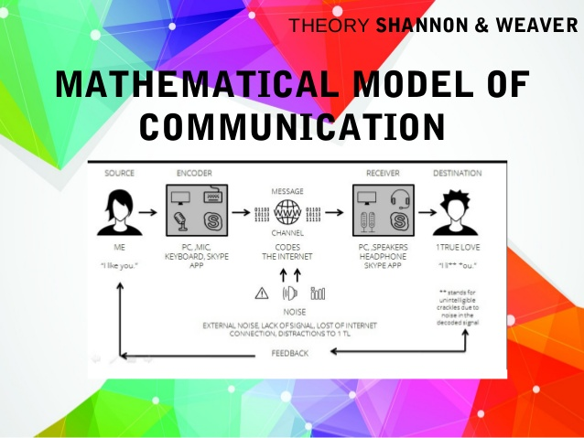
There are limitations to this model as is does not take into consideration non-verbal communication, the model is simple but does not take into consideration the interpretive dynamics. The more information received and the more consistent the information is the more likely the message will be delivered accurately.

Berlo’s – Model of Communication
David Berlo (1960) adapted the linear model by Shannon and Weaver and established the Sender-Message-Channel-Receiver (SMCR) model of communication. The SMCR model “Sender – Message – Channel – Receiver” is relevant to almost any media communication study because it can be applied to most communication exchanges. The SMCR model was designed to describe the transfer of information as the message passes from the sender to the channel to the receiver. The model, however, does not consider the complexity of the relationship between sender and receiver nor consider the receivers understanding.

Diagram 2
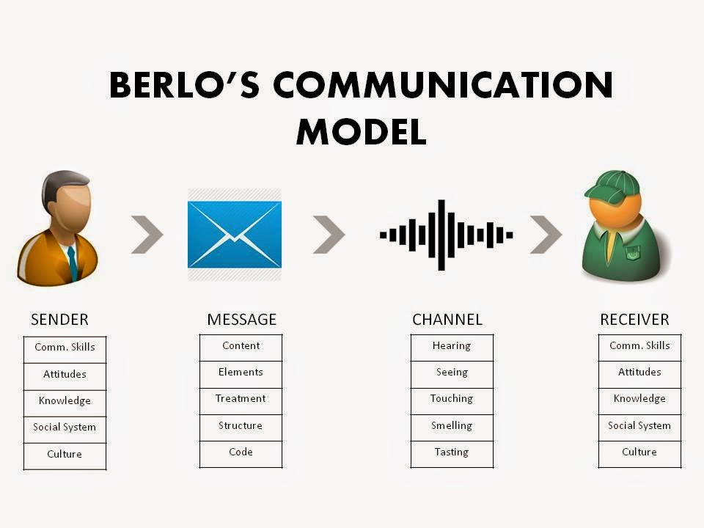

Schramm’s – Model of Communication
Seeks to explain how meaning is transferred between individuals, corporations and others, this widely used theory of communication that proposed by Wilbur Schramm in the late 1940’s. The Schramm model views communication as a process that takes place between a sender and a recipient, believing that communication is a two-way street, meaning that there’s at least a sender and a recipient. The model contains at least one other element as well; the message itself. The Schramm Communication Model is circular, meaning that at least two parties are required to send and receive a message. Both the sender and the recipient have to encode and decode the message to decipher the message accurately.
Diagram 3
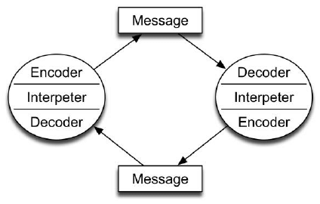

Conclusion
Effective communication is an essential and fundamental requirement in the workplace today. Daily duties can be carried out efficiently only if the communication flow is clear, precise and unhindered. In the workplace where there are many of communication awareness of audience is considered along with the urgency of the message for instance for speed a telephone call maybe suffice but if the message is to be relayed to several individuals at once an email communicate works for speed also so being aware of these factors within the workplace helps to communicate more effectively. A positive work ethic, and correct conduct and a safe working environment have a huge influence on effective communication. Take, for example, exit polls. Field investigators go to the polling stations to interview the voters. This is managed by a team leader who manages a few polling stations together. The data is sent to the main office, which is usually located at a distance from the polling stations. The data is sent at regular intervals via a secure digital database. This data is sent for analysis to a programmer who interprets it and sends it back to the office as the final report. This entire process depends on effective communication. The data has to be sent unadulterated from the polling station to the office and then to the programmer. Attention to detail is crucial whilst sending data, or this could render the entire report obsolete.
Therefore, effective communication relies on a plethora of skills. These skills of utmost importance to be success in employment and maintaining employment. Being aware of yourself helps you to communicate more effectively and efficiently with others and being aware of yourself assists with others awareness of you. Communication is not only what you say but how you say it, how you are viewed and also how you sound, so being positive and using language coherently does effect those around you how they respond and their opinion of you. While the means of communication may change due to evolving technology, effective communication still remains a fundamental foundation for success within todays working environment.
A postive working environment requires a effective communication to work collaboratively, whether written, spoken, heard or seen. My role as a civil servant requires constant communication, whether it is updating my database, answering the telephone responding to email or participating in a meeting. Being respectful and efficent at all time equipts me with the correct working ethics to be successful not only to my employer but also to the constituents that we represent. In class excercises have enabled me to become more aware of my peers views and ideas and also to listen more, but to also become more mindful of own my body language and also read others more accurately. In class excercises have also empowered my leadership abilities I am more aware that I have many skills and transferable qualities and am a lot more confident in my own abilities and regularly scoring high marks in The Business Student’s Guide to Study and Employability by Peter Morgan, Self Assessment Skills one in particular on reflection on page 50-51 was especially interesting as it allowed me to reflect on being a student and being an employee. Throught this assignment we have discussed different models of communication along with verbal, non verbal and para verbal communication and the importance of effective team working and communication and to be an effective team member communication needs to be administered effectivly, no only by what is spoken but also how its delivered, being mindful determines a teams success which reflects on the organisation as a whole.

References

Diagram 1 – Bing. 2020. Shannon Weaver Models of Communication. [ONLINE] Available at: https://www.bing.com/images/search?view=detailV2&id=710D0347C1A1D36A5ECB9F42B05A36E41750D0F8&thid=OIP.R9g7LDw6QMrDPcBKPUivYAHaFj&mediaurl=https%3A%2F%2Fimage.slidesharecdn.com%2Flasswellshannonweaver-150718122725-lva1-app6891%2F95%2Fbasic-linear-communication-models-lasswell-shannon-and-weaver-13-638.jpg%3Fcb%3D1437222593&exph=479&expw=638&q=shannon+and+weaver+communication+model&selectedindex=114&ajaxhist=0&vt=0&eim=0,1,2,3,4,6,8,10. [Accessed 6 January 2020]
Diagram 2 - Bing. 2020 Berlo Model [ONLINE] Available at: https://www.bing.com/images/search?view=detailV2&id=BF029AF2D3666C0F56CA7F24958B22EBB7B04AFA&thid=OIP.F0YMkpUvFGNcX6JSltqJ4AHaFj&exph=720&expw=960&q=berlo+model&selectedindex=18&ajaxhist=0&vt=0&eim=0,1,2,3,4,6,8,10 [Accessed 6 January 2020]
Diagram 3 Bing. 2020. Schramm Model. [ONLINE] Available at: https://www.bing.com/images/search?view=detailV2&id=32793E62501D5020C907A709B146319E46D9C24A&thid=OIP.KkC7N5ljreE_5i7VHRCCfwAAAA&mediaurl=https%3A%2F%2Fwww.researchgate.net%2Fprofile%2FJudee_Burgoon%2Fpublication%2F254051534%2Ffigure%2Ffig1%2FAS%3A298056361758729%401448073582746%2FSchramm-Model-of-Communication_Q320.jpg&exph=273&expw=273&q=schramm+model+of+communication&selectedindex=24&ajaxhist=0&vt=0&eim=0,1,2,3,4,6,8,10 [Accessed 6 January 2020]
Goleman, D. (2006) ‘Communication’ C.H.E: Education for the Workplace Student Yearbook, 2012, London: Sage Publication. Pg.50
Griffiths, B. A. and Dunham, E.B. (2015) “Communication” Certificate in Higher Education: Skills for the workplace Student Yearbook. Sage publication. London, Sage.
Hinkle 2001 ‘Verbal and Non-Verbal Communication’ C.H.E: Education for the Workplace Student Yearbook, 2012, London: Sage Publication. Pg 73
Kinnock and Parton (2005) ‘Communication’ C.H.E: Education for the Workplace Student Yearbook, 2012, London: Sage Publication. P.47
Morgan, P. (2017) The Business Student’s Guide to Study and Employability. Sage Publication. London, Sage.

APPENDIX 1

Effective Team Working and Communication – Term1: In class exercise 1



