Introduction

The purpose of this report is to state on Why professional career development is important for career success. In this 21st Century business environment, most employers are often looking to recruit employees who have self-awareness and who can define their abilities for a career success, despite their academic qualifications, attitude, knowledge and experience. During job interviews, the main question is ‘Tell me about yourself’; in other words: ‘Do a self-assessment of yourself’ or ‘How can you define yourself’. Many students are struggling to be employed after achieving studies due to the lack of what Peticca-Harris & McKenna (2013) identify as professional identity.

So, this module is very important for career success because it teaches me how to know my abilities and what I can achieve with these abilities. It is equipping me with necessary materials to measure myself in front of obstacles and challenging tasks, especially in the workplace. To be successful in career, I need to be able to identify my strengths and weaknesses, to allow me to minimize threats and take advantage of opportunities opened before me. This backs the philosophy of Socrates’ well-known dictum Know Thyself, even though Identity, as a tool of analysis, can be everything, something or nothing, insist Peticca-Harris & McKenna (2013).

Thus, I understand that I need to apply the knowledge acquired through my learning journey. Based on my experience, reflection, theory and planning, skills such as time management, analytical and critical thinking skills, resilience, leadership, digital competency and teamwork are essential to define my personal development and my readiness for employment. About the latter, it is believed that the empowerment perspective regards teamwork as a managerial strategy aimed at solving problems of inflexibility and resistance associated with reliance on more coercive control (Andrew Maund, 2017)

This report is set forth in the first person as it is based upon my analysis upon the harmonized results of my research. It aims to reflect and review my learning journey. I used my in-class notes, read so many books and articles available in the online library and watched different videos of well-known speakers and authors who stated on this same matter from websites and YouTube channels such as mindtools.com, gomadthinking.com, ted.com, etc. to ensure I have the appropriate tools that back up my personal development and how to make good use of them.

Main findings

SWOT analysis
Strengths
After doing a self-assessment on my strengths, I found out that I have some abilities that others don’t. I also possess skills and experience that make me unique. To begin with my abilities, I know I can do so many things at the same time and remain specific and objective. I am good in managing time, I can make decisions whenever needed, I can do things in perfection, I am a strong leader, I can learn fast, I am reliable, I have a sense of responsiveness, I am honest, I can adapt and adopt new technologies, I am disciplined.

However, I am still working on these strengths to build them up. These being internal factors, only me and me alone can use the provided tools to shape my success in career, such as strategic management in order to be able to identify strategic issues. Grant and Baden-Fuller (2018) state: Identifying strategic issues is more than simple observation. We must discern what is important in the organization's overall situation. This requires awareness of the purpose of strategic management. This is usually assumed to be enhancing the long-run performance of the organization. Hence, performance appraisal plays a central role in identifying strategic issues.

Weaknesses
Being aware of my weaknesses which I need to shore up, I have identified low tolerance and restriction to lateral thinking as my main weaknesses. There are tasks that I avoid, as I don’t feel comfortable doing them. There are also some negative work habits that I need to work on to make me be the kind of the efficient leader I dream to be. For that sake, I need to consider my existence, my relatedness and my growth as drawn by Alderfer. Understanding what the needs are and how they are satisfied will enhance insight into work-related behaviours that increase job performance, said Arnolds and Boshoff (2002). Thus, using my internal strengths, I need to minimize threats and take advantage of opportunities opened before me. (Furgison, 2019) From one of my strengths e.g. leadership, I can create and invest opportunities by eliminating one of my weaknesses e.g. being full of “should, oughts, and musts”. By doing so, I can now monitor my threats and face any obstacles in the workplace, which are problems caused by my weaknesses.

Learning styles
VARK
The image below shows 4 different learning styles.
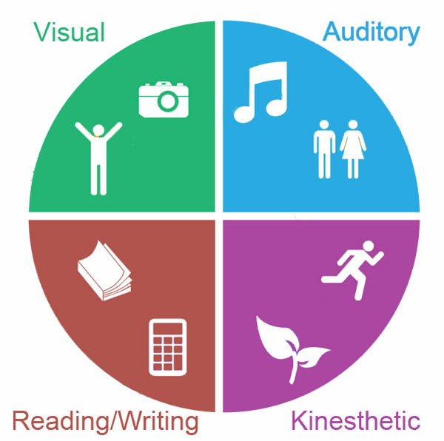
Source: www.nursebuff.com
In an investigation conducted in different universities in Romania, it is indicated that the students in management department preferred the Audio learning style, while the students in training department preferred the kinetic learning style. In addition, the students in teaching department preferred the visual learning style. Nevertheless, it is also indicated that female students were more in favor of visual learning style, and the male students preferred more kinetic learning style (Science, Movement and Health, 2019). In my case, a self-examination of myself indicated that I could learn using different learning styles such as Visual, Aural, Read/Write and Kinesthetic (See in-class notes).

Honey & Mumford

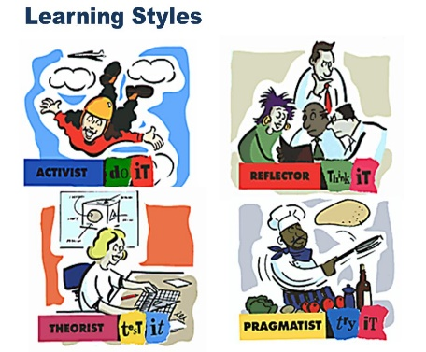
I’m Theorist…
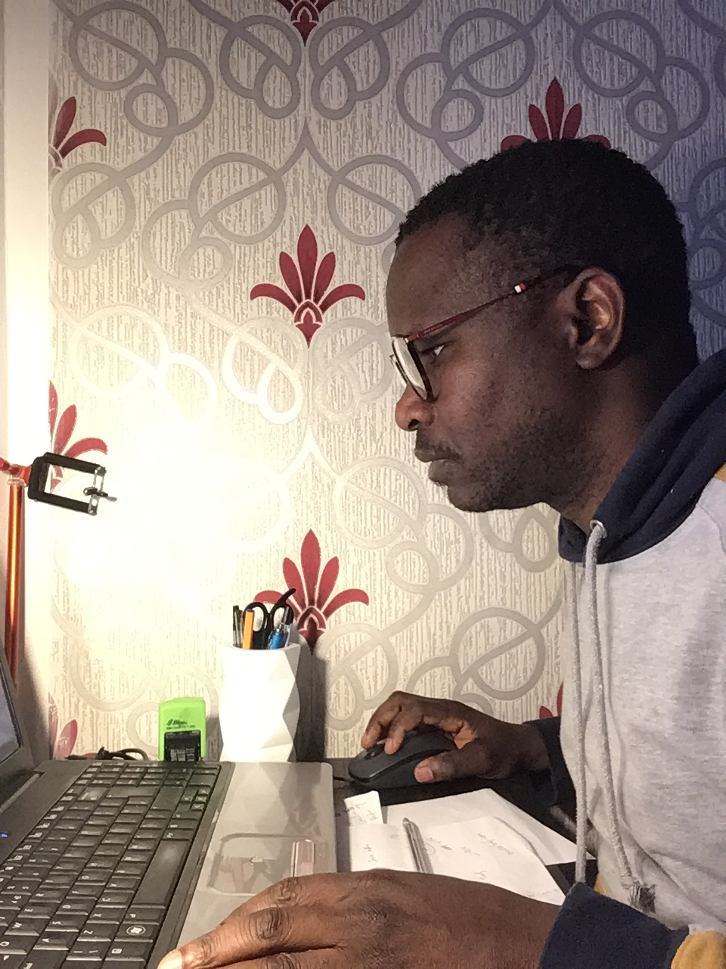

Individual differences such as language aptitude, motivation, creativity, self-esteem, anxiety, learner’s belief, and learning styles have an impact on second language acquisition (Dörnyei, 2005). According to Honey and Mumford learning style test, I have been identified as Theorist, as I tend to be highly logical and systematic in what I do. I have a perfectionist attitude and I like to use information to build logical models of the world around me that I will defend rigorously when challenged. (Morgan, 2017). This learning style really draws a picture of what I am. When it comes to fulfill a task, I take my time to ensure everything is done according to the picture I have in mind. I like lectures, books, discussions, assignments, tutorials, journals, etc. I am intellectually stretched, i.e. by analysing a complex situation, being tested in a tutorial session, by teaching high calibre people who ask searching questions. The test showed also that I have some weaknesses such as having low tolerance for uncertainty, disorder and ambiguity. Despite that, I am good in asking probing questions as a logical vertical thinker. In that, my goal is to overcome the tendency of asking: Shall I be with people of similar calibre to myself? (See in-class notes)

Personality profile
Myers Briggs
Conducting a self-assessment using Myers Briggs personality profiling test (See in-class notes), the results showed that I am Intuitive and Thinking. This really defines me in a position of Projects manager with responsibility of coordinating and completing projects as well as organizing the project team to ensure customer satisfaction. I can also use my thinking skills to solve problems and conflicts that can occur in the team, with a full picture of them, differently from a marketing manager who, as per Patterson Anthony (2012) often do not have the 'full picture' prior to making important decisions.

Go MAD

Applying GO MAD framework in my life, I need to make a link between my Why, What and How. (Jones, 1992) This means that I must be able to connect the reason why I want to do something to the personal responsibility after defining my goal and setting how to execute it accordingly. This also involves my self-belief in my goal before acting and get the expected results. After measuring the outcomes, I can now involve others to the project I need to accomplish.

Relying on my self-awareness, my interpersonal skills as well as my self-esteem, I can achieve my goal, being good in buying in and selling out. I also rely on my professional behaviour, as behaviour values self-esteem and self-efficacy, noticed Gottwald and Goodman-Brown (2012). For this, I will also need my family and friends’ involvement for the achievability of my defined goal.

So, my goal is specific: to lead my own company in three years, after getting my Distinction at university. I want to accomplish this in order to be self-employer and enjoy my freedom. This is so important because it will free me from the pressures and demands of the daily life in work. In the meantime, I am hunting for a challenging position within management sector in Cardiff. For that, I will be attending shortly some learning courses on management based on the results to get myself trained in the matter. I do allocate one year to this training to fashion my experience. I know this will enable me to measure my progress and stay focused and motivated, keeping other less important tasks from side.

To reach the achievability of my goal, I may prefer working in a one to one or with a group. To avoid the consequences of a bad management of my project in the past, I can now analyse why differences have been made or why differences haven't been made in the past. Using Go MAD as a diagnostic tool, I have picked up clues about which of the key principles were missing in the past: involving people who were not very good at doing certain things such as communicating and not considering the obstacles and the risks.

The image below is the summary of Go MAD framework can be like.
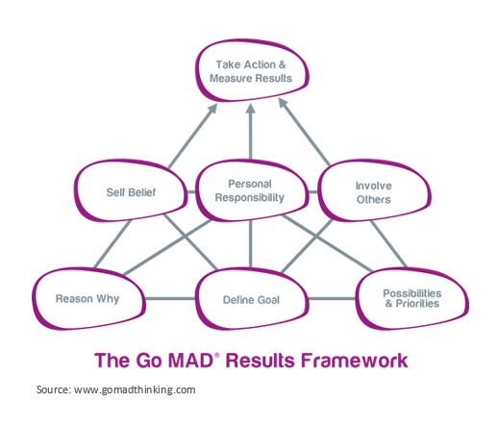

Conclusion
Along my learning journey, I have learnt how to be a genuine employee despite my academic qualifications, attitude, knowledge and experience. I learned it through self-awareness which allowed me to know my weaknesses and strengths. Through different learning styles, I can define my career and what is needed of me to do well. Self-awareness is very important because it helps to measure my abilities to do some tasks in the workplace or after setting a goal. Albert Einstein once said: If you want to live a happy life, tie it to a goal, not to people or things. But I can amend that defining a goal is one thing, and to achieve it is another thing. I need to be specific while defining a goal, think of the pros and cons linked to the project.

Personal Development Plan
After identifying my strengths and weaknesses, learning styles, set up my goal and what I would like to achieve, so here is a Personal Development Plan on how I plan on achieving them.

It is known of all of us that ‘Knowledge of the Self is the most desirable and worth having, over all other forms of knowledge. Self-knowledge leads to true freedom. It is declared to be one of the fundamental obligations of man’ Observed Khandkar (2019).

This is also identified as self-awareness which enables me to stand apart and examine even the way I see myself. “We are not our feelings. We are not our moods. We are not even our thoughts. The very fact that we can think about these things separates us from them and from the animal world. Self-awareness enables us to stand apart and examine even the way we “see” ourselves—our self-paradigm, the most fundamental paradigm of effectiveness. It affects not only our attitudes and behaviors, but also how we see other people.” Covey (2003)

Self-awareness enables me to maximize my management skills because as a leader I am supposed to know my own strengths and weaknesses before leading a complex category of people. Self-awareness is a very important tool to improve my own judgment and the other people’s, as my career match is leadership and management. Leadership is defined as the ability to have a clear vision, sharing that vision with others who would follow willingly, and coordinating conflicting interests of all members and stakeholders of an organization. Soni (2016) emphasizes that a leader comes forward in times of crisis and is able to think and act creatively to resolve problems. Probably, these are the leaders who are remembered the most, like George Washington. (Morgan, 2017) adds: Understanding and developing leadership skills is something that can take a lifetime, but the quicker we get to begin the process and develop our understanding of what we leadership actually is, the more likely it is what we will be able to demonstrate leadership when it comes to getting a leadership role after graduation.

In order to succeed in my career, I need to consider Maslow’s Hierarchy of Need and all the tools available for professional growth. I need to be motivated about my physiological needs as well as my safety and security. I also need to work on my relationships, my interpersonal skills, and be able to set my objectives and goals. In the same way, after setting my goal and defining my position in the leadership, I need to define SMART goal to increase my chance of success.

SMART is an effective tool that provides the clarity, focus and motivation you need to achieve your goals. It can also improve your ability to reach them by encouraging you to define your objectives and set a completion date. In the same line, Bill Copeland posits: the trouble with not having a goal is that you can spend your life running up and down the field and never score. (Mind Tools content team, 2016)

References
- Andrew Maund, M. S. a. P. K. T., 2017. Certificate in Higher Education: Skills for the workplace Student Yearbook. 1st ed. London: Sage Publications Ltd.
- Furgison, L., 2019. Bplans. [Online]
Available at: http://www.bplans.com
[Accessed 12 November 2019].
- Huang, M. B. a. J., 2019. Learning Styles among Non-native Speakers: A Comparative Study of Chinese and Iranian EFL Learners’ Perceptual Learning Styles, Hangzhou: International Management Review.
- Jones, S., 1992. Art in public: What, Why and How. 1st ed. s.l.:Sunderland: AN Publications.
- Morgan, P., 2017. The business student's guide to study and employability. 1st ed. London: Sage Publications Ltd.
- Morgan, P., 2017. The Business student's guide to study and employability. 1st ed. London: Sage Publications Ltd.
- Science, Movement and Health, 2019. Preferred learning styles among faculty of physical education, students in management, training and teaching branches - comparative study, s.l.: Larion Alin Cornel.
- Peticca-Harris, A. & McKenna, S., 2013. Identity struggle, professional development and career: A career/life history of a human resource management professional, Bradford: Emerald Publishing.

- Anthony, P. & Steve, Q. L. a. B., 2012. The power of intuitive thinking: a devalued heuristic of strategic marketing.. Liverpool: Taylor & Francis.

- Boshoff, C. A. &. C., 2002. International Journal of Human Resource Management. s.l.:Taylor & Francis Ltd.

- Covey, S., 2003. The 7 Habits of Highly Effective People: Powerful Lessons in Personal Change. London: Simon & Schuster.

- Goodman-Brown, M. G. &. J., 2012. A guide to practical health promotion. 1st ed. Berkshire: Maidenhead ; New York : McGraw-Hill Open University Press.

- Grant, R. M. & Baden-Fuller, C., 2018. How to Develop Strategic Management Competency: Reconsidering the Learning Goals and Knowledge Requirements of the Core Strategy Course.. 17 ed. London: Academy of management.

- Khandkar, A. C. K. a. A. C., 2019. Know Thyself. 1st ed. Oxford: Oxford Scholarship Online.

- Mind Tools content team, 2016. www.mindtools.com. [Online]
Available at: https://www.mindtools.com/pages/article/smart-goals.htm
[Accessed 11 November 2019].

- Morgan, P., 2017. The Business Student's Guide to Study and Employability. 1st ed. London: SAGE.

- Soni, B. S. &. R., 2016. Enhancing Maslow’s Hierarchy of Needs for Effective Leadership. In: B. S. &. R. Soni, ed. Leadership, Chakra System, Maslow’s Hierarchy of Needs, Compassionate ethical leadership. Pennsylvania: American Society for Competitiveness, p. 260.

- Peticca-Harris, A. & McKenna, S., 2013. Identity struggle, professional development and career: A career/life history of a human resource management professional, Bradford: Emerald Publishing.

