Univresity Of wales trinity saint david

L7 - Ethical Hacking (ACCA7033)
Student Name: Thomas Ellis Bennett
Student Number: 2033893
Student Email: 2003893@student.uwtsd.ac.uk

Lecturer: Nitheesh Kaliyamurthy


Contents
Part 1 - Research on Three Latest Cyber Security Attacks 4
Introduction 4
Background 4
Solarwinds supply chain attack 5
Attack Overview 5
Preventative Measures 6
Microsoft Exchange Server Hafnium Attack 7
Attack overview 7
Preventative measures 7
Colonial pipeline ransomware attack 8
Attack overview 8
Preventative measures 9
Task 2 9
Cureton Pharmacutical Company 9
Business nature 9
It infrastructure needs 9
Block Diagram of it infrastructure 10
Virtual Network Environment Overview 10
Network Scan 12
192.168.244.129 Network scan details 14
192.168.244.135 14
Vulnerability Assesment 16
Vulnerability Scan 192.168.244.129 16
Vulnerability Scan 192.168.244.135 17
Penetration test contngency plan 18
Penetration test 18
vsftpd 2.3.4 18
UnreallRCd backdoor 20
Proftpd 1.3.1 22
recommended solutions 23
Configuration Changes 23
New software and hardware 23
Defence strategy 23
COST OF solution 23
Invoice 25
Conclussion 25
Appendix 26
Appendix A – Full list of vulnerabilites identified in target 192.168.244.129 26
Appendix B – Full list of vulnerabilites identified in target 192.168.244.135 27

Part 1 - Research on Three Latest Cyber Security Attacks

Introduction
The growing digital landscape of the 21st century has transformed every corner of humanity. While technological advancements have significantly enriched the human experience, they have concurrently introduced complex challenges, particularly in safeguarding the security and integrity of data and systems. As people and organisations become ever more reliant on digital infrastructure, the scope for cyberattacks expands. This increase has led to more sophisticated and complex forms of cyberattacks.
Recent years have laid witness to a rise in cyberattacks and cyber-crimes, targeting organisations and critical infrastructure. The methods chosen for these attacks range from data breaches to ransomware. Each of these attacks have their own unique approach, having the potential to cause devastating consequences such as significant financial loss, damage to reputation, and even jeopardise national security.
The field of ethical hacking has emerged as a leading sector as a response to combat these growing threats. Ethical hackers are equipped with the same tools and knowledge as their malicious counterparts. They are employed to penetrate systems and discover vulnerabilities before hackers do. This pre-emptive form of proactive defence aims to identify and rectify any weaknesses in an organisations network.
The purpose of this section of the report is to delve into three recent cyberattacks, dissecting their nature, impact, and preventative measures that could have been put in place. By understanding these events, organizations can better arm themselves against future threats. This investigation will highlight the evolving landscape of cyberthreats. Furthermore, it will reinforce the necessity for constant improvement to cybersecurity frameworks and strategies, emphasising the importance of ethical hackers in this evolving landscape.

Background
The evolving landscape of cyber threats keep cyber security as a primary concern for organisations around the world. The integrity of data and continuity of operations are at risk due to cyber threats like phishing, ransom ware and Distributed Denial of Service (DDoS) attacks. To combat this ethical hacking has emerged as one of the leading sectors. This involves ethical hackers, or “white hats” employing their hacking skills to identify and secure vulnerabilities with authorisation before they can be exploited maliciously [1]. The method that is used by white hats is known as penetration testing. Penetration testing is the process of conducting simulated cyberattacks to identify and exploit vulnerabilities in a devices, system, network or web app. This approach uses a variety of tools and methods to simulate the attacks. Penetration testing proves to be an integral part of organisations security strategies[2].
As an ethical hacker it is important to abide to ethical and legal considerations. It is important for ethical hackers to follow legal frameworks by obtaining permission and defining the scope of their activities before beginning their assessment. By following these legal frameworks, they can avoid legal repercussions. It is also important for ethical hackers to respect the confidentiality and integrity of user’s privacy from an ethical and legal standpoint[3].

Solarwinds supply chain attack

Attack Overview
The SolarWinds supply chain attack marks one of the most significant cyberattacks in history. This is attributed to its extensive scale, advanced sophistication, and the widespread ramifications that came as a result. The attack was discovered in December 2020 and was a cyber espionage campaign that targeted and infiltrated SolarWinds software Orion. Orion is primarily used for IT infrastructure monitoring and management. The attackers implemented a backdoor into the software updates in the form of malware known as ‘SUNBURST’ [4]. SUNBURST allowed for the infiltration and observation of the internal networks of SolarWinds customers. Some of these customers included large scale organisations and government departments. This incident affected nearly 18,000 customers in total[5] [6] .
The initial compromise of the attack had started as early as march in 2020. However, the discovery of what had really been going on and the extent of the attack was not discovered until the end of that year. The attack had a substantial impact, affecting a broad spectrum of individuals, organisations, and government agencies. Tech giants, U.S. government agencies and other worldwide organisations being compromised lead to an outburst, compromising trust and security throughout the world[7].
The sophistication of the attack was considered to be extremely innovative from a technical standpoint. Infiltrating SolarWinds' infrastructure, the attackers inserted malicious code into the build process of the software, leading to the embedding of malware within legitimate updates. The SUNBURST malware would lay dormant for some time to avoid being detected in the system. The malware would then activate and communicate with a central command and control server where it would follow instruction for further lateral movement and data theft. The reason that the detection of the malware took so look, was that the actions were planned and executed to look like they were apart of regular day to day network activity[6].
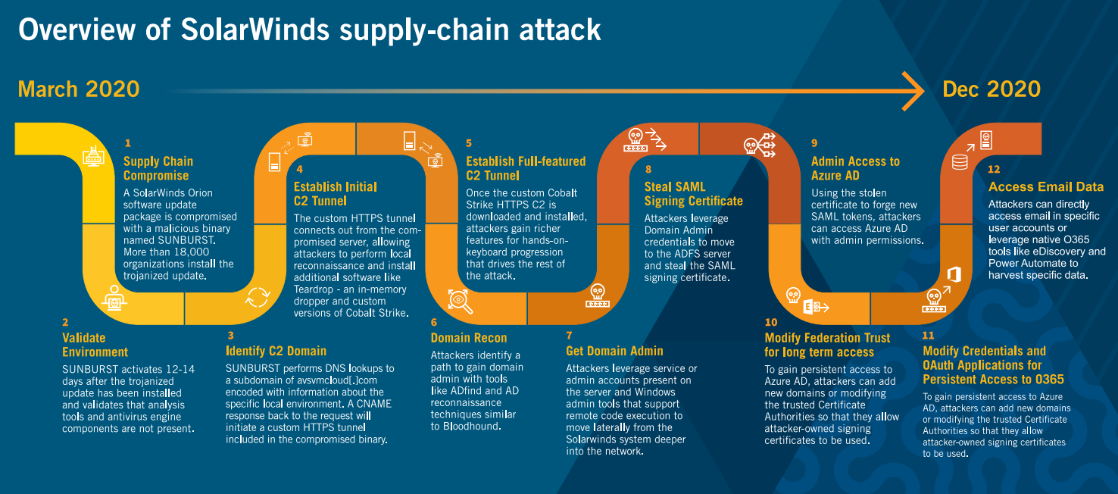
Attack Anatomy [8]
Based on the information from the image provided, which is VECTRA's overview of the SolarWinds attack, here is a concise timeline of the events:
March 2020:
- A malicious update of SolarWinds Orion, named SUNBURST, is released and installed by over 18,000 organizations.
- SUNBURST activates, camouflages itself from security tools, and establishes a covert communication channel.
Following Steps:
  - Attackers set up an initial and then a full-featured command and control (C2) tunnel using Cobalt Strike.
  - Domain admin rights are obtained by the attackers, enabling them to perform advanced reconnaissance and establish persistence in the network.
December 2020:
  - Attackers steal SAML signing certificates to access Azure AD with elevated privileges.
  - Long-term access is ensured by altering federation trust and modifying credentials in Azure AD and O365.
  - Sensitive email data is accessed and extracted.
This summary encapsulates the sophisticated steps of the SolarWinds supply-chain attack as depicted in VECTRA's detailed visual overview [8].

Preventative Measures
Upon uncovering the breach, swift measures were taken to nullify the impacted software and roll out an untainted secure update. Organisations were then instructed by SolarWinds to track their networks for any irregular activities that could be tied to the incident. Long-term preventive strategies looked at the introduction of more robust supply chain security. This would be done be conducting regular audits of any third-party vendors and a zero-trust architecture was adopted. The whole incident highlighted the importance of ensuring the integrity of software updates and having the network traffic continuously monitored[9].
The SolarWinds attack serves as a reminder of how important cybersecurity diligence is. One key recommendation for prevention is to ensure that software supply chains are vetted to a high standard. It is also important to ensure that third party vendors follow strict security standards, and that all systems are regularly updated and patched. Advanced threat detection and response systems should also be installed with endpoint detection and response tools to reduce the risk of an attack this sophisticated[10].
It is important to understand that there is a need for continuous education of strong security culture within organisations. By training all employees at all levels they can learn to recognise the signs of a breach and understand the role and importance that they play within their organisation’s security. It is necessary for the safety and integrity of an organisations data for every individual to feel responsible by creating a cyber secure culture[11].

Microsoft Exchange Server Hafnium Attack

Attack overview
The “MESHA” (Microsoft Exchange Server Hafnium Attack) occurred in 2021 when the cybersecurity sector was alerted to a breach that had implications for organisations around the globe. The attack exploited four zero-day vulnerabilities in on site Microsoft Exchange servers. The state-sponsored Chinese hacking group Hafnium were identified as the group behind the attack. The initial stage of the attack consisted of Hafnium exploiting four of Microsoft exchange zero-day vulnerabilities[12]:
CVE-2021-26855 (ProxyLogon): Server-side request forgery (SSRF). This vulnerability This enabled the attacker to dispatch any HTTP requests and authenticate as the Exchange server.
CVE-2021-26857: This vulnerability was present in the Unified Messaging service. The vulnerability was an insecure desterilisation, this occurs when a program deserializes data controlled by an untrusted user. By exploiting this vulnerability, HAFNIUM could execute code as SYSTEM on the Exchange server.
CVE-2021-26858: This vulnerability is a post authentication arbitrary write that was found in the exchange server. This would allow for the hackers to write any file of their choice to any path on the server. To authenticate this, they could exploit the CVE-2021-26855 vulnerability.
CVE-2021-27065: This vulnerability is another post authentication arbitrary write found on the exchange server which would allow for them to write any file to any path on the server.
The attackers then exploited these vulnerabilities through Remote Code Execution (RCE). These gaps in the security were leveraged to run code on susceptible servers to bypass authentication and security measures[13]. The next stage of the attack consisted of the hackers escalating their privileges to “Domain Administrator”, which is the highest level of permissions that could be obtained. This granted Hafnium complete access over all accounts, systems, and data in the network[12]. With the compromised accounts the hackers then made lateral movement through the systems giving them access to sensitive data within the system. Web shells were then installed on the compromised servers as a backdoor so that the hackers could keep gaining access to the servers even after the vulnerabilities that they identified were patched[14]. With the backdoor access sensitive data theft was the primary focus of the attackers. They aimed at acquiring emails, passwords, and any other sensitive information they could find in the compromised servers. In some cases, they resorted to encrypting the data that they had stolen and demanded ransom payments through ransomware for decryption[14].

Preventative measures
After the aftermath of the MESHA, there was a need for Microsoft to take some measures to resecure their system. Microsoft implemented a series of measures the first being updated tools and investigation guidance. The updated tools and investigation guidelines were in place to help any IT professionals and incident response teams by giving them the resources they need to identify, fix and defend against the MESHA. A one click mitigation tool was also introduced for customers who do not have a dedicated security or IT team. The one click mitigation tool was introduced as a way of safeguarding systems and fix any issues related with the Microsoft Exchange server in just a single action. Furthermore, the CVE-2021-26855, CVE-2021-26857, CVE-2021-26858 and CVE-2021-27065 vulnerabilities were addressed, and patches were released while the Microsoft customer support team urged all customers to update their system immediately. Additionally, a script was created by the Exchange server team that would check log files for any patterns and signatures that was associated with the MESHA. This scan for Indicators of Compromise (IOCs) helped in aiding the system administrator to check if their system was compromised, by detecting and identifying any suspicious activity. The final measure that was taken by Microsoft was the observation of any host IOCs. This involved Microsoft releasing a collection of IOCs from any attacks associated. This included web shell hashes and paths that would indicate there is a breach[13].
To mitigate the risk of a zero-day attack like the Hafnium incident a multi layered security approach could be adopted. The recommendation would be to implement network segmentation and monitoring. By segmenting the network into smaller segments, it would limit the spread of an attack on the network. By controlling the traffic flow between the compartmentalised sub-networks, it would have limited the access that hafnium would have had to the overall system. This strategy would have limited the spread of malware throughout the network and would reduce the overall damage and limited the time, money and effort that was spent in dealing with the attack [15].
Employee training in threat mitigation would have been another preventative measure that could have helped to lessen the impact of the attack. Employees are considered the first line of defence against an attack. But they can also be the weakest part of the defence when they are uneducated on the risks and vulnerabilities around them. By providing staff with cyber security awareness training, they can develop their skills and understanding to identify and respond more appropriately to threats[16].

Colonial pipeline ransomware attack

Attack overview
The colonial pipeline is a U.S. pipeline system that delivers refined oil products over a 5500 mile stretch from Texas to New York. In May of 2021 the pipelines IT systems were hit with a ransomware attack that shut down all operations for several days. The attack was carried out by a criminal group called named DarkSide[17].
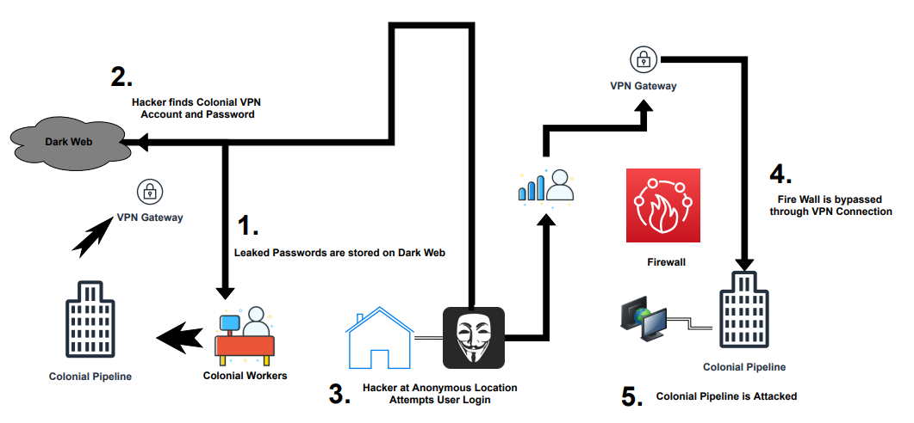
Diagram of the Process of access to colonial pipeline infrastructure from ‘A Review of Colonial Pipeline Ransomware Attack’[18]
The above diagram shows the method in which Darkside used to gain initial access to the network which will now be discussed in more detail.
The initial breach took place in May when DarkSide identified and exploited a vulnerability in an Inactive VPN account in the network. This VPN account used an old password which had been sold on the dark web. The account had a lack of authentication methods enabled, allowing the hackers to gain access to the network. DarkSide were able to bypass the Firewall of the colonial pipeline network through the VPN access that they had obtained. Once the hackers had access to the network, they deployed Ransomware that targeted the pipelines business networks. The ransomware encrypted the systems and demanded bitcoin for the decryption key. The attack targeted most of colonial’s operational technology which brought a complete shutdown to the pipeline’s operations. When the malware was discovered, several systems were shut down to limit the spread of the malware to contain the threat[18].
In terms of impact the attack had enormous economic and social disruption. Due to the pipeline being shutdown there was an increase in gas prices across the east coast of the U.S, this then led to panic buying and fuel shortages. The attack highlighted both the vulnerability in the Colonial Pipelines IT security and the huge effect that one small vulnerability can have on the economy, national security and day to day life[19]. The attack also caused immediate industry and government action to update policies and make industry changes to improve the cyber defences of critical infrastructure. The attack resulted in new security postures for companies and overall improved security measures across all sectors[20].

Preventative measures
In terms of removal of the ransomware and recovery of the systems, colonial had to pay close to $5 million in ransom fees. With the help of the FBI, they were later able to recover a large portion of the money however this extremely rare in these cases [21].
In terms of preventative measures that colonial pipeline could have taken the first being the most obvious is VPN security. Due to the attack being caused by a compromised VPN account, the first recommendation would be to strengthen VPN security. This could be achieved by ensuring that any old passwords are regularly updated, and multi-factor authentication is applied to all accounts. Combining this with regular monitoring of access logs would have completely mitigated this disaster. Additionally, adopting a Zero Trust network architecture would be appropriate for operations that are vital to everyday life, ensuring robust security and resilience. By having all entities inside or outside the network untrusted as default it would have significantly increased the security posture of their systems[22].

Task 2

Cureton Pharmacutical Company

Business nature
Size: small enterprise
Industry: Pharmaceutical research and development with a focus on respiratory viruses.
Operation: Primarily engaged in early-stage research for new vaccines

It infrastructure needs
Research and development server: This is where all the data will be stored relating to drug formulas, trial results and any scientific data.
Employee Workstations: These PCs are used by Researchers, admin staff and managers for day-to-day work. These computers run on Windows operating systems and will be used to access email, document creation/sharing and other generic tools.
Web Server: The webserver is used to host an informational website about the company.

Block Diagram of it infrastructure
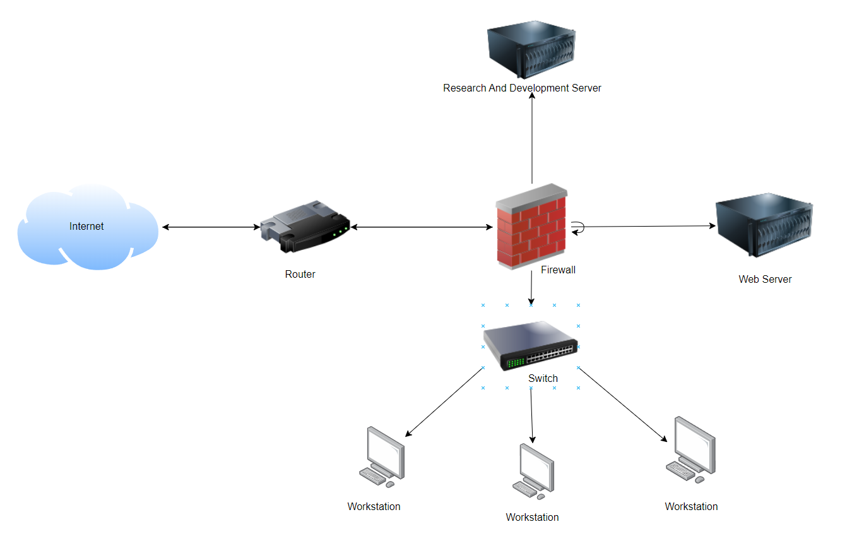
Figure 1 - Simplified diagram of CPCs Network
The diagram that has been created represents the core components of CPCs IT infrastructure. This includes one Research and development server, One Web Server, 3 Workstation PC’s which are interconnected by a switch. All the components are protected by a firewall and connect to the router. The router then connects the internal network to the internet. This setup will form the basis of a virtualised environment to conduct an ethical hacking simulation to identify potential vulnerabilities in the system.

Virtual Network Environment Overview
This virtual network environment has been set up to simulate a controlled setting for conducting the ethical hacking exercises. By using a virtual environment safe practice of vulnerability assessment and penetration testing techniques can be used without compromising a real system. The configuration is set up to reflect a realistic setup that a small pharmaceutical company would use.
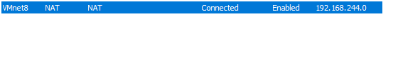
Subnet: Vmnet 8
Subnet IP Range: 192.168.244.0
The virtual network that has been created has been configured to a subnet named Vmnet8 so that the various devices in the network can communicate. The subnet Uses the IP address range 192.168.244.0. All the machines are connected by the Vmnet 8 allowing intercommunication and resource sharing. A firewall is assumed to be incorporated into the network protecting it from external threats and controlling the flow of traffic.

Virtual Machines Configurations
Web Server (Bee-box v1.6)
IP Address: 192.168.244.129
The bee-box is set up as the CPC’s webserver. This VM is set up with tools and services that simulate a real-world web server environment. Bee-box is known for its extensive list of vulnerabilities which is ideal for penetration testing purposes.
Research and Development (R&D) Server (Windows Server 2019)
Ip Address: 192.168.244.133
The R&D server is a critical part of the network as this is where all the research data will be stored. This server runs on windows server 2019. This server will be the backbone of the company’s research.
Employee Workstations 1 & 2 (Windows 10):
Desktop 1 IP: 192.168.244.130
Desktop 2 IP: 192.168.244.131
These workstations are designed to be used for day-to-day operations by research and administration staff. All the PCs are running windows 10.
Employee Workstation 3 (Metaspolitable 2 Linux)
IP Address: 192.168.244.135
This workstation will serve as a target within the subnet. Metasploitable 2 includes a wide range of common vulnerabilities found in poorly secured systems.

Vulnerability assesment and Penetration Testing VM OVerview
Pen testing VM (Kali Linux)
IP Address:
This virtual machine has been configured as the central point for penetration testing and vulnerability assessments against the CPC virtual network.
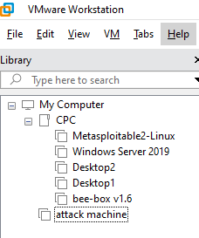
With all the VMs now set up to replicate CPC’s infrastructure the vulnerability assessment and penetration test can now take place.

Network Scan
Objectives:
  - Identify Active Hosts
  - Discover Open Ports
  - Service and Version Detection
  - Operating System detection
To achieve these objectives Zenmap will be used which is a GUI for the Nmap security scanner. A series of scans will be conducted to identify the active hosts, open ports, services and their versions and the operating systems that the active hosts are running.
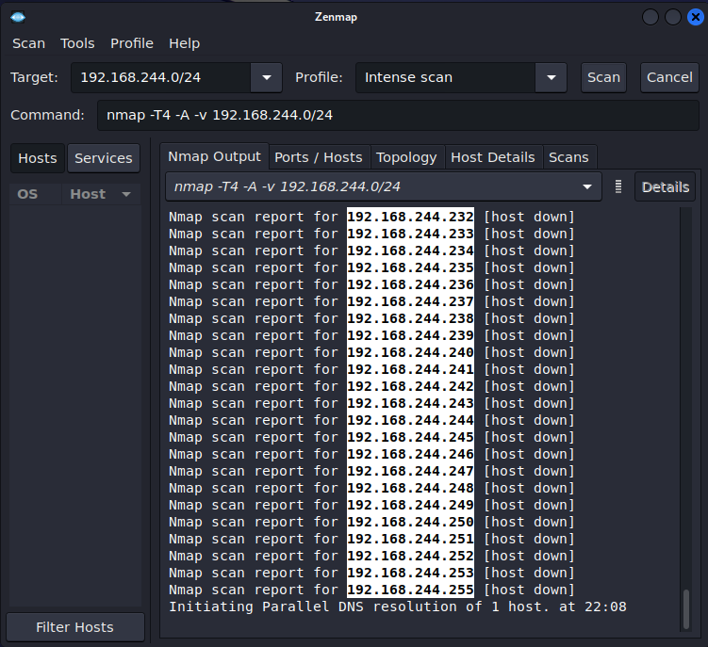
Figure 2 - Intense Scan on CPC network
Using the Zenmap tool a target has been set ‘192.168.244.0’ which is the CPC subnet. An intense scan has been selected which will perform a detailed examination of the target network.

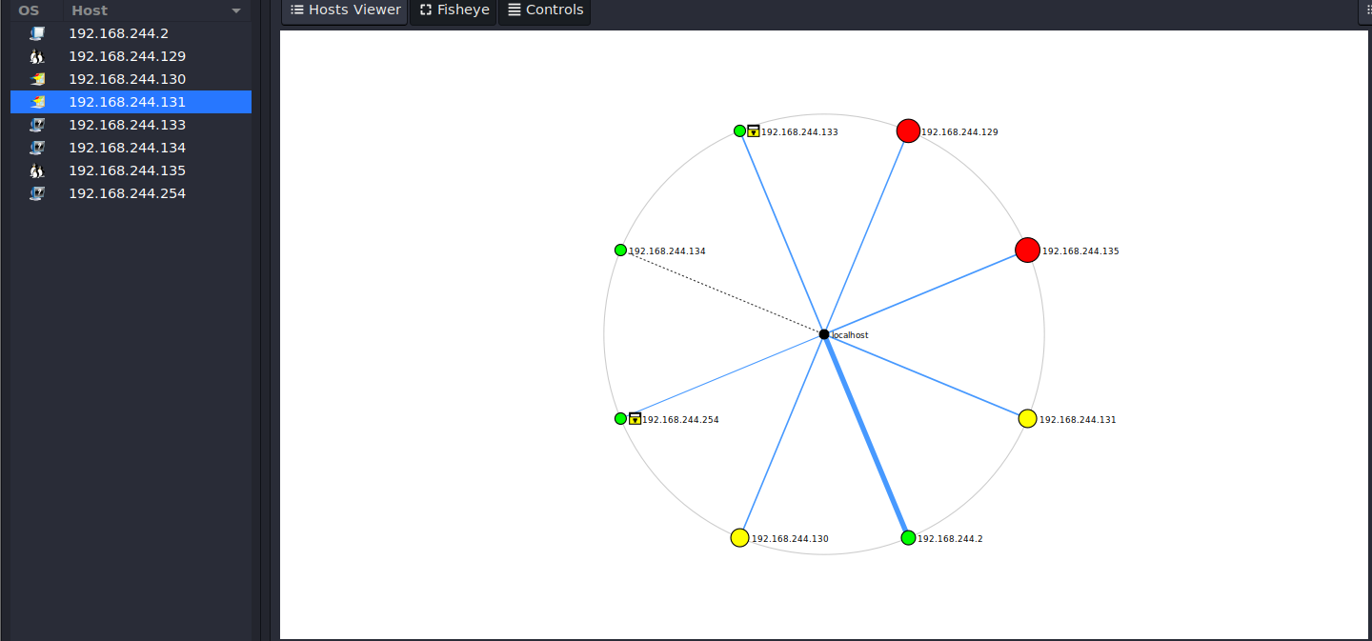
Figure 3 - Zenmap scan with network topology
The Zenmap scan of the network reveals all the active hosts in the network. On the left of the figure the IP address of each host can be seen along with a network topology of CPC. The network topology is colour coded.
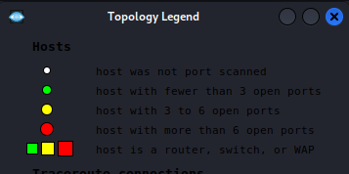
Figure 4 - topology Legend
The colours given to each of the hosts represents the number of open ports. The green hosts have fewer than 3 open ports meaning that they are likely to be secure. The yellow hosts have 3 to 6 making them moderate. Finally, the red hosts are targets with 6 or more open ports making them the key targets for the penetration test.
Two targets stand out after the scan are ‘192.168.244.129’ and ‘192.168.244.135’. Due to the large number of open ports, they will be the focus for the rest of the assessment.

192.168.244.129 Network scan details
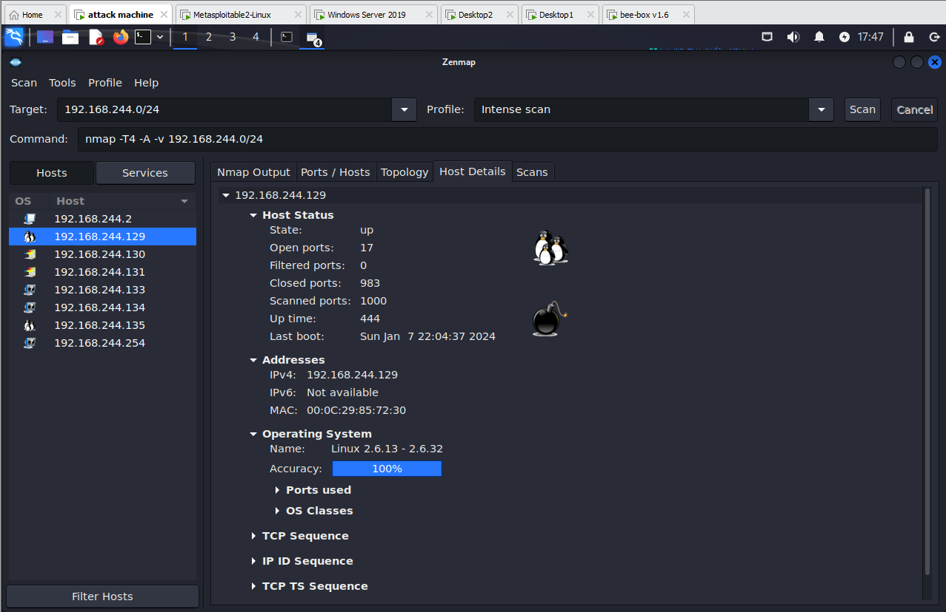
Figure 5 - Additional information about 192.168.244.129
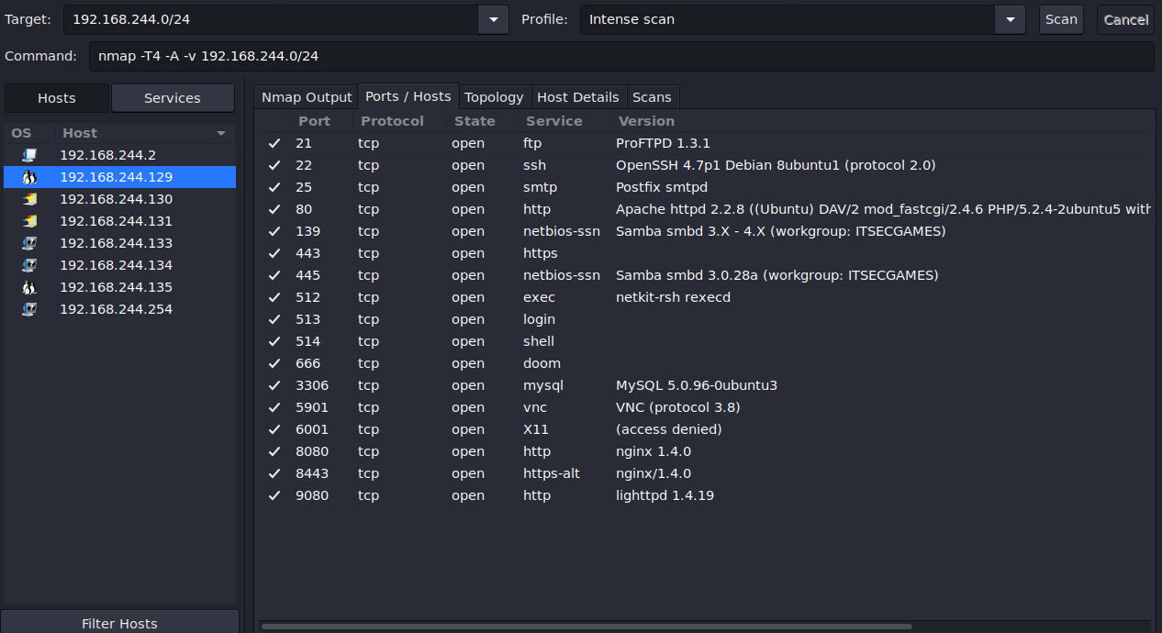
Figure 6 - Open ports 192.168.244.129
By selecting the ‘host details’ and ‘ports/hosts’ tabs in Zenmap additional information can be found about the target. ‘192.168.244.129’ is a Linux based machine which has 17 open ports. There are many outdated and unsecure services and versions open on this target. Some of the standouts are as follows:
  - ProFTPD 1.3.1: There are many vulnerabilities know to exist in this ftk version. Arbitrary code execution and denial of service (DoS) being two of them.
  - OpeNSSH 4.7p1: This is an old and outdated version of ssh and is likely to have several vulnerabilities
  - Apache httd 2.2.8: Outdated version which is likely to have several vulnerabilities.
  - Samba 3.x: This samba series is known to have had multiple serious vulnerabilities.
Most of the services on open ports in this host are outdated and vulnerable. These will be considered in the next phase of the vulnerability assessment.

192.168.244.135
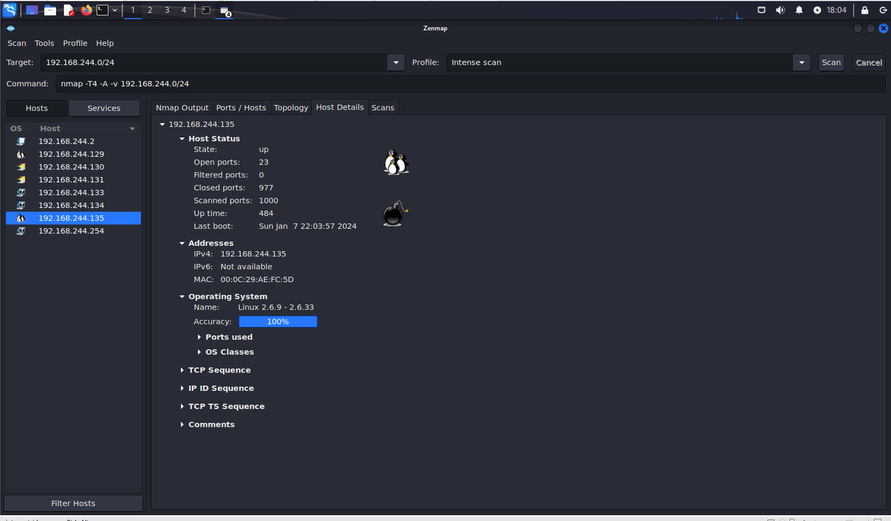
Figure 7 Additional information about 192.168.244.135
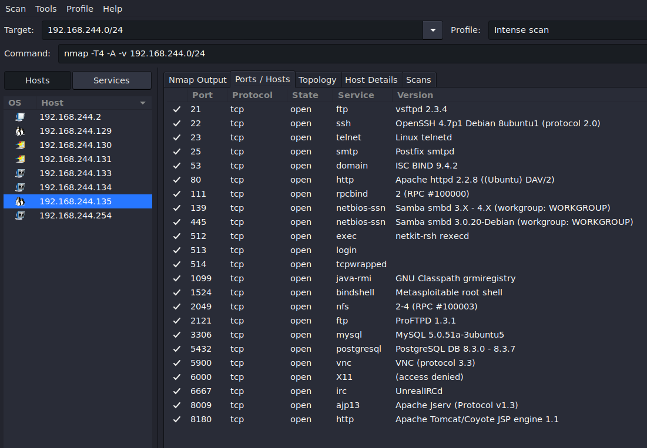
Figure 8 - Open ports 192.168.244.135
The second target ‘192.168.244.135’ is also a Linux based machine. This machine has 23 open ports making it a valuable target. From the ‘Ports/hosts’ most of the versions of the services running on the open ports are outdated. The ones that stand out the most are as follows:
  - Telnet (port 23): Telnet is known to be unsecure as it transmits all data without encryption including passwords.
  - Bindshell(Port 1524): Bindshell is often associated with compromised systems as they are used my hackers to establish a backdoor into the network.
  - Java RMI(Port 1099): This service can potentially be used to allow remote code execution which is a significant security risk.

Vulnerability Assesment
For the vulnerability assessment Nmap Scripting Engine (NSE) has been chosen. NSE has a large library of scripts which can help discover potential vulnerabilities. By leveraging NSE we will aim to scan the two previously identified targets to uncover potential vulnerabilities that can be exploited in further steps.

Vulnerability Scan 192.168.244.129
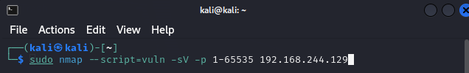
The following command is run on the first target ‘192.168.244.129’ and does as follows:
--script=vuln: Tells Nmap to run all vulnerability scripts.
-sV: Enables service version detection.
-p 1-65535: Scans all ports.
192.168.244.129: Specifies the target.
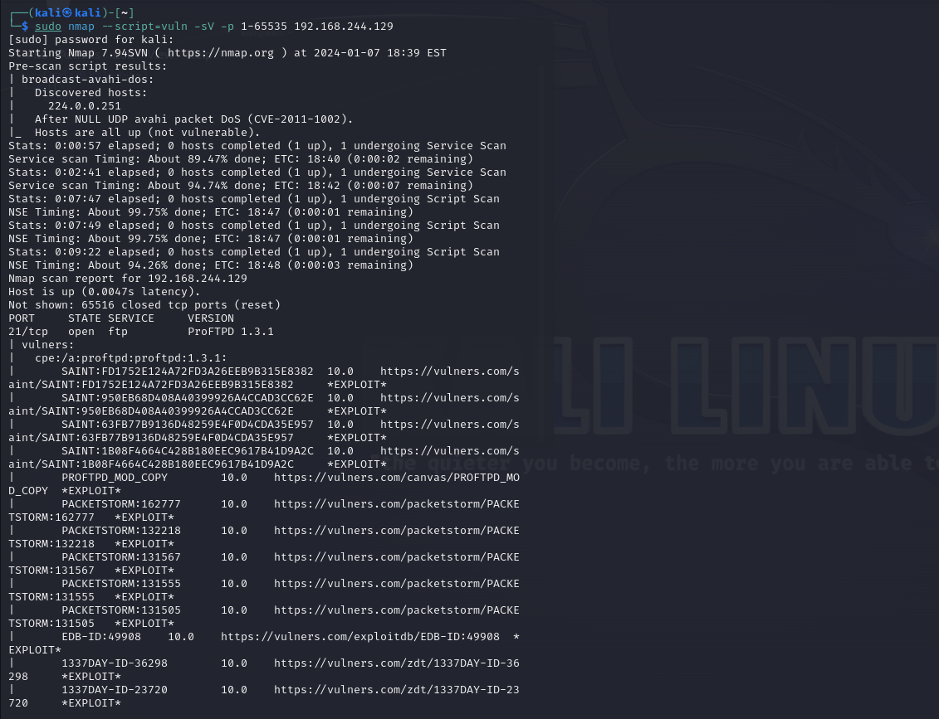
Figure 9- Part of the NSE vulnerability scan
The NSE returned a large finding from the scan. Here is a summarised version of the findings of vulnerabilities on 192.168.244.129. For a full list of Vulnerabilities identified please refer to Appendix A:
  - FTP Service on Port 21(ProFTPD 1.2.1): Multiple vulnerabilities have been detected on this port including arbitrary code execution and DoS.
  - SSH Service on Port 22(OpenSSH 4.7p1): This is an outdated version that has several vulnerabilities that include weak encryption and potential for unauthorised access on information.
  - SMTP Service on Port 25(Postfix smtpd) Vulnerabilities related to anonymous Diffie-Hellman key exchange which can potentially allow attackers to intercept communications. SSL/TLS protocol weaknesses were also found.
  - HTTP Service on Port 80 (Apache httpd 2.2.8): The server version used on this is outdated and has several vulnerabilities. These being that it is susceptible to SQL injections, DoS attacks and misconfigured cross-domain policy files.
From this scan it is apparent that many of the services are outdated and poses a lot of know vulnerabilities which could be exploited in the next phase.

Vulnerability Scan 192.168.244.135
The same vulnerability scan is run on ‘192.168.244.135’.
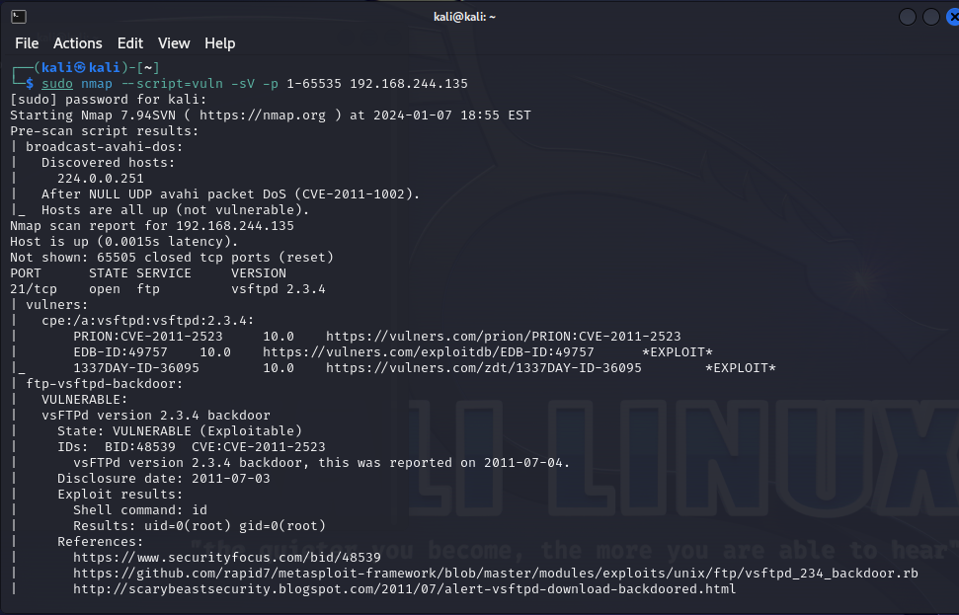
Figure 10 - Part of NSE vulnerability scan on 192.168.244.135
Based on the extensive report that was created by NSE the following is a summary of the key vulnerabilities identified. Please refer to appendix B for a full list and description of all vulnerabilities identified:
  - FTP Service (vsftpd 2.3.4 on Port 21): This version is known to allow remote command execution and full system access along with several other vulnerabilities. This is highly vulnerable.
  - SSH Service (OpenSSH 4.7p1 on Port 22): This outdated service has several vulnerabilities are associated including potential unauthorised access and DoS attacks.
  - Telnet, SMTP, Domain, and HTTP Services (Ports 23, 25, 53, 80): Various vulnerabilities related to information disclosure, denial of service, and man-in-the-middle attacks.
  - Distributed Computing (distccd on Port 3632): This vulnerability allows for potential remote command execution.
Like the first target this machine also runs many outdated and vulnerable services. Many of these vulnerabilities are critical and if exploited by an external threat could lead to extensive consequences for CPC.

Penetration test contngency plan
In the event that the machine attempting to exploit a vulnerability is unable to execute the following steps will be taken:
  - A description of the exploit will be given. This will include the method that will be used and any relevant technical information.
  - A successful exploit could result in adverse effects to CPC. The potential end results of the exploit will be detailed with possible consequences.
  - Mitigation suggestions will also be given even if the exploit is unsuccessful. Although the exploit may not have been successful from the penetration test machine, a hacker may be able to leverage the exploit in another way, so it is best to mitigate the vulnerability completely.

Penetration test
A penetration test will now take place based on some of the vulnerabilities identified in the vulnerability scan. The first exploit that will be attempted is associated with the FTP service running “vsftpd 2.3.4”. This version often has a backdoor inserted in the code. When a user signs in with a username that has a colon (:) in it a backdoor can be opened through a command shell on port 6200.

vsftpd 2.3.4
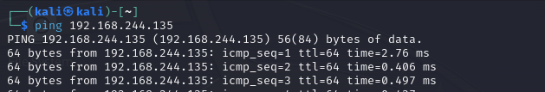
The first step using the kali machine is to make sure that the target is running using the ping command.
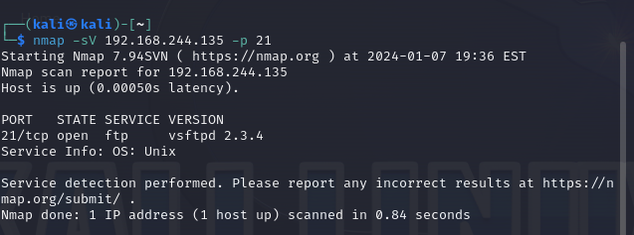
Nmap is then used to verify that vsftpd 2.3.4 is open and running on port 21.
The next step is to attempt to connect using ftp.
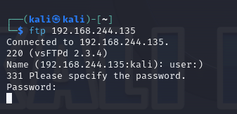
When attempting to connect to ftp a username is entered with a colon (:) which is supposed to trigger a backdoor. To connect to the shell listening on port 6200 the following command should be used in another terminal ‘nc 192.168.244.135 6200’. ‘nc’ Netcat will establish a TCP connection from the kali machine to the backdoor created in 192.168.244.135.
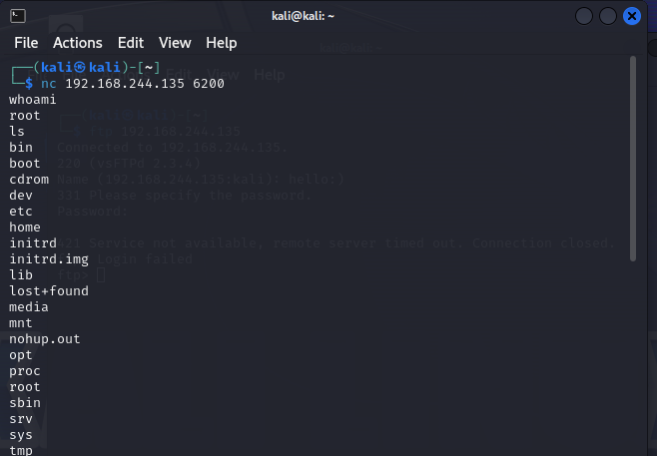
Figure 11 - succesful exploit
The exploit was successful allowing for the kali machine to take control of the target. The ‘whoami’ command was used and ‘ls’ to identify the name of the target and the directories it contains.
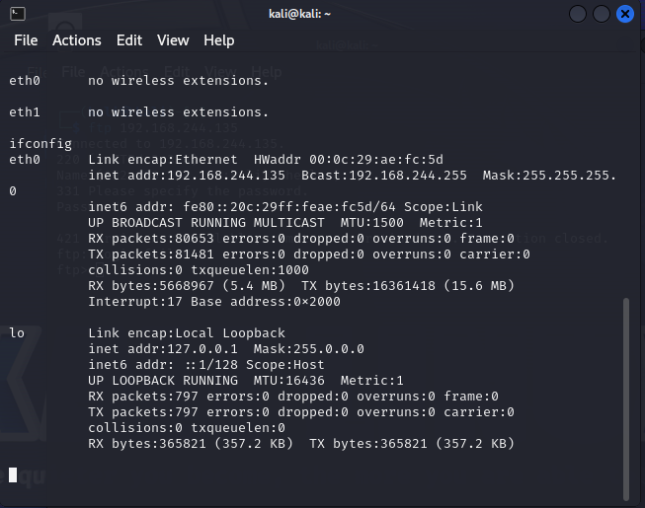
Figure 12 - ifconfig through Netcat
‘ifconfig’ command was also used to prove that it was the target machine that it had taken over.
The vsftpd backdoor exploit was successful, it established an unauthorised command shell on the target server. This backdoor gave the attacking machine the same level of access as the service itself (this would typically be escalated privilege). This hole in the system could be used as a starting point for various malicious activity in CPCs system. Attackers could potentially install more backdoors to maintain persistent access and could escalate their privileges to gain full access over the network. To mitigate this vulnerability vsftpd should be upgraded to the latest version as the vulnerability is specific to v 2.4.4.

UnreallRCd backdoor
This vulnerability that was detected on target ‘192.168.244.135’ is an issue where UnreallRCd source code contained a backdoor. This backdoor can be exploited by hackers to execute commands.
This first step is to ensure that the service is still running on the target machine.
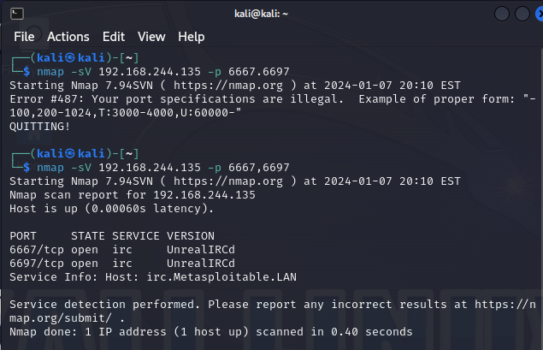
Figure 13 - confirmation of UnreallRCd running on ports 6667 and 6697
The next stage of the exploit is to use the Metasploit framework to exploit the backdoor. First Metasploit is used to search for the UnreallRCd vulnerability.
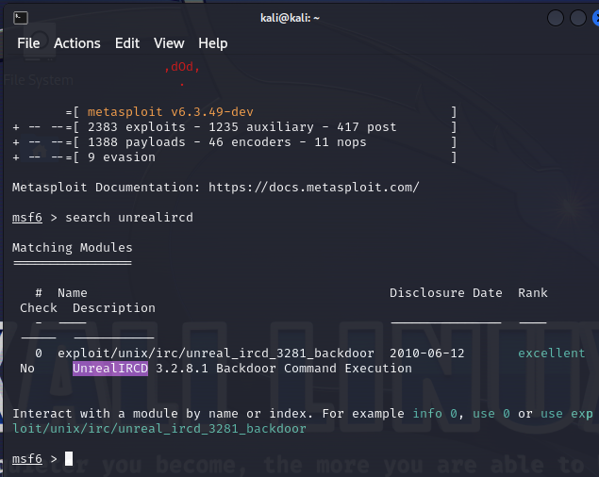
The search on Metasploit reveals the ' unreal_ircd_3281_backdoor’. This exploit is then selected.
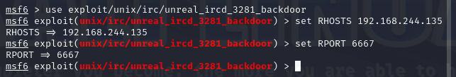
The target is then selected by setting the ‘RHOSTS’ and the port selected by setting the ‘RPORT’. The exploit is then run with ‘exploit’.
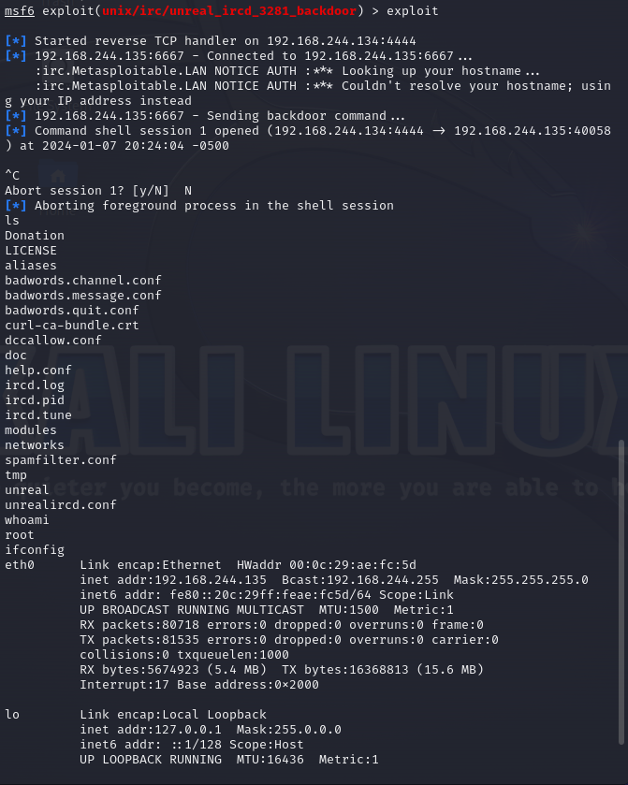
Figure 14- exploit successful.
The exploit on the UnreallRCd backdoor was successful. This vulnerability allowed for the ability to execute arbitrary commands on the vulnerable machine. This level of access would allow for a hacker to steal data and information and potentially leverage access to gain further access to other parts of the network. To prevent this vulnerability, the system and software should be updated, this vulnerability was removed in later versions of UnreallRCd so by upgrading to a newer version it would fix this issue.

Proftpd 1.3.1
ProFTPD 1.3.1 is a version of ProFTPD that has known vulnerabilities that can be used to gain unauthorised access to a machine. When attempting to exploit this vulnerability there was an error while trying to use Metasploit so the contingency plan will be followed.
To exploit this vulnerability Metasploit should be opened using the ‘msfconsole’ command and a search should be conducted for vulnerabilities related to ‘search ProFTPD’. This will list all related exploits to this vulnerability. The exploit should then be selected and configured the same way that the ‘UNREALLRCD BACKDOOR’ vulnerability was selected. The target should be set with ‘RHOSTS’ and the listening host should be set with ‘LHOST’. The exploit should then be run and if successful the attacker will have access to the target system. From this point the attacker can escalate privileges and explore the system for sensitive data.

recommended solutions

Configuration Changes
Configuration changes are a crucial step to strengthening the security posture of CPC. Specific configuration changes on the exploitations that have been made in the assessment have been given but now a more general look at the network will be taken. First it is important for CPC to update and patch all their software and operating systems to the latest versions to reduce the risk of them succumbing to known bugs. Strict access controls should be implemented across the network limiting the permissions that users have. Each user should have the lowest level of access possible that they are able to complete their job with. This will help mitigate the risk of internal threats.
Firewalls and intrusion detection systems (IDS) should both be enabled and configured. They should both be utilised to monitor and control the flow of traffic throughout CPCs network, this will help create a protective membrane against attacks. Finally, and most crucial to CPCs network unnecessary ports and services should be disabled. CPCs network was filled with devices with open ports running outdated versions of services creating a large attack surface for hackers. Each of these steps if implemented correctly will help create a more robust network.

New software and hardware
In terms of new software and hardware two machines stood out in the assessment as being both outdated and vulnerable to exploits. These machines being a vulnerable Linux machine and a vulnerable Linux webserver. In terms of the webserver, it is recommended that a secure web application framework is adopted. ASP.Net is a good example of a web framework that implements proper security measures. Web Application firewalls (WAF) should also be implemented to detect and prevent any attacks that may try reach the webserver.
In terms of the other vulnerable linux machine, it would be advised to upgrade to a supported version of Linux that receives regular security updates.

Defence strategy
To bolster the security of CPCs, network a robust defence strategy should be followed. The first step in the defence strategy should be to conduct regular vulnerability assessments and penetration tests, this will allow for continuous identification and mitigation of new vulnerabilities in the system. The second step should be to develop an incident response plan, this will be an effective action plan that can be followed if the system is compromised which will reduce the total impact of the attack. All employees of the company should attend mandatory cyber security awareness classes, to ensure that they understand the best practices and their role in maintaining the security posture of the network.

COST OF solution

Cost of replacing software and hardware
WebApp Framework (ASP.NET): .NET is an opensource platform that does not require and licensing fees to be paid. Microsoft can be paid for enterprise support how ever this will not be required for CPC due to the sixe of the company.
The WAF that would be recommended for CPC is the AppTrana Managed Web Application Firewall by Indusface which costs $1068 yearly [23].
Upgrading to a supported version of Linux doesn’t cost any license fees however it may come with complexities when setting up.

Cost of implementing the fix based on your staff hourly rates and consultancy
Average hourly rates for IT staff range from £30 to £100/hr. In this case a fee of £50/hr will be applied.
Average hourly IT security consultancy range from £100 to £200. In this case a fee of £150/hr will be applied
Configuration Changes
  - Updating and patching system: 10/hr x £50 = £500
  - Access control implementation: 15/hr x £50 = £750
  - Firewalls and IDS: 20/hr x £50 = £1000
  - Disabling ports/services = 8/hrs x £50 = £400
Software
  - WAF: £1068/ year
  - Linux upgrade: 12/hrs x £50 = £600(Time to upgrade, no cost for software)
Defensive strategy
  - Regular vulnerability assessment: 40/hr/year x £150 = £6000
  - Incident response plan development: 25/hr x £150 = £3750
  - Cyber Awareness Classes: 30/hr x £50 = £1500
Cost of Implementing the Fix Based on Staff Hourly Rates: £4750
Cost for Consultancy of Security Measures: £9750
Cost for New Software and Hardware: £1068
Grand Total for 1st Year: £15,568

Invoice
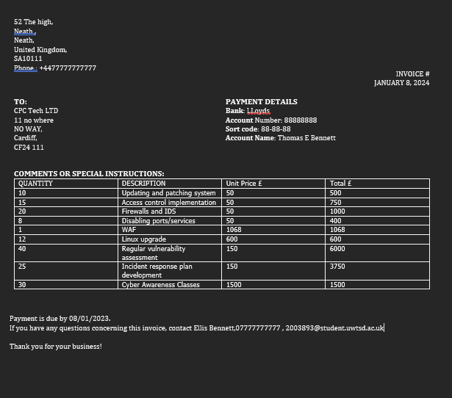

Conclusion
In conclusion this report has aimed to produce an in-depth analysis on ethical hacking techniques and its practical application. Three case studies were conducted on the SolarWinds supply chain attack, the MESHA, and the Colonial Pipeline Ransomware attack. These three attacks provided valuable insight into the sophistication of cyber attacks and the potential impact they can have to IT infrastructure and even day to day life. A vulnerability assessment was then conducted on a virtualised version of Cureton Pharmaceutical Company’s network. Several tools were used to identify and exploit vulnerabilities in CPCs network and emphasis was put on the necessity for CPC to regularly secure and update their security posture. It was implied that robust security measures, continuous education on cyber security awareness and the use of ethical hacking techniques are vital strategies when creating a robust IT network. Using a proactive approach like this helps to safeguard the valuable assets of an organisation and creates a safer digital environment for all.

Appendix

Appendix A – Full list of vulnerabilites identified in target 192.168.244.129
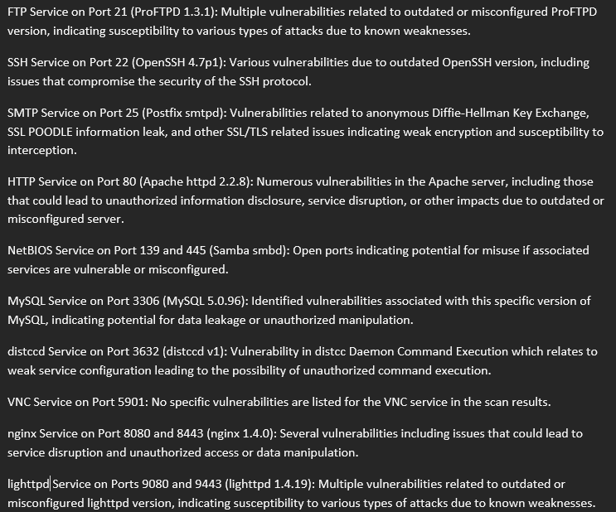

Appendix B – Full list of vulnerabilites identified in target 192.168.244.135
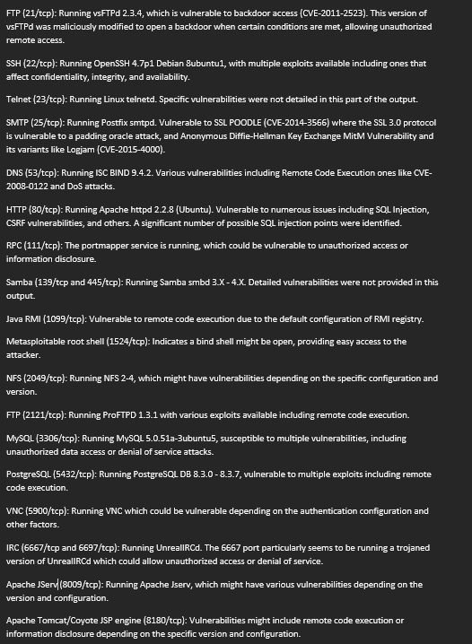

References
[1] G. Vishnuram, K. Tripathi, and A. Kumar Tyagi, ‘Ethical Hacking: Importance, Controversies and Scope in the Future’, in 2022 International Conference on Computer Communication and Informatics (ICCCI), IEEE, Jan. 2022, pp. 01–06. doi: 10.1109/ICCCI54379.2022.9740860.
[2] M. Denis, C. Zena, and T. Hayajneh, ‘Penetration testing: Concepts, attack methods, and defense strategies’, in 2016 IEEE Long Island Systems, Applications and Technology Conference (LISAT), IEEE, Apr. 2016, pp. 1–6. doi: 10.1109/LISAT.2016.7494156.
[3] R. W. Bellaby, ‘An Ethical Framework for Hacking Operations’, Ethical Theory and Moral Practice, vol. 24, no. 1, pp. 231–255, Mar. 2021, doi: 10.1007/s10677-021-10166-8.
[4] SolarWinds, ‘SolarWinds Security Advisory’. Accessed: Oct. 09, 2023. [Online]. Available: https://www.solarwinds.com/sa-overview/securityadvisory#anchor1
[5] FireEye, ‘Highly Evasive Attacker Leverages SolarWinds Supply Chain to Compromise Multiple Global Victims With SUNBURST Backdoor’, Mandiant. Accessed: Jan. 03, 2024. [Online]. Available: https://www.mandiant.com/resources/blog/evasive-attacker-leverages-solarwinds-supply-chain-compromises-with-sunburst-backdoor#:~:text=block%20this%20attack.-,Summary,IT%20monitoring%20and%20management%20software.
[6] Brad Smith - Vice Chair & President, ‘A moment of reckoning: the need for a strong and global cybersecurity response’, Microsoft. Accessed: Nov. 03, 2023. [Online]. Available: https://blogs.microsoft.com/on-the-issues/2020/12/17/cyberattacks-cybersecurity-solarwinds-fireeye/#:~:text=It%20requires%20that%20we%20look,and%20coordinated%20global%20cybersecurity%20response.
[7] CISA, ‘Advanced Persistent Threat Compromise of Government Agencies, Critical Infrastructure, and Private Sector Organizations’, CISA. Accessed: Nov. 03, 2023. [Online]. Available: https://www.cisa.gov/news-events/cybersecurity-advisories/aa20-352a
[8] VECTRA, ‘Attack Anatomy: SunBurst SolarWinds Attack’, VECTRA. Accessed: Nov. 09, 2023. [Online]. Available: https://www.vectra.ai/resources/attack-anatomies/rapid-response-sunburst-attack
[9] B. Krebs, ‘SolarWinds: What Hit Us Could Hit Others’, KrebsonSecurity. Accessed: Nov. 03, 2023. [Online]. Available: https://krebsonsecurity.com/2021/01/solarwinds-what-hit-us-could-hit-others/
[10] NIST, ‘CYBERSECURITY FRAMEWORK’, National Institute of Standards and Technology. Accessed: Jan. 03, 2024. [Online]. Available: https://www.nist.gov/cyberframework
[11] D. Tolossa, ‘IMPORTANCE OF CYBERSECURITY AWARENESS TRAINING FOR EMPLOYEES IN BUSINESS’, VIDYA - A JOURNAL OF GUJARAT UNIVERSITY, vol. 2, no. 2, pp. 104–107, Aug. 2023, doi: 10.47413/vidya.v2i2.206.
[12] R. ’ ’Peter, G. Anthony, T. ’Dean, D. ’Morgan, and F. ’Joey, ‘HAFNIUM Targets Microsoft Exchange Zero-Day Vulnerabilities’, IronNet. Accessed: Nov. 11, 2023. [Online]. Available: https://www.ironnet.com/blog/hafnium-targets-microsoft-exchange-zero-day-vulnerabilities
[13] Microsoft Threat Intelligence, ‘HAFNIUM targeting Exchange Servers with 0-day exploits’, Microsoft Security. Accessed: Jan. 04, 2024. [Online]. Available: https://www.microsoft.com/en-us/security/blog/2021/03/02/hafnium-targeting-exchange-servers/
[14] A. M. Pitney, S. Penrod, M. Foraker, and S. Bhunia, ‘A Systematic Review of 2021 Microsoft Exchange Data Breach Exploiting Multiple Vulnerabilities’, in 2022 7th International Conference on Smart and Sustainable Technologies (SpliTech), IEEE, Jul. 2022, pp. 1–6. doi: 10.23919/SpliTech55088.2022.9854268.
[15] Threat Intelligence, ‘Network Segmentation and How it Can Prevent Ransomware’, Threat Intelligence. Accessed: Nov. 04, 2023. [Online]. Available: https://www.threatintelligence.com/blog/network-segmentation
[16] Institute of Data, ‘The Importance of Cybersecurity Awareness Training for Employees’, Institute of Data. Accessed: Nov. 25, 2023. [Online]. Available: https://www.institutedata.com/us/blog/cybersecurity-awareness-training/#:~:text=Cyber%20threats%20are%20constantly%20evolving%2C,inform%20them%20about%20emerging%20threats
[17] Congressional Research Service, ‘CRS INSIGHT Prepared for Members and Committees of Congress Colonial Pipeline: The DarkSide Strikes’, 2021. [Online]. Available: https://crsreports.congress.gov
[18] J. Beerman, D. Berent, Z. Falter, and S. Bhunia, ‘A Review of Colonial Pipeline Ransomware Attack’, in Proceedings - 23rd IEEE/ACM International Symposium on Cluster, Cloud and Internet Computing Workshops, CCGridW 2023, Institute of Electrical and Electronics Engineers Inc., 2023, pp. 8–15. doi: 10.1109/CCGridW59191.2023.00017.
[19] T. Tsvetanov and S. Slaria, ‘The effect of the Colonial Pipeline shutdown on gasoline prices’, Econ Lett, vol. 209, p. 110122, Dec. 2021, doi: 10.1016/j.econlet.2021.110122.
[20] S. Kerner, ‘Colonial Pipeline hack explained: Everything you need to know’, TechTargets. Accessed: Nov. 22, 2023. [Online]. Available: https://www.techtarget.com/whatis/feature/Colonial-Pipeline-hack-explained-Everything-you-need-to-know
[21] ‘US authorities recover most of Colonial Pipeline ransom’, Network Security, vol. 2021, no. 6, pp. 1–2, Jun. 2021, doi: 10.1016/S1353-4858(21)00057-X.
[22] NCSC, ‘Zero Trust: Is it right for me?’, National Cyber Security Centre. Accessed: Dec. 05, 2023. [Online]. Available: https://www.ncsc.gov.uk/blog-post/zero-trust-is-it-right-for-me
[23] indusface, ‘WEB APPLICATION & API PROTECTION’, indusface. Accessed: Jan. 02, 2024. [Online]. Available: https://www.indusface.com/waf-pricing.php#:~:text=Pricing%20Per%20Month%20Per%20Month,36

