

LOCATION: Swansea | LLEOLIAD: abertawe
LEVEL 6 | LEFEL 6
EXAMINATION PERIOD | CYFNOD ARHOLIADAU
January 2026 | IONAWR 2026
MODULE CODE: ACDA 6008
SCIENTIFIC PRINCIPLES OF OME DESIGN
TIME: 2 HOURS

answer all of section A

answer 2 out of 3 QUESTIONS in section B

Equipment or materials required. Please select from the following:
Adnoddau neu ddefnyddiau sydd eu hangen.

Cyfrifiannell/Calculator
Llyfr Agored/Open Book.
Arall/Other Nodwch/Please Note ……………………….

BEGIN EXAM QUESTIONS HERE!

SECTION A

ANSWER ALL 6 QUESTIONS IN THIS SECTION

- Describe the differences between an ideal and non-ideal detonation
Ideal detonation – short induction zone (microns) and detonaton driving (1 – 10 mm), with reaction completing in 300 – 400 ns. Gases produced in reaction zone then expand in the non-driving zone, but follow the progression of detonation.

Non-ideal - significant departure of highly non-ideal detonations from idealised one-dimensional wave propagation. Difficult to predict. Reactions continue beyond behnd the detonaton driving zone, leading to lower detonation pressures and longer impulse durations.
[5 marks]

- a) Using the diagram below, explain the significance of the point highlighted on the lethality curve for a 70 kg male in the free field

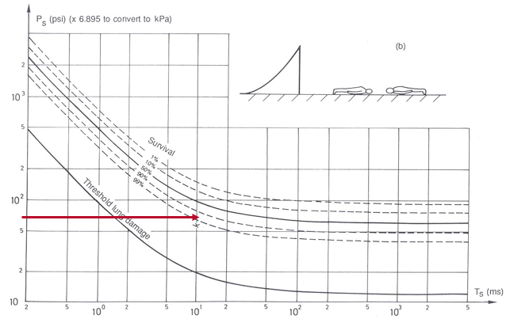
At the point highlighted, the threshold for lung damage has been exceeded and sits between the 90 and 99% survivability threshold for a human lying down in the free-field. Chances of survival are good, but there will be respiratory injury and perhaps injury to the ears.
[3 marks].

b) If the individual were standing next to a reflecting surface, would you expect survivability to be better or worse, and why?

When an individual is beside a reflecting surface they become to susceptible to incident as well as reflected pressures, which can be orders of magnitude higher than the incident pressure. As such, survivability is much reduced.

[2 marks]

- Describe 5 different shock waves that a submarine may experience from an underwater explosion. Assume the detonation is of sufficient strength to generate reflection from the sea floor and water surface.

There are 4 marks for the statements relating to the image above. A 5th mark is allocated for migration of the bubble towards a rigid boundary
[5 marks]

- a) An explosive comprises 50% TNT, 40% Ammonium Nitrate and 10% aluminium. Given the parameters described in the table below, and the equation provided, what is the theoretical detonation velocity of the mixture in km s⁻¹?

D_{i} TNT | 6.970 km s⁻¹
Di Al | 6.850 km s⁻¹
Di AN | 3.143 km s⁻¹
V_{i} | The volume fraction of component

$$D_{mix}=\sum{D_{i}V_{i}}$$

$D_{mix}=\left(6.97×0.5\right)+3.143\left(0.4\right)+\left(6.85×0.1\right)=5.43$ km s⁻¹

[3 marks]

b) If the theoretical density (ρ) of the composition is 1.65 g cm⁻¹, calculate the detonation pressure (P_{cj}) in GPa

$P_{cj}≅$ $\frac{ρD_{mix}^{2}}{4}$

$P_{cj}≅$ $\frac{1.65({5.43)}_{mix}^{2}}{4}=12.16$ GPa

[2 marks]

- Describe 5 factors that would influence the penetration of a shaped charge in a semi-infinite armoured plate of RHA.
Student can choose from liner material, confinement, stand off, type of explosive, spin rate, axial symmetry, cone angle, cone thickness etc. Provide one or two sentences to support each answer.

[5 marks]

- a) Describe the mechanical properties required of a cased munition and its explosive to produce blast as the primary lethal mechanism.

[3 marks]
We are looking for low ductility, thin-walled case and highly brisant explosive to shatter the case easily, thereby allowing less energy from the explosive to be absorbed in breaking up the case.

- b) What type of fragmentation may a designer choose for a hand grenade, where each fragment provides similar lethality at close range?

[2 marks]

We are looking for pre-formed fragmentation where each fragment would be of a similar mass and cross-sectional area to provide similar lethality.

SECTION B
ANSWER 2 OUT OF 3 QUESTONS IN THIS SECTION

- a) From the diagram and data below, calculate the initial fragmentation velocity (V_{o}) and beam angle for a static cylindrical warhead detonated from the centre.

$ρ=\frac{m}{v}$ Relationship between density, mass and volume

$πr^{2}l$ Equation to describe the volume of a cylinder
$V_{o}=\sqrt{2E}{\left(\frac{M}{C}+0.5\right)}^{-0.5}$Gurney Equation for a Cylinder

$θ=\sin^{-1}\left\{\left(V_{o}\cos{∝}\right)/2D\right\}$ Equation to determine Taylor Angle

Case material density (steel) | 7850 kg m⁻³
Explosive density | 1890 kg m⁻³
Gurney Constant $\sqrt{2E}$ | 2860 ms⁻¹
Initial fragment velocity V_{o} | What you must calculate in ms⁻¹
Mass of case material M | What you must calculate in kg
Mass of explosive material C | What you must calculate in kg
Velocity of detonation of explosive D | 6840 ms⁻¹

C of explosive material = density x volume = 1890 x pi x 0.09² x 0.4 = 19.24 kg

M of case material = (volume total – volume explosive) x density

= [(pi x 0.1² x 0.4) – (pi x 0.09² x 0.4)] x 7850 = 18.74 kg

$V_{o}=\sqrt{2E}{\left(\frac{M}{C}+0.5\right)}^{-0.5}=2860\sqrt[-0.5]{\frac{18.74}{19.24}+0.5}=2355.67$ ms-1

$$θ_{B}=θ_{A}=\sin^{-1}\left\{\frac{\left(2355.67×\cos{(\tan^{-1}{\frac{100}{200}}}\right)}{2×6840}\right\}= 8.86$$

Therefore, Beam Angle = 8.86 + 8.86 = 17.72 degrees

[25 marks]

- b). If we assume that the warhead has detonated at sea level (density of air 1.225 kg m⁻³) and each steel fragment is a cube of dimensions (10 x 10 x 10 mm) with a drag coefficient of 1.6, will a fragment defeat a target with a kinetic energy density of 100 J mm⁻² at 30 metres? You should use the following equation as a start point, where:
Vs = slant range [m]
Cd = drag coefficient
ρ_{air} = density of air at given altitude [kg m⁻³]
A = cross-sectional area of fragment [m²]
S = slant range [m]
m = mass of fragment [kg]

$$V_{s}=V_{0}e^{\left(\frac{-C_{d}ρ_{air}AS}{2m}\right)}$$

Note: you are expected to know the equation for kinetic energy density at Level 6.

$$V_{s}=2355.67e^{\left(\frac{-1.6×1.225×0.01×0.01×30}{2×7850×0.01×0.01×0.01}\right)}=2355.67e^{-0.3745}=1619{ms}^{-1}$$

Kinetic energy density = (1/2mv²)/A = ½ x (7850 x 0.01 x 0.01 x 0.01) x (1619²)/(10 x 10) = 102.99 J mm⁻²

- a) In relation to a kinetic energy projectile (such as a bullet or a long rod penetrator), describe the following velocity regimes that would apply to their use. Your answer should include the primary mode of penetration in both case

- Sub-hydrodynamic
- Hydrodynamic
In the answer I am looking for sub-hydrodynamic being bounded by velocities up to 800 ms-1, with hydrodynamic above 1200 ms-1. The mode of penetration for sub-hydrodynamic is influenced by mechanical properties with ductile failure or brittle fracture dominant – adiabatic shear and work hardening.

For the hydrodynamic regime it is the battle of the densities between target material and penetrator that becomes important. The mechanical properties can be largely ignored and the problem treated as one of hydrodynamics.

[6 marks]

b) Draw a graphical representation of Penetration vs Velocity for these regimes, explaining why velocities between 800 ms⁻¹ and 1200 ms⁻¹ should be avoided by the designer for a long rod penetrator.

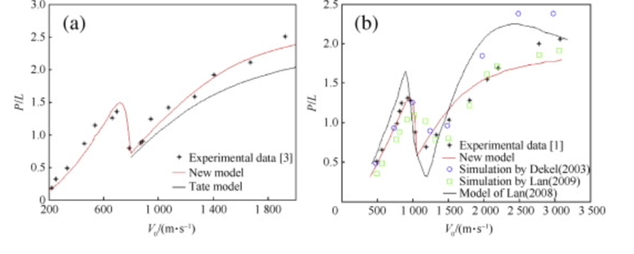

[6 marks]

c) Explain the optimum criteria that should apply in the design of a long rod penetrator. Your answer should demonstrate an understanding of the role of purpose of the discarding sabot, target material properties, penetrator material properties, adiabatic shear, strain rate, angle of attack, the effects of yaw, the shape of the penetrator’s nose and types of material would afford the best design.

$$p=l×η\sqrt{\frac{ρ_{p}}{ρ_{t}}}$$
$$p=l\sqrt{\frac{ρ_{p}}{ρ_{t}}}$$

The student should introduce the equation above and explain the variables, or even a modified version where the nose shape is taken into consideration. Diagrams can be used to represent the process of penetration.

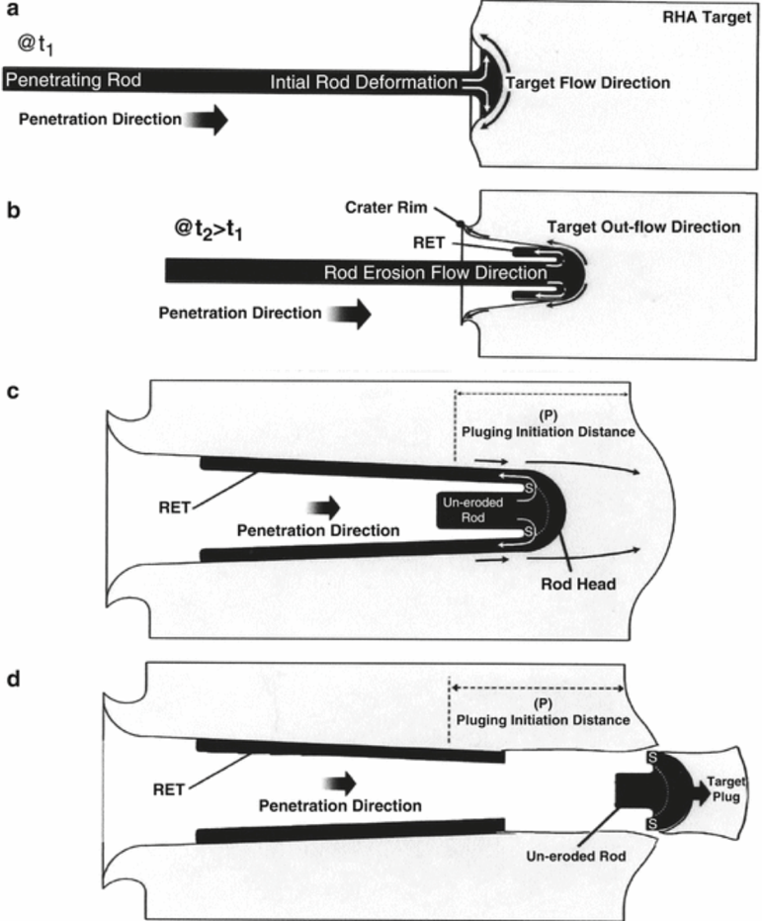

Key aspects I’m looking for are:

- The impact pressure of long rod penetrators at strike velocities in excess of 1200 m/s is the order of 100 x the yield stress of RHA. Strain rate in the order of 10⁵s⁻¹
- During the penetration process, material flows at the target-rod interface and a mushroom nose shape* is formed in the rod and a crater in the target.
- Long rod penetration is deeply influenced by the diameter ratio of nose to rod. The greater the ratio, the greater the loss of KE and the greater the erosion of rod tip.
- Terminal effects dictate a small diameter shot with a high velocity.
- The final radius of the crater will be larger than the radius of the rod.
- The sabot provides the sacrificial support in the barrel at launch, and also allows calibre to impart energy from propellant
- For the impact to be stable the penetrator must not topple – APFSDS L/D around 23 with yaw 1%
- Penetration above this value of yaw degraded about 6% per degree
- “Self sharpening” for greater penetration
- Rod length decreases as erosion occurs during penetration (only at nose tip). Increased diameter ratios increase erosion and reduce penetration

[20 marks]

d) For an armoured platform, what could the designer consider in terms of countermeasures against a long rod penetrator?

Given the speed of travel, it is all about presenting as small a target as possible. Sloped armour to increase penetration length or promote ricochet. ERA to increase mass of material. Modern methods to promote stealth. Reduction of detection signature.
[3 marks]

- a) Discuss the most suitable types of propellant you would design for the following applications, including their composition and method of ignition. Justify your choices in terms of calorimetric value, highlighting any additives that may be required to support performance and prolong barrel life:

- To defeat a main battle tank using a long rod penetrator
[15 marks]

- To propel a 7.62 mm sniper’s bullet with increased accuracy and range
[5 marks]

- To propel 4.5” naval ammunition over long ranges, whilst keeping muzzle flash to a minimum.
[10 marks]

In this answer, we would expect to see HEN for the MBT, with a description of double base propellant, incorporating RDX/NC/NG. High force constant, high Q and high T_{o}, therefore require additives to reduce barrel erosion. Mention stick propellant, not granular propellant with a base pad igniter using TVE.

The 7.62 will be double base. Again high F, Q and To, but not in the realms of tank ammunition. Could talk about surface moderant on grains. Ignited using primer.

The 4.5” would require triple base, with NQ added to reduce muzzle flash. As this is a rifled barrel, the propellant will require a number of additives to reduce fouling etc. Answer should mention granular propellant and the need for a central primer in a fixed cartridge case.

(b) Describe the principal differences of regressive, neutral and progressive burning, providing an example of the shape of a propellant grain to support your argument:

[5 marks]

In this answer, it should be surface area reduces as grain burns, stays neutral or increases. Typical shapes would be ribbon, slotted tube or multi-tubular.

Diwedd/End

