Qualification: CIPD Diploma in Applied Human Resources

Module Name: Contributing to the Management of Change

Word Count: L01 – 1098 words
L02 – 1096 words
L03 – 1091 words

Student Name: Nicola Westcott
Student Number: 1909408
CIPD Membership Number: 55478551

By signing below, I confirm that the work/evidence presented is my own, unaided work. I understand the regulations pertaining to candidate malpractice and the action that may be taken as a result.

Signed: N Westcott
Date: 24/01/2021

Content Page

Evidence Matrix 3 - 4
- LO1 Personal Statement 5 - 7

Evidence LO1 8 - 31
- LO2 Personal Statement 32 - 34
Evidence LO2 35 - 45

- LO3 Personal Statement 46 - 48
Evidence LO3 49 - 59

References 60 - 61

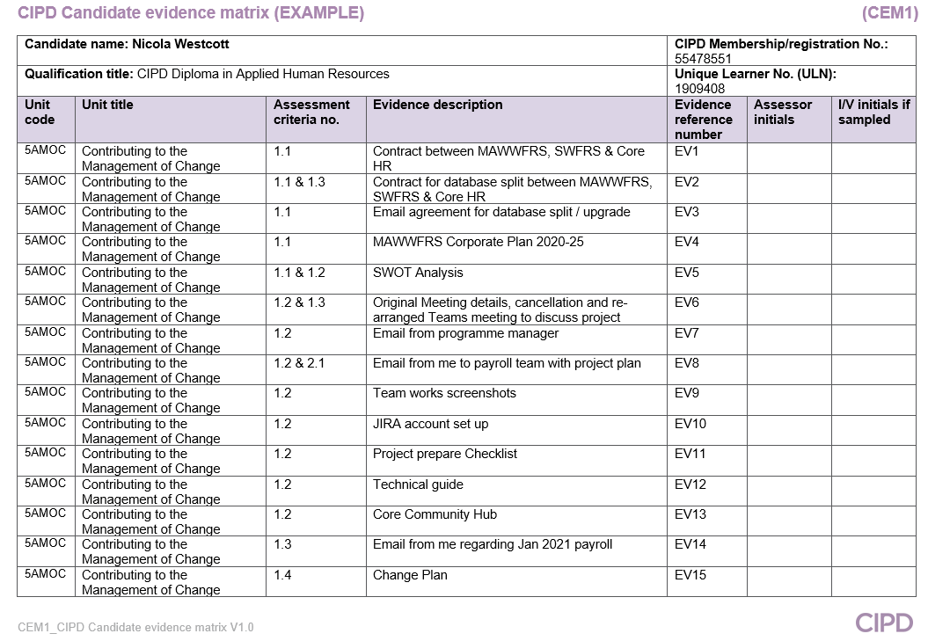
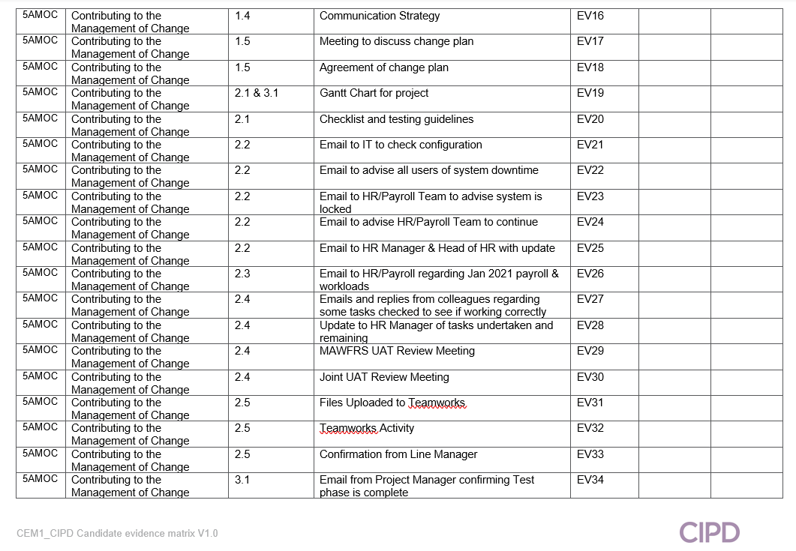
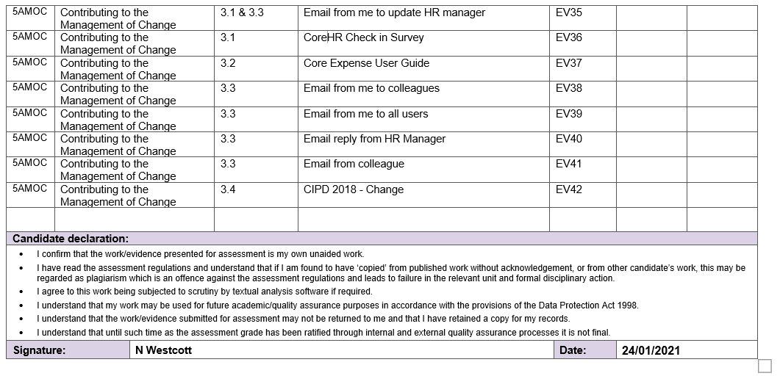

  - Establish the need, objectives and potential benefits in relation to a specific change requirement.
I’m involved in a change project involving a new database/upgrade to the CoreHR system. MAWWFRS utilises the Core HR/Payroll system, introduced in 2015 in collaboration with SWFRS (EV1) with NWFRS joining later, in line with the government’s plan to have an all Wales Fire Service. However, plans changed, and the Services remained operating separately.
Currently MAWWFRS/SWFRS share a database on the system, however both Service’s work very differently, causing limitations in the way that it could be used to its full potential.
SWFRS pushed ahead with developing the system for online modules for recruitment/expense/rostering/time, whilst for various reasons this was paused for MAWWFRS. MAWWFRS now wishes to push ahead with developing CoreHR as its main system but in order to do so, must split away from SWFRS, the agreement to do this was made in 2020 (EV2 & EV3).
Change, including technological change is unavoidable for all organisations and must happen in order to future-proof organisations (Wilkinson and Taylor, 2016 & CIPD, 2021).
Tapping into technology is identified as one of the essential ways HR leaders can lead business resilience and agility (Sage Group Plc, 2020).
This development work is in line with the MAWWFRS commitment to developing IT platforms to support and enhance business performance, as part of the Strategic Corporate Plan 2020-25 (MAWWFRS, 2021a) (EV4). There were both internal and external drivers of this change. Results from employee engagement surveys undertaken (MAWWFRS, 2021b) stated that MAWWFRS was too reliant on paper-based processes which often led to delays/issues with processing.
Focus groups were held to come up with new ideas/ways of undertaking tasks or as a result of dissatisfaction from employees about current processes (Johns and Ellis, 2016). In align with CIPD, (2020c) a SWOT analysis was undertaken to identify the strengths and opportunities, and new technology is seen as an opportunity to strengthen the organisation by streamlining processes and accessing data (EV5).
The database split/upgrade to the platform/system was planned to start in March 2020 however, the global pandemic caused a delay in the project but highlighted the need for this development work. ‘Organisations have had to swiftly adopt agile and flexible working practices and must continue to review these, and technology being used is fit for purpose’ (CIPD, 2020b).
The project was re-arranged to start in December 2020 until February 2021 (EV6 & EV7). Following this MAWWFRS will be able to fully implement and develop online recruitment/expenses/time management before moving onto introducing other modules.
Many benefits are identified for stakeholders such as time saved for HR/payroll staff, line managers/heads of departments, employees as well as long-term budget savings. Reduction in paperwork produced, which currently needs to be scanned/stored for the relevant timescales. Being held online will reduce the need of printing/filing/scanning/storing this paperwork. Reporting will be easier as data will be held on one system rather than multiple systems/paper.

It will be more environmentally friendly and reduce the carbon footprint of the Service. This change also aligns with the business partnering model that has been introduced recently in the HR department (CIPD, 2019a). Roles in the HR department will change to incorporate this technological development.
Digitalisation will MAWWFRS to become less bureaucratic/more agile. The coronavirus pandemic has shown that if MAWWFRS had been more agile/digital beforehand, it would have adapted to remote working easier (CIPD, 2020b).

  - Analyse who will be affected by the changes and their potential information and support needs.
The changes being introduced will affect the following:
- HR/Payroll team – will be involved planning/providing data to Core consultants, testing the new upgraded system to check if there are any issues. I kept team members up to date of what is required of them and the timelines to achieve this (EV8). Main project users were kept up to date via Teamworks, which provided key information in relation to the project (EV9) (CoreHR Teamworks, 2021). Any issues identified and raised via a JIRA, which supports the needs of individuals by providing a way of logging issues/resolutions (EV10). I provided a prepare checklist (EV11) to ensure project participants were aware of tasks and a technical factsheet (EV12) and access on the Core community hub to view any information regarding the project (Core Community Hub, 2021).

- Line Managers/Heads of departments/employees - once the system is developed as required for future use i.e. online expenses/recruitment. Users will require the necessary training on how to use the modules and guidance/support on the new ways of working. This will be provided by a variety of means such as user guides (Core Community Hub, 2021) or instructions via Moodle (MAWWFRS, 2021c) as well as being able to contact anyone from the HR department who will be able to assist.
Research has shown that people react differently to change. Having clear communication when dealing with change is vital and managing change effectively is about having a structured/planned approach, understanding how people experience change, supporting them through the process (CIPD, 2020a). Using tools/techniques for effective change management to ensure projects are managed effectively and risks mitigated (CIPD, 2020a).
  - Identify the resources required for the change process and how these will be made available.
For any change to be a success the correct resources must be in place in order to manage the change. ‘Change management is defined as a structured approach to transitioning individuals, teams and organisations from a current state to a desired future state’ (Society of Human Resource Management, 2015).
Following the re-arranged dates for implementation, best practice was followed by appointing a project manager from Core (XpertHR, 2021). For the initial part of the project the main resources will mainly be the HR/Payroll team. As this project will run alongside day to day work planning is essential in order that the work is completed at the appropriate times to ensure the project is a success. Discussions were held in the team to arrange the timings and availability of staff (EV6). The planning involved working backwards from the Go Live date of mid-February 2021 to ‘determine critical milestones, deliverables, tasks and dependencies’ (XpertHR, 2021).
It was decided that testing for the HR/Payroll would commence Jan 2021, when resources were available following Christmas annual leave and would involve undertaking the testing alongside normal day to day work (EV14). The funding for the required work has been made available from the Finance department (EV2) as part of the Service’s commitment to developing and supporting innovative ways of working.
  - Devise a plan, including objectives, actions and timescales for implementing the required change.
In order to ensure the project would be manageable I devised a change plan (EV15). A change management plan can help manage the change process by ensuring control of the budget/schedule/scope/communication and resources. It helps minimise the impact a change can have on the business/employees/customers and other important stakeholders (APM, 2017). Following Kotter’s (1996) 8-step change model (Mindtools, 2021a & XpertHR, 2021), MAWWFRS already had a vision to improving IT systems but the current global pandemic has caused a sense of urgency and a guiding coalition has been put in place to assist in communicating the vision and empowering employees to act.
As part of the change plan and based on ACAS (2020) guidelines, I also devised a communication strategy for the development work on Core and forthcoming introduction of various modules to utilise the system fully in order to meet the needs of MAWWFRS (EV16).
  - Communicate the change plan, and gain agreement for its implementation, from decision makers.
A meeting was arranged between myself and my line manager to communicate the change plan (EV17), to ensure the facts were established and to gain agreement for the implementation. Following discussions agreement from my line manager was given for the change plan (EV18).

EV1
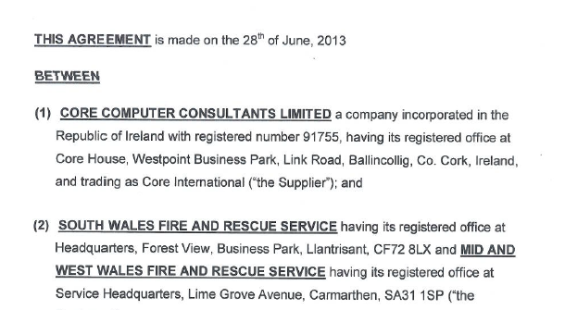

EV1 (Cont…)
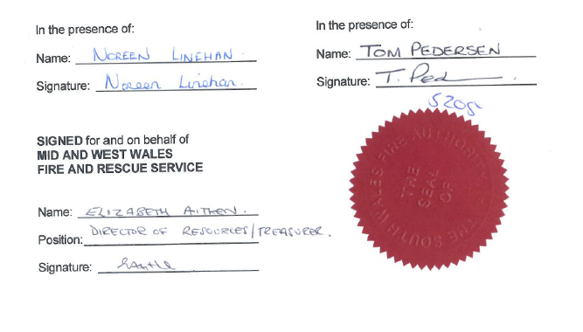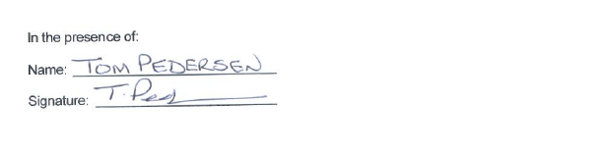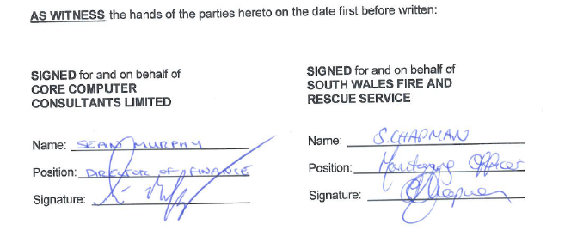

EV2
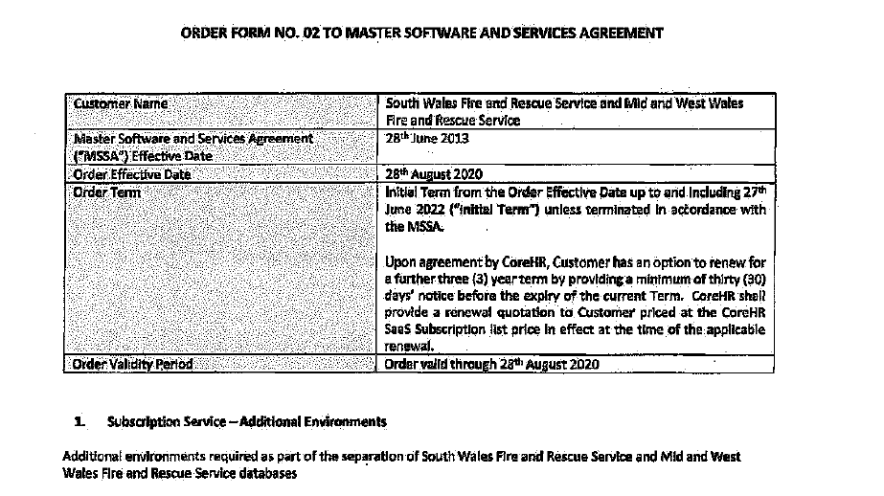
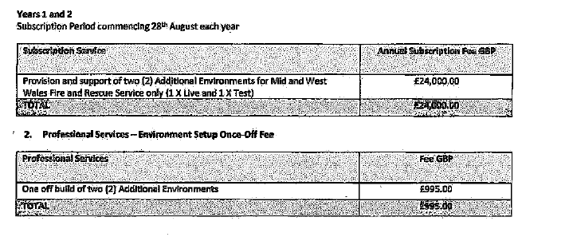
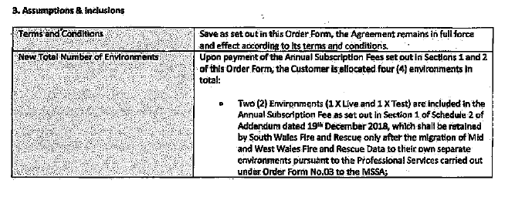

EV2 (cont…)
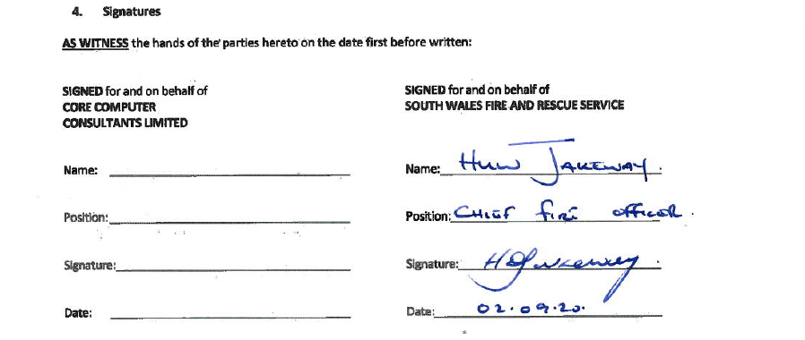
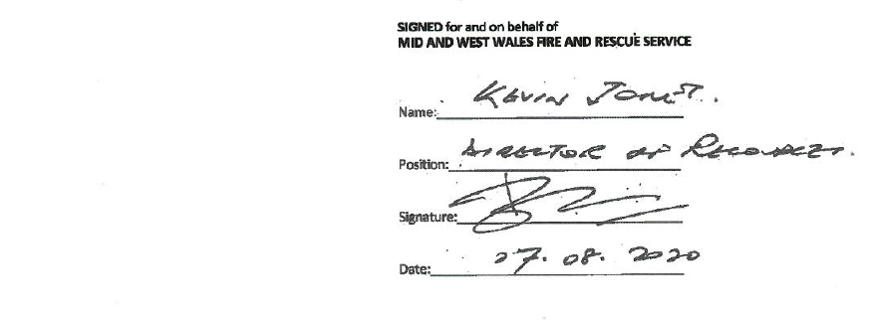
EV3
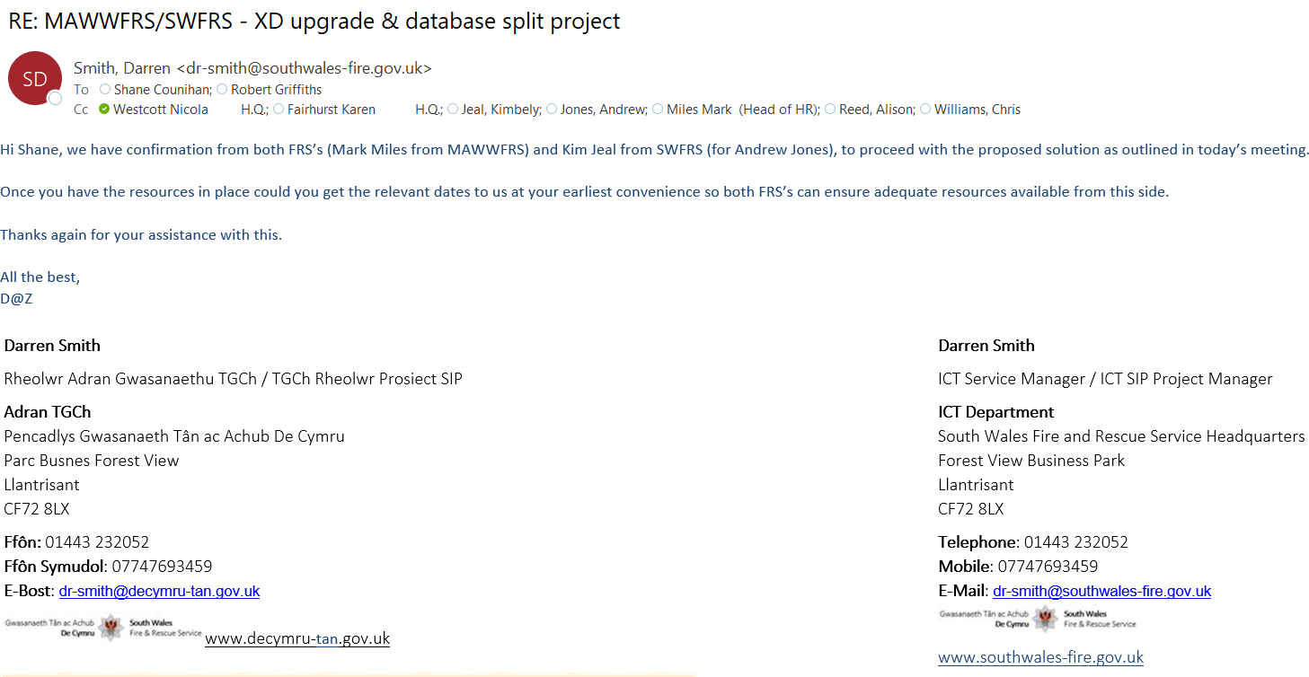

EV4



EV4 (Cont…)
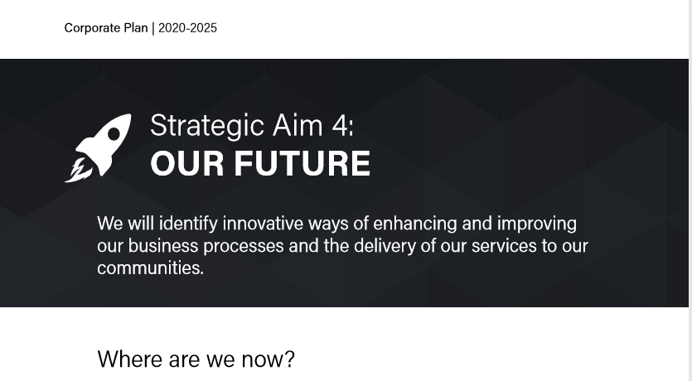
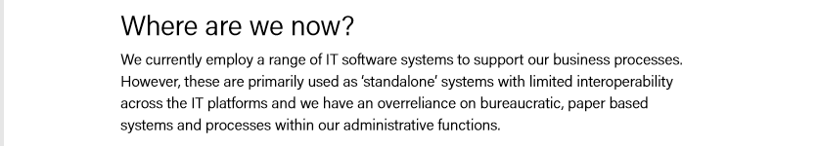
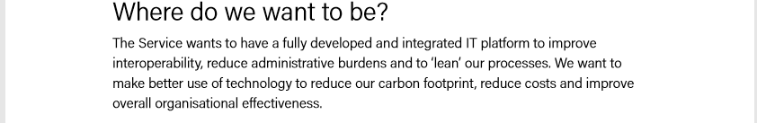
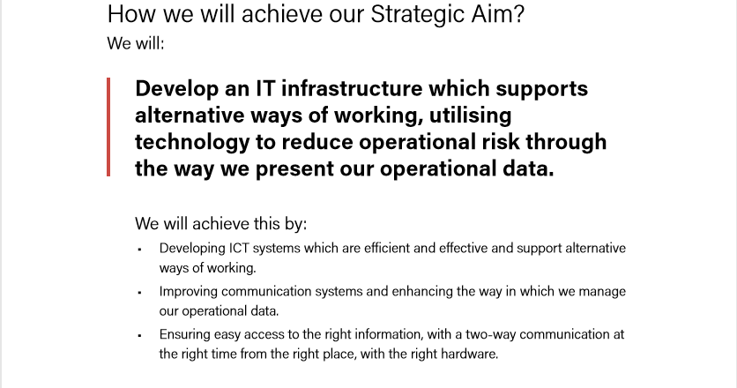
EV4 (Cont…)
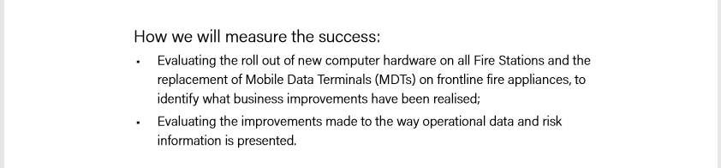

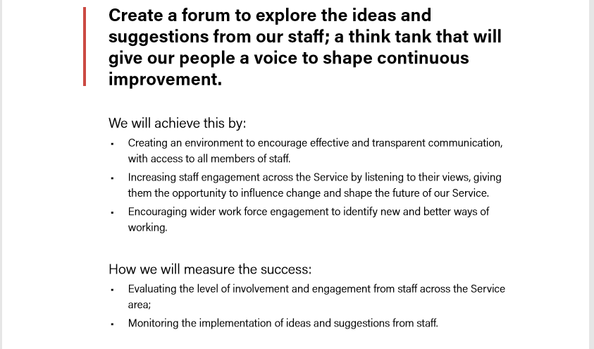

EV4 (Cont…)
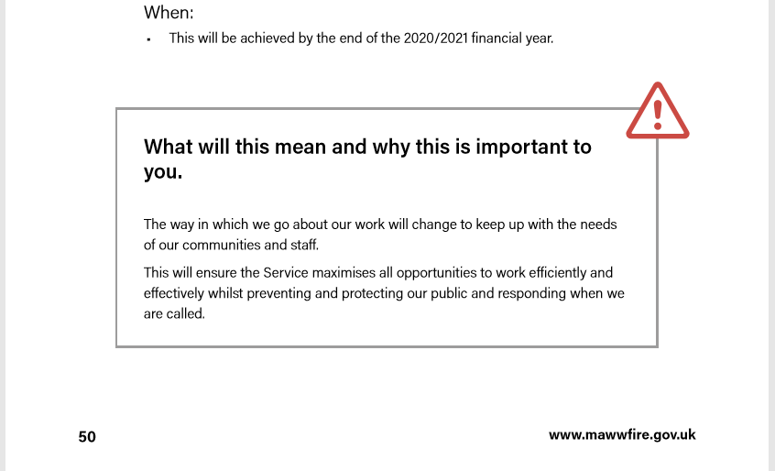

EV5
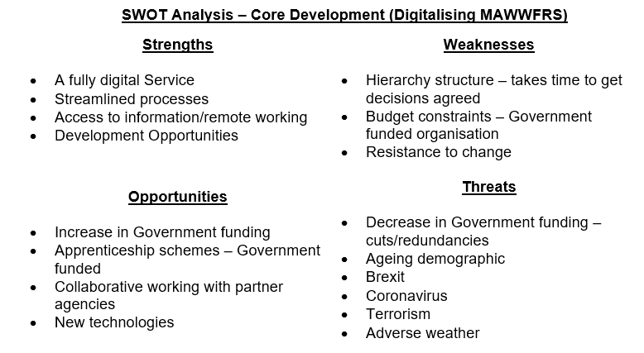

EV6
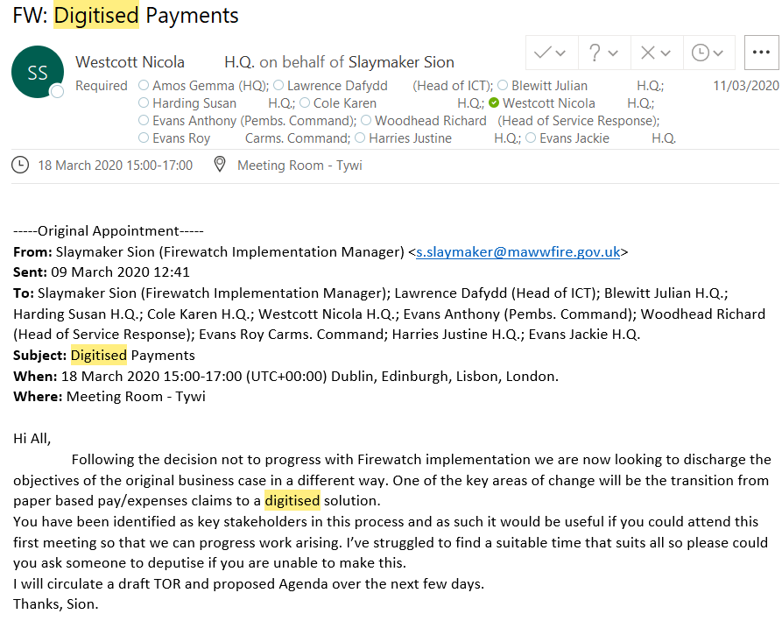

EV6 (Cont…)
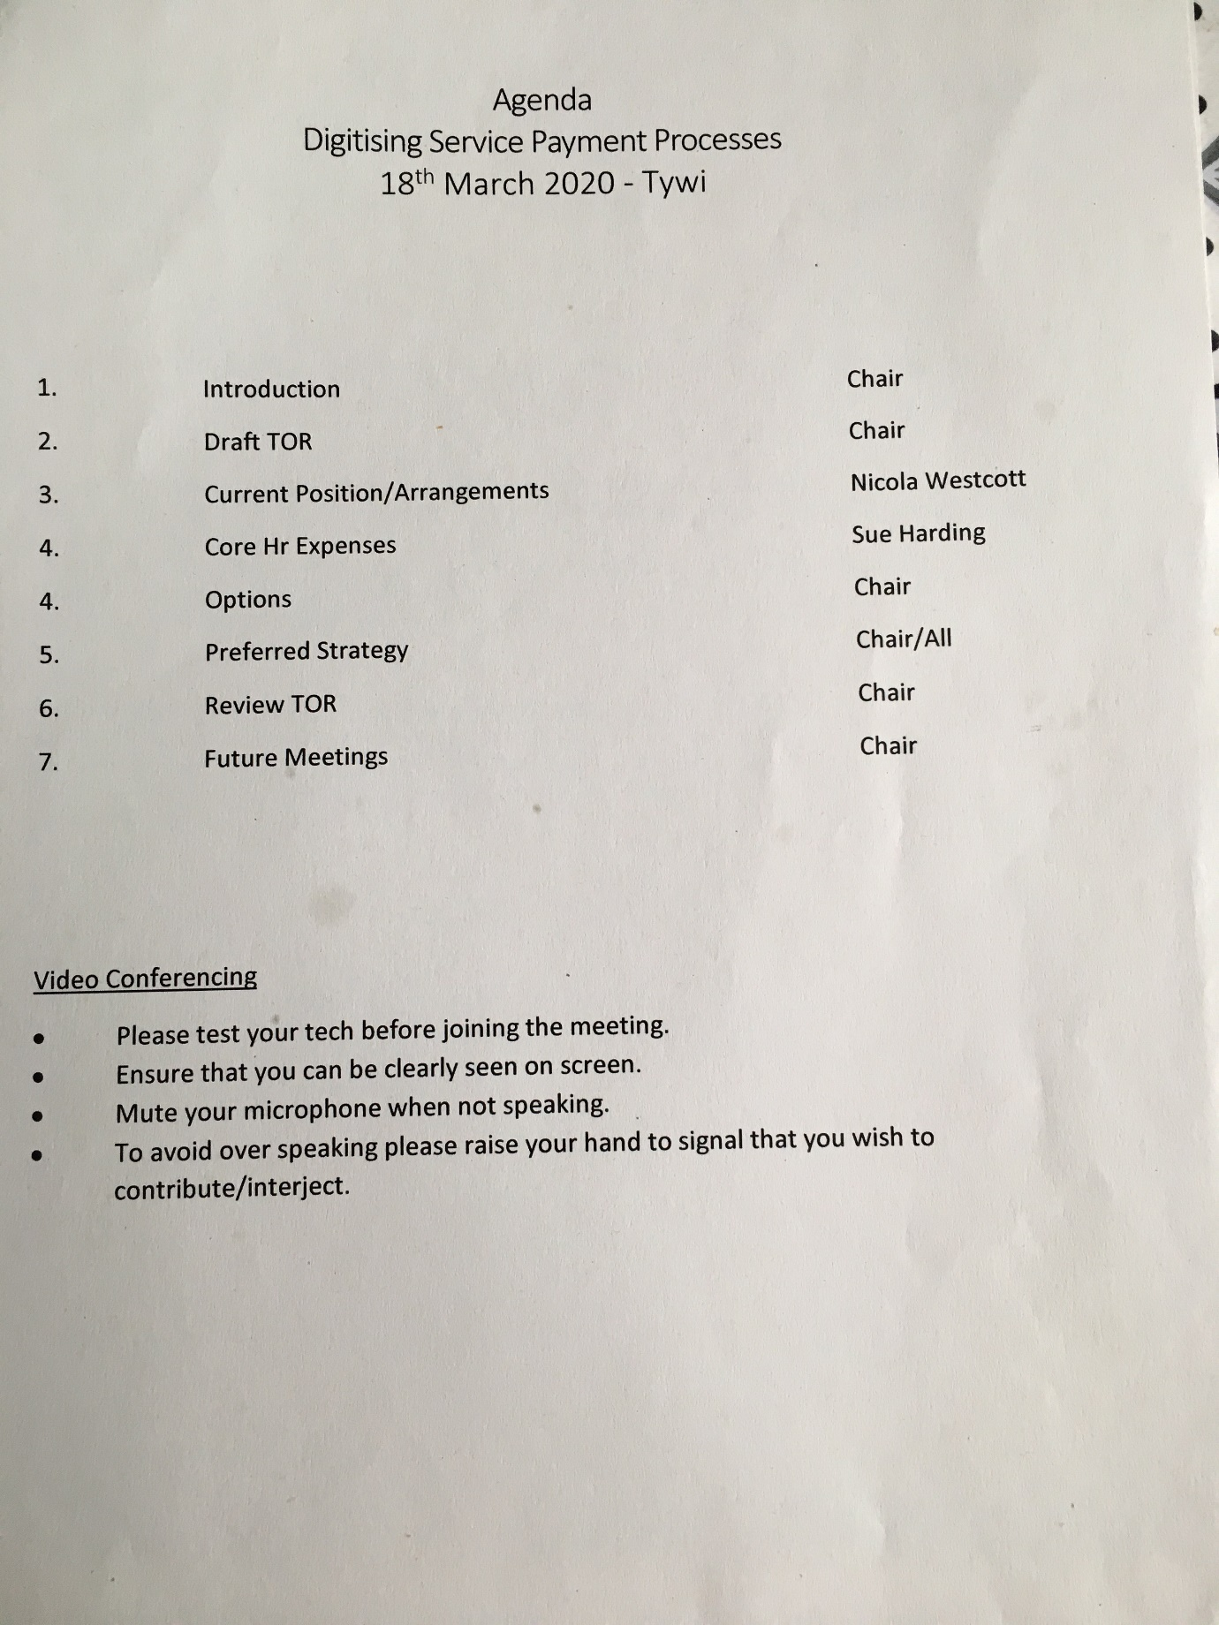

EV6 (Cont…)
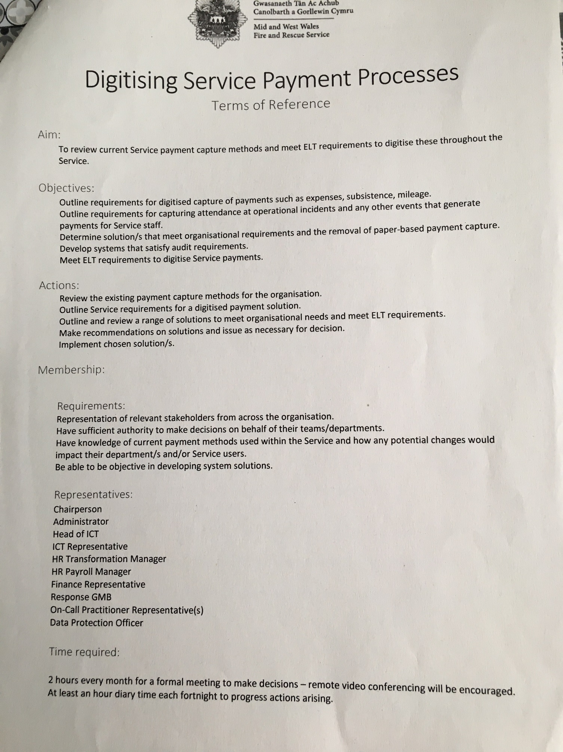

EV6 (Cont…)
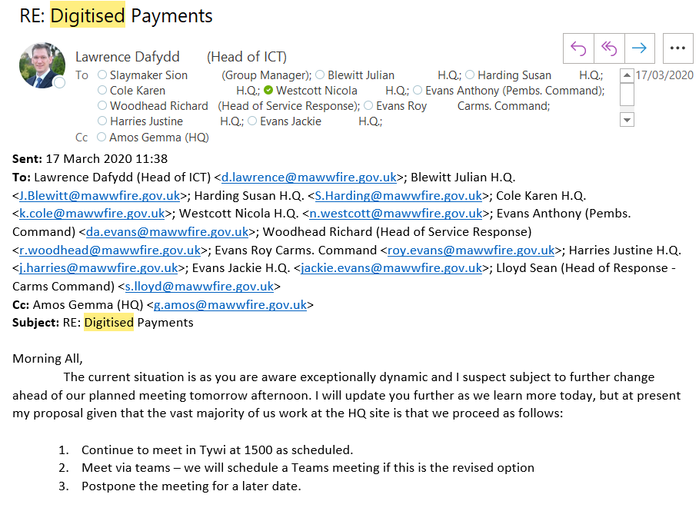
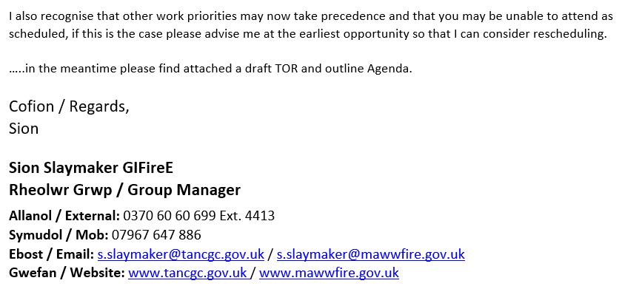

EV6 (Cont…)
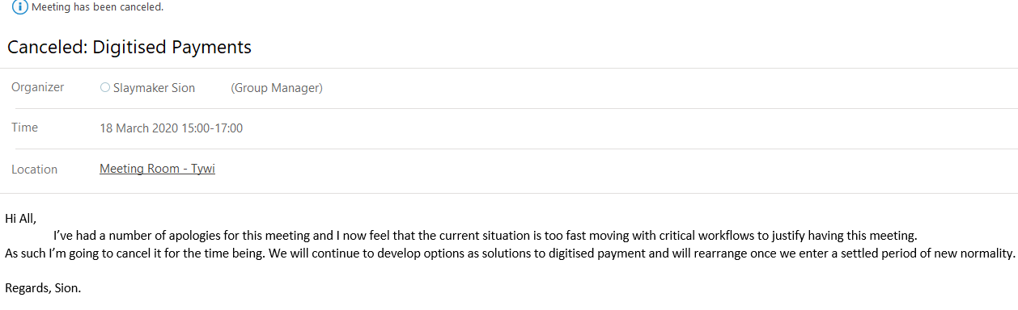
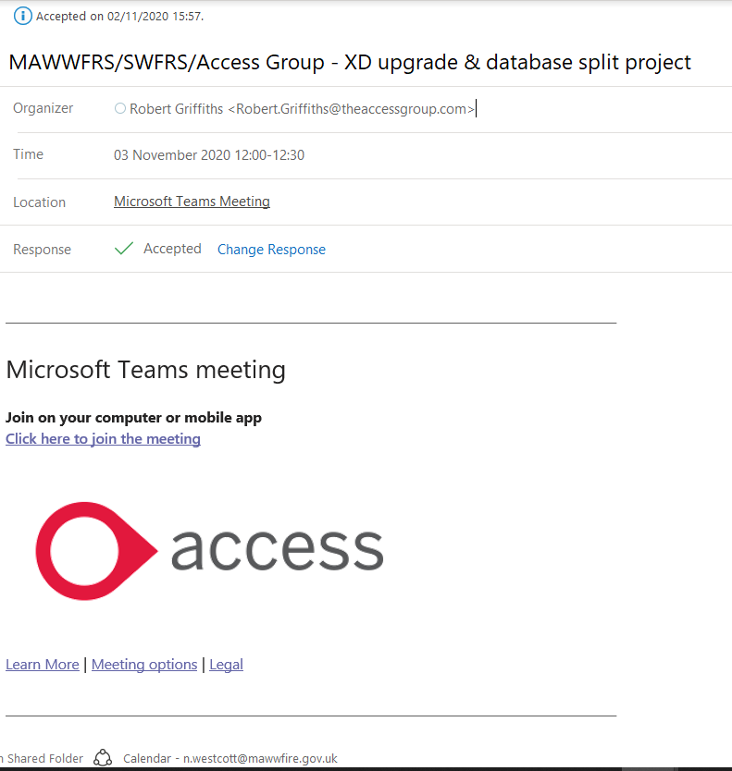

EV7
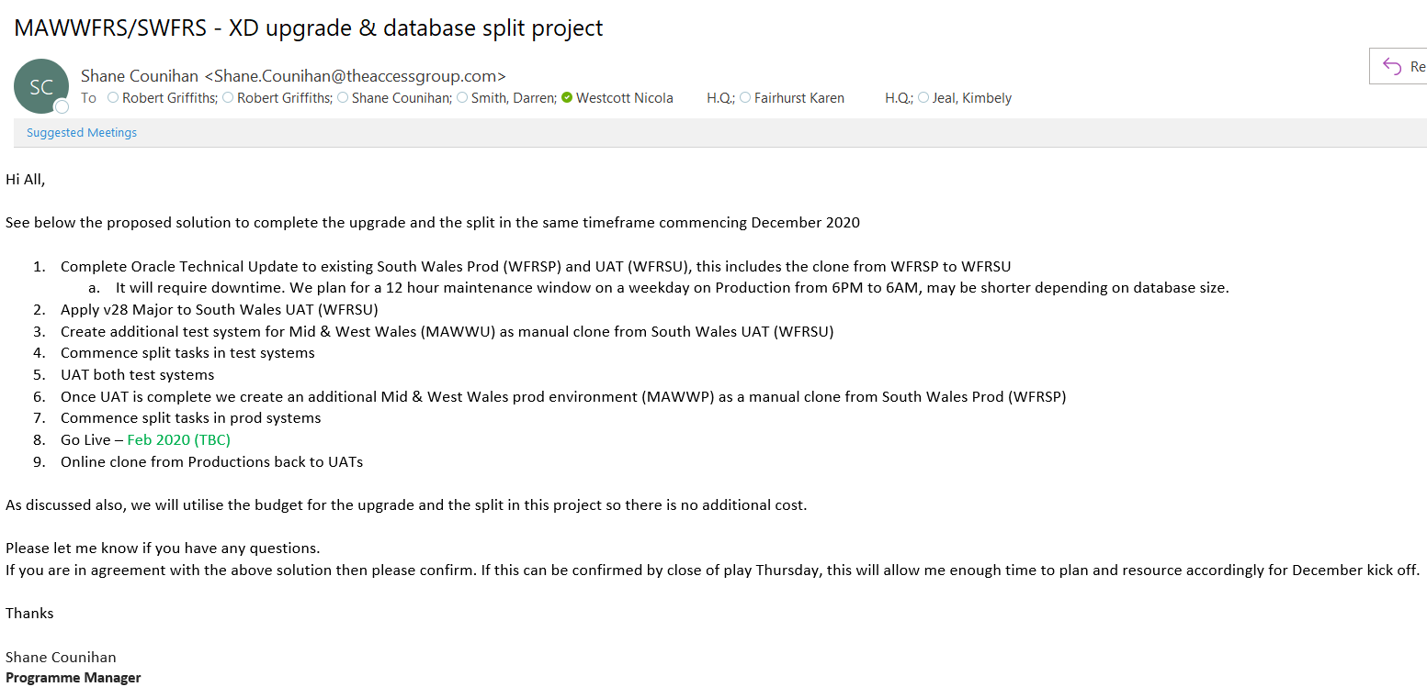
EV8
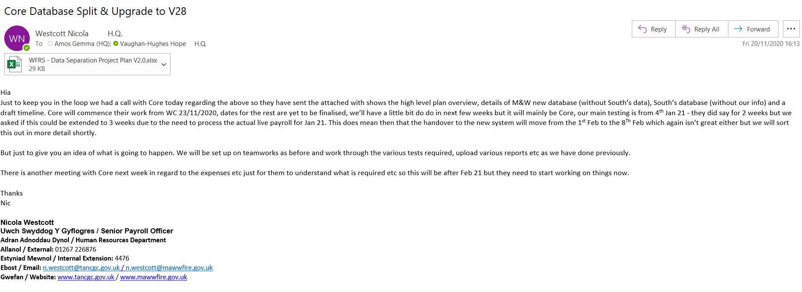

EV9
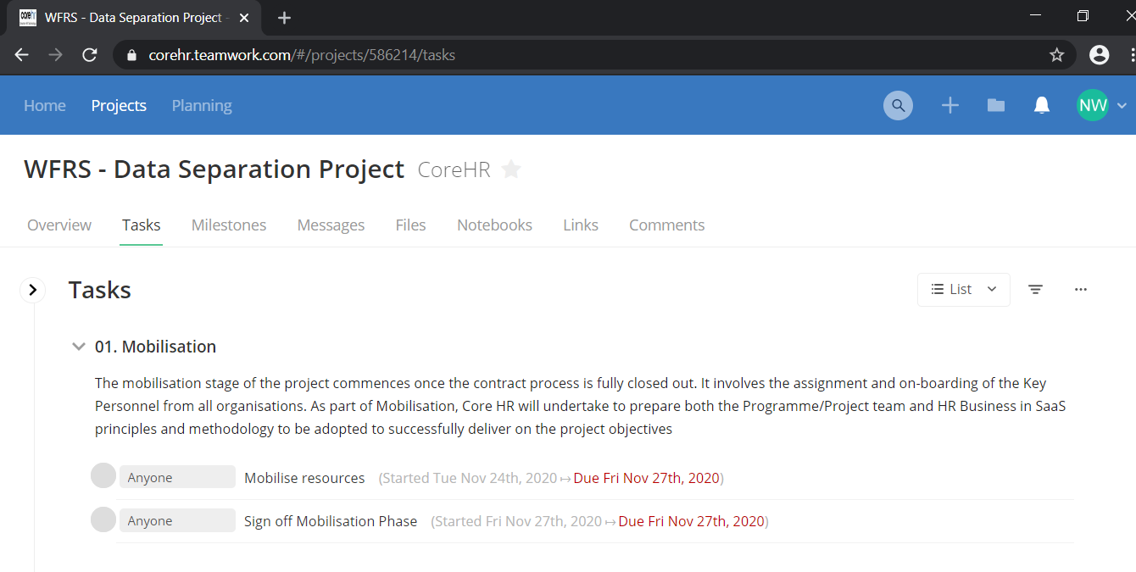
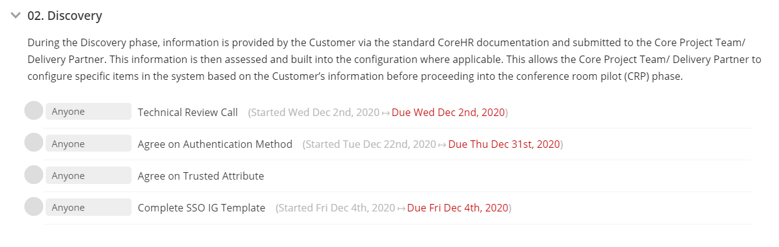
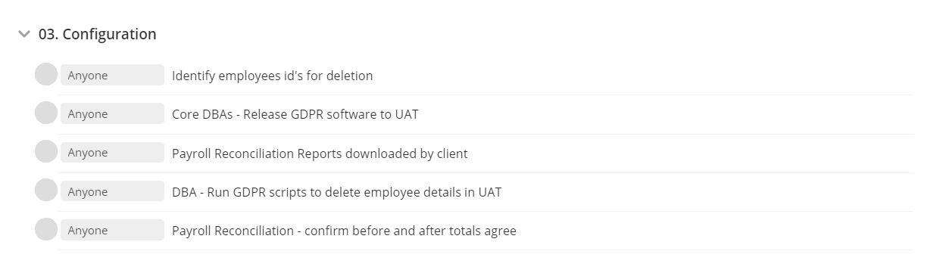
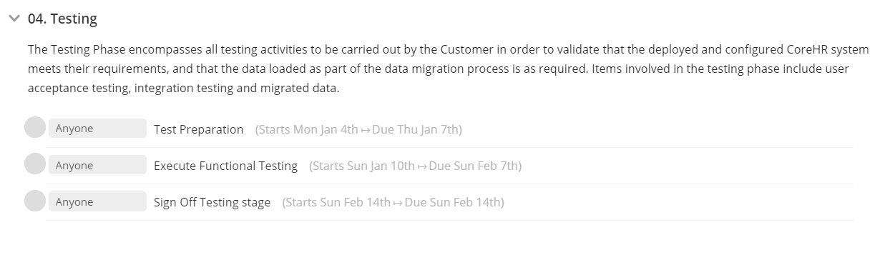
EV9 (Cont…)
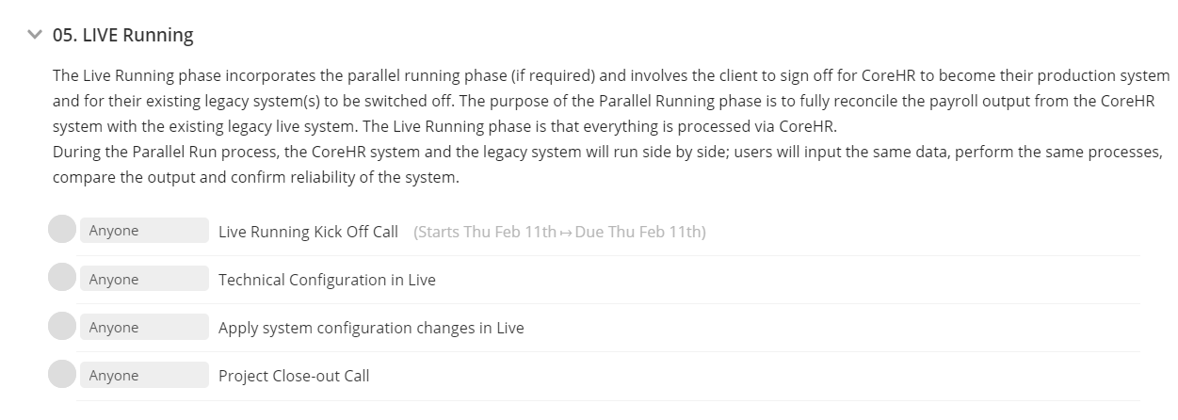
EV10
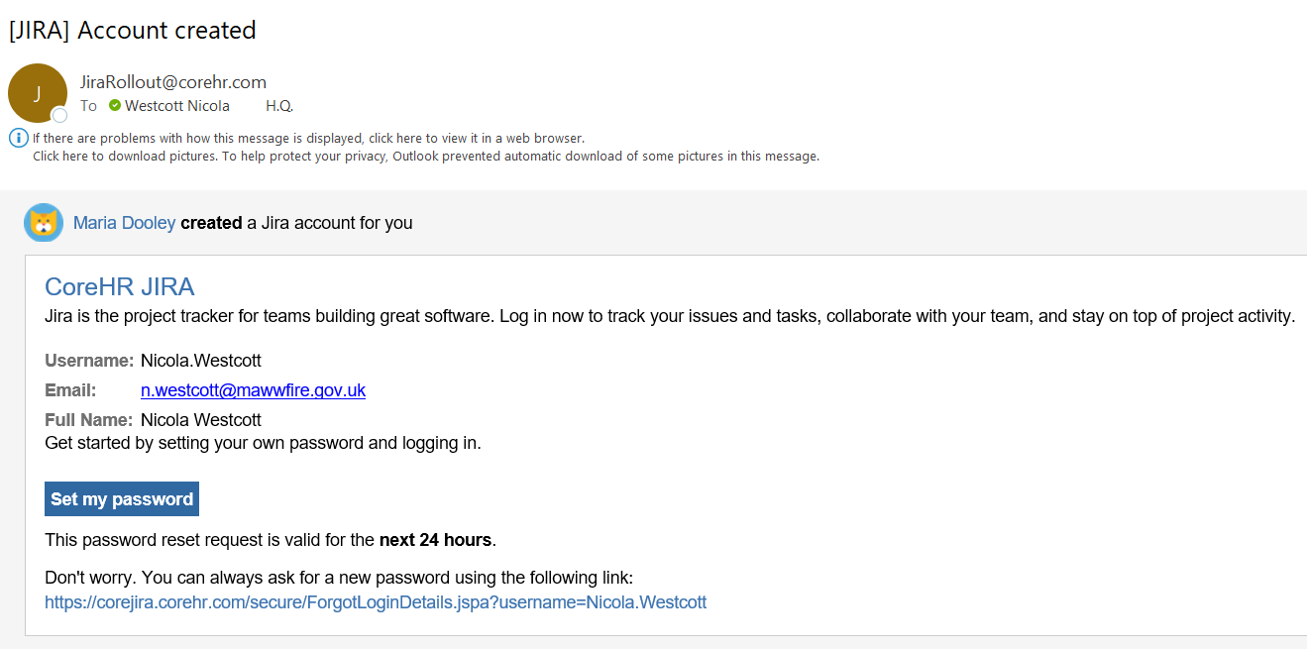
EV11
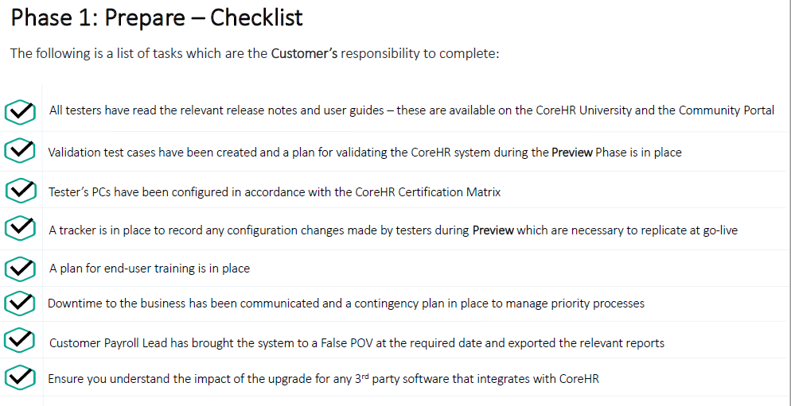
EV12
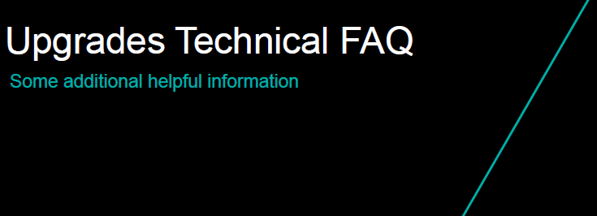
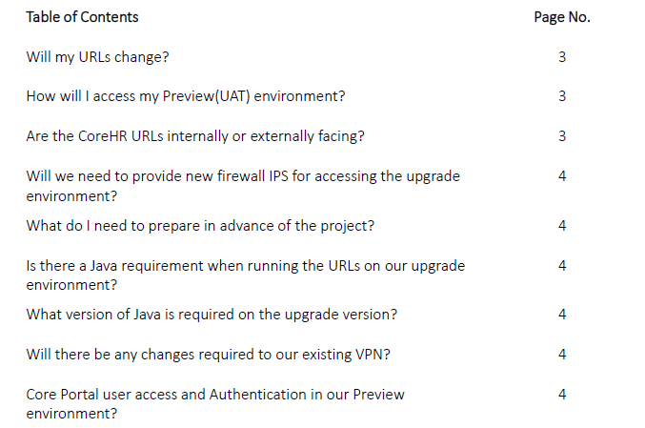
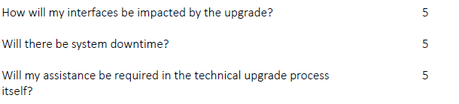

EV13
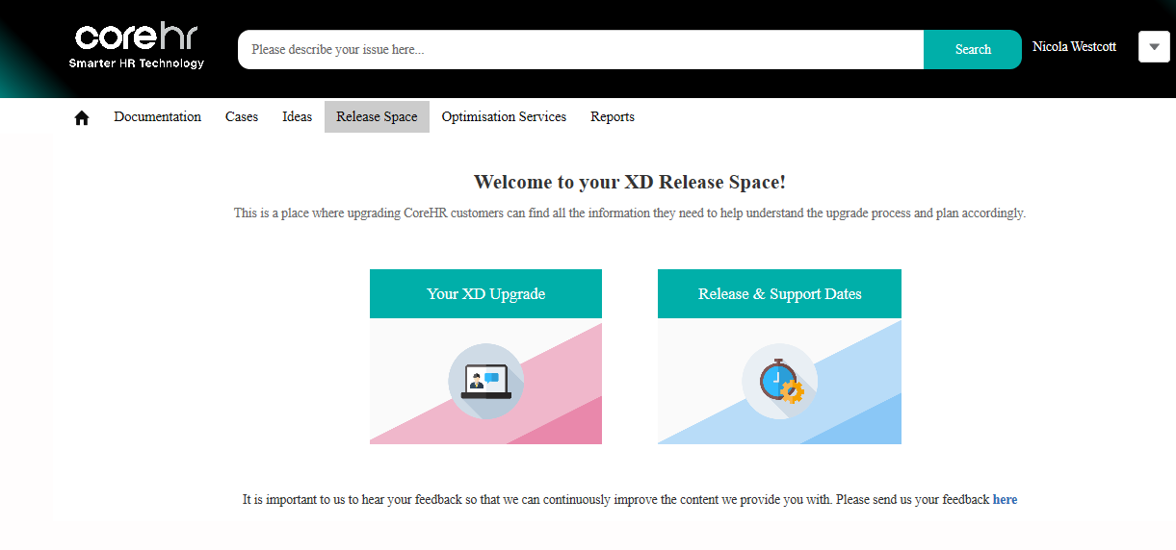
EV14
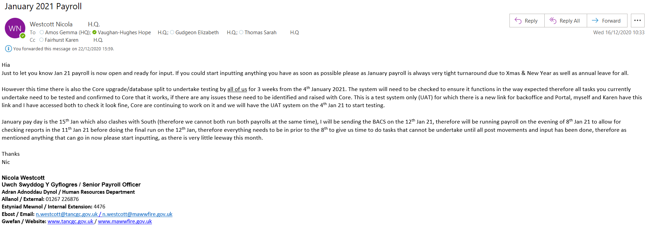

EV15
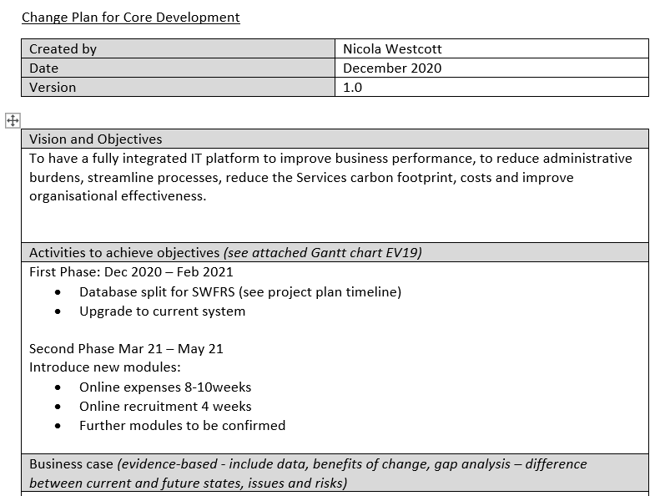
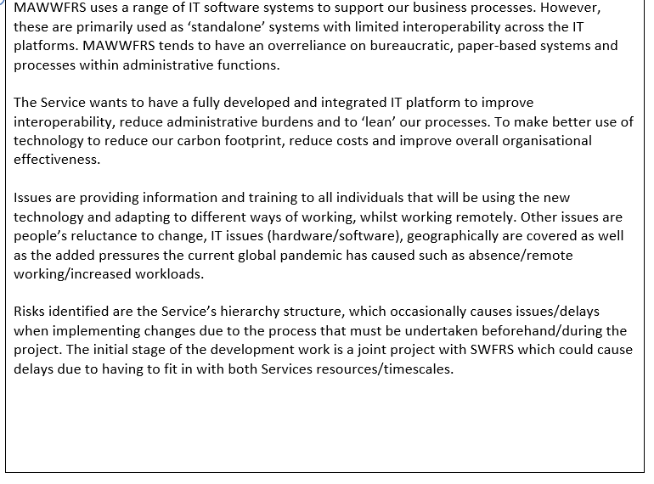
EV15 (Cont…)
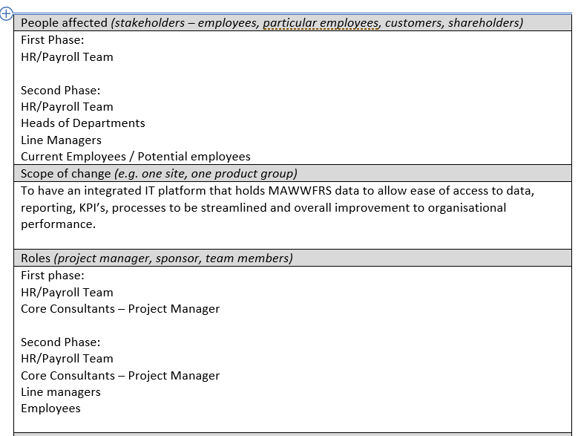
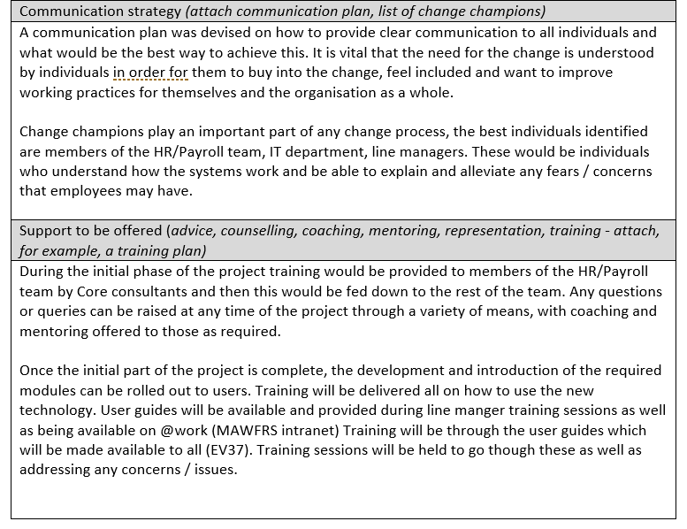
EV15 (Cont…)
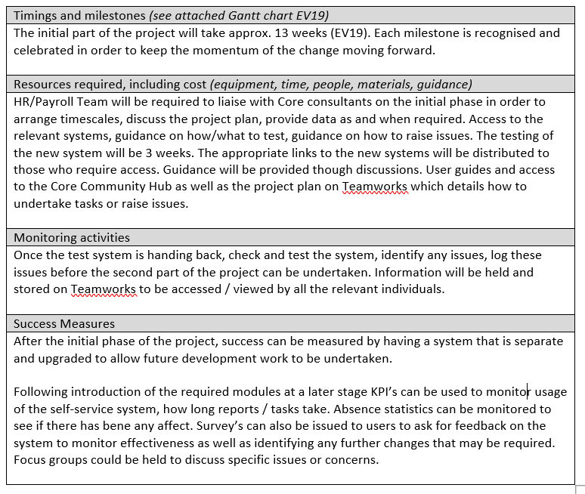

EV16
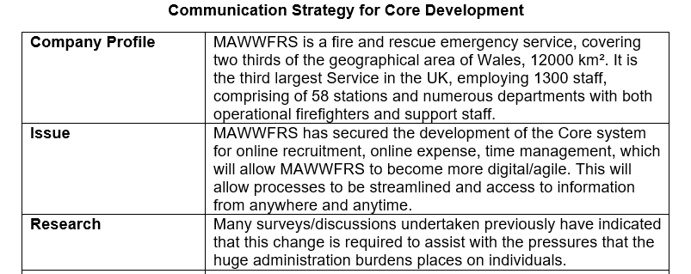
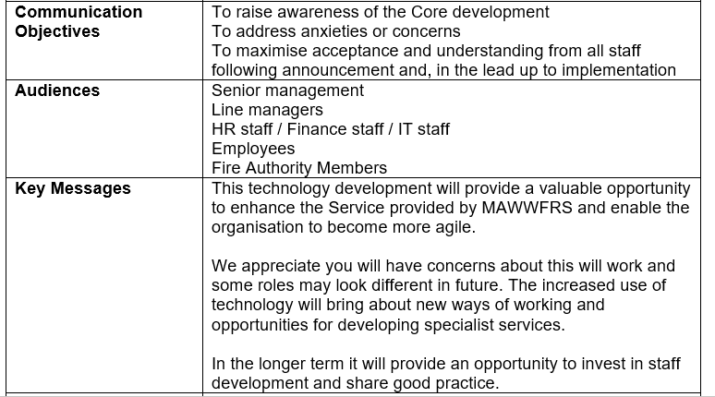
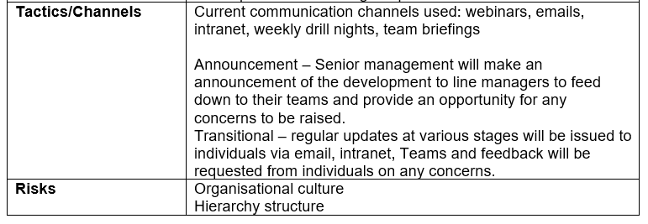

EV16 (Cont…)
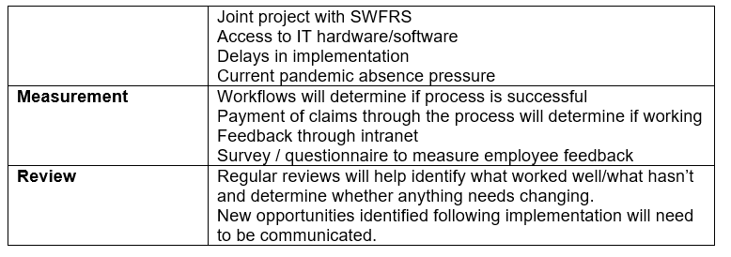
EV17
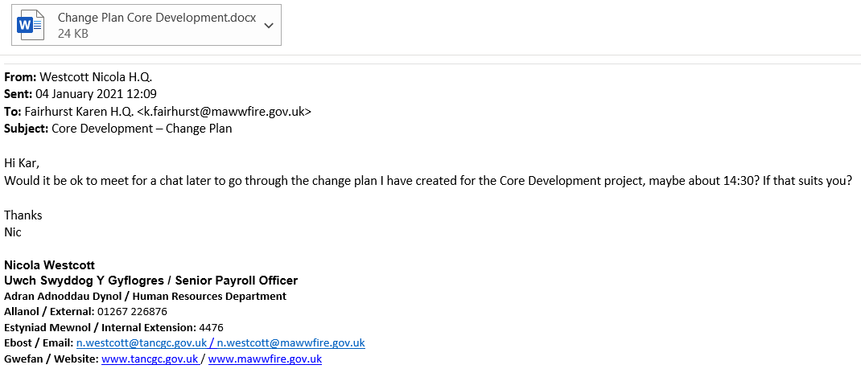

EV18
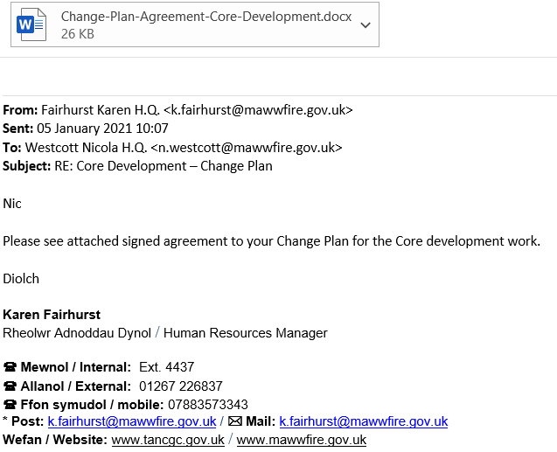
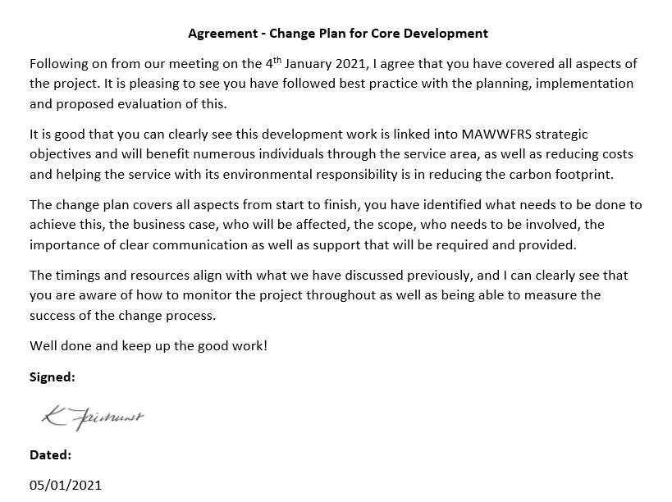
2.1 Follow the agreed plan to implement change processes.
In order to implement the development work, I used a variety of project management skills. This included using a Gantt chart to monitor the activities that would be undertaken during the project (EV19). This allowed for a visual representation of the timelines and made it easier to see/understand the steps that would be taken. It enabled me to explain the timelines to colleagues/team members (EV8).
This allowed for planning of when/how and by whom tasks would be undertaken alongside normal day-to-day activities. I used and provided checklists and testing guidelines to assist colleagues (EV20) (CoreHR Community Hub, 2021). Tasks involved checking that all current system functionality was still present and working as expected. Any issues identified would be recorded and flagged to Core. Tasks checked and completed would be noted and each milestone would be celebrated. It was important that all deadlines were met, and planning was essential. this would enable the system developers to replicate the system and then test that all was working correctly.
Any change has both controllable and uncontrollable aspects (CIPD, 2020a). By ensuring the correct people were involved, they had the correct skills/training and provided with regular communications/update. The uncontrollable aspects are how people will react to the change but by ensuring people feel involved and their opinions count helps create an environment that embraces change, thus helping to make it a success.

Best practice for implementing any change process is to have clear communication as to why is the change happening, what is the overall vision and what the benefits of the change will be. Maintaining regular communication throughout the change project and have supporting mechanisms in place aligns to Kotter (Mindtools, 2021a and XpertHR, 2021) ‘communicating the vision to stakeholders adequately and consistently is crucial if they are to understand and commit to the change’ (XpertHR, 2021). During the process continually monitor resources and budget and adjust the change plan for changes identified throughout the journey. When the change is complete measure the success of the change initiative.

2.2 Provide information and support to stakeholders in line with their identified requirements.
There are many stakeholders of the project, including HR/Payroll colleagues, Head of HR – who would feed updates to the Senior Leadership Team, HR Managers, other departments as well as all users of the systems, including the self-service employee portal which serves 1300 plus employees. Due to the current situation of home working most information or communication was via emails/phone or Teams meetings.
During the implementation I ensured I made regular communication with all stakeholders, by providing information as and when necessary as well as regular updates. Clear and tailored communication is an essential part of any change process (ACAS, 2020).
I provided information to the IT department regarding the certification matrix as well as timelines of the project in order to ensure the appropriate systems and support were in place (EV21). Part of the project meant that all systems would require a period of downtime and I communicated this to all users by email (EV22).
I also communicated to the HR/payroll team that the system was locked for a certain time for the clone of the system to be undertaken (EV23), and then advised that the system was available once completed (EV24).
Following any meetings with the system developers I updated the head of HR, HR manager (EV25) as well as colleagues.
2.3 Apply techniques for maintaining positive working relationships throughout the change processes.
Having positive work relationships can help support the change process in an organisation, and line managers play an important role. Therefore, as a line manager myself, I always ensured that I kept colleagues updated in order to maintain and build trust, thus reducing any conflict that may have arisen. I ensured that I provided a clear message regarding why the development work was happening and what the benefits would be. Positive relationships can lead to discretionary behaviour from people (CIPD, 2019b). As most of the work for this part of the project was undertaken in the payroll team, I was seen as the change champion as the most senior and longest serving of the team, I could see the benefits of the changes would bring to the section and was able to explain this to the others, enabling them to buy into the change.
I ensured that I included them in any discussions and asked for their feedback on issues (EV26). This ensured that they felt included in the process and that their opinions and thoughts were valued. Engaged employees are more likely to accept and adapt to any changes being implemented and helps with the emotional journey (CIPD, 2019b and ACAS, 2020).
Any change can affect the way individuals feel as they are being put in new positions regarding workflows or processes, this can often lead to anxiety and well-being issues if not handled correctly. Well-being at work is ‘linked to employees having a degree of control over their work and how it is done’ (ACAS, 2020).
As the introduction of the new modules on the system would mean that work would be undertaken differently it was important to ensure that any concerns or worries people may have had were addressed and alleviated. Changes being introduced can lead to employees going through the Kubler Ross Change Curve (Mindtools, 2021b), where the following are experienced:
- Denial – reaction to change is shock/denial
- Anger – resist/protest the change
- Depression – look at what is lost
- Bargaining – begin exploring what the changes mean
- Acceptance - begin to accept and embrace change, rebuild working ways
2.4 Monitor the effectiveness of the implementation, agreeing and making justified adaptations where required.
Throughout the project as well as keeping our own records of various tasks that were checked (EV27 & EV28), any files were uploaded to Teamworks (CoreHR Teamworks, 2021) and issues raised and logged through JIRA. Both MAWWFRS and SWFRS has twice weekly Teams meetings separately with Core on a Tues and Thursday (EV29) in order to discuss progress as well as a joint meeting on a Friday (EV30) in order to discuss any issues, developments in order to assist each other and monitor effectiveness.
This allowed for any adaptions, discussions and agreements if required. Having the correct team working in the project meant that support was gained for the change, removing any resistance to the forthcoming changes which would be introduced. As tasks were checked and measured, each milestone was celebrated however small, thus maintaining the momentum, which aligns with Kotter’s (Mindtools, 2021a and XpertHR, 2021).
According to SHRM (2015) there are three phases of change management, it was evident that the project was aligning to this:
- Designing – plans made for the future of the organisation based on internal and external factors
- Enacting – project team identified based on expertise, best practice project management, stakeholders identified, regular clear communication.
- Sustaining – data collected/recorded to monitor progress and impact on stakeholders, adapt for any changes required, remind employees why the change is happening, momentum maintained for further development programmes.
2.5 Maintain records of the change process in line with organisational requirements.
Throughout the project any files required for checking testing by Core were uploaded securely to teamwork and locked to view by the necessary individuals (EV31) (CoreHR Teamworks, 2021). This in line with organisational requirements as well as GDPR.
The data being recorded was quantitative – the processes and functions were being checked to see if functioning correctly. Spreadsheets containing a variety of data detailing tasks, processes (EV32).
Qualitative data was sought from users of the system. I checked with colleagues what they thought of the technology and asked for feedback/opinions. I also sought feedback from my line managers on if my contribution to the project was effective and the objectives of the project were met (EV33).

EV19
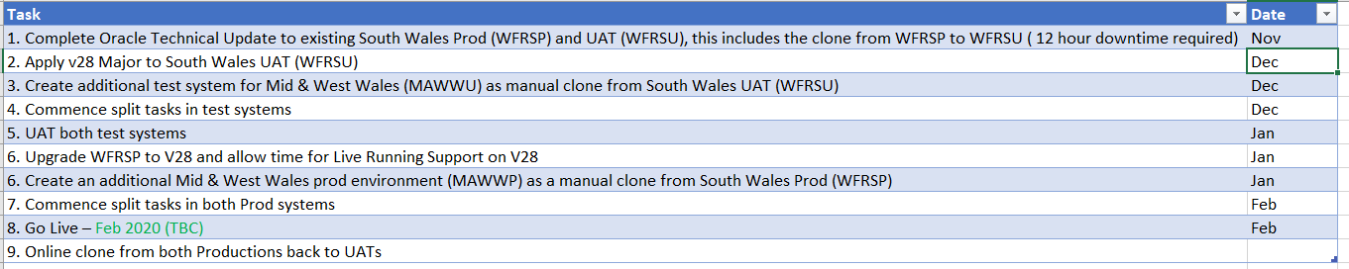
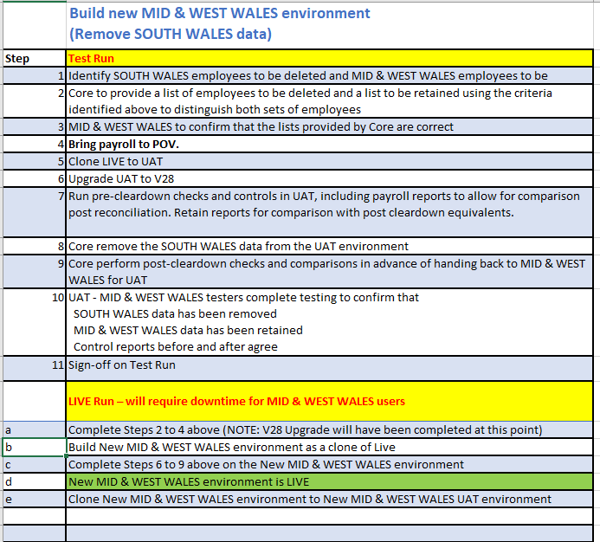

EV19 (Cont…)
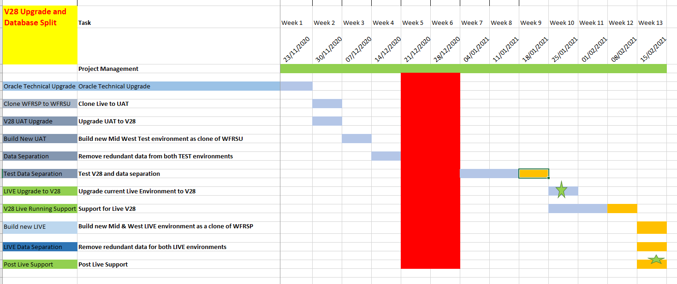
EV20
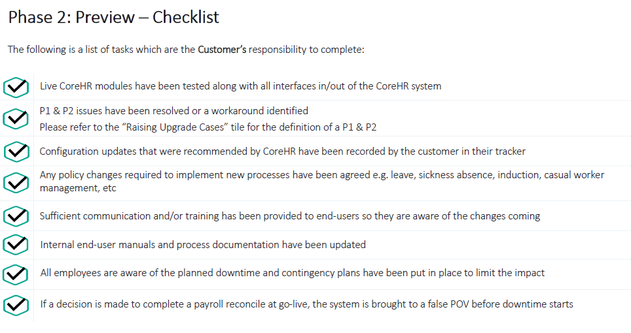

EV20 (Cont…)
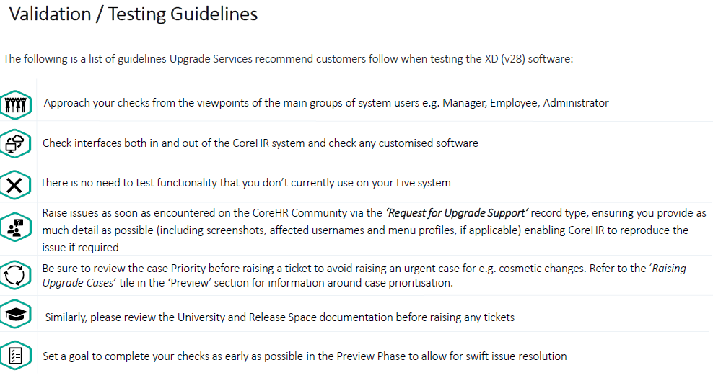
EV21
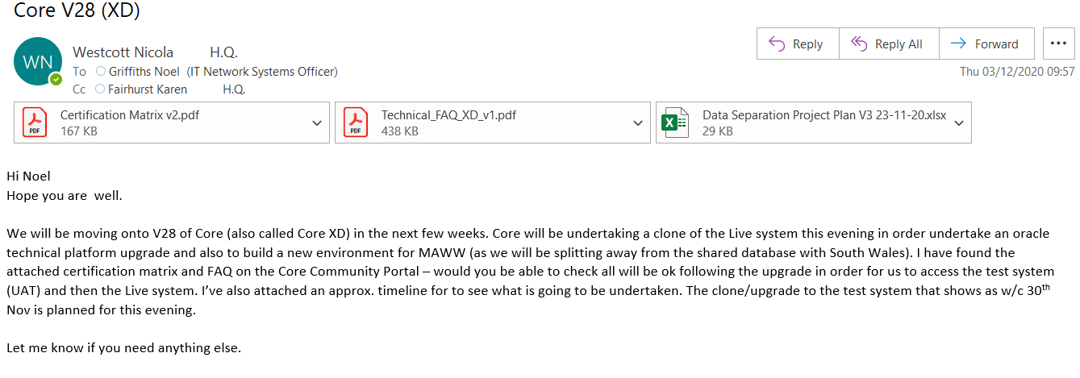


EV22
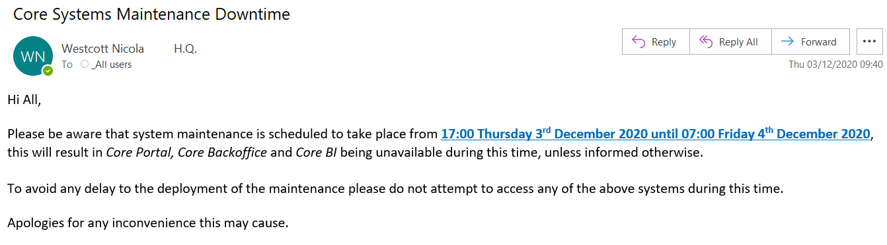

EV23
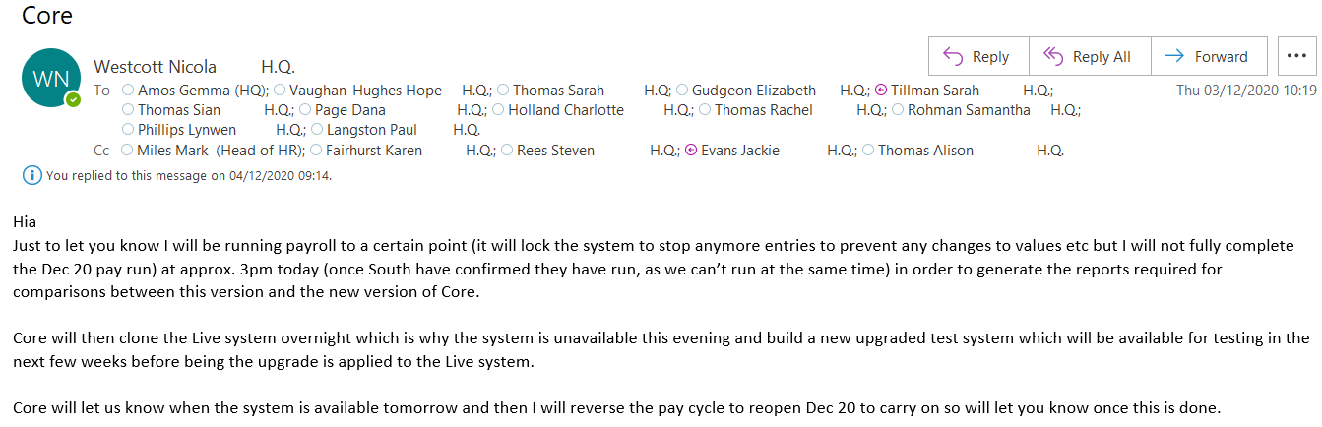

EV24
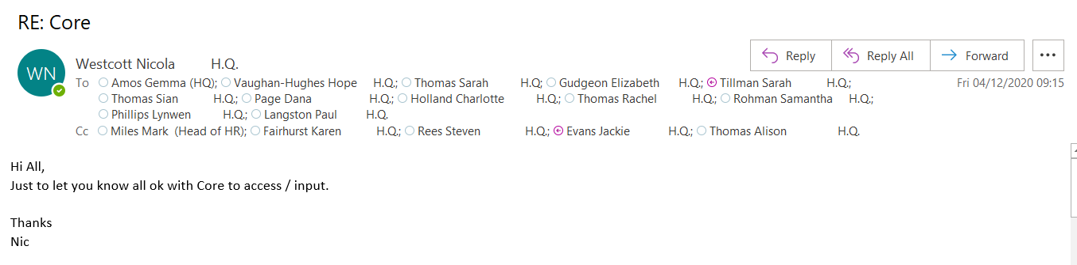

EV25
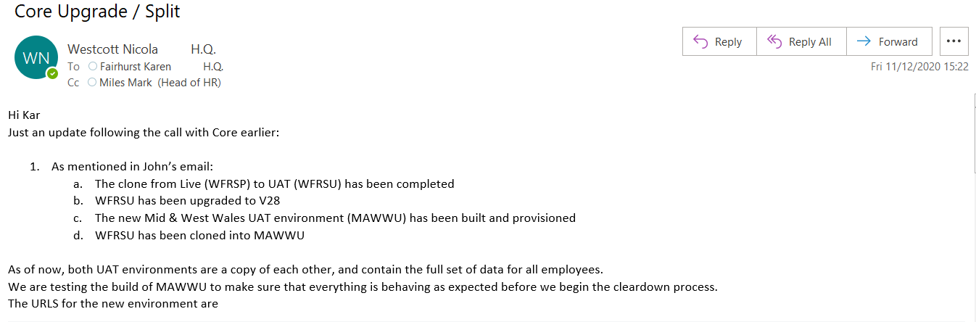
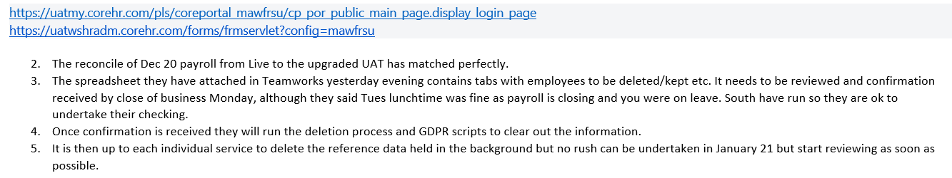
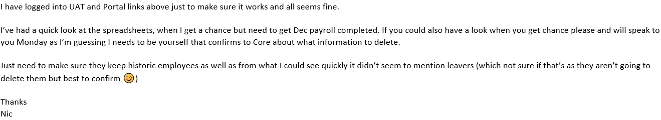

EV26
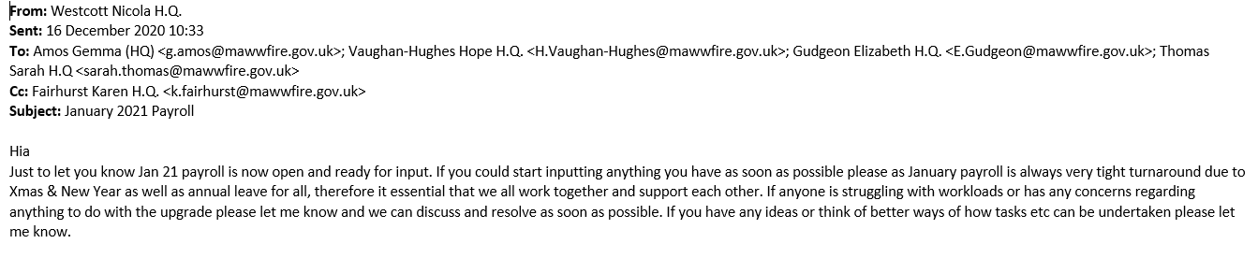
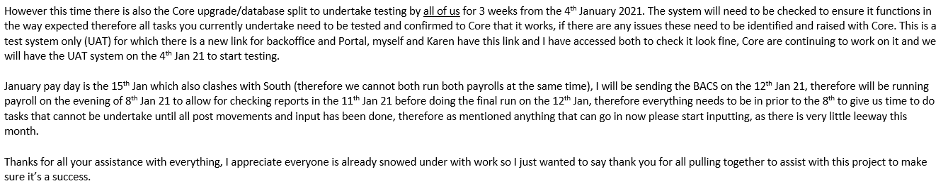

EV27
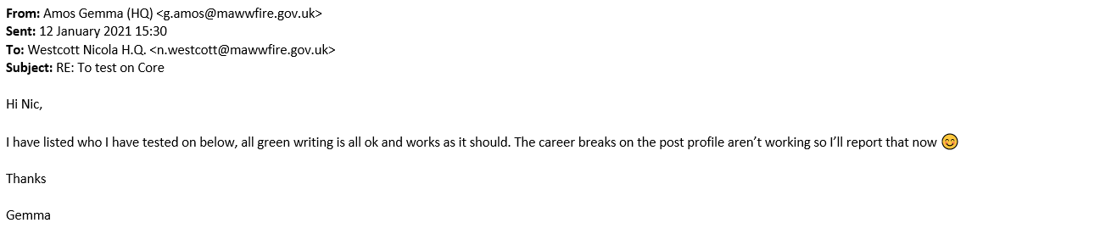
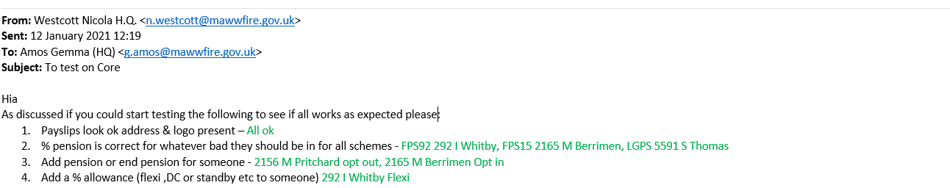
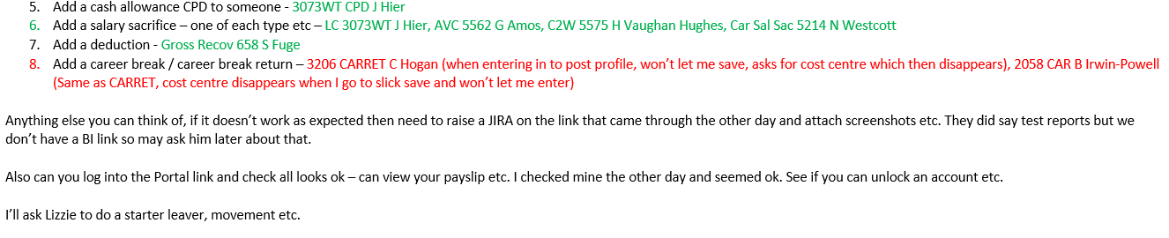

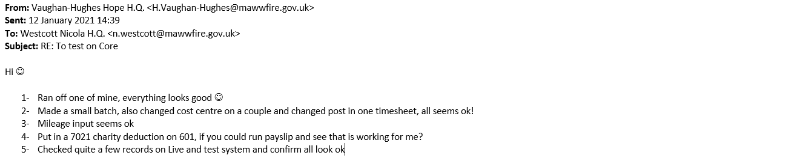
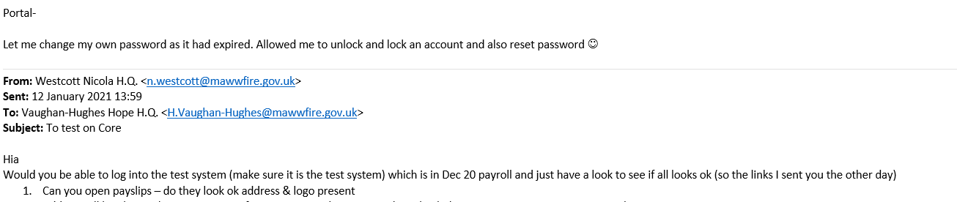
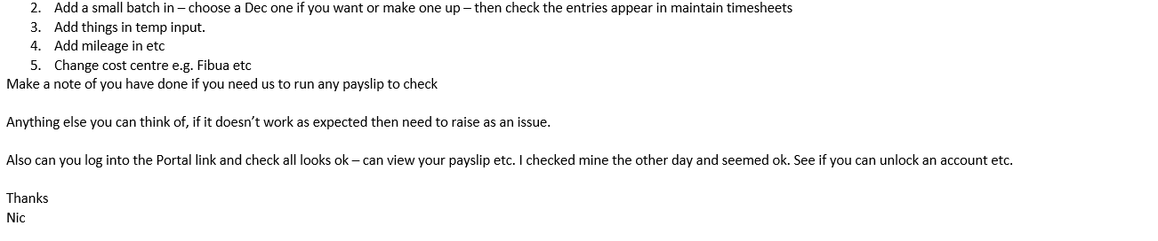

EV28
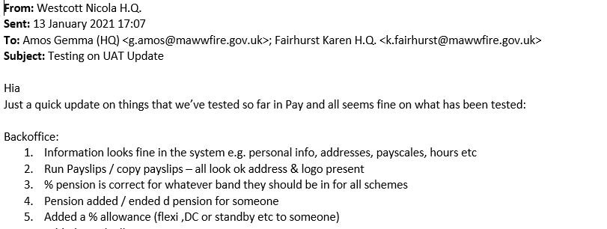
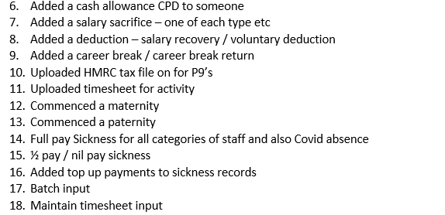
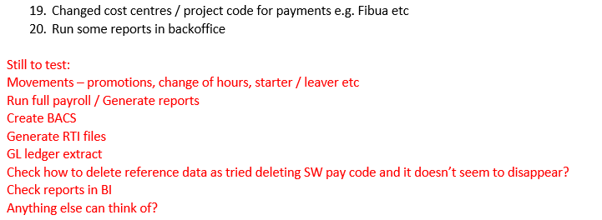
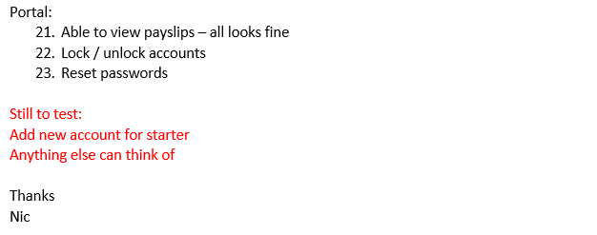

EV29
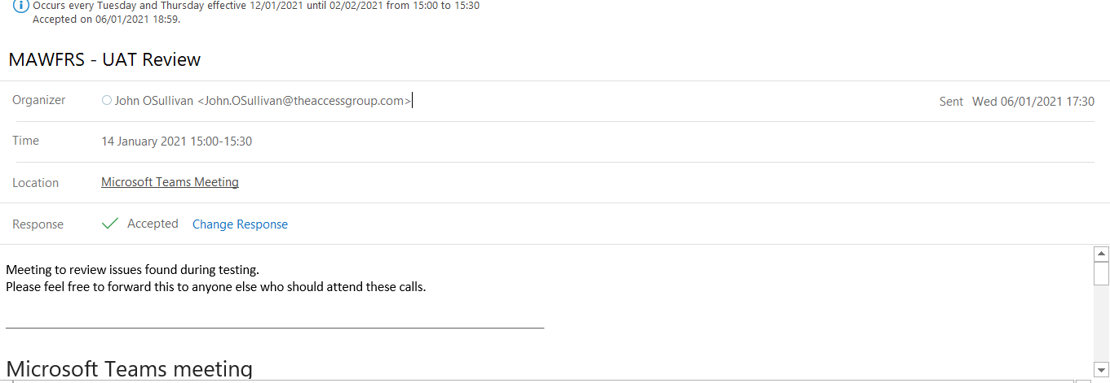
EV30
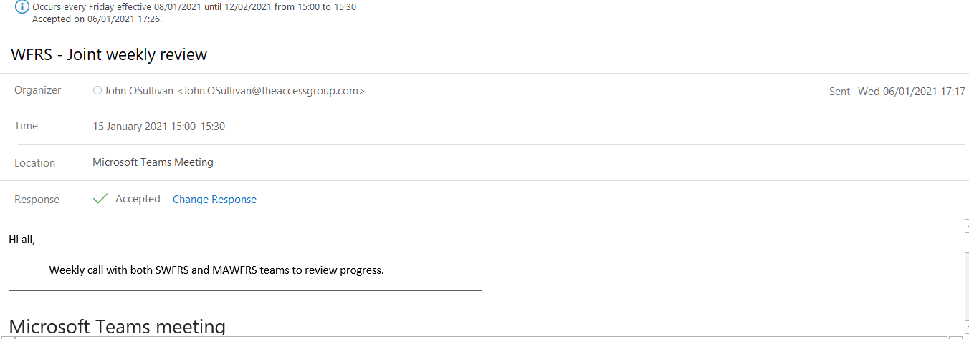

EV31
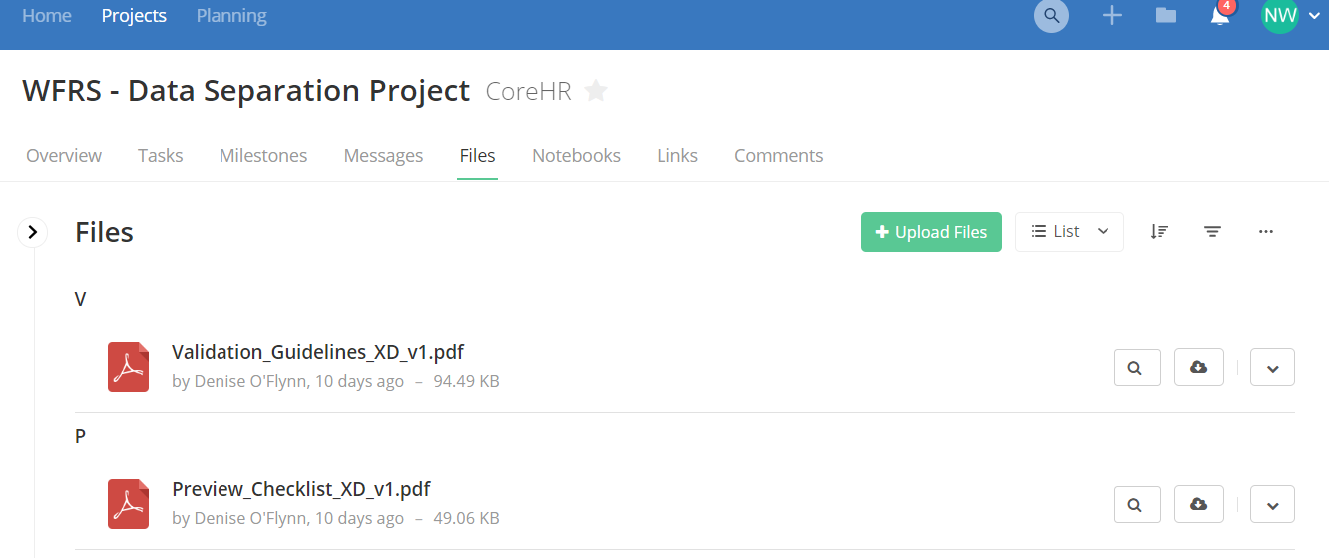
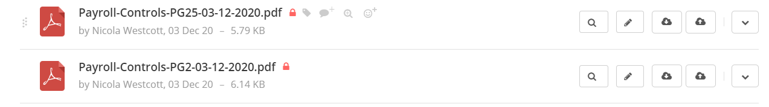
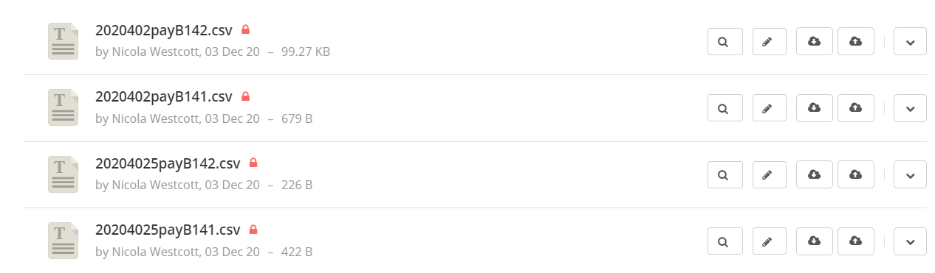
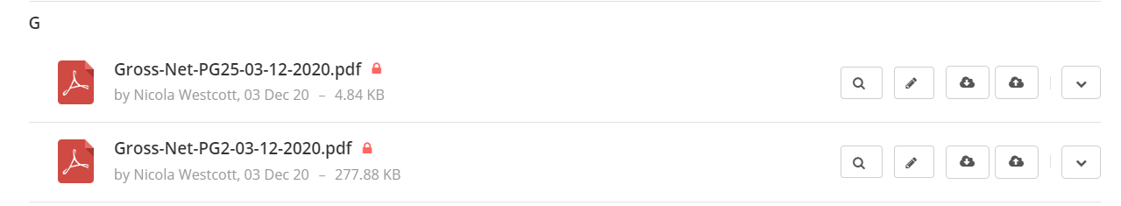
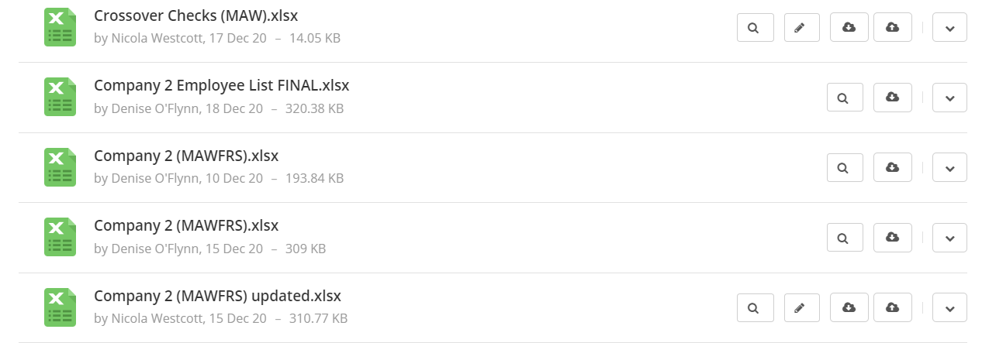
EV32
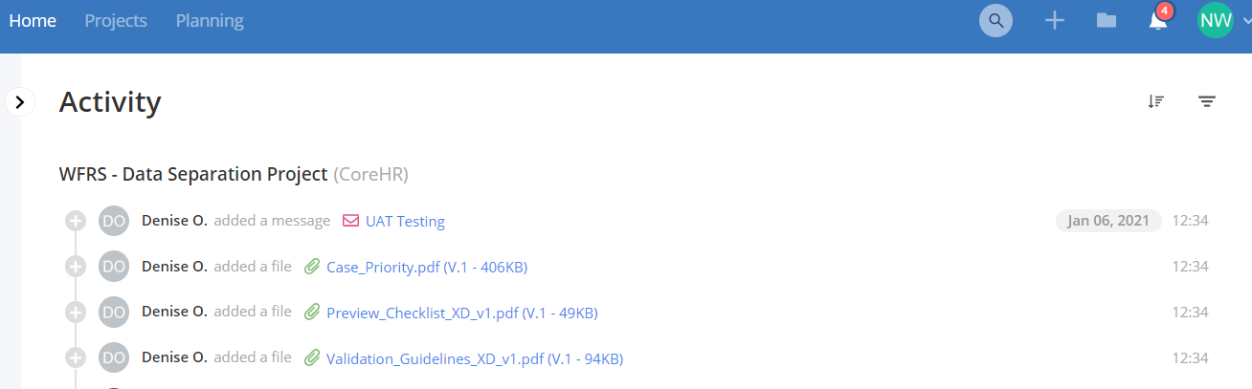
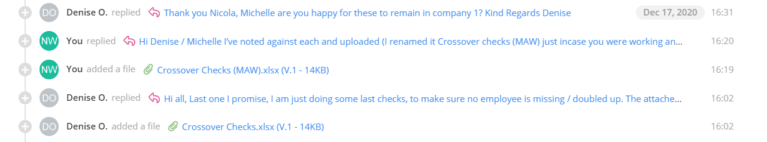

EV33
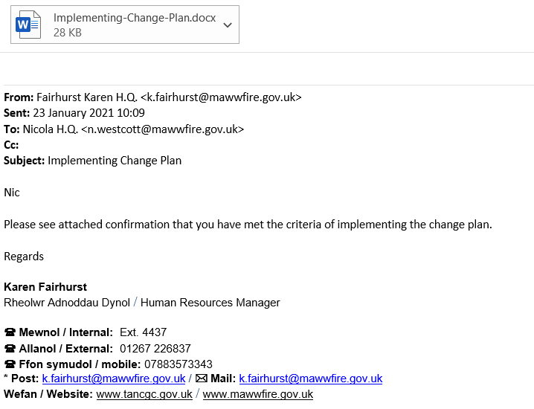

EV33 (Cont…)
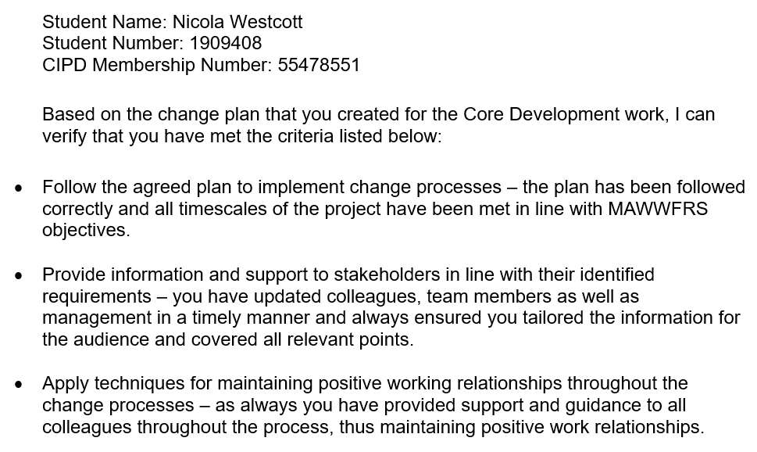
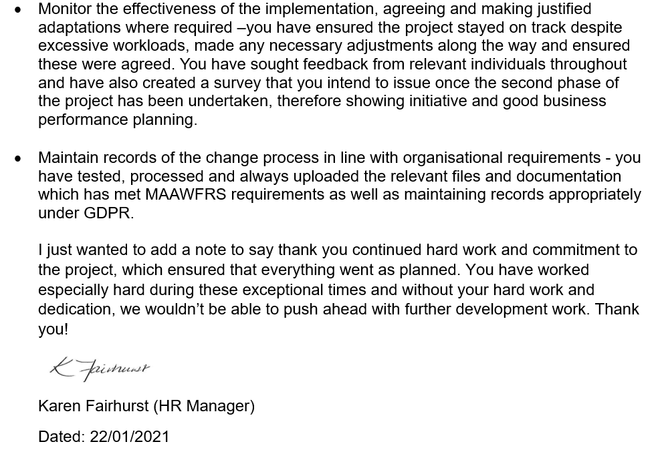

  - Measure the effectiveness of the change process in meeting the required objectives.
The sign off the upgrade and database split on the test environment (UAT) that was created specifically for MAWWFRS was completed and signed off on the 22/01/2021 (EV34). Therefore, enabling the same process to be applied to the Live system, which should now be seamless. The project is progressing as expected with milestones being met (EV19) which I’ve communicated to the HR Manager (EV35).
Measuring the success of change will identify if the process is on the right track or whether any adjustments are needed. Change is not a linear process and both internal and external changes along the way will influence the plan and need to be taken into consideration (APM, 2017).
Evaluation methods include:
Quantitative data:
Data collected from statistics/outcomes or quality data, collected manually or using technology/apps/pulse surveys or social media. Workflows in the system can record/capture the data. I would use KPI’s to monitor take up/usage of the self-service system and record how long claims/processes take on the new system. Prompt payment of claims and a straightforward recruitment process, that captures and records the appropriate data will be extremely useful and can be used in monitoring the pre/post changes within MAWWFRS.
HR data such as employee turnover, absence, skills/development needs can also be used. Data such as absence statistics/reasons for absence can be used to monitor if the change has improved overall absence and employee well-being. Many individuals throughout MAWWFRS noted heavy workloads/administration burdens which could lead to stress and anxiety thus leading to absence, therefore the introduction of technology that can aid these burdens may lead to lower levels of absence and higher employee engagement. Although care must be taken to ensure was it the change that improved the statistics and rather than other factors.
Qualitative data:

Feedback/opinions from employees through MAWWFRS intranet or through surveys/questionnaires would provide valuable feedback on the change process as well as helping to identify any further development work. Once modules are in place and being utilised, I have created a quick survey I’d like to issue employees across MAWWFRS(EV36) to gain employee feedback as well as requesting feedback from colleagues/line managers to gather their opinions on the change, to determine if it was successful and if any further changes/developments are required. Surveys could be used to ask specific questions for which the respondents provide answers (Bryman and Bell, 2015). Focus groups could be held to discuss any specifics identified as well as interviews and observations.

Data collected from surveys can be very useful as it can identify trends or performance and can be used to monitor how the organisation has improved or not following the change, but it should be noted that surveys don’t allow to prompt for more information or response rates could be low (Perkins and Woodhams, 2016).

I would monitor the effectiveness by arranging regular reviews of the change process to help identify what worked well/what hasn’t and determine whether anything needs changing (APM, 2017 & XpertHR, 2021). Outcomes from these reviews could be circulated to stakeholders to aid future change processes (XpertHR, 2021). Opportunities/training needs identified following implementation will need to be explored/communicated. The increased use of technology will also allow for individuals to develop themselves not only in the use of the technology, but by undertaking additional training to develop themselves enabling career progression.
  - Identify further work required to embed changes and/or further developments required.
This project is on on-going development of the current system in order to meet MAWWFRS strategic objectives. Once this stable database is in place, further development to introduce modules such as online expenses and recruitment can commence. Once these are embedded and the appropriate user training provided (EV37), other modules such as rostering/training can be considered aligning with MAWWFRS vision to become a digital service. Any ideas from feedback from survey’s, team meetings can be used to identify further work as the project gains momentum.
Recently MAWWFRS has received confirmation that another standalone system used by HR/Commands used to record maintain absence/shifts/rostering will no longer be supported after the 31st March 2021, therefore this means that the development work currently being undertaken to develop Core HR now has to consider the implications of this and a decision has been made to incorporate this into the same project meaning further modules will be introduced/developed sooner than first anticipated.
  - Communicate the key outcomes and the impact of change to stakeholders.
The initial test phase of the project is now complete, and in line with CIPD (2020a) I communicated the key outcomes to the HR Manager (EV35) as well as colleagues (EV38). I also issued communication to all users to inform them that there was system downtime required between certain times on certain days (EV39). Confirmation from the HR Manager, as one of the stakeholders was received to state that the changes made to date are effective (EV40) as well as feedback from colleagues (EV41).The project is on track and has met the milestones, changes along the way such as the need to now incorporate further development of the system have been considered, discussed and considered for the future development work. The impact of the changes being introduced will mean a change to the way individuals carry out their roles and tasks therefore it is vital that the appropriate training and support mechanisms are put in place to deal with the effects these changes will bring.
  - Evaluate the effectiveness of own performance in contributing to the management of change.
Being involved in this change process to effective and efficient IT systems in place that support alternative ways of working by the end of 2020/21 (MAWWFRS, 2020). I feel that I have learnt a lot and developed my skills in this area, by being part of a process that will enable MAWWFRS to meet one of its strategic objectives. In line with the new CIPD Profession Map (CIPD, 2018), I can see that change is about having a structured/planned approach, understanding how people experience change, support them through the process and this project has shown just that.
From the outset of the project I was able to use problem solving techniques such as SWOT analysis to identify the weaknesses of MAWWFRS, identify opportunities and see how bringing in change could build on the strengths of MAWWFRS, thus reducing any threats.
I can see that it is vital that the change was planned in order to meet the milestones or targets. Having the correct resources in place, including the right people, including change champions, skills and budget can ensure that the change is successful. I can understand and see how the various change models identified by Kotter, Kubler-Ross and Lewin (Mindtools, 2021a, 2021b, 2021c and XpertHR, 2021) assist with any change process by identifying the steps that occur with any change. By applying these to this change gave me a good understanding of change management approaches and the advantages/disadvantages of these.
I can see that by using the right tools and techniques for effective change management it mitigates risks and ensures projects are managed effectively (ACAS, 2020).
I understand that change is unavoidable for all organisations and must happen in order to future-proof organisations (Wilkinson and Taylor, 2016). Research in my workplace has shown me how people react differently to change and why different approaches are required. I can see how important communication is when dealing with any kind of change in order to support individuals through the change process and reduce the risk of resistance.
My involvement on this project has shown me that I can plan and deliver projects successfully and assist MAWWFRS with meeting its strategic objectives. I can identify goals, milestones, mitigate risks, identify resources as well as understand how a project has interdependencies of many individuals and teams that the project covers in line with the skills identified on the CIPD Profession Map (2018) (EV42).

EV34
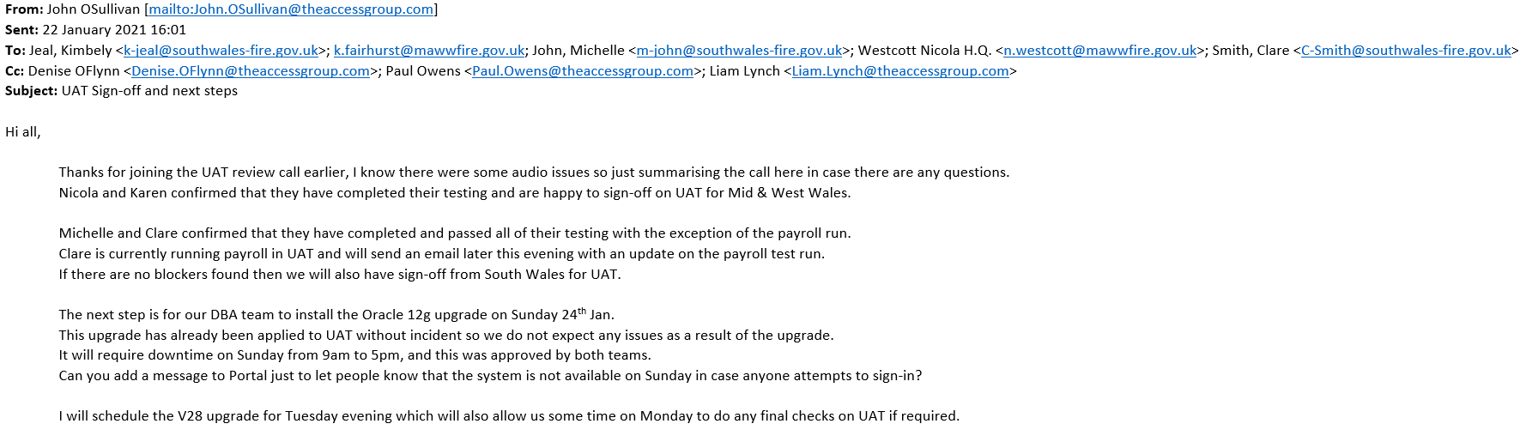
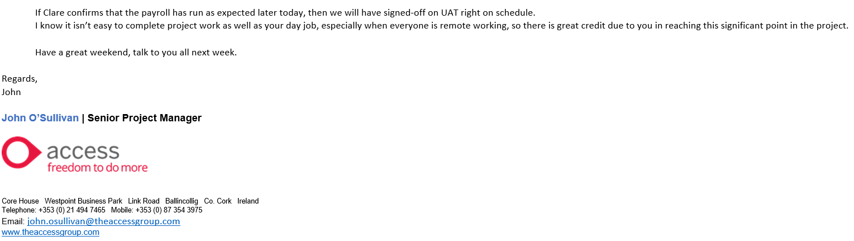

EV35
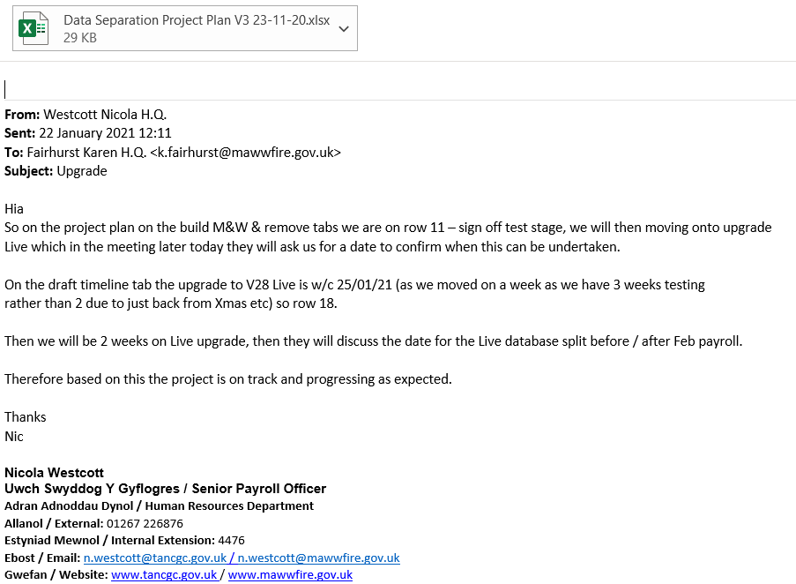

EV36
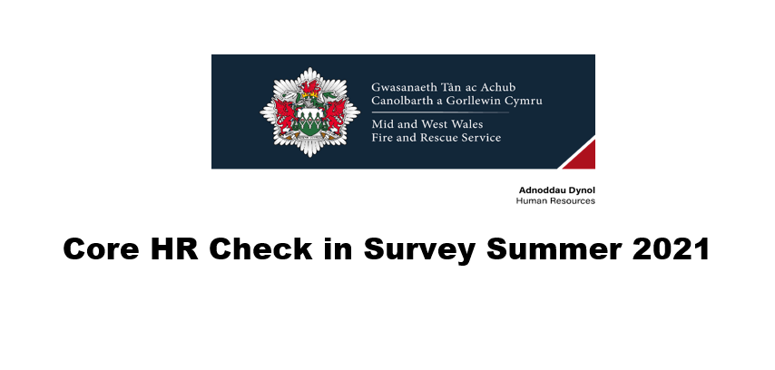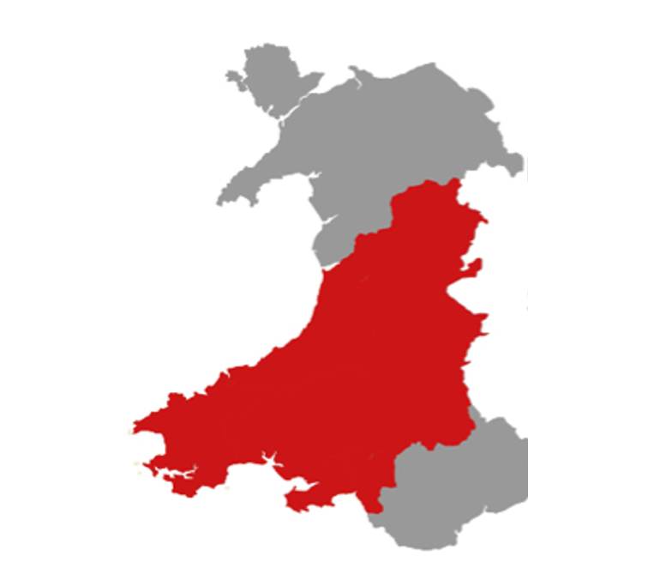

EV36 (Cont…)
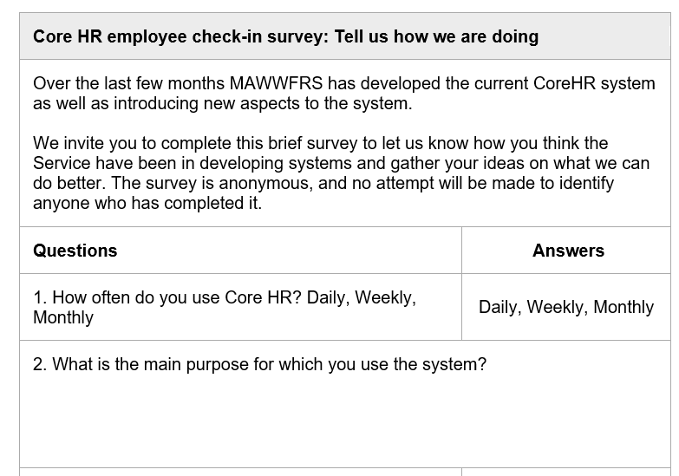
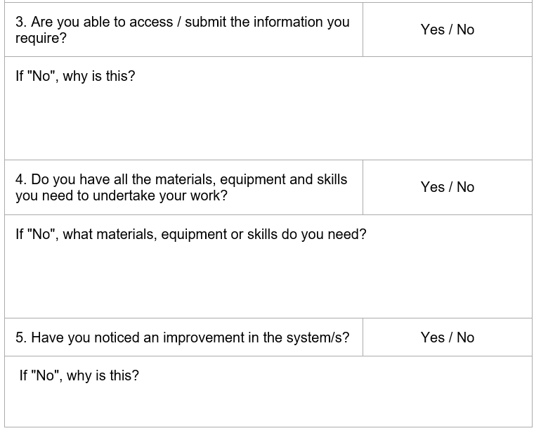
EV36 (Cont…)
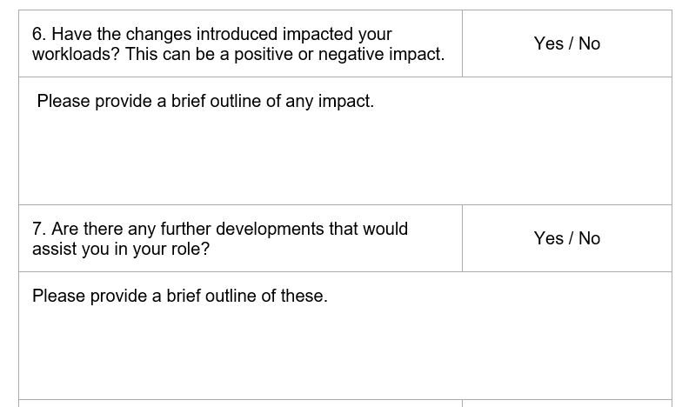
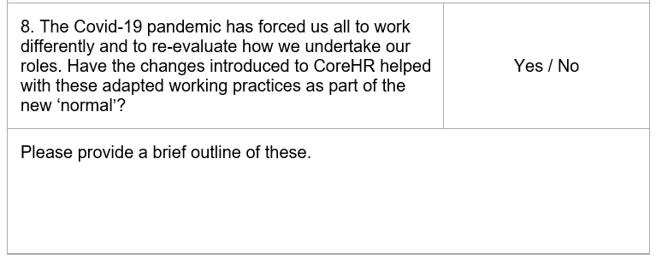

EV37
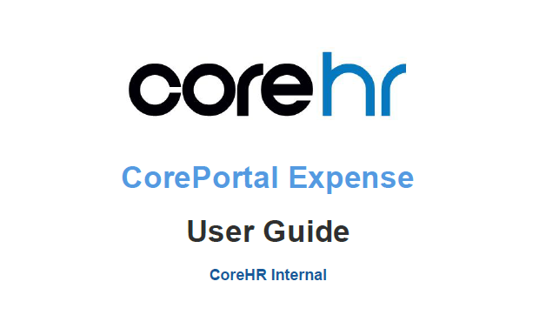

EV37 (Cont…)
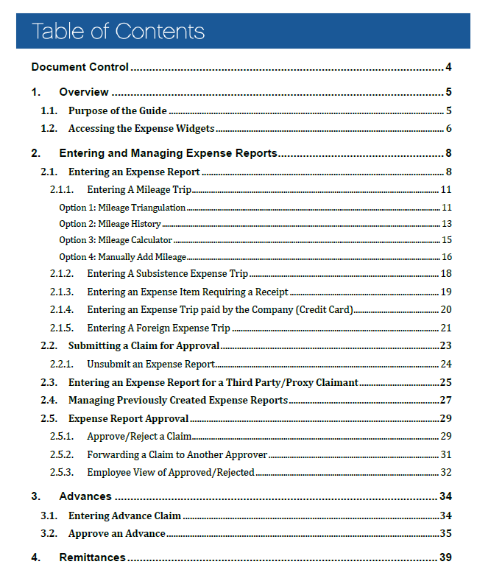

EV37 (Cont…)
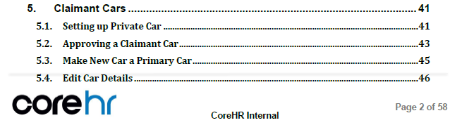
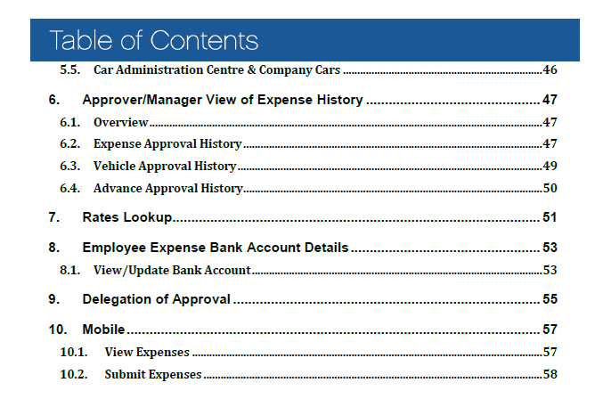

EV38
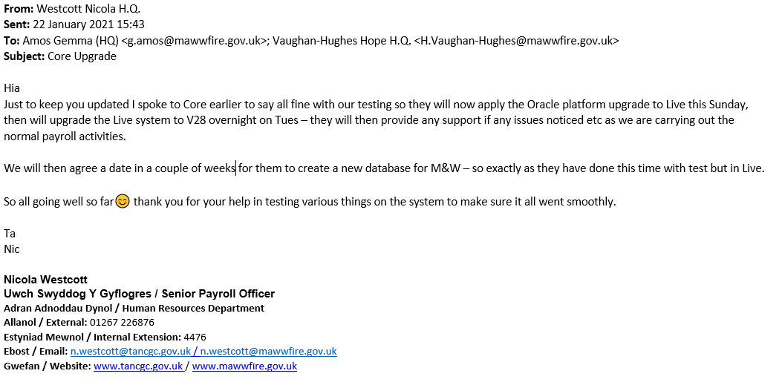
EV39
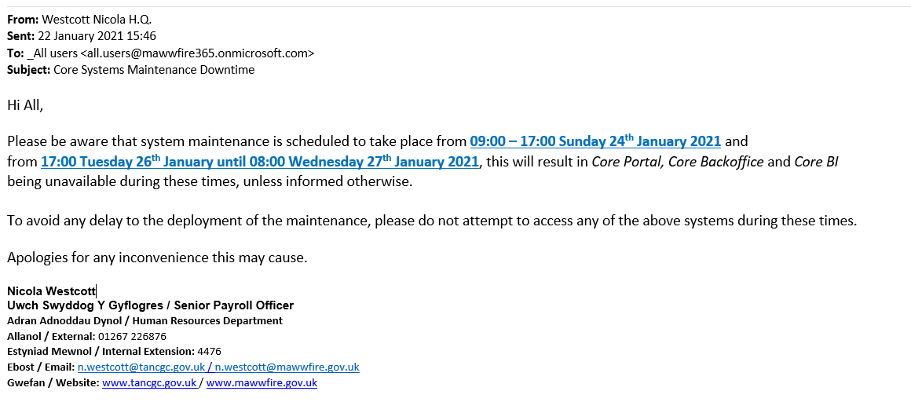

EV40
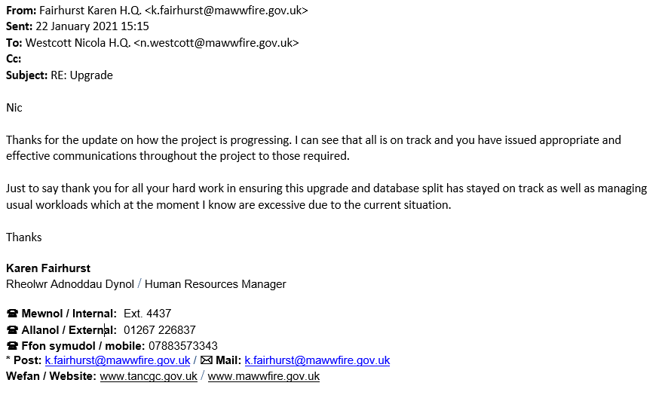
EV41
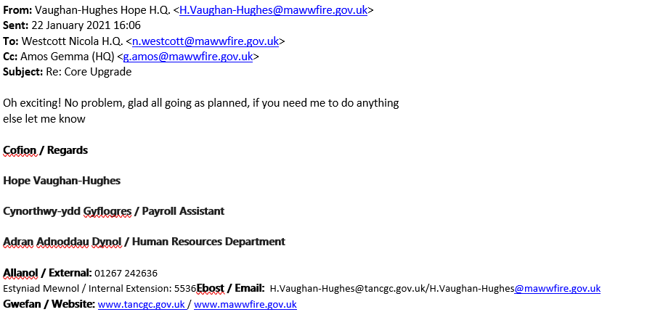

EV42
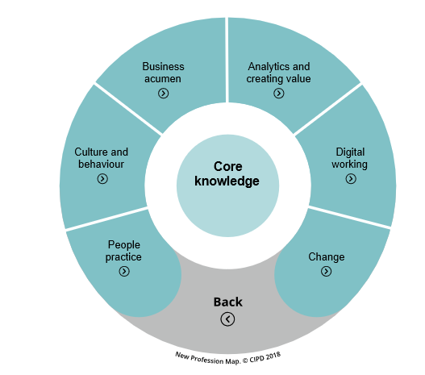
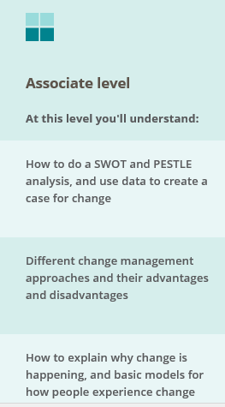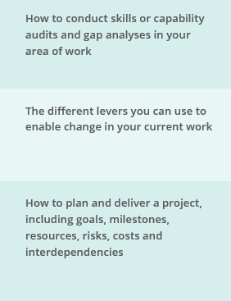

References
ACAS (2020) How to Manage Change [advisory booklet]. Available at: https://archive.acas.org.uk/index.aspx?articleid=4669 Accessed 28 Nov 2020).
APM (2017) Introduction to Managing Change. Buckinghamshire: Association of Project Management.
Bryman, A. and Bell, E (2015) Business Research Methods. 4th ed. Oxford: Oxford University Press.
CIPD (2018) Profession Map Available at: https://peopleprofession.cipd.org/profession-map/core- knowledge/change (Accessed 10 Dec 2020).
CIPD (2019a) HR Business Partnering [Factsheet] 06 Aug 2019. Available at: https://www.cipd.co.uk/knowledge/fundamentals/people/hr/business-partnering-factsheet (Accessed 05 Mar 2020).

CIPD (2019b) Employee engagement and motivation [Factsheet] 19 Dec 2019. Available at: https://www.cipd.co.uk/knowledge/fundamentals/relations/engagement/factsheet. Accessed 03 Oct 2020.
CIPD (2020a) Change Management [Factsheet] 10 Aug 2020. Available at: https://www.cipd.co.uk/knowledge/strategy/change/management-factsheet (Accessed 21 Nov 2020).
CIPD (2020b) Responding to the Coronavirus. Available at: https://www.cipd.co.uk/news-views/coronavirus (Accessed 21 Nov 2020).
CIPD (2020c) Swot Analysis [Factsheet] 26 Feb 2020. Available at: https://www.cipd.co.uk/knowledge/strategy/organisational-development/swot-analysis-factsheet (Accessed 14 Mar 2020).

CIPD (2021) Technology and Digital Transformation. Available at: https://peopleprofession.cipd.org/insights/research-action/technology-digital-transformation-trend (Accessed 02 Jan 2021).

CoreHR Community Hub (2021). Available at: https://community-corehr.force.com/portal/s/login/?startURL=%2Fportal%2Fs%2F&ec=302 (Accessed 02 Jan 2021).

CoreHR Teamworks (2021) WFRS Data Separation Project. Available at: https://corehr.teamwork.com/#/projects/586214/files (Accessed 22 Jan 2021).

Johns, T. and Ellis, C. (2016) ‘Employee Engagement’, in Taylor, S. and Woodhams, C. (ed) Human Resource Management: People and Organisations. 2nd ed. London: Chartered Institute of Personnel and Development.

MAWWFRS (2021a) Corporate Plan 2020-25. Available at: https://www.mawwfire.gov.uk/media/3197/jr0943-corporate-plan-2020_25_eng.pdf (Accessed 02 Jan 2021).
MAWWFRS (2021b) Internal documents / Surveys.
MAWWFRS Intranet (2021c).
Mindtools (2021a) Kotter's 8-Step Change Model [online article] Available at: https://www.mindtools.com/pages/article/newPPM_82.htm (Accessed 12 Jan 2021).

Mindtools (2021b) Kubler-Ross Change Curve. Available at: https://www.mindtools.com/pages/article/newPPM_96.htm (Accessed 15 Jan 2021).

Mindtools (2021c) Lewin’s Change Management Model [Online article]. Available at: https://www.mindtools.com/pages/article/newPPM_94.htm (Accessed 12 Jan 2021).

Perkins, G. and Woodhams, C. (2016) ‘Using Information Human Resources’, in Taylor, S. and Woodhams, C. (ed) Studying Human Resource Management. 2nd ed. London: Chartered Institute of Personnel and Development.
SAGE Group plc (2020) Building resilience and agility: How HR leaders can empower change. Available at: https://www.sage.com/en-gb/sage-business-cloud/people/resources/ebooks/business-resilience/ (Accessed 02 Jan 2021).

Society of Human Resource Management (2015) Managing Organizational Change. Available at: https://www.shrm.org/resourcesandtools/tools-and-samples/toolkits/pages/managingorganizationalchange.aspx (Accessed 21 Nov 2020).
Wilkinson, K. and Taylor, S. (2016) ‘Managing and Co-ordinating the HR Function’, in Taylor, S. and Woodhams, C. (ed) Studying Human Resource Management. 2nd ed. London: Chartered Institute of Personnel and Development.

XpertHR (2021) Available at: https://www.xperthr.co.uk/good-practice-manual/managing-an-hr-change/161236/?keywords=change+management&searchrank=1(Accessed 15 Jan 2021).

