The impact of Virtual Learning Environment (VLE) – Moodle on students’ learning experience at the University of Wales Trinity Saint David London Campus.



Module name: Digital skills and Research Methods Module code: BMSW4003
Task : Research Report
Student ID : 2115350
Student name: Daniela Ambros
Lecturer name: Koushik Modak

Abstract
The study is conducted to find out how VLE-Moodle has an impact on students at the University of Wales Saint David London campus. The first phase of the report involves a completed student survey and the second part a revised and analysed literature. Furthermore, the research report will change student’s views and reveal the usefulness of using VLE-Moodle.

Table of contents:
Abstract..........................................................................................................................................................2
Introduction.....................................................................................................................................................4
Rationale........................................................................................................................................................4
Research Objectives......................................................................................................................................5
Literature Review...........................................................................................................................................5
Research Methodology..................................................................................................................................6
Primary data analysis................................................................................................................................7-11
Secondary data analysis.........................................................................................................................12-13
Conclusion and Recommendation................................................................................................................13
References....................................................................................................................................................14
Appendices.........................................................................................................................................15-

Introduction
Virtual Learning Environment (VLE) is an online system consisting of a variety of tools to support study and also the management of the study. Moreover, this platform supply learning resources online to students and assist in the communication between learner and lecturer. This is a virtual platform where students do not need to present physically at a school or university for the study purpose. In this research report will be discussed about VLE-Moodle. The Moodle platform is designed to eliminate the necessity to meet face to face by providing high standards in the online study: online library, communication with lecturers and students, completing and sending assessments.
Rationale
The reason that this report was done is that VLE has a place on top of all forms of study and feels a necessity to find the impact faced by students. For evaluating and validating the impact of the VLE-Moodle on student life, a primary and secondary data analysis part will be established for better evaluation.
Research Objectives
This report aims to discuss and analyse the impact of the virtual learning environment-Moodle on students on the UWTSD campus in London. The research process to be carried out is necessary to follow some steps, therefore the diagram below will clarify and identify the research objectives.

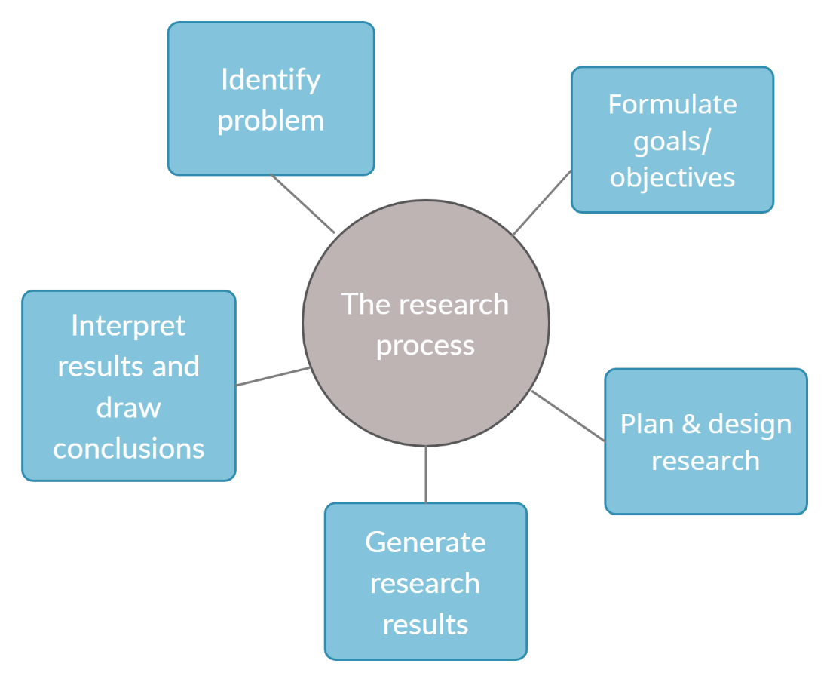
Literature review
This study is based on the following authors and their work: Dudeney & Hockly ( 2007); Green Brown & Robinson (2008); Walker & White (2013) and Ayres (2002). According to them VLE plays an important role in educational field, therefore here will be reviewed some research methods and processes.

Research Methodology
The research methods used in this study are quantitative and qualitative, in addition the primary data are obtained directly from students and the secondary data are obtained from the revised literature.

- Data collection process
The data used in this research will come in two ways. The first data will be collected from the survey that was conducted online by e-mail. Other data will come from online articles, books and websites.

- Population, Sample and Sample size
The total number of students is 3,000 on the UWTSD London campus. The main goal is to reach 200 students out of the total number which will be the Sample. For instance, till the end of the research, the sample size was just 20, therefore the research will be based on that number of learners.
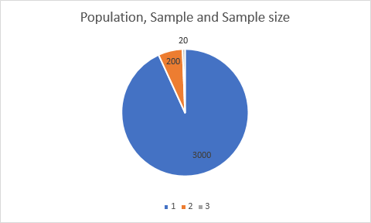

- Ethics in data collection
Potter Steward said: "Ethics means knowing the difference between what you have the right to do and what is right to do." According to these words, the whole research process was done with moral values and principles. Also, under art. 5 GDPR, ’’personal data have been processed lawfully, correctly and transparently ”. Before starting this survey, students were asked to give their consent to participate and were informed about the whole process in advance.

Primary data analysis
VLE is a very useful sector for the students. However, students may consider this digital platform differently. For analysing the actual viewpoint of the students regarding the support of Virtual Learning Environment and finding out the engagement ratio of the students, primary data analysis will be created (Comeaux, 2020). Primary data analysis is prepared by a researcher for a specific topic or purpose to create a proper justification and consideration based on the analysis. So, considering the VLE topic, twenty students are chosen for gathering the primary data from them regarding the impact and efficiency of VLE-Moodle on their life. The data will be collected through the questionnaire. The surveys of the students based on the questionnaire are given below:
1 Do you think, VLE –Moodle is increasing your efficiency?
YES | 17
NO | 3

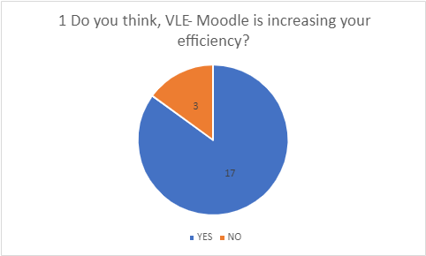

According to the answer that was received, the majority of students feel that VLE-Moodle help them to study and increases their efficiency. Even if there are situations where students miss classes due to work, transport or another reasons, they can always access the topics and review in more detail way. Therefore, by implementing many educational resources in the virtual platform makes it easier for students to study from the comfort of their home. So it's a place where a student can easily increase their productivity with academic knowledge (Pedersen and Wilkinson, 2019)

2 Would you agree by saying that VLE- Moodle is a useful platform ?
STRONGLY AGREE | 11
AGREE | 6
DISAGREE | 3

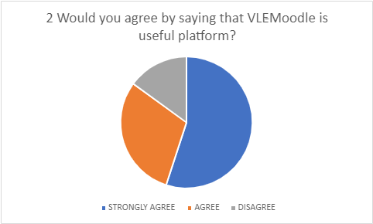

The Covid-19 pandemic has severely affected academic studies, so many students have been forced to return home and study online. For this reason, many students face problems academic lessons because they cannot physically attend their courses (AlSamhouri, 2021). However, VLE creates a virtual place where students can alleviate their problems with the help of lectures and also with the team behind this portal which support it by creating lots of resources and space for students so that they can learn from the VLE-Moodle on their own. The above Graph demonstrates how students feel using Moodle and by looking at the numbers it is obviously that majority of them feel that this platform is a great tool.

3 How often are you using the VLE-Moodle platform?
1 - 2 Times in the week | 6
3 - 4 Times in the week | 8
5 - 7 Times in the week | 6

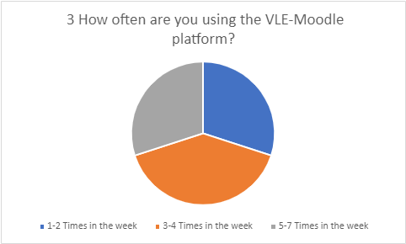

By looking at the numbers above, which shows how often students are using the VLE-Moodle platform, it is obvious that this platform is used on a large scale by keeping a record number per week. Therefore, the graph shows how students believe in technology and support Virtual Learning Environment.

4 Which platform is more suitable for you: VLE-Moodle or Physical?
VLE-Moodle | 17
Physical | 3

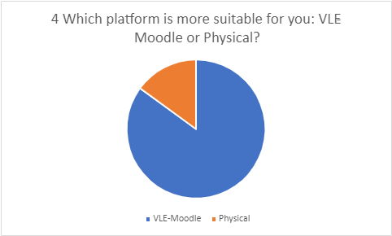

Before the Covid-19 situation, the use of the VLE platform was not at a satisfactory level. But at the pandemic and after the pandemic, maximum students are involved in the online platform for their academic study and VLE is the most useful online learning environment which helps the students in various ways. Students can easily perform their classes, exams, research, analysis, etc. through the VLE platform. For that reason, maximum students accepted the usefulness of the VLE platform than the physical platform (Savin-Baden and Tombs, 2020). Also, VLE is savings more time than a physical platform for the students.

5 Please explain the reason why did you choose that platform in the question above?
Most students chose VLE because it is easy to use, convenient, and not time-consuming. Other students which chose Physical said that they can learn better face to face.

Most students who have chosen VLE-Moodle are confident that this platform will benefit those who use it. Moreover, one of the benefits is that you can study at home, you do not have to waste time traveling or spend money, it is enough to have internet and a computer to use this platform. Other students who have chosen the physical study platform have supported their choice by the fact that they can learn face to face more effectively. Therefore, being in class nothing and no one can distract them, also having a lecturer in your front students feel more confident to ask questions and share their thoughts.

6 Could you rate from 1-10 how happy you are by using VLE?
The average number received from students is 9. This proves that VLE-Moodle is an extremely welcome and useful platform.

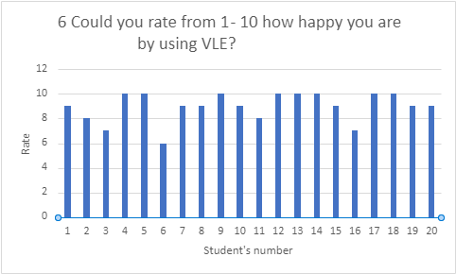

According to the summary of the answers to question 6, most students consider VLE-Moodle to be an excellent and beneficial platform that helps students to improve their knowledge and to become more confident. Moodle allows users to access all modules of the academic year, both past and future, and students can also download power point slides and other resources for free. Moreover, they can check the similarity of the assessments and upload them there.

Secondary Data Analysis
VLE-Moodle is a continuous learning platform and students can make their learning process more
efficient and digitalized. By the existing qualitative and quantitative data
of the VLE platform, this secondary research process will be prepared (Kiecolt and Nathan,
2018). This platform has positive and negative parts too. Therefore, analysing those parts
will be more efficient for analysing how the VLE platform is impacting the students and their
academic, practical life.

Positive impact
VLE is creating an online platform for the students and for that reason, students are enabled
to enrich a vast amount of academic and skills increasing resources from the VLE platform.
By establishing proper engagement with the VLE platform one student can learn 40% more
effectively than a random student. The platform is managed system so that students can
learn and increase their skills properly. By the VLE platform, the student’s efficacy rate will
be increased. They will gather and inherit the knowledge of different skills which is
increasing their productivity and proficiency (Herrera Mosquera, 2018). Also, VLE-Moodle is helping
the students with time management. As they are studying from their respective places,
students are saving the journey and staying cost and time in the academic institutions. VLE can easily reflect the student’s needs and by the course assessments process by covering the academic and skills learning sources. Using VLE is increasing the
digitalized educational platform. and saving student’s time, cost, it is improving their skills
and expanding their knowledge worldwide. In the Covid-19 pandemic, 80% of students were
completed their courses and exams through the VLE process in the UK educational
institutions. Also, currently, 78% of students are thinking that the VLE platform is very useful
for the students for performing academic tasks properly (Herrera Mosquera, 2018).
Negative Impact
Although VLE has many positive impacts, it has some negative impacts also. From the
collected data, it was seen that many students are getting lazy for staying in their home and
they are getting separate from their studies. Also, they are not willing to use the VLE-Moodle
platform for their development. Another negative impact is, many students do not have the
well-equipped instruments and scope to use the VLE platform from their respective places.
Also, in a survey, it was found that in every
exam or session, 5% of students try to cheat in the respective terms through online media
(Hiscock, 2020). It also decreases the scope of their development. Also, as it was not
connecting human to human connections, therefore many students are getting frustrated for
not connecting with their teachers and respective ones. Discussion, building team, etc. are
hampering sue to making the academic education through the VLE platform. In the online
assessments, 13% of students are cheating on their roles but unable to identify as it is
complicated. So, VLE-Moodle is not covering the full grounds but have many advantages too.

Conclusion
To increase the learning experience and create a more digital platform, VLE is
currently the best virtual platform for students. According to the analysis, it is also confirmed that
VLE is very acceptable in student’s opinion , because creates space for students to think
and learn beyond their personal life. So, without a doubt, the Virtual Learning Environment (VLE) is
an excellent online platform to improve and increase your academic skills and knowledge.

References
Herrera Mosquera, L., (2018). Impact of Implementing a Virtual Learning Environment (VLE)
in the EFL Classroom. Íkala, Revista de Lenguaje y Cultura, 22(3), pp.479-498.
Kiecolt, K. and Nathan, L., (2018). Secondary analysis of survey data. Newbury Park, Calif.:
Sage Publ.
Hiscock, C., (2020). International Student Voices and the VLE. International Journal of
Computer-Assisted Language Learning and Teaching, 10(3), pp.16-27.
Comeaux, P., (2020). Assessing online learning. Bolton, Mass.: Anker Pub. Co.
Peddersen, R. and Wilkinson, J., (2019). Increasing Productivity in Education. Chicago:
Institutions/Volume feeding magazine; distributed by Cahners Books, Boston.
AlSamhouri, T., (2021). Education Fights the Pandemic.
Savin-Baden, M. and Tombs, G., (2020). Research methods for education in the digital age.
Dudeney, G., & Hockly, N. (2007). How to Teach English with Technology. England: Pearson Education Limited.
Green, T.D., Brown, A., & Robinson, L. (2008). Making the Most of the Web in your Classroom: A Teacher's Guide to Blogs, Podcasts, Wikis, Pages and Sites. Thousand Oaks: Corwin.
Walker, A., & White, G. (2013). Technology Enhanced Language Learning. Connecting Theory and Practice. Oxford, UK: Oxford University Press.
Ayres, R. (2002). Learner attitudes towards the use of CALL. Computer Assisted Language Learning, 15(3), 241-249.
BrainyQuote,(2022). Potter Steward ,Quotes.[Online] Available at: https://www.brainyquote.com/quotes/potter_stewart_390058 (Accessed: 2 January 2022)
Intersoft Consulting, (2022). Principles relating to processing of personal data, Art. 5 GDPR. [Online] Available at: https://gdpr-info.eu/art-5-gdpr/ (Accessed: 5 January 2022)

