DEVELOPING RELATIONSHIPS AND WORKPLACE ACHIEVEMENT

MODULE NUMBER: BMSK5002
STUDENT NAME: MOHAMMED SHUNA MIAH
STUDENT NUMBER: 1605672
MODULE CODE: BMSK5002
LECTURER: ZEE ZOOK
WORD COUNT: 4458

Table of Contents
Title | Page Number
“Introduction” | 3
“Critically assess the potential benefits to the organisation and the individual of personally developing individuals in the workplace” | 4
“Critically evaluate development vehicles available to an organisation appropriate to the development needs of the individual” | 6
“Develop a plan to meet the identified development needs and expectations of an individual” | 13
“Evidence of wide reading and research, encompassing the application of relevant academic theories and models” | 16
“Conclusion” | 19
“Reference” | 20

Introduction
Personally developing individual is a lengthy process. It is a way for persons to assess their skills and qualities, contemplate their opinions in lifecycle besides put down the purposes with an exact finale objective to recognise and enlarge their possible. McLeod (2007) mentions that every person have an in-fabricated necessity for individual growth which occurs by the process called actualisation to oneself (Goldstein and Bokoros, 1992). In today’s commercial organizations are worried about the personal and professional; development of the staffs and Tesco also make emphasis on this issue. Tesco Plc always perform in a way that motivate their staffs to develop personally.
The grade to which persons have the ability to make trusts on upon exact requirements actuality talked as well as these requirements construction an advanced scheme. Just once one level of wish is satisfied an advanced one can also be shaped. Observing that variation occurs all through lifetime, however, the strength of necessity encouraging somebody's behaviour at any one period would similarly correct. It is important that the professional principles are encountered by the talents that one owns. The present abilities of an active character, decent communication, and positive philosophy have been established since childhood. But it is the duty of the individual to develop himself or herself according to demand of the businesses.
Organization Overview– Tesco PLC
Tesco is a UK based organization. It is one of the leading grocery organization in UK. It perform businesses more than thirty country in the world and keep in third place for retail industry. The hierarchical organisational structure of Tesco PLC are described in following figure.
Case Study: Tesco PLC
Tesco PLC currently perform better but they face problem due to their poor performance of the workforce. They introduce several program to improve the performance of the employees. They develop a career plan for all individuals according to their needs and demand. In today’s commercial organizations are worried about the personal and professional; development of the staffs and Tesco also make emphasis on this issue. Tesco Plc always perform in a way that motivate their staffs to develop personally.

Critically assess the potential benefits to the organisation and the individual of personally developing individuals in the workplace.
Today’s world is becoming tougher day by day due to the extreme competition and development of the world. A business needs to take several strategies and learn more to compete with several competitive organization. This is also true for the worker of the organization to develop themselves time to time to survival in today's world. All the business in the world now offer jobs for those who are skilled and knowledgeable. A person can develop himself or herself individually and individual learning has several benefits for the person as well as the organization also. For understanding the benefits first it would better to have a better understanding of what is personally developing individuals. The worker of the organization will be hindering the growth of his or her success if they do not take proper care to develop their skills in their own way.
For improving performance, work-life, and health, it is necessary to improve by oneself and this is called personal development. The quality of life has been improved by the personal development process. There is so many ways that a person can learn by themselves and improve themselves. Not only the person but also the organization can get benefit from the personal development process. From practical knowledge, an employee can improve themselves and overcome his or her week points. Every organization needs to create the structure to evaluate own performance. Employees of the organization can improve their talents and ability through this whole process.
Benefits to Individuals:
Self-learning benefits individual in many ways such as teamwork, presentation skills, communication skills, and so on. These are:
Personal Development: By doing group performance or teamwork an individual can able to learn a valuable lesson and improve their various ability. Every university now a day give project as a team not individual for gather experience and this is beneficial for the organization when they perform in an organizational context. A person can learn so many important activities from other members of the team. It is one of the best ways to learn personally (Marzband, Sumper, Ruiz-Álvarez, Domínguez-García and Tomoiag, 2013).
Presentation Skills: To represent the product or activities of the organization, it is essential for all staffs of the organization to have vast knowledge about how to deliver an effective presentation. Many universities arranges professional courses for improving presentation skills. An individual can benefit a lot by taking this professional courses. Presentation skills not only helpful for the person but also for the organization. Hence, every person those want to perform in an organization needs to have good presentation skills.
Communication Skills: In today’s organization communication skills plays an important role. Due to globalization, every organization wants to go into international market. For performing globally, every organization prefers to have employee who has good communication skills. The more outgoing a person the more successful a person in organization context. The confidence of the employees can grow by communication skills.
Benefits to Organization:
There are lots of benefits to the organization like Tesco PLC of personally developing the individual. These are:
Better decision making: decision-making skills help the person as well as Tesco PLC to perform effectively and accurately. A person can acquire decision-making skills by personally developing individual.
Become more ethical: it is necessary for Tesco PLC to have ethical and moral employees. The performance of the employees will be very professional if they learn personally. A worker of the organization will be more ethical if they personally developing individual.
Problem-solving method: by developing personally, an individual can develop problem-solving skills which are beneficial for the growth of Tesco PLC. Every organization always demand an employee those have better knowledge about problem-solving skills.
To get flexible worker: in today's world, every organization tries to get multi-tasked employee to perform in any condition. Only this personally developing individual process offer this kind of flexible working in the business. To take any kind challenges within Tesco PLC this skills plays a significant role.
Get Ahead of the Competition: Taking staffs who have the newest abilities and knowledge will aid the business to be economical.
If nothing constantly changes, the business would develop motionlessly and drop behindhand. It is not wise to let that occur. Give oneself and the staffs the abilities they essential to flourish and continue in the commercial world.

The Ability to Attract New Talent
Taking the finest as well as brightest employed for Tesco PLC is continuously helpful, besides through proposing training chances and the capability for staffs to develop and recover, an individual might be able to entice talent employees from the beginning.
Having more effective staffs: by learning individually, an employee of the Tesco PLC can develop his or her week side and try to do better in the business. So in this way an organization can get more appropriate and effective workforce.

Critically evaluate development vehicles available to an organisation appropriate to the development needs of the individual.
Personal learning is the procedure of learning several things from the requirement, needs as well as demands of the situation. A person in the workplace needs to develop or create a gaols for performing or learning new skills. Only when an individual gets the true purposes of learning or developing needs then he or she create targets to accomplish those needs. For performing in today's competitive global organization an employee of the organization need to learn thing personally. There are several ways that a person can develop his or her skills within the business.
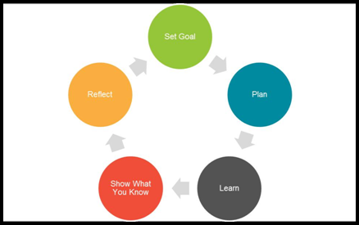
The different ways to self-managed learning (Source: Self-Study)

The different approaches to personally developing individual are:
- Training / career development – It is the duty of the HR management to evaluate the performance of the staffs and offer training to improve their performance. Only training can develop the professional career of the staffs.
- Conflict Resolution – a business need to have plan and policy to mitigate internal conflict among employees and also between staffs and management team. Tesco PLC introduce several plan for eliminate the conflict.
- Compensation (payroll and wages) – Tesco PLC motivate their all staffs by offering several compensation system and this is very effective process. They paid their staff’s timely and also offer yearly bonus.
- Recruitment – it is the duty of the HR team of the Tesco PLC to recruit more skilled employees who can perform effectively. Recruitment process plays an important role for personal development as by this way business can motivated other to acquire this skills.
- Conferences and seminars – conference and seminars are proved to be the most appropriate and effective way to gain experience and knowledge. An employee can express his or her personal opinion as well as thoughts by the seminars and conference of the organization. Presentation and communication skills can be gained by the conference and an individual becomes more outgoing as well as confident to represent themselves in the business environment (Goldstein and Bokoros, 1992).
- Social Network– with the advance of technology the social network plays an important role to gain knowledge. An individual can learn so many unknown things with the help of social media. There is nothing that an employee cannot be able to learn in social network. Further, they can share their thoughts and collect feedback from the experienced persons.
- Performing individually: Though group work is important for the business but performing individually is also beneficial for the persons as by this way they can gain confidence to take challenging job. An employee can express his or her personal opinion as well as thoughts by the seminars and conference of the organization. Also, they have to learn more to do the job individually.
- Effective Goal Setting: the more challenging the objective, the more possible it would be accomplished. Objectives hold individuals responsible for our effort principle as well as challenge individuals toward improving abilities that individuals might or might not previously be knowledgeable in. In Tesco PLC, we set the aim of making strategy to gain customer satisfaction as well as learn the way of making customer relationship. This whole concept help to learn new things within the business environment.
- Organisational structure / Company Hierarchy- Corporate Business Hierarchy will methodically describe the stages that business employ for describing the roles, responsibilities, stages of power distribution in their operational structure.
Individual can gain vast knowledge about the problems in the workplace by personally developing individual. They will be motivated to take action at work, improved focus and effectiveness, and also gained a sense of direction by personally developing the individual. This process of learning helps the employee of the organization to gain knowledge and potential, and their personal development in the business context. WE can be able to gain our professional as well as personal growth by personally development process.
There are several vehicles in organization for the evaluation of personal development needs. Among the most appropriate SWOT analysis is one of the best ways to evaluate personal development needs. As a worker of the Tesco PLC, WE always asses our personal development needs by this SWOT analysis process. By this way, WE are able to find out our strength, weakness, opportunity as well as threats within the business environment.
As per our SWOT analysis our strengths and weakness are:
Strengths
- WE find out that WE are a quick learner. WE always learn from practical experience that makes me learn more and accurately. Quick learner is essential for performing in a business environment as for effective and accurate performance it is crucial for a business to have quick learner employees.
- Another strength is ambitious. An employee needs to be ambitious for working independently and taking challenges.
- WE can be able to contract with a foreign company as WE have good communication skills. Better communication skills serve as an important element or resource for the organization. For performing globally a business need to have good communication skills employee.
- WE are more outgoing as well as a friendly person. WE always maintain a good relations with all the workers in workplace.
Weakness
- WE tend to get stressed very early
- Take so many time to complete a task for completing its task accurately.
Opportunities
- WE have the opportunity to continue with further education
Threats
- Money
- Recession
Under this SWOT analysis, it is clear that WE have to take several development and professional program to overcome all our problems. It is crucial for the business to create a feature like SWOT analysis for personal development as in this way employees can find out their needs, weakness, threats, and opportunity in the workplace.
The study includes finding out the abilities of an individual. SWOT is an assessment instrument used for classifying the gaps and robust facts and applying them in an arranged style. Afterward the assessment procedure, a strength is compulsory toward implementing variations which are optimistic and be able to lead to additional prospects. Resounding out SWOT examination highlights the advantages and disadvantages an individual owns however the consequence will be contingent on how a person answers to the examination and implements it consequently (Johnston, 2013).
The key notion of SWOT is to improve strengths which are recognized, overcome flaws, exploiting on chances, as well as changing fears into chances and flaws into powers. WE also need to put possibilities in place. There are numerous welfares of using SWOT examination for individual growth.
SMART is the most appropriate process for the business as it ensures that the goals of the Organizations are successfully achieved. In the present commercial environment the purposes must be SMART:

S – Specific
M – Measurable
A – Achievable
R – Realistic
T – Time-bound
The objectives of the business can be attained through assessing the opportunities and abilities they want from the persons they have hired. It is necessary for business like Tesco PLC to hire employee those have skills like a team player, communication skills, management, leadership skills, and so on. For the case Tesco PLC the objectives are described below:
- The main objective is to provide facilities toward individuals.
- To create the job or task of the individual in a way that focuses on the individual needs also facilitate their careers.
- Responding instantly to the demand of the customers.
- Try to improve the services as well as the quality of the products.
- Valuing and supporting the staff

Kolb Learning Cycle
This is the experimental learning process. There is another way an individual can personally developing individual. Learning styles precisely deal with specific methods of learning. Kolb offers a concept of empirical education that contains four main phases:
- Reflective observation,
- Concrete experiences,
- Abstract conceptualization, and
- Active experimentation
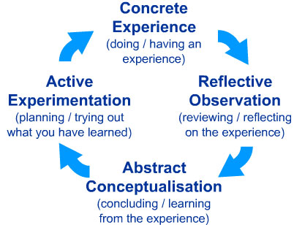
Source: (Johnston, 2013)
This model develop four different types of learning style and it found some individuals are good in learning from theory, some from analysing past events, some is real time viewing, etc.
Our Individual skills and capabilities against the Tesco PLC objectives
We have developed several skills during performing this organization. We possess good presentation skills, researching skills, written skills as we as written communication skills. By these skills, we are able to perform with groups and independently in an effective way. We also process good customer relation skills as the sales of the business increase by better relation with customer. For effective performance within the business, we had to take several development programmes as we want to perform effectively in the business department.

CASE STUDY – Recommended Solutions
Every organization wants to have employees those are capable of performing vast skills. It is also true for the case of Tesco PLC. For performing better in this organization, we have to learn IT skills, Management skills as well as leadership skills. For this reason, we are planning to take initiative to acquire those skills. We can engage myself in a tanning programme in the workplace to gain this type of skills. By taking appropriate leadership training classes as well as management classes, we can overcome all weakness within the business.
By reading several business reviews like Harvard business review we can be able to develop the skills. We can learn from several business people's biography about how they improve their skills and learn in their own way. By learning through research is one of a suitable process for me as we can learn in our own way by using the internet. PEST is also the appropriate process of evaluating the business situation as this helps me to meet our growth needs. For our personal as well as professional growth it is necessary to learn from these approaches.
Identify development opportunities to meet current and future defined needs
Our current and future needs are mentioned as follows:
Current needs: currently we are pursuing a degree for our professional growth. We will try our best to complete our courses with a good result as this will help me to research further or get the opportunity from university to enrol in the higher study program. We will try to complete all of our assignment within time and also with proper care (Johnston, 2013).
Future needs: Future needs means to have certain goals and targets to accomplish for performing better in the workplace. We want to gain our various business skills by taking training and courses in the near future. Although it is very difficult to find out the accurate needs to perform in businesses, from time to time evaluation process we can be able to find out our needs or weakness.

Develop a plan to meet the identified development needs and expectations of an individual.
An individual needs to find out their personal needs first and then need to create a plan that helps him or her to accomplish it. Without a proper strategy, it is very difficult for the individual to accomplish their needs. Personal development is essential for individual to perform better within the business (Goldstein and Bokoros, 1992). It is necessary for me to develop a strategy or plan so that we can follow this plan in the future to accomplish all of our needs.
MASLOW’S Hierarchy of Needs
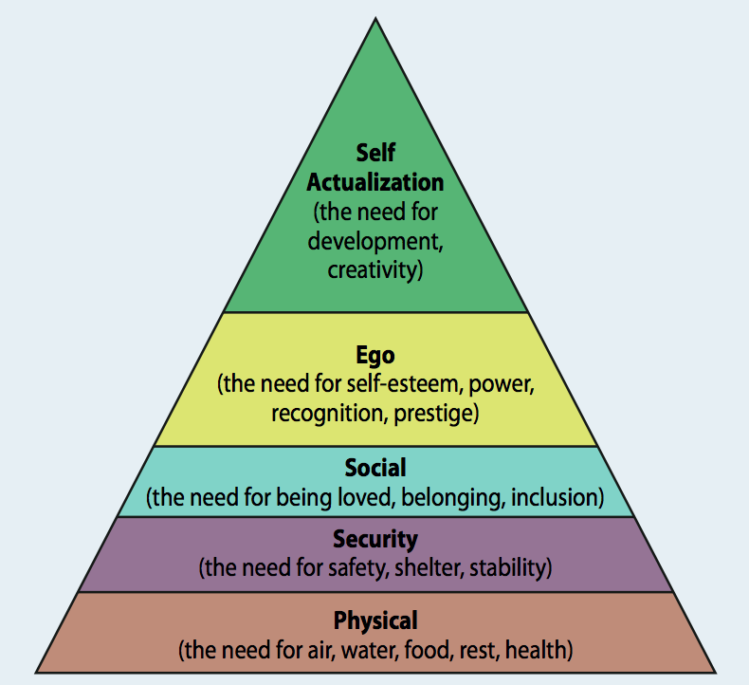
Figure: MASLOW’S Hierarchy of Needs
We have to make this plan in a way that needs to flexible to adjust the changing environment as well as the demand of the organization. Currently we are pursuing a degree for our professional growth. We will try our best to complete our courses with a good result as this will help me to research further or get the opportunity from university to enrol in the higher study program. We will try to complete all of our assignment within time and also with proper care (Johnston, 2013). The world is changing rapidly due to the globalization also the competition among the business also increase. For this reason, it would better to change me with the demand of the market. We will be more accurate as well as more skilled person if we follow this strategy. Our individual learning processes are described below:
It is important for an employee or individual to have effective curriculum vitae as this helps the company to find out the skills and experience of the individual. So our first plan is to create a curriculum vitae in a way that highlights all of our success and skills (Brian, 2001).
It is also crucial for me to find out our short term goals that are relevant to our career growth. Our short term goal is to complete our present business degree and try to involve in a further research project.
Long term objective mainly consists of detail policy with dates within the next five years. WE have to make this plan to evaluate our progress and find out the right direction.
SWOT analysis – Swot analysis would help me to find out our personal strength as well as our weakness. So it is the best way to monitor our progress time to time and overcome it in an effective way (Johnston, 2013).
Defining the time frame –in this section there will be our professional courses time frame from the time WE have started our course and the time WE will finish it. This time frame helps me to create a plan and utilize our time in an effective way.
Our learning plans
Regular review of the personal and professional development plan

PERSONAL AND PROFESSIONAL DEVELOPMENT CHART
We are four members directly involved with the project. After finishing the project, we find out that we have to develop our professional and career. Our professional and development chart are given below:
Action | Resource | When
Further Studies | We will try to study hard so that we can enroll myself in the world-renowned university in the UK. | From July 2020 till July 2021
IT Training | We will complete our It course in a university that offer short courses (Brian, 2001). | WE try to take this course as soon as possible and complete it within four months.
Time management skills Decisional skills, and Leadership skills | various training and a workshop that will develop our leadership and decisional skills and manage time | To be completed in six months from now
Masters in strategic management | We will find the college to taking a course in masters in strategic (Furnham, 1996). | We will try to complete it within one year.
Joining the Tesco PLC | We will try to join the strategic department of the Tesco PLC with our acquired knowledge and degree. | For joining this department WE have to complete the master in strategic courses.
Registration with a professional body | Finding the professional body of strategic management to associate with them | During the course of employment with Tesco PLC

The processes and activities required to implement the development plan
It is significant to creating a correct process for attaining the individual development plan. Our process for attaining the individual development strategy comprises:
Creating the target time structure – It is significant to improve the time structure as well as execute the plan within the pre definite time outlines.
Self-assessment – We will evaluate our abilities, understanding, and capabilities because this would benefit me in assessing our skills, knowledge as well as awareness and the greatest method to apply that in attaining the individual development strategy (Allinson and Hayes, 1990).
Learning Strategy – We would denote to personally developing individual and accept its methods for improving our skills.
Learning Resources–We would create the use of accessible assets for applying the growth policies.
Getting the feedback – feedbacks are important for personal assessment as well as upcoming development strategies. It is supportive of becoming further operative in the application of the strategy (Furnham, 1996).
By reading several business reviews like Harvard business review we can be able to develop the skills. We can learn from several business people's biography about how they improve their skills and learn in their own way. By learning through research is one of a suitable process for me as we can learn in our own way by using the internet. PEST is also the appropriate process of evaluating the business situation as this helps me to meet our growth needs. For our personal as well as professional growth it is necessary to learn from these approaches (Marzband, Sumper, Ruiz-Álvarez, Domínguez-García and Tomoiag, 2013).

Evidence of wide reading and research, encompassing the application of relevant academic theories and models.
Undertake and document development activities as planned
The improvement actions as planned are established on the following activities:
Appropriate trainings – it is significant to get the suitable preparation within the definite timeframe toward achieving the essential abilities in the business environment. It would supportive in adapting the business strategies successfully (Allinson and Hayes, 1990).
Accomplishment of education – to attain the targets of enrolling the strategic department of Tesco PLC it is significant toward taking the professional training in strategic management. It must be finished in a certain period structure so that the objectives could be attained proficiently as well as efficiently (Brian, 2001).
According to the individual improvement strategy, we are supposed to finish the several skills preparation in three months which comprise the exercises similar to time managing skills, decision making abilities and management skills. Though on evaluating the detail, this altogether cannot be finished concurrently in three months because these abilities need the applied preparation skills on case studies also. Within this specific time structure, we have likewise intended the IT preparations. Hence after appropriate assessment, it is experiential that the Individual improvement strategy has this disadvantage because the time structure isn’t correctly enlisted. This likewise displays our weakness because not capable to achieve the time correctly. All these opinions need the re-assessment of the individual improvement strategy (Furnham, 1996).
Update the development plan based on feedback and evaluation
Based on the above feedback and evaluation the revise personal development will look like this:
Action | Resource | When
Further Studies | We will try to study hard so that we can enroll myself in the world-renowned university in the UK. | From July 2020 till July 2021
IT Training | We will complete our It course in a university that offer short courses (Furnham, 1996). | Will be completed in three months.
Time management skills Decisional skills, and Leadership skills | various training and a workshop that will develop our leadership and decisional skills and manage time | Eight mothers after the completion of the IT course.
Masters in strategic management | We will find the college to taking a course in masters in strategic | Need one year after completing the above mention courses.
Joining the Tesco PLC | We will try to join the strategic department of the Tesco PLC with our acquired knowledge and degree (Allinson and Hayes, 1990). | For joining this department We have to complete the master in strategic courses.
Registration with a professional body | Finding the professional body of strategic management to associate with them | During the course of employment with Tesco PLC

Conclusion
In this report, we have to concentrate on the abilities accessible and talents required to achieve the individual as well as career objectives of a person. It shelters the abilities required to develop and display to achieve the objectives deprived of much of interruptions. Personal learning is the procedure of learning several things from the requirement, needs as well as demands of the situation. A person in the workplace needs to develop or create gaols for performing or learning new skills. Only when an individual gets the true purposes of learning or developing needs then he or she create targets to accomplish those needs. For performing in today’s competitive global organization an employee of the organization need to learn thing personally. There is a correct essential of advertising preparation, establishing, and rationalization, arranging and carrying out of those strategies with an operative assessment.

Reference
Allinson, C., & Hayes, J. (1990). Validating the Learning Style Questionnaire. Psychological Reports, 67, 859±866. Arneson, S., Millikin-Davies, M., & Hogan, J. (1993). Validation of personality and cognitive measures for insurance claims examiners. Journal of Business and Psychology, 7, 459±473.
Brian, M. (2001). Activists and difficult people, Social Anarchism, (27–47), nu.30.
Eysenck, H. (1996). Personality and the experimental study of education. European Journal of Personality, 10, 427± 439.
Furnham, A. (1996). The Myths of Management. London: Whurr.
Goldstein, M., & Bokoros, M. (1992). Tilting at windmills: comparing the Learning Style Inventory and the Learning Style Questionnaire. Educational and Psychological Measurement, 52, 701±708.
McLeod, J. (2007). Counselling Skills, Maidenhead, Open University Press.
Trevithick, P. (2003). ‘Effective relationship-based practice: a theoretical exploration’, Journal of Social Work Practice. 17(2), 163-176.
Zuckerman, M., Bernieri, F., Koestner, R., & Rosenthal, R. (1989). To predict some of the people some of the time: In search of moderators. Journal of Personality and Social Psychology, 57, 279-293.
Bunderson, J.S. and Boumgarden, P., 2010. Structure and learning in self-managed teams: Why “bureaucratic” teams can be better learners.Organization Science, 21(3), pp.609-624.
Crookston, R. K. (2012). Working with Problem Faculty.John Wiley & Sons.
Dweck, C.S. (2013). Self Theories.Psychology Press.
Gallagher, K. (2013). Skills Development for Business and Management Studies. OUP Oxford
Gibbons, M. (2013).The self-directed learning Handbook.John Wiley & sons.
Hastings, J. (2015). Physical Asset Management.Springer.
Johnston, D.H., 2013. Practical applications of time-lapse seismic data.Distinguished Instructor Short Course, SEG, 16, p.270.
Kolb, A.Y. and Kolb, D.A., 2012. Experiential learning theory.InEncyclopaedia of the Sciences of Learning (pp. 1215-1219).Springer US.
Marzband, M., Sumper, A., Ruiz-Álvarez, A., Domínguez-García, J.L. and Tomoiag?, B., 2013.Experimental evaluation of a real time energy management system for stand-alone microgrids in day-ahead markets.Applied Energy, 106, pp.365-376.
Maslow, A.H. (2013). A theory of Human Motivation. Start Publishing LLC.
McLean, S. (2016). Six Step Approach to Problem Solving. [online available at:]. http://catalog.flatworldknowledge.com/bookhub/reader/16451?e=collins-ch06_s06 . (assessed on 23/7/16)

