

Developing an MS Access Database for Coastal

Tourism Management


ACCA4023: Introduction to Web and Database Concepts
Author: Zoe Clark
Student ID: 97011450


Contents:
Section A 3
1. Users. 3
2. Department needs and responsibilities. 3
Design and Implementation 3
3. Entity Relationship Diagram (ERD) 3
4. Relational Database Schema 7
Application of DBMS 8
5. DBMS File (Access) uploaded via Moodle. 8
Reports Design 8
6. Reports 8
Form Design, User Interface and Menus 10
7. Form Design 10
8. Navigation Menu 17
Section B 19
9. Database Importance for Coastal Tourism Management 19
10. Transition Challenges and Benefits 20
References 22

Section A

Users.

The Scenario mentions three groups of users: Tourists, local business, and database administrators. I identify three user groups:

- Customers: New, or registered via previous bookings, require front end access, for data view or provision. Limited access, new records only (bookings/ feedback/ registration).
- Local Businesses: Third-party accommodation or events providers involving interaction with staff and customers. Require front end view and editing access for own services/ product management.
- Staff: Require front and back-end access to view information, administration and system management (viewing feedback, package updates, database administration etc).

Department needs and responsibilities.

Several activities/ processes are required for core service and supporting activity:

- HR: Staff need training and sensitive data about them needs managing. Compliance with data handling policies and legal requirements. Requiring access limited to staff details.

- Managers: Involved in core activities, training and performance management. Requiring further access than their staff.

- Finance: To remain profitable, cash flow requires active management. Income from customer bookings. Outgoings to local businesses. Operating overheads such as staff salary. Payroll including as not indication of branches. If required later, an external view change (conceptual/ user view not physical layer of the database) could accommodate this.

- Core Service Delivery: Two distinct teams involving business liaison/ development and customer services to manage stakeholder interactions, package design and review. Require access for adding, viewing, updating, and deleting packages and their 3rd party provider components. Viewing customer details and feedback.

Design and Implementation

Entity Relationship Diagram (ERD)

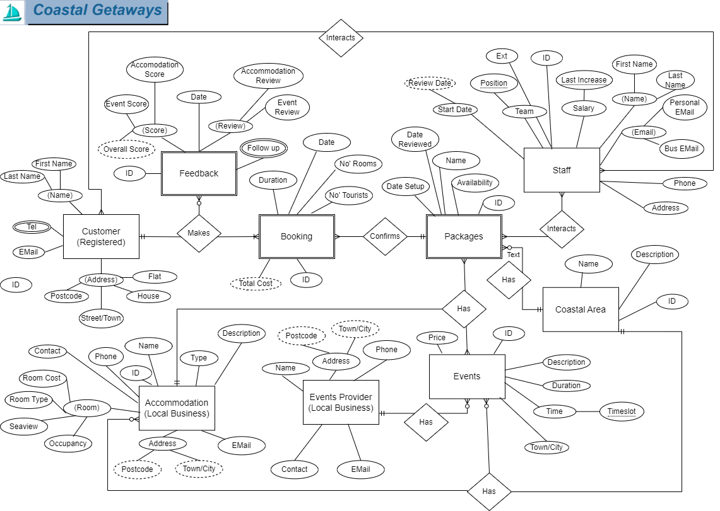
Figure 1: ERD
The Scenario identified key activities and interdependencies for entities.

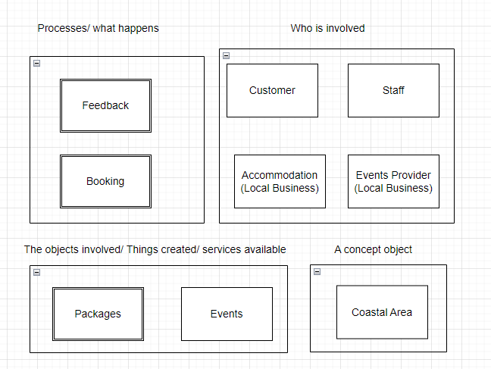
Figure 2: Entities

‘Accommodation’ and ‘Events’ (linked with ‘Bookings’ and ‘Packages.’) have a logical proximity, forming a ‘Coastal Area’ concept. Creating potential to streamline connections using its Primary key as a foreign key for the other entities (tables).
‘Accommodation’ location is fixed, so location/ provider information combines well. ‘Packages’ have multiple events (scenario uses plural) with a single provider. A separate ‘Events Provider entity reduces redundant data, storing relevant attributes (fields) once and linking with ID rather than every event. Service provision occurs by ‘Staff’ to ‘Customers.’ We have exploration of ‘Packages,” Reviews and ‘Feedback.’ The latter two can combine (post core service). Separating feedback attributes from scores/ not making mandatory gives flexibility. Streamlining with customer choice in line with examples (Booking.com) encouraging, not forcing feedback.
Entities require unique identifiers for effective retrieval. Customer ID (Primary Key/ PK) identifies separate bookings for a father and son, even with identical names, address, and phone number. Entities were assigned an “ID” attribute for linking and precision.
Pearson's approach (as described by Connolly and Begg) using Nouns assisted in identification of attributes, simple (house number) or composite (whole address). [1]
Attributes are allocated by related entity interaction in business activities, procedures, and policies. Further breakdown of customer addresses for marketing or identification of town to filter suitable options.

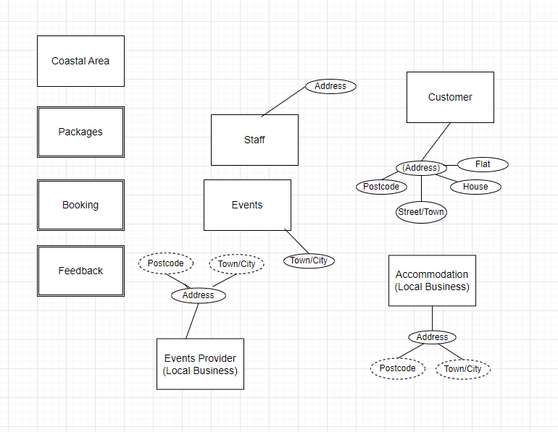
Figure 3: Attribute snapshot

For confirmations, “Booking” attributes can link via relationships with “Customer” and “Packages” attributes (ID’s as foreign keys). Other attributes apply at point of booking (data entry by customer/ calculated data). When? How many tourists/ nights, all in one room? Are there policies to consider (no hen-parties solved by number validation)? I have considered what core pricing elements are required and most relevant entity, aiming to exclude items that can be calculated at the time of use to reduce storage. The scenario indicates itinerary (date attributes).
Communication conventions suggest phone and e-mail options are required.
Event provider logically separated but this didn’t always appear suitable. Phone numbers/ e-mail with different purposes are repeated across entities. I considered where orphan data might occur or where data could stand independent. Finance may not require full customer details, but dependencies arise where fields rely on calculation of data across entities. Setting relational integrity will assist in prevention of orphan data.

Relational Database Schema
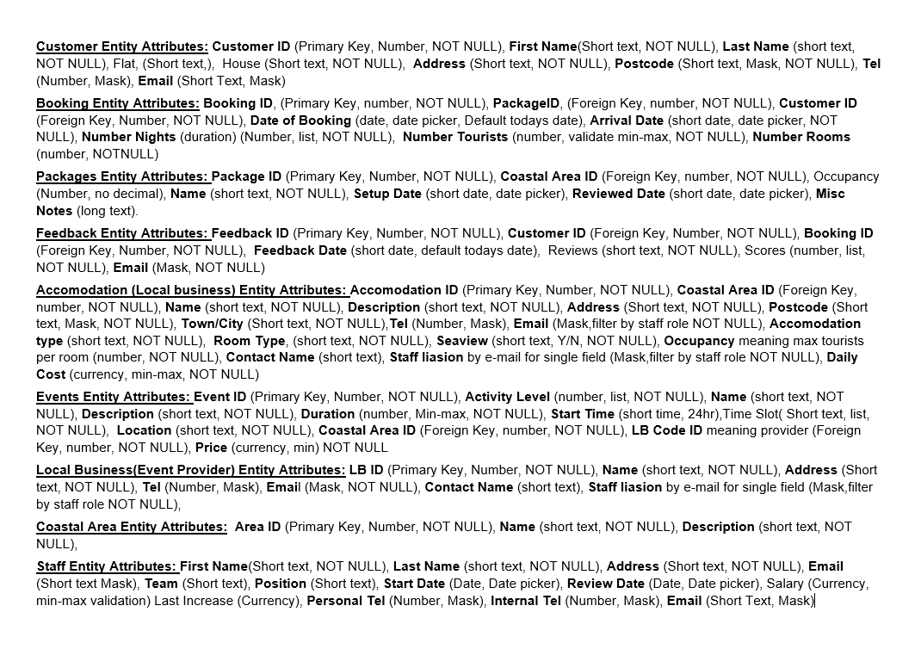
Figure 4: Schema Design

Application of DBMS

DBMS File (Access) uploaded via Moodle.

Backup can also be accessed via the following link:
https://drive.google.com/file/d/1invoJkd0P9-VDNU04G1SHFeYJBc4aBeL/view?usp=drive_link

Screenshots:

Reports Design

Reports

Total Revenue Report

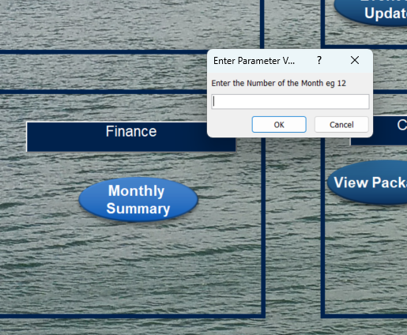
Figure 5: Selecting Report month
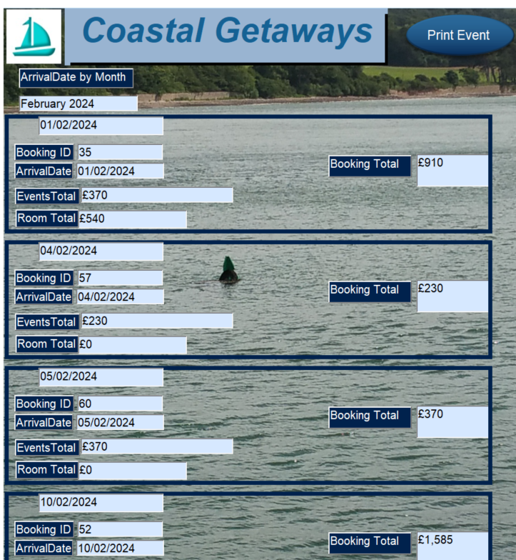
Figure 6: report View
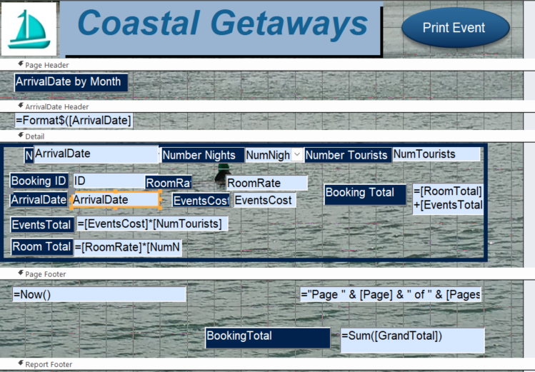
Figure 7: Report Design

Feedback and Review Report

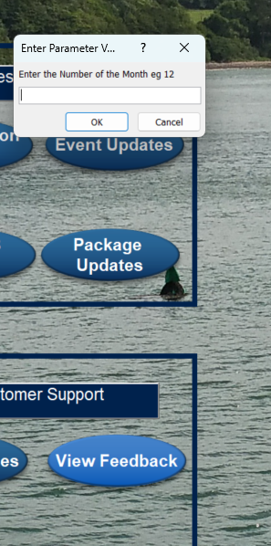
Figure 8: Feedback by Month
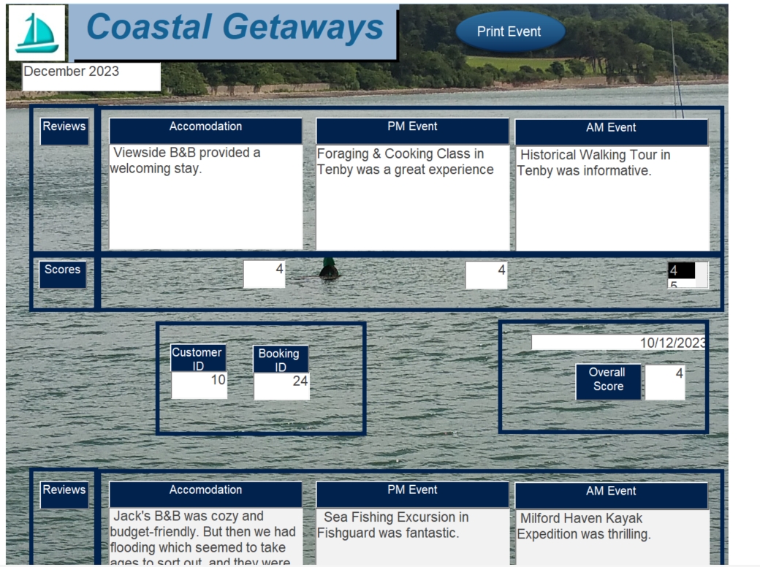
Figure 9: Feedback Report

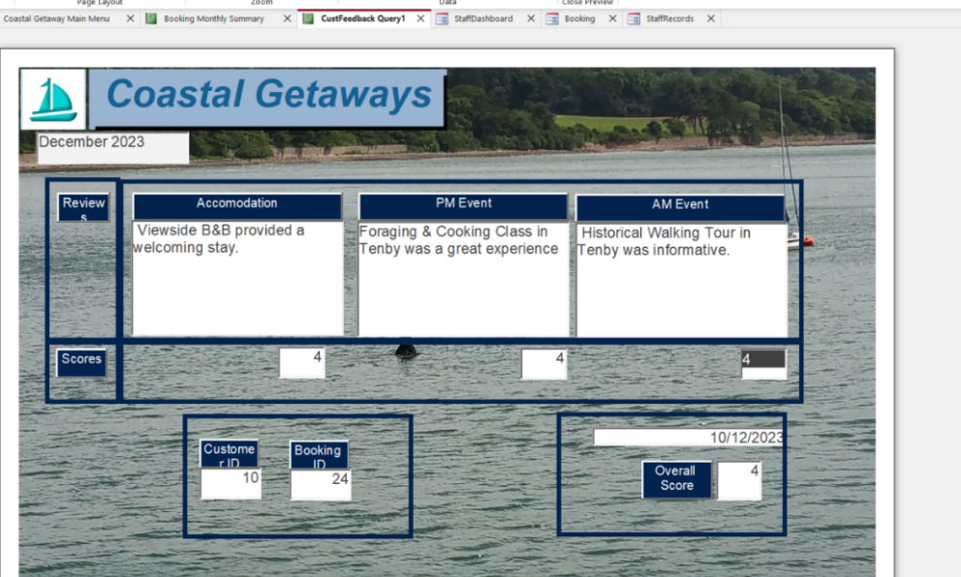
Figure 10: Per page prints

Form Design, User Interface and Menus

Form Design

Reservation Form

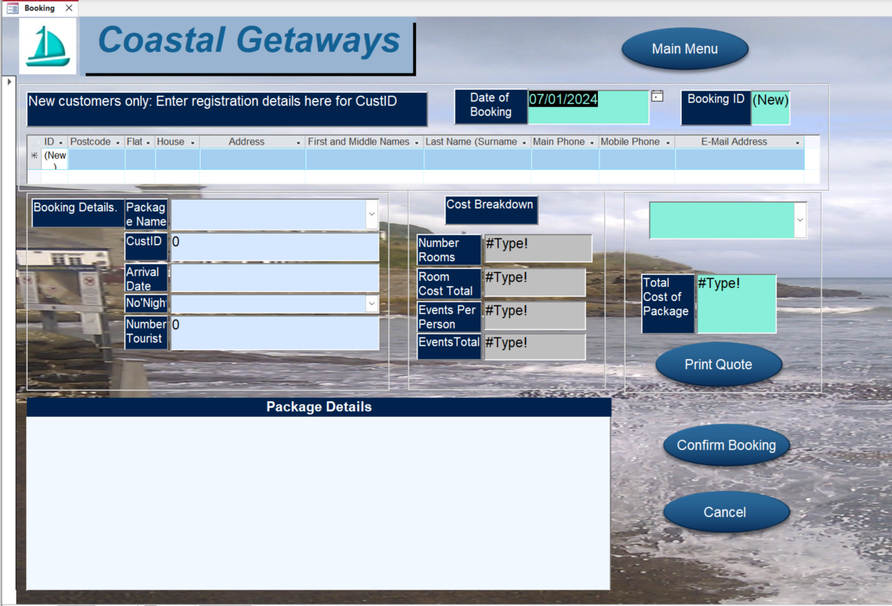
Figure 11: Registration and Booking Form

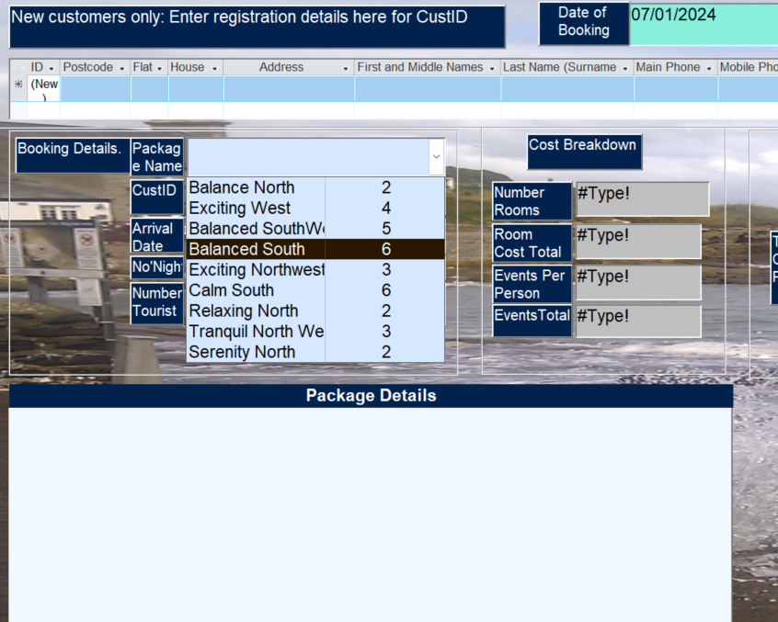
Figure 12: Package Selection
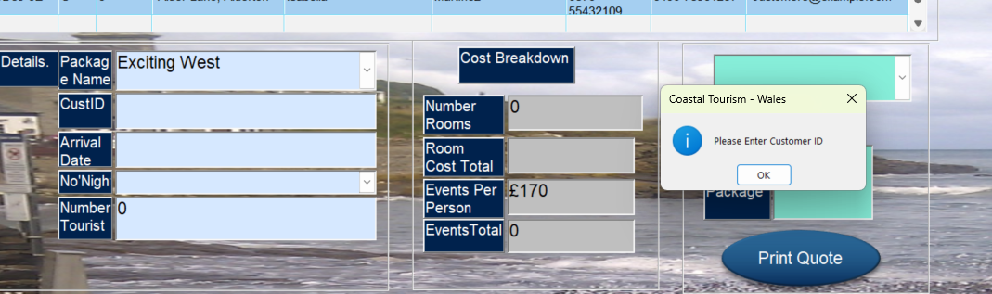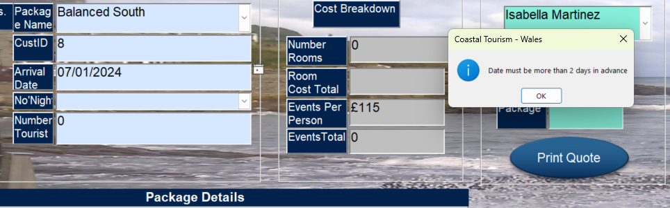
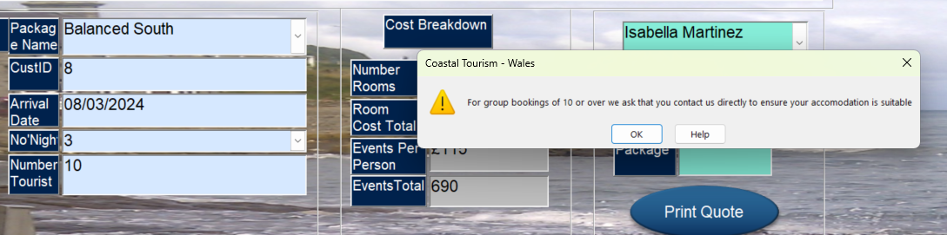
Figure 13: Mandatory information Messages


Figure 14: accuracy improvement by list restriction and validation rules
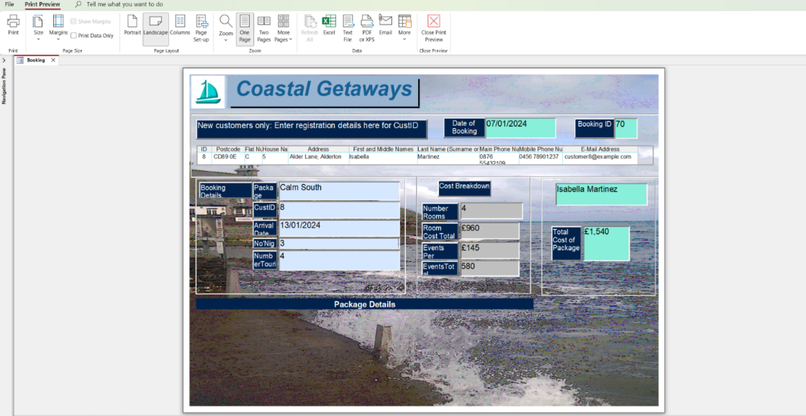
Figure 15: Quote Print without saving
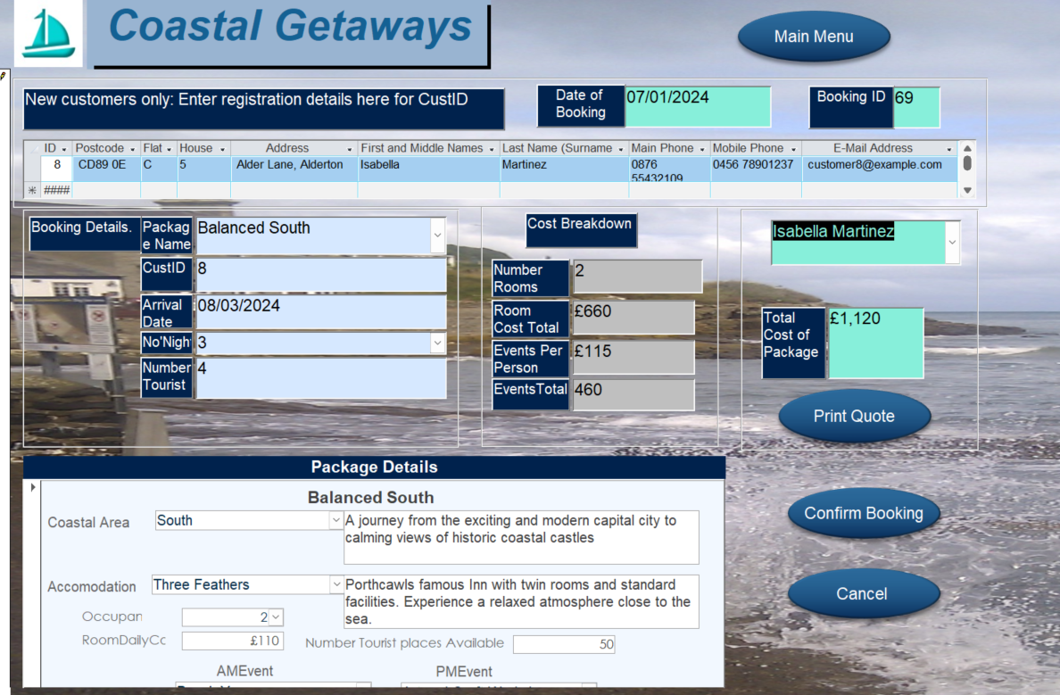
Figure 16: Booking example showing types of data activity by color
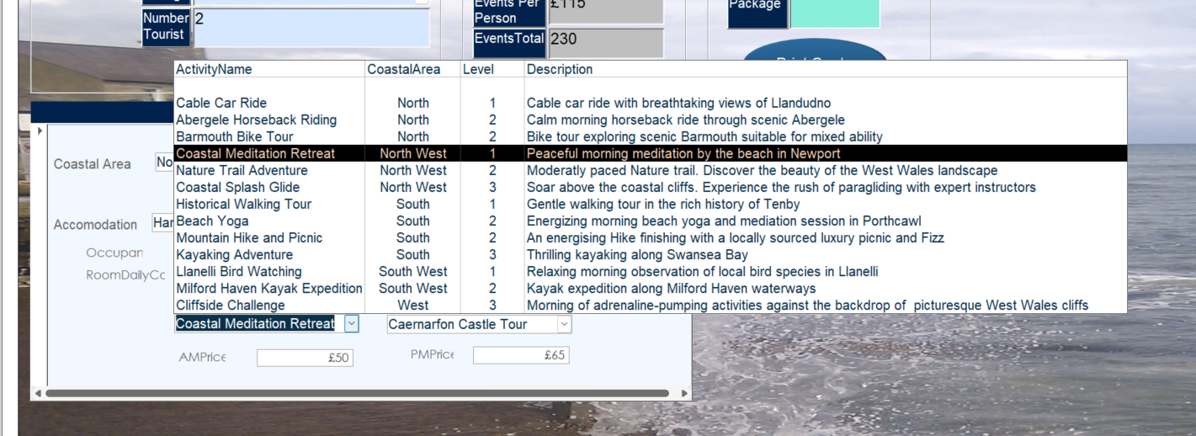
Figure 17: Package Detail Sub-form

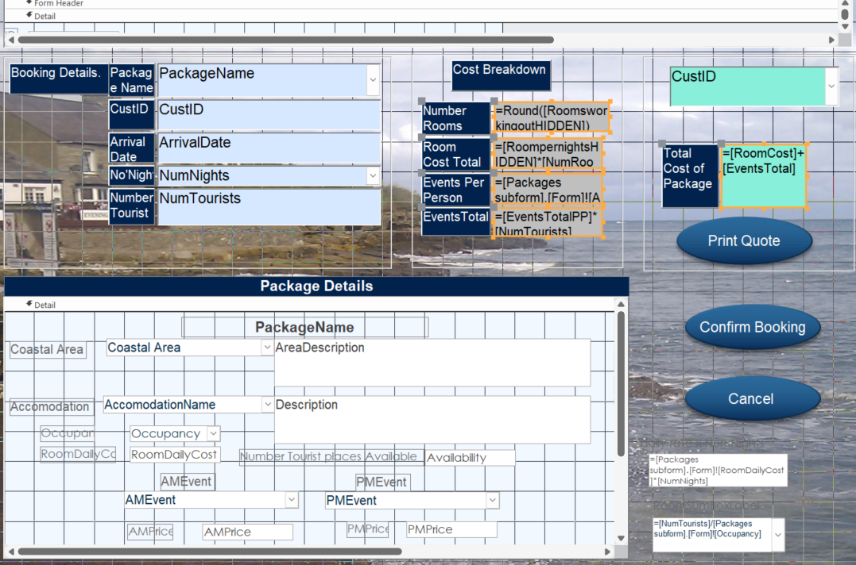
Figure 18: Form data entry, calculated and default data design

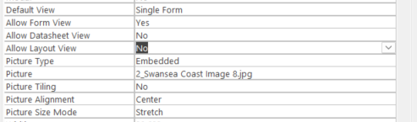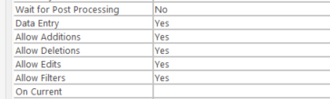
Figure 19: data entry and view option changes


Figure 20: Button hover and clicks by type. Cancel clears and deletes.

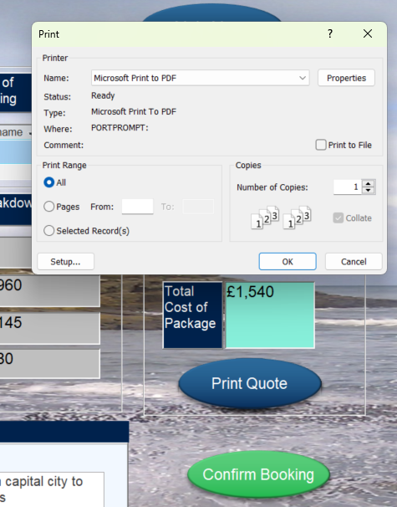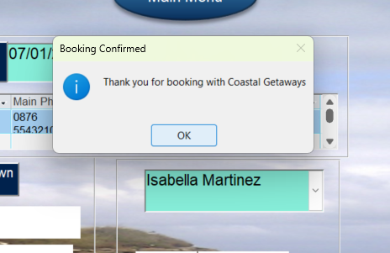
Figure 21: Macro adjustment combined print, confirmation and form close

Event Owner Update Form

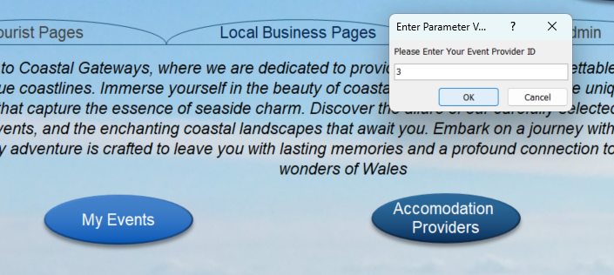
Figure 22: filter and open with ID

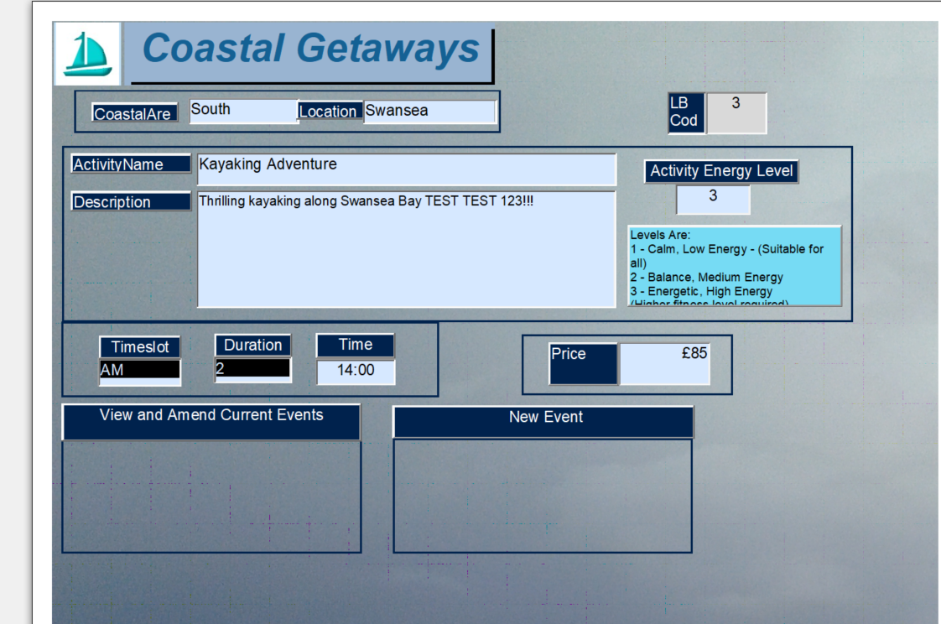
Figure 23: Filtered data entry, record amendments


Figure 24: User friendly navigation


Figure 25: List options to reduce errors

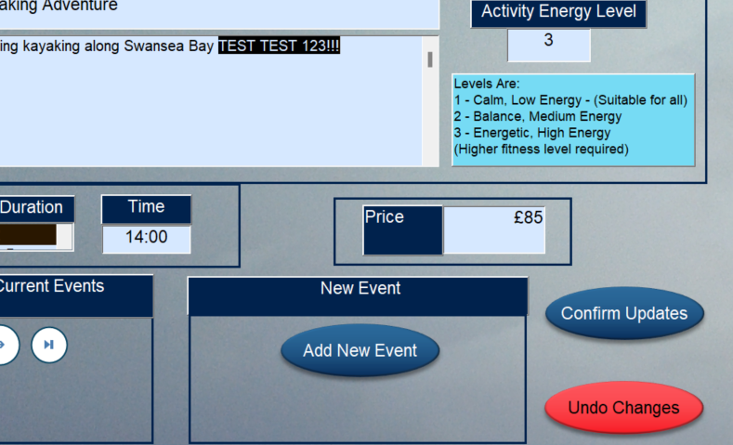
Figure 26: Clear not delete to protect data being edited

Navigation Menu

Navigation of DB

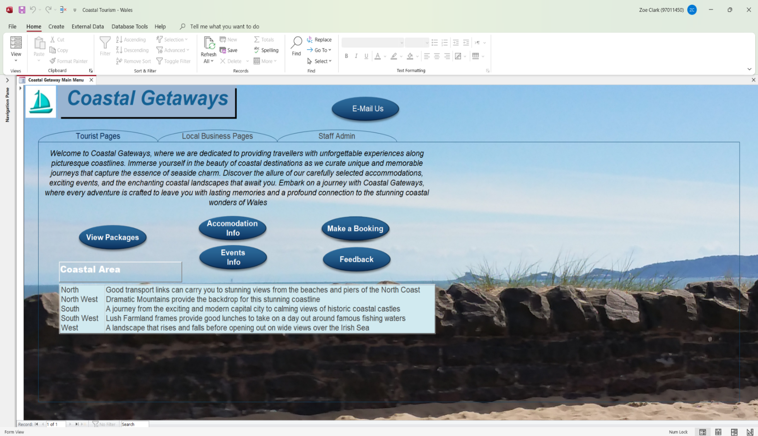
Figure 27: Tabbed Navigation menu

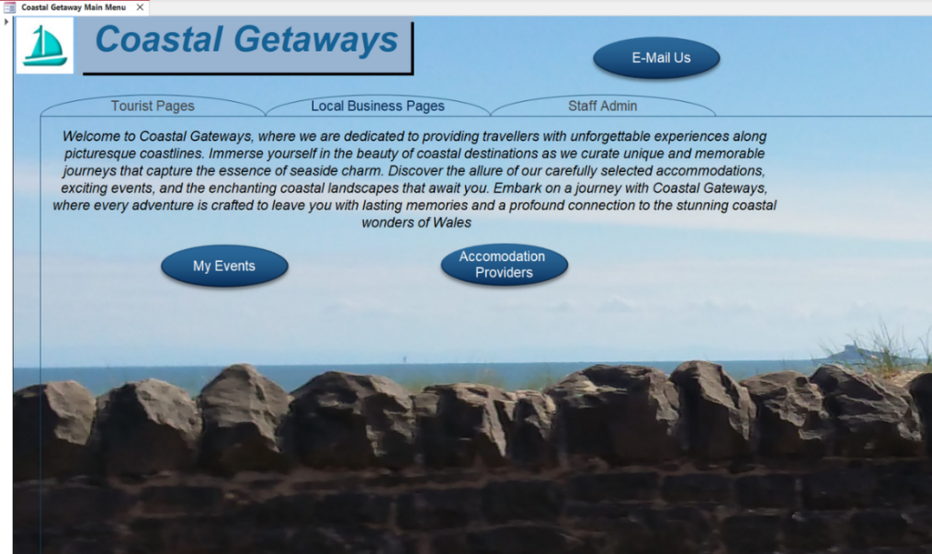
Figure 28: Second Tab

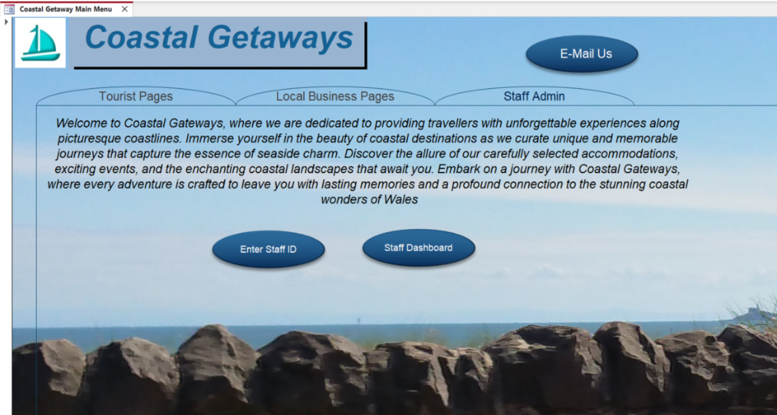
Figure 29: Third tab

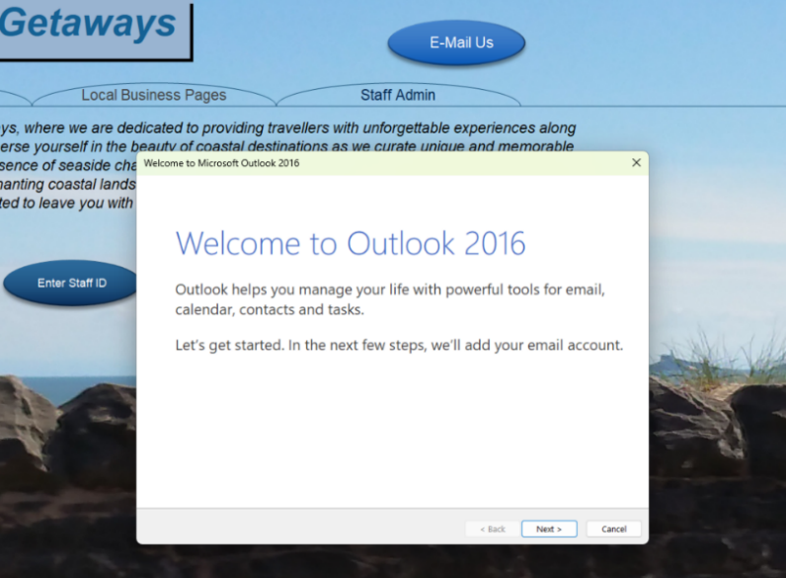
Figure 30: Email button

Display on DB opening

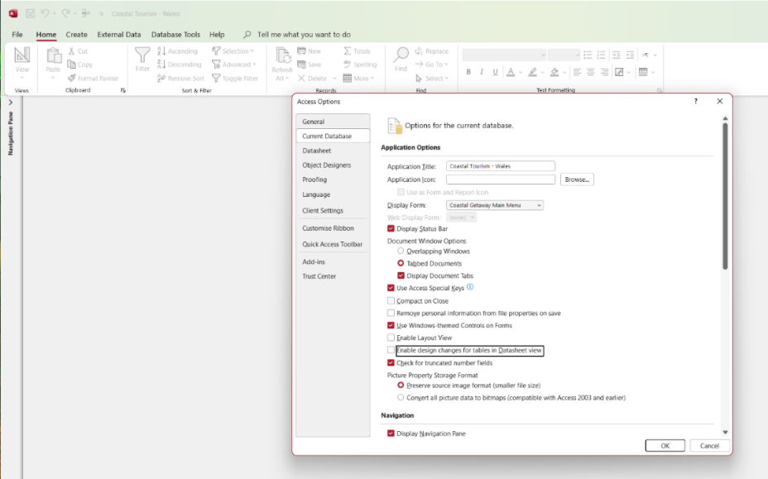
Figure 31: Main menu selected on open

Section B

Database Importance for Coastal Tourism Management

Carrying out business activities (Section 2A), generates substantial data, both "naturally occurring” and “artificial data”, as defined by Paul Bocij [2, p7]. Natural data includes interactions with local businesses, artificial data includes generating reports e.g., monthly total income. Bocij emphasizes that this data should be meaningful, processed for a purpose, interpreted, and understood. [2, p7-8].
The DBMS gives meaningful structure to meaningful data, storing processing and managing data. Using a relational structure allows efficient cross-referencing with radically reduced data storage. By setting up in Access as per the design based on requirements (fig.1 / fig.2) this ensures understanding of the data purpose for core business or supporting activity and gives a framework from which enquiries can be made for greater insight. Greater processing speed delivers filtered information in a short turnaround, precise output giving improved insights needed to keep them competitive. Good decisions can go awry if not based on accurate data.
Tables and relationships set out data and function while queries and reports allow further questioning and collating. The company gains adjustable control. Retained by restricting data entry to a list, a range or format (phone number masks). Or by auto populating a form via an ID (Primary key) on data entry. Control is expanded such as queries that allow a user to enter the month the report will provide the data for or forms that allow users to safely navigate, view and print information regardless of their knowledge of Access.
Greater flexibility is achieved through changing the user interface, tailoring design to requirements. And branding. Accessible ‘user journeys’ through form types. This separates their activities and risks of accidental damage/ amendment from the valuable core data. Centralising this also provides controlled access to sensitive data.
Access queries enable space saving quick retrieval. Output created in the moment through the query (e.g., through SQL), it does not need to be held in that form until delivered as output. New queries do not require expensive or complex redesign. Employing a DBMS, will help Coastal Tourism reduce data duplication, streamlines administration, and saves time. It reduces the burden of data management across the business, freeing staff to focus on core activities, relationship management, and income generation. The system's integrity of data is maintained automatically, reducing errors. The DBMS engages with the administrative side while the staff engage with streamlined data, they need to succeed.

Transition Challenges and Benefits

Once requirements are captured, a transition plan is a crucial consideration along with the actual development of the DBMS itself.
Challenges include resource intensive transfer of historical data and staff training. There may be reluctance to change approach or centralise control of data, so early engagement is essential. Benefits through engagement are feedback gained from end users in testing and roll out, reducing risks of critical flaws with negative impacts on business.
The DBMS is a sustainable method, even with expanding data volumes and it can be scaled up as the business expands. As the structure is fixed new data is automatically stored in the correct formats and indexing optimising it for use at the point of capture.
I would argue IT setup is less of a challenge than implementation. Ziemba observes on Strategic Information Systems that “research findings reveal that the ICT quality, ICT management, and information culture have a significant impact on the sustainability in the SIS, whereas the outlay on ICT does not have such an impact.” [3].
However, If the volume and complexity of the database does increase substantially in the future, it may be necessary to factor in costs for upscaling the DBMS and any associated systems. This would need to be considered to avoid potential reductions in processing power. There would still be benefits to be gained and the company would need to consider this against the outlay.
Reduces logistical burden of data storage in other forms such as paper files, reduced complexity of data enquiry, reduced data corruption and loss. Even with IT failure or loss by fire, back-ups are far easier to make and preserve. A leaky roof could be more than a problem if it destroys paper-based data needed for financial audit for example. The same problem avoided by a simple cloud or other device backup of DBMS snapshot. However there needs to be strict housekeeping to fully realise this benefit. Some storage of historical archives may be required legally or contractually.
Staff time increases for training and data transfer around implementation, potentially impacting productivity in the short-term. It could add to payroll where overtime or extra staff are needed to transfer data manually.
There are challenges around where the cutoff point is for data. E.g. old data, old system archive/ new data on DBMS or give the business the benefit of comparing old and new data. However, the quality of the historical data could be crucial in determining if the core data will continue to be meaningful even if corrupted or containing gaps. Would this cause errors in queries and reports/ will constraints need to be added, a simple disclaimer and reminder on user forms and reports? Do they need separate queries to handle the data from older dates that will still return some data rather than blank if no exact matches all needs careful thought and design.
Staff efficiency through reduced data entry/ processing, allowing more focus on business processes and data interpretation. Staff with data at their fingertips can respond promptly to customer/ provider enquiries and issues leading to better relationships with stakeholders. Marketing can be more proactive and business development respond quicker to trends .
“Data governance needs to shift from inefficient, unreliable, quickly outdated manual processes that prevent teams from capturing and leveraging the value of their data and move toward data-driven automation capable of unleashing the power of data insight.” [2]
Better decision-making happens through more accurate baselines and other data. Historical data inconsistencies may pose challenges but as time passes the DBMS era consistent data will become the most pertinent reducing this.
Audit becomes easier with a reliable database system, ensuring data assurance. Even inexperienced staff can be more confident in meeting auditor requirements within timelines, backed by the DBMS boosting data organisation, indexing, handy queries, reports and user-friendly forms.
In conclusion, despite initial challenges, transitioning to a computerised system offers substantial, long-term benefits, including increased efficiency, enhanced data accuracy, and improved decision-making processes. Along with reduced administrative burden and overheads. Making sure that data held and processed provides and retains maximum value to Coastal Tourism on a sustainable basis.



References
[1] T. Connolly and C. Begg. T. Connolly and C. Begg. Database Systems: A Practical Approach to Design Implementation, and Management Database Systems, (6th ed.), Pearson, 2015. P512, 513. [E-book]
[2] P. Bocij. A, Greasley. S, Hickie. Full Details and Actions for Business Information Systems: Technology, Development and Management for the Modern Business, (Sixth ed.), Harlow: Pearson, 2019. P’s ???? . [E-book]
3] E. Ziemba. “The contribution of ICT adoption to the sustainable information society”. The Journal of Computer Information Systems. 5959(2), pp. 116–126. pp. 116–126. 2019. [Online]. Available: https://www-tandfonline-com.ezproxy.uwtsd.ac.uk/doi/full/10.1080/08874417.2017.1312635 [Accessed: December 30, 2023]
[4] D. Sirota. “Council Post: Data Governance: Why Companies Need To Shift From Manual Management To Machine-Automated.” Forbes.com, 07, 27, 2023 [Online] Available: https://www.forbes.com/sites/forbestechcouncil/2021/07/27/data-governance-why-companies-need-to-shift-from-manual-management-to-machine-automated/. [Accessed: November 12, 2023]

Further Reading
J, L, Viescas. Full Details and Actions for SQL Queries for Mere Mortals: A Hands-on Guide to Data Manipulation in SQL, (4th ed.), Boston: Pearson, 2018, [E-book]
A, Wilbert, “Relational databases essential training”. Linkedin learning, 2019. [Online] Available : https://www.linkedin.com/learning/learning-relational-databases-2/develop-subtypes-and-supertypes?autoSkip=true&resume=false&u=77966930 Adam Wilbert. [Accessed: November 12, 2023]
M, J, Hernandez, Database design for mere mortals : a hands-on guide to relational database design, (4th ed) Boston: Addison-Wesley, 2021. [E-Book]
Indeed Editorial Team. “What Is a Database Management System? (With 12 Benefits)”, Indeed.com. June, 25, 2022 [Online] Available: https://www.indeed.com/career-advice/career-development/what-is-database-management-system [October, 30, 2023].
A, Browne. “Rounding to create a whole number,” allenbrowne.com December, 2007, updated August, 2008. [Online] Available: http://www.allenbrowne.com/round.html [January 4, 2024]
Computer Learning Zone, “Create a Data Entry Form in Microsoft Access OR Open an Existing Form in Data Entry Mode”,, YouTube, May, 8, 2021. [Online], Available: https://www.youtube.com/watch?v=6zI2VROuQn8, [Accessed December. 10,2023].

Images
Figure 1: ERD 4
Figure 2: Entities 5
Figure 3: Attribute snapshot 6
Figure 4: Schema design 8
Figure 5: Selecting report month 9
Figure 6: Report view 9
Figure 7: Report design 10
Figure 8: Feedback by Month 10
Figure 9: Feedback report 11
Figure 10: Per page prints 11
Figure 11: Registration and booking form 12
Figure 12: Package selection 12
Figure 13: Mandatory information Messages 13
Figure 14: Accuracy improvement by list restriction and validation rules 13
Figure 15: Quote print without saving 14
Figure 16: Booking example showing types of data activity by color 14
Figure 17: Package detail sub-form 15
Figure 18: Form data entry, calculated and default data design 15
Figure 19: Data entry and view option changes 15
Figure 20: Button hover and clicks by type. Cancel clears and deletes. 16
Figure 21: Macro adjustment combined print, confirmation and form close 16
Figure 22: Filter and open with ID 16
Figure 23: Filtered data entry, record amendments 17
Figure 24: User friendly navigation 17
Figure 25: List options to reduce errors 17
Figure 26: Clear not delete to protect data being edited 18
Figure 27: Tabbed navigation menu 18
Figure 28: Second tab 19
Figure 29: Third tab 19
Figure 30: Email button 19
Figure 31: Main menu selected on open 20

