Riverside Museum by Zaha Hadid

Designed by Zaha Hadid Architects (ZHA), one of the world’s most famous and renowned architects. With two consecutive RIBA (Royal Association of British Architects) Stirling prizes, being the first woman to win the Pritzker Prize, being awarded the Royal Gold Medal for Architecture (the highest accolade available from RIBA), she was also made a Dame Commander of the Order of the British Empire (DBE) in 2012 (Zukowsky, 2023) . It’s fair to assume that her achievements in her field were exceptional and the Riverside Museum (RSM) was going to be a highly anticipated and talked about building. Hadid was also made a Dame Commander of the Order of the British Empire (DBE) in 2012 (Zukowsky, 2023) . Hadid’s career and previous work will be discussed, to uncover whether she had a signature style that was typical and expected, and whether that signature style materialised within RSM, whether the status of such a celebrated architect, had any impact on the public’s view of the building, pre and post construction, before discussing and concluding whether the building was successful, both in the eyes of its critics, as well as the people it was created for- the general public.

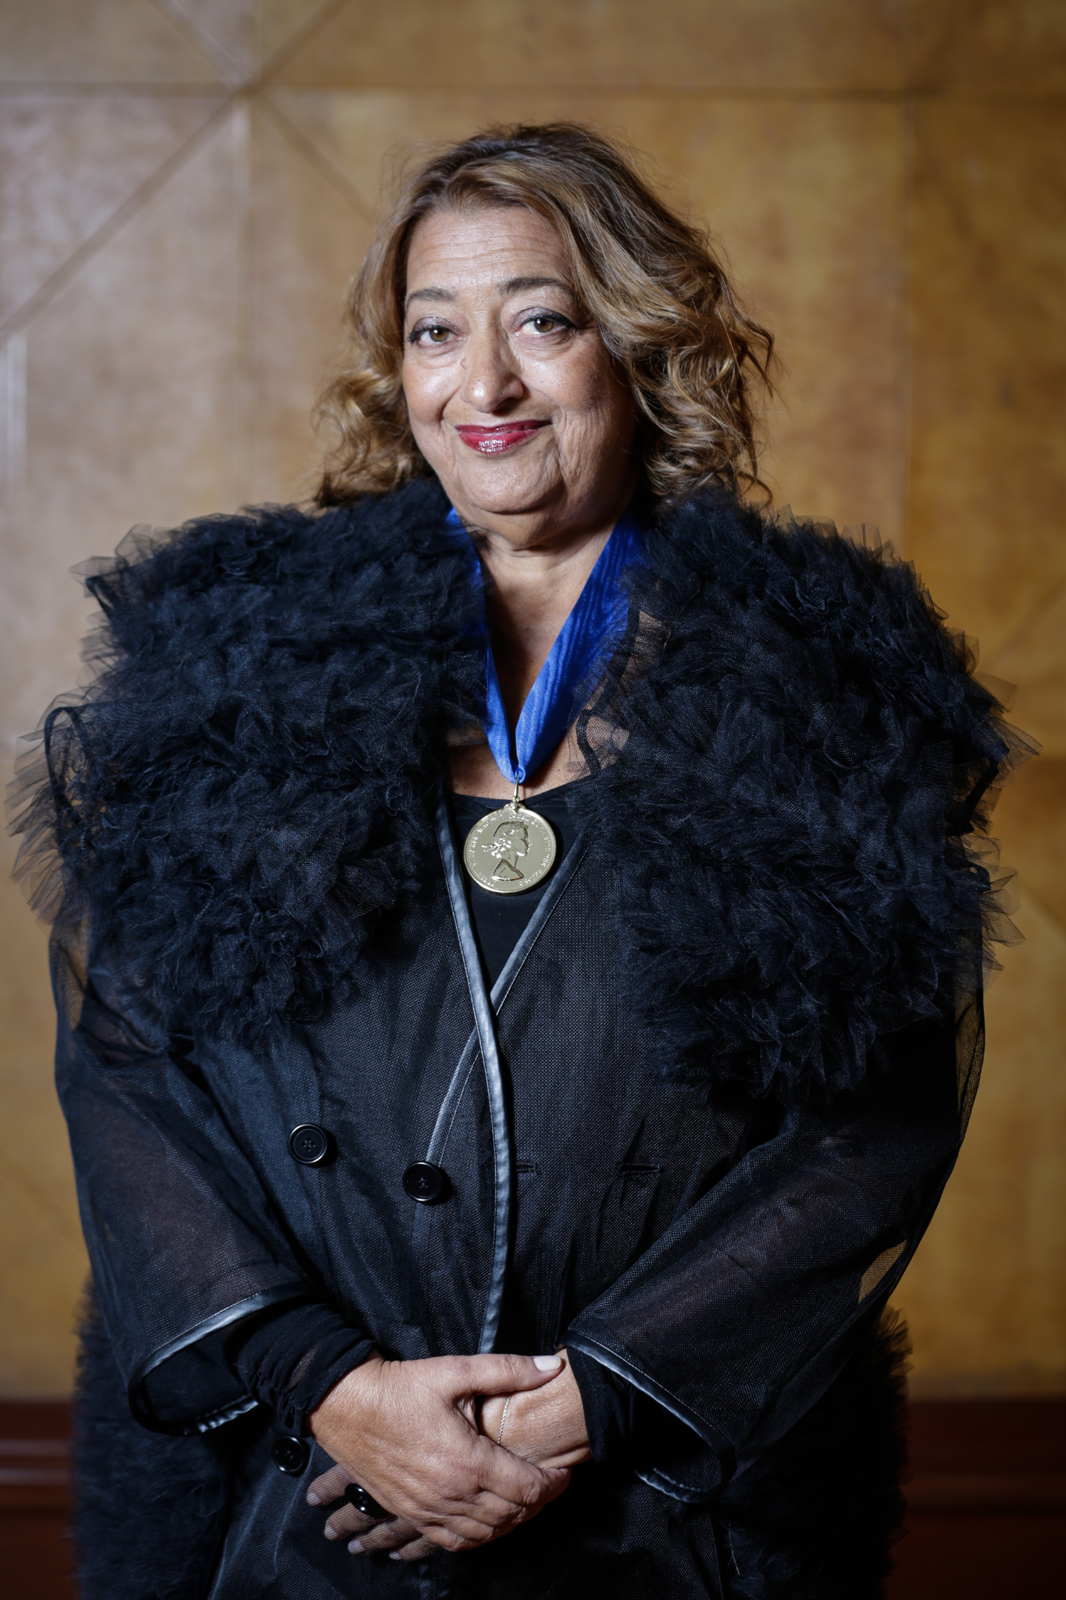
Image 1- Dame Zaha after receiving her RIBA Royal Gold Medal

Hadid was known in the media as a ‘star architect’ or ‘starchitect’, meaning there was a lot of media coverage and excitement for the RSM, however, with some architects now being known as celebrities, with increased power and influence associated to their name, this essay will examine whether this project designed by such an architectural powerhouse lived up to the media hype and met the expectations of ZHA fans, critics and general public, alike. Often, architecture created by ‘Star architects’ is referred to as art work, sometimes carrying the cliche that its appearance and stature is more important than its use for human need and being fit for purpose. Cities require structures that will enhance them, with buildings designed to work agreeably with each other and what surrounds them, rather than being single bespoke pieces designed without its locality in mind. This essay will discuss how RSM fits within this conversation and whether it was designed to strengthen its area and add value to it, or whether it was designed as a custom ZHA structure, relying on its creators name alone, being enough to make it a success, regardless of its relationship to its surrounding area.

At the time of design and creation of The Riverside Museum, Zaha Hadid was already known as one of the world’s most successful architects. Having already been the first woman in history to win the Pritzker Architecture Prize in 2004, in 2010, Hadid was awarded her first Stirling Prize, one of the highest accolades available, within the world of architecture. She won another Stirling Prize the following year, which was the same year that the Riverside Museum opened its doors to the public. Later in her career, Hadid was nicknamed ‘The Queen of the Curve’, and secured herself a place in history with the great architects, also putting her in the ‘Starchitect’ category, which garnered a great deal of talk and media coverage, while creating huge expectations for the unveiling of her design.

Hadid had been designing since the 1970’s, graduating “The Architectural Association” (AA) in 1977. Her early designs and drawings were all created by hand and demonstrated a strong abstract style that continued in her works through to the 90’s; this style is described by Serrazanetti and Schubert in their series of monographs of Hadid’s work:

During the 1980s Zaha Hadid’s drawings were, then, an experimental method at a time when the crisis of modernism invited architects to brave new frontiers in design: for Hadid, this meant liberating geometries and distorting spaces.
Serrazanetti and Schubert, 2017, pp. 7

These early paintings and drawings consisted of sharp edges, shifting lines, vibrant colours and planes, which were inspired by Hadid’s love of Russian Suprematism and her fondness of The Russian Avant-Garde. An interview with Hadid, published in ‘Early Drawings and Paintings’, Schumacher et al (2017), discusses Hadid’s inspirations and influences from this movement in modern art. Hadid describes how she was introduced to Russian Constructivism by her teacher, Elia Zenghelis, during her first year at AA. In a project, during her fourth year there, titled ‘Malevich’s Tektonik’, Hadid explains how she was able to draw inspiration from 20th Century artist Malevich's work and impose it on to Hungerford Bridge in London.

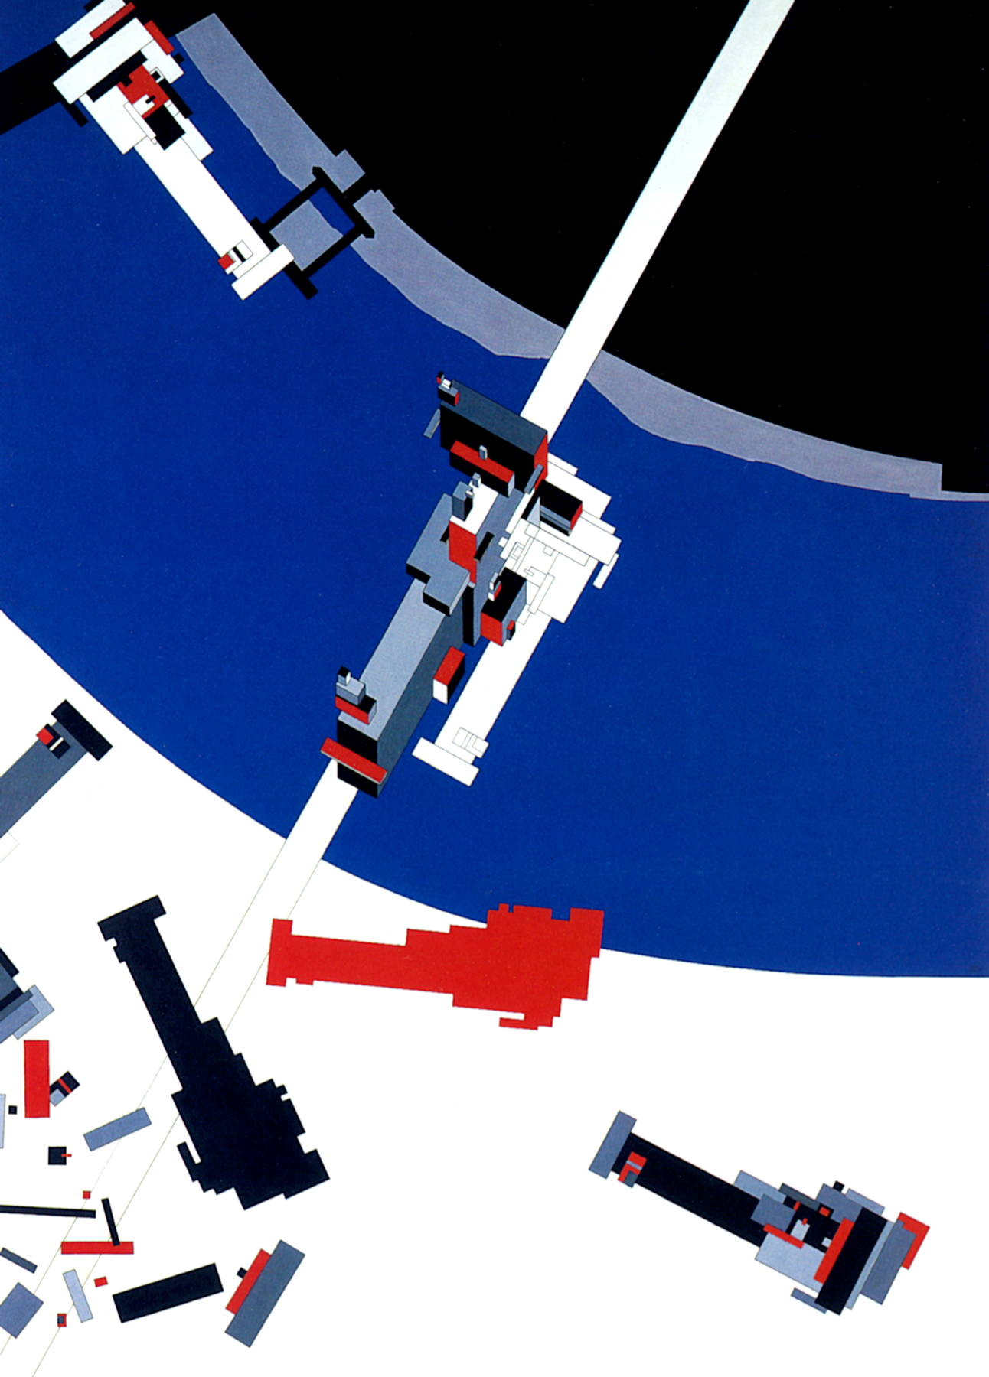
Image 2- Malevich’s Tektonik, London, 1976-77

In ‘Zaha Hadid, The Complete Buildings and Projects’, Hadid is quoted “ The project has particular resonance with my later projects'' (Betsky, 1998, p. 16), when talking about this design, implying that this first project had some meaning to her and went on to inspire many more of her creations in the future. Many of Hadid’s earlier designs that went on to be built, clearly demonstrate her authentic style with clean, sharp lines and experimentation with shape. Her first build, Vitra Fire Station in Germany, is a great example of this.

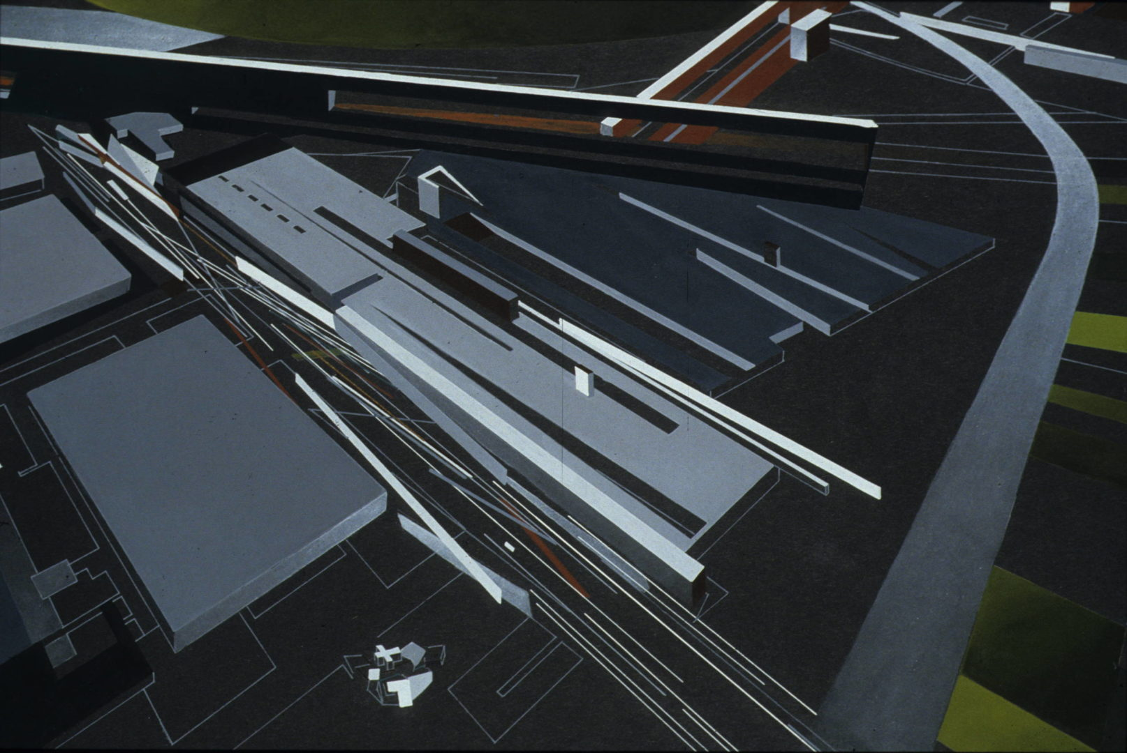
Image 3- One of Hadid’s concept paintings for Vitra Fire Station

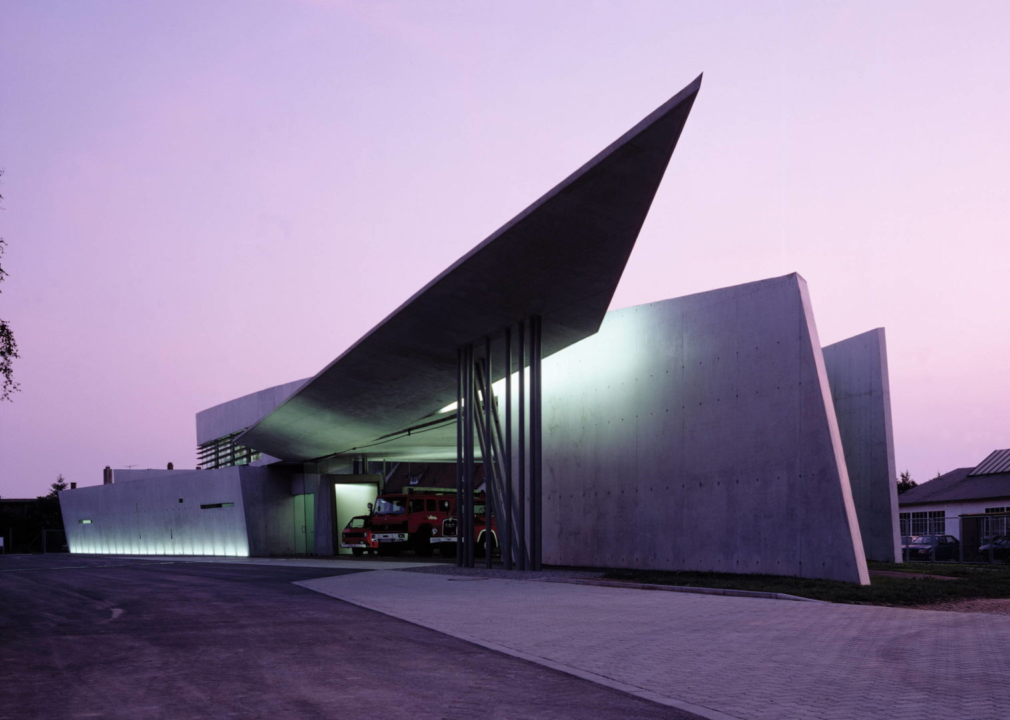
Image 4- Vitra Fire Station, built

This was Hadid’s signature style until advancements in technology, in the 1990’s opened up new design possibilities for her, allowing her to create new shapes and complex curves that, until then, hadn’t been possible, when simply drawn by hand. It was around this time that there was a noticeable change in Hadid’s drawings, where her hard lines and angular designs started to soften in tone and started to incorporate softer lines and create feelings of movement. Since then, many of Hadid’s most iconic creations appear to represent more fluid shapes, often described as wave-like. This new style is shown in buildings, such as the Heydar Aliyev Centre in Baku, Azerbaijan, The London Aquatics Centre and The Dongdaemun Design Plaza in Seoul, South Korea.

According to an article in architecture and design magazine, Dezeen, Zaha “delivered unprecedented expansion”, with glowing reviews being presented for some of these buildings shown (Winston, 2016)-

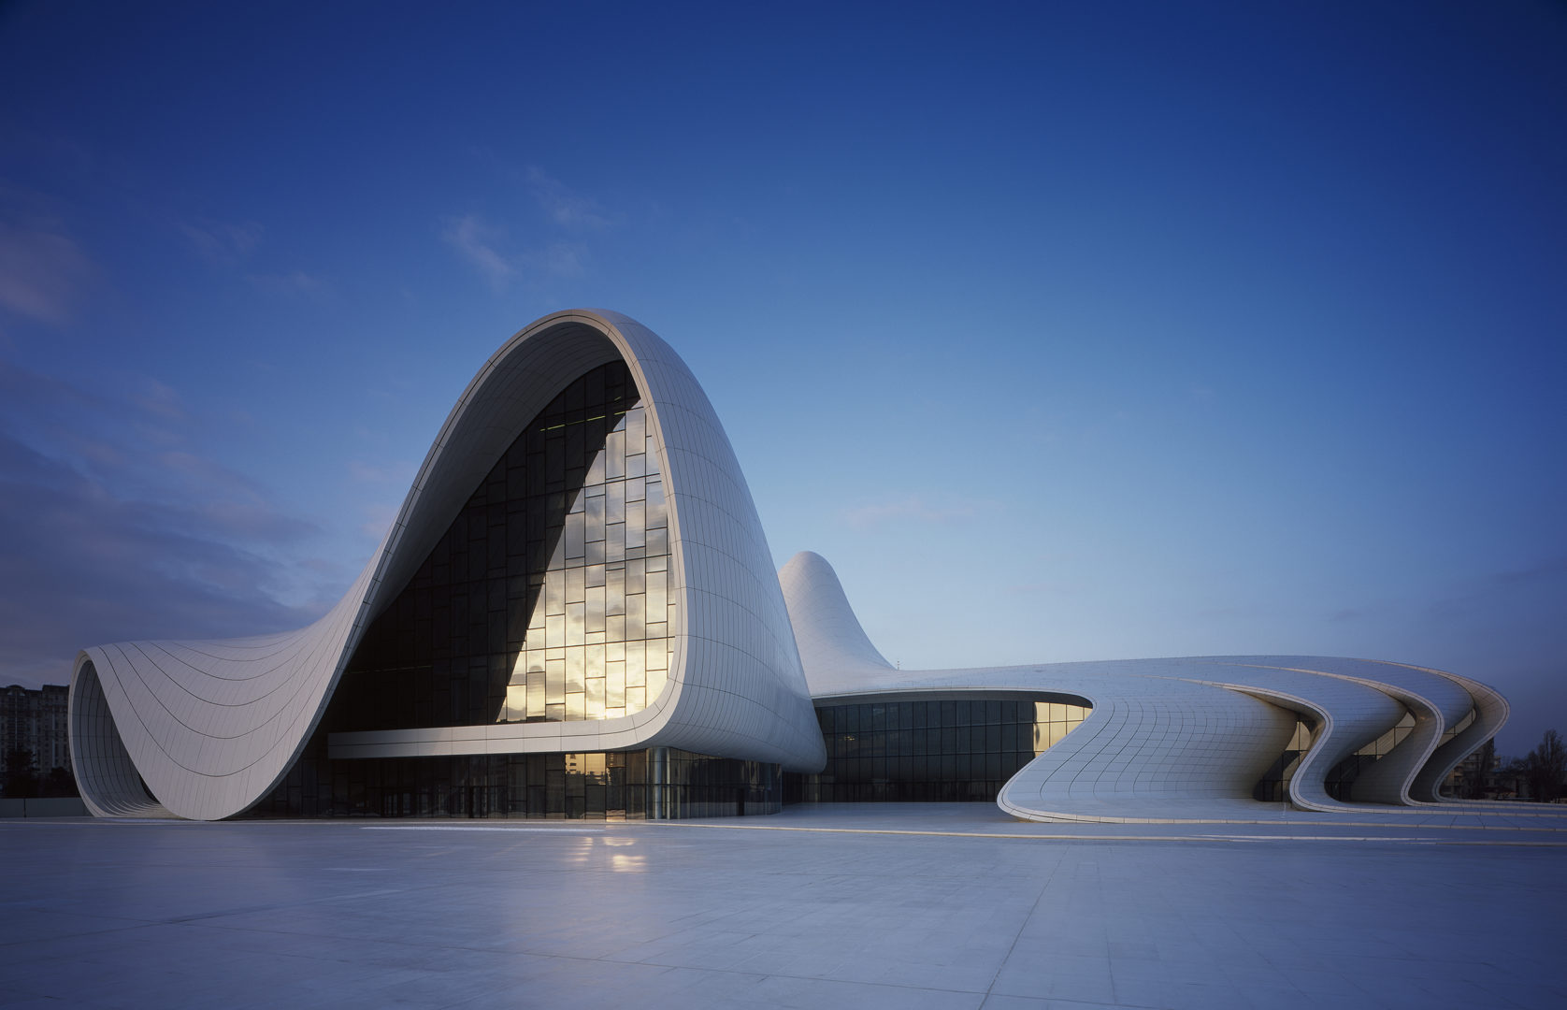
Image 4- Heydar Aliyev Centre

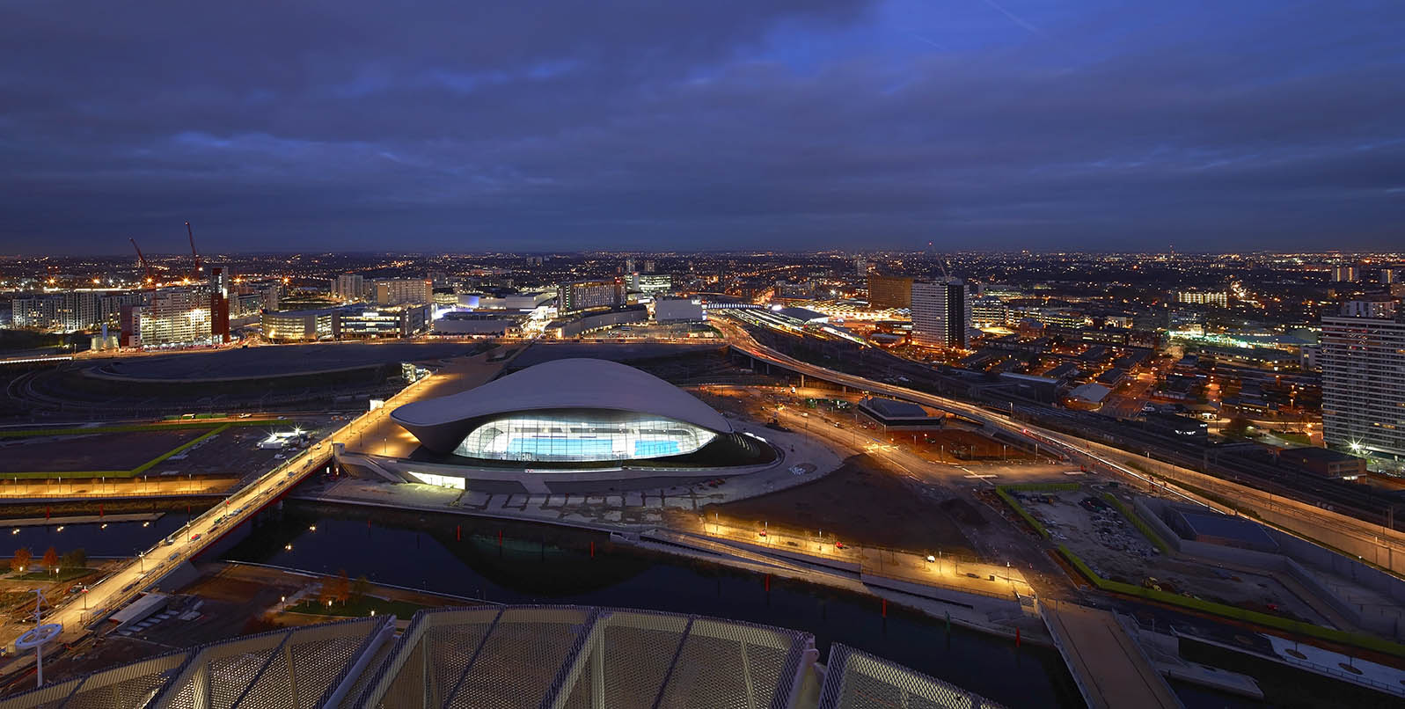
Image 5- London Aquatics Centre

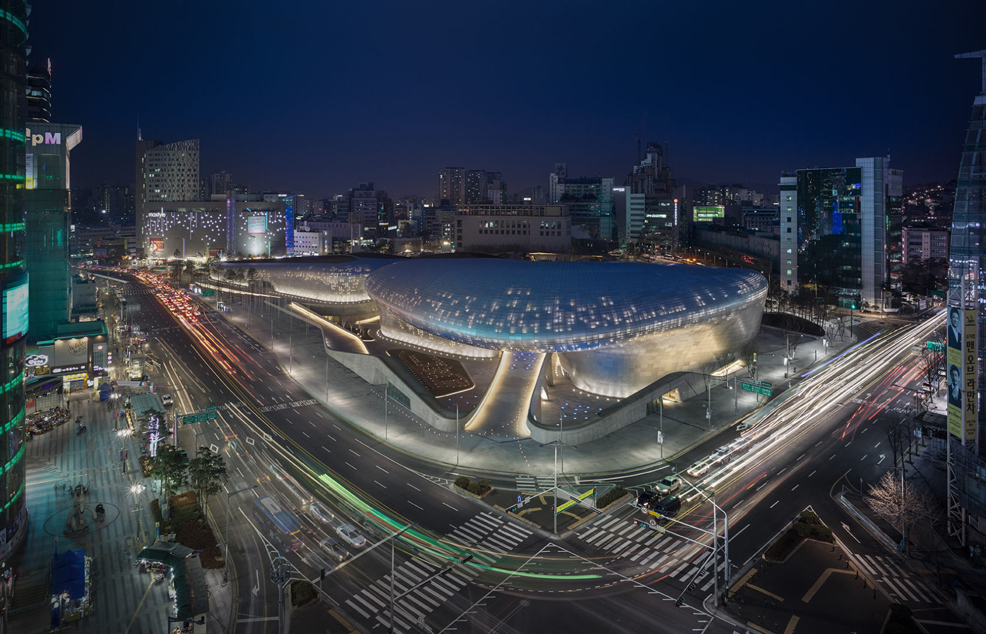
Image 6- Dongdaemun Design Plaza

In an interview with Hadid, published within Inspiration and Process in Architecture (2017, p. 16), the interviewer points out that Hadid’s work could be separated between before and after the digital age and questions her about her work from both eras. Hadid explains how the use of computers “have made it possible to achieve a greater degree of complexity in our digital work” (Serrazanetti and Schubert, 2017, pp. 16), after also admitting she was a little resistant of incorporating new technologies in to her practice, to begin with. This difference in designs produced, from Zaha’s hand drawings to those developed using digital software is exhibited in the images shown above.

The RSM was created to provide a new home to the exhibitions that were once displayed within the Museum of Transport, also known as Kelvin Hall, which closed its doors in 2010. ZHA won an international competition in 2004, to design the new museum, with its doors eventually opening to the public in 2011. Designed to connect the city to the river, the RMS is a large winding structure made up of reinforced concrete, with the roof panels and facades clad in pre-patinated zinc. Each end of the structure has its own glass wall that serves as an entrance and exit, with an elaborate design above each that continues to flow through the building, meeting itself on the opposite end. ZHA describes it as:

A sectional extrusion open at both ends, its outline encapsulating a wave or pleat, flows from city to waterfront, symbolizing dynamic relationship between Glasgow and the ship-building, sea-faring and industrial legacy of the river Clyde.
(Hadid, 2023)

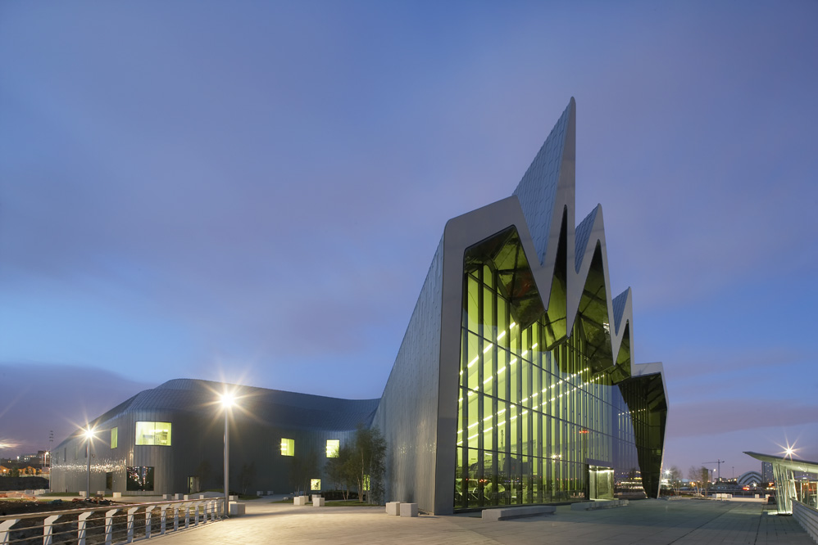
Image 7- The Riverside Museum

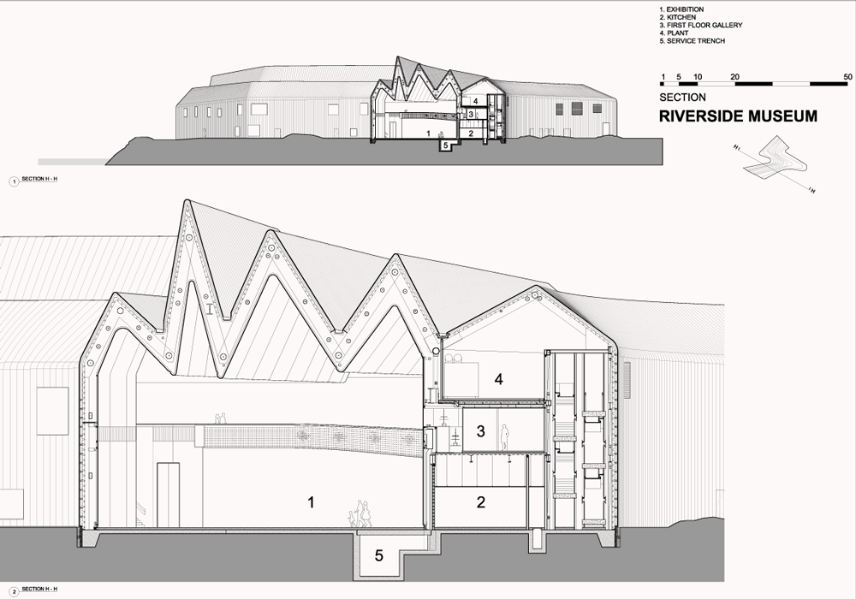
Image 8- A Section of Riverside Museum

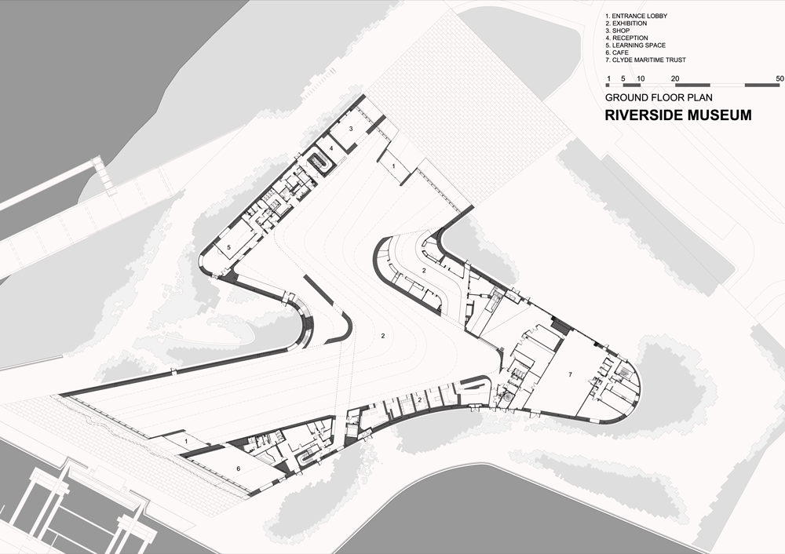
Image 9- Ground Floor Plan of Riverside Museum

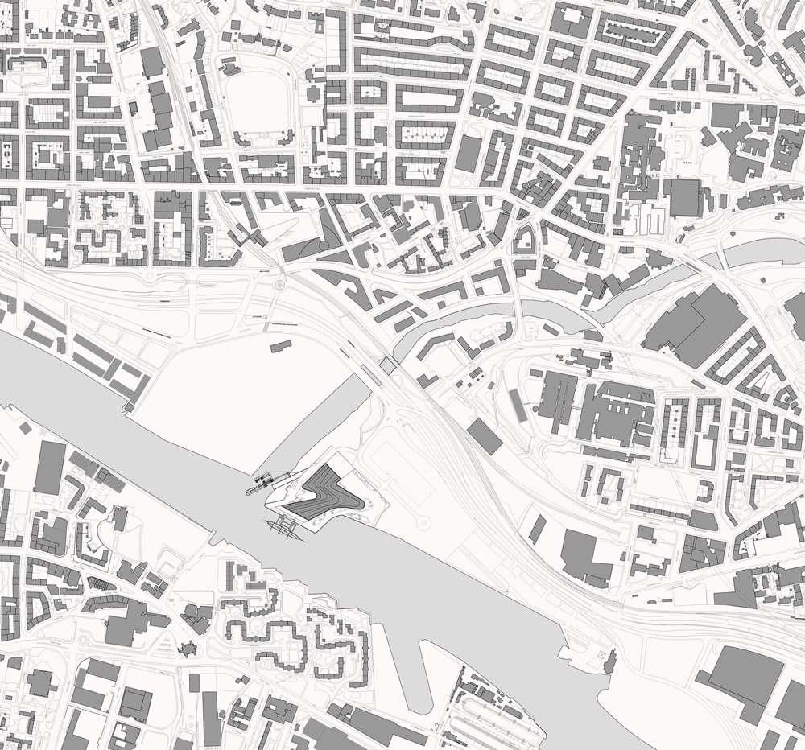
Image 10- RSM Site Plan

The images above show the scale and shape of the museum, including its flowing movement, mirrored in the internal space, while the map image shows how its positioning connects it to the river .

The image below shows the planning application for RSM, taken directly from Glasgow Council's planning portal, showing 30/04/2007 as the application date. There are no original drawing submissions shown on the planning portal (it is unsure if this is because of the length of time that has since passed), there are also no objections or planning conditions stated or available for viewing. The planning application was approved on 25/10/2007.
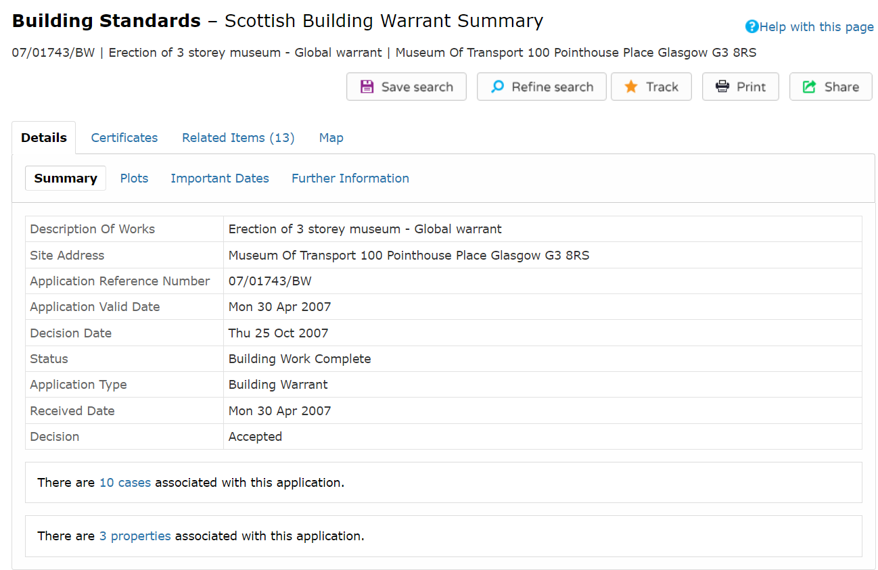
Image 11- Available information for RSM from Glasgow’s Planning Portal

With a price tag of £50 million, RSM was delayed by 18 months and went on to go well over budget. Coming in at a final cost of £74 million (GlasgowArchitect, 2010) to build and situated on the River Clyde, it is one of the most prominent structures in the area, however is also surrounded by other notable modern pieces of architecture and major attractions, including structures designed by other award winning architects, Norman Foster and David Chipperfield. On the Northern edge of the River and only 1200 yards away, is the Clyde Auditorium and the SSE Hydro. Opposite the RSM, sits the Glasgow Science Centre. Entry to RSM is free to all visitors, adding to its appeal and making it clear that it is intended for public consumption and enjoyment.

In 2003, The Clyde Waterfront partnership was created to help regenerate the River Clyde and was the largest regeneration project in Scotland. The river was identified as one of the city’s most underutilised assets and so a master plan was created, with the main aim of delivering improved social, environmental and economic benefits by incorporating a varied mix of housing, business, tourism, leisure and transport offerings. According to Step Up, an initiative that was created alongside the Clyde Waterfront Partnership to improve Glasgow’s energy planning systems, “approximately 50,000 jobs will be created, 25,000 new homes will be built and around 2.8 million m2 of new commercial space created” (Glasgow Clyde waterfront- STEP UP, 2015), as a direct result of this project.

Despite these initiatives being created to help economic development and enhance the attractiveness of Glasgow, the reviews for RSM were varied after its launch. Newspapers and journalists were quick to point out that despite how much investment had gone into creating something so large in scale and how much merit the architecture alone might demonstrate, how disconnected it was from its surroundings and the other notable pieces of architecture that it shared the riverside with. The Guardian described the area as “an underplanned business estate”, adding that there was no coherence between the buildings and the site lacked in positive quality that could have been better if designed “as part of a coherent Clyde regeneration programme” (Moore, 2011). The same article suggests that more time was spent on the interior of the museum, than on the exterior, with the exterior being compared to a “retail shed” and a “superstore”. Such comparisons appear to be a far cry from ZHA’s vision (quoted previously) and the Clyde Waterfront initiative.

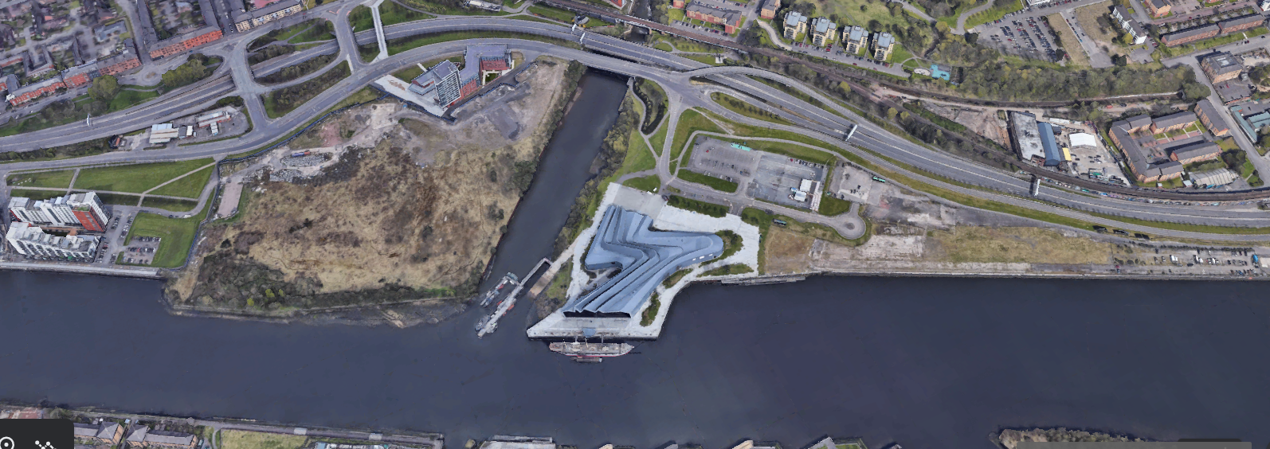
Image 12- RSM shown on Google Earth

Image 12, shown above, gives a little more context to the museum and the reality of how it sits in its surroundings. The site plan shown in image x also accurately depicts RSM’s positioning on the river and its surrounding buildings, however, it fails to present the truth about the quality and appearance of its landscaping. Other structures nearby, appear to have some level of tidiness and good presentation of their adjoining grounds, whereas RSM appears to be sat in what some might describe as wasteland or unkempt land, at best. Visitors can get to RSM by bus, train or by driving, with an on site car park being provided.

With these poor reviews of the riverside landscaping in mind, it is worth noting that Glasgow’s most recent Local Development Plan (LDP) does discuss major future works and improvements that have since been approved for the regeneration of the riverfront. It presents a very clear action plan that the council will follow, to turn it into a “world class destination”, with “an accessible waterfront and attractive spaces where people want to spend time” (Glasgow Council, 2020). This suggests that the local council may have identified the negative impact that ignoring such important details, such as failing to encourage cohesiveness and connectivity between all buildings along the River Clyde, may be having on trade, tourism and the local economy. Image 13 below, shows an overview of said action plan.

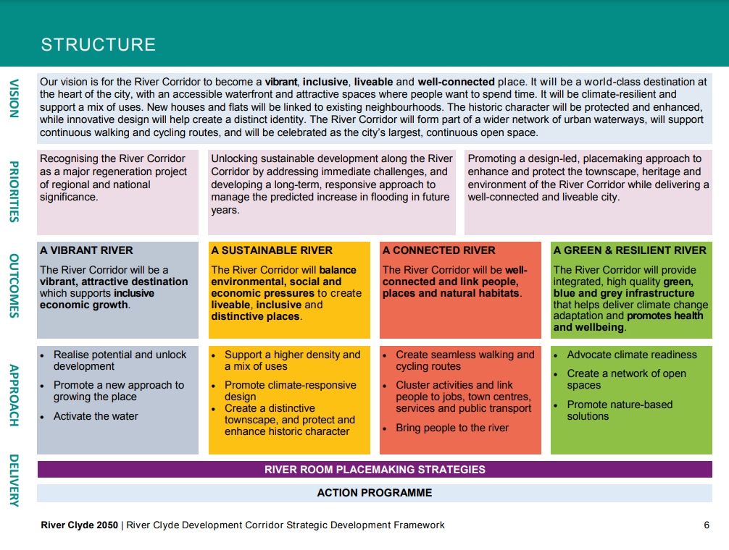
Image 13- Excerpt from Glasgow Council’s 2020-2050 LDP

Some other newspapers had less concerns about the exterior of the RSM, the architecture itself, or how it interacted with its neighbouring buildings, and instead focussed on the use of the building and whether it was successful in its intended purpose of serving the public as a museum. Describing how some children were too excited to sleep the night before its opening, local newspaper, The Scotsman, chose to focus its journalism on feedback from the public who had visited the museum, and reviewed the success of the building through the eyes of its users, as opposed to its architectural design (The Scotsman, 2019).

Said article was filled with quotes from happy visitors who all had positive things to say of their experience within, with some calling it “brilliant”, “impressive” and “amazing”, others marvelled at the interactivity of the museum and being able to touch, use and sit within many of the exhibits, instead of having to peer at them from a distance. Some expressed their delight at the number of exhibits that were available for viewing, due to the colossal space that was created to house them, while others commented on how well the museum was designed to allow visitors to create their own journey throughout the space, looking at the exhibits that they were drawn to, instead of feeling like they were being ushered through a rigid one way system, created by someone else. The images below show some parts of the interior, including a green coloured roof, with bicycles hung as a quirky feature, as well as another image which shows many of the vehicles and exhibitions that visitors can marvel at and learn from.

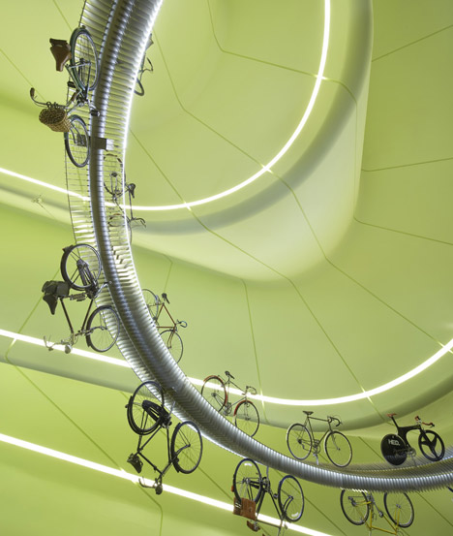
Image 14- A view of the roof display, from within RSM

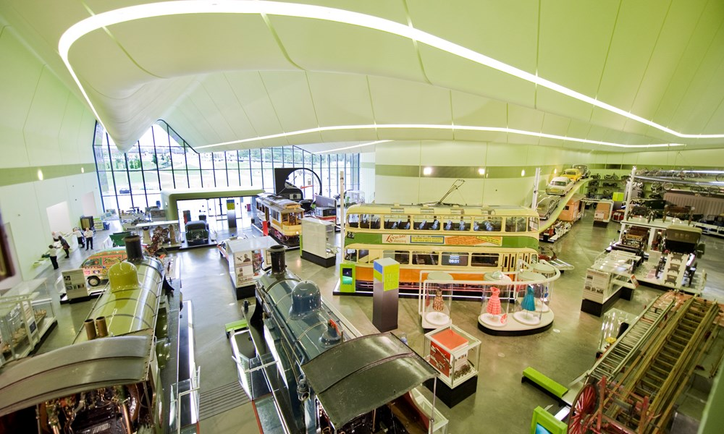
Image 15- A view of some of the exhibitions within RSM

The reviews alone, would not be enough to give anyone a clear understanding of whether RSM was deemed a success, as for every positive title found, there is a negative one, to counter it. Some of the positive titles read- “Riverside Museum: Building an Icon” (The Herald, 2011), “The beautifully built Riverside Museum proves hiring Zaha Hadid was the right thing for Glasgow” (Architects Journal, 2011) and “Zaha Hadid Wins European Museum of the Year Award for Riverside” (Arch Daily, 2013). On the other hand, some more negative articles read- “Architecture awards snub for the Riverside Museum” (The Herald, 2012), “Cost-cutting fears over Zaha’s Glasgow Museum” (BD Online, 2008).

To look at the RSM with fresh eyes, most people who knew of Zaha Hadid and her work, would likely be able to recognise this building as one of her designs at first glance. Both its scale and design scream ZHA, from its enormous size, its sweeping and exaggerated curves to its bold and unapologetic presence, among other award winning buildings along the riverside.

With so many varying opinions on the RSM, generally, defining its success would be difficult. If aesthetic features alone were discussed, most would agree that it has a definite star quality and is a unique and beautiful building. The evidence presented in this essay shows that it was designed with its end users in mind, by creating a building that allows for ease of access and connectivity between the attractions and exhibitions within, whilst also encouraging interactivity and education, which the previous museum that housed the same pieces, failed to do. The approach to and entrance of the RSM is easily discernible to its users, with its large and eccentric openings, shown at not one, but both ends of the building, which, in addition to still offering free admission to all who want to visit, makes it successful as a public museum, designed for public service, as opposed to turning a profit.

Although considered a sculptural piece of art and iconic architecture, that most would expect from ZHA, the RSM still manages to perform as a building, which is something that is unfortunately, not always expected from many ‘starchitects’, making this building unique and successful in yet another sense.

There are however, some elements that don’t seem to be as well considered, such as its surrounding context and connection to anything else in its locality. The public spaces surrounding the RSM are not particularly inviting and don’t compliment the beauty of the building. With so much investment , both in terms of thorough design and cost, surely some of this could have been better directed at ensuring that RSM sat in a more welcoming, better designed setting that helped to improve and add value to the River Clyde as a whole, instead of only taking care of itself.

The LDP that has been previously referenced, with associated image, suggests that the issues raised surrounding the context and poor neighbouring landscape that surrounds RSM and the River Clyde are being prepared for improvement, with funding and planning already being approved for its further regeneration. Words such as ‘vibrant’, ‘sustainable’, ‘connected’ and ‘green & resilient’ have all been used within this document, providing suggestion and hope that what is currently viewed as RSM’s biggest downfall, could be changed for the better, making this iconic building truly successful in every sense.

Bibliography

Arch Daily (2013) Zaha Hadid Wins European Museum of the Year Award for Riverside. Available at: https://www.architectsjournal.co.uk/archive/riverside-museum-glasgow-by-zaha-hadid-architects (Accessed 22 March 2023)
Architects’ Journal (2011) The beautifully built Riverside Museum proves hiring Zaha Hadid was the right thing for Glasgow. Available at: https://www.architectsjournal.co.uk/archive/riverside-museum-glasgow-by-zaha-hadid-architects (Accessed 22 March 2023)
BD Online (2008) Cost-cutting fears over Zaha’s Glasgow Museum. Available at: https://www.bdonline.co.uk/cost-cutting-fears-over-zahas-glasgow-museum/3121758.article (Accessed 22 March 2023)
Betsky, A (1998) Zaha Hadid The Complete Buildings and Projects. London: Rizzoli International Publications, Inc

Britannica (2023) Zaha Hadid, British Architect. Available at: https://www.britannica.com/biography/Zaha-Hadid (Accessed 29 March 2023)

Dezeen (2016) Zaha “delivered an unprecedented expansion” of architectural style says Patrik Schumacher. Available at: https://www.dezeen.com/2016/05/03/zaha-hadid-unprecedented-expansion-architectural-style-space-making-patrik-schumacher/ (Accessed 29 March 2023)

Glasgow Architecture (2010) Glasgow Museum of Transport, News Update May 2007. Available at: https://www.glasgowarchitecture.co.uk/museum-of-transport-building?utm_content=cmp-true (Accessed 29 March 2023)

Glasgow Council (2020) River Clyde Development Corridor Strategic Development Framework. Available at: https://www.glasgow.gov.uk/CHttpHandler.ashx?id=49640&p=0 (Accessed 25 March 2023)

Moore, R. (2011) ‘Riverside Museum of Transport and Travel, Glasgow- review’, The Guardian 12th June. Available at: https://www.theguardian.com/artanddesign/2011/jun/12/zaha-hadid-glasgow-architecture-review (Accessed 16 March 2023)

SerrazanettI, F and Schubert, M (2017) ZAHA HADID Inspiration and Process in Architecture. 1st edn. Italy: Moleskine Srl

Step Up (2015) Glasgow Clyde waterfront- STEP UP. Available at: https://www.stepupsmartcities.eu/Portals/51/Documents/3%20point%202%20reports/Glasgow%20Clyde%20waterfront%20pdf.pdf (Accessed 19 March 2023)
The Herald (2011) Riverside Museum: Building an Icon. Available at: https://www.heraldscotland.com/life_style/13041343.riverside-museum-building-icon/ (Accessed 22 March 2023)
The Herald (2012) Architecture awards snub for the Riverside Museum. Available at: https://www.heraldscotland.com/news/13053107.architecture-awards-snub-riverside-museum/ (Accessed 22 March 2023)
The Scotsman (2019) Does the Riverside Transport Museum in Glasgow live up to its billing?. Available at: https://www.scotsman.com/arts-and-culture/does-riverside-transport-museum-glasgow-live-its-billing-2441539 (accessed 19 March 2023)
Zaha Hadid Architects (2023) Glasgow Riverside Museum of Transport. Available at: https://www.zaha-hadid.com/architecture/glasgow-riverside-museum-of-transport/ (Accessed: 08 March 2023)

Images

Image 1- Arch Daily. (2016) Zaha Hadid REceives the RIBA Royal Gold Medal at a Ceremony in London. Available at: https://www.archdaily.com/781552/zaha-hadid-receives-the-riba-royal-gold-medal-at-a-ceremony-in-london (Accessed: 29 March 2023).

Image 2- ZHA. (2023) Malevich’s Tektonik. Available at: https://www.zaha-hadid.com/architecture/malevichs-tektonik/ (Accessed: 08 March 2023).

Image 3- ZHA. (2023) Vitra Fire Station. Available at: https://www.zaha-hadid.com/architecture/vitra-fire-station-2/ (Accessed: 08 March 2023).

Image 4- ZHA. (2023) Vitra Fire Station. Available at: https://www.zaha-hadid.com/architecture/vitra-fire-station-2/ (Accessed: 08 March 2023).

Image 5- ZHA. (2023) Heydar Aliyev Centre. Available at: https://www.zaha-hadid.com/architecture/heydar-aliyev-centre/ (Accessed: 08 March 2023).

Image 6- ZHA. (2023) London Aquatics Centre. Available at: https://www.zaha-hadid.com/architecture/london-aquatics-centre/ (Accessed: 08 March 2023).

Image 7- ZHA. (2023) Dongdaemun Design Plaza. Available at: https://www.zaha-hadid.com/architecture/dongdaemun-design-park-plaza/ (Accessed: 08 March 2023).

Image 8- ZHA. (2023) Glasgow Riverside Museum of Transport. Available at: https://www.zaha-hadid.com/architecture/glasgow-riverside-museum-of-transport/ (Accessed: 08 March 2023).

Image 9- Dezeen. (2011) Riverside Museum by Zaha Hadid Architects. Available at: https://static.dezeen.com/uploads/2011/06/dezeen_Riverside-Museum-by-Zaha-Hadid-19_1000.gif (Accessed: 08 March 2023).

Image 10- Dezeen. (2011) Riverside Museum by Zaha Hadid Architects. Available at: https://static.dezeen.com/uploads/2011/06/dezeen_Riverside-Museum-by-Zaha-Hadid-16_1000.gif (Accessed: 08 March 2023).

Image 11- Dezeen. (2011) Riverside Museum by Zaha Hadid Architects. Available at: https://static.dezeen.com/uploads/2011/06/dezeen_Riverside-Museum-by-Zaha-Hadid-15_1000.gif (Accessed: 08 March 2023).

Image 12- Glasgow City Council (2023) Building Standards- Scottish Building Warrant Summary . Available at: https://publicaccess.glasgow.gov.uk/online-applications/scottishBuildingWarrantDetails.do?previousCaseType=Property&keyVal=JHD9AYEX0AT00&previousCaseNumber=L8JADYEX0UT00&previousCaseUprn=906700436854&activeTab=summary&previousKeyVal=L8JAEEEX0UT00 (Accessed: 22 March 2023).

Image 13- Google Earth (2023) Riverside Museum, Glasgow. Available at: https://earth.google.com/web/@55.86478258,-4.30266746,3.16526732a,428.07848595d,35y,25.7120722h,0.2876228t,360r (Accessed: 26 March 2023).

Image 14- River Clyde 2050 (2020) River Clyde Development Corridor Strategic Development Framework. Available at: https://www.glasgow.gov.uk/CHttpHandler.ashx?id=49640&p=0 (Accessed: 22 March 2023).

Image 15- Dezeen. (2011) Riverside Museum by Zaha Hadid Architects. Available at: https://www.dezeen.com/2011/06/10/riverside-museum-by-zaha-hadid-architects/ (Accessed: 26 March 2023).

Image 16- Glasgow Life. (2023) Riverside Museum. Available at: https://www.glasgowlife.org.uk/museums/venues/riverside-museum (Accessed: 26 March 2023).

