University of Wales Trinity Saint David
HKBM 7004 Quantitative Research Methods

Title :
Understanding Gen Z's Perception of “Meaning of Work” and Its Impact on Job Satisfaction in Hong Kong's Insurance Sector

Student Name : Claudia Man Yuen Hodges
Student ID : 223233

Words : 8025

Contents
Abstract 3
Purpose 3
Design/Methodology/Approach 3
Findings 3
Keywords 3
Introduction 4
Background 5
Literature Review 6
Meaning of work 6
Job Satisfaction 8
Generation Z 9
Business challenges 10
Hypothesis 11
Methodology 13
Conceptual Framework 13
Method 15
Participants 15
Instrument 15
Procedure 15
Data Analysis 15
Descriptive Analysis 16
Findings 22
Discussions 23
Limitations 24
Conclusion 24
References 35

Abstract

Title : Understanding Gen Z's Perception of “Meaning of Work” and Its Impact on Job Satisfaction in Hong Kong's Insurance Sector

Purpose
The aim of this study is to critically evaluate how Generation Z's interpretation of the meaning of work influences their level of job satisfaction within the insurance industry in Hong Kong.

Design/Methodology/Approach
A quantitative research design was utilized, employing snowball sampling to distribute a structured survey questionnaire via social media platforms, including WhatsApp and WeChat. The questionnaire was grounded in the five core dimensions of work meaning—Usefulness, Value, Respect, Success & Recognition, and Remuneration—as conceptualized by Morin and Cherré (Morin, 2003; Morin & Cherré, 2004; Pignault & Houssemand, 2021)1999, 2001, 2003, 2004), and incorporated measures of job satisfaction based on the work of Spector (1997).

Findings

The analysis of job satisfaction drivers among Generation Z within the insurance industry reveals that intrinsic factors—specifically, the perceived usefulness of work, a sense of value, feeling respected and recognition—have a significant positive correlation with job satisfaction. These findings suggest that Generation Z employees place a high premium on roles that provide meaningful work and acknowledge their contributions. Interestingly, remuneration does not exhibit a substantial link with job satisfaction, indicating that financial rewards may not be the primary motivator for this cohort. Organizations should leverage these insights to refine their compensation strategies, ensuring that they encompass competitive pay and elements that foster a sense of purpose and achievement. By aligning their strategies with these intrinsic motivators, companies can cultivate a more motivated, engaged, and satisfied Generation Z workforce.

Keywords
Meaning of Work, Generation Z, Value, Usefulness, Respect, Success & Recognition, Remuneration, Job Satisfaction

Introduction

Organizations in the sales sector are increasingly recognizing the importance of designing compelling compensation strategies to enhance the motivation of sales personnel and drive desirable business results. Sales executives, who are well-versed in the critical impact of rewards and recognition, view these factors as direct influencers on sales performance outcomes. Traditionally, organizational psychology and agency theory suggest that compensation and related factors, once considered and controlled, render effort a cost to an agent (Christen et al., 2006). (Christen et al., 2006)Therefore, when designing and developing incentive strategies and employment contracts, it is crucial to understand this interrelationship clearly to maximize organizational performance while offering attractive incentives and compensation for employees. However, the entrance of Generation Z into the workforce has shed light on new challenges. This generation may perceive effort as burdensome or feel that the effort exerted is not adequately rewarded. Their unique interpretation of the meaning of work has profound implications for traditional motivational strategies. The effectiveness of extrinsic motivators, such as compensation programs, is being questioned when these incentives do not align with the intrinsic values and aspirations of these younger employees. The established "carrot and stick" method, although fundamental, is not universally effective in eliciting positive performance across this evolving workforce.

It is noteworthy that the diverse reactions to extrinsic rewards, heavily influenced by how they resonate with individuals' values and search for meaning in their work, underscore the need for a more tailored approach. While the absence of rewards and recognition can negatively affect performance outcomes and lead to higher turnover rates, the presence of such incentives does not automatically equate to job satisfaction or business success. (Zaki Ismail & Ahmed, 2015) emphasize the importance of organizations assessing which rewards are most compelling to their workforce to avoid mis-investment in reward systems. Indeed, while an environment rich in rewards and recognition could help reinforce a positive work culture, it does not guarantee job satisfaction or successful business results. Organizations aim to cultivate a highly productive and engaged workforce that finds a sense of purpose and fulfilment in their work. The meaning employees derive from their work goes hand-in-hand with their performance and job satisfaction. As (Sonnentag & Frese, 2002) identified, when performance is rewarded in a manner that resonates with employees' sense of achievement and recognition, it leads to heightened job satisfaction. This satisfaction can become a cornerstone for future career progression and sustained motivation.

Considering these insights, a growing imperative exists for sales organizations to understand and integrate the meaning of work into their motivational strategies. Doing so can bridge the gap between generating a positive work environment and achieving tangible business outcomes, fostering an engaged, satisfied, and high-performing workforce.

Therefore, this study aims to assess how Generation Z perceives the meaning of work and how this perception influences their response to extrinsic rewards, such as monetary gains. To provide valuable insights for sales organizations, key concepts including the definitions of Generation Z, the Meaning of Work, and Job Satisfaction will be clearly described. This will enable the study to directly address the current challenges sales executives face in designing and developing compensation strategies. The study will adopt a quantitative research methodology, utilizing an electronic self-administered survey questionnaire for data collection. A snowball sampling method will be executed through social media platforms such as WhatsApp and WeChat to gather data. Six core dimensions—usefulness of work, respect, value derived from and through work, success and recognition, remuneration, and job satisfaction—will be measured to define the Meaning of Work. The findings indicate a positive intercorrelation between the meaning of work and the level of job satisfaction. It has been noted that when Generation Z finds their work meaningful and useful, they tend to perform better and experience higher job satisfaction. Most importantly, the study reveals that when Generation Z feels valued and respected in the workplace, their job satisfaction is significantly higher. These positive indications suggest that they are satisfied with their work; however, this does not necessarily imply that they perceive the rewards, including pay and benefits, as fair. It has been observed that monetary gain still plays a critical moderating role in job satisfaction.

Background

As the work environment in Hong Kong continues to change and evolve at an accelerated pace—driven by globalization, local government policies, increased utilization of information and communication technologies, and rapid expansion in the service sector and labour outsourcing—insurance companies are facing the dual management challenges of staff retention and fostering engagement. They are increasingly focused on harnessing the potential of the local, younger workforce to secure long-term sustainable business growth. These organizations offer opportunities for employees to increase their earning potential, become more entrepreneurial, and pursue self-managed, boundaryless careers. However, traditional sales management methods are proving to be less effective with this demographic. Generation Z financial planners in Hong Kong find daily reporting and escalating sales targets burdensome. They frequently question the necessity of daily office attendance and view the pressure to exceed sales performance as overly demanding. This cohort is becoming increasingly frustrated at work and is seeking opportunities for greater self-expression and fulfilment (Bunting, 2004)

Therefore, this study will focus specifically on Hong Kong-born Generation Z to explore their unique work value perceptions. The research aims to equip sales executives with insights that will enable them to effectively lead and manage this segment by employing diverse leadership styles and perspectives.

Literature Review

Meaning of work

Exploring work's meaning is a rich field of study that has been approached from multiple disciplinary angles. Scholars have extensively examined the role of meaning in work and how it affects employees' emotions, thoughts, and behaviours. They look at how individuals find meaningfulness in their work, the various interpretations of similar job tasks, and the evolution of work's meaning over time and across different cultures. Additionally, a noted discrepancy exists between personal and organizational perspectives of work's meaning, often leading to contrasting management expectations (Rosso et al., 2010).

In organizational psychology, companies seek to understand what makes work meaningful for their employees and why perceptions of work vary widely among individuals. They also endeavour to determine how to instill the work assigned to employees with more significant meaning. The significance of work's meaning is well-documented, with substantial impacts on a range of organizational outcomes, including motivation (Hackman, 1980), behaviour (Berg et al., 2010), engagement (May et al., 2004), job satisfaction (Christen et al., 2006; Jalagat, 2016), empowerment (Spreitzer, 1996), stress (Elangovan et al., 2010), individual performance (Hackman, 1980), and personal fulfilment (Kahn, 1990).

While much literature focuses on identifying singular factors or processes that contribute to the meaning of work, Rosso et al. (2010) suggest that research should consider the origins of work's meaning and the underlying psychological and social mechanisms that make work meaningful. They underscore the importance of distinguishing between 'meaning' and 'meaningfulness' to enhance the clarity and validity of research findings. The concept of 'meaning' can be elusive as it is subjectively constructed by individuals or collectively through social norms and shared perceptions (Pratt & Ashforth, 2003). The organizational behaviour literature often adopts a psychological perspective, assuming that individuals find meaning in their work is influenced by their subjective experiences and interactions (Rosso et al., 2010, Wrzesniewski, 2003). This perspective examines meaning from the individual's point of view, focusing on personal experiences and the significance of work. However, this perspective does not provide a full understanding of the concept of meaning of work.

Conversely, from a sociological perspective, the meaning of work is presumed to reflect culturally influenced worldviews and value systems, suggesting that societal and cultural forces also shape how work is perceived as meaningful (Rosso et al., 2010). It is, therefore, crucial to differentiate between 'meaning,' which refers to the cognitive sense-making process, and 'meaningfulness,' which relates to the emotional significance of work. Pratt & Ashforth (2003), as cited by Rosso et al. (2010), propose that 'meaning' could relate to the type of meaning employees derive from their work or the degree of significance they attribute to it. They further explain that 'meaning' signifies the interpretation of work by individuals, the roles their work plays, and the relevance of work in the context of their lives. Ultimately, the individual determines the perception of meaning and can be influenced by their work environment or social context (Wrzesniewski et al., 2003). Lee (2015) provides a further definition of meaningful work, stating that it involves an individual discovering existential meaning through their work experiences, the work itself, and the purpose or goals of the work. From this perspective, Lee (2015) proposes a conceptual framework comprised of the work context and three additional elements: the self, others, and the spiritual realm. While the term 'meaning' is often interpreted positively, traditional research focuses on how employees find or create meaning in their work. 'Meaningfulness' is a dependent variable that reflects an individual's felt significance of performing a task, which can vary across different tasks and over time. Hence, 'meaningful work' is characterized by experiences that individuals find particularly significant, carrying a more positive connotation (Pratt & Ashforth, 2003; Rosso et al., 2010).

Therefore, it is essential to construct a clear definition of the "meaning of work" to provide conceptual clarity for this study. Additionally, defining "work" is necessary to offer perspective and enhance the understanding of this research. According to Both-Nwabuwe et al., (2017a), work is defined as activities that are morally justifiable, legal, and remunerated. Some studies suggest, as cited by Veltman (2016)(Veltman, 2016) in Both-Nwabuwe et al. (2017a), that the concept of work should encompass a more holistic view that includes caring for family members, volunteer work, or other forms of unpaid work. People work not solely for financial needs but also out of personal interest and autonomous choice between paid and unpaid activities. These personal choices will likely influence individuals' sense of meaningfulness from their tasks. Therefore, this study will concentrate on the context of paid work, meaning work activities that are compensated on an occupational basis and are lawful, exemplified by financial planners selling insurance policies.

It is noted that most literature reviews suggest that the meaning of work is often interpreted as having a positive connotation for both individuals and organizations, Cartwright & Holmes (2006) argue that the modern, globalized workplace is now facing a negative impact on employees in terms of job uncertainty, job losses, ambiguity, and increased mental health issues due to factors such as globalization, international competition, organizational delaying, and downsizing. They contend that increased work stress, stretched goals, and the demand for high-performance productivity and financial profits cannot be sufficiently counterbalanced by employee compensation and benefits (Cartwright & Holmes, 2006).

In Bibby (2001)study on young people's perceptions of the critical characteristics of a good job, interesting work was considered important by 86% of respondents, a feeling of accomplishment by 76%, helpful colleagues by 63%, and adding value to people's lives by 59%. These factors were deemed nearly as important as pay (66%) and job security (57%) (Cartwright & Holmes, 2006). Thus, the growing emphasis and influence of work's intrinsic aspects are becoming a more vital motivational force than extrinsic rewards. Besides, more recent studies, such as Chalofsky (2003), show that people rate purpose, fulfilment, autonomy, satisfaction, close working relationships, and learning opportunities as significant as monetary gain. The younger generation tends to seek a greater sense of meaning and purpose in their extended working lives. Therefore, this study will attempt to assess the characteristics that Generation Z considers important in a good job.

Job Satisfaction

Understanding Generation Z's perception of the meaning of work is crucial, as numerous studies suggest that job satisfaction has a positive impact on work performance at both individual and organizational levels (Jalagat, n.d., 2016). Job satisfaction encompasses employees' feelings, thoughts, and emotions towards their tasks and efforts (Rakhmatia Nabahani & Riyanto, n.d.) and can manifest as either positive or negative. (Hulin & Judge, 2003) define job satisfaction as a combination of psychological, physiological, and environmental circumstances that leads an individual to express contentment with their job.

The significance of job satisfaction cannot be overstated; it can motivate employees to work harder, while dissatisfaction may drive them to resign. Senior executives frequently use job satisfaction as a metric to measure and assess organizational effectiveness and efficiency. In response to these insights, modern management teams are giving serious consideration to employees' personal needs and desires, aiming to improve job satisfaction levels (Colquitt et al., 2013)(Colquitt et al., 2013).

In recent research, it is found that employees prefer jobs that are interesting, challenging, and utilize their skills and abilities, as opposed to repetitive tasks that require no special skills (Colquitt et al., 2013). However, job satisfaction is a subjective, intrinsic concept that varies and is interpreted differently among individuals. Additionally, Rakhmatia Nabahani & Riyanto (2020) highlight the association between job satisfaction and employees' attitudes in the workplace, which consist of cognitive, affective, and behavioural components. The behavioural aspect relates to the intention to act in a certain way toward a situation or person, which is also linked to work motivation (Rakhmatia Nabahani & Riyanto, 2020).

Therefore, job satisfaction can significantly influence an employee's intention to remain with or attend work, which is a critical factor in managing and leading a Generation Z team. It is implied that for Generation Z, this may involve a deeper understanding of their values and aspirations, which tend to emphasize meaningful work and personal fulfilment.

Generation Z

Ozkan and Solmaz (2015) (Ozkan & Solmaz, 2015)conceptualize a generation as a collective shaped by the same pivotal events during their formative years, which significantly influence their consumer behaviors and foundational social values. These influences stem from the environmental and cultural contexts they are exposed to during their growth. Andrea et al., (2016a) extend this discussion by highlighting how differences among generational groups—in their thought processes, attitudes, behaviours, and value systems—may pose challenges in the workplace, particularly in areas of management and leadership.

To address these generational distinctions, this study will draw on contemporary research to delineate the birth years that define the four recognized generational cohorts: Baby Boomers (1946 - 1960), Generation X (1961 - 1980), Generation Y (1981 - 1995), and Generation Z (1996 - 2010).

Baby Boomer | 1946 -1960
Generation X | 1961 - 1980
Generation Y | 1981 - 1995
Generation Z | 1996 - 2010

Understanding the unique characteristics of each generation—including their values, relationships with others, life aspirations, self-discovery, and technological literacy—is critical for tackling the managerial challenges that arise from generational differences (Andrea et al., 2016b)(Appendix 1). Organizations must create strategies that foster teamwork, knowledge exchange, and skill development to unite diverse generational perspectives towards common business objectives, thereby cultivating a workplace where trust and cooperation flourish.

Specifically, Generation Z, as described by Andrea et al. (2016) and others, stands out as the quintessential digital natives, having come of age during the rise of digital technology. This generation is characterized by a high degree of connectivity, adaptability, and a community-centric approach, shaped by the boundless information access provided by the internet (Rakhmatia Nabahani & Riyanto, 2020). They are notably affected by global issues such as climate change and digital transformation and are known for their ability to respond to these challenges with innovation and courage (Csiszárik-Kocsír & Garia-Fodor, 2018). Mccrindle (2011)(Mccrindle, 2011) observes that Generation Z is task-oriented, adept at multitasking, and possesses an innate capacity to process a vast array of information, which reflects their sophisticated approach to learning and work. Yet, they are also recognized for their propensity to change jobs frequently, with job satisfaction and motivation being key factors in their decision to stay or leave an employer.

Grasping the motivational drivers for Generation Z within the workplace is imperative. Investigating their job preferences, perceptions of work, and career expectations can provide valuable insights for organizations aiming to enhance job satisfaction among this cohort (Agarwal, 2018). Therefore, this study will concentrate on identifying the specific attributes of Generation Z that influence their understanding of work's meaning and how this understanding impacts their level of job satisfaction.

Business challenges

Theoretical frameworks suggest that work motivation is a fundamental driver of job commitment, which, in turn, fuels more significant effort in performance. Such increased effort can yield better outcomes and, ultimately, elevate job satisfaction. Work motivation is the impetus to act or perform tasks from external and internal factors influencing an employee's behaviour (Colquitt et al., 2013). As Rakhmatia Nabahani Riyanto (2020) described, motivation can manifest as an intrinsic urge to advance or be propelled by external environmental pressures. This implies that employees are inspired to pursue organizational objectives, ideally driven by their interests to exert optimal effort (Riyanto et al., 2017).

From an organizational perspective, companies must develop and execute effective compensation strategies to incentivize employee effort. Furthermore, organizations should consistently review and design work structures that facilitate staff development and foster a nurturing and engaging company culture. However, in modern management, more than these strategies alone may be needed to motivate Generation Z effectively. This generation has grown up in a world with advanced technology and is comfortable with it. They live in a constant virtual connection, and unlike previous generations, the concept of prolonged struggle alienates them; they are inclined towards immediate gratification and success. They are pragmatic, impatient, and adaptable, always looking for new challenges and unafraid of change (Andrea et al., 2016b).

Neglecting how Generation Z perceives work and what motivates them to give their best can lead to subpar performance, low motivation, and job dissatisfaction, potentially resulting in a high turnover rate. Sales organizations must look beyond traditional motivators such as compensation strategies or external factors like flexible working hours and the work environment. Instead, there is a need to delve into the unique characteristics of Generation Z to comprehend how they find meaning in work and identify critical mediating factors that influence their commitment. It is essential to consider whether they find their helpful work, derive value from their work and through it, feel respected, recognize their contributions, and ultimately believe they are being rewarded fairly.

Hypothesis

Hypothesis 1: The perception of work utility and the ability to help others mediate the relationship between job performance and job satisfaction among Generation Z employees.

This hypothesis is founded on the notion that job satisfaction among Generation Z employees is shaped not only by their job performance but also by how they perceive their work's usefulness and capacity to help others. Christen et al. (2006) have identified that job perfrmance directly affects job satisfaction and related outcomes, such as employee turnover. It is essential to recognize that factors like effort, compensation, quality of supervision, job clarity, and perceived job utility exert direct and indirect effects on job performance and satisfaction. These factors are critical determinants of the sustainability of any employment scenario.

Building on the Self-Determination Theory (Ryan & Deci, 2000), which underscores the significance of intrinsic motivation, the hypothesis suggests that the influence of job performance on job satisfaction is amplified when employees view their work as meaningful and contributory to the welfare of others. This enhancement is particularly evident when work fulfils intrinsic needs, such as competence, autonomy, and relatedness, which are central to the theory. By integrating these perspectives, the hypothesis aims to comprehensively understand the variables that contribute to job satisfaction among Generation Z employees.

Hypothesis 2: The level of respect felt in the workplace and support from the team moderate the relationship between job performance and job satisfaction in Generation Z employees, such that the relationship is stronger when respect and support are higher.

This hypothesis posits that the social dynamics of the workplace, particularly respect and support among team members, are key determinants of an employee's job satisfaction. It proposes that the link between job performance and job satisfaction is reinforced when there is a higher degree of respect and support within the team. According to the study by Rakhmatia Nabahani & Riyanto (2020), Generation Z places great value on knowledge, trust, and security. The research revealed that many respondents experience trust issues at work and express a preference for a workplace characterized by transparency and open communication.

The findings suggest that for Generation Z, a clear career trajectory and a work environment that is both supportive and fosters a sense of community rank highly as factors that drive their commitment and, consequently, their job satisfaction. Interestingly, the study also indicates that Generation Z's trust in a company is not necessarily correlated with the company's prestigious branding. Instead, the authenticity of the workplace culture and the quality of interpersonal relationships are more influential in shaping their trust and satisfaction levels. This underscores the importance of fostering a workplace that aligns with the values and expectations of Generation Z to enhance their job satisfaction and commitment to the organization.

Hypothesis 3: The recognition of work and efforts by Generation Z employees mediates the relationship between the quality of their work and their overall job satisfaction.

The hypothesis in question is shaped by Vroom's Expectancy Theory of Motivation ((Vroom et al., 2015)), which suggests that the recognition of employees' work and efforts plays a mediating role in the relationship between the quality of their work and their overall job satisfaction. This perspective is supported by the findings of Rakhmatia, Nabahani, and Riyanto (2020) argue that work motivation can be cultivated through personal interest in the work or through external recognition of the employees' efforts. The theory posits that as employees experience more interest in their tasks or receive more recognition, their motivation levels increase.

Moreover, it is recognized that personal interests, which may be influenced by the employees' own characteristics, can affect their levels of motivation. Therefore, motivation is considered a dependent variable that is subject to various determinants. The motivational factors that are effective for one individual may not necessarily resonate with another, highlighting the subjective nature of motivational drivers.

The link between work motivation and job satisfaction is critical; job satisfaction is an indicator that measures how employees feel about their work. It assesses whether the job or its outcomes align with their expectations. The relationship is such that as work motivation rises, so does job satisfaction. In essence, the more motivated employees are at work, the greater their job satisfaction is likely to be. This interplay underscores the importance of acknowledging and addressing individual motivators to enhance job satisfaction among employees.

Hypothesis 4: The ability to demonstrate self-autonomy in accomplishing tasks moderates the relationship between task significance and job satisfaction among Generation Z employees.

Bowie (1998) clarifies the meaning of work by emphasizing that it encompasses employment that individuals willingly engage in, which promotes autonomy and independence. This perspective aligns with the intrinsic value of work, suggesting that employment should not merely be a means to an end but should also contribute to the moral and rational development of employees. According to this view, work should enable employees to utilize and expand their rational capabilities while also providing sufficient income to ensure their physical welfare. Importantly, the nature of work should respect the employees' personal pursuits of happiness without paternalistic interference in their life choices (Both-Nwabuwe et al., 2017b).

Additionally, autonomy and empowerment are highlighted as critical components within the Job Characteristics Model, as proposed by Hackman and Oldham (1976). In this model, task significance—a job dimension that measures a job to what extent it has a substantial impact on the lives or work of other people, both in and outside the organization—is a key factor influencing job satisfaction. It is contended that when Generation Z employees are afforded higher levels of autonomy and are empowered in their roles, the positive impact of task significance on their job satisfaction becomes more significant. This assertion recognizes the changing expectations of newer generations in the workplace, who tend to value self-direction and meaningful contributions to their work more highly.

Hypothesis 5: The perception of remuneration is proposed to mediate the relationship between actual remuneration and job satisfaction.

This hypothesis incorporates the principles of the traditional Equity Theory (Adams, 2015), which emphasizes the perceived balance between efforts and rewards. It operates alongside the assumptions of agency theory (Christen et al., 2006), highlighting the significance of anticipated rewards in shaping behaviour. According to Christen et al. (2006), an effective reward and recognition system should align with the organization's mission, vision, values, and competitive context. For instance, in a highly competitive sales-driven organization, the reward system might need to be structured around production metrics to encourage enhanced sales performance.

This framework suggests that job satisfaction for Generation Z employees is affected by their perception of remuneration rather than the actual amount itself. They make their own decision in joining the company or not. Besides, compensation is the two least concerned items for the Generation Z. Instead, they prefer to get a meaningful, interesting, and great job rather good compensation (Rakhmatia Nabahani & Riyanto, 2020). Supporting this perspective, Zaki Ismail and Ahmed (2015) argue that rewards must be as diverse as the individuals receiving them, pointing out the futility of offering rewards that do not resonate with the recipient. They advocate for the involvement of employees in the design phase of reward, recognition, and motivation programs, proposing that monetary incentives may have more drawbacks than benefits. According to their findings, the effects of monetary rewards are often ephemeral, whereas non-cash rewards with high intrinsic value tend to be more effective (Zaki et al., 2015). Therefore, for long-term job satisfaction and employee motivation, it is crucial to consider a holistic approach to reward systems beyond financial incentives.

Methodology:

Conceptual Framework

In the study by Pignault and Houssemand (2021), the meaning of work is conceptualized at three levels. In their study, they define the first level as the individual’s representation of work, including the values he or she associates with it, drawing on the framework established by the International Research Team (1987). At the second level, the meaning of work pertains to an individual’s motivations, shaped by the intentions that steer one’s conduct, an idea initially posited by Super & Šverko, (1995) and later cited by Pignault and Houssemand (2021). The third level is described as the harmony between an individual and their work, analogous to the equilibrium sought in one’s relationship with their profession, a concept further detailed by Morin and Cherré (2004), as referenced by Pignault and Houssemand (2021).

Expanding upon the established framework, Pignault and Houssemand’s 2021 study introduces a nuanced construct for understanding the significance of work in an individual’s life. This multidimensional construct recognizes work as fulfilling critical functions: economically providing for oneself, socially connecting with others, enhancing one’s status, and contributing to psychological well-being through identity formation and acknowledgement.

In this scholarly landscape, the research posits five hypotheses to dissect Generation Z’s attitudes towards work and its impact on their job satisfaction.

Rosso and colleagues, in their 2010 publication, articulated a theoretical construct that delineates four primary pathways through which individuals find meaning in their work: individuation, which involves personal autonomy, competence, and self-esteem; contribution, relating to the perceived influence and significance of one’s work; self-connection, which ties work to identity and personal investment; and unification, which aligns work with one’s value system and community ties.

The seminal MOW (Meaning of Work) project by the International Research Team in 1987(International Research Team, 1987) pioneered this type of assessment, establishing 14 elements to gauge consensus on work perceptions across 11 distinct sample groups.

England’s (1991)study expanded the framework and introduced four methodological approaches to measuring work’s meaning: societal norms regarding work, the importance of work goals, the centrality of work, and the labour force’s definition of work. Since these early studies, many measurement tools have emerged, each reflecting a distinct methodological approach, highlighting the challenge of choosing the appropriate instrument to measure the multifaceted concept of work’s meaning.

The current study employs the Morin and Cherré model from 2004, which identifies 14 characteristics to assess the meaning of work, including the utility of work, its societal contribution, task rationalization, workload, collaboration, remuneration, skill utilization, learning opportunities, autonomy, responsibilities, integrity in social and organizational practices, service orientation, working conditions, and acknowledgement of employees’ efforts (Pignault & Houssemand, 2021) (Appendix 2).

To capture these dimensions with greater precision, a 33-item questionnaire was developed. Furthermore, to explore the relationship between the meaning of work and job satisfaction, this study incorporated the job satisfaction model proposed by Spector in 1997, culminating in a concise 5-item questionnaire designed for this purpose (Spector, 1997).

Method

Participants

The survey was administered to 30 active insurance financial planners working in Hong Kong. The gender composition of the respondents was 56.6% female. The age range of the respondents was 19 to 28 years, which falls within the demographic cohort known as Generation Z.

Instrument

The survey consisted of a 38-item Meaning of Work (Morin & Cherré, 2004) questionnaire accompanied by five sociodemographic questions (i.e., gender, age, education, job title, and length of service) (Appendix 2). The questionnaire was distributed in English using an online self-administration platform, specifically Microsoft Forms. Responses to the Meaning of Work questionnaire were recorded on a 7-point Likert scale, with rates ranging from 1 (strongly disagree) to 7 (strongly agree). A simple and short introduction to the questionnaire's purpose was written at the beginning of the questionnaire. Two senior executives currently working as Chief Agency Officers and Deputy Chief Agency officers reviewed and endorsed all questionnaires at two different multinational insurance organizations.

Procedure

A pilot test with six respondents was conducted to ensure that the form format was correct and all questions could be answered. The pilot test went smoothly, and data collected and recorded correctly. Then, the researcher utilized personal networks on WhatsApp and WeChat to recruit participants via snowball sampling. All respondents were volunteers and received no compensation or individual feedback regarding their responses. They answered the self-administered online Microsoft form, and responses and completion time were collected automatically. Overall, the respondents took an average of 3.24 minutes to complete the assessment. Due to the default design of the Microsoft form, each question would be answered accordingly, and no data was missing.

Data Analysis

Three statistical analyses were run on the data: descriptive, T-test and partial correlation. Descriptive analysis is performed to understand the variability of respondents’ answers, to compute the discriminatory power of items, to verify the distribution of items by using descriptive indicator (like, mean, standard deviation, skewness)., corrected item-total correlations and functions of responses for distribution) (Pignault & Houssemand, 2021).

The T-test examines the statistical significance of the mean differences between two related groups. It helps determine if the observed differences in sample means are due to random chance or an actual difference in the population means under the assumption of normally distributed data.

Partial correlation, in contrast, is a technique that quantifies the association between two continuous variables while factually accounting for the influence of other variables. Holding one or more other variables constant discerns the specific correlation unaffected by external factors, providing a clearer view of the direct relationship between the two main variables of interest.

Descriptive Analysis

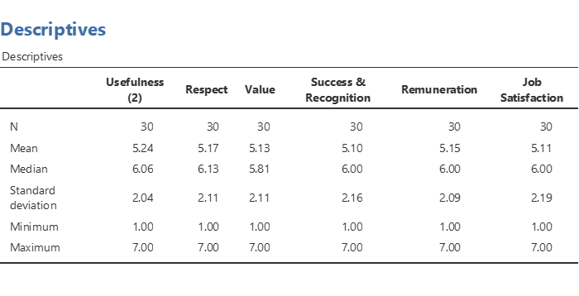

The survey results provide an insightful look into the perceptions of employees across six key dimensions: Usefulness, Respect, Value, Success & Recognition, Remuneration, and Job Satisfaction. The analysis includes 30 responses for each dimension.

Descriptive Statistics:

Usefulness: Employees rated 'Usefulness' with a mean score of 5.24, suggesting a generally high perception of their job's utility. The median score of 6.06 indicates that more than half of the respondents rate their job's usefulness above the scale's midpoint. The standard deviation of 2.04 points to a moderate variation in how employees perceive the usefulness of their jobs.

Respect: The mean score for 'Respect' in the workplace is 5.17. A median of 6.13 is slightly higher than that for usefulness, implying that most respondents feel quite respected at work. The standard deviation is 2.11, showing a similar response spread as 'Usefulness'.

Value: 'Value' has a mean score of 5.13, closely aligned with the other dimensions, indicative of employees feeling valued at work. The median of 5.81 reflects that the central tendency of the responses is also positive. The standard deviation of 2.11 indicates variability in how different employees perceive value.

Success & Recognition: This dimension scored a mean of 5.10, with a median score 6.00. This suggests that while the average is slightly lower than other factors, there is a consensus towards feeling successful and recognized by the majority. The standard deviation of 2.16 is the highest among the dimensions, indicating a wider range of sentiments about success and recognition.

Remuneration: The average score for 'Remuneration' is 5.15, and the median is 6.00. This shows a positive sentiment towards compensation, with half of the respondents scoring it above the midpoint. A standard deviation of 2.09 signifies a moderate spread in the perception of remuneration.

Job Satisfaction: With a mean score of 5.11 and a median of 6.00, 'Job Satisfaction' reflects a positive trend similar to the other dimensions. The standard deviation is 2.19, suggesting the broadest range of responses, indicating that job satisfaction levels vary more among the employees than other aspects.

Overall Implications:
For all dimensions, the minimum score is 1.00, and the maximum is 7.00, indicating that the survey captured a full range of employee sentiments. The means are above the scale's midpoint, implying a generally positive perception in all areas.

The medians at or above 6 for all dimensions except 'Value' suggest that over half of the participants rated their perceptions relatively high. This could indicate that employees, overall, feel their jobs are useful, respected and valued, recognize success, find remuneration fair, and are satisfied with their jobs.

However, the relatively high standard deviations across all dimensions, especially in 'Job Satisfaction', reveal that there is still a significant diversity in employee perceptions and experiences. This variability is an essential consideration for the organization, as it suggests that while overall trends are positive, there is room to explore individual differences and address any underlying issues contributing to the spread of responses.

After all, the survey results indicate a generally positive outlook among employees regarding key job aspects, but with noticeable variability that warrants further qualitative investigation to understand the individual employee experiences and to ensure a consistently positive work environment.

T-Test

The summary results for the one-sample t-tests conducted on six workplace variables are presented below, along with their descriptive statistics:
Usefulness: The one-sample t-test resulted in a t-value of 6.01, with a statistically significant p-value (< .001), indicating that the mean rating for Usefulness (M = 5.24) is significantly different from the test value of 3. The mean difference was 2.24, with a 95% confidence interval ranging from 1.48 to 3.00. The effect size, measured by Cohen's d, was 1.098, suggesting a large effect size, with a confidence interval for the effect size ranging from 0.637 to 1.55.
Respect: The t-test yielded a t-value of 5.63; the p-value was again < .001, suggesting a significant difference from the test value. The mean difference was 2.17, with a confidence interval from 1.38 to 2.95. Cohen's d was 1.029, indicating a large effect size, with its confidence interval from 0.578 to 1.47.

Value: With a t-value of 5.52 and a p-value < .001, the test suggests the mean rating (M = 5.13) significantly differs from the test value. The mean difference was 2.13, and the confidence interval was between 1.34 and 2.91. The effect size was also large (Cohen's d = 1.009), with an interval from 0.561 to 1.44.
Success & Recognition: The t-value was 5.32, and the p-value was < .001. The mean difference was 2.10, with a confidence interval from 1.29 to 2.91. The effect size had a Cohen's d of 0.972, with a confidence interval between 0.530 and 1.40.
Remuneration: This variable had a t-value of 5.62 and a p-value < .001. The mean difference was 2.15, with a confidence interval from 1.37 to 2.93. The effect size (Cohen's d) was 1.027, and the confidence interval for the effect size ranged from 0.577 to 1.46.
Job Satisfaction: The t-test resulted in a t-value of 5.27 with a p-value < .001. The mean difference was 2.11, with a confidence interval from 1.29 to 2.92. Cohen's d was 0.962, indicating a large effect size, with a confidence interval ranging from 0.522 to 1.39.

All variables showed a similar pattern: highly significant differences from the test value of 3, suggesting that the observed means for Usefulness, Respect, Value, Success and recognition, Remuneration, and Job Satisfaction are notably higher than the midpoint of a typical 1-to-7 Likert scale. The effect sizes are significant across all variables, indicating that the differences are statistically significant and practically meaningful. The confidence intervals for both the mean differences and the effect sizes do not include the test value or null effect size, respectively, reinforcing the robustness of these findings.

The descriptive statistics for six workplace variables are summarized below for a sample size of 30 respondents:
Usefulness: The average rating was 5.24 with a median of 6.06, indicating a slight skew towards higher ratings. The standard deviation (SD) was 2.04, which suggests moderate variability in the responses. The standard error (SE) was 0.372, providing an estimate of the precision of the mean. Respect: The mean rating was 5.17, and the median was slightly higher at 6.13, again reflecting a skew. The responses varied with an SD of 2.11 and an SE of 0.385. Value: Respondents rated this with a mean of 5.13 and a median of 5.81, pointing to a skew in the data. The SD was 2.11, and the SE was 0.385. Success & Recognition: The average score was 5.10, with a median of 6.00. The SD of 2.16 and an SE of 0.394 indicate variability and the precision of the mean respectively. Remuneration: This had a mean score of 5.15 and a median score of 6.00. The SD was 2.09 and the SE was 0.382, showing the data's spread and the mean's precision. Job Satisfaction: The mean was 5.11, with a median of 6.00. The SD was 2.19, which was the highest among the variables, suggesting the greatest variability in responses, and an SE of 0.400.
Overall, all variables had mean scores around the 5-point mark and medians above 6.00, indicating a tendency for ratings to be above the midpoint of the scale used. The standard deviations were fairly consistent, showing a similar degree of variability across responses. The standard errors were relatively small, indicating good precision of the mean estimates.

Partial Correlation

The summary results for the partial correlation analysis, while controlling for 'Job Satisfaction', are as follows:

Usefulness and Respect: There is a strong positive correlation (Pearson's r = 0.733) which is statistically significant (p < .001).
Usefulness and Value: A very strong positive correlation is observed (Pearson's r = 0.825) with significance (p < .001).
Respect and Value: Also exhibit a strong positive correlation (Pearson's r = 0.636), with the relationship being statistically significant (p < .001).
Usefulness and Success & Recognition: A moderate positive correlation is noted (Pearson's r = 0.362), and the result is statistically significant (p = 0.027).
Respect and Success & Recognition: The correlation is moderate (Pearson's r = 0.356) and significant (p = 0.029).
Value and Success & Recognition: A weak and non-significant positive correlation is found (Pearson's r = 0.208, p = 0.139), suggesting a weaker linear relationship.
Usefulness and Remuneration: There is a negligible correlation (Pearson's r = -0.087), and it is not statistically significant (p = 1.000), indicating no linear relationship.
Respect and Remuneration: A weak negative correlation is observed (Pearson's r = -0.291), but it is not statistically significant (p = 1.000).
Value and Remuneration: Shows a weak negative correlation (Pearson's r = -0.179), with no statistical significance (p = 1.000).
Success & Recognition and Remuneration: There is a slight positive correlation (Pearson's r = 0.130), which is not significant (p = 0.250).

Overall, Usefulness, Respect, and Value show strong, significant correlations with each other. Success & Recognition has a moderate positive correlation with Usefulness and Respect but not with Value. Remuneration does not have a significant correlation with any of the other variables. It is important to note that these correlations are calculated controlling for the variable 'Job Satisfaction'.

Findings

In conclusion, the partial correlation results, alongside an extensive review of social demographic factors as outlined in appendices 1-5, contribute to a comprehensive understanding of job satisfaction determinants among Generation Z employees. These findings are pivotal in evaluating the proposed hypotheses.
Hypothesis 1 posits that the perception of work utility, or Usefulness, mediates the relationship between job performance and job satisfaction. The data affirm this hypothesis, revealing a strong positive correlation between Usefulness and other job satisfaction dimensions. Given the significant association of Usefulness with Respect and Value, it is evident that the sense of contributing meaningfully to the workplace is intricately linked to the satisfaction levels of Generation Z employees, thereby supporting their perceived job performance.
Hypothesis 2 suggests that the level of Respect and team support moderates the relationship between job performance and job satisfaction, which is expected to be more robust when Respect and support are higher. The strong correlation between Respect and Usefulness bolsters this hypothesis, highlighting that when employees feel esteemed and supported, their job performance and satisfaction will likely be positively influenced.
Hypothesis 3 focuses on the mediation effect of recognition of work, or Success and recognition, on the relationship between the quality of work and job satisfaction. The moderate positive correlation of Success and Recognition with Usefulness and Respect partially supports this hypothesis. Although Success and Recognition do not correlate significantly with Value, their importance cannot be discounted as they still affect job satisfaction, albeit less strongly than Usefulness and Respect.
Hypothesis 4 asserts that self-autonomy, possibly reflected in the variable Value, moderates the relationship between task significance and job satisfaction. The hypothesis is supported by Value showing the strongest correlation with Usefulness and a strong correlation with Respect. Generation Z employees value autonomy and meaningful work, and when these are present, job satisfaction is enhanced.
Hypothesis 5 deals with the perception of Remuneration, proposing it as a mediator between actual Remuneration and job satisfaction. The results indicate no significant correlation between Remuneration and other job satisfaction variables, which fails to support this hypothesis. For Generation Z employees, the perception of fair pay may not be as critical to job satisfaction as other factors such as Usefulness, Respect, and Value.

Social demographics provide additional insights (Appendix 3 - 7). Gender differences suggest that women may perceive workplace environments more positively than men, a factor that could impact the perceived relationship between job performance and satisfaction. Age differences reveal that younger employees tend to be more satisfied, with satisfaction waning as employees grow older, potentially affecting how different age groups view the importance of the variables in question. Education and job roles further delineate satisfaction levels. Diploma and advanced degree holders report higher job satisfaction, indicating the potential impact of educational attainment on workplace experiences. Job roles like Financial Planners and Unit Managers express positive workplace sentiments, with variations among different positions suggesting that job role is a critical factor in job satisfaction. Finally, tenure portrays a nuanced picture. Employees with less service time report higher satisfaction, which gradually declines with tenure, pointing to changing needs and perspectives over time.

Discussions

When analysed through partial correlation and social demographics, the exploration of job satisfaction determinants within Generation Z employees yields insights that warrant a critical discussion. The strong interplay between Usefulness, Respect, and Value signifies a paradigm where intrinsic motivators outweigh extrinsic factors like Remuneration. This is particularly intriguing as it contradicts traditional assumptions that Remuneration is a primary driver of job satisfaction. The findings challenge Hypothesis 5, suggesting that for Generation Z, meaningful work and recognition may be more valued than financial rewards.

The partial support for Hypothesis 3, with Success and Recognition showing a moderate correlation with only some variables, prompts a re-evaluation of recognition practices in the workplace. While recognition is essential, it may not be the sole determinant of job satisfaction for Generation Z, necessitating a more holistic approach to employee engagement and motivation.

Demographic data further refines the discourse, uncovering subtle patterns of job satisfaction across gender, age, education, job role, and tenure. The consistent positive outlook reported by women and the initial high satisfaction levels reported by the youngest employees suggest that factors beyond the scope of the current hypotheses, such as optimistic career expectations or gender-specific workplace experiences, shape early career perceptions.

The decline in job satisfaction with age and tenure indicates a potential dissonance between employee expectations and workplace realities. This highlights the importance of continued engagement strategies and career development opportunities to sustain satisfaction among older and longer-tenured employees.

In summary, the critical analysis reveals that while Usefulness, Respect, and Value are central to Generation Z's job satisfaction, the importance of Success, Recognition, and Remuneration must be more definitive. The findings prompt a rethinking of traditional job satisfaction models, advocating for a more employee-centric and developmental approach to managing Generation Z in the workplace.

Limitations

The rigorous design of the questionnaire, though underpinned by a proven framework to ensure validity and reliability, presented limitations due to its finite scope. These are vital dimensions from the previous research framework, but this process may have inadvertently excluded other relevant factors not initially deemed critical. While a strength, the specificity of the questionnaire also meant that the dynamics of the insurance organization in question may have yet to be fully captured. This introduces a potential bias, limiting the breadth of application and the generalizability of the results to other contexts or industries.
Future research should broaden the investigative lens, especially regarding the role of remuneration in job satisfaction. A deeper dive into how different compensation models influence employee satisfaction could significantly inform the design of more tailored and effective compensation strategies, particularly within the unique operational framework of the insurance sector.

Conclusion

This study has illuminated key factors influencing job satisfaction among Generation Z employees within the insurance sector, notably highlighting the significance of intrinsic over extrinsic motivators. However, the research's focus on preselected dimensions and its application to a single organization suggest caution when extrapolating findings. Future research must expand on the interplay between remuneration and satisfaction to aid in crafting comprehensive compensation strategies. The insights offered provide a valuable foundation for enhancing salesperson engagement and tailoring workplace practices to meet the evolving preferences of the emerging workforce.
Appendix 1 – Generational behavioural characteristics of different age-groups. (Bencsik & Bencsik, 2016)

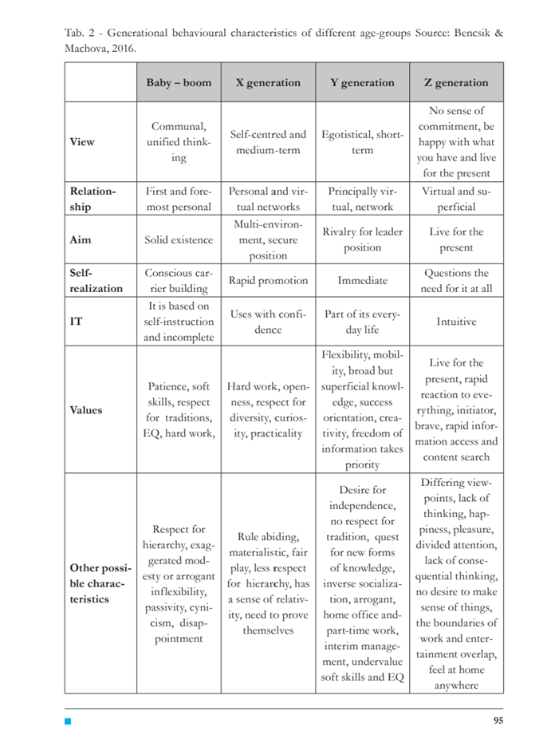

Appendix 2 – Conceptual Framework

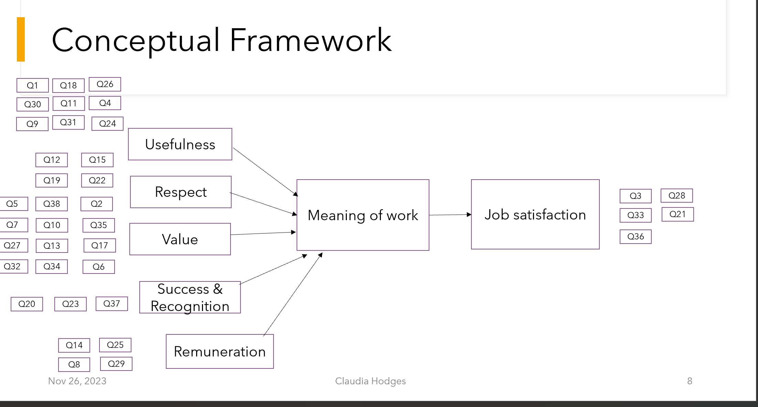

Appendix 3 – 38 item Questionnaire

Appendix 4 – by Gender

Appendix 5 – By AGE group

Descriptives

–

By
A
g
e

Descriptives

Age
group

Usefulness
(2)

Respect

Value

Success &
Recognition

Remuneration

Job
Satisfaction

Mean

1

7.00

6.75

6.92

6.67

7.00

7.00

2

6.24

6.55

6.18

6.67

6.55

6.48

3

6.17

6.21

6.33

6.17

6.08

6.33

4

4.55

4.35

4.33

4.22

4.35

4.21

Median

1

7.00

6.75

6.92

6.67

7.00

7.00

2

6.11

6.50

6.38

6.67

6.50

6.60

3

6.33

6.50

6.77

6.50

6.50

6.90

4

5.00

5.00

5.00

5.00

5.00

5.00

Standard
deviation

1

NaN

NaN

NaN

NaN

NaN

NaN

2

0.363

0.326

0.670

0.408

0.274

0.390

3

0.958

0.886

0.885

0.983

1.11

0.961

4

2.34

2.35

2.35

2.36

2.31

2.39

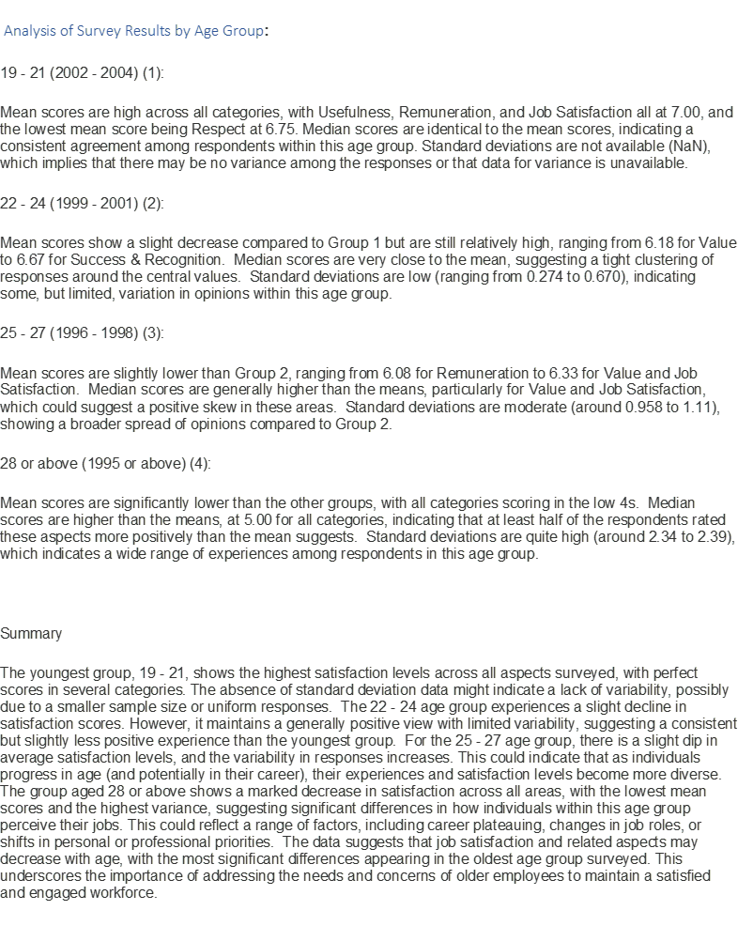

Appendix 6 – by Educational Level

Descriptives
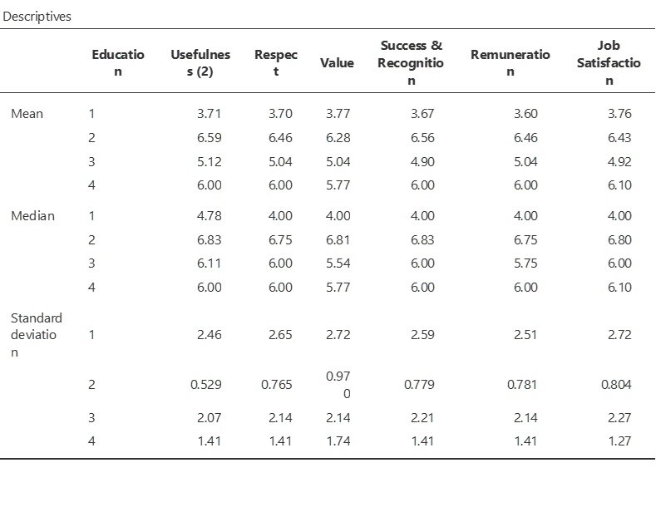

Appendix 7 – Work Title
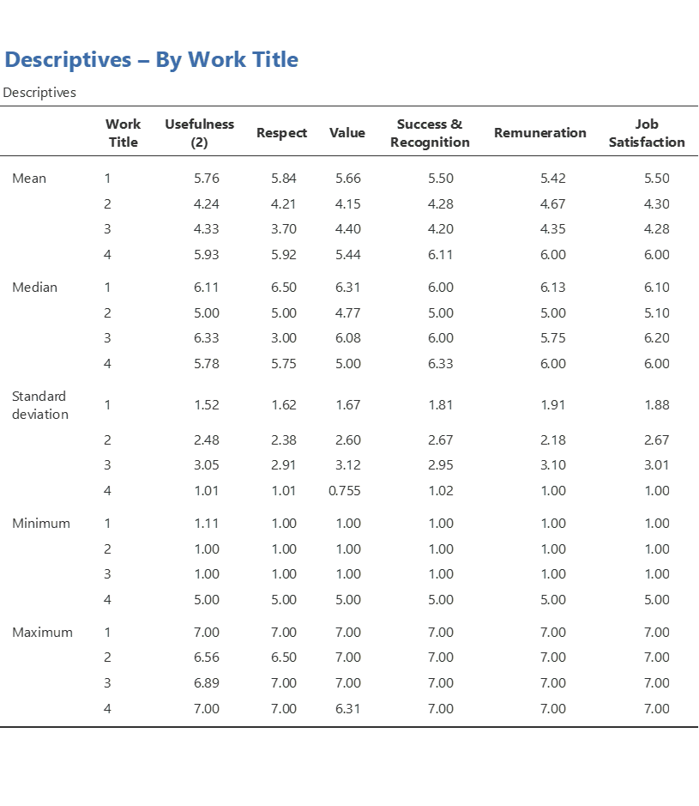
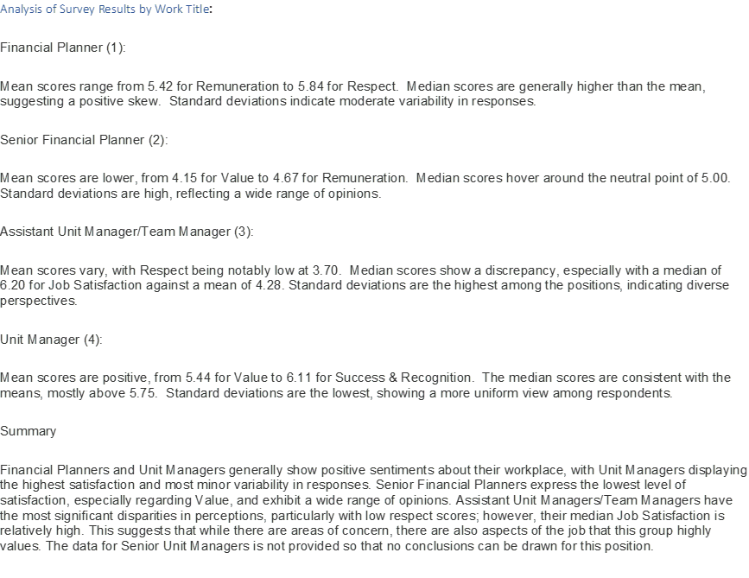

Appendix 8 – By Length of Service
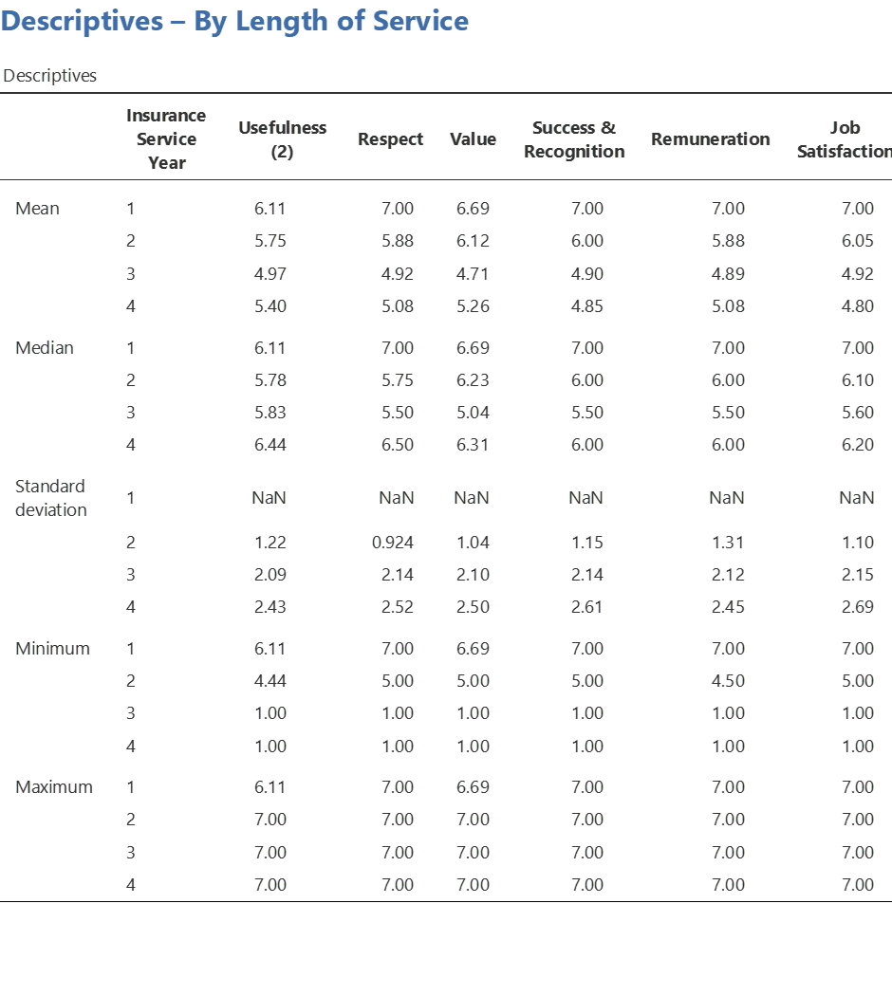

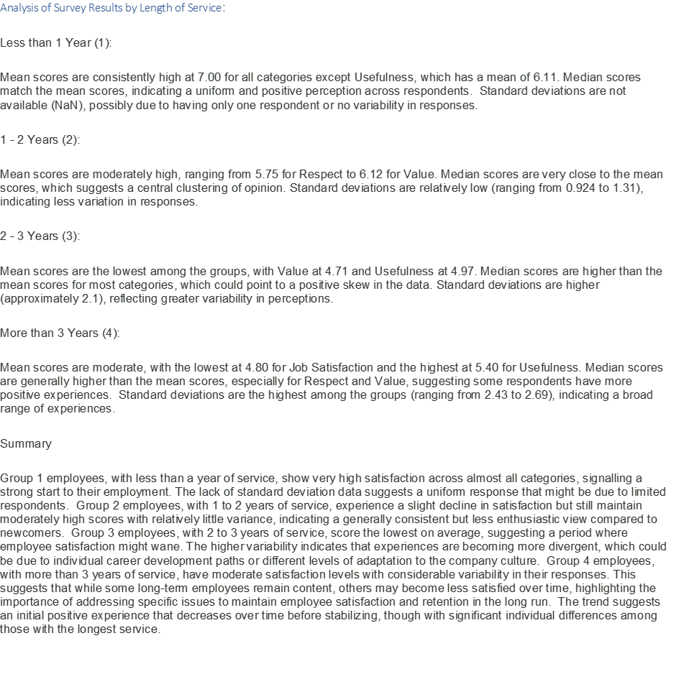

References

Adams, J. S. (2015). Equity theory. In Organizational Behavior .
Agarwal, H. (2018). WORK VALUES OF GEN Z:Bridging the Gap to the Next Generation.
Andrea, B., Gabriella, H. C., & Tímea, J. (2016a). Y and Z generations at workplaces. Journal of Competitiveness, 8(3), 90–106. https://doi.org/10.7441/joc.2016.03.06
Andrea, B., Gabriella, H. C., & Tímea, J. (2016b). Y and Z generations at workplaces. Journal of Competitiveness, 8(3), 90–106. https://doi.org/10.7441/joc.2016.03.06
Bencsik, A. and M. R. , 2016, & Bencsik, A. and M. R. , 2016. (2016). Knowledge sharing problems from the viewpoint of intergeneration management. ICMLG2016-4th International Conference on Management, Leadership and Governance:
Berg, J. M., Wrzesniewski, A., & Dutton, J. E. (2010). Perceiving and responding to challenges in job crafting at different ranks: When proactivity requires adaptivity. Journal of Organizational Behavior, 31(2–3), 158–186. https://doi.org/10.1002/job.645
Bibby, R. W. (2001). Canada’s Teen: Today. yesterday and tommorrow. Stoddart Distributed by General Distribution Services.
Both-Nwabuwe, J. M. C., Dijkstra, M. T. M., & Beersma, B. (2017a). Sweeping the floor or putting a man on the moon: How to define and measure meaningful work. Frontiers in Psychology, 8(SEP). https://doi.org/10.3389/fpsyg.2017.01658
Both-Nwabuwe, J. M. C., Dijkstra, M. T. M., & Beersma, B. (2017b). Sweeping the floor or putting a man on the moon: How to define and measure meaningful work. Frontiers in Psychology, 8(SEP). https://doi.org/10.3389/fpsyg.2017.01658
Bowie, N. E. (1998). A Kantian theory of meaningful work. Journal of Business Ethics, 17, 1083–1092.
Bunting, M. (2004). Willing slaves: How the overwork culture is ruling our lives. London : Harper Collins.
Cartwright, S., & Holmes, N. (2006). The meaning of work: The challenge of regaining employee engagement and reducing cynicism. Human Resource Management Review, 16(2), 199–208. https://doi.org/10.1016/j.hrmr.2006.03.012
Chalofsky, N. (2003). An emerging construct for meaningful work. Human Resource Development International, 6(1), 69–83.
Christen, M., Iyer, G., & Soberman, D. (2006). Job Satisfaction, Job Performance, and Effort: A Reexamination Using Agency Theory. Journal of Marketing, 70, 137–150.
Colquitt, Jason., LePine, J. A., & Wesson, M. J. (2013). Organizational behavior : improving performance and commitment in the workplace. McGraw-Hill/Irwin.
Csiszárik-Kocsír, Á., & Garia-Fodor, M. (2018). Motivation analysing and preference system of choosing a workplace as segmentation criteria based on a country wide research result focus on generation of Z. Online Journal Modelling the New Europe, 27, 67–85. https://doi.org/10.24193/OJMNE.2018.27.03
Elangovan, A. R., Pinder, C. C., & McLean, M. (2010). Callings and organizational behavior. Journal of Vocational Behavior, 76(3), 428–440. https://doi.org/10.1016/j.jvb.2009.10.009
England, G. W. (1991). The meaning of working in the USA: Recent changes. The European Work and Organizational Psychologist, 1(2–3), 111–124.
Hackman, J. R. (1980). Work Redesign and Motivation.
Hulin, C. L., & Judge, T. A. (2003). Job attitudes (Handbook of psychology: Industrial and organizational psychology, Ed.; Vol. 12).
International Research Team. (1987). The Meaning of Work. New York : Academic Press.
Jalagat, R. (n.d.). Job Performance, Job Satisfaction, and Motivation: A Critical Review of their Relationship. 5, 36. www.managementjournal.info
Kahn, W. A. (1990). Psychological Conditions of Personal Engagement and Disengagement at Work. In Academy of Management Journal (Vol. 33, Issue 4).
Lee, S. (2015). A concept analysis of “Meaning in work” and its implications for nursing. Journal of Advanced Nursing, 71(10), 2258–2267. https://doi.org/10.1111/jan.12695
May, D. R., Gilson, R. L., & Harter, L. M. (2004). The psychological conditions of meaningfulness, safety and availability and the engagement of the human spirit at work. Journal of Occupational and Organizational Psychology, 77(1), 11–37. https://doi.org/10.1348/096317904322915892
Mccrindle, M. (2011). An Excerpt from the ABC of XYZ. www.markmccrindle.com
Morin, E. (2003). Définition, mesure et validation. Dimensions individuelles et sociales de l’ investissement professionnel, . . In C. Vandenberghe, N. Delobbe, & G. Karnas (Eds.), 11–20.
Morin, E., & Cherré, B. (2004). Réorganiser le travail et lui donner du sens. In A. Lancry, & C. Lemoine (Eds.), La Personne et Ses Rapports Au Travail, (Pp. 87–102). Paris: L’Harmattan., 87–107.
Ozkan, M., & Solmaz, B. (2015). The Changing Face of the Employees – Generation Z and Their Perceptions of Work (A Study Applied to University Students). Procedia Economics and Finance, 26, 476–483. https://doi.org/10.1016/s2212-5671(15)00876-x
Pignault, A., & Houssemand, C. (2021). What factors contribute to the meaning of work? A validation of Morin’s Meaning of Work Questionnaire. Psicologia: Reflexao e Critica, 34(1). https://doi.org/10.1186/s41155-020-00167-4
Pratt, M. G., & Ashforth, B. E. (2003). Fostering meaningfulness in working and at work. Positive Organizational Scholarship: Foundations of a New Discipline, 309–327.
Rakhmatia Nabahani, P., & Riyanto, S. (n.d.). Job Satisfaction and Work Motivation in Enhancing Generation Z’s Organizational Commitment ARTICLE INFO ABSTRACT.
Riyanto, S., Sutrisno, A., & Ali, H. (2017). International Review of Management and Marketing The Impact of Working Motivation and Working Environment on Employees Performance in Indonesia Stock Exchange. International Review of Management and Marketing, 7(3), 342–348. http:www.econjournals.com
Rosso, B. D., Dekas, K. H., & Wrzesniewski, A. (2010). On the meaning of work: A theoretical integration and review. In Research in Organizational Behavior (Vol. 30, Issue C, pp. 91–127). https://doi.org/10.1016/j.riob.2010.09.001
Sonnentag, S., & Frese, M. (2002). Performance Concepts and Performance Theory. In Psychological Management of Individual Performance (pp. 1–25). Wiley. https://doi.org/10.1002/0470013419.ch1
Spector, P. (1997). Job Satisfaction (C. Sage. Copyright. © Thousand Oaks, Ed.).
Spreitzer, G. M. (1996). Social Structural Characteristics of Psychological Empowerment. In Source: The Academy of Management Journal (Vol. 39, Issue 2). http://www.jstor.orgURL:http://www.jstor.org/stable/256789Accessed:15-11-201508:33UTC
Super, D. E., & Šverko, B. E. ,. (1995). Life roles, values, and careers: International findings of the Work Importance Study. Jossey-Bass.
Veltman, A. (2016). Meaningful work.
Vroom, V., Porter, L., & Lawler, E. (2015). Expectancy theories. In Organizational Behavior .
Wrzesniewski, A. (2003). Finding positive meaning in work. Positive Organizational Scholarship: Foundations of a New Discipline, 296–308.
Zaki Ismail, A., & Ahmed, S. (2015). Employee Perceptions on Reward/Recognition and Motivating Factors: A Comparison between Malaysia and UAE. American Journal of Economics, 2015(2), 200–207. https://doi.org/10.5923/c.economics.201501.25

