Explain The Terms Black And White Box Testing

By Eben Stewart

P115266

In fulfilment of the requirements for

ACCB6006

Advanced Web Development

Coursework Two

Lecturer

Dr. Michael Dacey

20 June 2020

Table of Contents
Contents

Introduction 1
Black Box Testing 1
Advantages 2
White Box Testing 2
Code Coverage 2
Static and Structural Tests 2
Conclusion 4
References 4

Table of Figures
Figure 1 a state transition testing diagram 4
Figure 2 flow chart for pseudocode paths 6
Figure 3 illustrated paths through flowchart 6

Introduction
Software testing means the running of an application in order to find errors and defects in it.
It is an important part of the development process in that it builds confidence (or not) that the software functions as intended, as per requirements [1]. There are many different tests performed at different stages of the development life-cycle, such as unit, integration, system, acceptance, regression, alpha and beta tests.
Testing can never guarantee that an application is fault free because there might be faults that were not tested for or that are intermittent. It can only definitely show that there are faults.
It is important that testers have no vested interested in the software being fault free. That excludes code authors or others who would have to do the work of fixing the code. The best testers those with a motivation to find faults, who expect them. In addition to seeing whether a program does what it is supposed to, it is equally as important to investigate whether or not it does what it is not supposed to. [2].
A program written to exercise code is called a test harness.

Black Box Testing
Black box tests are those that can be done through an API, without knowledge of the contents of the module being tested. The system is treated as a monolithic item, the insides of which are unseen. Tests are designed to check the outputs generated by the system in response to selected inputs . The inner workings of the code are not examined, therefore tests must be designed from the code’s specifications or system architecture[1], [3].
Here is an example of state transition testing, a type of black box testing:
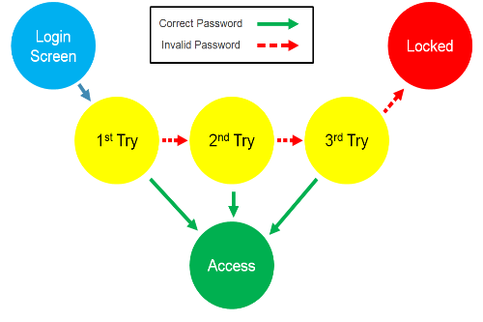
Figure 1 a state transition testing diagram

It tests the program’s behaviour given permutations of its inputs, the states that it passes through, and the outputs at each stage and at the end [4].

Advantages
Because the structure of the code is unknown, only the output of the systems workings, black box testing is purely about testing how a system functions, not its structure [3]. As the inner intricacies of the code are ignored, black box testing is relatively quick and resource efficient so is suitable for testing large amounts of code. It is also suitable for automation [5].

Disadvantages
Testers ability to design effective tests is constrained by the quality of the system specifications. Usually only a selected few test scenarios are conducted, so there is potential to miss bugs that way. Because a major motivation for performing black box testing is to cover lots of ground as efficiently as possible, there is a motivation to design tests that sacrifice thoroughness for speed [5].

White Box Testing
White box tests test the inner workings of the code, so full knowledge of the source code is required. The details of the structure and internal logic are inspected. Overall inputs and outputs are not the focus. Tests are designed to exercise and reveal bugs in the various structures of the source code, so internal structures are isolated and examined [1].
Different types of tests do this at different levels of detail. Unit tests test the smallest units of source code, such as conditionals, loops, methods etcetera, up to the complexity of a class. Error catching and messaging are also looked at. Integration tests investigate how modules interact [1].

Code Coverage
In order to comprehensively make sure that all the code has been tested, there are three modes of keeping track of what has been covered. Statement coverage keeps track of the percentage of all instructions that were executed during tests. Branch Coverage evaluates the percentage of conditional decisions that have been evaluated on both true and false sides [3]. Path Coverage tests that there are no bugs in any of the paths of the program. This rapidly becomes very complex as the number of decision nodes increases. One measure of this is cyclomatic complexity [6].

Advantages
Inner inefficiencies and bottlenecks can be uncovered. Excess code can be removed, sometimes revealing hidden errors [5]. By analysing exactly how a structure is implemented, how it actually does function can be more comprehensively known [5].

Disadvantages
White box testing is far more resource intensive than black box testing. It requires much coding proficiency, so the time of qualified white box testers is expensive. Therefore it is much more expensive to do thoroughly at large scale [5].

Static and Structural Tests
Static testing is done during the development process. It involves only the source code not compiled artefacts. It is performed by the coders as they work and by more experienced, team members both informally and formally. Structural tests are more comprehensive tests that can involve executables and detailed analysis of code modules performance, involving various analytic tools and visualisation aids [1].
An example of flow analysis for this simple program:
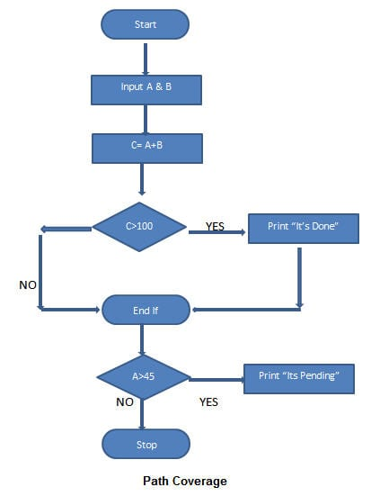
Figure 2 flow chart for pseudocode paths
INPUT A & B
C = A + B
IF C>100
PRINT “ITS DONE”

END IF
IF A>50
PRINT “ITS PENDING”
END IF
In order to have fully covered all paths of the branching code, both paths of the first decision point must be followed, then both paths of the next decision point each of those path encounters and so on.
Illustration 2 is a flow chart of the above pseudocode and Illustration 3 shows lines representing all the paths through it given the following inputs:
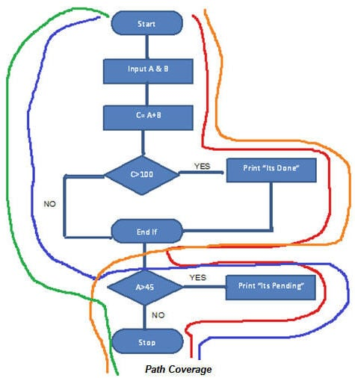
Figure 3 illustrated paths through flowchart

“Red Line – TestCase_01 = (A=50, B=60)
Blue Line = TestCase_02 = (A=55, B=40)
Orange Line = TestCase_03 = (A=40, B=65)
Green Line = TestCase_04 = (A=30, B=30)”
Example from [7].

Conclusion
Black and white box testing are not mutually exclusive techniques. Instead they each have their place in the software development cycle. They complement each other in terms of practicality and expense, in terms of the sort of assurance they provide and in terms of the aspects of the program: correctness of inner structure and of overall functionality. Both are necessary to producing valid, verified, trusted software.

References
[1] S. Nidhra and J. Dondeti, ‘Black box and white box testing techniques-a literature review’, Int. J. Embed. Syst. Appl. IJESA, vol. 2, no. 2, pp. 29–50, 2012.
[2] G. J. Myers, C. Sandler, and T. Badgett, The art of software testing. John Wiley & Sons, 2011.
[3] M. E. Khan, ‘Different approaches to black box testing technique for finding errors’, Int. J. Softw. Eng. Appl., vol. 2, no. 4, p. 31, 2011.
[4] ‘Black Box Testing Techniques with Examples’, Testbytes, Nov. 25, 2019. https://www.testbytes.net/blog/black-box-testing/ (accessed Jun. 20, 2020).
[5] M. E. Khan and F. Khan, ‘A comparative study of white box, black box and grey box testing techniques’, Int J Adv Comput Sci Appl, vol. 3, no. 6, 2012.
[6] C. Ebert, J. Cain, G. Antoniol, S. Counsell, and P. Laplante, ‘Cyclomatic Complexity’, IEEE Softw., vol. 33, no. 6, pp. 27–29, Nov. 2016, doi: 10.1109/MS.2016.147.
[7] ‘White Box Testing: A Complete Guide with Techniques, Examples, & Tools’. https://www.softwaretestinghelp.com/white-box-testing-techniques-with-example/ (accessed Jun. 20, 2020).

Evaluate the Benefits of Behaviour Driven Development

By Eben Stewart

P115266

In fulfilment of the requirements for

ACCB6006

Advanced Web Development

Coursework One

Lecturer

Dr. Michael Dacey

20 June 2020

Table of Contents

Introduction 1
Behaviour Driven Development 1
Conclusion 2
References 2

Introduction
The problem of miscommunication of intent between those who require software and the builders of it, is a thorny one. The translation of requirements to code has gone from Waterfall to more iterative techniques that are better able to track the fickle and shifting target that is human expectation. Agile has spawned a plethora of offspring, each claiming to have better cracked the nut of easily, accurately and reliably making software that is just what the customer wanted.

Behaviour Driven Development
Behaviour Driven Development (BDD) is an Agile software development methodology that aims to foster communication between software developers and the other collaborators, business people and customers involved with a project [1].
As with its antecedent, Test Driven Development (TDD), tests are written for a module before any coding is done, so that developers have a clear target to work toward. Unlike TDD, BDD tests are written in natural language so as to be understandable to the other partners and encourage mutual agreement and understanding of the evolving requirements. BDD therefore complements other agile techniques such as User stories in the building of shared understanding [1]. Indeed, User stories are integral to the BDD process.
Both tests and the resulting development sprint are small so there is a fairly rapid alternation between them. This makes testing is an integral part of the coding process [2].
It is also influenced by Acceptance Test Driven Development (ATDD), which is closely related to TDD but with more orientation to customer viewpoints than TDD [3].

2b || !2b
In and of itself, the integration of all stakeholders in the process and writing of tests comprehensible to them is not expected to completely solve the problem of translating a business problem/viewpoint to hard code. Because BDD tests, called specifications or scenarios, are not code, software test code must be derived from them. So the problem of the translation, or perhaps misinterpretation of original intent still must be dealt with.
In BDD, the process by which stakeholders work toward formulation of ‘specifications of behaviour’ of a module which is BDD language for test for a module, is one of reducing the imprecision of natural language. To this end, specific language structures are constrained to mean corresponding code or logic structures[4].
The storytelling also follows a set structure that is designed to facilitate the elicitation of specifications [4]. The founder of BDD, Dan North provides this story formulation template:
Title (one line describing the story)

Narrative:
As a [role]
I want [feature]
So that [benefit]

Acceptance Criteria: (presented as Scenarios)

Scenario 1: Title
Given [context]
And [some more context]...
When [event]
Then [outcome]
And [another outcome]...

Scenario 2: ... [4]

There are automated tools that aim to facilitate BDD. They leverage the already more precise language used, and predictable story structure to try to generate test code [2].

Conclusion
Without experience with it it is hard to know how effective BDD is at its stated goals. The problem of, to put it bluntly, ‘garbage in, garbage out’ is older than computing. That which makes human languages such as English useful for poetry is a stumbling to facile, reliably accurate translation into the exactitudes of computer code. The techniques that BDD uses do not seem without promise, but it is difficult to evaluate them without first-hand experience.
Perhaps those in the constructed languages community, particularly lojban speakers, have a better idea: provide the human brain with a language based on predicate logic, that can be parsed by computers out of the box [5].

References
[1] M. Diepenbeck, M. Soeken, D. Große, and R. Drechsler, ‘Behavior Driven Development for circuit design and verification’, in 2012 IEEE International High Level Design Validation and Test Workshop (HLDVT), Nov. 2012, pp. 9–16, doi: 10.1109/HLDVT.2012.6418237.
[2] ‘Behaviour-Driven Development - Cucumber Documentation’. https://cucumber.io/docs/bdd/ (accessed Jun. 20, 2020).
[3] ‘Acceptance Test Driven Development (ATDD) | Agile Alliance’, Dec. 17, 2015. https://www.agilealliance.org/glossary/atdd/ (accessed Jun. 20, 2020).
[4] ‘What’s in a Story?’, Dan North & Associates, Feb. 11, 2007. https://dannorth.net/whats-in-a-story/ (accessed Jun. 20, 2020).
[5] ‘Lojban’. https://mw.lojban.org/papri/Lojban (accessed Jun. 20, 2020).

