

Assessment 2

Student name:​ Shalma Begum
Student ID: ​1813709
Module name: Mental Disorders and Psychopathology​
Module code: BMHP6006
Lecturer name: Bianca Sanfilippo ​
Date: 5/1/22

Table of Contents

Type chapter title (level 1) 1
Type chapter title (level 2) 2
Type chapter title (level 3) 3
Type chapter title (level 1) 4
Type chapter title (level 2) 5
Type chapter title (level 3) 6

Introduction:
This report will provide an overview of three mental health disorders that are included in the ICD-10 Manual. Which are General Anxiety disorder, Schizophrenia, and Autism. These disorders will be critically analysed by looking at the diagnosis, treatment, and measurements of treatment. This will be followed by recommendations.

General Anxiety Disorder
According to NHS (2021), GAD Is a sense of uneasiness, like concern or fear, this can be mild/moderate or severe. While many individuals may be anxious or experience uneasy feelings sometime in their lives, individuals that suffer from generalised anxiety say that it is exceptionally challenging to manage fears. Overall, their feelings of anxiety are more constant which can then affect their daily life, (Anxiety UK, 2021).
(GAD) is a mental disorder that is categorised by extreme and tenacious anxiety in addition to overpowering worry that arises for at least 6 months or so, (Portman et.al 2012). During March 2020, approximately 49.6% of individuals in the UK stated elevated rates of anxiety; this was dramatically higher contrasted to 2019 where 21% of individuals out of the 25 million population that are aged 16 and above, (Anxiety UK, 2020).

Classification of GAD within ICD-10
GAD is classified within ‘F40-F48 Neurotic, stress-related and to form disorders’, (WHO, 2010). In this group there are different types of anxiety disorders like Panic disorder and mixed anxiety depressive disorder. GAD is under F41.1 and is described and grouped under disorders in which the symptom of anxiety is the major indicator and is not constrained to any specific environmental condition.
Causes (Aetiology)
GAD is thought to be the result of a complex web of genetic, biological, trauma-linked, and psychological influences. Traumatic and stressful experiences can be key contributors to the development of GAD, especially during childhood. Neglect, emotional or physical abuse, the death of a loved one, divorce, loneliness, and rejection can all be supportive factors, (Munir and Takov, 2021). Research says that caffeine and alcohol, as well as illegal drugs, can make some people feel anxious, (Mental Health UK, 2021). Another cause could be genetics, blood-related family like parents or siblings who have GAD increases the risk for the individual.
According to Portman et al (2012) studies have shown that traumatic and abusive events in childhood can seriously affect the physical development of a child's brain making them more susceptible to anxiety disorders later in life. These early social interactions and learning experiences can directly influence the development of GAD later, (Baldwin, et al, 2018). They suggest that having a primary caregiver or parent who engages in anxious behaviour during a child's developmental years can significantly increase the risk of GAD. Research also implies that brain structure can be a cause of the development of GAD, (Fedoce, et al 2018).
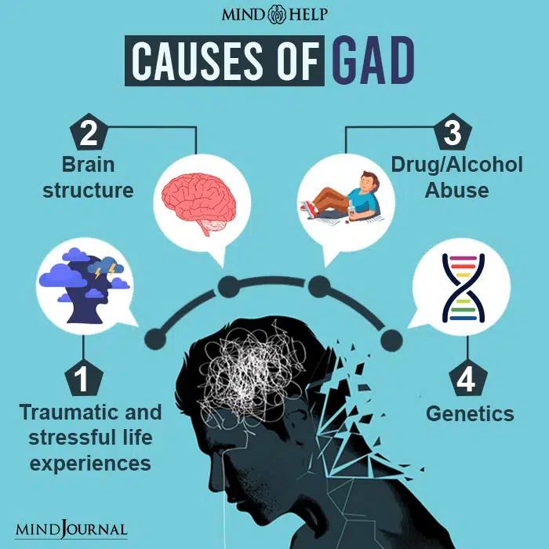
Source:

Signs
According to the NHS (2021), GAD can produce a shift in behaviour as well as how a person thinks and feels about certain situations, this then causes psychological and physical symptoms. Psychological symptoms are being restless, continuously feeling on edge, hard to concentrate, irritable, and always feeling on edge. Symptoms can make a person feel the need to isolate themselves from family and friends to stay away from the feelings of trouble and fear. Physical signs include fatigue, trembling, sweating a lot, difficulty swallowing, aching muscles, nausea, headaches, stomach aches, dry mouth as well as palpitations.
Diagnosis
The diagnosis of GAD is generally made using the DSM and ICD-manual. The DSM-V and ICD-10 criteria generally have similarities however, they vary in terms of some aspects, which include the length of symptoms. NICE, (2021) suggests that clinical judgement should then be applied to establish the general possibility of a verdict of GAD. In primary care, individuals with GAD regularly show solely only physical symptoms, they might not easily speak about issues or psychological distress.
According to NICE (2021), GAD is initially diagnosed by a physical examination. This is usually normal in the absence of co-existing medical problems or substance abuse, but individuals with GAD can display an increase in heart rate, shortness of breath, shaking, and an amplified shock reaction. The assessment commences by addressing behavioural or bodily signs. Screening tools like GAD-7 questionnaires are also used to ascertain the severity of GAD.
Rosellini et.al (2018) suggests that in general, GAD is generally underdiagnosed and undertreated. When not treated, anxiety disorders such as GAD frequently head to acute depression as well as drug and alcohol abuse. Furthermore, there is a soaring level of suicide among these patients.
Current treatment
Following the diagnosis of GAD, individuals will be recommended to seek self-help or if GAD affects a person’s life hugely psychological treatment will be offered before any medication is prescribed. Self-help comes in the form of exercises, quitting smoking, cutting back on caffeine, support groups, or downloading apps that are available in the NHS apps library. Self-help suggests a less conventional approach that helps in managing anxiety symptoms with limited guidance, (Wells and Carter, 2016).
Smartphone technology is used by everyone, and these come with the soaring status of apps. The use of electronic self-help alternatives can provide support for individuals seeking self-help for GAD. There are also applications available with limited, anxiety managing measurements, like recreation practices and mindfulness concentration exercises. They can be applied in combination with continuing treatment, or to avert decline as well as stimulate continual improvement following the termination of psychotherapy, (Coull et al, 2012). Cognitive behavioural therapy (CBT) is used for a short time, it is a coordinated treatment that concentrates on the relationship among the mindful beliefs, feelings, and behaviours that propagate unease. CBT concentrates on present-day problems and current circumstances. Psychotherapy like CBT may be lengthier to provide symptom alleviation than medicine, however, the positive note is that the effects can be long-term because aids understood in psychotherapy are implemented after treatment finishes. Psychological therapies like cognitive behavioural therapy (CBT) are available on the NHS.
Treatment for GAD intends to improve individuals to feel well mentally and physically as well as to enhance interaction with the individuals, areas, and settings that formerly stimulated concern. According to Eva and Hiller, (2013) and NHS, (2021), CBT is one of the most prevalent treatment options used for GAD.
Measurements of rehabilitation
To measure the efficacy of the treatments, it is vital to know the measurements of rehabilitation. This is because if treatment is not successful, it must be modified. As mentioned earlier, one of the measurements of rehabilitation in GAD is the ‘Generalised Anxiety Disorder Questionnaire (GAD-7), (see appendix A). This questionnaire is a tool to measure the level of anxiety for two weeks.
This is determined by allocating scores of 0, 1, 2, and 3, to the reply to categories of not at all, several days, more than half the days, and almost every day, individually. The overall score for the seven questions extends from 0 to 21. Scores of 5, 10, and 15 represent cut points for mild, moderate, and severe anxiety, respectively. According to Jordan et al, (2017), the GAD-7 is used frequently as a diagnostic self-report measurement for screening, diagnosis, and severity assessment of anxiety disorder.
Principles of care when working with individuals with GAD
When working with individuals who suffer from GAD we must ensure that we create a connection and work in an accessible, pleasing, and non-judgemental approach. NICE (2019) says we must look at the individual's concerns to jointly understand the impact of GAD and look at treatment options together showing that decision making is a shared procedure. We must make sure any discussions about treatment are in settings where privacy and dignity are respected. If achievable, make sure that treatment information is presented in the individual's desired language and offer interpreters if required.
These principles and more are entailed in the Equality Act 2010, Human Rights Act 1998, Mental health Act 1983 as well as the Confidentiality and Data Protection Act 2018.

Schizophrenia
According to WHO (2019), schizophrenia is a persistent and serious mental disorder that affects around twenty million individuals around the world.
Schizophrenia is distinguished by misrepresentations in the way a person thinks, awareness, feelings, speech, perception of identity and conduct. General experiences involve delusions and illusions.
Schizophrenia within the ICD –10
In the ICD-10 manual schizophrenia is classified as schizotypal and delusional disorders, it can be found in F20-29, (WHO, 2010). There are different types of schizophrenia, some of these are paranoid schizophrenia, catatonic schizophrenia, and post-schizophrenic depression to name a few. The length of schizophrenic disorders can be either constant or occasional.
Causes (Aetiology)
The causes of schizophrenia have not been entirely determined therefore an exact cause cannot be made for certain. However, studies say that it is normally a mixture of factors such as brain chemistry, genetics, and complications at birth. According to Gilmore, (2010), genes play a role in development and agility. Environmental and social risk factors are likely to have multiple effects on the developing brain. Environmental stressors connected to this disorder involve childhood disturbance, ethnic minorities, and social isolation. In addition, social stressors, such as discernment or economic adversity, may predispose individuals toward delusional or paranoid thinking. According to studies Faden, (2019), suggests that obstetrical problems can also be another cause. This consists of bleeding while pregnant, gestational diabetes, emergency c section, lack of oxygen, and low birth weight, which have been linked with schizophrenia in later life.

Signs/symptoms of Schizophrenia
According to the NHS (2021), signs of schizophrenia include being socially introverted and unemotional or shifts in sleeping patterns. Another sign is hallucinations, which are encounters that seem genuine, however, they are produced by a person’s mind. These consist of signs such as seeing things, hearing voices, or smelling things that people near you cannot sense. People also experience delusions, which occur when they hold the belief about something regardless of proof or details that say otherwise.
Diagnosis
The GP can diagnose a person with schizophrenia following a detailed psychiatric evaluation. The GP will see the person a few times to see how frequently symptoms occur. Currently, there are no blood tests or diagnostic imaging that can show if a person has schizophrenia the GP uses the ICD-10 manual to diagnose schizophrenia as well as other mental health disorders.
The manuals say that a person presented with symptoms such as hearing voices should at least be experiencing it for a month before a diagnosis can be made, (WHO, 2019).

Current treatment for schizophrenia
Schizophrenia is usually treated with individually tailored talk therapy and medication. Medication is the mainstay of treatment for schizophrenia with many people maintaining successful rehabilitation after receiving appropriate drug therapy. However, studies say non-supportive medication should not be viewed as a golden remedy for patients with schizophrenia. Many people with schizophrenia have problems with non-adherence to medication. Factors that influence non-compliance vary from person to person, however, non-compliance continues to be a persistent problem for many people with schizophrenia, therefore a combination of medication and therapy is thought to work well, (Kahn et al., 2015).
Psychological treatments for schizophrenia include cognitive-behavioural therapy (CBT) and art therapy. CBT helps to identify thought patterns the cause of unsolicited emotions and behaviours and educates how to alter these belief patterns with practical and helpful thoughts, (NHS, 2021). It may also help treat some of the negative indicators of schizophrenia, such as apathy or disinterest in daily activities that were once enjoyed. Art therapies are also designed to promote creative expression. Working with an art therapist in a small group or one-on-one may allow a person to articulate their experiences with schizophrenia.

Measurements of rehabilitation
With this condition, we can only measure the quality of care and treatments provided to effectively control and manage the condition and avoid complications, such as self-harm and suicide, substance misuse, neglect and self-neglect, lack of dignity, and violation of human rights. We can measure the quality of life with the indicators that are used for long-term mental disorders.
The ‘Quality Indicator for Rehabilitative Care is a tool used that includes certain indicators that show that quality of care and effectiveness are provided to manage the condition (see appendix b).

Principles when working with people with Schizophrenia
When working with individuals who suffer from schizophrenia we must ensure that we are trained in assessment skills for individuals from various cultural backgrounds and be able to clarify the reasons for psychosis or schizophrenia as well as treatment choices. We must follow the Equality Act 2010 as well as the Human Rights Act and others ensuring that the individual is treated with respect and dignity.
Individuals detained under the Mental Health Act require crucial treatment and can be at risk of detriment to themselves and others. We must make sure the individual remains involved in a joint attempt to their struggles. Pursuing shared intentions is a very important component of treatment.

Autism
Autism is part of a group of complex neurodevelopmental disorders that are categorised by monotonous and distinctive behavioural patterns as well as difficulties with interaction and communicating with others. The NHS, (2019) says that autism is a spectrum and every individual with the disorder is not the same, some may require help with everything whereas others may require little daily support. It is projected that around 1 in every 100 individuals from the UK are autistic.
According to studies, Lord et al, (2018) suggest that in the past 50 years, autism has moved from a scarcely distinctive and unique disorder to a well-publicised, supported, and studied long term disorder. The depiction of the main characteristics of autism as societal interaction shortfalls and monotonous and irregular sensory-motor behaviours has not altered. Yet, autism is currently viewed as a spectrum that can vary from extremely mild to severe.

Classification of autism within ICD-10
Autism within the ICD –10 is classified as a disorder of development F80-F89. The ICD-10 says the disorders comprised in this group share a few symptoms like, begins at the start of infancy or childhood; weakening or adjournment in the progress of functions that are powerfully linked to biological growth of the dominant nervous system. Some of the other disorders in this group are Rett syndrome, atypical autism, and Pervasive developmental disorders, (WHO, 2010).

Aetiology of autism
The exact cause of autism is not known; however, studies say that genetics and environmental factors may play a part in the cause of autism. All of which affect brain development and function.
Research appears to imply that there is a genetic impact that raises a child’s risk of being autistic. If one child in a family has autism, a sibling has a 3 to 5 per cent possibility of also having the disorder.
Environmental factors like parental age, maternal dietary and metabolic status, illnesses while pregnant, prenatal anxiety, as well as contact to specific contaminants, heavy metals, or drugs. Parental age may be a factor in genetic alterations. Increased maternal age has been indicated a rise in the possibility of autism in children (Wu et.al, 2016); though, some studies have contradicted this theory (Karahmadi et.al 2017).
Signs of autism
Some common signs in autism in children are no eye contact, non-verbal, distraught because they do not like the taste, smell, or sound of things, rhythmic movements, like flailing their hands, flipping their fingers, \
or swaying their body and not talking and much as others their age. Older children can get upset if they cannot follow their strict daily routine, having no understanding of how others think and feel. Some signs in adults include avoiding social interaction, having the same routine every day, and getting very anxious if it changes, (
Diagnosis
The first step in getting a diagnosis of autism is speaking to the GP, if it is regarding a child then people can speak to the child’s health visitor or special educational needs (SENCO) in school. The GP can refer the person for an autism assessment. The assessment is carried out by autism specialists. During the assessment, the team might ask about the child's growth, like when they started speaking, and observe how the individual their child interacts, and how they play. They will also read any medical and school reports to get a clearer view of the diagnosis.
The assessment for adults is a bit different as the adult will be asked to fill in a questionnaire regarding themselves and if they have any problems. They will also try and speak to family/friends to find out about the adult’s childhood as well as read medical reports. When the assessment is finished, a report will be provided stating what the team discovered, (NHS, 2020).
Current treatment
Although there is no cure for autism there is still a wide scale of interventions, from young childhood as well as through the life span which can enhance the development, well-being, and excellence of living for individuals with autism. Evidence-based psychosocial interventions can enhance the capability of infants with autism to speak effectively and have social interactions.
Speech-language therapy can assist individuals with autism to develop their capabilities to communicate and interact with others, (Castilo et al, 2019). It can also involve approaches to develop social abilities and social behaviours. A child may discover how to make eye contact or to stand in a relaxed space from other individuals. These skills may make it slightly simpler to intermingle with others.

Measurements of rehabilitation
The Childhood Autism Rating Scale (CARS) is a fifteen element behavioural rating scale created to recognise children with autism as well as to classify these behaviours from mild to moderate to severe, (Chlebowski, et al 2010). Another measurement used is the Autism Diagnostic Observation Schedule (ADOS). It is a structured, harmonised measurement of transmission, social interface, and play or the creative application of resources for people who have been told they may have autism. The ADOS tool contrasts with the other instruments as it is not centred on evolving data and thus simply looks at current behaviour and skills.

Principles when working with individuals with autism
When working with people who have autism we must have empathy and understand the perception of the individual with autism. Treatment and care must take into consideration the individuals’ requirements and inclinations. They must have the chance to make knowledgeable choices regarding their care and treatment in collaboration with their healthcare specialist. However, if the adult with autism cannot make choices, healthcare professionals should adhere to the Department of Health’s advice as well as the code of practice that comes with the Mental Capacity Act 2005, (NICE, 2020).
The National Autistic Society has a framework named SPELL which is used to raise awareness and act to the requirements of autistic infants and adults. It concentrates on five principles that have been recognised as fundamental components of good quality practice when working with autistic individuals and underlines approaches to alter the setting coupled with methodologies to take on the requirements of every individual.
The SPELL framework acknowledges the unique requirements of every child and adult and accentuates that development and mediation be established on this foundation. It can be utilised with all autistic individuals, irrespective of age or how much help they require, (National Autistic Society, 2020).
Acts such as the Autism Act 2009 and the Care Act 2014 are there to protect individuals with autism and ensure that they are treated fairly and not discriminated against.

Conclusion
To summarise, this report has critically examined three mental disorders which are General anxiety disorder, schizophrenia, and autism. CBT is proven to help improve GAD symptoms but another step to treatment could be via complementary therapies. One type of complementary therapy that has seen good results is meditation. When employed appropriately, meditation lets the person slow down and observe the world without judgment. Meditation is also known to aid in reducing worry and introducing calm feelings and focus, ( therefore complementary therapies such as meditation can be a recommendation of treatment.

Eating a healthy diet as well as cutting back on smoking and drinking is known to help manage symptoms of schizophrenia. Alcohol and drugs could offer a brief respite from symptoms; however, they are prone to make signs increase.

There is no known cure for autism, but we should understand that autism may not require a cure as it can be viewed as a variation, not a detriment. As the need for evaluation services rises, individuals have said they go through prolonged setbacks in getting a diagnosis. Shortening waiting times should be implemented for individuals to receive early intervention.

References
Anxiety UK,( 2020). https://www.anxietyuk.org.uk/wp-content/uploads/2020/07/Key-Facts-and-Figures-2020.pdf.
Anxiety UK (2021) Generalised Anxiety disorder, [online] Available at: https://www.anxietyuk.org.uk/anxiety-type/generalised-anxiety-disorder/. (Accessed: 25th December 2021).
Baldwin D., Stein, M.B. and Hermann, R., (2018) Generalized anxiety disorder in adults: Epidemiology, pathogenesis, clinical manifestations, course, assessment, and diagnosis. UpToDate [Online] Available at: https://medilib.ir/uptodate/show/496. (Accessed: 27th December 2021).
Castillo, M. A., Urdaneta, K. E., Semprún-Hernández, N., Brigida, A. L., Antonucci, N., Schultz, S., & Siniscalco, D. (2019). Speech-Stimulating Substances in Autism Spectrum Disorders. Behavioral sciences (Basel, Switzerland), 9(6), 60. Available at: https://doi.org/10.3390/bs9060060. (Accessed: 30th December 2021).
Chlebowski, C., Green, J. A., Barton, M. L., & Fein, D. (2010). Using the childhood autism rating scale to diagnose autism spectrum disorders. [Online] Journal of autism and developmental disorders, 40(7), 787–799. Available at: https://doi.org/10.1007/s10803-009-0926-x.(Accessed 28th December 2021).
Coull, G. and Morris, P.G., (2011). The clinical effectiveness of CBT-based guided self-help interventions for anxiety and depressive disorders: a systematic review. Psychological medicine, 41(11), pp.2239-2252.
Faden, J., (2019). Treatment-Resistant Schizophrenia. The Journal of Clinical Psychiatry, 80(4).
Fedoce, A.D.G., Ferreira, F., Bota, R.G., Bonet-Costa, V., Sun, P.Y. and Davies, K.J., (2018). The role of oxidative stress in anxiety disorder: cause or consequence?. Free radical research, 52(7), pp.737-750.
Hans and Hiller, (2013) A meta-analysis of nonrandomized effectiveness studies on outpatient cognitive behavioral therapy for adult anxiety disorders, Clinical Psychology Review, Volume 33, Issue 8, Pages 954-964, Available at: https://doi.org/10.1016/j.cpr.2013.07.003. (Accessed: 25th December 2021).
Quality indicator rehabilitative care,(2021) available at: https://quirc.eu/quirc-sa/. (Accessed: 30th December 2921).
Jordan, et. al, (2017). Psychometric analysis of the Generalized Anxiety Disorder scale (GAD-7) in primary care using modern item response theory. PloS one, 12(8), e0182162. Available at: https://doi.org/10.1371/journal.pone.0182162. (Accessed: 21st December 2021).
Kahn, R., Sommer, I., Murray, R., Meyer-Lindenberg, A., Weinberger, D., Cannon, T., O'Donovan, M., Correll, C., Kane, J., van Os, J. and Insel, T., (2015) Schizophrenia. Nature Reviews Disease Primers, [Online] 1(1). Available at: https://www.nature.com/articles/nrdp201567. (Accessed: 19th December 2021).
Karahmadi, M., Karimi, P., Kamali, E. and Mousavi, S., (2017). Environmental factors influencing the risk of autism. Journal of Research in Medical Sciences, [Online] 22(1), p.27. Available at: https://www.jmsjournal.net/article.asp?issn=1735-. 1995;year=2017;volume=22;issue=1;spage=27;epage=27;aulast=Karimi. (Accessed: 28 December 2021).
Mental Health UK, (2021) Causes of anxiety disorder, [Online] Available at: https://mentalhealth-uk.org/help-and-information/conditions/anxiety-disorders/causes/. (Accessed: 25th December 2021).
M.E. Portman, J.H. Riskind, N.A. Rector,(2012) Generalized Anxiety Disorder, Editor(s): V.S. Ramachandran,Encyclopedia of Human Behavior (Second Edition), Academic Press, Pages 215-220, Available at: https://doi.org/10.1016/B978-0-12-375000-6.00175-0. (Accessed: 21st December 2021).
Munir S, Takov V. (2021) Generalized Anxiety Disorder. In: StatPearls [Online]. Treasure Island (FL):. Available from: https://www.ncbi.nlm.nih.gov/books/NBK441870/. (Accessed: 19th December 2021).
National Autistic Society, (2020).Autism [Online] Available at https://www.autism.org.uk/advice-and- guidance/topics/strategies-and-interventions/strategies-and-interventions/spell (Accessed: 30th December 2021).
NHS, (2021) GAD [Online] Available at: https://www.nhs.uk/mental-health/conditions/generalised-anxiety-disorder/overview/. (Accessed: 19th December 2021).
NHS, (2021) GAD Symptoms, [Online] Available at: https://www.nhs.uk/mental-health/conditions/generalised-anxiety-disorder/symptoms/. (Accessed: 19th December 2021).
NHS, (2021) Schizophrenia treatment [Online] Available at: https://www.nhs.uk/mental-health/conditions/schizophrenia/treatment/ . (Accessed: 28th December 2021).
(NHS, (2020), Diagnostic Instrument for Social Communication Disorders [Online] Available at: https://www.NHS.uk/conditions/autism/getting-diagnosed/assessments/. (Accessed: 30th December 2021).
NICE, (2021) Generalised anxiety disorder diagnosis [Online] Available at: https://cks.nice.org.uk/topics/generalized-anxiety-disorder/diagnosis/diagnosis/. (Accessed: 20th December 2021).
NICE, (2019), Generalised anxiety disorder Guidelines, [Online] Available at: https://www.nice.org.uk/guidance/CG113. (Accessed: 20th December 2021).

Rosellini AJ, Bourgeois ML, Correa J, Tung ES, Goncharenko S, Brown TA. Anxious distress in depressed outpatients: Prevalence, comorbidity, and incremental validity. J Psychiatr103:54-60.
Wells, A. and Carter, K., (2016). Generalised anxiety disorder. In The handbook of adult clinical psychology (pp. 458-486). Routledge.
WHO, (2010), F40-F48 [Online] Available at: https://icd.who.int/browse10/2010/en#/F40-F48 (Accessed: 19th December 2021).
WHO, (2010) F20-F29 [Online] Available at: https://icd.who.int/browse10/2010/en#/F20-F29. (Accessed: 30th December 2021).
WHO, (2010) F80-F89 [Online] Available at: https://icd.who.int/browse10/2010/en#/F80-F89. (Accessed: 30th December 2021).
Wu, S., Wu, F., Ding, Y., Hou, J., Bi, J., and Zhang, Z., (2016). Advanced parental age and autism risk in children: a systematic review and meta-analysis. Acta Psychiatrica Scandinavica, [Online] 135(1), pp.29-41. Available at: https://onlinelibrary.wiley.com/doi/10.1111/acps.12666. (Accessed: 31 December 2021).

Appendix A
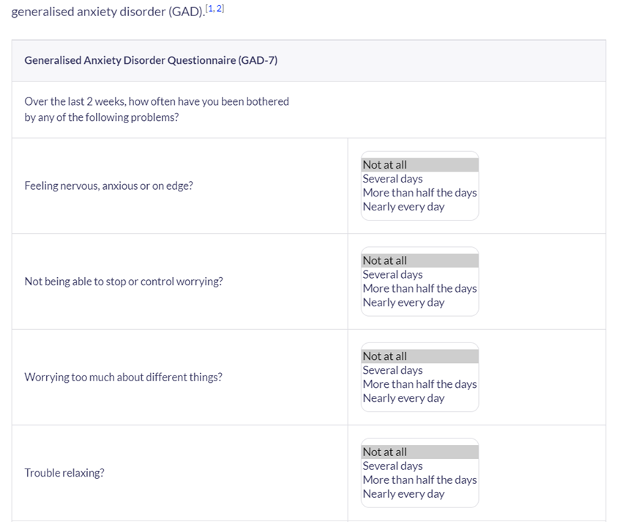

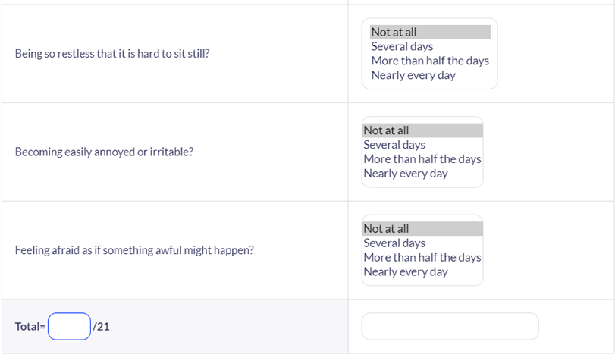

Appendix B

Indicators for rehabilitative care: ‘Quality Indicator for Rehabilitative Care (QuIRC-SA)’
The indicators to be considered are the these:
‘Living Environment’,
‘Therapeutic Environment’,
Treatments and Interventions,
Self-Management and Autonomy,
Social Interface,
Human Rights
Recovery Based Practice.

Appendix C

