16/11/2017
Identification and Evaluation of Starbucks Competitive Strategy
By Scott Rees P147192
Strategic Management and Sustainability (M3X9111)
BA Business Management

Contents
1. Executive Summary 2
2. Introduction 3
3. Main Findings 4
3.1 Research analysis and identification of Starbucks Competitive Strategy 4
3.2 An Analysis of Starbucks procedure to achieve Differentiation 7
3.3 Analysis on Advantages and Disadvantages of the Differentiation Strategy in the current environment 8
3.3.1 Disadvantage of Differentiation Strategy 8
3.3.1.1 Imitation 8
3.3.2 Advantages of Differentiation Strategy 9
3.3.2.1 Customer Loyalty 9
3.3.2.2 Distinctive Competencies 10
4. Conclusion 11
5. Recommendations 12
Bibliography 13

Executive Summary

- Purpose of the Report is to identify whether a Competitive Strategy influences development of Competitive Position.
- Organisational example Starbucks is used for the study.
- To identify Organisational Strategy used and Evaluate development of the Organisation’s Competitive Position.
- Report concluded Differentiation Strategy is used within Starbucks and it has developed the Organisation’s Competitive Position in the Coffee Industry.
- The outcome was achieved through Flexibility of the Matrix Structure.
- CEO Howard Schultz’s Goal and Direction.
- Practical Operations of Product and Service Innovation.
- Organisational Partnerships.
- Report identified Differentiation still could be improved within Starbucks.
- Relevant Recommendations were advised to further improve Differentiation and Competitive Position.
- Report analyses Central Advantages and Disadvantages of the Differentiation Strategy.
- Porter’s Generic Strategy Model was utilised to provide clear concept of Competitive Strategy for the study.

Introduction

The purpose of the report is to identify whether a Competitive Strategy can influence an Organisation to develop Competitive Position. To provide clear understanding of the following Strategies available for an Organisation, an Academic Model called Porter’s Generic Strategies Model will be used. Created by Michael E. Porter. In order to identify the effectiveness of a Strategy, focus on a specific Company will be conducted. Using the Generic Strategy Model and Secondary research, Starbucks Strategy will be identified and then analysed. Specifically, analysis will consist of whether the Strategy has developed the Organisation’s Competitive Position in the Coffee Industry and the measures Starbucks has taken achieved the desired Strategy. To further analyse effectiveness, focus will aim towards the central Advantages and Disadvantages of the discovered Strategy. After analysis and evaluation has been conducted, relevant recommendations will be provided to aid Starbucks Strategy and Competitive Position.

Main Findings

3.1 Research analysis and identification of Starbucks Competitive Strategy

To establish understanding of the different Competitive Strategies identified in theory and to discover which Strategy corresponds to Starbucks Current Competitive Position. A Competitive Strategy framework will be used from a leading Academic in the area.
Lower Cost Differentiation
- Cost Leadership | - Differentiation
3A. Cost Focus | 3B. Differentiation Focus

Broad
Target
Competitive Scope
Narrow
Target

Source: (Porter, 2004, p. 12).
Starbucks Differentiation Strategy was derived from the organisation’s goal and perception realignment directed by Howard Schultz. Instead of being perceived and judged by customer numbers, Howard Schultz desired Starbucks to be seen from the customer value and high-quality product it can deliver to the world. Making the organisation the definitive coffee seller in the industry, this desire adapted ‘Community. Connection. Respect. Dignity. Humor. Humanity. Accountability’ into the organisation’s global goal. The adaptions were infused into practical operations for example, the updated taste of Starbucks coffee conveyed the company message. Which is the organisation wants to establish a connection between customers and create a community realising Starbucks has a new competitive attitude that will not settle for anything less than industry dominance. (Schultz & Gordon, 2011).
Evidence supports Schultz and Gordon (2011) explaining Starbucks has used a Differentiation Strategy to dominate competitors and attain new customers for over a decade, through creating partnerships with other organisations across different markets. One collaboration consisted with ‘Hyatt Hotels’, the company would only provide Starbucks coffee through a widely recognised luxury coffee appliance called ‘French Press’ in their establishments. Also, Starbucks engaged consumers within the American Navy. Distributing shop services to bases through a large food trader ‘Sodexho’. (Seaford, Culp, & Brooks, 2012, p. 48).
Further evidence supports Schultz & Gordon (2011) and Seaford et al (2012) explaining, through the effective application of Differentiation and investment of technology. Starbucks has developed numerous digital facilities to improve the overall customer experience. The organisation has produced a new method through online mobile technology to improve product distribution, where consumers can purchase specific coffee flavours desired at any location and can pick up at the desired company store. Starbucks also introduced Wi-Fi technology and established connections with other companies to provide additional digital incentives. For example, reputable newspapers being The New York Times into coffee stores. Providing the following technological innovations Starbucks ensure customers will attain a unique experience not offered by competitors, therefore developing the organisation’s competitive position in the marketplace. (MarketLine, 2017).
Chen and Lee (2015) argues Differentiation Strategy is not conducted effectively throughout Starbucks’s operations, as detailed in the organisation’s environmental procedures within the country of Taiwan. One operation Starbucks introduced into the product it provides is ‘cup recycling’, in order to encourage a new sense of purchase value for customers and result in a developing competitor position. Although it failed to obtain maximum consumer attention. This is because a majority of customers in Taiwan have already witnessed the same procedures from competitors. (Chen & Lee, 2015).
Chen and Lee (2015) are supported with evidence explaining the Differentiation Strategy Starbucks use is not appropriately applied to all business practices, as detailed in the following study. Raw material obtainment of Coffee Beans is necessary to create Starbucks’s core product which is the drink Coffee itself. To ensure this, the organisation purchases the skills and raw materials from Coffee Bean Growers which are not associated with the company, therefore lowering fixed costs for the organisation. At the present it is considered ‘outsourcing material growing’ is a ‘practice followed by many companies’. (Pollard, Chuo, & Lee, 2016, p. 105).

It can be identified from analysis of previous evidence Starbucks does conduct a Differentiation Strategy industry wide, operating from western to eastern parts of the world. Although in some operations the strategy is not effectively conducted. Because of this Starbucks is compromising some development of Competitive Position in the marketplace. Starbucks must completely utilise the efficiency of the Differentiation Strategy, producing products or services unique to competitors and hold significant environmental benefits. Starbucks must also emphasize on competitive advantages of their Raw material obtainment. For example, Starbucks only choose farmers supplying the highest quality coffee bean and provide sufficient support to ensure farmers receive a safe and healthy working life. Performing the Differentiation Strategy more effectively in the specified areas, Starbucks will develop current competitive position further by persuading customers to purchase only from the organisation.
Although, it is essential to inform the Differentiation Strategy is effectively used at the customer service level. Providing a unique customer experience through In-Store and Mobile digital features and diverse availability.
The reason for the outcome above and how Starbucks can align itself with a Differentiation Strategy could be because of organisation’s structure, which is set out as a Matrix layout. Shown in the diagram below.
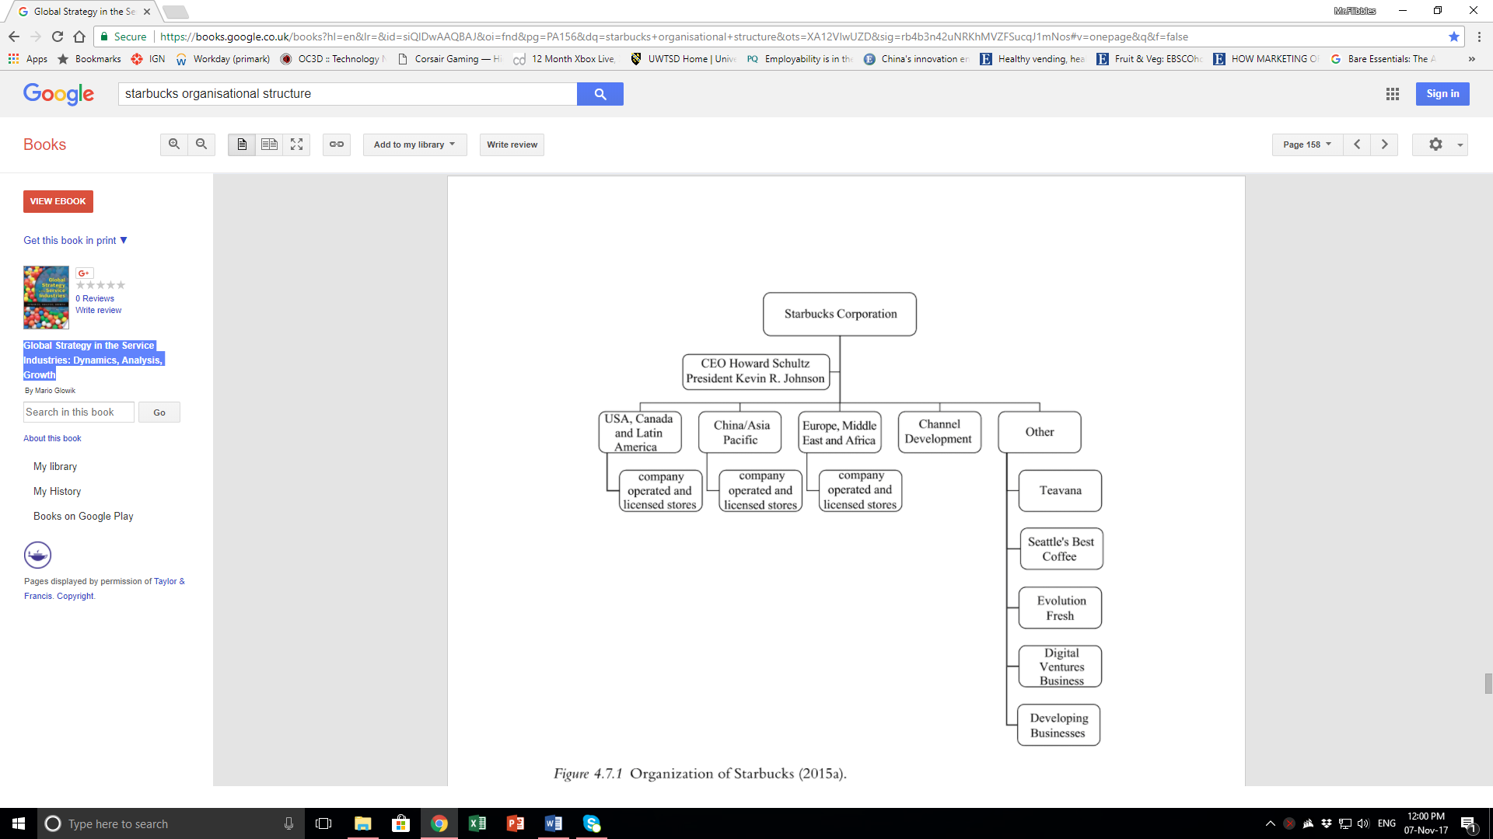
Source: (Glowik, 2017, p. 158)
A Matrix Organisational Structure consists of ‘departments that provide a stable base for specialised activities and a permanent location for members of staff’, similar to a hierarchal structure where purposes of sectors and staff expertise are clearly defined and recognised. This allowing Board Members, CEO etcetera to easily direct vital instructions down the layout to the correct sectors. Although Matrix possess ‘units that integrate various activities of different functions on a project team, product, programme, geographical or system basis’. Therefore, allowing Management lower down the organisation to exert control across the structure to specific staff who are located from different sectors. Although their skills are relevant to the project success and are appointed to the said project. This increase in lower management control encourages ‘flexibility, greater security and control of project information, and opportunities for staff development’ within the organisation. (Mullins & Christy, 2016).

3.2 An Analysis of Starbucks procedure to achieve Differentiation

To accomplish a Differentiation Strategy, Starbucks invests in innovation techniques to successfully diversify themselves from the competition and to become the leader in the coffee market. Innovation is conducted into the organisation’s product line, creating new flavours first to produce a differential variety. A past example is, ‘Pumpkin spice latte, one of the seasonal favorites at Starbucks, was recently relaunched’. During this time rivals ‘McDonald’s and Dunkin’, which launched the same coffee shortly before the relaunch, saw their market share recede’, whilst Starbucks market share increased. Shown in the diagram below.
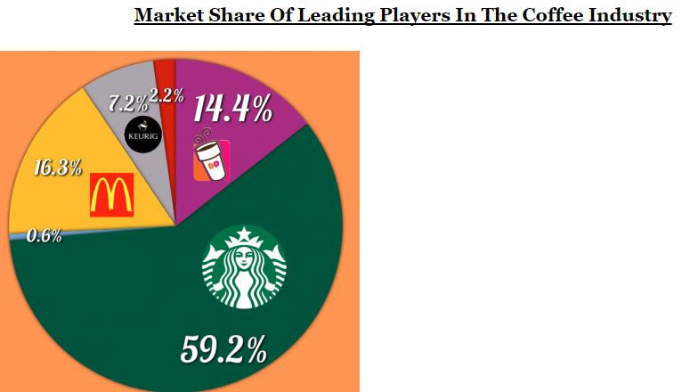
Source: (Team, 2016).
Although it can be argued, Starbucks Product Innovation has prevented organisational growth and differentiation. Specifically, the introduction of alcoholic beverages into stores. Even though the innovation helps diversify the organisation from competitors, it does not fulfil the differentiation strategy purpose to develop competitive position. Starbucks established the new products ‘to help increase traffic to its shops at night’. Although the innovation failed to achieve financial targets and the company rid the product line to prevent organisational harm. (Anderson, 2017).
Team (2016) argues against Anderson (2017) with evidence detailing further investment Starbucks directs to product innovation. Apart from adding unique products to the variety list, Starbucks also provided coffee customisation to further differentiate the product it can provide to customers. A customer can purchase a ‘espresso choice (e.g. regular, decaf, extra shots, half-caf), choice of syrup (e.g. hazelnut, vanilla, caramel), choice of milk (e.g. full fat, half-fat, fat free)’. In conducting this, Starbucks retained consumers, achieved growth and the organisation plans to keep coffee customisation as a long-term growth provider. (MarketLine, 2014).

3.3 Analysis on Advantages and Disadvantages of the Differentiation Strategy in the current environment

3.3.1 Disadvantage of Differentiation Strategy

3.3.1.1 Imitation

The Differentiation Strategy can succumb to risk of not being able to serve an organisation’s goal to achieve superior Competitive Positioning in the marketplace. For reasons such, the disadvantage is it solely depends on the uniqueness of marketing value created and delivered by an organisation. Without this, the strategy is ineffective and the organisation itself will experience an opposite effect of Competitors replicating the product or service. (Hooley, Piercy, & Nicoulaud, 2012).
Although further evidence argues a Differentiation Strategy leaves little impact to an organisation’s individuality, preventing smooth imitation from competitors and instead producing difficulties through strategy capability. The Differentiation Strategy is capable to provide focus on marketing value and especially product uniqueness through research and design. Processes which are specific to the company and difficult to be replicated rapidly. This increasing time for the differentiated organisation to maximise on competitive advantage, differentiate further and forcing competitors fall behind. (Banker, Mashruwala, & Tripathy, 2014).
Hooley et al (2012) argues against Banker et al (2014) explaining it is a recognised issue in the marketplace, a typical experience of numerous companies which release a unique product would be easily replicated by competing organisations. This ridding the aspiration to promote company individuality and undertaking a Differentiation Strategy. (Johnson, Scholes, & Whittington, 2008).
Further evidence supports Hooley et al (2012) detailing imitation negatively impacts the success of an organisation’s Differentiation Strategy. Within newly introduced large markets, an organisation who is the differentiative director among other companies will obtain further market data to help development of position. Afterwards competitors will acquire the already discovered data to replicate the leading organisation’s innovative processes. This increasing the similarity between the two entities and reducing profit for the market leader. (Yang, Cai, Chen, & Yang, 2017).

3.3.2 Advantages of Differentiation Strategy

3.3.2.1 Customer Loyalty

The Differentiation Strategy used in organisational service can have a significant advantage, it can establish customer loyalty to the brand and as a result creates customer fulfilment and oral communication between consumers. The outcome was identified through data analysis in a research survey, obtaining key member knowledge who possess a connection with the organisations in question. (Chenet, Dagger, & O'Sullivan, 2010).
Chenet et al (2010) is supported with further evidence explaining test results conducted in the present study, aimed towards customers who purchase one of two specific cleaning products correspond with past research. Which details if an organisation undertakes a higher differentiative approach to a product which stimulates the customer value image, it can be a beneficial factor to achieving customer loyalty. (Suh and Yi, 2006) cited by (Vera, 2016).
Chenet et al (2010) is supported with evidence explaining Customer Loyalty provides a beneficial impact to an organisation’s success. In order to achieve ‘customer loyalty and growth in sales, a supplier should not only offer superior quality of core goods/services, but also superior quality of supplementary and basic customer services’. This was evident in a primary data analysis of customer thoughts on specific businesses located within India. The data was inputted into a grid as shown below, showing the increase of organisational growth received in three years. Companies who focused on leading customer service quality received more growth than those who did not.
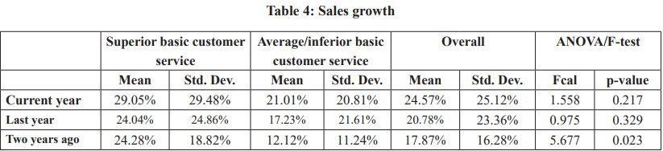
Source: (Dash, Havaldar, & Jacob, 2014, pp. 16,20).

3.3.2.2 Distinctive Competencies

Another advantage of the Differentiation Strategy is, it possesses the ability to encourage organisations using it to create opportunities of sustainability. This applies to the organisation’s competitive position and the strategy itself. To achieve the following, plans have to be created to establish ‘distinctive competencies’ which are ‘capabilities that are rare, valuable, costly to imitate and non-substitutable’ to competitors. Competencies will offer organisations leading customer service in line with the Differentiation Strategy. (Singleton & Nissen, 2014, p. 465).
Although it can be argued Competencies can possibly harm an organisation’s differentiation. This can occur when competencies have been widely, repletely used and have received extra layers of complexity. Therefore, failing the purpose of creating differentiation and forcing the organisation to stay in the current position. (Chrysostome, Nigam, & Jarilowski, 2013)
Although Singleton and Nissen (2014) are supported with further evidence, detailing ‘Capabilities are internal skills and practices that a firm possesses such as manufacturing processes, research and development, sales, distribution, and financial control’. Specific skills are then transferred to create ‘Distinctive Competencies’ unique opportunities to prevent competitor imitation, substitution and also increase differentiation. Competency uniqueness can be identified when it allows an organisation to deliver leading customer service. (Chen, et al., 2015, pp. 153-154).

Conclusion

From the findings in the report it can be concluded, a Differentiation Strategy is used within Starbucks to provide unique products of coffee and services to a large market. The utilisation of Differentiation is made possible through the Matrix Structure Starbucks operates within. This allows clear instructions from CEO etcetera to be sent down the organisation, although lower management possess greater opportunity for flexibility. Management can obtain specialised staff from different sectors and assign them to teams, in order to promote creative and differentiational products and services. It can also be explained Differentiation was achieved through the goal of Howard Schultz, Starbucks CEO. The goal consisted of enrichment to the customer experience and value, which influences the organisation’s Competitive Position to be the most developed within the industry.
Overall the Differentiation Strategy has been conducted effectively to Starbucks goal. The strategy has been able to facilitate and guide innovative procedures and organisational partnerships. Therefore, improving customer value delivered, competitive positioning and achieving differentiation. Although to inform, in minor areas such as environmental and material obtainment, Differentiation use could be improved and prevent competitive position to be sacrificed. The strategy itself is like any other approach a business can use, it is not perfect. Although with careful planning of use, advantages of customer loyalty and Distinctive Competencies can be utilised at maximum and disadvantages of competitor imitation can be avoided. Contributing further to an organisation’s development of competitive position. Careful planning is shown in the measures Starbucks has taken for example, Product Innovation of Coffee which has improved customer value, retained consumers and increased Starbucks market share and reduced competitors.
For the purpose of the report, Porter’s Generic Strategy model was used. In order to provide identification and perform analysis of the Strategy conducted within Starbucks. Even though the model was successful, it did possess limitations. It can be considered the model itself provides clear categorisation of the different strategies, although the model is basic as it provides minimal explanation between the strategies.
However, Bowman and Faulkner’s Strategy Clock provides a more detailed classification with positioning each strategy and organisation according to the level of perception and price. Also, the model provides identification of how organisations can fail. Using a term of getting stuck in the middle, organisations cannot align themselves to the targeted price and perception ideal for the market. Utilising the Strategy Clock in the report could have provided a deeper identification and analysis of Starbucks Strategy. Therefore, providing further enrichment to the reader’s knowledge in regards to the subject.

Recommendations

From the findings of the report, three recommendations will be advised for Starbucks, to ensure further Customer Value and Competitive Position Development. First recommendation is for Starbucks to ensure all differentiation strategies relate to the core product of coffee, the core customer and not to irrelevant products such as alcoholic beverages which are for a different market. The company must focus how the planned procedures will further enrich the coffee purchasing experience. Whether it is how the coffee influences senses, the store layout, the staff and additional services. The following factors will enable customers to perceive Starbucks as unique to competitors and the service it provides is related to the customer’s personal desires.
Secondly, Starbucks must focus on the Intangible Assets it possesses and use them to maximum capacity. One asset could be the organisation’s identity in terms for what it stands for, specifically customers or the industry. Using identity, the organisation can connect to the wider audience, obtain new customers and retain existing customers. Intangible Assets prove as measures which promote an organisation’s uniqueness and are problematic for competitors to imitate, enabling Starbucks to obtain a higher competitive position.
Thirdly, to establish a positive environmental image in consumer minds. Starbucks must not advertise the environmental procedures it conducts in countries where competitors have already influenced. For example, Taiwan. Instead the organisation must focus advertisement in areas which have not received and undertook sufficient environmental operations. In conducting this Starbucks will be the first to diversify from competitors and attain a developing competitive position.

Bibliography
Anderson, G. (2017, January 18th). Starbucks Knows How To Fail Fast, Just Like Amazon. Retrieved November 14th, 2017, from Forbes: https://www.forbes.com/sites/retailwire/2017/01/18/starbucks-knows-how-to-fail-fast-just-like-amazon/#35e4651d7ea2
Banker, R. D., Mashruwala, R., & Tripathy, A. (2014). Does a differentiation strategy lead to more sustainable financial performance than a cost leadership strategy? Management Decision, 52(5), 875-876. Retrieved November 12th, 2017, from https://search.proquest.com/docview/1633967188?accountid=130472
Chen, D. C., Overby, J., Padgett, b. L., Long, N., Mellot, L. H., Vandermark, L., . . . Boone, L. (2015). INSTRUCTOR'S NOTES: SPRINKLES CUPCAKES: A CASE STUDY OF CREATING A SUCCESSFUL INTERNATIONALIZATION STRATEGY. Journal of the International Academy for Case Studies, 21(4), 153-154. Retrieved November 13th, 2017, from https://search.proquest.com/docview/1761070620?accountid=130472
Chen, M.-F., & Lee, C.-L. (2015). The impacts of green claims on coffee consumers' purchase intention. British Food Journal, 117(1), 203-204. Retrieved November 6th, 2017, from https://search.proquest.com/docview/1647084654?accountid=130472
Chenet, P., Dagger, T. S., & O'Sullivan, D. (2010). Service quality, trust, commitment and service differentiation in business relationships. The Journal of Services Marketing, 24(5), 336,340. Retrieved November 13th, 2017, from https://search.proquest.com/docview/734457923?accountid=130472
Chrysostome, E., Nigam, R., & Jarilowski, S. C. (2013). Revisiting Strategic Learning in International Joint Ventures: A Knowledge Creation Perspective. International Journal of Management, 30(1), 92. Retrieved November 13th, 2017, from https://search.proquest.com/docview/1315137193?accountid=130472
Dash, M., Havaldar, K. K., & Jacob, A. (2014). Exploring a New Dimension of Customer Service and its Impact on Sales Growth and Loyalty. International Journal on Customer Relations, 2(1), 16,20 . Retrieved November 13th, 2017, from https://search.proquest.com/docview/1845261696?accountid=130472
Glowik, M. (2017). Global Strategy in the Service Industries: Dynamics, Analysis, Growth (1st ed.). Abingdon, England, United Kingdom: Routledge. Retrieved November 7th, 2017, from https://books.google.co.uk/books?hl=en&lr=&id=siQlDwAAQBAJ&oi=fnd&pg=PA156&dq=starbucks+organisational+structure&ots=XA12VIwUZD&sig=rb4b3n42uNRKhMVZFSucqJ1mNos#v=onepage&q&f=false
Hooley, G., Piercy, N. F., & Nicoulaud, B. (2012). Marketing Strategy & Competitive Positioning (5th ed.). Harlow, England, United Kingdom: Pearson Education Limited. Retrieved November 11th, 2017
Johnson, G., Scholes, K., & Whittington, R. (2008). Exploring Corporate Strategy Text & Cases (8th ed.). Harlow, England, United Kingdom: Pearson Education Limited. Retrieved November 11th, 2017
MarketLine. (2014, June 27th). Starbucks Corporation Accelerated growth plan. MarketLine Case Study, 10. Retrieved November 14th, 2017, from http://advantage.marketline.com.ezproxy.uwtsd.ac.uk/Product?ptype=Case+Studies&pid=ML00017-028
MarketLine. (2017). COMPANY PROFILE Starbucks Corporation. London: MarketLine. Retrieved November 2nd, 2017, from http://advantage.marketline.com.ezproxy.uwtsd.ac.uk/Product?ptype=Companies&pid=E86AFA79-07E1-4115-AA0C-0016416541FE
Mullins, L. J., & Christy, G. (2016). Management and Organisational Behaviour (11th ed.). Harlow, England, United Kingdom: Pearson Education Limited. Retrieved November 7th, 2017, from https://www-dawsonera-com.ezproxy.uwtsd.ac.uk/readonline/9781292088518/startPage/655/1
Pollard, D., Chuo, S., & Lee, B. (2016). Strategies For Mass Customization. Journal of Business & Economics Research (Online), 14(3), 105. Retrieved November 6th, 2017, from https://search.proquest.com/docview/1804900743?accountid=130472
Porter, M. E. (2004). Competitive Advantage Creating and Sustaining Superior Performance (1st ed.). New York, New York, United States of America: Free Press A Division of Simon & Schuster Inc. Retrieved November 9th, 2017
Schultz, H., & Gordon, J. (2011). Onward How Starbucks Fought for Its Life without Losing Its Soul (1st ed.). Chichester, England, United Kingdom: John Wiley & Sons. Retrieved November 6th, 2017, from https://www-dawsonera-com.ezproxy.uwtsd.ac.uk/readonline/9781119979227/startPage/9/1
Seaford, B. C., Culp, R. C., & Brooks, B. W. (2012). STARBUCKS: MAINTAINING A CLEAR POSITION. Journal of the International Academy for Case Studies, 18(3), 48. Retrieved November 2nd, 2017, from https://search.proquest.com/docview/1037815154?accountid=130472
Singleton, J. A., & Nissen, L. M. (2014). Future-proofing the pharmacy profession in a hypercompetitive market. Research in Social and Administrative Pharmacy, 10(2), 465. Retrieved November 13th, 2017, from https://ac-els-cdn-com.ezproxy.uwtsd.ac.uk/S1551741113000971/1-s2.0-S1551741113000971-main.pdf?_tid=a3c5834e-c8a4-11e7-8cd6-00000aacb362&acdnat=1510599691_67aecf0bee8b25e6c2511c878b39f120
Team, T. (2016, October 13th). Starbucks Is Maintaining Its Competitive Edge. Retrieved November 14th, 2017, from Forbes: https://www.forbes.com/sites/greatspeculations/2016/10/13/how-is-starbucks-maintaining-its-competitive-edge/#3eacca40759c
Vera, J. (2016). Two paths to customer loyalty: the moderating effect of the differentiation level strategy in the performance-satisfaction-value-intentions relationship. The Journal of Product and Brand Management, 25(2), 171,178. Retrieved November 13th, 2017, from https://search.proquest.com/docview/1826809603?accountid=130472
Yang, X., Cai, G., Chen, Y.-J., & Yang, S.-J. (2017, June). Competitive Retailer Strategies for New Market Research, Entry and Positioning Decisions. Journal of Retailing, 93(2), 183. Retrieved November 12th, 2017, from https://search.proquest.com/docview/1903916695?accountid=130472

