

ASSASMENT 1
Student name:​ Maritza Ramirez Rivera

Student ID:2020220951 ​

Module name: Living with Care :The Older People

Module code: BMHP6009

Lecturer name: Dr Leila Surani

Date: Submission of Supporting Paper 11th August 2023,2pm (UK time).

Introduction:
In this debate, we will sustain the disadvantages of older people with the use of technology and the negative impact of technology on the aging population of the UK and older person's life. Here we will explain all the negative effects on older people. The following supplementary essay will focus on the unfavourable aspect of the discussion surrounding how the UK's ageing population uses technology. The discussion's stance will be described in this supplemental document, along with the benefits and drawbacks of the use of technology by older people. A personal assessment of the critical issues mentioned selected issue will also be explored in the paper during the discussion. Moreover, the current UK government's assistance for senior services and the effects of the pandemic on the supporting article will also discuss the ageing of the UK population.

- Physical
- Social Isolation
- Memory and Cognitive Issues
- Perception, Mobility and Balances, Change in Vision and hearing

When with talking about mind physical ability When with talking about the mind's physical ability, older people The UK (United Kingdom) has a population that is getting older, with one in every five individuals aged 65 or over in 2019, up from one in every six people in 1999 and indicates to be one in every four by 2029 . Because of their fragility, restricted mobility, and diminished physical reserves, elderly individuals are more prone to trauma and its sequelae, according to Kirshenbom et al. (2017). In the UK, 6312 patients aged 60 years and over were killed or seriously injured in MVCs in 2019 .

Social isolation Describe the absence of social bonds. Socially isolated people have little interaction with others in their everyday life. Social isolation may impact everyone for several causes, resulting in various adverse health effects. The possible effects include :

- Loneliness
- Depression
- Poor sleep quality
- Impaired immunity
- Accelerated cognitive decline
- Poor cardiovascular function
- Impaired executive function
- Increased risk of premature death

Memory and cognitive issues It provides practical principles for design experts to follow to adapt to these changes and better satisfy the requirements of older persons. Designing for older folks is inclusive in that it accommodates a wide range of physical and cognitive abilities while promoting simplicity, adaptability, and ease of use for persons of all ages.
According to (www.ncbi.nlm.nih.gov) The following subsections address typical and anticipated changes in sensory function, movement, and cognition as people age and provide practical advice for adapting to these changes.

Perception, Mobility and Balances, Change in Vision and hearing

Standing point :

The standpoint in the debate chosen for further discussion is that the ageing UK population does not require technology usage. The first point of emphasis is technology's loss of physical exercise, which contributes to several ailments like high blood cholesterol, CVD, and others. Older adults in the UK are becoming more sedentary because they may now complete their everyday tasks with technology. Loneliness and social isolation are a topic of discussion that has also received much attention. Most seniors are turning away from online purchasing since going to physical stores allows them to interact with friends and have a strong sense of social duty. It has been estimated that aged people above 75 years of age are not much aware of the scams, fraud and privacy taking place due to online transactions .According to (Bailey et al., 2021). Additionally, the most aged. The population struggles with cognitive issues that make it hard for them to recognise and have knowledge about cybercrimes Technologies launched without surveying and consulting older adults lead to failures in the market. Experts worldwide may face various barriers while designing technologies that can meet individuals’ unique needs and limitations. This leads to changes in vision and mobility prospects and limits their functioning. Moreover, the covid-19 pandemic harmed the life of older people as travel, visits and interactions became restricted, resulting in extreme loneliness.

Theory of ageing relevant to the topic:
Disengagement Theory

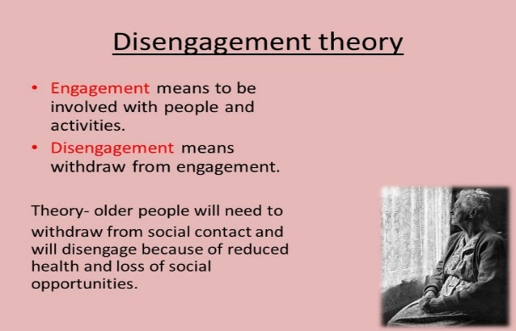

The Disengagement Theory contends that excessive and unfavourable effects of technology
use may cause older people to become detached and withdraw when utilised by the growing
the older population of the UK. As technology develops quickly, older adults may find it difficult to continue keeping up with the digital world could lead to fewer interactions with others,
emotions of isolation, and a decline in mental and emotional health (Nickerson, 2023).
The increasing dependence on technological devices for interaction, knowledge, and daily activities could unintentionally bar older people from taking part in a range of social activities, widening generational divides. By restricting older people 63; access to resources, information, and connections and widening existing age-related disparities, this disinterest in technology could lower older people 63; overall quality of life and make it more difficult for them to integrate into developing modern society (Foster & Walker, 2021).

Current statistical data on the negative impact of the use of technology on elderly people.

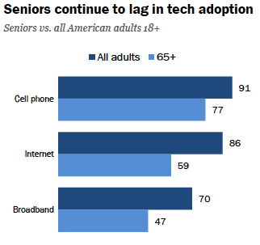
The graph above illustrates how seniors and older people who are 65 or older reject technology. From the graph above, this age group uses broadband, cell phones, and the internet potentially less frequently than when adults of various ages are gathered together. Regarding broadband, 70% of all adults use this technology, but just 47% of seniors over 65 use it.
Similarly, older persons use the internet and cell phones at rates of 59% and 77%, respectively, compared to 86% and 91% of all adults.

UK government services for supporting the elderly population in the UK
Services NHS elderly Care.

The UK government offers several healthcare services primarily aimed at the senior population through NHS, or the National Health Service (NHS, 2023). These services include specialised medical care, geriatric assessments, residential care, and community support to guarantee senior adults' general health and wellbeing.

Financial Assistance and Pension.
The UK government provides pensions and benefits to senior citizens who want financial assistance. The government pension system ensures a consistent income for seniors, giving them a measure of financial security (GOV.UK, 2021). Additional benefits like Participation Compensation and Winter Fuel Payment cater to the unique needs of the elderly. These elements provide financial support to cover supplemental costs and assistance during winter.

Impact of the pandemic on the ageing UK population.

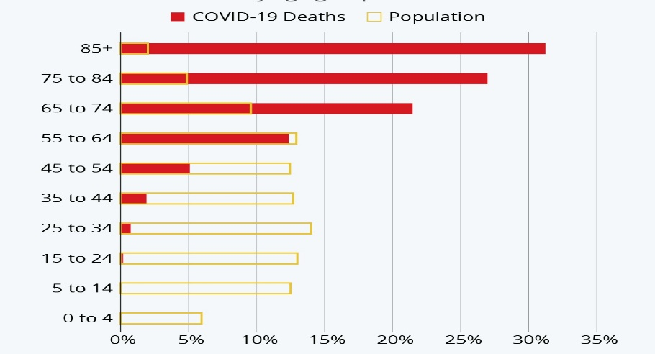

The COVID-19 epidemic has considerably impacted the older population in the UK.
Older adults, particularly those with pre-existing medical issues, were more likely to suffer from fatal illnesses and other catastrophic conditions. The adverse effects of the pandemic on the senior population in the UK in 2020 are depicted in the graph above. The graph above shows that Covid-19 had a substantially more significant than 30% impact on the oldest population—those who were 85 years or older. This is closely followed by 27% of adults aged 75 to 84, which indicates that there have been about 150,000 deaths in just this age group. The enforced social isolation brought on by the virus exacerbated the mental health problems of seniors. The social isolation brought on by the virus's tight lockdown measures worsened things. Routine care and medical procedures were delayed as a result of the increase. According 2020 (Richardson et al.). The pandemic highlighted the vulnerabilities of the elderly and the requirement for professional support, improved medical facilities, and effective .They are handling crises to guarantee their security in such situations.

Reflection on the information provided in the debate

The evidence provided in the debate regarding the negative impact of technology on the elderly UK population is valid and up-to-date. The physical aspects
discussed in the debate are vital for discussing the impact of technology on the mobility and
vision of these age groups. I also believe that the scams and frauds caused by these technologies are growing daily as changes within the grey-and-white matter within the brain make it hard for them to recognise these cybercrimes. I have prepared this supporting paper also focusing on designing technology for these adults should be thoughtful and universal. Further, I have realised that the changes that come with age and the impact of the pandemic on the daily life activities of the elderly UK population have been presented effectively in the debate.
References:
- Absolute Trust Counsel. (2019). How Problems With Using Technology Can Lead to Earlier Dementia diagnosis. Available at: https://absolutetrustcounsel.com/how-problems-with-using-technology-can-lead-to-earlier-dementia-diagnosis/. (Accessed: 3/7/2023)​

- Age UK (2016). The Internet and Older People in the UK -Key Statistics. Available at: https://www.ageuk.org.uk/globalassets/age-uk/documents/reports-and-publications/reports-and-briefings/active-communities/rb_july16_older_people_and_internet_use_stats.pdf. (Accessed: 25/6/2023)​

- Age UK (2021). Briefing Paper Digital inclusion and older people -how have things changed in a Covid-19 world? Available at: https://www.ageuk.org.uk/globalassets/age-uk/documents/reports-and-publications/reports-and-briefings/active-communities/digital-inclusion-in-the-pandemic-final-march-2021.pdf. (Accessed: 25/6/2023)​

- Age UK (2021). Nearly Two Million over-75s in England Are Still Digitally Excluded in a COVID-19 World. Available at: https://www.ageuk.org.uk/latest-press/articles/2021/nearly-two-million-over-75s-in-england-are-still-digitally-excluded--in-a-covid-19-world/. (Accessed: 7/7/2023)​
- Barbosa Neves, B. and Vetere, F. (2019). Ageing and Digital Technology. Springer Singapore. doi:https://doi.org/10.1007/978-981-13-3693-5. (Accessed: 3/7/2023)​

- Absolute Trust Counsel. (2019). How Problems With Using Technology Can Lead to Earlier Dementia diagnosis. Available at: https://absolutetrustcounsel.com/how-problems-with-using-technology-can-lead-to-earlier-dementia-diagnosis/. (Accessed: 3/7/2023)

- Age UK (2016). The Internet and Older People in the UK -Key Statistics. Available at: https://www.ageuk.org.uk/globalassets/age-uk/documents/reports-and-publications/reports-and-briefings/active-communities/rb_july16_older_people_and_internet_use_stats.pdf. (Accessed: 25/6/2023)

- Age UK (2021). Briefing Paper Digital inclusion and older people -how have things changed in a Covid-19 world? Available at: https://www.ageuk.org.uk/globalassets/age-uk/documents/reports-and-publications/reports-and-briefings/active-communities/digital-inclusion-in-the-pandemic-final-march-2021.pdf. (Accessed: 25/6/2023)

- Age UK (2021). Nearly Two Million over-75s in England Are Still Digitally Excluded in a COVID-19 World. Available at: https://www.ageuk.org.uk/latest-press/articles/2021/nearly-two-million-over-75s-in-england-are-still-digitally-excluded--in-a-covid-19-world/. (Accessed: 7/7/2023)

- Barbosa Neves, B. and Vetere, F. (2019). Ageing and Digital Technology. Springer Singapore. doi:https://doi.org/10.1007/978-981-13-3693-5. (Accessed: 3/7/2023)
- Absolute Trust Counsel. (2019). How Problems With Using Technology Can Lead to Earlier Dementia diagnosis. Available at: https://absolutetrustcounsel.com/how-problems-with-using-technology-can-lead-to-earlier-dementia-diagnosis/. (Accessed: 3/7/2023)

- Age UK (2016). The Internet and Older People in the UK -Key Statistics. Available at: https://www.ageuk.org.uk/globalassets/age-uk/documents/reports-and-publications/reports-and-briefings/active-communities/rb_july16_older_people_and_internet_use_stats.pdf. (Accessed: 25/6/2023)

- Age UK (2021). Briefing Paper Digital inclusion and older people -how have things changed in a Covid-19 world? Available at: https://www.ageuk.org.uk/globalassets/age-uk/documents/reports-and-publications/reports-and-briefings/active-communities/digital-inclusion-in-the-pandemic-final-march-2021.pdf. (Accessed: 25/6/2023)
- Age UK (2021). Nearly Two Million over-75s in England Are Still Digitally Excluded in a COVID-19 World. Available at: https://www.ageuk.org.uk/latest-press/articles/2021/nearly-two-million-over-75s-in-england-are-still-digitally-excluded--in-a-covid-19-world/. (Accessed: 7/7/2023)

- Barbosa Neves, B. and Vetere, F. (2019). Ageing and Digital Technology. Springer Singapore. doi:https://doi.org/10.1007/978-981-13-3693-5. (Accessed: 3/7/2023)

