

Module Name: International Marketing: Principles and Practices
Module Code: LCMB7028
Individual Report on International Market Entry Strategy and Marketing Mix – Cadbury (UK & India)
Lecturer’s Name: Tola odugbesan
Student Name: Vivekkumar Yatinbhai Patel
Student ID: 2523277
Submission Date: 13th Aug 2026

Word count = 4600 (excluding references, tables, and headers).

Term 2

Executive Summary
The following report analyses Cadbury’s international marketing strategy by comparing its domestic market in the UK with India. It becomes clear that the UK market represents a mature and well-developed confectionary market while India provides good growth potential; however, the market should be better adapted to the local culture, price sensibilities, climate and fragmented distribution system. PESTLE, Hofstede’s cultural dimensions, STP, and 7 Ps help understand how Cadbury adjusts its products, prices, promotion and distribution to the local conditions.
According to the report, the key factors behind the localization success achieved by Cadbury in India include cost-effective products, cultural promotions, package modification, and wide distribution network. The wholly owned subsidiary was instrumental for having complete control over production, branding, and local supply chain. The recommendations in the report call for more premiumization of products, health benefits, sustainable packaging, efficient cold chain logistics, and use of quick-commerce platforms.
AI Acknowledgement
AI technologies have been employed in aiding the development of this report, particularly in the editing process. The author is entirely accountable for the research, findings, analysis, interpretations, recommendations, and conclusion.

Contents
1.0 Section 1: International Market Analysis & Strategy 2
1.1 Introduction and Strategic Background 2
1.2 Macro-Environmental Comparative Analysis (PESTEL) 3
1.3 Socio-Cultural Analysis via Hofstede’s Cultural Dimensions 7
1.4 Comparative Segmentation, Targeting, and Positioning (STP) 10
1.5 Comparative International Marketing Mix (7Ps) 12
1.6 Evaluation of Market Entry Strategy in India 16
1.7 Critical Analysis of Ethical Controversies in the Host Market 18
1.8 Forward-Looking Strategic Recommendations 20
Section 2: Reflective Account on Research and Analytical Process 21
2.1 Description 21
2.2 Feelings 22
2.3 Evaluation 22
2.4 Analysis 22
2.5 Conclusion 23
2.6 Action Plan 24
3.0 References 26

1.0 Section 1: International Market Analysis & Strategy

1.1 Introduction and Strategic Background
Cadbury is a well-known brand among multinational confectionery companies in the world of commerce and acts as an excellent example of a company that would help examine international marketing adaptation in different economic environments. Originating from Birmingham, UK, in 1824 by John Cadbury, the company grew from a small store that sold tea, coffee, and drinking chocolate to a large-scale confectionery brand that is currently owned by Mondelēz International. The brand entering other markets illustrates the conflicting interests in brand equity standardization and local conditions. This report will review the marketing of Cadbury by contrasting the UK home market and India, which is Cadbury's primary emerging market.
There are reasons why we choose UK and India for comparison. They have different economic and cultural backgrounds. The UK is a developed and highly-consolidated market for confectionery with high levels of consumption and dominating supermarkets retail formats. On the other hand, India is a developing and highly fragmented market where there is an emerging retail infrastructure, climatic differences and a strong socio-cultural tradition of consuming sweets. In order to understand Cadbury's strategy in both markets, we need to study macro-environment factors, culture, segmentation and marketing tactics.
Table 1: Comparative Strategic Profile of Cadbury’s UK and Indian Markets 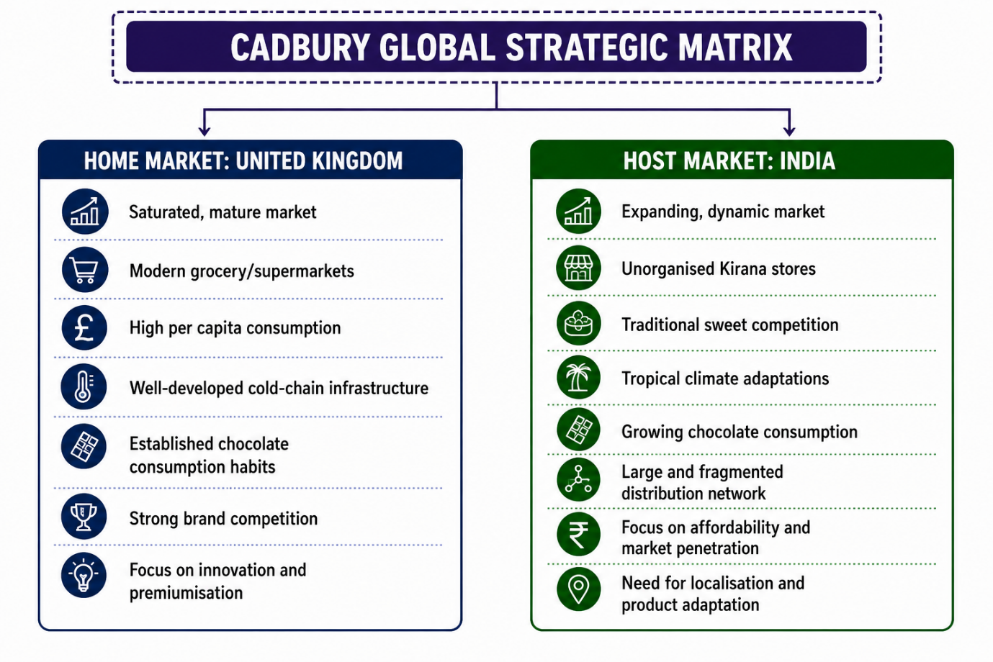

1.2 Macro-Environmental Comparative Analysis (PESTEL)
Political Factors
The political environment has direct influence on how multinational candy companies operate. In the UK, political stability is a feature of the environment, but regulations meant for enhancing the health of citizens have increased considerably within the last decade. The UK government passed Health and Care Act regulations prohibiting HFSS products' marketing at various retail stores and online channels (Department of Health and Social Care, 2022). This change in legislation compelled Cadbury to adapt its marketing strategies and placement of products.
The political strategy in India Favors the production locally and digitalization, thereby providing a very different business environment. In the case of the Indian government’s “Make in India” strategy, there is motivation for foreign companies to set up their manufacturing plants in the country, something that was adopted by Cadbury through the establishment of manufacturing plants in Baddi and Sri City (IBEF, 2023). In addition to that, foreign direct investments rules in single-brand and multi-brand retail have previously played an important role in how international firms distribute their products across different Indian states.
Economic Factors
The economic metrics indicate the structural discrepancies that exist regarding the purchasing power, market growth patterns, and sensitivity to prices in both mature and developing countries. The United Kingdom has high GDP per capita, which means there is consistency in consumer purchasing power and expenditure on luxury or impulsive snacks (Office for National Statistics, 2023). However, there have been macroeconomic forces like rising prices of energy and ingredients that have put pressure on profit margins, thus necessitating the adjustment of prices for the products of Cadbury. The market is mature; growth is linear.
Table 2: Economic Profile Comparison of the UK and Indian Markets
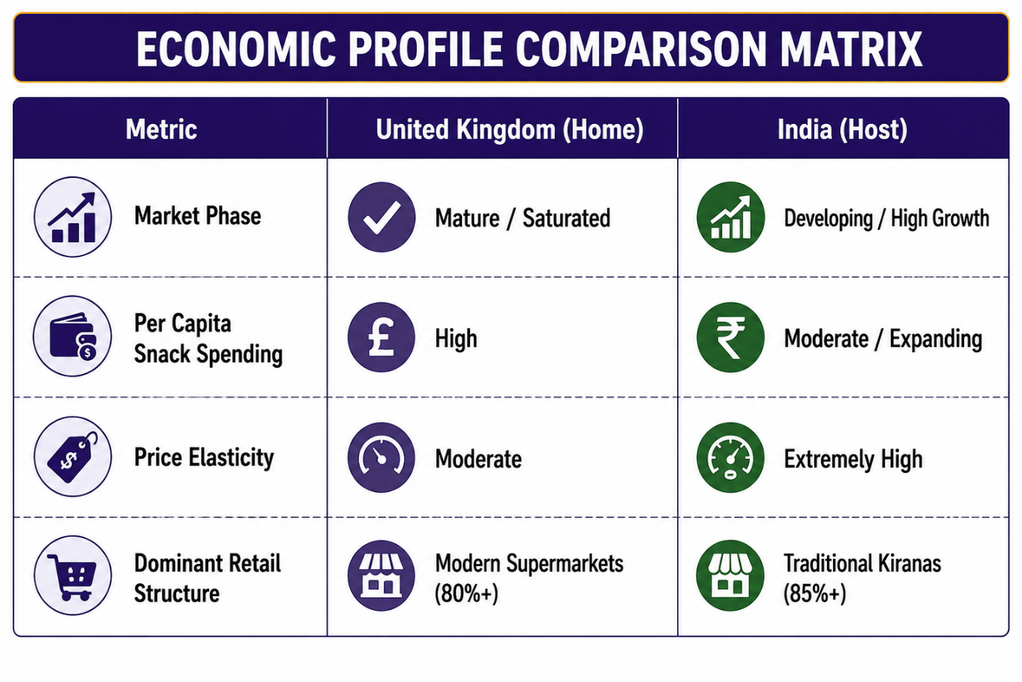 Unlike the case for India, the FMCG industry in the country is driven by the growth of the middle class and an increase in disposable income (IBEF, 2023). Consumers in India tend to be very price sensitive. A small increase in prices can lead to loss of market share. In order to penetrate into the rural and semi-urban markets, Cadbury employed price points per unit which were quite low. For example, Cadbury sold small packs of chocolate for prices ranging from 5 INR to 10 INR and 20 INR.
Socio-Cultural Factors
The socio-cultural trends determine consumer eating behaviors, gift-giving behaviors, and perceptions of brands around the globe. The consumption of chocolates in Britain has been deeply rooted into daily life, emotional comfort, and holiday traditions including Easter and Christmas (Faber, 2019). The contemporary UK marketplace has increasingly become health conscious and therefore there has been increasing demand for low sugar content, dark chocolate, and even vegan varieties. The eating behavior is frequent, personal, and indulgent.
In India, the consumption of traditional sweetmeats (mithai) has traditionally dominated consumer behaviors during festive periods, weddings, and family occasions. Chocolate used to be considered as an exotic, pricey, and artificial product. Cadbury brought about a socio-cultural revolution over many years through positioning its chocolate as a hygienic and modern substitute of the traditional sweets. Cadbury positioned itself in the Indian culture successfully and replaced mithai in cultural festivals including Diwali and Raksha Bandhan.
Technological Factors
Technology is what determines the integrity of the supply chain, the ability to integrate with e-commerce, and promotions. The UK is blessed with a sophisticated logistics network and country-wide cold-chain facilities which ensures the quality of products despite temperature variations in the supply chain. Integration with e-commerce is very high because the majority of FMCG sales is done through online grocery shopping.
In India, there is a fast digital world combined with poor physical infrastructure. Despite the high speed internet connection and unified payments interface (UPI), which transformed mobile commerce, the cold-chain logistics infrastructure is highly inadequate outside the metropolitan cities. This makes the chocolates melt due to high atmospheric temperatures. To cope with this infrastructural limitation, Cadbury introduced modified packaging technology, product formulations, and visicoolers.
Environmental Factors
Environmental concerns and sustainability requirements have increased the pressure on the confectionery industry across the globe. In the United Kingdom, environmental policies along with consumer pressure require sustainable packaging and responsible source of ingredients. The UK Plastic Packaging Tax policy requires a threshold amount of recycled material, which has resulted in Cadbury UK making the Dairy Milk packaging eco-friendly by using only 100% recyclable paper and recycled plastic packages (Mondelēz International, 2022).
In India, environmental issues are related to plastic waste management, sustainability in agriculture, and extreme heatwaves due to climate change. India's Ministry of Environment, Forest and Climate Change has introduced the Extended Producer Responsibility policy to take care of post-consumer plastic waste management (MoEFCC, 2022). Cadbury India needs to be economical about micro-packaging and comply with environmental policies. It also needs to support sustainable cocoa cultivation in agriculture programs to safeguard against yield variability due to climate change.
Legal Factors
Compliance regimes are set out in legislation and define the standards required for food safety, labelling, and compliance processes in various international jurisdictions. In the case of the UK, the regulatory regime is handled by the Food Standards Agency (FSA), which has stringent requirements concerning nutrition information, allergens, and ingredients traceability. Lack of compliance could lead to severe penalties and brand equity loss.
As regards India, the food regulation body in that country is the Food Safety and Standards Authority of India (FSSAI). The FSSAI sets very high standards concerning food additives, shelf-life information, and vegetable fat content information on chocolate products. For foreign brands, compliance in India involves navigating through a complex legal environment that varies from state to state in India.

1.3 Socio-Cultural Analysis via Hofstede’s Cultural Dimensions
An appreciation of the cultural gap that exists between the UK and India is crucial for grasping the marketing changes made by Cadbury. The cultural dimensions of Hofstede present an analysis tool for assessing the differences.
Table 3: Hofstede’s Cultural Dimensions: UK–India Comparison
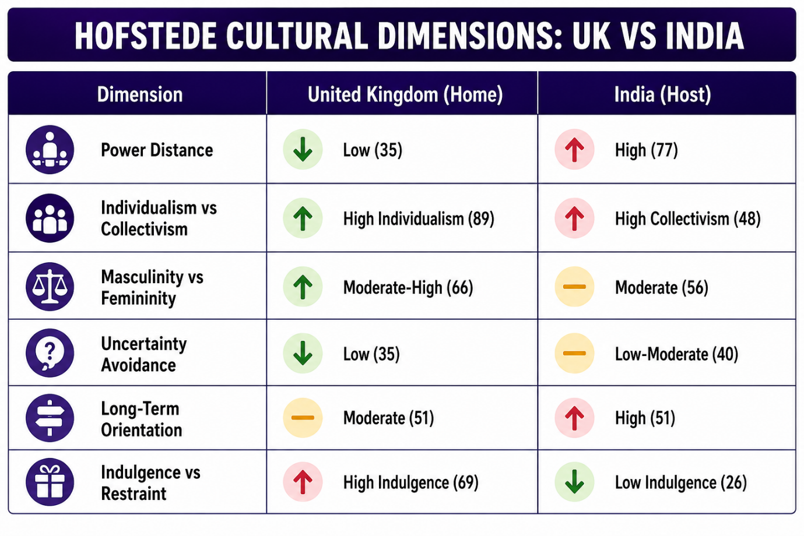Power Distance
The UK ranks lowly on Power Distance (35) and is considered egalitarian in nature with decentralized authority and consumer brand interaction that is informal in nature. Communication marketing strategies in the UK are driven by individuality, egalitarianism, and self-depreciating humor. Many of Cadbury's ads in the UK include common people in egalitarian settings without any reference to authority or status driven elements.
India rates highly on Power Distance (77) and has a society that accepts hierarchical order and stratification of its society. In societies with high power distance, authority figures such as elders within the family, celebrities and other respected individuals have considerable persuasive powers. Cadbury was able to leverage this social element in their marketing strategy by using the services of famous celebrity ambassadors to restore the faith of consumers in crisis situations, particularly Amitabh Bachchan of Bollywood.
Individualism vs Collectivism
The UK is one of the most individualistic societies in the world with a score of 89. The consumer culture in the UK focuses on individual satisfaction, individuality, and rewarding oneself. Snack marketing in the UK views chocolate eating as a self-indulgence activity or an individual break amidst a busy working day. Brands such as “Cadbury Twirl” or “Cadbury Boost” fit into the theme of individual indulgence.
The Indian culture is a collectivist one, which scores 48. Social harmony, extended families, and strong community relationships influence the choices that people make in their consumption behavior. Sweet products are not consumed for self-satisfaction alone; they are bought to be shared by the community, celebrating milestones of the family, or enjoying the collective joy. Cadbury has adapted its marketing strategy in the Indian scenario based on the collectivist orientation. Cadbury chocolates were marketed through slogans such as “Shubh Aarambh” (Auspicious Beginnings) or “Kuch Meetha Ho Jaaye” (Let’s Have Something Sweet).

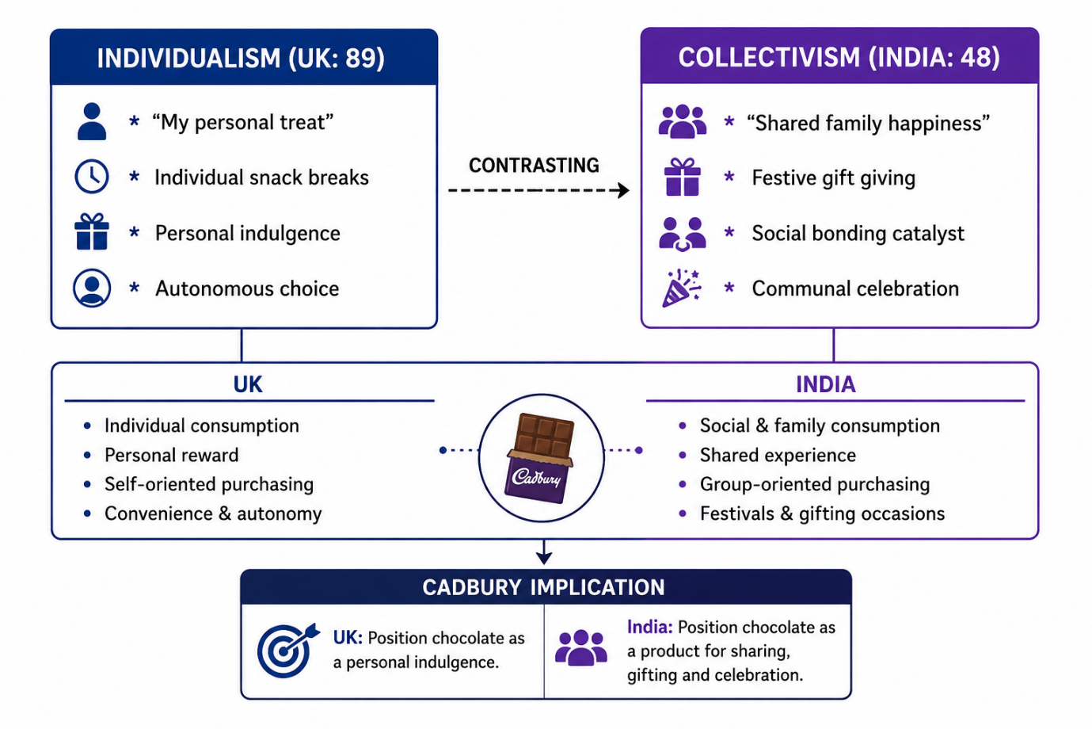Indulgence vs Restraint
In the UK, the society ranks high on Indulgence (69), signifying that there is a propensity for indulgence, enjoyment, and pleasure in their lifestyle. Chocolate in the British society is used as an indulgent and luxurious item for the common masses. Therefore, their consumers are sensitive to hedonistic appeals.
However, India ranks quite low on Indulgence (26), which reflects a conservative society that focuses on their duties, saves money, and leads a simple lifestyle rather than enjoying life. Spending money on luxurious items for purely personal reasons evokes a sense of guilt in the consumer. In order to break through this cultural barrier, Cadbury needed to market its chocolate as a viable alternative to traditional Indian sweets in festivals.

1.4 Comparative Segmentation, Targeting, and Positioning (STP)
Table 3: Hofstede’s Cultural Dimensions: UK–India Comparison
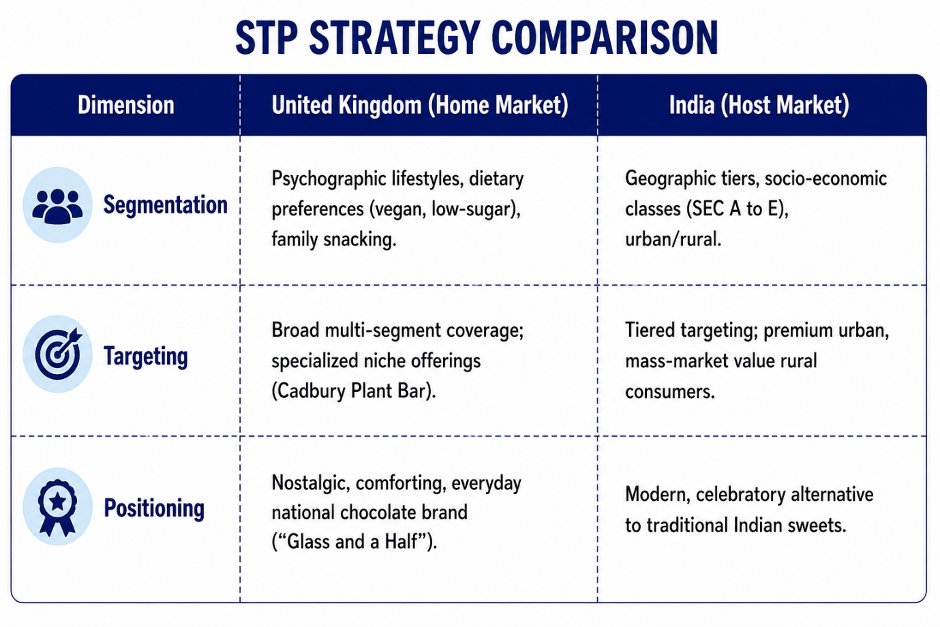Segmentation Strategies
Segmentation methods need to be changed depending upon the differences in demography, geography, and psychology of the population in different markets. The UK market uses a lot of psychographic segmentations along with lifestyle, eating habits, and demographics. Segmentation in Cadbury’s UK market is time-strapped commuters needing energy, families purchasing multipack of chocolates, consumers searching for low-calorie chocolates, and premium gift chocolate buyers. Geography based segmentation in the UK market is mostly homogeneous because of uniformity in the retail structure.
The Indian market, however, depends more upon geographic and economic segmentation due to regional differences. Segmentation in the Cadbury Indian market is Tier I urban cities, Tier II/III developing towns, and the rural hinterland. Urban segment has life styles like Western markets and wants premium chocolates such as Cadbury silk and Bournville. Rural segments have low income consumers requiring extremely affordable prices and packaging.
Targeting Strategies
Cadbury utilizes a differentiated multi-segment approach in the UK. It targets children and families with playful products such as Cadbury Buttons and Freddo, working adults with countline impulse products such as Crunchie and Boost, and elderly groups with heritage brands like Roses and Milk Tray. Each target group is offered different products and promotions.
In India, Cadbury adopted a hierarchical targeting approach. First, the company chose to target the rich and urban population where chocolate was considered a prestige symbol. Upon realizing that it could not serve this niche alone due to its limitations, Cadbury began targeting the entire middle-class community by associating Dairy Milk with the sweet that every Indian family can afford. At present, Cadbury is targeting young people and youth through the indulgent Cadbury Dairy Milk Silk and also the price conscious rural people with 5-rupee micro-packs.
Positioning Strategies
Positioning describes how a brand exists within the mind of a customer compared to its competitors. Cadbury uses positioning based on heritage, nostalgia, and abundant warmth associated with the brand. The existing slogan “There’s a glass and a half in every half pound” supports the idea of the high quality of products, healthiness, and friendly mood. In this way, Cadbury is considered a natural element of British culture.
In India, Cadbury cannot use any references to historical and British nostalgic feelings. Therefore, Cadbury positioned itself as a progressive company compared to traditional Indian sweets called mithai. It developed the “Celebrations” sub-brand, which was positioned as a perfect festive present. Positioning stories were built around the small successes in life and festive happiness. Thus, Cadbury has developed a unique positioning, which has changed gifting practices in India.

1.5 Comparative International Marketing Mix (7Ps)
Table 5: Comparative International Marketing Mix (7Ps): UK and India
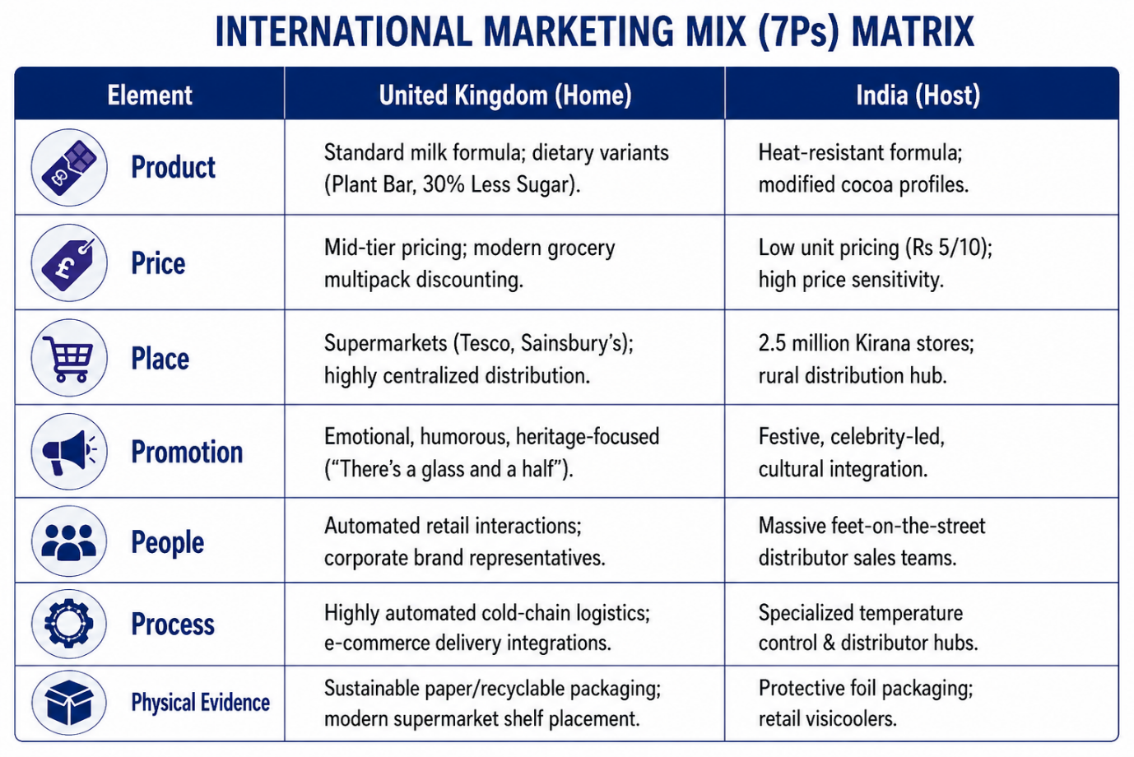
Product
Adaptation of products becomes inevitable to fit into the market realities and the physical environment. For instance, in the UK, the unique recipe used by Cadbury Dairy Milk is formulated using a special fresh-milk crumb that results in creaminess favored by the British people. The product extensions are designed following dietary needs, such as "Cadbury Dairy Milk 30% Less Sugar" and "Cadbury Plant Bar," apart from flavor combinations.
In India, physical environmental factors dictated changes in the product. The regular UK recipe would melt very quickly due to tropical ambient temperatures. Hence, there have been modifications in the recipes to increase the temperature at which the chocolate melts while maintaining mouthfeel. Apart from this, there have been modifications according to flavors favored by local people, with eggless versions being made for vegetarians and festive offerings like Cadbury Celebrations.

Price
Pricing strategies should take into consideration purchasing power of customers and market structure. In UK, pricing for Cadbury is done through competitive and value based pricing strategy. The products are priced in such a way that they can be afforded by customers on a regular basis, with the use of promotional prices and multipack discounts in major supermarket retailers including Tesco, Sainsbury's, and Asda.
In India, due to highly price sensitive nature of consumers, LUP (Low Unit Price) strategy was employed. Small sized packages were priced at economical levels of 5, 10, and 20 INR to cater for lower income group of consumers while higher income urban group was targeted with premium pricing for their product range including Cadbury Silk and Dark Milk. 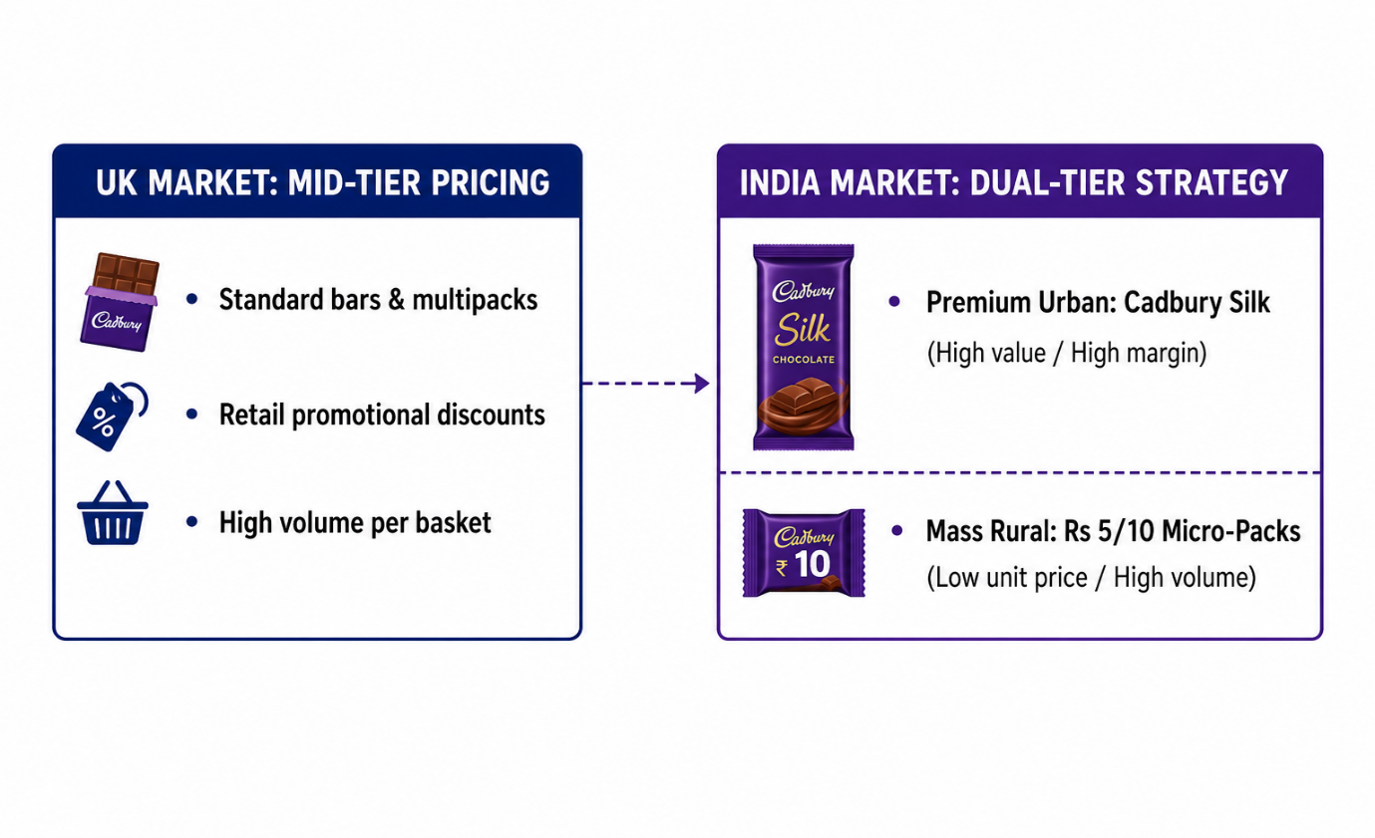
Place
Distribution Channels depend upon the retail network of each country. In the UK, the distribution process is highly centralized and characterized by a network of large supermarket chains, convenient stores, and internet retailing. Efficient distribution channels involve automated distribution centers as well as direct to store delivery systems.
In India, distribution channels are fragmented. Over 85% of the total sales through traditional Kirana stores. Cadbury has developed a comprehensive distribution network for delivering their products through more than 2.5 million retail channels. In order to fill the gap in the infrastructure, Cadbury provided branded visicoolers to thousands of retailers to ensure product preservation.
UK DISTRIBUTION CHANNEL: CENTRALIZED & CONSOLIDATED
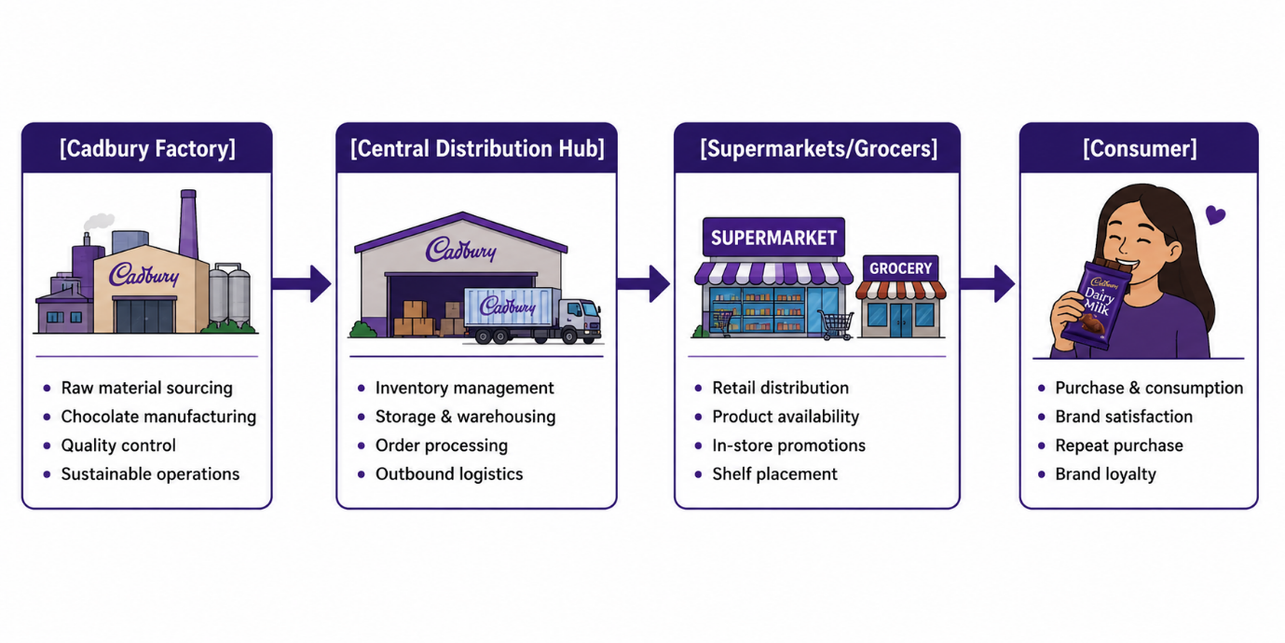
INDIA DISTRIBUTION CHANNEL: DECENTRALIZED & FRAGMENTED
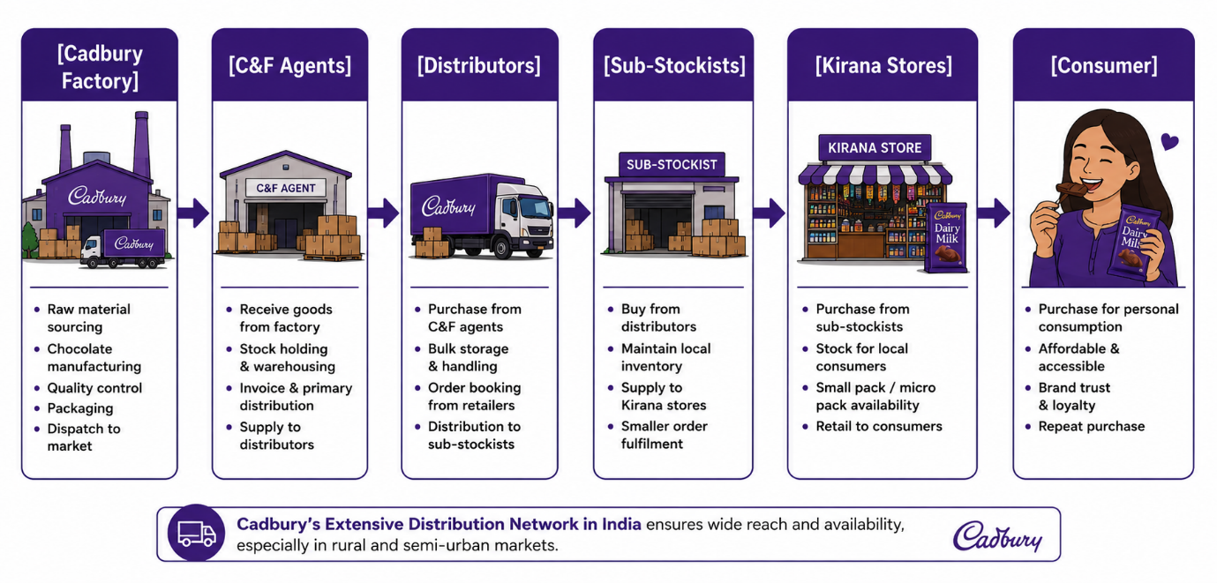

Promotion
Methods of promotion should be connected with culture and its signs. In the United Kingdom, promotion of Cadbury uses such tools as emotional narratives, jokes, and cultural heritage. "Gorilla" advertising campaign and "Mum's Birthday" campaign do not promote any features of product directly and concentrate on happiness, generosity, and emotions.
In India, methods of promotion were deeply integrated in Indian culture. "Kuch Meetha Ho Jaaye" advertising campaign promoted chocolate as perfect companion to achievements of people in daily routine. "Shubh Aarambh" advertising campaign used the tradition of Indian culture to eat some sweets before new venture. Thus, the company integrated its brand in Indian culture.
Table 6: Comparative Promotional Narrative and Cultural Communication Strategy
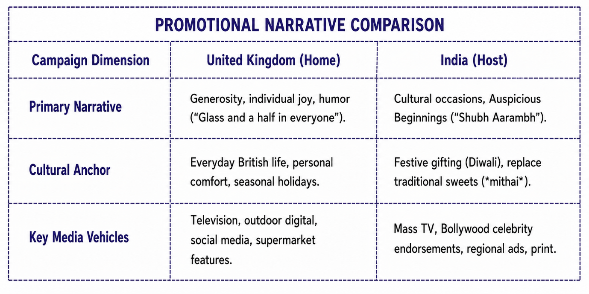People
Human interaction is a key factor for brands in all contact points. In the case of the UK, the human factor works indirectly via customer service representatives, automated checkout personnel at retail outlets, and corporate social responsibility teams. Human interaction between the brand and its consumers takes place only occasionally.
As far as India is concerned, people play a significant role in the process of distributing and managing retail shops. For Cadbury, the role played by people is very significant since the company depends on its huge sales force which interacts with millions of Kirana shop owners.
Process
Process operations guarantee quality and continuity of supply. Processes in the UK are extremely automated and standardized and are part of the sophisticated logistical systems. Forecasting mechanisms for demand prevent cases of stockouts in major supermarket chains.
However, process operations in India have to incorporate logistics and climatic variations in different regions. Cadbury adopted a hub and spoke model where goods flow from the centralized factory to the clearing and forwarding agents, to sub-stockists and local distributors.
Physical Evidence
Physical evidence includes tangible and visual cues from brands. Physical evidence in the UK is made up of innovative and environmentally friendly packaging that shows nutritional facts and ethical stamps (for example, Cocoa Life). The placement of the products in large supermarkets is organized and branded.
Physical evidence in India is made up of packaging material that is able to handle the humidity and high temperatures. The bright purple foil packaging stands out against the chaotic backdrop of Kirana stores. Moreover, the blue Cadbury-branded refrigerators in small retail shops constitute physical evidence.

1.6 Evaluation of Market Entry Strategy in India
Upon entering the Indian market in 1948, Cadbury found itself in a relatively unevolved confectionary market along with being culturally unknown. The selection of an appropriate international market entry strategy becomes vital.

Table 7: Comparison of International Market Entry Modes and Cadbury’s Application
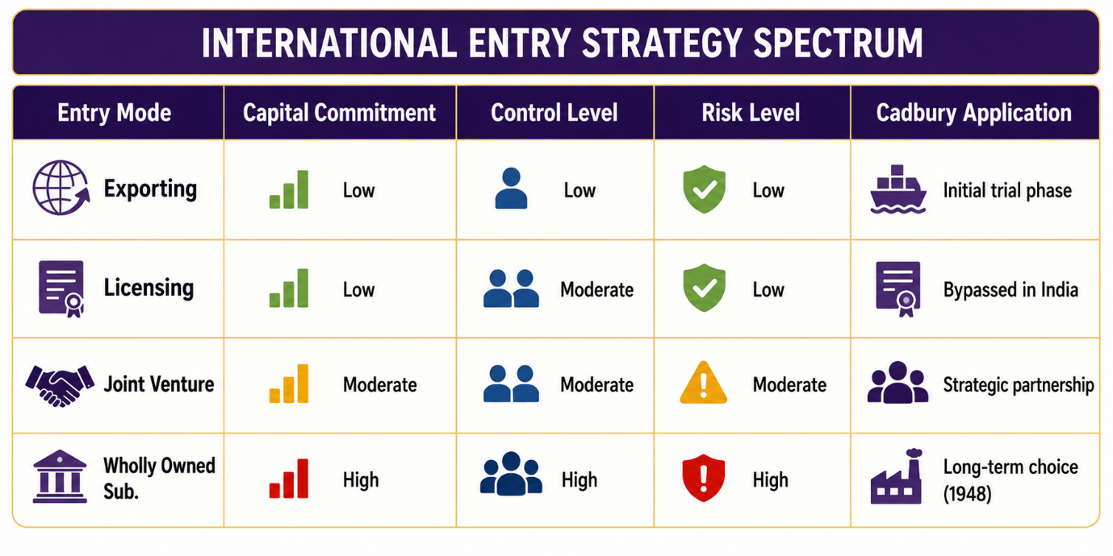 The entry of Cadbury into India happened through a wholly owned subsidiary called Cadbury India Ltd., now Mondelēz India Foods Pvt. Ltd. Such an investment strategy meant heavy capital investment in building manufacturing plants, setting up distribution channels, and brand building.
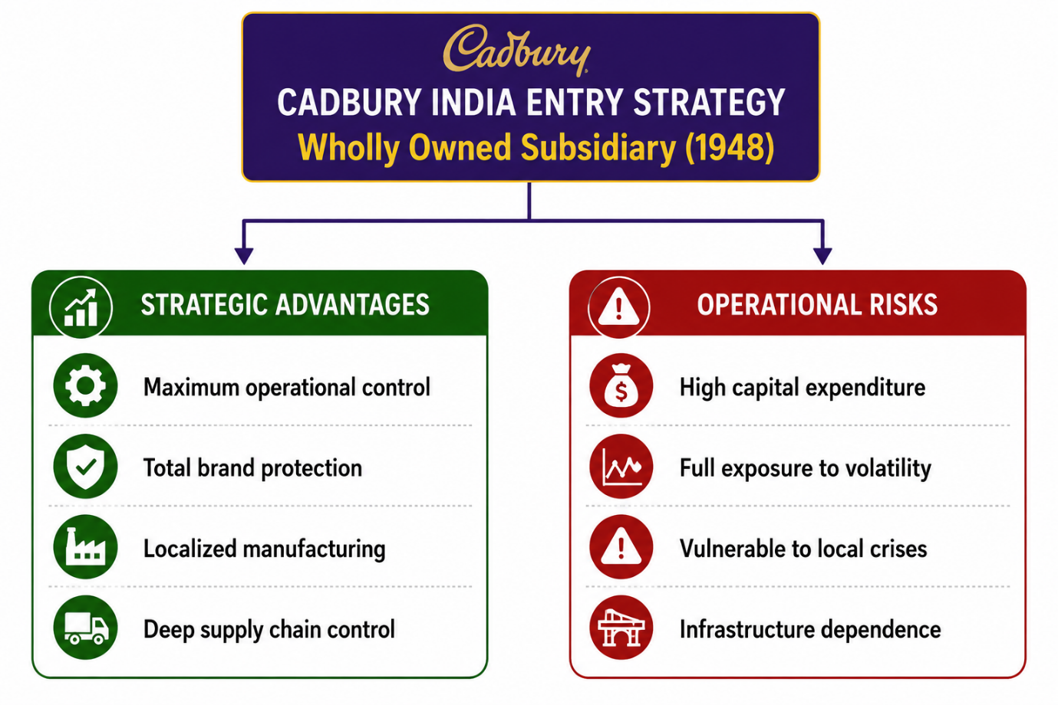

Strategic Rationale
1. Operational Control: With direct ownership of the subsidiary, Cadbury was able to gain total control over manufacturing quality, brand message, and pricing strategy.
2. Localized Supply Chain: Through direct ownership, Cadbury was able to create a localized supply chain network, which included growing their own cocoa plants in Southern India to reduce dependence on imports.
3. Market Commitment: Direct investment was a sign of market commitment, which helped the company develop strong relations with various agencies and partners.
Risks and Mitigation
The direct investments made Cadbury vulnerable to macroeconomic fluctuations, changes in regulations, and underdeveloped infrastructure. The trade policies in India during the mid-20th century favored a protectionist approach for foreign companies. However, Cadbury addressed such concerns through gradual localization of the management, procurement of local raw materials, and alignment of company objectives with those of India's economy.

1.7 Critical Analysis of Ethical Controversies in the Host Market
Businesses operating in international markets may encounter business risks and ethical challenges. In October 2003, there was a significant crisis within Cadbury India, where worm contamination was found in Dairy Milk products in Maharashtra shops (Pabla, 2014). 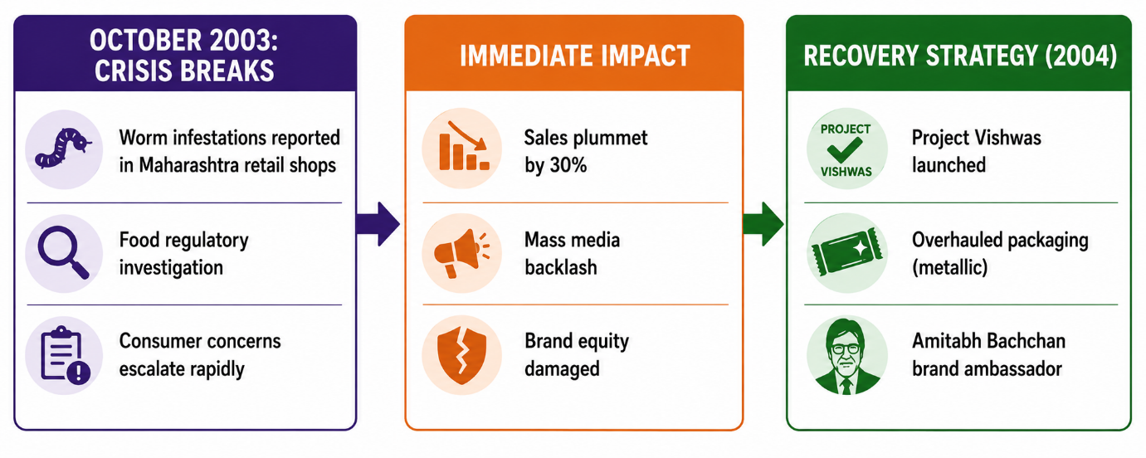
Crisis Dynamics
The outbreak took place just ahead of the most important festive season of Diwali, which is an important sales period for Cadbury. The news was reported by the media, causing immense backlash among consumers, and the FDA of Maharashtra made raids on the stores of Cadbury throughout its regional centers (Pabla, 2014). The outbreak happened because of improper storing conditions for the chocolates at Kirana stores, where the chocolates were unboxed and infested with pests.
Strategic Response & Recovery
- This defense by Cadbury made the matter even more sensitive for its consumers. The sales of Cadbury dropped by 30 percent in the best season of the year for it. Realizing the seriousness of the issue, Cadbury took many steps to overcome this problem and it is known as “Project Vishwas” (Trust):
Table 8: Project Vishwas Crisis Recovery Strategy and Strategic Outcomes
- 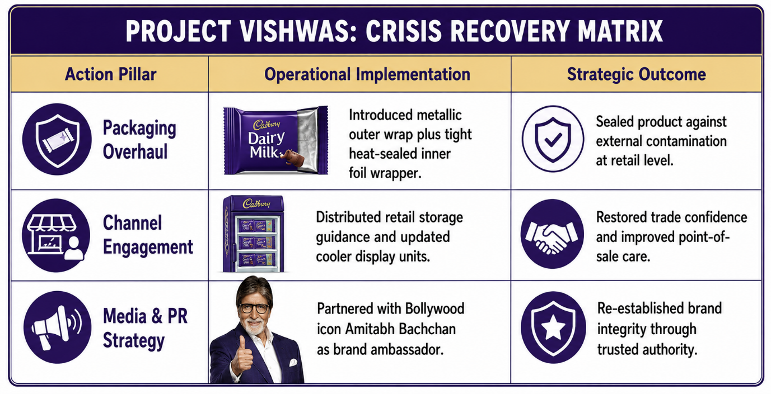
Packaging Re-design: Cadbury spent a considerable amount of time and resources in re-designing its packaging technology. The company changed its packaging from fragile paper to heat sealed metallic foils which were placed within an external cover.
- Retailer Education: The brand introduced initiatives aimed at educating more than 100,000 retailers about the right storage and inventory procedures.
- Celebrity Endorsement: Brand ambassador of Cadbury was Bollywood superstar Amitabh Bachchan. Bachchan toured Cadbury factories, checked the new packaging, and participated in transparent media campaigns to ensure the safety of products.
With these strategies, Cadbury was able to restore their brand equity and recapture their market share within eight months' time, providing an ideal example for international crisis communication.

1.8 Forward-Looking Strategic Recommendations
- For Cadbury to sustain its market leadership in both the UK and India, it should adopt the following strategies:
Table 9: Strategic Recommendations Roadmap for Cadbury in the UK and India
- 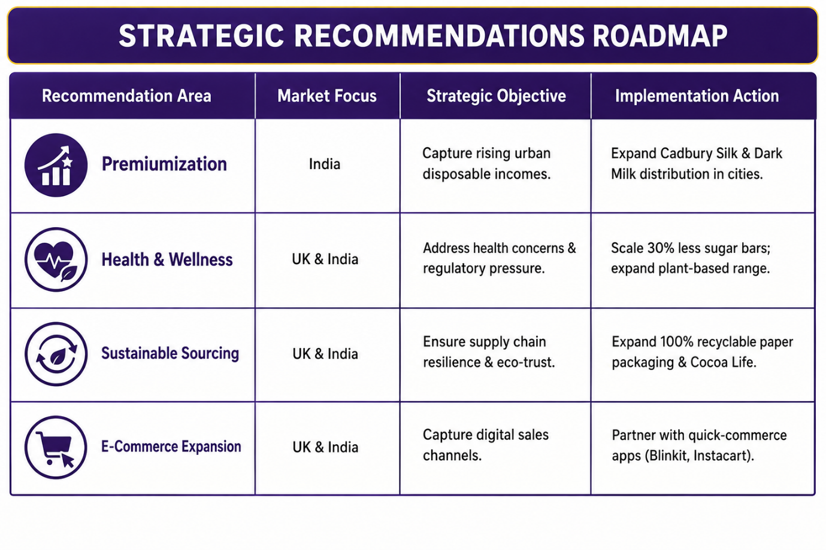 Fast-Track Premiumization Within Host Urban Clusters: Given the increasing disposable incomes in Tier 1 & Tier 2 Indian urban centers, Cadbury should focus on increasing its premium range such as Cadbury Dark Milk, Bournville and Artisanal ranges.
- Expand Health-Conscious Product Variants Globally: Given the regulations in the UK regarding HFSS products and the increased concerns about diabetes in India, Cadbury should develop more low sugar, plant-based, and portion-controlled products without compromising on taste.
- Invest in Sustainable Packaging and Cold-Chain Logistics: The Cadbury company should continue replacing single-use plastics with completely recyclable substances, alongside investing in solar-powered retail refrigeration technologies in rural areas of India.
- Leverage Quick-Commerce Platforms: Shopping behavior of consumers is moving towards apps which deliver their products very quickly (such as Blinkit and Zepto in India; Deliveroo and Instacart in the UK). Cadbury should plan accordingly for its digital inventory and impulse buying.

Section 2: Reflective Account on Research and Analytical Process

2.1 Description
This part is a reflection of my academic experience in writing the international marketing report. In order to organize my reflections, I have employed Gibbs’ (1988) Reflective Cycle that consists of six steps: Description, Feelings, Evaluation, Analysis, Conclusion, and Action Plan.
In this assignment, there was a need to conduct a comparative study of market entry strategy, macro environment, socio cultural environment, and marketing mix for a globally recognized brand in two different countries. For my comparative study, I chose Cadbury by comparing its home country market with one of its major markets. In this research, sources used were peer reviewed journals, industry reports, press releases, and food safety regulations.

2.2 Feelings
At the beginning of undertaking this assignment, I experienced a feeling of both excitement and apprehension. Excitement because analyzing the well-known company Cadbury was fun. At the same time, the challenge of writing an elaborate comparative report was intimidating.
As I started to synthesize information from the PESTLE framework and Hofstede’s dimensions of culture, I feared becoming superficial. I was afraid that I will use a lot of descriptions without providing any critical insight. During the course of researching, I had difficulty in sourcing academic information about the early entrance of Cadbury into the Indian market (1948).

2.3 Evaluation
After reflection, there were some areas where things went well and there were some areas where things did not go very well. Positive aspects included the use of theories such as Hofstede’s cultural dimensions in understanding Cadbury's marketing changes from the UK to India. The direct relationship established between the cultural dimensions and actual marketing activities such as the relation between collectivism and "Kuch Meetha Ho Jaaye" campaign made my critical evaluation deeper.
One challenge that came up is managing my word count in each section. At first, I used too much word count on background information on macro-environmental factors which left me less time to critically evaluate the 7Ps and ethical issues.

2.4 Analysis
The research process reinforced how critical local context is to international marketing success. Brands cannot simply export domestic strategies into host markets and expect identical outcomes. Analyzing Cadbury’s adaptation strategies highlighted the ongoing debate between standardisation and adaptation in global marketing literature (Levitt, 1983; Zou and Cavusgil, 2002).

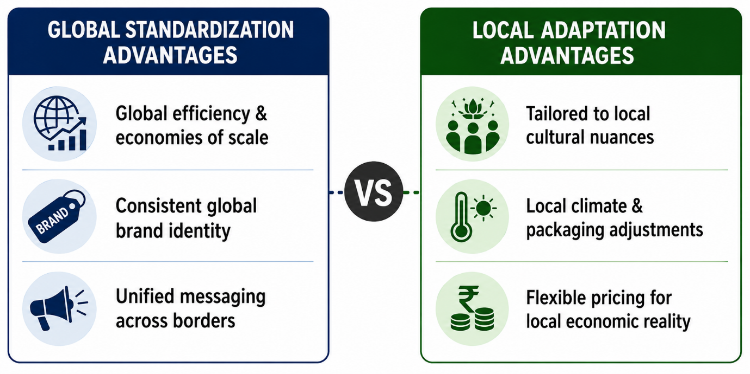 Through my research, I discovered that Cadbury was able to succeed in the Indian market through adapting rather than imposing its British identity in the form of product formula, package design, prices, and branding. Through investigating the 2003 worm contamination incident, it is evident that mistakes in operations within host countries pose a risk to the brand equity of any firm.

2.5 Conclusion
The global expansion of Cadbury illustrates how companies need to achieve a balanced combination of standardization and adaptation strategies in terms of operating within different economic settings. The macro environmental conditions in the home environment of Cadbury (the UK market) contrast sharply with those of the main emerging host country for Cadbury (India). Whereas the UK is a mature and saturated market with high per capita spending, strong consolidation in supermarket channels, and individualistic consumers, India is a developing market that is highly price sensitive with fragmented retail and a collectivist culture. The difference in the macro environment was overcome by Cadbury by adopting a long-term entry strategy into India in a wholly-owned subsidiary since 1948.
The crux of Cadbury's international performance depends on the customization of its STP and marketing mix (7Ps). For instance, in the United Kingdom, Cadbury is positioned as a brand that is a combination of nostalgia and comfort, adopting moderate pricing strategy, innovation in diet products like plant-based and sugar-free bars, and centralization of its distribution in supermarkets. On the other hand, Cadbury re-positioned its brand in India as a modern and celebration-oriented version of traditional sweetmeat (mithai) through its communications related to cultural celebrations and shared family moments like "Kuch Meetha Ho Jaaye" and "Shubh Aarambh" Campaigns. The products have been formulated in a way that they can bear the melting point of tropical climates, and the use of Low Unit Price (LUP) packs of 5, 10, and 20 INR made it possible for them to penetrate into the rural market.
The resilience of the institution is also shown in its reaction to the worm contamination controversy in October 2003 in India. Cadbury's crisis management strategy "Project Vishwas" can be considered a model of risk management in the host market. Through packaging transformation into protective metal-sealed bags, training 100,000 retailers in proper storage of their inventory, and utilizing the influence of Bollywood star Amitabh Bachchan as a goodwill ambassador, Cadbury regained the consumer's trust and recaptured the lost market share in just eight months.
In order to preserve market leadership in both markets, Cadbury has to undertake a progressive roadmap. The company needs to accelerate the process of urban premiumization in India via Silk and Artisanal variants while diversifying low-sugar and portioned product variants worldwide to counteract the HFSS regulations in the UK. In addition, Cadbury has to implement sustainable supply chain management through 100 percent recyclable packaging and the "Cocoa Life" program while maximizing its digital distribution through quick-commerce partnerships like Blinkit in India and Deliveroo in the UK. Through those balanced adaptation processes, Cadbury proves that the essence of successful international marketing is rooted in the correlation of core brand identity with local conditions.

2.6 Action Plan
To build on these insights and improve my performance in future academic projects, I will implement the following action plan:

Table 10: Future Professional Action Plan
- 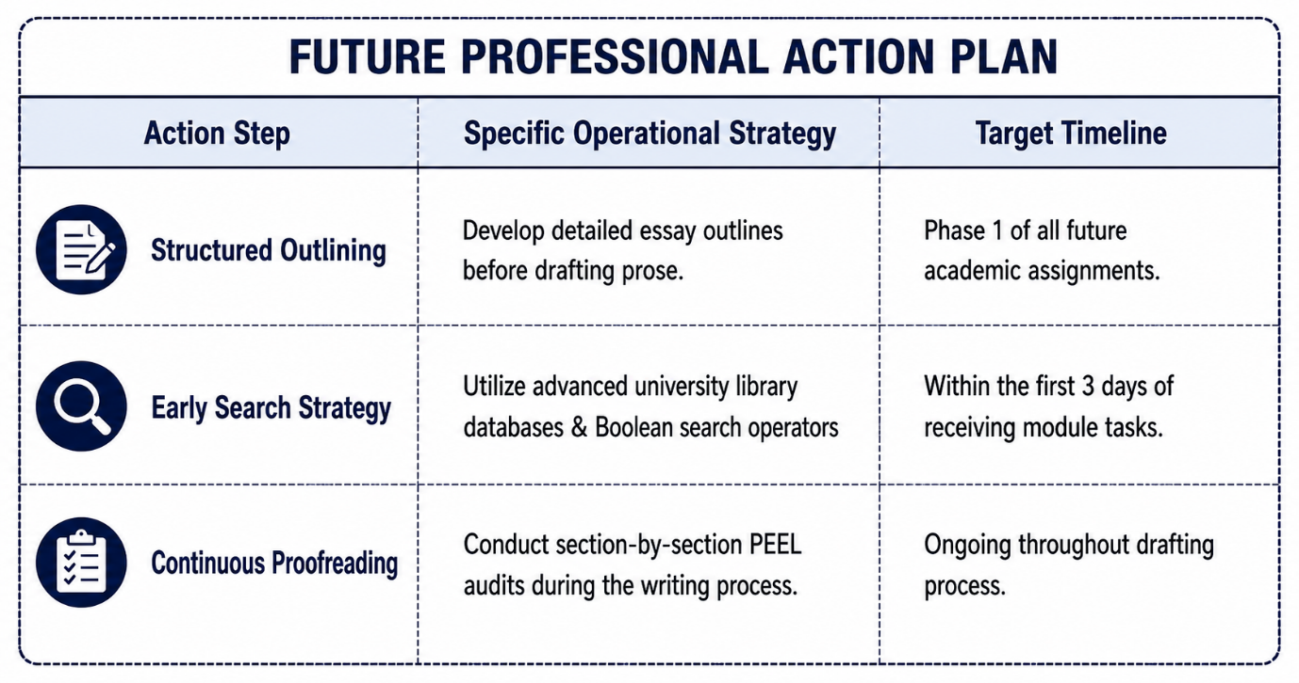
Adopt a Structured Essay Framework Early: Before I begin writing, I will create clear outlines of paragraphs through the use of the PEEL technique.
- Refine Search Strategies for Academic Literature: Advanced Boolean operators will be employed in the process of searching for scholarly sources through databases such as ScienceDirect and Emerald Insight.
- Implement Iterative Proofreading and Editing: Instead of rewriting the whole paper later on, I will edit the sections one by one so that there is coherent argumentation and academic style.

3.0 References
Department of Health and Social Care. (2022) Restricting promotions of products high in fat, sugar or salt (HFSS) by location and by volume price: guidance. London: DHSC.
Faber, G. (2019) The Sweetmakers: A History of the British Confectionery Industry. London: Palgrave Macmillan.
Gibbs, G. (1988) Learning by Doing: A Guide to Teaching and Learning Methods. Further Education Unit. Oxford: Oxford Polytechnic.
Hofstede, G. (2011) 'Dimensionalizing Cultures: The Hofstede Model in Context', Online Readings in Psychology and Culture, 2(1), pp. 1-26.
IBEF. (2023) Indian Fast Moving Consumer Goods (FMCG) Industry Report. New Delhi: India Brand Equity Foundation.
Levitt, T. (1983) 'The Globalization of Markets', Harvard Business Review, 61(3), pp. 92-102.
Ministry of Environment, Forest and Climate Change. (2022) Guidelines on Extended Producer Responsibility for Plastic Packaging. New Delhi: Government of India.
Mondelēz International. (2022) Snacking Made Right: 2022 ESG Report. Chicago: Mondelēz International.
Office for National Statistics. (2023) Consumer price inflation, UK: December 2022. London: ONS.
Pabla, S. (2014) 'Case Study: Cadbury's Worm Controversy in India and Brand Recovery', Journal of Food Products Marketing, 20(4), pp. 341-355.
Zou, S. and Cavusgil, S.T. (2002) 'The GMS: A Broad Conceptualization of Global Marketing Strategy and Its Performance Implications', Journal of Marketing, 66(4), pp. 40-56.

