International Meetings Management for the Hotel Industry
Student Name: Raducu – Viorel Ciolpan
Student ID: 2221478

I confirm that I have not used any AI tools in the research and creation of this assignment. I confirm that I have not presented any AI generated materials as my own work. I confirm I have copies of my drafts, notes, and other resources I used, which I may be asked to provide in evidence.

Table of Contents
Event Overview 3
Event Content & Context 4
Market Factors – Target Market 5
Market Factors Demand & Supply 6
Market Factors – Competition 7
Operational Factors – Venue Selection 9
Operational Factors – Resources 10
Financial Factors – Costs Breakdown 12
Financial Factors – Predicted Revenues & Funding 13
Conclusion 14
References 15

Title slide:
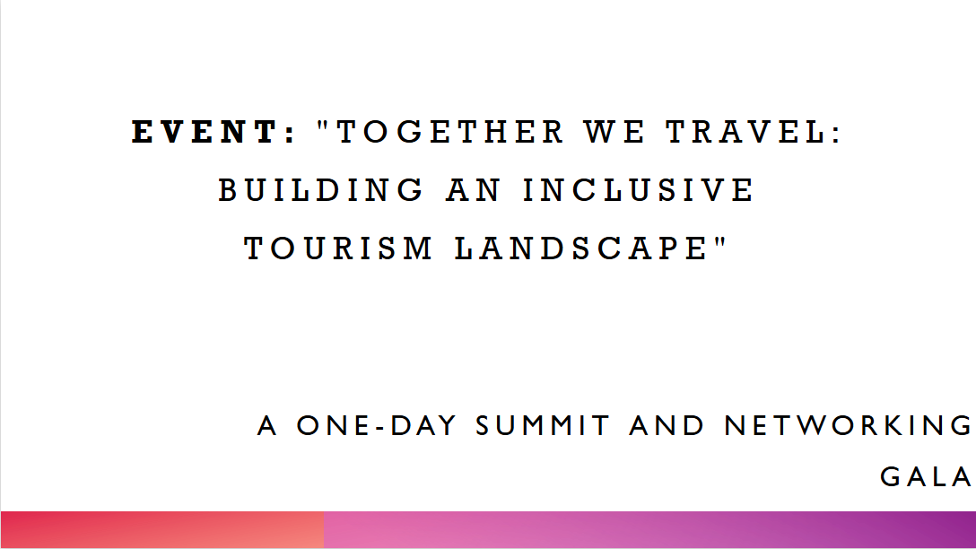

Event Overview
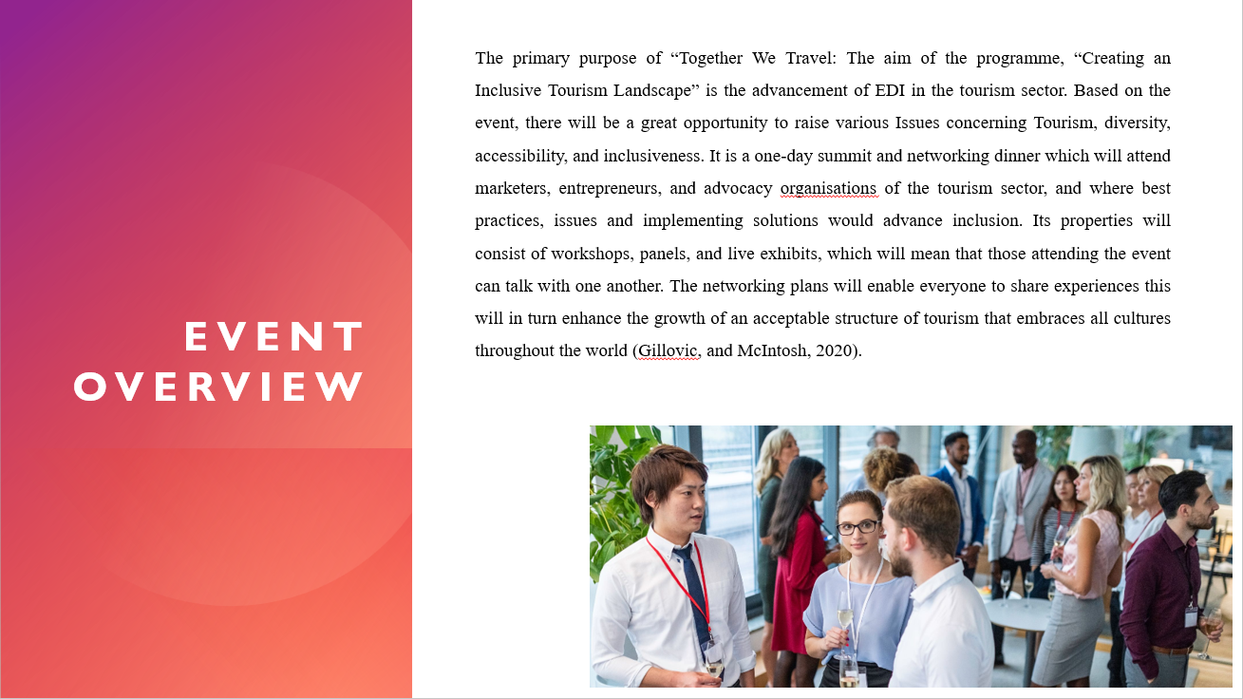
The primary purpose of “Together We Travel: The aim of the programme, “Creating an Inclusive Tourism Landscape” is the advancement of EDI in the UK tourism sector. Based on the event, there will be a great opportunity to raise various Issues concerning Tourism, diversity, accessibility, and inclusiveness. It is a one-day summit and networking dinner which will attend marketers, entrepreneurs, and advocacy organisations of the tourism sector, and where best practices, issues and implementing solutions would advance inclusion. Its properties will consist of workshops, panels, and live exhibits, which will mean that those attending the event can talk with one another. The networking plans will enable everyone to share experiences this will in turn enhance the growth of an acceptable structure of tourism that embraces all cultures throughout the world (Gillovic, and McIntosh, 2020).

Event Content & Context
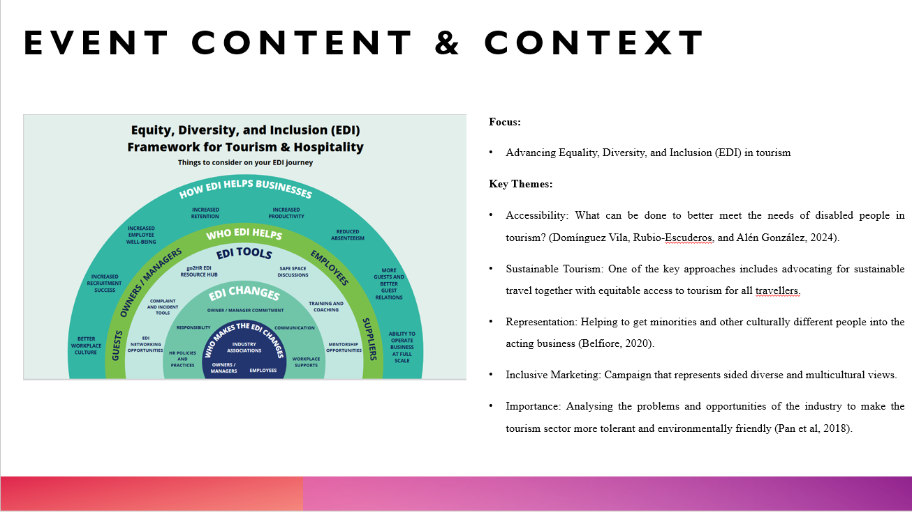
Focus: Advancing Equality, Diversity, and Inclusion (EDI) in tourism
Key Themes:
- Accessibility: What can be done to better meet the needs of disabled people in tourism? (Domínguez Vila, Rubio-Escuderos, and Alén González, 2024).
- Sustainable Tourism: One of the key approaches includes advocating for sustainable travel together with equitable access to tourism for all travellers.
- Representation: Helping to get minorities and other culturally different people into the acting business (Belfiore, 2020).
- Inclusive Marketing: Campaign that represents sided diverse and multicultural views.
- Importance: Analysing the problems and opportunities of the industry to make the tourism sector more tolerant and environmentally friendly (Pan et al, 2018).
Notes:
This event shall be centred on promoting EDI in tourism with matters of discussion including; accessibility and sustainable tourism, representation, and tourism marketing. This will discuss ways of increasing accessibility for tourism, sustainable tourism, representation of culture and origin and creating representations for marketing tourism. The event is necessary to address the need to address industry problems and take advantage of the opportunities for developing a more balanced and sustainable tourism environment.

Market Factors – Target Market
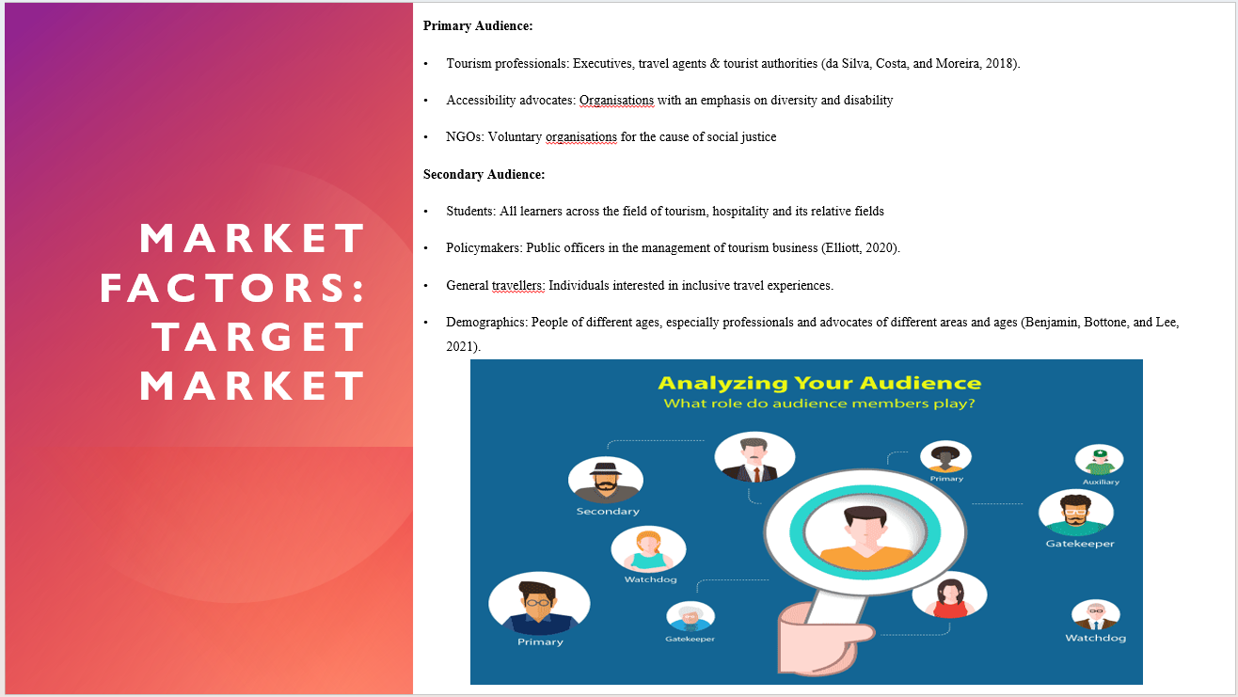
Primary Audience:
- Tourism professionals: Executives, travel agents & tourist authorities (da Silva, Costa, and Moreira, 2018).
- Accessibility advocates: Organisations with an emphasis on diversity and disability
- NGOs: Voluntary organisations for the cause of social justice
Secondary Audience:
- Students: All learners across the field of tourism, hospitality and its relative fields
- Policymakers: Public officers in the management of tourism business (Elliott, 2020).
- General travellers: Individuals interested in inclusive travel experiences.
- Demographics: People of different ages, especially professionals and advocates of different areas and ages (Benjamin, Bottone, and Lee, 2021).
Notes:
The core audience of the event shall be the representatives of the tourism industry including tourists and participants with disabilities, organisations working to improve accessibility for the disabled as well as non-governmental organisations aimed at the promotion of social justice. The second audience mainly targets learners who are taking tourism and hospitality courses, tourism policymakers who would need to understand the various policies required in tourism as well and general tourists who need to understand the importance and impacts of tourism. The event will target professionals and advocates of diverse ages, sexes, ethnicities, is, and occupations from the global community.

Market Factors Demand & Supply
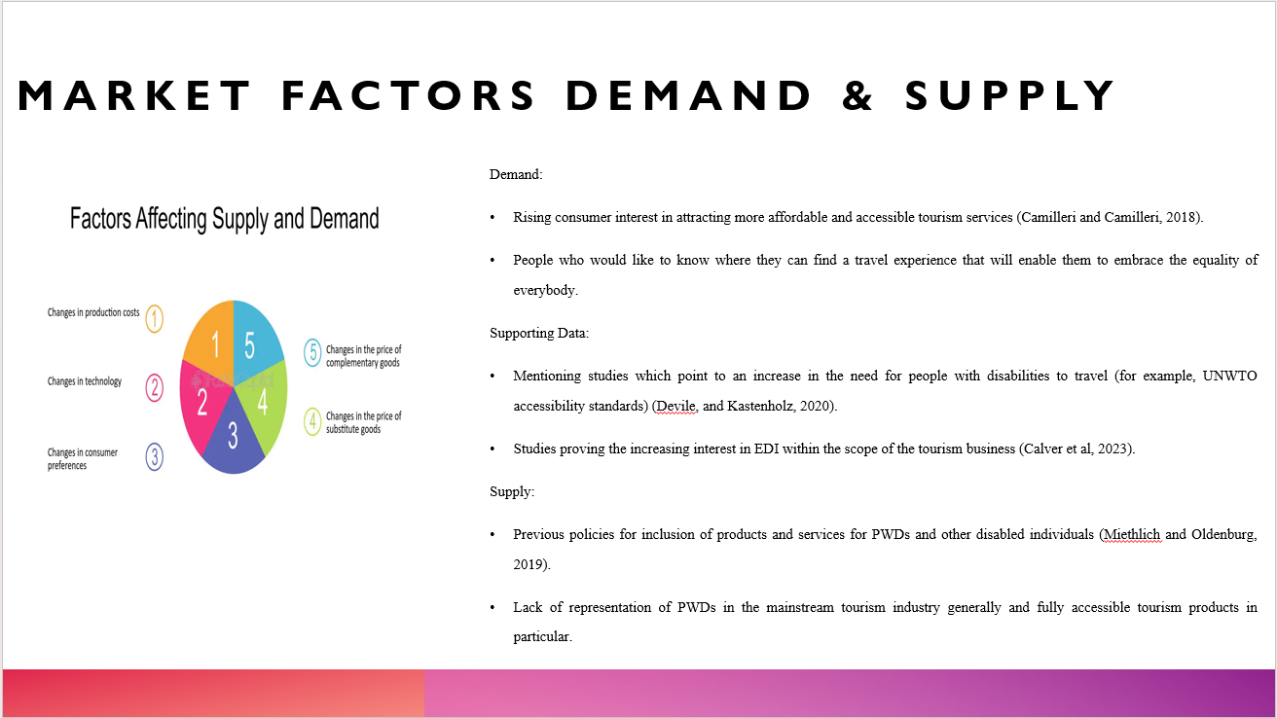
Demand:
- Rising consumer interest in attracting more affordable and accessible tourism services (Camilleri and Camilleri, 2018).
- People who would like to know where they can find a travel experience that will enable them to embrace the equality of everybody.
Supporting Data:
- Mentioning studies which point to an increase in the need for people with disabilities to travel (for example, UNWTO accessibility standards) (Devile, and Kastenholz, 2020).
- Studies proving the increasing interest in EDI within the scope of the tourism business (Calver et al, 2023).
Supply:
- Previous policies for inclusion of products and services for PWDs and other disabled individuals (Miethlich and Oldenburg, 2019).
- Lack of representation of PWDs in the mainstream tourism industry generally and fully accessible tourism products in particular.
Notes:
There is a rising trend in ethical and accessible tourism; the niche of tourism that is now in high demand by travellers is diverse. Various sources and journals available – especially those from UNWTO - show interest in EDI within tourism committing to the change in consumer behaviour. Despite the ongoing drives towards accessibility and diversity, there are still voids within the market for truly inclusive tourism facilities and services which will provide expansion opportunities.

Market Factors – Competition
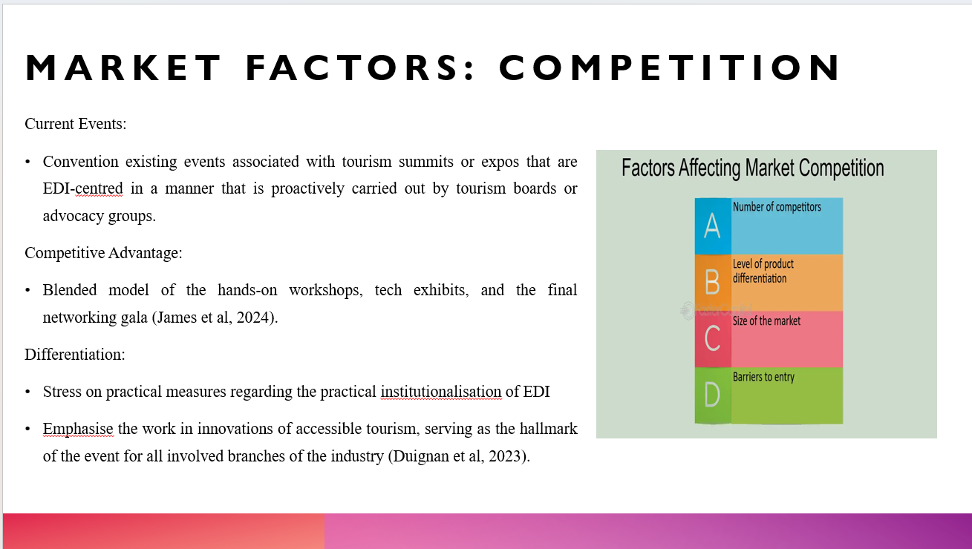
Current Events:
- Convention existing events associated with tourism summits or expos that are EDI-centred in a manner that is proactively carried out by tourism boards or advocacy groups.
Competitive Advantage:
- Blended model of the hands-on workshops, tech exhibits, and the final networking gala (James et al, 2024).
Differentiation:
- Stress on practical measures regarding the practical institutionalisation of EDI
- Emphasise the work in innovations of accessible tourism, serving as the hallmark of the event for all involved branches of the industry (Duignan et al, 2023).
Notes:
Although there exist other summits and expos mainly focused on EDI for the tourism sector that are usually hosted by tourism boards and other advocacy organisations, our event stands out since it will host practical workshops and technology fairs as well as a bidding gala. This is the case since this format is among the most effective when it comes to eliciting people’s participation and cooperation. Part of the event’s positioning reflects its primary goal of offering suggestions on how to implement EDI in practice and present the latest technologies in inclusive tourism, thus making it unique on the market.

Operational Factors – Venue Selection
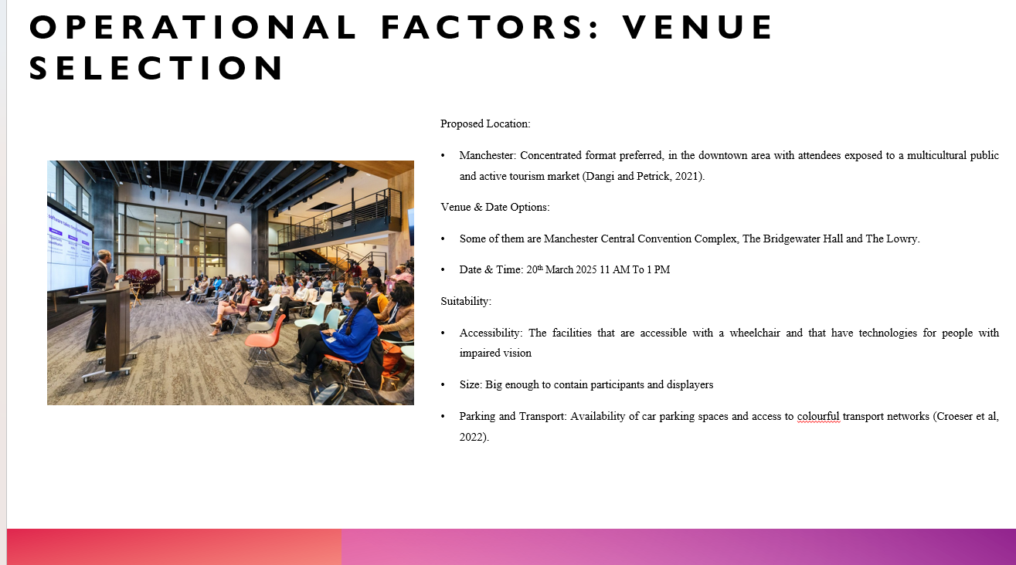

Proposed Location:
- Manchester: Concentrated format preferred, in the downtown area with attendees exposed to a multicultural public and active tourism market (Dangi and Petrick, 2021).
Venue & Date Options:
- Some of them are Manchester Central Convention Complex, The Bridgewater Hall and The Lowry.
- Date & Time: 20th March 2025 11 AM To 1 PM
Suitability:
- Accessibility: The facilities that are accessible with a wheelchair and that have technologies for people with impaired vision
- Size: Big enough to contain participants and displayers
- Parking and Transport: Availability of car parking spaces and access to colourful transport networks (Croeser et al, 2022).
Notes:
Manchester is the city of choice in which the event is to take place – this is a city that has an excellent tourism industry as well as great transport links. Appropriate facilities include Manchester Central Convention Complex, The Bridgewater Hall and The Lowry each providing enough room for the occasion. These venues are appropriate because they are physically accessible for disabled people, sufficient to contain both attendees and exhibitors and easily accessible by car and public transport to enable all participants to enjoy a smooth experience.

Operational Factors – Resources
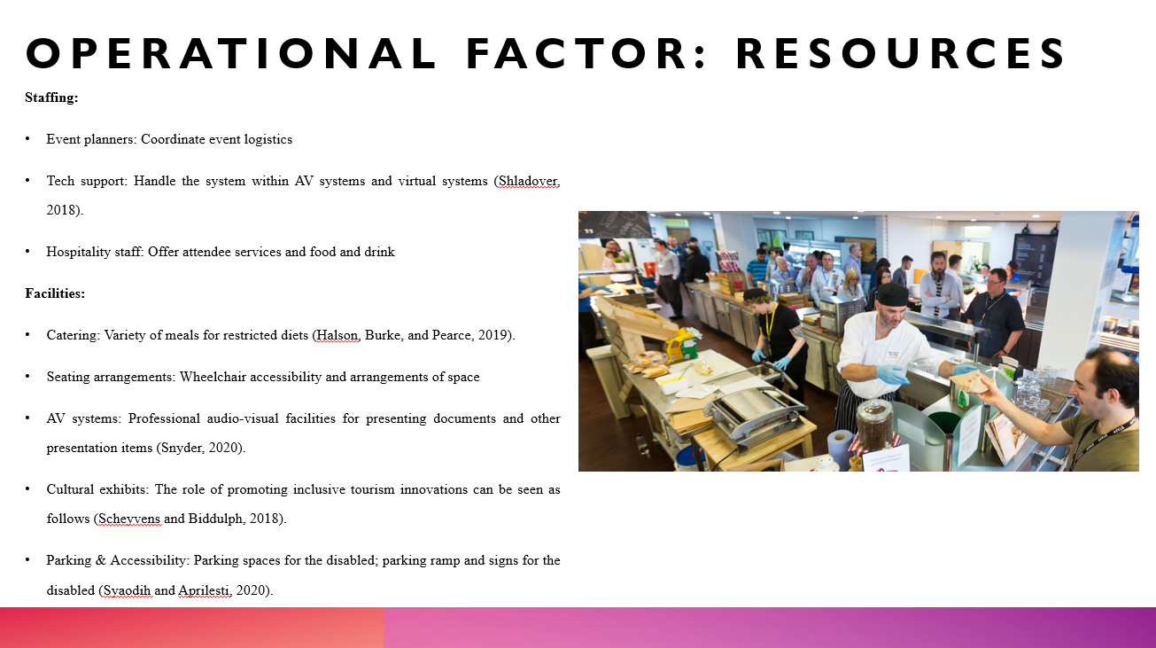
Staffing:
- Event planners: Coordinate event logistics
- Tech support: Handle the system within AV systems and virtual systems (Shladover, 2018).
- Hospitality staff: Offer attendee services and food and drink
Facilities:
- Catering: Variety of meals for restricted diets (Halson, Burke, and Pearce, 2019).
- Seating arrangements: Wheelchair accessibility and arrangements of space
- AV systems: Professional audio-visual facilities for presenting documents and other presentation items (Snyder, 2020).
- Cultural exhibits: The role of promoting inclusive tourism innovations can be seen as follows (Scheyvens and Biddulph, 2018).
- Parking & Accessibility: Parking spaces for the disabled; parking ramp and signs for the disabled (Syaodih and Aprilesti, 2020).
Notes:
Hiring personnel that will be needed throughout the event will include event organisers for navigating or coordinating the event physically, technical support for audio visibility and virtual sections of the event and hospitality staff for handling food and services to the attendees. Some of the amenities will range from various food services for various dietaries, transformative seating arrangements, as well as quality systems for presentations. Returning culturally themed models and displays of newly developed programmes on inclusive tourism will also be displayed. Safety would be provided through such measures as accessible parking spaces, ramps and clear signs.

Financial Factors – Costs Breakdown
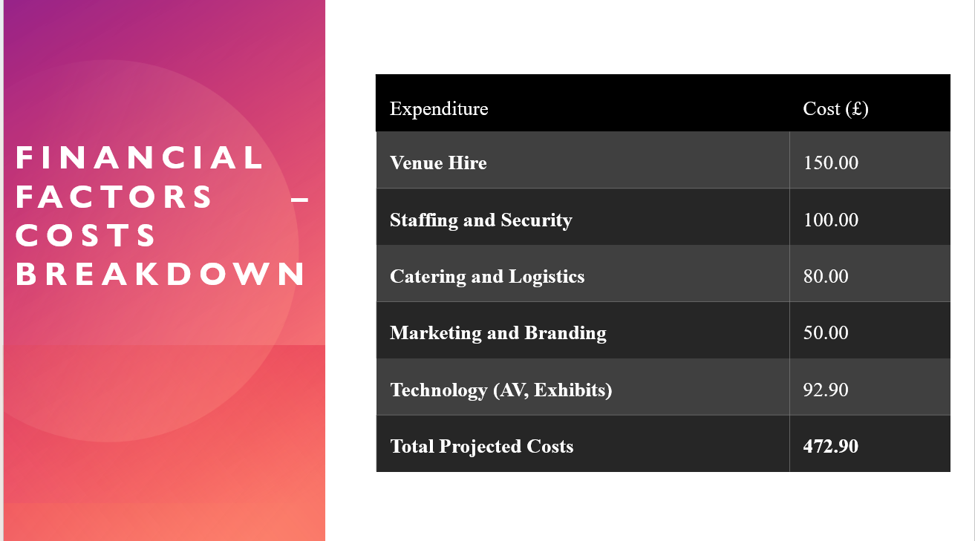
Expenditure | Cost (£)
Venue Hire | 150.00
Staffing and Security | 100.00
Catering and Logistics | 80.00
Marketing and Branding | 50.00
Technology (AV, Exhibits) | 92.90
Total Projected Costs | 472.90

Financial Factors – Predicted Revenues & Funding
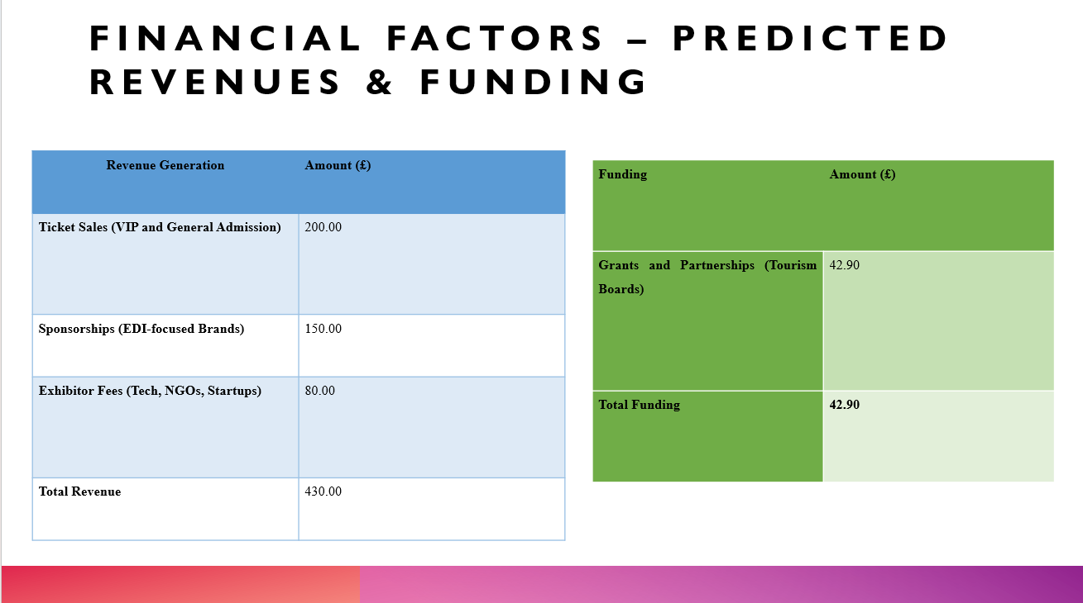
Revenue Generation | Amount (£)
Ticket Sales (VIP and General Admission) | 200.00
Sponsorships (EDI-focused Brands) | 150.00
Exhibitor Fees (Tech, NGOs, Startups) | 80.00
Total Revenue | 430.00

Funding | Amount (£)
Grants and Partnerships (Tourism Boards) | 42.90
Total Funding | 42.90

Conclusion
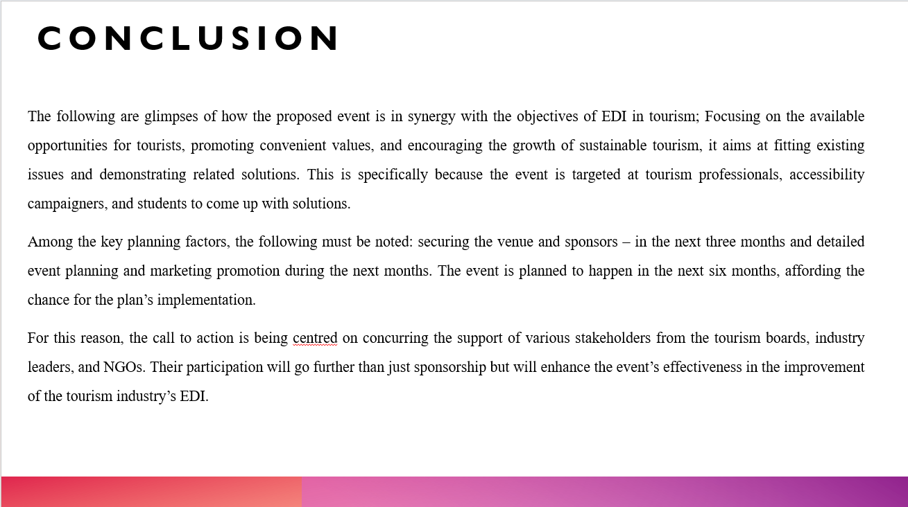
The following are glimpses of how the proposed event is in synergy with the objectives of EDI in tourism; Focusing on the available opportunities for tourists, promoting convenient values, and encouraging the growth of sustainable tourism, it aims at fitting existing issues and demonstrating related solutions. This is specifically because the event is targeted at tourism professionals, accessibility campaigners, and students to come up with solutions.
Among the key planning factors, the following must be noted: securing the venue and sponsors – in the next three months and detailed event planning and marketing promotion during the next months. The event is planned to happen in the next six months, affording the chance for the plan’s implementation.
For this reason, the call to action is being centred on concurring the support of various stakeholders from the tourism boards, industry leaders, and NGOs. Their participation will go further than just sponsorship but will enhance the event’s effectiveness in the improvement of the tourism industry’s EDI.

References
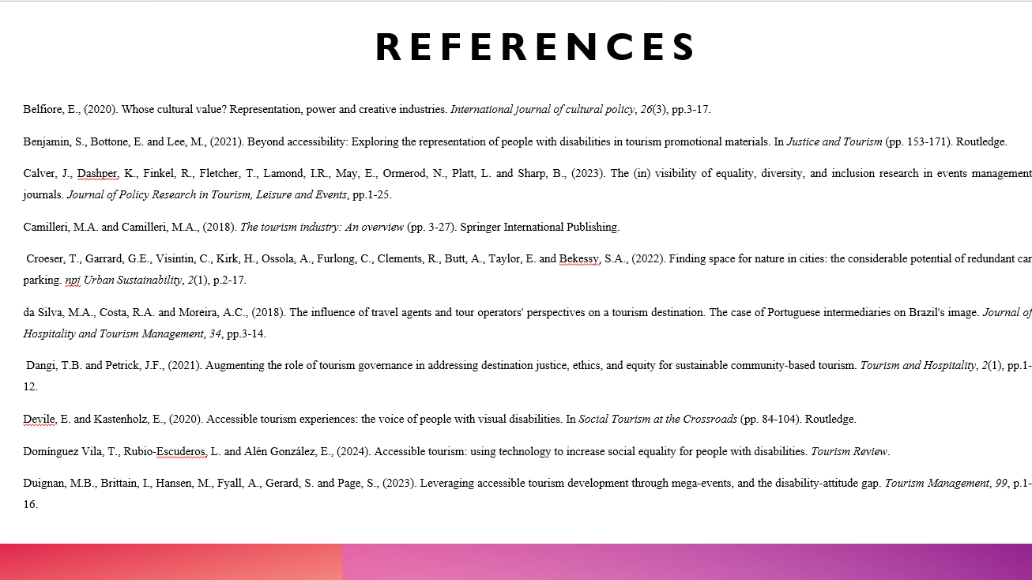
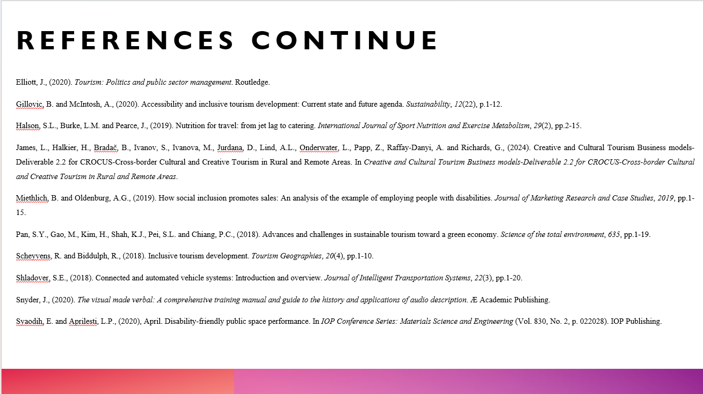
Belfiore, E., (2020). Whose cultural value? Representation, power and creative industries. International journal of cultural policy, 26(3), pp.3-17.
Benjamin, S., Bottone, E. and Lee, M., (2021). Beyond accessibility: Exploring the representation of people with disabilities in tourism promotional materials. In Justice and Tourism (pp. 153-171). Routledge.
Calver, J., Dashper, K., Finkel, R., Fletcher, T., Lamond, I.R., May, E., Ormerod, N., Platt, L. and Sharp, B., (2023). The (in) visibility of equality, diversity, and inclusion research in events management journals. Journal of Policy Research in Tourism, Leisure and Events, pp.1-25.
Camilleri, M.A. and Camilleri, M.A., (2018). The tourism industry: An overview (pp. 3-27). Springer International Publishing.
Croeser, T., Garrard, G.E., Visintin, C., Kirk, H., Ossola, A., Furlong, C., Clements, R., Butt, A., Taylor, E. and Bekessy, S.A., (2022). Finding space for nature in cities: the considerable potential of redundant car parking. npj Urban Sustainability, 2(1), p.2-17.
da Silva, M.A., Costa, R.A. and Moreira, A.C., (2018). The influence of travel agents and tour operators' perspectives on a tourism destination. The case of Portuguese intermediaries on Brazil's image. Journal of Hospitality and Tourism Management, 34, pp.3-14.
Dangi, T.B. and Petrick, J.F., (2021). Augmenting the role of tourism governance in addressing destination justice, ethics, and equity for sustainable community-based tourism. Tourism and Hospitality, 2(1), pp.1-12.
Devile, E. and Kastenholz, E., (2020). Accessible tourism experiences: the voice of people with visual disabilities. In Social Tourism at the Crossroads (pp. 84-104). Routledge.
Domínguez Vila, T., Rubio-Escuderos, L. and Alén González, E., (2024). Accessible tourism: using technology to increase social equality for people with disabilities. Tourism Review.
Duignan, M.B., Brittain, I., Hansen, M., Fyall, A., Gerard, S. and Page, S., (2023). Leveraging accessible tourism development through mega-events, and the disability-attitude gap. Tourism Management, 99, p.1-16.
Elliott, J., (2020). Tourism: Politics and public sector management. Routledge.
Gillovic, B. and McIntosh, A., (2020). Accessibility and inclusive tourism development: Current state and future agenda. Sustainability, 12(22), p.1-12.
Halson, S.L., Burke, L.M. and Pearce, J., (2019). Nutrition for travel: from jet lag to catering. International Journal of Sport Nutrition and Exercise Metabolism, 29(2), pp.2-15.
James, L., Halkier, H., Bradač, B., Ivanov, S., Ivanova, M., Jurdana, D., Lind, A.L., Onderwater, L., Papp, Z., Raffay-Danyi, A. and Richards, G., (2024). Creative and Cultural Tourism Business models-Deliverable 2.2 for CROCUS-Cross-border Cultural and Creative Tourism in Rural and Remote Areas. In Creative and Cultural Tourism Business models-Deliverable 2.2 for CROCUS-Cross-border Cultural and Creative Tourism in Rural and Remote Areas.
Miethlich, B. and Oldenburg, A.G., (2019). How social inclusion promotes sales: An analysis of the example of employing people with disabilities. Journal of Marketing Research and Case Studies, 2019, pp.1-15.
Pan, S.Y., Gao, M., Kim, H., Shah, K.J., Pei, S.L. and Chiang, P.C., (2018). Advances and challenges in sustainable tourism toward a green economy. Science of the total environment, 635, pp.1-19.
Scheyvens, R. and Biddulph, R., (2018). Inclusive tourism development. Tourism Geographies, 20(4), pp.1-10.
Shladover, S.E., (2018). Connected and automated vehicle systems: Introduction and overview. Journal of Intelligent Transportation Systems, 22(3), pp.1-20.
Snyder, J., (2020). The visual made verbal: A comprehensive training manual and guide to the history and applications of audio description. Æ Academic Publishing.
Syaodih, E. and Aprilesti, L.P., (2020), April. Disability-friendly public space performance. In IOP Conference Series: Materials Science and Engineering (Vol. 830, No. 2, p. 022028). IOP Publishing.

