BA Business Management
Strategic Management and Sustainability – LCBB6004
Lecturer: Jayalakshmi Gopalkrishnan
ASSIGNMENT 1
Boris Vladimirov – 2124687



Strategic Review and Future Roadmap for Unilever Plc
Embracing Sustainability for Competitive Advantage

Table of Content
1. Introduction 3
2. Company Overview 3
3. Making Strategic Choice 4
3.1 Porter's Generic Strategies 4
3.2 Ansoff Matrix Application 6
4. Resources and Capabilities 7
4.1 VRIO Analysis 8
4.2 Porter’s Value Chain Analysis 9
5. Strategy Implementation Success 9
5.1 The SAF Framework 9
5.2 Assessing Strategies Implementation 10
6. Competitiveness and Sustainability 11
7. Future Strategic Direction 11
8. Conclusion 12
9. Reference List 13
10. Appendix 17
10.1 SWOT Analysis 17
10.2 PESTEL Analyses 18
10.3 Industry Five Forces Analysis 20

1. Introduction
In the present diversified and complex business world, corporations need to undertake strategic management. It allows for the restoration of balance due to constant fluctuations in competition pressure, customer preferences, technologies, and regulations. Applying the strategic management procedure to address these factors improves organisational profit, competitiveness, and brand reputation (Barney, 2018). For instance, the management process incorporates the resource deployment process, thereby enhancing organisational competitiveness in the context of globalisation. It emphasises the importance of management, change management, and organisational development in keeping organisations relevant and responsive (Hitt, Ireland, and Hoskisson, 2017). Management teams also continue to use the management procedure to progress their companies' affairs and increase their sizes ceaselessly. The core activities can be distinguished in strategic management as follows: analysing an organisation's strategic positions, deciding which strategies to pursue, implementing the chosen strategies, and maintaining control over the implemented strategies (Teece, 2018). The procedure can thus enable Unilever to have an effective resource management plan, change management, and monitoring to realize its long-term objectives.

2. Company Overview
Since its beginning in 1929, Unilever is a fast-moving consumer goods associate based in Britain. The company, based in the UK, supplies beverages, snacks, food items, hygiene products, and other consumer goods to customers worldwide. According to current statistics, the company's various outlets touch about two billion customers daily (Statista.com, 2024); (Unilever.com, 2024). The company sells FMCG, which includes home care, beauty and wellbeing, nutrition, and personal care. Notably, the company operates in the UK and owns more than 400 brands; the firm actively engages the services of about 128,000 employees; and the firm generates about £96 billion in sales annually (Unilever.com, 2023). The following four strategies can be considered as providing the key directions for Unilever's improvement of competitiveness in the international FMCG market: diversification, supplier collaboration, sustainability, and product quality optimisation. Still, the company can make more profit and be more competitive in the future by using smart strategic management.

3. Making Strategic Choice
The analysis of strategic choices is one of the procedures in the strategic management process of organisations operating in a modern business environment. During this step, professionals make important decisions related to the current market and organisational activities (Porter and Heppelmann, 2017). Thus, the procedure allows organisations to establish connections between strategies, strengths, and resources to achieve sustainable competitiveness. In global organisations, management teams make strategic decisions at the business and corporate levels, as in the case of Unilever. The business-level strategy involves decisions related to the framework of the organisational strategy and the overall objectives. Management at this stage, keeps decision-making strategic and focuses on corporate-level activities like divestitures, acquisitions, mergers, downsizing, and diversification (Grant, 2018). Business-level strategy refers to the decisions that help a company achieve its objectives and attain its goals. Therefore, decisions at this level seek to convene strategies like cost focus, differentiation focus, differentiation leadership, and cost leadership. Hence, the Ansoff matrix and Porter’s generic strategies provide a detailed analysis of Unilever's strategic decision.

3.1 Porter's Generic Strategies
Porter's generic strategies assist businesses in formulating strategies that can increase their operations' competitiveness in their respective markets. The framework categorizes strategic management initiatives at the corporate level of optimising organisational competitiveness in existing market segments into three broad groups: focus, cost leadership, and differentiation (Teece, 2018). Unilever can use cost leadership to leverage the efficiency of cost-cutting measures in the most effective competition within the market. Specifically, the company's primary strategy involves producing high-quality products at a lower cost in comparison to other FMCG companies (Unilever, 2024). Other strategies include supply chain optimisation, which involves reducing overall spending to achieve cost reduction for Unilever; operating costs; value chain configuration (VCC), which implies an ideal setting of the value chain to support cost reduction aims for Unilever; and finally, the economy of scales, which involves satisfying over demand as a strategy to support cost reduction at Unilever on a large network of supply chains to source raw materials that are both good quality and cost-efficient (Unilever.com, 2023). It is confirmed that the implementation of the VCC procedure lowers production costs by fostering technological advancements, managing inventories, and cultivating high-performing workers' ownership by controlling the total overhead cost as well as the various manufacturing costs.
In the process of creating and maintaining its position on the global market for fast-moving consumer goods, Unilever applies the differentiation strategy. More specifically, the tactic makes it easy for the multinational company to position its products apart from those of its multiple competitors (Hamel and Prahalad, 2013). The company's emphasis on innovation, research, development, automation, and the supply chain drive product differentiation (Unilever.com, 2023). Together, Unilever employs these plans to develop quality, differentiated, and sustainable products that meet customer needs (Reza, 2020). For example, the MNC has €5.9 billion in dividend returns. The MNC allocated €949 million to its research and development program, aiming to create innovative and unique products. Further, such investments and values made it possible to manufacture and sell quality products ensuring that it can generate high switching costs, thus enhancing its capacity to retain a pool of loyal customers (Unilever.com, 2023).
The firm finds the focus strategy useful in satisfying the demands of various consumer types. The business-level strategy effectively enables Unilever to target specific consumers in the market and promote products tailored to their needs. The multinational company employs the business concept of exploiting every market opportunity to increase sales and profitability. Unilever achieves this by emphasising the unique design of its products in terms of size, taste, value, and price, catering to specific consumer needs (Miskell, 2010). For example, the cost focus enables the company to sustain low prices to attract price-sensitive clients. The company's management understands how to reduce prices and enhance quality to provide the best value for the investment. Periodic evaluations of product design and packaging material aid the company in meeting the psychological needs of the targeted consumer group. In other words, R&D, quality, and innovation are three strategic enablers for this multinational firm to embrace the focus strategy.

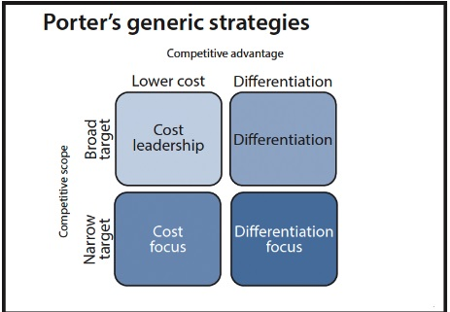

3.2 Ansoff Matrix Application
The assessment of the Ansoff matrix reveals more details about Unilever's strategic positioning in the global FMCG industry. The matrix focuses on different strategic options for the multinational company, namely product development, diversification, market development, and diversification. The product development strategy has been useful in achieving the company’s profit maximisation goals together with the unrelenting quest for expansion. New product development procedures, such as new product introductions, research and development, and constant product change, are some of the ways through which Unilever propels its product development strategy (Czinkota et al., 2021). The organisation's creativity and innovativeness justify new product launches and improvements. Therefore, the company employs the diversification technique to reduce risks, advance competitiveness, and meet different groups of consumers and has taken advantage of the strategy of adding more products beyond those related to home care (Teece, 2018). Specifically, the company implements both unrelated and related diversification strategies to maintain a competitive edge across a range of industries. The company has achieved this by developing partnerships in different sectors. Conversely, the unrelated diversification has necessitated the acquisition of subsidiaries that deal with products such as beauty and cosmetics.
Unilever uses the market penetration strategy to expand its presence in established markets through the utilisation of its existing products. The strategy helps the company maintain product development in markets where they have successfully established their brand. This process encompasses actions like forming strategic alliances, managing the marketing mix to ensure effective marketing, acquiring competitors, and implementing strategic pricing (Rumelt, 2017). Unilever employs efficient advertising to promote and increase demand for its products in the markets it serves. Pricing strategies, which, with the British company offering competitors prices that are like those of competitors' acquisitions, give protection to its market shares and profitability interest in these markets, are how this market influence is attained (Czinkota et al., 2021). Finally, the market development strategy is closely linked to Unilever's intensive growth plan, as it involves the introduction of existing products into new markets. Marketing, research and development, and expansion to different regions are some of the approaches used by the firm's professional team in executing the market development strategy (Teece, 2018). As a result, the marketing strategy assists Unilever in popularising its existing products in new markets, which helps it expand globally and regionally.
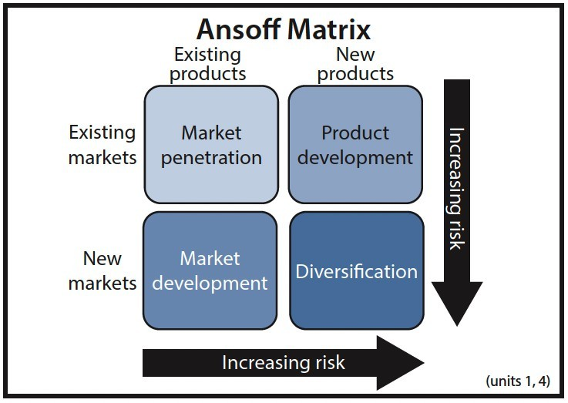

4. Resources and Capabilities
Resources and capabilities are the building blocks of organisational strategies in the existing globalised environment. As a result, professional and management teams should leverage quantities and qualities to enhance their operational business and corporate strategies. The resource-based theory emphasizes the fact that companies need to apply and utilize scarce resources in support of their different operations. Unilever relies on both tangible and intangible resources (Unilever.com, 2023). The multinational company's numerous tangible assets include suppliers, infrastructure, plants, equipment, machines, cash, and raw materials. Other examples include intellectual property, copyrights, a well-established distribution system, brand image, quality and experienced staff, and online facilities. Unilever's current success stems from its commitment to nurturing and enhancing key competencies like customer connections, effective collaboration, customer involvement, transformational leadership, creativity, and responsibility (Miller and Miller, 2018). Because of their uniqueness, these resources and capabilities create greater economic performance and a sustainable competitive advantage for the multinational company.

4.1 VRIO Analysis
The VRIO analysis is a useful framework for assessing resources through which firms gain a strategic advantage in their industry. In this case, the criteria specified in the tool establish that Unilever complies with valuableness, inimitability, rarity, and organisational dimensions. For example, it has valuable assets that provide it with competitiveness, customer goodwill, and the ability to underprice rivals (Schilke, 2017). The FMCG company also has strategic resources that include superior brands, highly trained employees, and sufficient financial power, among other things. Sufficient funds improve resource allocation in various fields, while other emerging opportunities within different industries increase the company's competitiveness. In its current markets, Unilever has a certain competitive balance against which few other competitors exist except for P&G (Unilever.com, 2023); hence, it controls rare competencies. Some specialist skills that set the business apart in its markets include adaptability to market volatility, problem-solving for future shocks, and the implementation of a robust research and development department across all markets. Unilever's unique resources and competencies, which include efficient and effective marketing communication, strategically positioned stores and offices, high-quality products, and affordable prices, contribute to its success. Similarly, the company's professional team's ability to strategically organize distribution networks and manage available financial capital gives it a sustainable competitive advantage (Galpin, 2019).
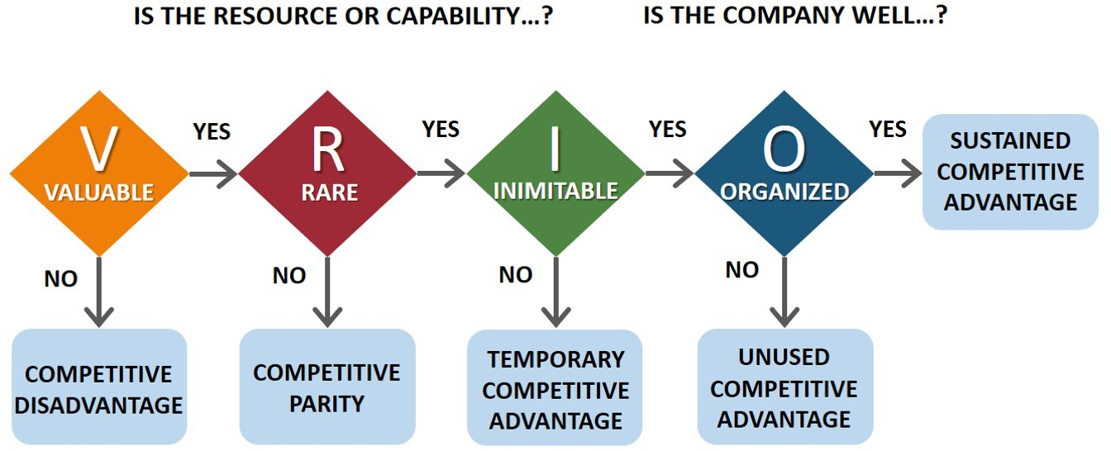

4.2 Porter’s Value Chain Analysis
It is useful to use Porter's Value Chain Analysis model to figure out the actions and outputs of a transnational company that make the target customers happy. With the assistance of the review tools, professionals can more easily find activities that give businesses an edge in their fields. As it turns out, Porter and Kramer's (2019) paradigm divides activities that improve an organization's performance into two groups: primary or core activities and secondary or supporting activities that happen within value delivery systems or strategic business units. Operations, sales and marketing, inbound and outbound logistics, and services are some of the first strategic value tasks that can help the business run better. Inbound logistics is the process of getting items and other materials for production and delivering them. In one way or another, the acquired raw materials undergo a process that includes assembly, packaging, and testing to become finished products. Outbound logistics entails some activities that involve the delivery of products to clients, such as warehousing, packaging, order processing, and shipment. Infrastructure, human resources management, purchasing, and technology are other auxiliary activities that support Unilever's operations. The value chain activities assist a multinational company in supporting the appropriate primary activities.
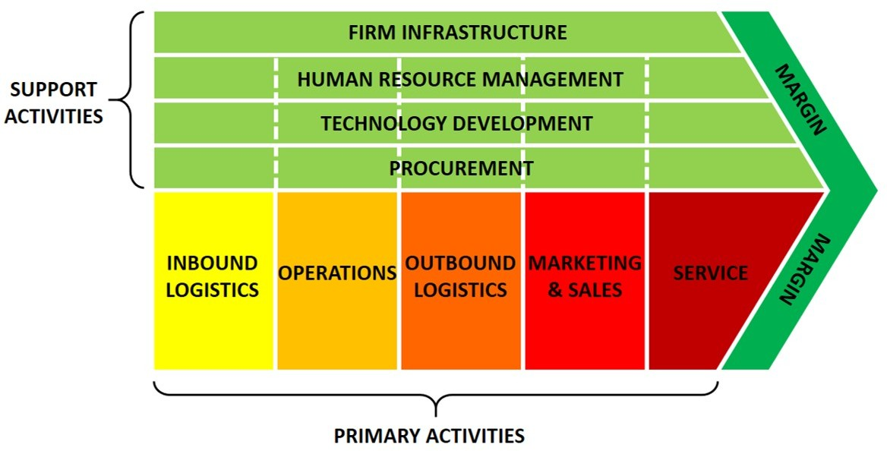

5. Strategy Implementation Success

5.1 The SAF Framework
The only part of tools that have been used in the determination of the strategy implementation decision in the SAF framework are the ones belonging to the assessment areas; (S) suitability, (A) acceptability, and (F) feasibility. The suitability assessment is also useful in assessing the degree of coordination of some strategies toward the achievement of organisational goals. The practical approach to Unilever's long-term objectives is to optimize product quality, diversify product portfolios, apply innovative technologies, and implement sustainable management practices (Carroll and Buchholtz, 2017). The company employs these techniques to achieve its long-term goals of expanding the firm and adapting to market fluctuations. It is simply this that helps Unilever target different clients with different needs, while also striving to avoid operating at a loss as much as possible. For example, an acquisition strategy provides a company with the capacity and assets it needs to provide quality. An analysis of feasibility is useful in identifying the strengths and resources needed to ensure the success of a given corporate or business-level strategy. The assessment shows that for Unilever to employ the various strategies, it needs skilled personnel, sufficient and effective capital, as well as teamwork.

5.2 Assessing Strategies Implementation
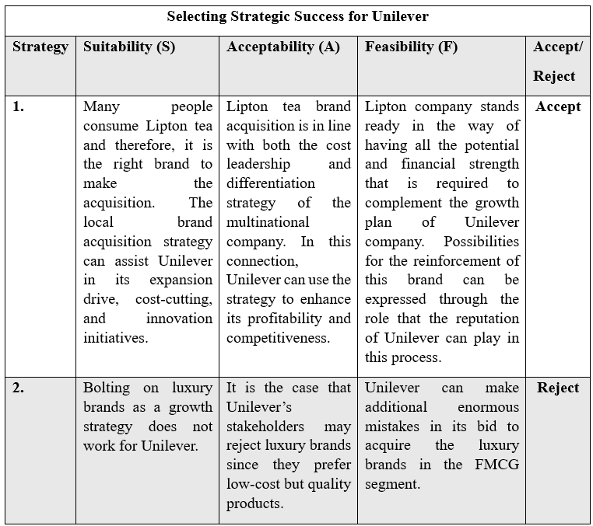

6. Competitiveness and Sustainability
To increase competitiveness Unilever has focused more on environmental sustainability in its operations as a player in the international FMCG industry. The company's environmental sustainability plans include agriculture regeneration, emission control, plastic waste management, and renewable energy. For example, Unilever has set the goal of decreasing CO₂ emissions in manufacturing and distributing its products, as well as in procurement levels (Unilever.com, 2023). The management's goal in logistics and distribution is to reduce carbon emissions by procuring electric vehicles. The MNC’s strategic plan involves decarbonising its storage and production facilities with direct investment in renewable energy. As a result, Unilever aims to improve investment in innovative product portfolios within the home care sector to address emissions (Unilever.com, 2023). It can be claimed that Unilever has been engaged in a collaborative process with its suppliers to turn captured carbon into soda ash. Sustainable investment in packaging material has helped Unilever reduce its use of plastic packaging by approximately 70% (Ajwani-Ramchandani et al., 2021). The management has gone further to declare its policy on compliance with the use of 100% renewable energy in all its warehouses, stores, offices, and production facilities. It has helped the company follow some of the ecological policies and obtain the attention of environmentally conscious customers.

7. Future Strategic Direction
Unilever has potential strategic options for the future that include expanding its product portfolio, fostering relationships with suppliers, enhancing product differentiation, managing the environment, and acquiring competitors. The differentiation strategy can assist Unilever in effectively delivering the best quality products in the market to clients at reasonably low prices (Czinkota et al., 2021). In this respect, the company will engage with various suppliers to ensure accessibility to quality, low-cost inputs. Investment in relationships with construction, manufacturing technology, and human capital resources will help the company differentiate its products from its 'competitors'. To achieve another form of product portfolio expansion, Unilever will need to acquire other brands from competing firms. In some cases, the company may acquire competitors to ensure that there is no erosion of its market position in the global market. The next-generation environmental sustainability programs will allow the company to use 100% sustainable packaging materials, enlist 100% green power, and reduce the company's carbon footprint to net zero (Ajwani-Ramchandani et al., 2021).

8. Conclusion
Conclusively, the complex and rapidly changing business environment of modern-day commerce employs strategic management. In particular, the strategic management operation's utilisation allows Unilever to be an MNC and deal with diverse products and services including home care, beauty and well-being, nutrition, and personal care leading the sector. However, the challenges are identified and elaborated. Among the major corporate strategies for the multinational company, it is possible to point to market development strategies which include new product market opportunities, divestiture, acquisitions, and mergers. Concerning this company, business-level strategies are the focus strategy, differentiation strategy and cost leadership strategy and it is analysed that Unilever is maintaining each of these based on its brand differentiations and it would be recommended to continue with it. Unilever holds the efficiency of capital investments and existing consumer band loyalties can eliminate the competitive threats through sustainable revamping of its brands. The SAF model's frameworks and strategies relevant to the multinational company include product quality optimisation, product differentiation, technique innovation, and sustainability. On this basis, the company continues to rely on environmentally sustainable business practices in managing competitiveness within the fast-moving consumer goods market.

9. Reference List
Ajwani-Ramchandani, R., Figueira, S., de Oliveira, R., Jha, S., Ramchandani, A., and Schuricht, L. (2021) 'Towards a circular economy for packaging waste by using new technologies: The case of large multinationals in emerging economies', Journal of Cleaner Production, 281, 125139.
Arunachalam, S., Bahadir, S., Bharadwaj, S. and Guesalaga, R., (2020) 'New product introductions for low-income consumers in emerging markets', Journal of the Academy of Marketing Science, Volume 48, pp. 914-940.
Barney, J.B. (2018) 'Why resource-based theory’s model of profit appropriation must incorporate a stakeholder perspective', Strategic Management Journal, 39(13), pp. 3305-3325.
Carroll, A.B. and Buchholtz, A.K. (2017) Business and society: Ethics, sustainability, and stakeholder management. Cengage Learning.
Chen, L., Lee, H. and Tang, C., (2022) 'Supply chain fairness', Production and Operations Management, 31(12), pp. 4304-4318.
Czinkota, M., Kotabe, M., Vrontis, D., Shams, S., Czinkota, M., Kotabe, M., . . . Shams, S. (2021) Product and service decisions. In Marketing Management: Past, Present and Future (pp. 341-397).
Dahlmann, F. and Grosvold, J. (2017) ‘Environmental Managers and Institutional Work: Reconciling Tensions of Competing Institutional Logics’, Business Ethics Quarterly, 27(2), pp. 263-291.
Egolum, P., Iliemena, R. and Goodluck, H., (2020) 'Exchange Rate Fluctuations and Financial Performance of Nigerian Companies: Study of Quoted Conglomerates (2007-2018)', International Journal of Innovative Research and Development, 7(7).
Galpin, T. (2019) 'Strategy beyond the business unit level: corporate parenting in focus,' Journal of Business Strategy, 40(3), 43-51.
Grant, R.M. (2018) Contemporary strategy analysis: Text and cases edition. John Wiley & Sons.
Hamel, G., and Prahalad, C. (2013) Creating global strategic capability. In Strategies in Global Competition (RLE International Business) (pp. 5-39). Routledge.
Hitt, M.A., Ireland, R.D., and Hoskisson, R.E. (2017) Strategic Management: Competitiveness and Globalization, 12th edn. Cengage Learning.
Jones, G. (2020) Renewing Unilever: transformation and tradition. OUP Oxford.
Lockhart, C., Vermeulen, P. and Kearins, K. (2019) ‘Sustainable Development at Unilever’, Journal of Business Strategy, 40(1), pp. 3-13.
Martin, M., (2020) Corporate Peace: How Global Business Shapes a Hostile World. s.l.:Hurst & Company.
Miller, W., and Miller, D. (2018) Enabling Innovation with Human Values: A Recipe for Transformation. In Handbook of Personal and Organizational Transformation (pp. 757-795).
Miskell, P. (2010). Unilever’s (other) brand wars: retailers, private labels, and struggles for supremacy within product supply chains. In Trademarks, Brands, and Competitiveness (pp. 237-256). Routledge.
Moon, J., Crane, A. and Matten, D. (2020) ‘Corporate Power and Responsibility: Issues in the Theory of Corporate Social Responsibility’, Business Ethics Quarterly, 30(3), pp. 371-398.
Nguyen, H. H., Ngo, V. M. and Tran, A. N. T. (2021) ‘Financial performances, entrepreneurial factors and coping strategy to survive in the COVID-19 pandemic: case of Vietnam’, Research in International Business and Finance, 56, p. 101380.
Pandin, M. Y. R., Sandari, T. E., Surahman, D. and Ananda, N. (2020) ‘The Effect of Sustainability Report on the Financial Performance of Consumer Goods Companies’, Jurnal Mutiara Ilmu Akuntansi, 1, pp. 42-58.
Porter, M.E. and Heppelmann, J.E. (2017) 'Why every organization needs an augmented reality strategy', Harvard Business Review, 95(6), pp. 46-57.
Porter, M.E. and Kramer, M.R. (2019) 'Creating shared value', Harvard Business Review, 89(1-2), pp. 62-77.
Reza, M. (2020) 'Marketing strategy and sustainable plan of Unilever', International Journal of Scientific Research and Engineering Development, 3(4), 680-692.
Rumelt, R.P. (2017) Good strategy/bad strategy: The difference and why it matters. Profile Books.
Schilke, O. (2017) 'On the contingent value of dynamic capabilities for competitive advantage: The nonlinear moderating effect of environmental dynamism', Strategic Management Journal, 38(2), pp. 489-514.
Stanley, A. O., Ovie, E. A., Ughovero, B. A. and Ijoyah, C. T. (2022) ‘Sustainable Production Strategy and Product Availability: A Study of Unilever Nigeria PLC’, Lafia Journal Of Economics and Management Sciences, 7, pp. 44-65.
Statista.com, (2024) Unilever - statistics & facts. [Online] Available at: https://www.statista.com/topics/1397/unilever/#topicOverview [Accessed 9 August 2024].
Sulkowski, A., Edwards, M. and Freeman, R., (2018) 'Shake your stakeholder: Firms leading engagement to cocreate sustainable value', Organization & Environment, 31(3), pp. 223-241.
Teece, D.J. (2018) 'Business models and dynamic capabilities', Long Range Planning, 51(1), pp. 40-49.
Unilever. (2024) Implementing growth action plan at pace Unilever [Online] Available at: https://www.unilever.com/news/press-and-media/press-releases/2024/implementing-growth-action-plan-at-pace/ [Accessed 9 August 2024].
Unilever.com, (2023) Unilever Annual Report and Accounts. [Online] Available at: https://www.unilever.com/files/92ui5egz/production/b09c3510ee7cec58440d5f044f02bdefe85aa186.pdf [Accessed 9 August 2024].
Unilever.com, (2024) Unilever at a glance. [Online] Available at: https://www.unilever.com/our-company/at-a-glance/ [Accessed 9 August 2024].
Unilever. (2024) Leading and delivering on sustainability through our Compass commitments [Online] Available at: https://www.unilever.com/news/news-search/2023/leading-and-delivering-on-sustainability-through-our-compass-commitments/ [Accessed 9 August 2024].

10. Appendix

10.1 SWOT Analysis
Strengths
Unilever Plc possesses several strengths that have propelled its success. Primarily, it has a strong brand portfolio, which consists of very well-known names globally, including Dove, Knorr, and Lipton. Such a wide product range allows Unilever to cater to several consumer needs and preferences at large, extending its reach in the market, and hence potential customer loyalty. Innovation too has been a solid area of focus wherein sustainable product development is concerned where the company is simply outstanding. (Stanley et al., 2022).
Weaknesses
Some of the major weaknesses faced by Unilever include the single dependence on a few superior brands. This makes the company vulnerable to market changes that will hurt these few key products. High operational costs may also hurt profit margins, as the global operation is large, and the company has also committed itself to promoting sustainability (Sulkowski, Edwards, and Freeman, 2018)..
Opportunities
Unilever has several growth opportunities in new categories, channels, and geographies. It is expanding into growing markets where consumers are becoming quality-conscious. Global demand for sustainable and greener products ideally fits into Unilever's strategic priorities and gives room to showcase innovations of new environment-friendly products. Partnerships and strategic acquisitions will further strengthen Unilever's market position and expand its product offerings, for instance (Nguyen et al., 2021).
Threats
Unilever must contend with the threat of strong competition in the consumer goods industry. Leading players like Procter & Gamble among others constantly introduce new goods into the market and try to grab a larger market share. Economic downturns and fluctuating foreign exchange rates also hit the company since it operates globally (Martin, 2020).

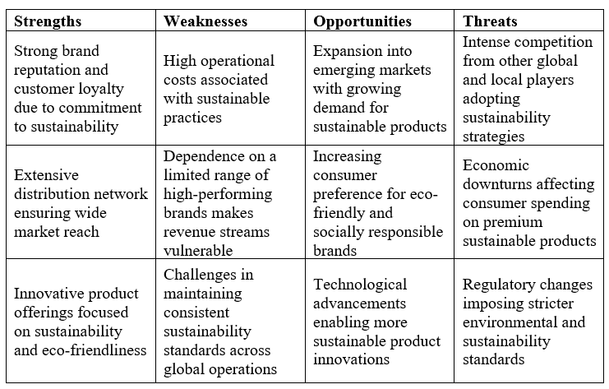

10.2 PESTEL Analyses
Political Factors
In many countries, Unilever operates in a very complex political environment. The company's operation is heavily influenced by the government's policies, trade regulations, and the general situation. For instance, trade agreements and tariffs can affect how easy the supply chain is or product prices (Chen, Lee, and Tang, 2022). Political instability can pose a risk to operations and supply chains in some regions.
Economic Factors
Economic conditions directly impact Unilever's performance. Economic growth rate, inflation rate, and exchange rate are essentials that alter the purchasing power of the consumer and the cost of operations. A fall in economic conditions causes a shift in the lowly priced commodities, thus affecting the premium brands of the company (Egolum, Iliemena, and Goodluck, 2020).
Social Factors
Social trends and demographic changes generally impact how Unilever functions. Growing awareness and demand for sustainable and ethically produced products fit with the sustainability initiatives of Unilever. Change in consumer lifestyles and preferences, for example, in developing a taste for health and wellness products, also opens the way for Unilever to innovate and diversify its product lines. Variance in cultural differences across markets means that Unilever has to tailor the products and marketing strategy to effectively capture local consumer preferences successfully (Arunachalam, et al., 2020).
Technological Factors
Technological developments: These offer Unilever several channels and opportunities for innovation and operational improvement. The business has invested in research and development, which enables the ability to both develop new products and improve existing ones to gain a competitive advantage. E-commerce and analytics aid in the digital transformation of understanding the nature of customer behaviour and operational efficiency within the supply chain (Lockhart et al., 2019).
Environmental Factors
One of the areas where Unilever is greatly committed is environmental sustainability. As a clear testament to this, the Unilever Sustainable Living Plan has been drafted. Climate change, scarcity of resources, and tougher environmental legislation greatly direct how the company's operations are undertaken and its products developed (Dahlmann and Grosvold, 2017).
Legal Factors
For Unilever to remain relevant in business, there must be compliance with legal and regulatory requirements. However, it has been noted that laws regulating product safety, labeling, advertisement, and environmental standards differ from one country to another. Such regulations may affect its choices and marketing strategies in developing products in some countries, and therefore the company is expected to institute a risk-based approach towards effective intellectual property (Nguyen et al., 2021).

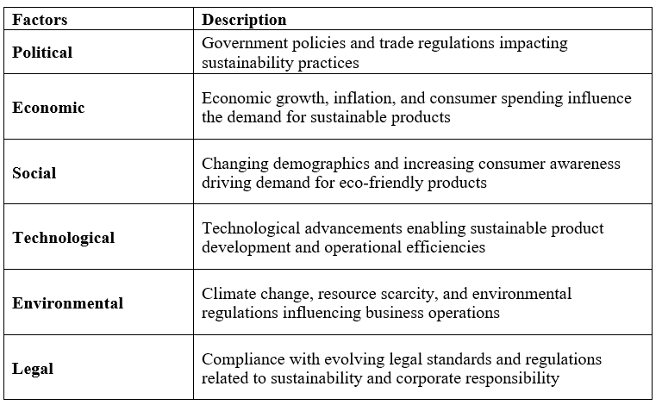

10.3 Industry Five Forces Analysis
Threat of New Entrants
The customer goods industry involves high barriers to entry such as considerable capital outlay, brand loyalty by consumers, and economies of scale. Unilever has a vast brand portfolio and distribution channels, which makes the competitors' barriers to entry even higher. The main threat comes from niche markets and innovative start-ups since they focus on sustainable goods and health products. In this way, Unilever has to remain ever-innovative and competitive (Jones, 2020).
Bargaining Power of Suppliers
The bargaining power of suppliers depends on the availability of substitute inputs and the concentration of suppliers. Unilever is a company that has a very diversified product range; its operations are located around the globe and therefore depend on many suppliers. It reduces its dependence on one supplier affecting the general operation of the company, supply chain disturbance, and price volatility. Other ways that can be used to handle the supplier's power include strategic supplier relationships and effective supply chain management (Lockhart et al., 2019).
Bargaining Power of Buyers
Buyer power: In the consumer goods industry, the buyer power is high. Many substitutes are there for the available products, price sensitivity is also high amongst buyers, and switching costs are minimal. All combined forces create a strong buyer power in this segment. Unilever is a market with a strong brand image and their strategic focus towards quality and sustainability has helped them reduce the buyer power to an extent. However, other challenges comprise shifting consumer preferences and the increased pressure on demand for retail chains. Therefore, Unilever needs to continue engaging consumers, innovating new product lines, and pricing products competitively (Moon et al., 2020).
Threat of Substitute Products or Services
Since there is a large number of substitutes in a wide number of product categories, their threat is high for the business of consumer goods. For instance, personal care products have several brands, or consumers can make them at home. To this, product differentiation helps Unilever by innovating and following sustainable methods. But still, it needs to be done with alertness, as consumers can switch to other companies with better offerings on further parameters of satisfaction (Pandin et al., 2020).
Rivalry Among Existing Competitors
Consumer goods are highly competitive industries, with large corporates like Procter & Gamble, Nestlé, and Colgate-Palmolive competing for market dominance. High rivalry compels constant innovation in the realm of marketing and prices. A diversified product portfolio, high brand equity, and sustainability are some competitive edges that can be reaped by Unilever; however, these advantages require constant investment in both research and development as well as marketing to enhance operational effectiveness. Collaborations and strategic acquisitions can also enhance Unilever's market position (Dahlmann and Grosvold, 2017).

