Colour Chemistry
By Marcus Baker-Wells

Aim of Experiment | 2
Theory | 2,3
Chemicals And Equipment | 3,4
Procedure | 4
Observations | 5,6
Calculations | 6,7
Results | 7
Conclusion | 7
References | 7,8

Aim of the Experiment

The main objective of this experiment is to deduct 8 different metallic ions in 8 unlabelled containers that hold unknown samples. This will be done by using colour chemistry. The experiment will show and give a practical understanding of the effects of colour chemistry, this is when different chemical elements when in contact with a “blue/roaring” flame and determine the different chemicals, that were in unlabelled containers which would contain the said chemicals.
The main tasks of the experiment are as follows: to deduct the different chemicals using colour chemistry, to understand the basic concepts and laws of the theory which outlines colour chemistry and to explain the applications of colour chemistry within an OME environment. IT is important to note that whilst this experiment was conducted the correct PPE (Personal Protective Equipment) was worn and all Health & Safety procedures were followed, as well as the experiment being held in a professional environment.

Theory

The basic concept of Colour Chemistry is as follows, the thermal energy from the flame transfers from the blue flame to the electrons within the chemicals which in turn give the electrons in the shells the energy to become excited. This therefore will make the electrons move excitably and this in turn will make the electrons absorb wavelengths of light. This is what will make the flame change colour for a small period until the chemical has been burnt off, this is more commonly called “Photon Emission”, [1].
For Photon Emission to work the electrons need to be excited and this will absorb wavelengths of light as talked about above, this is how the chemicals, and the chemical mixtures make different colours. This is useful to know due to the experiment mainly focusing on these atomic events, however, another scientific principle comes into play within the experiment because being used in the experiment was blue cobalt glass (the full list of lab tools and supplies will be listed later in the report). The reason this was used is because the blue colour of the glass would separate the electromagnetic radiation into the frequencies that are unique to those colours made from the flame.
The way to find out the energy of a photon to then calculate the wavelength/frequency is as follows:
The constant speed of light is C = 3.00x10⁸m/s
The Energy of a Photon (E_{photon}) is calculated by:
E_{photon} = HV[2]
H= 6.626x10⁻³⁴J/s (Planck’s constant)
You can also calculate the velocity by doing:
Wavelength – frequency, which will give you the velocity to then answer:
E_{photon} = 6.626x10⁻³⁴ x Velocity
This should give you the information to calculate the necessary answers one would need for this experiment.

The applications of the mentioned above can be widely used within the OME world (Ordnance, Munitions, Explosives) because mostly everything within the OME sphere runs off chemistry and physics, which involve atoms and chemical bonds. For example, the Signal Set for a Scuba dive team would need to have lots of energy in the photons due to the H₂O resisting some of the reaction that takes place. Another example would be to calculate the amount of energy a photon would have within the charge of a 105mm cartridge, this is where you will have the cartridge be filled with propellant which will then be ignited causing a reaction where energy will need to be transferred into kinetic energy. Colour Chemistry can also be used in OME to figure out the contents of a thermal ammunition/ chemical fill, for example if the fill burns a certain colour, you can deduct the chemical contents of the fill. In everyday life the application of colour chemistry can be useful because it can be used to decipher what is included into a prototype fuel or a household chemical cleaner.

Chemicals And Equipment

In this experiment the chemicals were supplied to us as well as the equipment. The equipment used within the experiment are as follows:
Bunsen Burner
Heat Resistant mat
Matches
Metal Rod
1M solutions of unknown metal salts labelled.
Beaker with 1 M HCL
Beaker with Deionised water
Blue Cobalt Glass
These were used in the physical aspect of the experiment and the health and safety part of the experiment ensured the users that the correct PPE was worn, the PPE worn were: Lab coats, goggles and rubber surgical gloves. Each of these was to help limit the risk of an irritation or worse on the skin.
The chemicals used are as follows:
Hydrochloric Acid solution
Barium Chloride
Calcium Chloride
Lithium Chloride
Strontium Chloride
Strontium Nitrate
Potassium Chloride
Potassium Nitrate
Sodium Chloride
Copper Chloride [3]

All of these were used safely and under supervision.

Procedure

The way the experiment was set out was to first set up the Bunsen Burner onto the heat-resistant mat, then proceed to light the Bunsen burner with a match and open the air vent to make the safe yellow flame into a blue flame that had two cones (one at the inner cone and one at the outer cone). It was important to keep the flames at a yellow safety flame when the Bunsen Burner wasn’t in use.
The second action was to clean the metal rod wire with the 1 M HCL to rid the metal wire of any unwanted chemicals or solutions. After this the wire was placed into the flame and if the flames colour changes, then there are still unwanted chemicals on the wire; otherwise continue onto the next step which was to lightly submerge the metal rod into the DI water and heat to make sure no unwanted chemicals get through to the chemical testing phase as it could ruin results and give you bias or wrong data. Then cool the rod down and then dip it into the solutions of unknown metal/salt mixtures, then proceed to heat the flame just above the inner cone of the flame but make sure this is done on a blue flame (“roaring”) and use the blue cobalt glass to maximise certainty of colour. It is advisable that the user repeat the cleaning of the metal rods after each chemical test to ensure an unbiased result.

Observations And Data

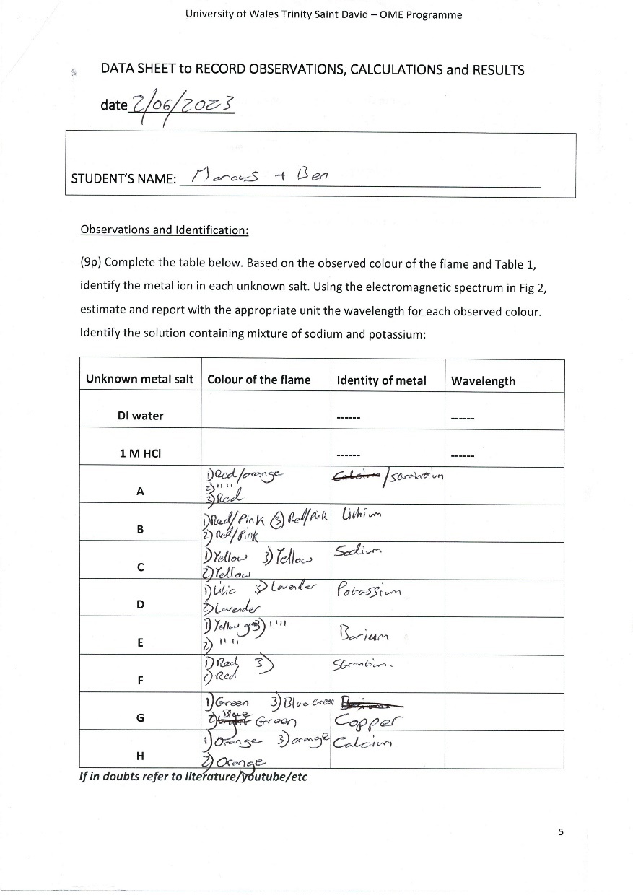
Figure 1, Data Sheet

The data sheet above shows which colours the pair I was in agreed we could see. Each test was done 3 times to ensure maximum certainty on the colours and chemicals that it could be. Many observations were made in this experiment, a major one would be the difference in colours between using the blue cobalt glass and not using it. The cobalt glass ensured a clear and easy way to identify colours by eliminating certain light wavelengths, this therefore made it easier to quickly identify the colours, but we made sure to continue the triple checking throughout the experiment.
For solution ‘A’, the first observation of colour was indecisive between red or orange. Orange would mean Calcium (Ca²⁺) and red would indicate Strontium (Sr²⁺), this was then when we decided to do multiple tests to ensure the clearest result possible. The next 2 results would then be unequivocally red which why the chosen chemical solution was Strontium (Sr²⁺). For ‘B’, the colour was an in between of red and pink on each trial run, this then required reference to ‘Table 1’ to then view that Lithium (Li⁺) was the closest choice to the visible colour. The experiment became harder to navigate the different colours the more the chemicals produced different shades of colours, for example Barium (Ba²⁺) has the colour “green/yellow” [3] and Copper (Cu²⁺) is “blue/green” [3]. These two are very good examples of how the cobalt glass helps with outlining the clear differences between to very similar colours.

Calculations

Below is Figure 2 which will be useful in helping calculate 3 different energies of their photons.

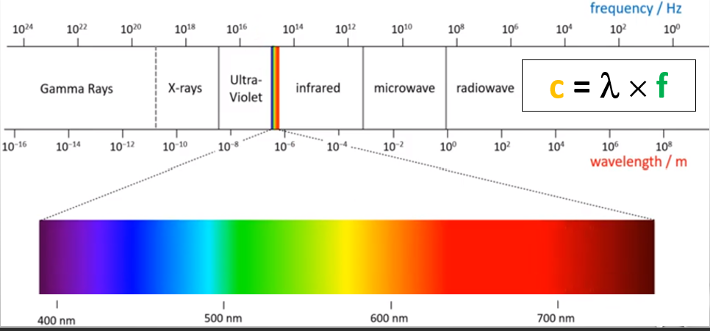
Figure 2 Colour graph
From this graph we can use it to gather the velocity of different chemical solutions based on the colours they gave off during the Laboratory Experiment. For example, a red would give 700nm velocity and it we use the equations from earlier, we can work out the energy of a photon:
(6.626x10⁻³⁴) x 700 = 4.6382x10⁻³¹ Joules
Using the information given, a verity of E_{photons} can be calculated. Using this basis, the energies of the photons that occurred in the lab experiment can be calculated as well. The three solutions that /will be calculated will be, Sodium, Potassium and Barium.

Sodium had a record of ‘yellow’ which would be 580nm, so doing (6.626x10⁻³⁴) x 580 = 3.8396x10⁻³¹ Joules.
Potassium had a record of lavender, 430nm. This means that (6.626x10⁻³⁴) x 430 = 2.8466x10⁻³¹ Joules.
Barium had a yellow/green colour, 560nm. This corresponds with (6.626x10⁻³⁴) x 560 = 3.7072 x 10⁻³¹ Joules.
Results

To start the identification of these chemicals seemed somewhat simple but quickly turned into a complex situation due to the similarities in colours, this meant that the metal rods used to help burn the chemicals had to follow the procedure specifically as to ensure correct choices for the colours and therefore the calculations following later.
A problem that occurred quickly was that different people have different perspectives on shades of colours, as this is a problem as one person might perceive green and blue for yellow and blue. This is where the equipment helped as it defined the colours and simplified this discussion .Following on from that conversation using the blue flame as opposed to the yellow safety flame when doing experiments because the blue flame holds more heat than the yellow safety flame.

Conclusions

In conclusion to this report, the main outcomes were the calculations of energy that a photon can hold as well as the colour of the flames, as this is a major part of colour chemistry. The part that would become most important to this experiment scientifically wise would be the glass cobalt due to the importance the colours play in the graph in the calculations zone. This is because without the correct colours there would be no correct numbers. However, the experiment was a success due to the outcome of varied colours as well as a chance to see how chemistry works practically.

Figures
Figure 1, Data Sheet 5
Figure 2 Colour graph 6

References

[1] | Andor , “Emmison Of Light”.
[2] | F. Scullion, “Finding The Energy Of A Photon,” p. 1, 28 09 2008.
[3] | D. E. Kazimierska, “ACBD 4011: COLOUR CHEMISTRY,” p. 3, 2023.

