Business Model Canvas

Student Name: A K M Amdadul Hoque
Student ID: 2107424
Module Name: Entrepreneurship
Module Code: BMIH 5001
Module Teacher: Chris Wilkin

Table of Contents
Introduction 3

Critical Evaluation of BMC and the Driving Factors that May Contribute to “PetHeaven” Resort Success 5
Conclusion: 9
Reflective Statement 12
References 13
Appendix ………………………………………………………………………………………16

Introduction
PetHaven Resort, a new hotel in the active hotel industry, meets the growing demand for pet-friendly accommodations. This complete concept offers a haven for dogs and their owners and pet-friendly lodgings (Permana & Andana, 2021). PetHaven Resort intends to revolutionise the pet-friendly experience by including cutting-edge aspects, partnering with adjacent pet services, and creating a cosy, welcoming ambiance inspired by current trends (Zoumpoulidis et al., 2021). PetHaven Resort offers unique, personalised, and exceptional pet experiences to fit changing consumer requirements.

Critical Evaluation of BMC and the Driving Factors that May Contribute to “PetHeaven” Resort Success
Customer Segments (Target Audience): Through digital channels, we want to reach pet lovers and highlight the unique qualities of our offerings. Since pet owners' holiday plans and leisure activities tend to align with seasonal patterns and local events, these factors have a substantial impact on our business (Das et al., 2021). We aim to cater to pet owners who have high standards and value personalised care. Incorporating state-of-the-art amenities, establishing strategic relationships, and cultivating a welcoming ambiance are what set PetHaven Resort apart from its competitors. For all of these reasons, PetHaven Resort is the best choice for dog owners looking for a chic and all-inclusive resort.

Target Customer Profiling 1:
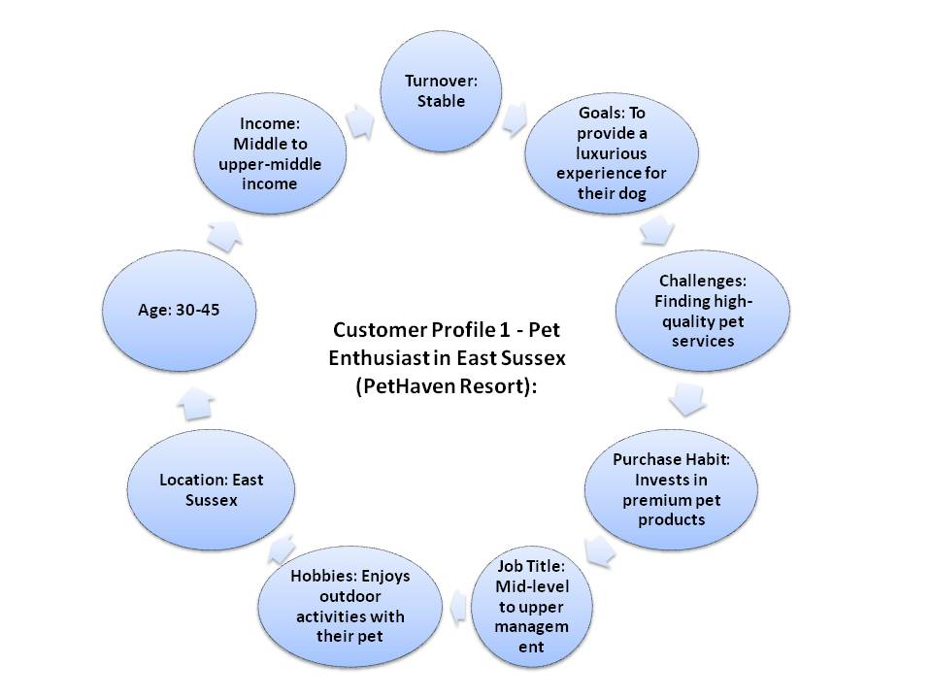
Source: (Pruengpanyanont, 2022)

Target Customer Profiling 2:
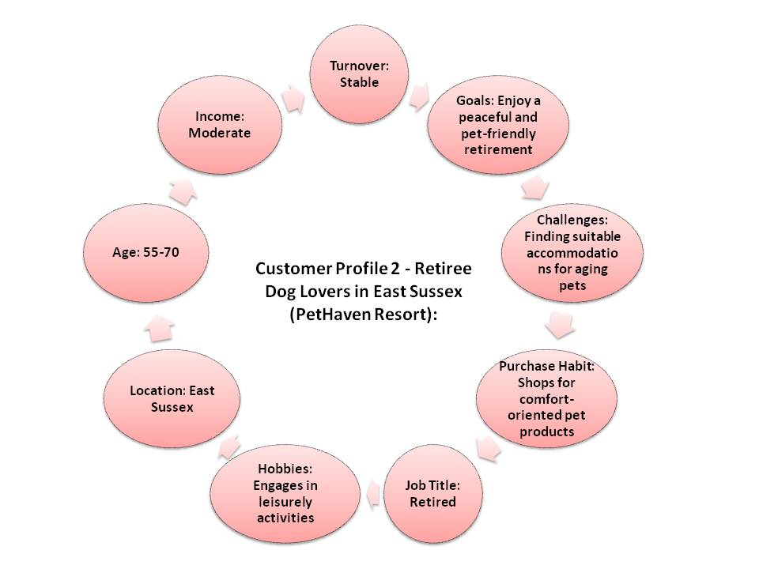
Source: (Buhalis and Chan, 2023)

Competitor Analysis:
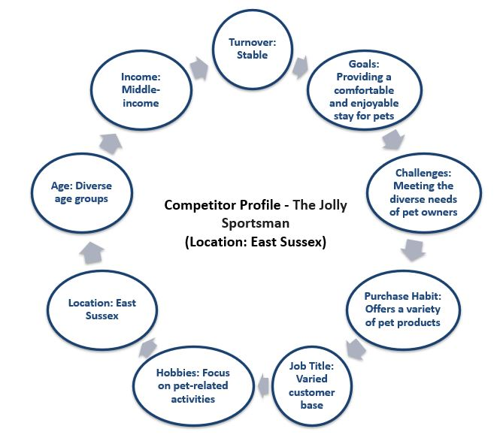
Source: thejollysportsman.com
Value Proposition: The PetHaven Resort is better than its competitors for certain reasons. Among them offering a dedicated team for pet care is one of the major ones. This resort offers a dedicated team to the guests to take care of their pets so that the guests can enjoy a better leisure time. Further, this resort also offers the cost-effective service to the guests. Here, PetHaven Resort offers a standard and luxurious service without charging much to the guests. PetHaven Resort uses cutting-edge technology and collaborations with local pet companies to provide the best pet-friendly experience. By delivering unique and excellent goods and services, we can provide our customers a competitive advantage and address their changing demands (Sipe, 2021). Our protected haven for dogs and their carers sets us apart from our competition. We achieve this by combining modern design with a comfortable atmosphere. We stand apart by giving individualised services, cutting-edge pet care, and tailored pet lodgings (Simanjuntak, 2021). PetHaven Resort gives canines an amazing, trend-focused, and complete experience by spotlighting pet owners' changing needs and cooperating with neighbouring businesses. PetHaven Resort in East Sussex provides unique pet-friendly vacations in a beautiful environment. We built our unique products with cutting-edge features with local firms to suit the area's pet owners.
Channels: Efficient communication and booking processes are facilitated by digital channels, including a user-friendly website and many social media sites navigation (Daou ET AL., 2020). By engaging in collaborative advertising, we may effectively expand our target audience by partnering with adjacent pet enterprises. In order to inform consumers about exclusive promotions and distinctive pet encounters, we use e-newsletters and customised notifications. Physical touchpoints include the careful placement of leaflets and signage at local pet-related businesses (Micieta et al, 2020). Our convenient on-site personal assistants and efficient online reservation system facilitate the acquisition of necessary things and services. Through analysis, we enhance our ability to attract, retain, and captivate our audience, while also gaining insights into our web-based strategy and competitive channels.
Customer Relationships: PetHaven Resort prioritizes client interactions by strategically implementing creative ideas. Adhering to the tenets of Relationship Marketing, we maintain frequent engagement with our customers via several channels, including newsletters and social media platforms (Jin et al., 2022). Loyalty programs, which provide customers discounts or other advantages in return for their ongoing support, were derived from the Loyalty Business Model. Customers in the fiercely competitive pet-friendly hotel industry need prompt and gratifying solutions to their difficulties (Mustaniroh, Prabaningtias & Citraresmi, 2020). The Service Recovery Paradox outlines the phenomenon of achieving very rapid responses.
Revenue Stream: PetHaven Resort's revenue streams complement contemporary business. Freemium models charge for premium services like grooming and training while delivering basic services for free. Dog owners and housing bills provide this money. The Resource Dependency Theory suggests partnering with local pet care providers to boost profitability and pet-friendliness (Muhtaroğlu et al., 2013). The Access Over Ownership philosophy may boost product sales. This may be done by providing pet owners unique accommodation options, accessories, and toys. PetHaven Resort offers multiple revenue streams, making it a powerful financial player in the pet-friendly hotel sector.

Key Resources: PetHaven Resort has state-of-the-art pet facilities, accommodations that warmly welcome pets, strong partnerships with nearby pet services, and a stylish and welcoming atmosphere, all of which contribute to its exceptional value. Essential advantages include state-of-the-art technology, elegantly adorned facilities, and collaborations with local pet businesses. These materials are crucial for meeting the growing demand for pet-friendly lodgings and transforming the whole pet-friendly accommodation offering in the contemporary hotel industry (Eisape, 2019). Additionally, they provide the delivery of distinctive, customised, and exceptional pet encounters.
Key Activities: Opening PetHaven Resort requires locating a decent site in a pet-friendly community with plenty of green space. One must get permissions and leases to run a dog-friendly establishment. We may create indoor play areas to make places more dog-friendly throughout design. A booking site with user-friendly interfaces improves website functionality and online revenues. Salespeople must find dog-savvy professionals to help.
Operational activities include selling pet products at the hotel's gift shop. The campaign involves working with local pet influencers to improve our social media presence. Security may be achieved by installing pet-friendly surveillance systems (Sort & Nielsen, 2018). We provide high-quality spa services and pet grooming. 'Paw-ties' themed pet birthday parties are a terrific marketing tool.
Key Partnership: PetHaven Resort partners with nearby pet services to provide a cohesive pet-friendly experience. One of the major partners of PetHaven Resort is Pet Supplies Sussex. This partner of Pethaven offers a variety of dog foods to the resort. Another major partners of PetHaven resort is KDT Pet Supplies Ltd. This supplier of PetHaven offers pet foods of different types and they are one call away from the resort. PetHaven Resort optimises its business strategy, minimises operational risks, and obtains key assets via these collaborations to provide consumers and their beloved canines an amazing experience (Setiawan et al., 2021). Access Over Ownership recommends working with pet food and supply providers to offer a broad range of high-quality products to save inventory expenses (Murray & Scuotto, 2015). Tourism companies may assist us recruit pet-friendly guests. This works with channel intermediates. These critical connections make PetHaven Resort popular with pet owners. PetHaven Resort partners with local firms like "Eastern Sussex Pet Shops" to offer the best facilities for our furry visitors in an eco-friendly, community-driven refuge for dogs and cats.
Cost Structure: The resort's careful financial planning is based on modern business philosophy. According to Cost Leadership theory, a pet-friendly environment must be well-maintained and developed to preserve a competitive edge. Staff compensation and training are based on the Human Capital Theory, resulting in a highly skilled team that offers excellent pet care. The marketing budget attempts to build the pet-friendly hotel brand's reputation via Brand Equity. The Resource Dependency Theory considers cooperative partnership fees smart investments to enhance local pet service partnerships and broaden alternatives (Eisape, 2020). Their pricing strategy prepares PetHaven Resort for development and competition in the pet-friendly hotel sector.

Conclusion:
PetHaven Resort serves consumers with current business procedures. We may work with local pet services and suppliers to provide a wide range of high-quality dog goods and services. The Resource-Based View says our strategic ties and massive assets let us dominate the market (Majidah et al., 2021). Modern marketing helps PetHaven Resort create consumer connections and efficient channels. Finally, this novel approach fulfils the growing need for pet-friendly hotels and pioneers the changing leisure sector (Adeyinka, 2021).

Reflective Statement
A few of weeks ago, I completed two tests designed to gauge my entrepreneurial spirit and abilities as I got the ball rolling on PetHaven Resort, a company that offers lodging for dogs. The findings have highlighted specific areas where improvement is necessary. This reflective report aims to analyse these characteristics and provide advice for development.

Overall GET2 Test Score (54%) - A total result of 54% on the entrepreneurial characteristics inventory shows a level of performance that is regarded to be average within the context of the inventory. Indicative of a thorough combination of strengths and places for development is the fact that this is the case.
Need for Achievement (58%) - A high score on the Need for Achievement assessment suggests a robust drive to set and achieve ambitious goals. To ensure the success of PetHaven Resort, it is crucial to use this unique edge. Nevertheless, with further scrutiny of other scores, it becomes evident that some areas may need enhancements.
Need for Autonomy (33%) - A potential barrier to accepting autonomy and taking charge of decision-making processes is highlighted by the lower Need for Autonomy score. I understand the need of actively seeking opportunities to exercise discretion and gradually taking on greater responsibilities in order to get over this shortcoming.
Creative Tendency (58%) - An individual with a high score in Creative Tendency have a solid foundation for creativity. At PetHaven Resort, we firmly think that cultivating a culture of creative thinking among our workforce members, consistently exploring new ideas, and being informed about current events are the most effective methods for nurturing creativity.
Calculated Risk-taking (75%) - An impressive accomplishment would be to get a high score in Calculated Risk-taking. The hotel industry is dynamic and ever-changing, so taking calculated risks is essential. In order to make the most of this advantage, I will continue to carefully weigh the risks involved, ensuring that PetHaven Resort's goals are realised via a systematic approach to decision-making.
Locus of Control (33%) - A decreased Locus of Control score indicates a tendency to see less influence over external events outside one's control. I want to address this issue by engaging in activities that enhance my self-assurance, such as setting and achieving realistic business goals. Developing a positive mindset might help strengthen one's internal locus of control.
For the sake of enhancing my capacity for self-governance, I pledge to steadily increase the amount of time I spend participating in decision-making processes. In order to increase their self-assurance in their ability to make autonomous decisions, it is beneficial for them to seek help when it is required and to participate in mentoring relationships. The formation of a growth mindset is something that may be actively worked on in order to reach the goal of taking control of one's life. As a result of seeing problems as chances for personal development and progress, one may be able to cultivate a more optimistic perspective on their capacity to control their own future. Having given the results of the class exam some serious consideration, I now have a much better understanding of the areas in which I excel as an entrepreneur and those in which I might need some development. As a result of the fact that the success of PetHaven Resort is dependent on my entrepreneurial spirit, I want to develop my talents in goal-setting, creativity, and risk-taking while simultaneously addressing my shortcomings in uniqueness and locus of control. In the fast-paced and ever-changing world of business, this path of self-reflection acts as a roadmap for continuous progress and adaptability.

References
Adeyinka-Ojo, S., 2021. Conceptualizing a Sustainable Digital Business Model Canvas for Tourism and Hospitality Business in a Novel Coronavirus Pandemic Age. Co-Editors.
Alves, H.M. and Valeri, M., 2022. Encouraging brand attachment on consumer behaviour: Pet-friendly tourism segment. Journal of Tourism, Heritage & Services Marketing (JTHSM), 8(2), pp.16-24.
Anggraeni, A.S., Jahroh, S. and Suparno, O., 2022. Sustainable Business Strategy at Hotel Selarong Bogor. Business Review and Case Studies, 3(3), pp.181-181.
Buhalis, D. and Chan, J., 2023. Traveling with pets: designing hospitality services for pet owners/parents and hotel guests. International Journal of Contemporary Hospitality Management.
Daou, A., Mallat, C., Chammas, G., Cerantola, N., Kayed, S. and Saliba, N.A., 2020. The Ecocanvas as a business model canvas for a circular economy. Journal of Cleaner Production, 258, p.120938.
Das, P., Perera, S., Senaratne, S. and Osei-Kyei, R., 2021. Developing a construction business model transformation canvas. Engineering, Construction and Architectural Management, 28(5), pp.1423-1439.
Eisape, D., 2019. The platform business model canvas a proposition in a design science approach. American Journal of Management Science and Engineering, 4(6), pp.91-107.
Eisape, D., 2020. Comparing platform business models: A balanced scorecard approach based on the platform business model canvas. Nordic Journal of Media Management, 1(3), pp.401-432.
https://thejollysportsman.com/story
Jin, Y., Ji, S., Liu, L. and Wang, W., 2022. Business model innovation canvas: a visual business model innovation model. European Journal of Innovation Management, 25(5), pp.1469-1493.
Majidah, M., Cahyaningsih, C., Saraswati, R.S. and Inawati, W.A., 2021. Self-Identification of Homestay Management Problems and Canvas Business Model. Journal of Innovation and Community Engagement, 2(1), pp.1-10.
Micieta, B., Fusko, M., Binasova, V. and Furmannova, B., 2020. Business model canvas in global enterprises. In SHS Web of Conferences (Vol. 74, p. 02010). EDP Sciences.
Muhtaroğlu, F.C.P., Demir, S., Obalı, M. and Girgin, C., 2013, October. Business model canvas perspective on big data applications. In 2013 IEEE International Conference on Big Data (pp. 32-37). IEEE.
Murray, A. and Scuotto, V., 2015. The business model canvas. Symphonya. Emerging Issues in Management, pp.94-109.
Mustaniroh, S.A., Prabaningtias, N. and Citraresmi, A.D.P., 2020, June. Analysis of business development strategies with business model canvas approach. In IOP Conference Series: Earth and Environmental Science (Vol. 515, No. 1, p. 012075). IOP Publishing.
Ningsih, R., Wijaya, F. and Herlinawati, E., 2023. Analysis of business development using a business model canvas approach. Journal of Management Science (JMAS), 6(1), pp.117-124.
Permana, G.P.L. and Andana, M.G., 2021. Canvas Business Model Established By the Bali Petro Jaya Company During Covid-19. Jurnal Ilmiah Manajemen Dan Bisnis, 6(2), pp.127-137.
Pruengpanyanont, E., 2022. Business plan for budget pet-friendly hotel (Doctoral dissertation, Thammasat University).
Rachman, G.P. and Do, A.D., 2020. Business Strategy for Atlantic City Hotel Facing Covid-19 Pandemic. International Journal of Current Science Research and Review, 5(2), pp.333-340.
Setiawan, J., Budiastuti, M.S., Gravitiani, E. and Setyono, P., 2021. Business model canvas (BMC) approach for tourism management strategy of the top selfie kragilan, Mt. Merbabu National Park. Geo Journal of Tourism and Geosites, 35(2), pp.297-303.
Simanjuntak, M., 2021. Designing of service dominant logic and business model canvas: Narrative study of village tourism. Golden Ratio of Marketing and Applied Psychology of Business, 1(2), pp.73-80.
Sipe, L.J., 2021. Towards an experience innovation canvas: A framework for measuring innovation in the hospitality and tourism industry. International Journal of Hospitality & Tourism Administration, 22(1), pp.85-109.
Sort, J.C. and Nielsen, C., 2018. Using the business model canvas to improve investment processes. Journal of Research in Marketing and Entrepreneurship, 20(1), pp.10-33.
Zoumpoulidis, V., Valsamidis, S., Nikolaidis, S. and Tsourgiannis, L., 2021. A unified business model canvas for digital intermediaries in tourism industry. Tourism Management and Sustainable Development, pp.71-87.


