
Rhys Taylor P150229

BREEAM NEW CONSTRUCTION ASSEMENT/ENERGY ASSEMENT
Assignment 2 of 2
BREEAM UWTSD assessment
Juan A. Ferriz Papi

Contents
Introduction 2
TRA01 2
TRA02 4
TRA03 4
TRA04 5
TRA05 6

Introduction
This following document is my personal completion of the Transport section of the BREEAM assessment process, in coordination with operations manual SD5070 V5.2. Following the technical manual my aim is complete tra01 – tra05, using the evidence provided, to produce the BREEAM score for the section in question. Once every element is complete by different team members we will be able to provide a BREEAM rating for the building.
The building in question is UWTSD’s new library which is currently under construction. Using the evidence provided by the principle contractor, KIER, and personal research the BREEAM score will be produced. (BRE, 2018)
The document is structured in such a way that the evidence is appended and only used in the main body when required. Please refer to back of document for any evidential reading

TRA01
To recognise and encourage development in proximity of good public transport networks, thereby helping to reduce transport-related pollution and congestion. Up to 5 credits are available for this section.
Methodology
The first step I took into the completion of tra01 was to use google maps to source all the local bus stops. As the train station was more than 100m away it was not a valid node. As a software google maps provides all the sufficient dated needed. Using the measuring tool, I could find out the distance of the node from the library site. By clicking on the highlighted bus stops within 1000m, note this is walking distance not as the crow flies, I was able to find out the service number of the buses that stopped. The technical manual states if a service stops at a different stop more than once then it is only to be included once at the closest stop to the building being assessed, the following are my calculations for the average frequency per hour
SA1 Bus Stop, 480m from building, 2 busses stopping
Bus 6. 12 stops between the hours of 08.00-19.00 (11hours) 12÷11 = 1.09 average frequency per hour
Bus 44. 21 stops between the hours of 08.00-19.00 (11hours) 21÷11 = 1.91 average frequency per hour
Fabian Way Bus Stop, 960m from building 5 buses stopping
Bus 58. 9 stops between the hours of 08.00-19.00 (11hours) 9÷11 = 0.82 average frequency per hour
Bus 84. 9 stops between the hours of 08.00-19.00 (11hours) 9÷11 = 0.82 average frequency per hour
Bus X1. 11 stops between the hours of 08.00-19.00 (11hours) 11÷11 = 1 average frequency per hour
Bus X3.8 stops between the hours of 08.00-19.00 (11hours) 8÷11 = 0.73 average frequency per hour
Bus X55. 16 stops between the hours of 08.00-19.00 (11hours) 16÷11 = 1.45 average frequency per hour
Sainsbury’s Bus Stop, 795m from building 5 buses stopping
Bus 31. 6 stops between the hours of 08.00-19.00 (11hours) 6÷11 = 0.55 average frequency per hour
Bus 32. 10 stops between the hours of 08.00-19.00 (11hours) 10÷11 = 0.91 average frequency per hour
Bus 33. 19 stops between the hours of 08.00-19.00 (11hours) 19÷11 = 1.73 average frequency per hour
Bus 57. 12 stops between the hours of 08.00-19.00 (11hours) 12÷11 = 1.09 average frequency per hour
Bus 57. 12 stops between the hours of 08.00-19.00 (11hours) 12÷11 = 1.09 average frequency per hour
Then after completing these calculations I completed the TRA01 Calculator. Using the building type and nodes required box I was able to input all the data I had sourced. The results as displayed below and are self-conclusive
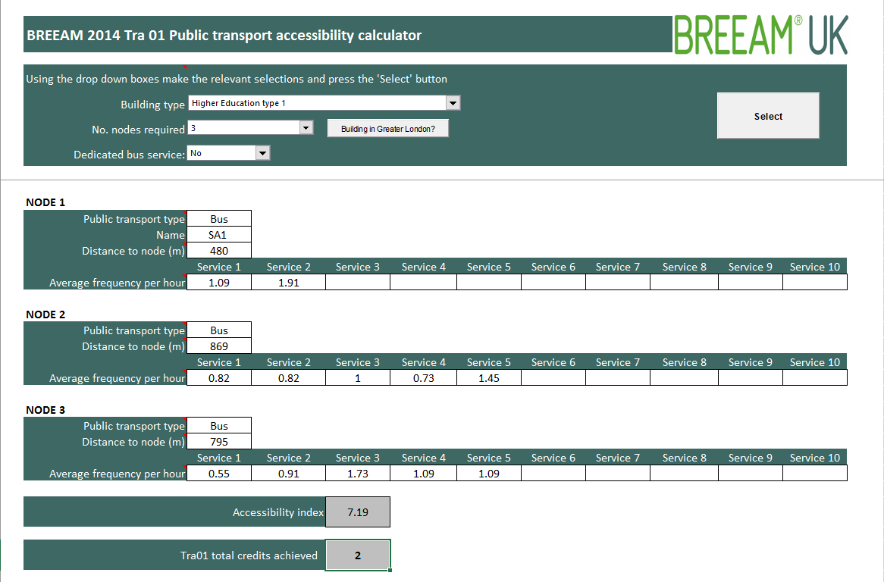
Accessibility index 7.19
TRAO1 credits achieved 2
(uk, 2018)

TRA02
To encourage and reward a building location that facilitates easy access to local services and so reduces the environmental, social and economic impacts resulting from multiple or extended building user journeys, including transport-related emissions and traffic congestion. Up 2 two credits are available.
Methodology
The first step of completing TRA02 was to determine what type of building the library was. Using the table, I found out that the building was building type3 higher education and further education. Then using table 31 I was able to look at the core elements required by building type three. There are core elements that need to be met to achieve the 1 credit available. The building is required to meet 4 amenities within 500m. the building needs the following amenities
- Appropriate food outlet C
- Access to cash C
- Access to recreation/leisure facility for fitness/sports C
- Access to outdoor open space
Evidence appended to this document. However,
- Sainsbury food store less than Exceeds 500m
- Cash point at Sainsbury’s less than 500m away
- Access to recreation/leisure facility for fitness/sports available at village hotel more than 500m away
- I feel these criteria is met based on the site plan and surrounding areas
(Google, 2018)
0 CREDIT ACHIEVED

TRA03
To encourage building users to cycle, so promoting exercise and helping reduce congestion and emissions, by ensuring adequate provision of cyclist facilities. Three credits available one credit available to build.
Methodology
The first step I took was to refer to table 32 cycle storage criteria for each building type, using this table I was able to see that the library required. FE and HE requires 1 cycle space per 10 students and staff using the formula provided in CN4 I was able to calculate the amount of spaces require.
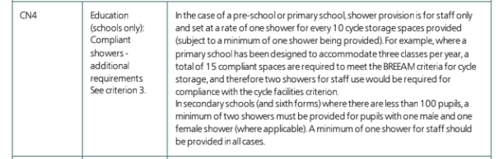

I found out the building user number from the Kier letter stating that there will be 500 users. Following is the calculation used. Sliding scale of compliance. Number 3. 401+users @ 1 space per 25 users (standard unit of measure x 2.5) =16 spaces.
$$500+\frac{50}{10×2.5}$$
$$\frac{550}{25}=22 spaces required$$
Technically this could mean 11 hoops as they are doubled sided.
There is no evidence available for the amount of bike storage provision at the library building at this moment in time. Therefore there are no credits awarded.
0 CREDIT ACHIEVED

TRA04
To encourage the use of alternative means of transport other than the private car to and from the building, thereby helping to reduce transport-related emissions and traffic congestion associated with the building’s operation. Two Credits available.
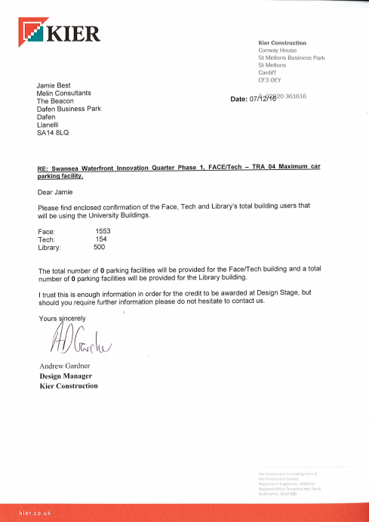
Methodology
Table 33 of TRA04 states that there should be a maximum of 1 space for 25 building users, therefore the library must have no more than the following spaces.
$$\frac{500}{25}=20 spaces maximun$$

The letter adjacent confirms there are 0 parking spaces for the library building, therefore I see no reason why the 1 credit cannot be awarded.
1 CREDIT ACHIEVED

TRA05
To recognise the consideration given to accommodating a range of travel options for building users, thereby encouraging the reduction of reliance on forms of travel that have the highest environmental impact. One credit available.
Methodology
There is a list in the technical manual that must be met the criteria is as follows.
- A travel plan has been developed as part of the feasibility and design stages.
A travel plan has been created. Titled Transport assessment.
- A site-specific travel assessment/statement has been undertaken to ensure the travel plan is structured to meet the needs of site and covers the following as minimum.
An existing travel plan is in place, and there are options for site users towards cycling and walking. The travel patterns and transport impacts have been considered and the current local environment for walkers and cyclists has been consider. Disabled access and current facilities for cyclists have also been mentioned.
- The travel plan includes a packet of measures to encourage the use of sustainable modes of transports.
1 CREDIT ACHIEVED

Overall credits/ results
Section | Result
TRA01 | 2
TRA02 | 0
TRA03 | 0
TRA04 | 1
TRA05 | 1
 | Total, 4
Out of the 12 credits available for this BREEAM assessment the library only achieved 4. This is due to many reasons which I will evaluate in my conclusion.

TRA03 is technically a pending element although for the purpose in this task I’ve had to make a decision in a real life scenario there would be a lot of chasing up and trying to source the data needed as the BREEAM assessors aim is often to get the best score out of the building or at least meet the score intended by the client.

Conclusion
In conclusion I feel like this assessment isn’t as accurate as it possibly could be due to many restrictions I had when sourcing evidence. Although a lot of the evidence was readily available some of the smaller details weren’t available. Such as for TRA03, neither the drawings nor specification stated how many bike storage facilities had been allocated to the library building. It was on these grounds I had to make the assumption of there not being any and not award any credit. If any evidence comes to light at a later date then this could be rectified. The reliability of the data used for TRA01 is also questionable into it reliable as I could only use google maps. The data used for the bus times was accurate as it was directly from the first bus company website. These documents are appended in the evidence document. (BRE, 2018)
I feel that the geographical location of the site has impacted this bream rating as it is on a dock land and not part of a bus service route. This also affects the proximity to amenities section as Tesco and Sainsbury’s would be rather close it’s just they aren’t direct due to Swansea docks, and the location of the existing foot bridges.
I feel some of the design elements of the building have definitely been chosen to aid a positive BREEAM score, which is proactive thinking, however feasibility has to be considered. Such as having 0 parking spaces. This is a rather contradictory element as BREEAM classes the building as higher education type 1 as it has less than 25% residential students yet TRA04 is trying to limit car park spaces.
I will be interesting to see whether the remaining elements of the assessment will compensate for what I feel is a low score in this element. And also if the building meets it target BREAM rating as I feel this elements score does not reflect the building quality or ethos.

Evidential document

TRA01
Bus timetables used in Transport 01.

Bus stops in question, location, all within 1000m using measure tool on google maps
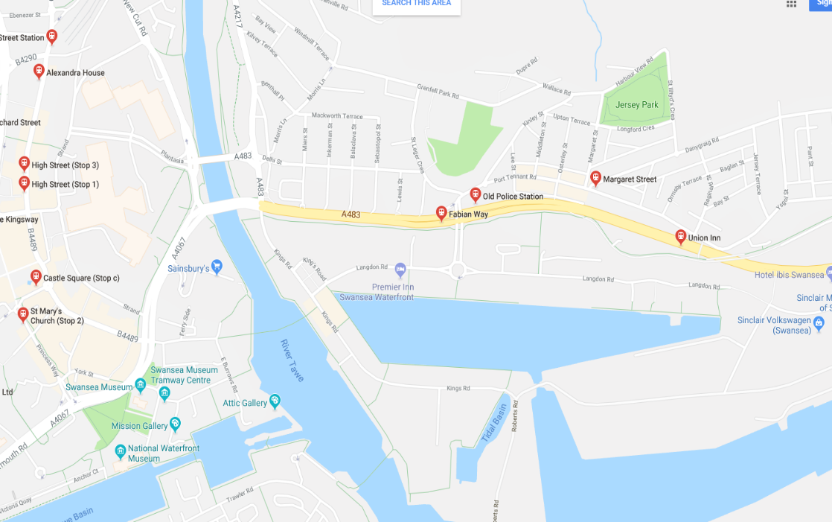

TRA02

Leisure facilities
Food outlet and cash point

- Sainsbury food store less than Exceeds 500m
- Cash point at Sainsbury’s less than 500m away
- Access to recreation/leisure facility for fitness/sports available at village hotel more than 500m away
- I feel these criteria is met based on the site plan and surrounding areas

TRA03
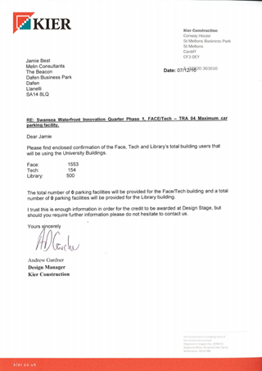
KIER LETTER to Jamie Best: States there is 500 building users

TRA04
Letter states again that there a 0 car park spaces allocated.

TRA05
Below is the transport assessment used to complete TRA05
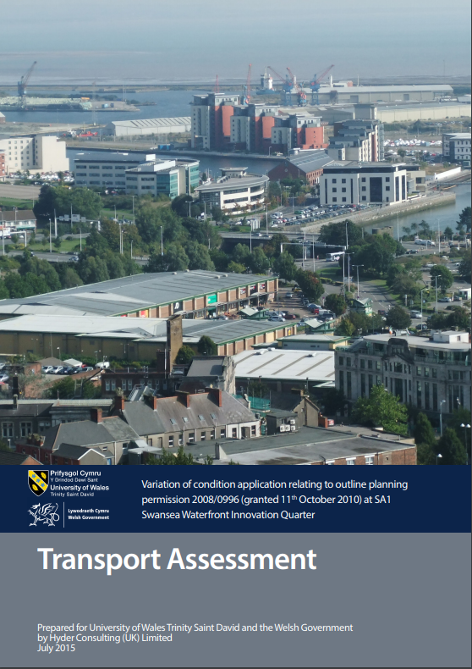

References
BRE. (2018, May 1). Technical manual SD5076: 5.0 - 2014 .
Google. (2018, 4 28). Google earth . Retrieved from www.google.co.uk/maps: https://www.google.co.uk/maps/@51.6220023,-3.9479766,15z
uk, F. B. (2018, 4 28). Firdt bus . Retrieved from https://www.firstgroup.com/: https://www.firstgroup.com/

